Martin Villasenor

CC1350 TI-RTOS/RF LAB5

**11/24/2018**

**------------------------------------------------------------------------------------**

Youtube link: Task3- <https://youtu.be/fYBMR5qtIJ0>

Task4- <https://youtu.be/_6y_snHQXwQ>

**Modified Code:**

**TASK0:**

Labeled both boards,

Collector:

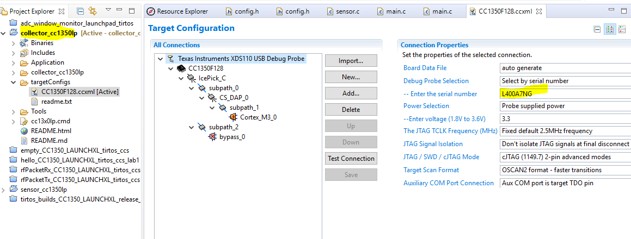

Node:

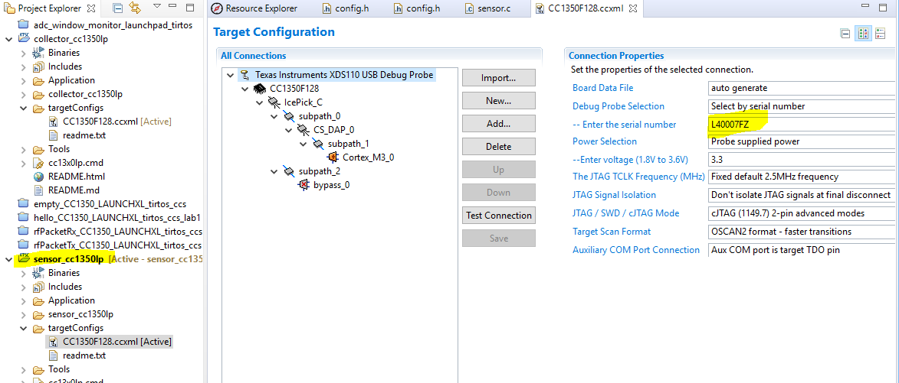

**TASK1:**

Building and Loading collector example.

After loading collector_cc1350lp project, opened config.h in Application/subg

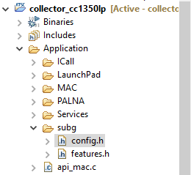

The CONFIG_PHY_ID was defined to APIMAC_STD_US_915_PHY_1 by default. No change was performed.

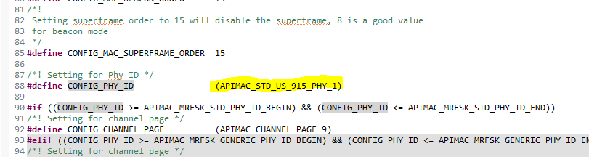

The channel mask was modified to a specific channel I chose. In my case I chose channel 4 (0x10)

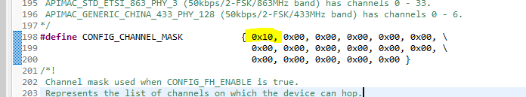

No concern on conflicts from other boards since my two boards are isolated from others.

Changing the reading value received by collector from node. Originally the vale is set to be sensor ID. Changing the value to temperature reading.

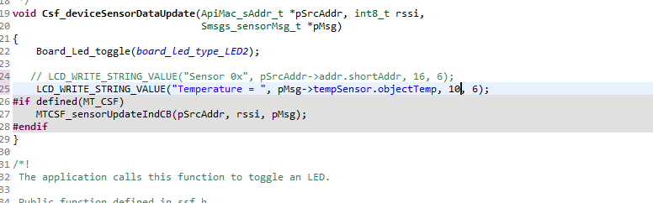

**TASK2:**

Building and Loading node example.

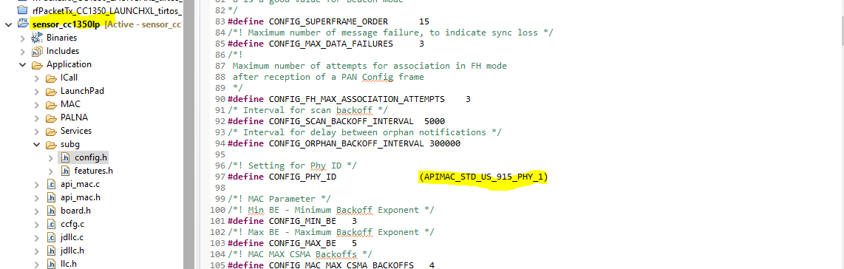

Configuring channel for node.

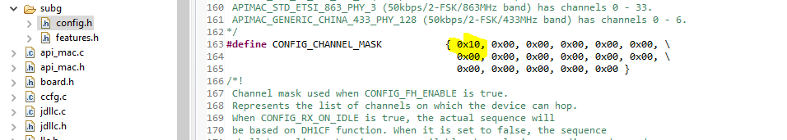

Built and debugged Node board.

**TASK3:**

Using Collector and Sensor.

Configuring and connecting Serial terminals to collector and node boards.

The Collector board receives the Temperature reading.

Collector

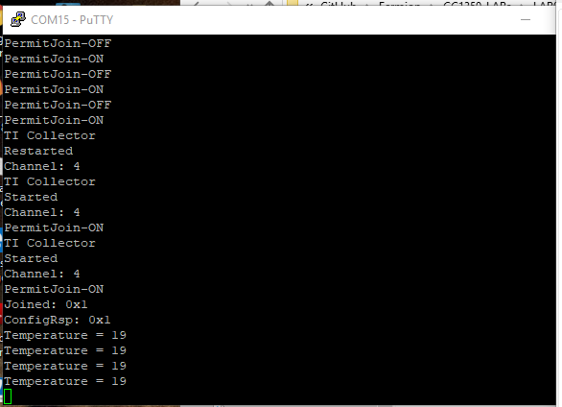

Node

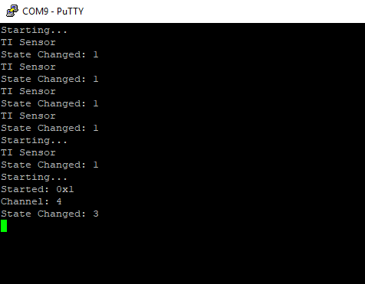

**TASK4:**

Updating sensor’s reporting rate

Code changes done in config.h of Collector project

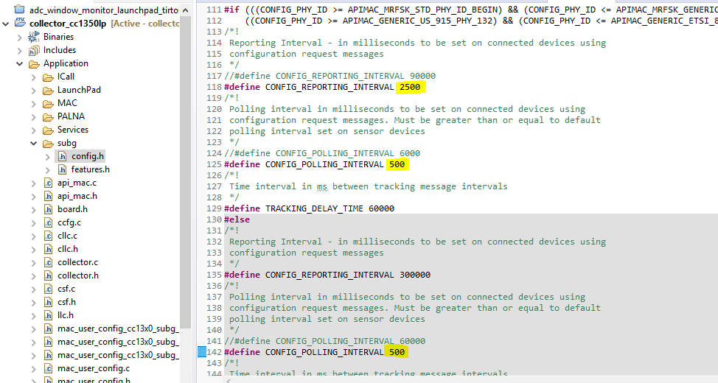

Temperature is now reported every 2.5 seconds on collector serial terminal.

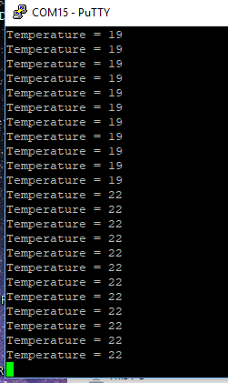

Code changes done on config.h for node project

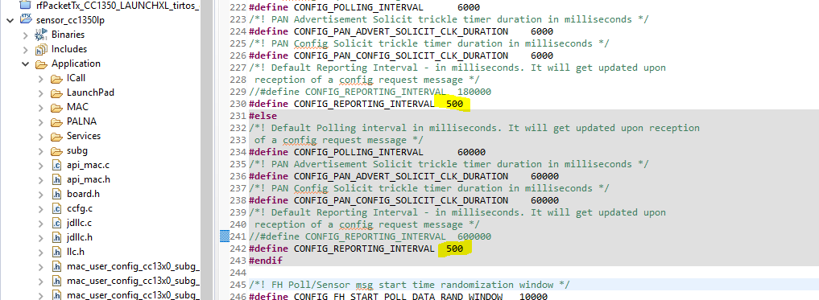

Code change done on sensor.c

