Martin Villasenor

CC1350 TI-RTOS/RF LAB6

**11/26/2018**

**------------------------------------------------------------------------------------**

**TASK0:**

Obtaining from Lab 0 images required for this lab 6. Images sent to my email

1)simple_peripheral_cc1350lp_app_stack.bin

2)rfWsnDmConcentratorOad_CC1350LP_868_app.bin

3)rfWsnDmNodeOad_CC1350LP_868_app.bin

Updating firmware on 1350 LaunchPad.

Opening UniFlash. My two CC1350 Launchpads have been identified as shown below

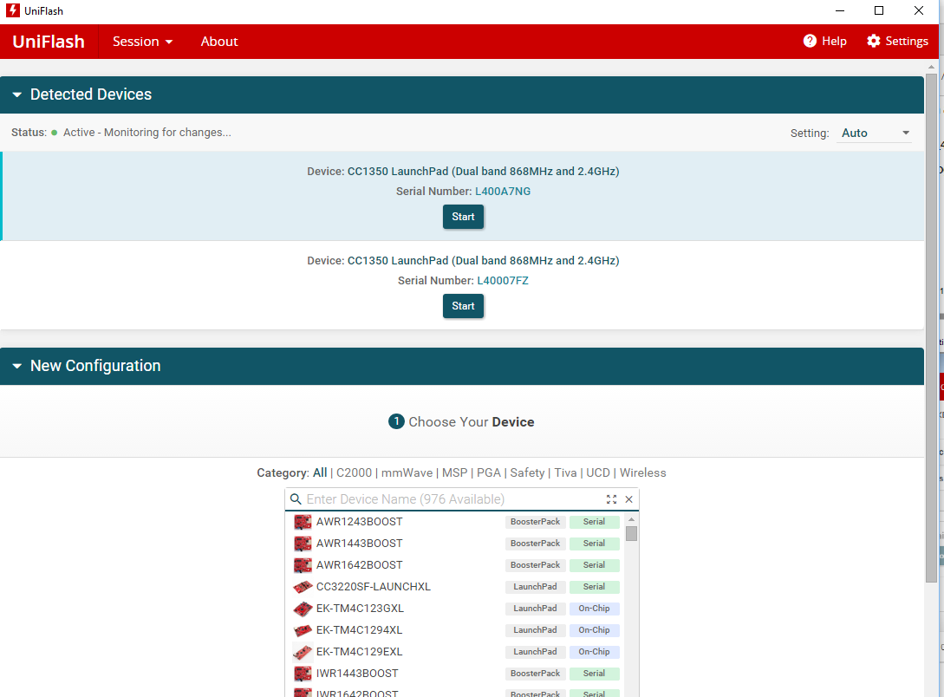

Loading EXFlashErase.hex image onto both Launchpads. One CC1350 Launchpad programmed example shown below.

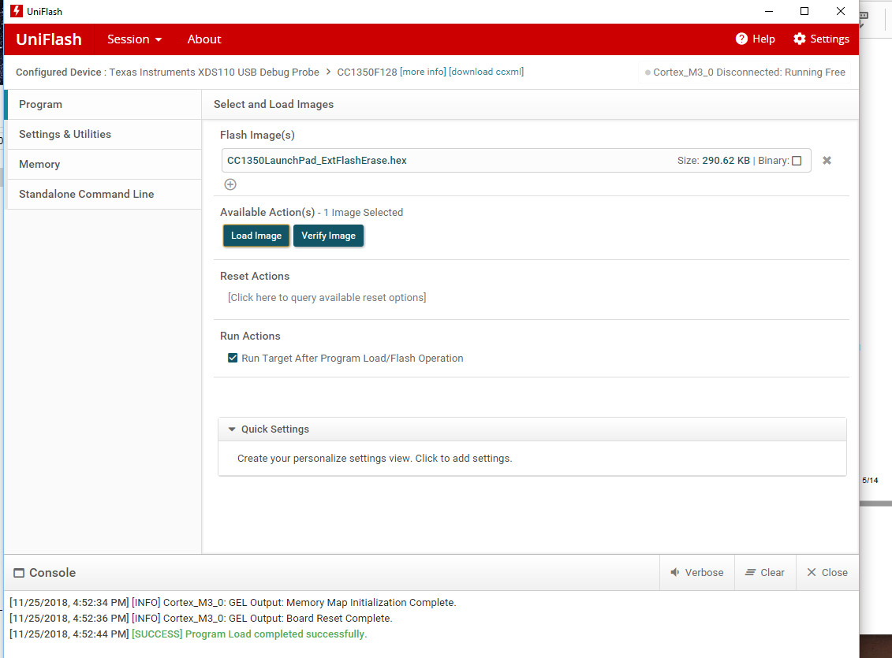

Boards display red and green leds flashing for a few seconds then settles.

Both boards have been resetted successfully.

Flashing simple_peripheral_cc1350lp_all.hex image onto one of the Launchpads.

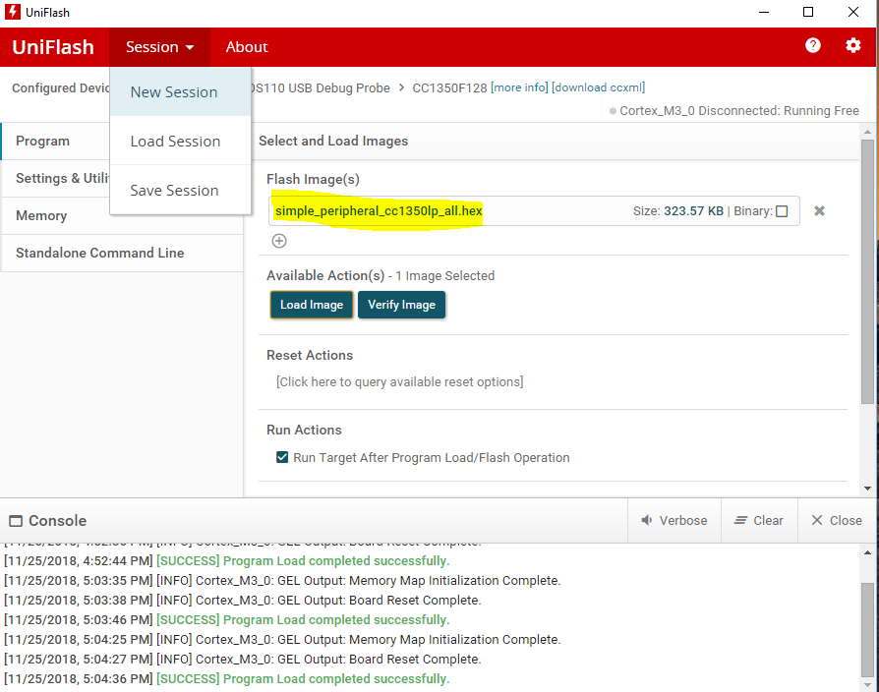

Opening TI SensorTag app from my iPhone. The BlueTooth Low Energy Devices menu displays my launchpad id as “(SimpleBLEPeripheral)”.

Selecting this device, then Sensor View. Selecting FW Download and image “simple_peripheral_cc1350lp_app_stack.bin”. Once downloaded, phone image displays “FW upgrade successful”.

OAD download sub-1GHz firmware images for Coordinator and Node.

Found BLE device on SensorTag app. One has been configured with node Oad bin which is shown being recognized as “CC1350 launchpad – 0xDC”. The other device is recognize as Simple BLE peripheral.

Figures below are snapshots taken from my iphone.

