**10/04/2018**

**Task 00: Execute provided code**

**------------------------------------------------------------------------------------**

**Task 01:**

Youtube Link: https://youtu.be/gTotu4k8hko

**Modified Code:**

uint32_t ui32PeriodHigh;

uint32_t ui32PeriodLow;

**int** **main**(**void**)

{

**SysCtlClockSet**(SYSCTL_SYSDIV_5|SYSCTL_USE_PLL|SYSCTL_XTAL_16MHZ|SYSCTL_OSC_MAIN);

**SysCtlPeripheralEnable**(SYSCTL_PERIPH_GPIOF);

**GPIOPinTypeGPIOOutput**(GPIO_PORTF_BASE, GPIO_PIN_1|GPIO_PIN_2|GPIO_PIN_3);

**SysCtlPeripheralEnable**(SYSCTL_PERIPH_TIMER0);

**TimerConfigure**(TIMER0_BASE, TIMER_CFG_PERIODIC);

ui32PeriodHigh = 3* (**SysCtlClockGet**() /2) /4; // Period of 0.375s 2Hz

ui32PeriodLow = (**SysCtlClockGet**()/2) / 4; // Period of 0.125s 2Hz

**TimerLoadSet**(TIMER0_BASE, TIMER_A, ui32PeriodHigh -1);

**IntEnable**(INT_TIMER0A);

**TimerIntEnable**(TIMER0_BASE, TIMER_TIMA_TIMEOUT);

**IntMasterEnable**();

**TimerEnable**(TIMER0_BASE, TIMER_A);

**while**(1)

{

}

}

**void** **Timer0IntHandler**(**void**)

{

// Clear the timer interrupt

**TimerIntClear**(TIMER0_BASE, TIMER_TIMA_TIMEOUT);

// Read the current state of the GPIO pin and

// write back the opposite state

**if**(**GPIOPinRead**(GPIO_PORTF_BASE, GPIO_PIN_2))

{

**TimerLoadSet**(TIMER0_BASE, TIMER_A, ui32PeriodLow -1); // loading Low

**GPIOPinWrite**(GPIO_PORTF_BASE, GPIO_PIN_1|GPIO_PIN_2|GPIO_PIN_3, 0);

}

**else**

{

**TimerLoadSet**(TIMER0_BASE, TIMER_A, ui32PeriodHigh -1); //loading High

**GPIOPinWrite**(GPIO_PORTF_BASE, GPIO_PIN_2, 4);

}

}

**Wave Form showing high signal of 0.375 seconds 2Hz 75% duty cycle**

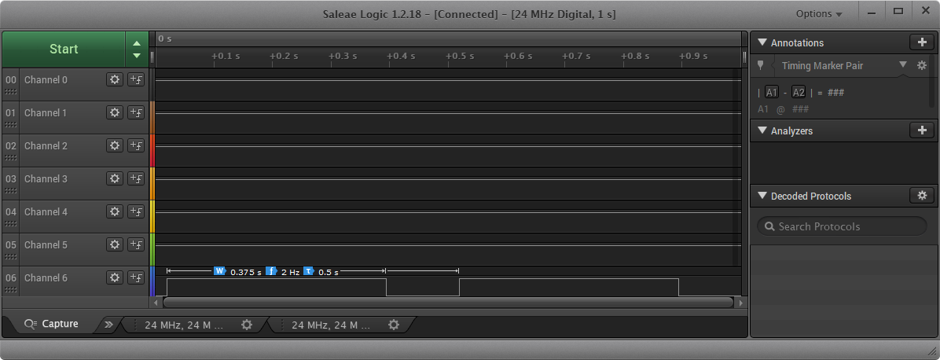

**Wave Form showing low signal of 0.125 seconds 2Hz 75% duty cycle**

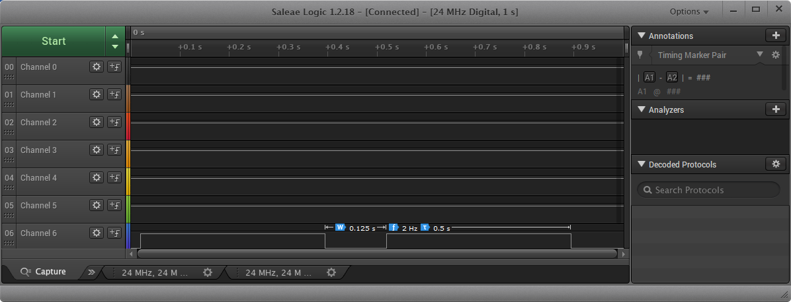

**------------------------------------------------------------------------------------**

**Task 02:**

Youtube Link: <https://youtu.be/k8VaDwzBQ0o>

**Modified Code:**

**void** **timer1A_delaymSec**( **int** ttime);

**int** **main**(**void**)

{

**SysCtlClockSet**(SYSCTL_SYSDIV_5|SYSCTL_USE_PLL|SYSCTL_XTAL_16MHZ|SYSCTL_OSC_MAIN);

**SysCtlPeripheralEnable**(SYSCTL_PERIPH_GPIOF);

**SysCtlPeripheralEnable**(SYSCTL_PERIPH_TIMER1);

**GPIOPinTypeGPIOInput**(GPIO_PORTF_BASE, GPIO_PIN_4);

**GPIOPadConfigSet**(GPIO_PORTF_BASE,GPIO_PIN_4,GPIO_STRENGTH_2MA,GPIO_PIN_TYPE_STD_WPU);

**GPIOPinTypeGPIOOutput**(GPIO_PORTF_BASE, GPIO_PIN_1|GPIO_PIN_2|GPIO_PIN_3);

**GPIOIntEnable**(GPIO_PORTF_BASE, GPIO_INT_PIN_4);

**GPIOIntTypeSet**(GPIO_PORTF_BASE, GPIO_INT_PIN_4, GPIO_RISING_EDGE);

**SysCtlPeripheralEnable**(SYSCTL_PERIPH_TIMER1);

**IntEnable**(INT_GPIOF);

**while**(1)

{

}

}

**void** **PortFPin4IntHandler**(**void**)

{

// Clear the GPIO interrupt

**GPIOIntClear**(GPIO_PORTF_BASE, GPIO_INT_PIN_4);

// Read the current state of the GPIO pin and

// write back the opposite state

**GPIOPinWrite**(GPIO_PORTF_BASE,GPIO_PIN_2, GPIO_PIN_2); // turn on blue led

timer1A_delaymSec( 1500 ); // 1.5 second delay

**GPIOPinWrite**(GPIO_PORTF_BASE,GPIO_PIN_2, 0); // turn off blue led

}

**void** **timer1A_delaymSec**( **int** ttime)

{

**int** i;

SYSCTL_RCGCTIMER_R |=2;

TIMER1_CTL_R = 0;

TIMER1_CFG_R = 0x04;

TIMER1_TAMR_R = 0x02;

TIMER1_TAILR_R = 640 - 1;

TIMER1_TAPR_R = 275 - 1;

TIMER1_ICR_R = 0x1;

TIMER1_CTL_R |= 0x01;

**for**(i=0; i < ttime; i++)

{

**while** ((TIMER1_RIS_R & 0x1) == 0)

;

TIMER1_ICR_R = 0x1;

}

}

**------------------------------------------------------------------------------------**