**10/09/2018**

**Task 00: Execute provided code**

**------------------------------------------------------------------------------------**

Modified code highlighted in yellow

**Task 01:**

Youtube Link: <https://youtu.be/EHXwowkUnkw>

**Modified Code:**

**int** **main**(**void**)

{

uint32_t ui32ADC0Value[4];

**volatile** uint32_t ui32TempAvg;

**volatile** uint32_t ui32TempValueC;

**volatile** uint32_t ui32TempValueF;

**SysCtlClockSet**(SYSCTL_SYSDIV_5|SYSCTL_USE_PLL|SYSCTL_OSC_MAIN|SYSCTL_XTAL_16MHZ);

**SysCtlPeripheralEnable**(SYSCTL_PERIPH_ADC0);

**SysCtlPeripheralEnable**(SYSCTL_PERIPH_GPIOF); // Enabling GPIO for LED

**GPIOPinTypeGPIOOutput**(GPIO_PORTF_BASE, GPIO_PIN_2); // Enable Pin2 for Blue LED

**ADCHardwareOversampleConfigure**(ADC0_BASE, 64);

**ADCSequenceConfigure**(ADC0_BASE, 2, ADC_TRIGGER_PROCESSOR, 0); // Changed to sequencer #2

**ADCSequenceStepConfigure**(ADC0_BASE, 2, 0, ADC_CTL_TS);

**ADCSequenceStepConfigure**(ADC0_BASE, 2, 1, ADC_CTL_TS);

**ADCSequenceStepConfigure**(ADC0_BASE, 2, 2, ADC_CTL_TS);

**ADCSequenceStepConfigure**(ADC0_BASE, 2, 3, ADC_CTL_TS|ADC_CTL_IE|ADC_CTL_END);

**ADCSequenceEnable**(ADC0_BASE, 2);

**while** (1)

{

**ADCIntClear**(ADC0_BASE, 2);

**ADCProcessorTrigger**(ADC0_BASE, 2);

**while**(!**ADCIntStatus**(ADC0_BASE, 2, false))

{

}

**ADCSequenceDataGet**(ADC0_BASE, 2, ui32ADC0Value);

ui32TempAvg = (ui32ADC0Value[0] + ui32ADC0Value[1] + ui32ADC0Value[2] + ui32ADC0Value[3] + 2)/4;

ui32TempValueC = (1475 - ((2475 * ui32TempAvg)) / 4096)/10;

ui32TempValueF = ((ui32TempValueC * 9) + 160) / 5;

**if** ( ui32TempValueF > 64 ) // This is the threshold of my environment temperature to detect change

{

**GPIOPinWrite**(GPIO_PORTF_BASE,GPIO_PIN_2, GPIO_PIN_2);

}

**else**

{

**GPIOPinWrite**(GPIO_PORTF_BASE,GPIO_PIN_2, 0);

}

}

}

**Displaying temperature using built-in graphing tool**

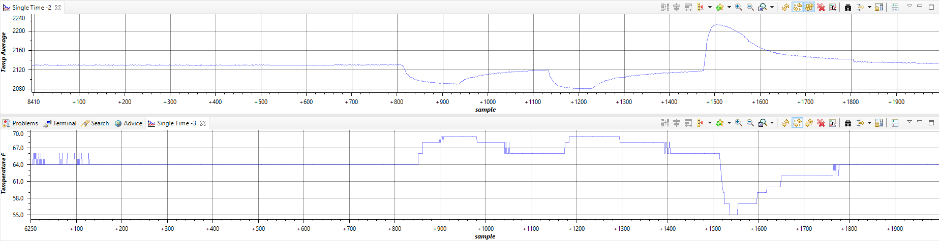

**------------------------------------------------------------------------------------**

**Task 02:**

Youtube Link: <https://youtu.be/gmuuoUaAxJ8>

**Modified Code:**

**#include** <stdint.h>

**#include** <stdbool.h>

**#include** "inc/tm4c123gh6pm.h"

**#include** "inc/hw_memmap.h"

**#include** "inc/hw_types.h"

**#include** "driverlib/debug.h"

**#include** "driverlib/sysctl.h"

**#include** "driverlib/adc.h"

**#define** TARGET_IS_BLIZZARD_RB1

**#include** "driverlib/rom.h"

**#include** "driverlib/gpio.h"

**#include** "driverlib/timer.h"

**#include** "driverlib/interrupt.h"

**#include** "driverlib/rom_map.h"

**#include** "driverlib/pin_map.h"

**#ifdef** DEBUG

**void__error__**(**char** *pcFilename, uint32_t ui32Line)

{

}

**#endif**

// Globals

uint32_t ui32Period;

uint32_t ui32ADC0Value[4];

**volatile** uint32_t ui32TempAvg;

**volatile** uint32_t ui32TempValueC;

**volatile** uint32_t ui32TempValueF;

**int** **main**(**void**)

{

// Clock configuration

ROM_SysCtlClockSet(SYSCTL_SYSDIV_5|SYSCTL_USE_PLL|SYSCTL_OSC_MAIN|SYSCTL_XTAL_16MHZ); //Clock configuration

// LED configuration

ROM_SysCtlPeripheralEnable(SYSCTL_PERIPH_GPIOF); // Enabling GPIO for LED

ROM_GPIOPinTypeGPIOOutput(GPIO_PORTF_BASE, GPIO_PIN_2); // Enable Pin2 for Blue LED

// ADC configuration

ROM_SysCtlPeripheralEnable(SYSCTL_PERIPH_ADC0); // ADC peripheral enabled

ROM_ADCHardwareOversampleConfigure(ADC0_BASE, 32); // Introducing hardware averaging of 32

ROM_ADCSequenceConfigure(ADC0_BASE, 2, ADC_TRIGGER_PROCESSOR, 0); // ADC trigger mode

ROM_ADCSequenceStepConfigure(ADC0_BASE, 2, 0, ADC_CTL_TS); // Sequences configuration

ROM_ADCSequenceStepConfigure(ADC0_BASE, 2, 1, ADC_CTL_TS);

ROM_ADCSequenceStepConfigure(ADC0_BASE, 2, 2, ADC_CTL_TS);

ROM_ADCSequenceStepConfigure(ADC0_BASE, 2, 3, ADC_CTL_TS|ADC_CTL_IE|ADC_CTL_END);

// Timer 1 configuration

ROM_SysCtlPeripheralEnable(SYSCTL_PERIPH_TIMER1); // Timer 1 enabled

ROM_TimerConfigure(TIMER1_BASE, TIMER_CFG_PERIODIC); // Timer in periodic mode

ui32Period = ROM_SysCtlClockGet()/2; // Period of 0.5s 2Hz

ROM_TimerLoadSet(TIMER1_BASE, TIMER_A, ui32Period -1); // setting timer to expire at 0.5 seconds

ROM_IntEnable(INT_TIMER1A); // Interrupt for Timer1A enabled

ROM_TimerIntEnable(TIMER1_BASE, TIMER_TIMA_TIMEOUT);

// Enable interrupts

ROM_IntMasterEnable();

ROM_ADCSequenceEnable(ADC0_BASE, 2);

ROM_TimerEnable(TIMER1_BASE, TIMER_A);

**while** (1) //wait forever

{

}

}

**void** **Timer1IntHandler**(**void**)

{

// Clear the timer interrupt

ROM_TimerIntClear(TIMER1_BASE, TIMER_TIMA_TIMEOUT);

ROM_ADCIntClear(ADC0_BASE, 2);

ROM_ADCProcessorTrigger(ADC0_BASE, 2);

**while**(!ROM_ADCIntStatus(ADC0_BASE, 2, false))

{

}

ROM_ADCSequenceDataGet(ADC0_BASE, 2, ui32ADC0Value);

ui32TempAvg = (ui32ADC0Value[0] + ui32ADC0Value[1] + ui32ADC0Value[2] + ui32ADC0Value[3] + 2)/4;

ui32TempValueC = (1475 - ((2475 * ui32TempAvg)) / 4096)/10;

ui32TempValueF = ((ui32TempValueC * 9) + 160) / 5;

**if** ( ui32TempValueF > 68 ) // This is the threshold of my environment temperature to detect change

{

ROM_GPIOPinWrite(GPIO_PORTF_BASE,GPIO_PIN_2, GPIO_PIN_2); // turn it on

}

**else**

{

ROM_GPIOPinWrite(GPIO_PORTF_BASE,GPIO_PIN_2, 0); // turn it off

}

}