**10/09/2018**

**Task 00: Execute provided code**

**------------------------------------------------------------------------------------**

Modifications highlighted in Yellow

**Task 01:**

Youtube Link: https: https://youtu.be/XQ_CwMC-BXc

**Modified Code:**

**#include** <stdint.h>

**#include** <stdbool.h>

**#include** "inc/hw_memmap.h"

**#include** "inc/hw_types.h"

**#include** "driverlib/sysctl.h"

**#include** "driverlib/gpio.h"

**#include** "driverlib/debug.h"

**#include** "driverlib/pwm.h"

**#include** "driverlib/pin_map.h"

**#include** "inc/hw_gpio.h"

**#include** "driverlib/rom.h"

**#define** PWM_FREQUENCY 55

**int** **main**(**void**)

{

**volatile** uint32_t ui32Load;

**volatile** uint32_t ui32PWMClock;

**volatile** uint8_t ui8Adjust;

ui8Adjust = 83;

ROM_SysCtlClockSet(SYSCTL_SYSDIV_5|SYSCTL_USE_PLL|SYSCTL_OSC_MAIN|SYSCTL_XTAL_16MHZ);

ROM_SysCtlPWMClockSet(SYSCTL_PWMDIV_64);

ROM_SysCtlPeripheralEnable(SYSCTL_PERIPH_PWM1);

ROM_SysCtlPeripheralEnable(SYSCTL_PERIPH_GPIOD);

ROM_SysCtlPeripheralEnable(SYSCTL_PERIPH_GPIOF);

ROM_GPIOPinTypePWM(GPIO_PORTD_BASE, GPIO_PIN_0);

ROM_GPIOPinConfigure(GPIO_PD0_M1PWM0);

HWREG(GPIO_PORTF_BASE + GPIO_O_LOCK) = GPIO_LOCK_KEY;

HWREG(GPIO_PORTF_BASE + GPIO_O_CR) |= 0x01;

HWREG(GPIO_PORTF_BASE + GPIO_O_LOCK) = 0;

ROM_GPIODirModeSet(GPIO_PORTF_BASE, GPIO_PIN_4|GPIO_PIN_0, GPIO_DIR_MODE_IN);

ROM_GPIOPadConfigSet(GPIO_PORTF_BASE, GPIO_PIN_4|GPIO_PIN_0, GPIO_STRENGTH_2MA, GPIO_PIN_TYPE_STD_WPU);

ui32PWMClock = **SysCtlClockGet**() / 64;

ui32Load = (ui32PWMClock / PWM_FREQUENCY) - 1;

**PWMGenConfigure**(PWM1_BASE, PWM_GEN_0, PWM_GEN_MODE_DOWN);

**PWMGenPeriodSet**(PWM1_BASE, PWM_GEN_0, ui32Load);

ROM_PWMPulseWidthSet(PWM1_BASE, PWM_OUT_0, ui8Adjust * ui32Load / 1000);

ROM_PWMOutputState(PWM1_BASE, PWM_OUT_0_BIT, true);

ROM_PWMGenEnable(PWM1_BASE, PWM_GEN_0);

**while**(1)

{

**if**(ROM_GPIOPinRead(GPIO_PORTF_BASE,GPIO_PIN_4)==0x00)

{

ui8Adjust--;

**if** (ui8Adjust < 33) // 90 degree right turn

{

ui8Adjust = 33; //56

}

ROM_PWMPulseWidthSet(PWM1_BASE, PWM_OUT_0, ui8Adjust * ui32Load / 1000);

}

**if**(ROM_GPIOPinRead(GPIO_PORTF_BASE,GPIO_PIN_0)==0x00)

{

ui8Adjust++;

**if** (ui8Adjust > 130) //90 degree left turn

{

ui8Adjust = 130;

}

ROM_PWMPulseWidthSet(PWM1_BASE, PWM_OUT_0, ui8Adjust * ui32Load / 1000);

}

ROM_SysCtlDelay(100000);

}

}

**------------------------------------------------------------------------------------**

**Task 02:**

Youtube Link: https://youtu.be/FNctQdqKf5s

**Modified Code:**

**#include** <stdint.h>

**#include** <stdbool.h>

**#include** "inc/hw_memmap.h"

**#include** "inc/hw_types.h"

**#include** "driverlib/sysctl.h"

**#include** "driverlib/gpio.h"

**#include** "driverlib/debug.h"

**#include** "driverlib/pwm.h"

**#include** "driverlib/pin_map.h"

**#include** "inc/hw_gpio.h"

**#include** "driverlib/rom.h"

**#define** PWM_FREQUENCY 55

**int** **main**(**void**)

{

**volatile** uint32_t ui32Load;

**volatile** uint32_t ui32PWMClock;

**volatile** uint32_t ui8Adjust; // changed type from uint8_t to uint32_t due to truncation

ui8Adjust = 500;

ROM_SysCtlClockSet(SYSCTL_SYSDIV_5|SYSCTL_USE_PLL|SYSCTL_OSC_MAIN|SYSCTL_XTAL_16MHZ);

ROM_SysCtlPWMClockSet(SYSCTL_PWMDIV_64);

ROM_SysCtlPeripheralEnable(SYSCTL_PERIPH_PWM1);

ROM_SysCtlPeripheralEnable(SYSCTL_PERIPH_GPIOF);

ROM_GPIOPinTypePWM(GPIO_PORTF_BASE, GPIO_PIN_1); // Setting pin PF1 to PWM

ROM_GPIOPinConfigure(GPIO_PF1_M1PWM5); // PF1 pin maps with PWM module 1 -> Gen2 -> PWM5

// For switch 1 unlock

HWREG(GPIO_PORTF_BASE + GPIO_O_LOCK) = GPIO_LOCK_KEY;

HWREG(GPIO_PORTF_BASE + GPIO_O_CR) |= 0x01;

HWREG(GPIO_PORTF_BASE + GPIO_O_LOCK) = 0;

ROM_GPIODirModeSet(GPIO_PORTF_BASE, GPIO_PIN_4|GPIO_PIN_0, GPIO_DIR_MODE_IN);

ROM_GPIOPadConfigSet(GPIO_PORTF_BASE, GPIO_PIN_4|GPIO_PIN_0, GPIO_STRENGTH_2MA, GPIO_PIN_TYPE_STD_WPU);

// setting pwm load for duty cycle configuration

ui32PWMClock = **SysCtlClockGet**() / 64;

ui32Load = (ui32PWMClock / PWM_FREQUENCY) - 1;

**PWMGenConfigure**(PWM1_BASE, PWM_GEN_2, PWM_GEN_MODE_DOWN);

// setting period for generator 2 on PWM module 1

**PWMGenPeriodSet**(PWM1_BASE, PWM_GEN_2, ui32Load);

// Setting default duty cycle to 50%

ROM_PWMPulseWidthSet(PWM1_BASE, PWM_OUT_5, ui8Adjust * ui32Load / 1000);

ROM_PWMOutputState(PWM1_BASE, PWM_OUT_5_BIT, true);

// Enables Generator 2 which connects to pwm5

ROM_PWMGenEnable(PWM1_BASE, PWM_GEN_2);

**while**(1)

{

**if**(ROM_GPIOPinRead(GPIO_PORTF_BASE,GPIO_PIN_4)==0x00)

{

ui8Adjust--;

**if** (ui8Adjust < 100)

{

ui8Adjust = 100; //10 percent high

}

ROM_PWMPulseWidthSet(PWM1_BASE, PWM_OUT_5, ui8Adjust * ui32Load / 1000);

}

**if**(ROM_GPIOPinRead(GPIO_PORTF_BASE,GPIO_PIN_0)==0x00)

{

ui8Adjust++;

**if** (ui8Adjust > 900)

{

ui8Adjust = 900; //90 percent high

}

ROM_PWMPulseWidthSet(PWM1_BASE, PWM_OUT_5, ui8Adjust * ui32Load / 1000);

}

ROM_SysCtlDelay(100000);

}

}

Default duty cycle of 50%, 9.09 ms high and low, period 18.18 ms, freq of 55Hz

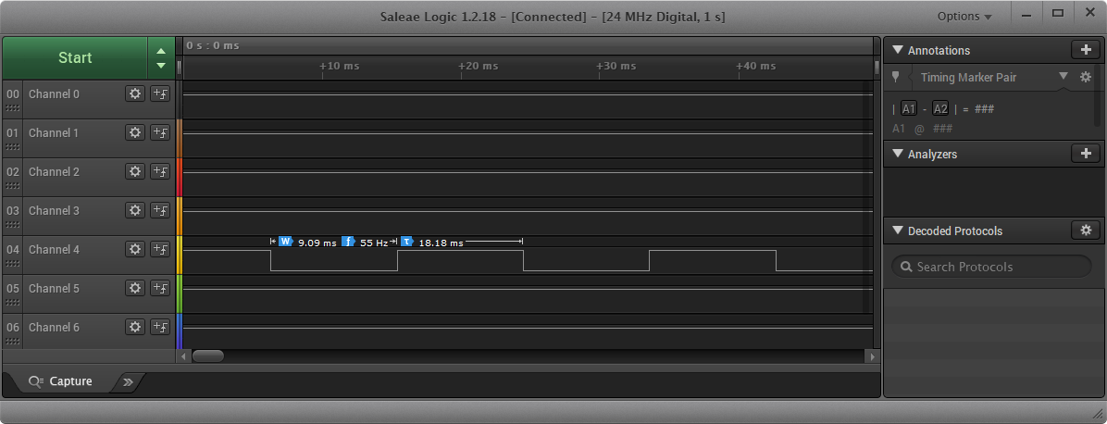

Duty cycle of 10%, 1.89 ms high, period 18.18 ms, freq of 55Hz

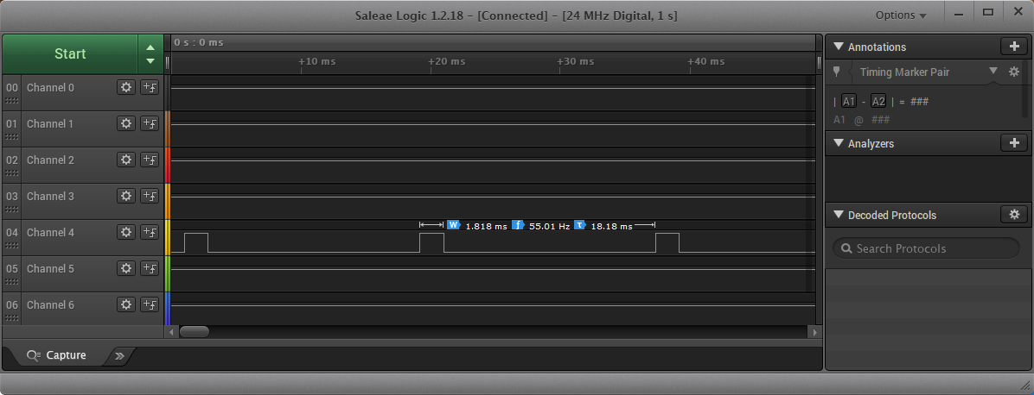

Duty cycle of 90%, 16.36ms high, period 18.18 ms, freq of 55Hz

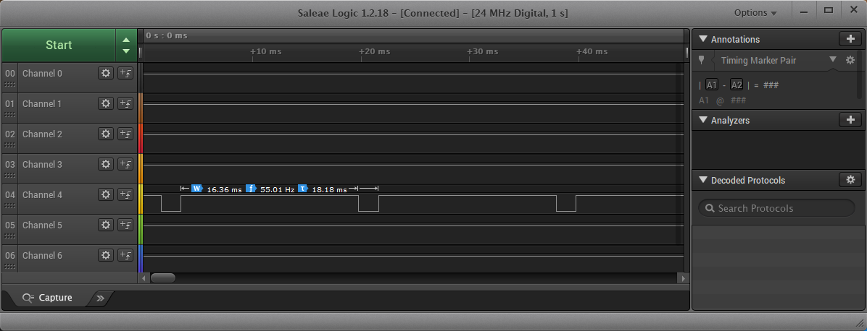

**------------------------------------------------------------------------------------**

**Task 03:**

Youtube Link: https://youtu.be/z1chUYLy9sA

**Modified Code:**

**#include** <stdint.h>

**#include** <stdbool.h>

**#include** "inc/hw_memmap.h"

**#include** "inc/hw_types.h"

**#include** "driverlib/sysctl.h"

**#include** "driverlib/gpio.h"

**#include** "driverlib/debug.h"

**#include** "driverlib/pwm.h"

**#include** "driverlib/pin_map.h"

**#include** "inc/hw_gpio.h"

**#include** "driverlib/rom.h"

**#define** PWM_FREQUENCY 55

**int** **main**(**void**)

{

**volatile** uint32_t ui32Load;

**volatile** uint32_t ui32PWMClock;

**volatile** uint32_t ui8AdjustRed; // Adjust variable for Red LED

**volatile** uint32_t ui8AdjustBlue; // Adjust variable for Blue LED

**volatile** uint32_t ui8AdjustGreen; // Adjust variable for Blue LED

// Default 10% duty cycle

ui8AdjustRed = 100;

ui8AdjustBlue = 100;

ui8AdjustGreen = 100;

ROM_SysCtlClockSet(SYSCTL_SYSDIV_5|SYSCTL_USE_PLL|SYSCTL_OSC_MAIN|SYSCTL_XTAL_16MHZ);

ROM_SysCtlPWMClockSet(SYSCTL_PWMDIV_64);

ROM_SysCtlPeripheralEnable(SYSCTL_PERIPH_PWM1);

ROM_SysCtlPeripheralEnable(SYSCTL_PERIPH_GPIOF);

// Setting pins PF1, PF2 and PF3 to PWM

ROM_GPIOPinTypePWM(GPIO_PORTF_BASE, GPIO_PIN_1 | GPIO_PIN_2 | GPIO_PIN_3);

// Configuring pins for module 1 pwm outputs 5,6 and 7

ROM_GPIOPinConfigure(GPIO_PF1_M1PWM5);

ROM_GPIOPinConfigure(GPIO_PF2_M1PWM6);

ROM_GPIOPinConfigure(GPIO_PF3_M1PWM7);

// For switch 1 unlock

HWREG(GPIO_PORTF_BASE + GPIO_O_LOCK) = GPIO_LOCK_KEY;

HWREG(GPIO_PORTF_BASE + GPIO_O_CR) |= 0x01;

HWREG(GPIO_PORTF_BASE + GPIO_O_LOCK) = 0;

ROM_GPIODirModeSet(GPIO_PORTF_BASE, GPIO_PIN_4|GPIO_PIN_0, GPIO_DIR_MODE_IN);

ROM_GPIOPadConfigSet(GPIO_PORTF_BASE, GPIO_PIN_4|GPIO_PIN_0, GPIO_STRENGTH_2MA, GPIO_PIN_TYPE_STD_WPU);

// setting pwm load for duty cycle configuration

ui32PWMClock = **SysCtlClockGet**() / 64;

ui32Load = (ui32PWMClock / PWM_FREQUENCY) - 1;

// Configuring PWM generator 2 for pwm5 and generator 3 for pwm6 and pwm7

**PWMGenConfigure**(PWM1_BASE, PWM_GEN_2 , PWM_GEN_MODE_DOWN);

**PWMGenConfigure**(PWM1_BASE, PWM_GEN_3 , PWM_GEN_MODE_DOWN);

// setting period for generators 2 and 3 on PWM module 1

**PWMGenPeriodSet**(PWM1_BASE, PWM_GEN_2 , ui32Load);

**PWMGenPeriodSet**(PWM1_BASE, PWM_GEN_3 , ui32Load);

// Setting default duty cycles

ROM_PWMPulseWidthSet(PWM1_BASE, PWM_OUT_5, ui8AdjustRed * ui32Load / 1000);

ROM_PWMPulseWidthSet(PWM1_BASE, PWM_OUT_6, ui8AdjustBlue * ui32Load / 1000);

ROM_PWMPulseWidthSet(PWM1_BASE, PWM_OUT_7, ui8AdjustGreen * ui32Load / 1000);

// Enabling PWM outputs 5,6 and 7

ROM_PWMOutputState(PWM1_BASE, PWM_OUT_5_BIT | PWM_OUT_6_BIT | PWM_OUT_7_BIT, true);

// Enables Generator 2 which connects to pwm5

ROM_PWMGenEnable(PWM1_BASE, PWM_GEN_2);

// Enables Generator 3 which connects to pwm6 and pwm7

ROM_PWMGenEnable(PWM1_BASE, PWM_GEN_3);

**while**(1)

{

// Nested loops driving all 3 LEDs with 5% duty cycle increments

**for**(ui8AdjustRed=100; ui8AdjustRed<900; ui8AdjustRed++)

{

ROM_PWMPulseWidthSet(PWM1_BASE, PWM_OUT_5, ui8AdjustRed * ui32Load / 1000);

ROM_SysCtlDelay(100000);

**for**(ui8AdjustBlue=100; ui8AdjustBlue<=10; ui8AdjustBlue++)

{

ROM_PWMPulseWidthSet(PWM1_BASE, PWM_OUT_6, ui8AdjustBlue * ui32Load / 1000);

ROM_SysCtlDelay(100000);

**for**(ui8AdjustGreen=100; ui8AdjustGreen<=900; ui8AdjustGreen++)

{

ROM_PWMPulseWidthSet(PWM1_BASE, PWM_OUT_7, ui8AdjustGreen * ui32Load / 1000);

ROM_SysCtlDelay(100000);

ui8AdjustGreen = (ui8AdjustGreen+50)-1;

}

ui8AdjustBlue= (ui8AdjustBlue+50)-1;

}

ui8AdjustRed= (ui8AdjustRed+50)-1;

}

**for**(ui8AdjustGreen=100; ui8AdjustGreen<900; ui8AdjustGreen++)

{

ROM_PWMPulseWidthSet(PWM1_BASE, PWM_OUT_7, ui8AdjustGreen * ui32Load / 1000);

ROM_SysCtlDelay(10000);

**for**(ui8AdjustBlue=100; ui8AdjustBlue<900; ui8AdjustBlue++)

{

ROM_PWMPulseWidthSet(PWM1_BASE, PWM_OUT_6, ui8AdjustBlue * ui32Load / 1000);

ROM_SysCtlDelay(10000);

**for**(ui8AdjustRed=100; ui8AdjustRed<900; ui8AdjustRed++)

{

ROM_PWMPulseWidthSet(PWM1_BASE, PWM_OUT_5, ui8AdjustRed * ui32Load / 1000);

ROM_SysCtlDelay(10000);

ui8AdjustRed= (ui8AdjustRed+50)-1;

}

ui8AdjustBlue= (ui8AdjustBlue+50)-1;

}

ui8AdjustGreen = (ui8AdjustGreen+50)-1;

}

}

}