**LEARNING THEORY**

Two guiding theory used in this course design are Cognitive and Constructivism. It served as a guide for the development and implementation of this course. The student should be able to tap into their current knowledge and existing ideas, and then apply that information to information presented in the course. From the learning materials/content, the student will learn specific skills by working on different content materials and projects. Different applications, software, videos, and websites will be utilized to enhance the learning of content. The instructor will serve as a facilitator and give guidance to students needing help with the course. By using the two learning theories, it is the hope of the designer and content expert to give students the necessary information to learn how to use different technology in their own courses.

**SCHEDULING**

The course is divided into 12 modules. A few of the modules need more time to learn the materials and will need more time for the student to learn how to apply the concept. Below is the proposed timeline for this course. The course does not have any due dates; faculty needs to add the due dates for each activity.

**Timeline of Course Delivery**

***Begin Here:***

*Learning Goals & Objectives*

* *Grading Policy*
  + *Introduction --- Tell us something about you*

***Week 1: Introduction to Technology - Par Up to Speed***

* Reading
  + Week 1 Reading Materials
* Discussions and Writing Activities
  + Discussion #1: Pros and Cons of Technology in the Classroom
  + Writing: List and write about some of your favorite technology.

***Week 2 & 3: Text Blogging and Video Blogging (Vlog) - (2 weeks)***

* Week 2: Text Blogging
  + Week 2 Reading Materials
* Discussion and Hands-on Activity
  + Discussion # 2: Blog: Benefits & Limitations
  + Create a blog
  + Create a blog entry - Reflection #1
* Week 3: Video Blogging (Vlog)
  + Week 3 Reading Materials
  + How to create a video blog
* Hands-on Activity
  + Create a video blog: Reflection #2

***Week 4: Writing Tools/Apps (Grammarly)***

* Reading
  + Week 4 Reading Materials
  + How to use Grammarly
* Discussion and Hands-on Activity
  + Discussion #3: Writing
  + Create a video blog: Reflection #3

***Week 5 & 6: Screencasting/Screensharing Tools (Screencast-o-matic)***

* Readings
  + Week 5 & 6 Reading Materials
  + What is screencasting?
  + Screencast-o-matic: How to use it?
* Discussion and Hands-on Activity
  + Discussion #4: Screencasting
  + Create a video blog: Reflection #4

***Week 7 & 8: Videos/Media (Screencast-o-matic & YouTube) (2 weeks)***

* Reading
  + Week 7 & 8 Reading Materials
  + How to create your own YouTube channel?
* Discussions and Hands-on Activity
  + Discussion #5: Videos in the classroom
  + Create a YouTube channel and record it using screencast-o-matic
  + Create a video blog: Reflection # 5

***Week 9: Interactive Quizzing (Kahoot)***

* Reading
  + Week 9 Reading
  + How to start your own Kahoot account
* Discussions and Hands-on Activity
  + Discussion #6: Interactivity and Engagement
  + Create a game/quiz with Kahoot
  + Create a video blog: Reflection #6

***Week 10 & 11: Social Media - Facebook and LinkedIn (2 weeks)***

* Week 10
  + Week 10 reading materials
  + Why use Facebook?
  + Facebook: How to use and incorporate into your course?
* Week 11
  + LinkedIn: What is?
  + LinkedIn: Why use it for education?
  + LinkedIn: How to use it for education?
* Discussion and Hands-on Activity
  + Discussion #7: Social Media
  + Create a Facebook group
  + Create a LinkedIn account
  + Create a video blog: Reflection #7

***Week 12: Google Tools - Docs and Slides (2 weeks)***

* Reading
  + Week 12 Readings
  + Google Apps: Why use it for education?
  + Google Apps: How to use it for education?
* Discussion and Hands-on Activity
  + Discussion #8: Google Apps
  + Create a presentation
  + Create a document
  + Create a video blog: Reflection #8

***Week 13: Audio and Video Conference Tool (Zoom)***

* Week 13 Reading: Audio and Video Conferencing
  + What is Zoom?
* Hands-on Activity
  + Create a zoom account and scheduled meeting
  + Create a video tutorial

***Week 14: Podcasting - Audacity***

* Week 14 Reading
  + Podcasting using Audacity
* Hands-on Activity
  + Create a video blog: Reflection # 9
  + Create your first podcast

***Week 15 &16: Final Portfolio & Presentation***

* Final Portfolio
* Presentation

**TIPS AND TRICKS**

The course is divided into 12 modules. Each module has reading materials, discussions, reflections and hands-on activity. At least 5 modules require 2 weeks to give student plenty of time to learn the application/software and create the project (hands-on activity and reflections). Each module is created to build the skills of the student to accomplish each task/activity.

**Faculty:** It will be advisable to hold a video conference session with the student every other week or for modules that run for 2 weeks. This will give the student time to ask for questions and any other clarifications. It is a must to learn how to use Canvas before teaching this course. It is also advisable to learn the content of the course to make facilitating the course easy. If any questions or assistance is needed, contact [VillaVance@my.unt.edu](mailto:VillaVance@my.unt.edu).

The **flexibility** of deadlines or due dates is also encouraged and to give feedback to the student projects. With this course, there is a flexibility to submit a draft and final version after feedback from faculty for the student to build the skills.

The student will need to be reminded to work as early as possible with the modules and encourage to use the FAQ and support if there are any questions.

**Final Portfolio**

At the end of the course, the student will need to submit a portfolio of all the projects/hands-on activities they did as well as a video presentation.

**Communications**

It is highly recommended to send announcements to the students every beginning of the week to let them know what are the things that need to be done. This will make communication much better for such an extensive course.

**GOALS AND OBJECTIVES**

At the end of this course students will be able to successfully:

***G.1:*** Learn new or current technologies to use for classroom improvement and integration.

***O.1.1***: Student will learn how to research information about technologies to use for classroom activities.

***O.1.2***: Student will be able to distinguish the right technology to use for their courses.

***O.1.3***: Students will discover new and relevant articles about technology and will be able to collaborate with classmates.

***G.2***: Teach how to use the different apps, websites, and software for instructional and learning improvement in the classroom.

***O.2.1***: Student will be able to do hands-on activities to create materials using the technology to learn the usability.

***O.2.2***: Student will be able to produce learning materials using the assigned technology every week.

***G.3***: Teach to design learning materials using the technology (apps, website, and software) provided.

***O.3.1***: Students will be required to create a weekly reflection using the apps/software, create videos, use collaborate tools to learn how it can be used in their course.

***G.4***: Provide an opportunity to be familiar with the technology to incorporate in their courses (screencast-o-matic, social media, google tools, podcast, vblog, kahoot, and grammarly).

***O.4.1***: Students will be required to show their knowledge of the different technology by developing materials using the apps, websites, and/or software assigned for the week.

***G.5***: Provide an opportunity to critique materials created and presented by other students.

***O.5.1***: Student will share the materials they created and will have the opportunity to give constructive criticism to their classmates.

***G.6***. Teach the learner how to incorporate learning technology tools into their courses.

***O.6.1***. Students will have the opportunity to utilize the learning technology to learn how it can be incorporate in their courses.

**Intended Sequence and Description of Instruction/Learning Activities:**

The course will be divided into different activities. Every week student learners will have to work on the following.

*Reading Materials (G.1, O.1.1, O.1.2, O.1.3)*

* Reading materials will be provided to the students. Students will read the materials and reflect on what the provided information. The reading materials will either be articles and/or research work.

*Discussions, Writing, and Reflections (G.4, O.4.1)*

* The student will write a post in the discussion area related to the topic for the week. The student will reflect on the reading and will write a blog entry or create a video blog to document what they did for the week.

*Hands-on Activity (G.2, O.2.1, O.2.2, G.3, O.3.1, G.6, O.6.1)*

* Students will perform different hands-on activities each week. This can vary from creating accounts on websites, creating a blog entry, creating vlog, screen sharing, screen capturing, creating a video, using google tools, and others.

*Critique and Final Presentation (G.5, O.5.1)*

* Students will critique other students created materials and will be presenting a final portfolio.

**ASSESSMENTS**

Students will be assess based on the submissions every week (discussions, assignments-hands on projects, reflections, portfolio and video presentations). The faculty is more than welcome to add their own rubric and connect it with the assignments. There is a set percentage for each category shown under grading policy below.

**GRADING POLICY**

This will include the following activities:

* Discussions                         15%
* Reflections (Blog /Vlog)     35%
* Hands-on Activities             40%
* Presentation                        10%

Total --------------------------- 100 %

The presentation includes the final portfolio and the video presentation.

Passing grade for this course is 75%

Feedback from students will be solicited through a satisfaction survey at the end of the course to determine if the design of the course was successful. The following student survey questions below will be used. The faculty teaching the course will need to remind the student to do the survey before the end of the course. Assessment is the last Module.

*Student Survey Questions:*

1. What do you think of the course design? Would you use any of the apps, websites or software to enhance the learning of students in your class?
2. Do you see any benefits and limitations of the course?
3. Are there enough resources to learn the technology covered in the course? If not, do you have any suggestions for the resources?
4. What would you suggest to improve the resources of the course?
5. Do you have any suggestions as to what applications, software, and/or websites that were not covered in the course?
6. Would you recommend this course to another instructor? Why? Why not?

**ENVIRONMENT**

This course is delivered 100% online. Faculty teaching the course must have the needed experience in using CANVAS LMS because the course was designed using Canvas. There is no need to calculate or any set up for grades. However, if the faculty want to change or add points, and has questions, contact [villavance@my.unt.edu](mailto:villavance@my.unt.edu).

The student will also need experience using Canvas for their LMS. If a student is not familiar with Canvas, they can use the Help Guide found on the left menu of their Canvas account. They can also do the [Canvas 101](https://canvas.instructure.com/courses/1045977) course.

**APPENDIX**

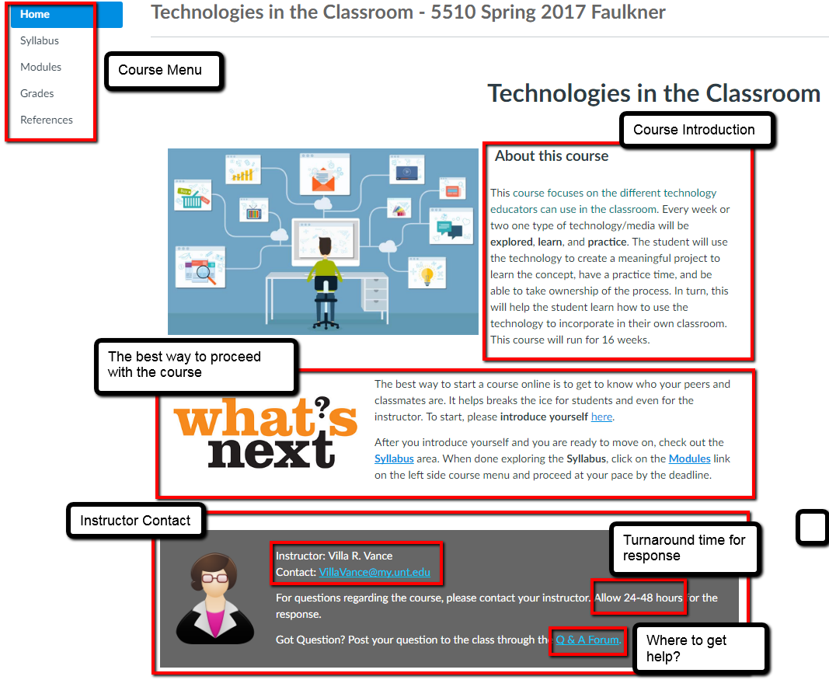**HOMEPAGE**

**GRADING INFORMATION**

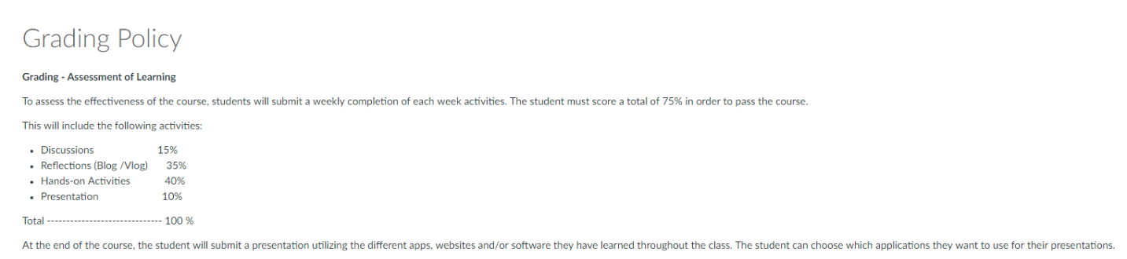

Remind the student that there is a forum area they can use for questions and answers. Faculty teaching must make it a habit to check this area.

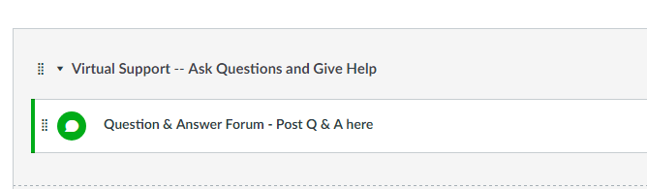

To keep the course up to date and make the necessary improvements, faculty teaching the course should always ask the student to do the end of course evaluation of design. Faculty will then need to submit the feedback of student to the course designer.

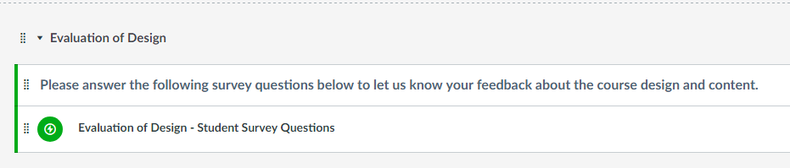

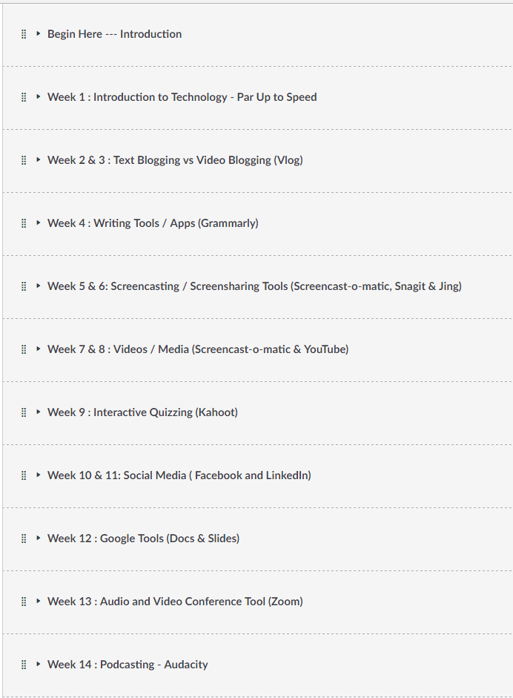**Modules**