

**How to Implement the New Program Packet**

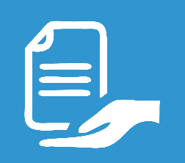

**INTRODUCTION**

The current process for New Program is too overwhelming both for new staff and program developer. The forms and templates are not contained in one packet and one has to guess what information they needed to submit to complete the documents for Curriculum Advisory Board. This program packet aims to make the process less cluttered, easier and put together.

The ***New Program Packet*** contains the following:

* Checklist of documents for the Curriculum Advisory Board
* New Program Documentation Checklist
* Forms/Samples
  + PCF Summary Page – form
  + PCF Signature Page – form
  + Curriculum Outline Sample
  + Generic Syllabus Template
  + Program Course Alignment – Form and Sample
  + Program Outcome Map – Form and Sample
  + SCANS/Competency Chart – Form and Sample
  + Enrollment Plan
  + Advisory Committee Minutes – form
  + Documentation for New Program Development
  + Strategic Enrollment Plan

These materials are contained in a program packet that is meant to be downloaded by the program developer which should help with the documentation process.

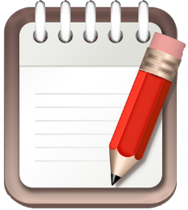**What you need to do? (Curriculum Staff)**

Go through the packet and see if all the documents (forms, templates, examples, explanations) are in the packet. If you have any questions or need to add other documents, let me know.

When everything is complete and ready, upload the whole packet to the website. Login to College portal, save the document to the portal and then create a link to the Curriculum website. The person uploading the document should at least know the basic of creating website (uploading files, creating link and publishing the page).

When the packet is ready and the link is available, the program developer can now download it from the website.

Follow through with the program developer to find out if they needed more information and need assistance with the packet. Otherwise, when the completed program is submitted and all documents are ready for CAB submission, send the survey to the developer to get feedback of the process/packet.

The link to the survey is <https://www.surveymonkey.com/r/KDJMDNF>

The New Program Packet will be sent out together with the completed design.

**Attached**: New Program Packet Design