Managing the Complexities of Digital Goods' Anti-Rivalry in Contemporary Business Model Innovation

ABSTRACT
Our study investigates how business models, analyzed from a business model pattern perspective, can benefit from the anti-rivalry of digital goods. Following the state-of-the-art research in digitalization, we acknowledge that digital goods have the potential to increase in value when used; hence, they are characterized as “anti-rival.” This contrasts with standard goods—which decrease in value when used, making them “rival.” Mixing anti-rival and rival resources and goods in a single business model creates institutional complexity, which can be addressed with complexity management. We are particularly interested in complexity management approaches that do not artificially limit the value-creation potential of anti-rival goods. To that end, our analysis revealed seven complexity management mechanisms and 39 related business model patterns. The mechanisms and patterns were categorized into three metamechanisms offering distinct opportunities and challenges for business model innovators seeking anti-rival benefits. When reflected against institutional complexity theory, the approaches can be further divided between symbiosis-seeking (leveraging complexity) and synergy-seeking (decreasing complexity) approaches. Our study contributes to the ongoing discourse surrounding anti-rival goods by highlighting how business models can unleash their additive value-creation potential without unsustainably exploiting rival resources.

Keywords:
anti-rival goods; anti-rivalry; institutional complexity; complexity management; business model innovation
INTRODUCTION
Digitalization has transformed data, information, and knowledge into critical economic success factors. Consequently, a new type of good—the digital good—has gained an increased role in society. Such transition alters operational structures, redefines business models, and forces strategic change (Yoo, Boland, Lyytinen, & Majchrzak, 2012). Even if such changes are radical, it has thus far been widely assumed that they can and will occur within current economic structures, based on markets. However, there is increasing concern that digitalization promotes more fundamental changes at the heart of general economic understanding. On the one hand, digital goods seem to be unleashing the economic system from scarcity due to zero marginal production costs; on the other hand, organizing around digital goods always, at the end of the day, uses some finite rival resources. The setting calls for a detailed, complex systems understanding that dares to look beyond current techno-economic institutions while acknowledging that the transitions happen within prevailing systems.
In this study, we focus on the so-called anti-rivalrous characteristics of digital goods and the potentially transformational changes they induce for economic institutions, especially at the microlevel. Digital goods increase in value when more people use them (hence the term “anti-rival”) rather than diminish with every unit consumed, as is the case for standard goods (which can be labeled as rival) (Cooper, 2006; Kubiszewski, Farley, & Costanza, 2010; Weber, 2004). In this setting, predominant macrostructures for economic organizing may function suboptimally or even fail (Bliss & Egler, 2020), as the predominant approaches to ownership, money, and banking are designed to properly serve a rival global economy (Ostrom, 2009). Similarly, the increasing role of digital goods is affecting the microfoundations of market institutions. The prevailing ways of designing firms’ value logics—business models (Casadesus-Masanell & Ricart, 2010; Massa, Tucci, & Afuah, 2017)—are based on resource rivalry; even textbook definitions of the business model highlight value capture, inherently connecting to the rivalrous mode of organizing (Teece, 2010).
We approach the anti-rivalrous characteristics of digital goods from the institutional logic perspective (Thornton, Ocasio, & Lounsbury, 2012), with a particular interest in managing institutional complexity (Battilana & Lee, 2014; Greenwood, Raynard, Kodeih, Micelotta, & Lounsbury, 2011; Pache & Santos, 2010). We acknowledge that due to finite planetary resources, all economic systems inherently include some rivalrous goods. At the same time, we recognize the increasing role of anti-rival goods, which are best benefited from when not artificially restricted. Together, such components comprise hybrid systems, as elaborated in institutional theory. From the institutional logic perspective, hybrid systems create logic misalignment—referred to as institutional complexity—which can be addressed with different complexity management approaches (Battilana & Lee, 2014).
Complexity management approaches tend to be quite abstract, so to ensure practical explanatory power in our research, we have chosen to remain at the microlevel and use the hybrid business model (including rival and anti-rival digital goods) as the unit of analysis (Ocasio & Radoynovska, 2016; Vaskelainen & Münzel, 2018), operationalizing it to be analyzed from the business model pattern (BMP) perspective (Gassmann, Frankenberger, & Csik, 2013, 2014). While acknowledging the paradoxical nature of using the traditionally rivalrous concept of business model in our analysis, we trust that how we focus on the microfoundations of existing economic systems—what firms do now—allows us to better design future economic models.
Our research question for this paper is as follows: How can hybrid business models benefit from the anti-rivalry of digital goods by managing institutional complexity? We answer the research question by systematically gathering BMPs from the literature and qualitatively analyzing the resulting BMP set. We integratively review academic journal articles that create or analyze BMPs and focus on papers that address contexts that include anti-rival digital resources and goods. Then, we analyze the BMPs described in such articles and focus on patterns that seek to benefit from the anti-rivalry while acknowledging the finiteness of rival resources. Finally, we synthesize the findings to reveal the business models’ institutional complexity management mechanisms and broader metamechanisms (mechanism categories). We thoroughly analyze the results to derive advice for business model innovators exploring anti-rivalry.
THEORY
Viewing Digital Goods as Anti-Rival Goods
From the economic perspective, the two most distinct features of digital goods are zero marginal production costs and negative subtractability (Weber, 2004). Zero marginal production cost means that while producing the first unit of a digital good (e.g., authoring an academic article) might be indeed very expensive, duplicating the good (downloading a copy) has a negligible cost, which is only dictated by the cost of running the sharing infrastructure (Olleros, 2018). Such characteristics are in stark contrast to standard goods, which always have nonzero reproduction cost. Negative subtractability, in turn, means that while standard goods wear out when used, digital goods do not depreciate, and they might even increase in value (e.g., when academic articles are used together in knowledge creation) (Weber, 2004).
While markets are the prevailing organizing structure of the capitalistic economic system, they allocate digital goods poorly (Bliss & Egler, 2020). Markets work by seeking a market-clearing price in which supply and demand are in equilibrium (Haeringer, 2018). Such a point defines pareto-optimal allocative efficiency, in which there is no excess supply or unmet demand and no market actor can be better off without making another actor worse. However, seeking equilibrium fails with digital goods due to their two distinct characteristics. An attempt to make a digital good market compatible requires either 1) making the good artificially scarce with digital rights management protection, leading to underprovision of the good (as there would still be demand after the set artificial limit of production), or 2) undercompensating for the producers as the marginal price of production nears zero and therefore also the “willingness to pay” of market actors, leading to producers exiting the market.
Due to such distinctness of digital goods and their increasing role in economic systems, there have been attempts to extend the traditional division of rival vs. nonrival goods with a new good type—the anti-rival good (Cooper, 2006; Weber, 2004), as illustrated in Table 1. The term “anti-rival” refers to the “anti-competitive” nature of digital goods. The concept of anti-rivalry seems to be increasingly accepted in academic discourse, mostly in the fields of ecological economics (Bliss & Egler, 2020; Farley, Costanza, Flomenhoft, & Kirk, 2015; Kemkes, Farley, & Koliba, 2010; Kubiszewski et al., 2010) and open-source software (Weber, 2004). In the extant discourse, there seems to be a consensus on defining an anti-rival good as one that gains value when used (Kubiszewski et al., 2010; Weber, 2004) and further making a distinction between excludable and nonexcludable anti-rival goods (Nikander, Eloranta, Karhu, & Hiekkanen, 2020).
------------------------------------
Insert Table 1 about here
------------------------------------
As markets fail to gain allocative efficiency with digital goods, there has been development to reach anti-rivalry compatibility with different organizing structures. So-called hybrid systems (Battilana & Lee, 2014) are increasingly prevalent in society: academic publishing, software development, creative and entertainment industries, and social networking, to name a few, all attempt to manage the tension of using rival resources (which are best organized through exchange relations in regulated markets) to create and disseminate anti-rival goods (which are best allocated, at least societally, through extensive scale sharing). Large-scale systems can use institutional and regulatory power—for example, innovation contests, specific compensation schemes (such as salary capping), and the setting of open-access conditions for receiving public funding (Kubiszewski et al., 2010). In small communities, anti-rival goods can be organized using interorganizational dependencies and interpersonal trust. Also, in specific settings, such as in open-source software development, systems can leverage the characteristic features of the particular context (e.g., in open source: codified contributions enabling transparent and auditable edit trails). A common denominator of all these structures is that they try to meet the compensation needs of the initial contributor, incentivize sharing of the good produced, and assure its societally optimal allocation.
Systems Involving Both Anti-rival and Rival Goods from the Institutional Logic Perspective
A common yet controversial feature of alternative organizing structures involving digital anti-rival goods is that such structures do not fit well with the “business narrative,” which is traditionally dominated by market and corporate logics. To understand such difficulties in greater detail and expand our thinking on the possibilities of organizing anti-rival digital goods, this study adopts a lens of institutional logic.
The institutional logic and the analytical perspective it provides for organization studies were initially defined and analyzed in the work of Friedland and Alford (1991) and significantly refined by Thornton et al. (2012) in particular. The argument is that institutional logics operate at the macrolevel (culture), providing sensemaking for the microlevel (individuals). Moreover, the ideal institutional logic types—family, community, religion, state, market, and corporation—define the organizing principles to maintain institutional order (Thornton et al., 2012). In practice, institutional logic defines, for an organizational field, which goals and means to achieve such goals are appropriate, desirable, and legitimate (Ocasio & Radoynovska, 2016; Pache & Santos, 2010). However, it is typical that organizations face situations where they must involve their operations with a large variety of stakeholders with divergent and even conflicting goals. Such fields become characterized by institutional plurality, which refers to a field populated with actors following different and only partly compatible institutional logics (Mair, Mayer, & Lutz, 2015). In this situation, the organization cannot usually select a behavior aligned with all actors, which creates institutional complexity (Greenwood et al., 2011).
From the institutional logic perspective, institutional complexity is inherent in economic systems involving both anti-rival digital goods and rival goods. Such complexity emerges because, at its core, organizing rival goods is about orchestrating with the logic of scarcity (Daoud, 2018) for pareto-optimal allocation, following “market” logic. However, with anti-rival goods, the allocation question concerns organizing with the logic of abundance (Abbott, 2014; Daoud, 2018): The marginal cost of reproduction is not only zero but potentially negative, as anti-rival resources gain value when used (Kubiszewski et al., 2010). As mentioned, here market structures fail (Bliss & Egler, 2020).
In the institutional logic domain, the discussion on managing institutional pluralism related to market and nonmarket institutions has already been held actively under the topic of hybrid organizing (Battilana & Lee, 2014). Hybrid organizations fit poorly into established organizational forms, sectors, industries, or institutional domains (Mair et al., 2015). Such organizations include, but are not limited to, social enterprises, public-private partnerships, and venture philanthropy organizations (Ocasio & Radoynovska, 2016). Here, the institutional logic tension usually arises in combining commercial and community-oriented logics (Mair et al., 2015).
The tenets of managing institutional complexity in hybrid organizing revolve around the core approaches identified in the broader institutional logic literature (Battilana & Lee, 2014). There are archetypal ways of managing logic tensions (Battilana & Lee, 2014; Kraatz & Block, 2008; Oliver, 1991; Pratt & Foreman, 2000): 1) escaping the need to align the logics (compartmentalization), 2) attacking other logics (defiance), 3) striving for alignment through adaptation (aggregation), and 4) devising creative solutions to change the rules of the game (integration). The compartmentalization-based approach decouples the conflicting logics by structurally separating them (Kraatz & Block, 2008; Pratt & Foreman, 2000). In defiance, the goal is to ultimately come up with only one dominating logic (Oliver, 1991). In aggregation-based approaches, in turn, adaptations are made, aiming to maintain the coexistence of the two logics not through isolation or separation but by negotiating a constructive solution to mitigate the tension (Kraatz & Block, 2008; Pratt & Foreman, 2000). The creative option, overcoming the tension through integration, tries then to seek new ways to perceive the institutional arena and, in that way, find a completely new framing to the logic alignment, thereby discovering a new shared logic between the initially conflicting actors (Kraatz & Block, 2008; Pratt & Foreman, 2000).
In addition, discussions in the ecological economics domain offer an interesting theoretical bridge directly connecting the discourses on anti-rival and rival goods, hybrid organizing, and institutional complexity management approaches. Daoud (2018) identified social strategies that actors using scarcity (rival) and abundance (anti-rival) logics can use to deal with logic misalignment. As seen in Table 2, such strategies are indeed closely interlinked with the institutional complexity management approaches: i) compartmentalization- and defiance-based approaches identified in the institutional logic discussion connect to the “defensive” social strategies used between scarcity- and abundance-based systems; ii) compromise-seeking aggregation approaches with “reactive” and iii) “adaptive” strategies, and finally, iv) integration-oriented approaches with “creative” strategies (Daoud, 2018: 214).
------------------------------------
Insert Table 2 about here
------------------------------------
Business Model Perspective on Institutional Complexity Management
Institutional logic sets the foundations for what is seen as valuable, desirable, and legitimate for organizations in a given domain (Thornton et al., 2012; Vaskelainen & Münzel, 2018). Taking a business model perspective in institutional analysis, in turn, allows us to assess the different ground-level implications of the prevailing institutional logics (and institutional complexity) in an organization’s value creation and, in particular, its value-sharing governance practices (Ocasio & Radoynovska, 2016).
What is interesting is that the institutional logic literature on business models challenges the normative imperative of being only about value capture, profit, and rent-seeking (Ocasio & Radoynovska, 2016). In the traditional so-called commercial view of business models, firms maximize their competitive advantage and market value. However, recent studies have suggested that institutional complexity directly affects firms’ operations. That is, the business models become shaped by many logics, combining several values, beliefs, and constraints (Gregori, Wdowiak, Schwarz, & Holzmann, 2019).
Business model innovators operating in such institutionally pluralistic fields must cope with conflicting institutional demands by creating balancing practices and strategies (Ocasio & Radoynovska, 2016; Pache & Santos, 2013; Vaskelainen & Münzel, 2018). Companies respond to institutional logic tension through the identified four approaches to institutional complexity management (Battilana & Lee, 2014). Herein, defensive responses (compartmentalization and defiance) are about framing complexities as sources of incompatibilities, whereas active responses (aggregation and integration) frame complexity as a paradox and, therefore, a possibility for enhanced organizational performance (Ocasio & Radoynovska, 2016).
Operationalizing Business Models as BMPs
A business model can be defined in several ways (Massa et al., 2017). To allow a detailed analysis in our study, we adopted the approach closest to the institutional logic perspective: the business model as a value-creation logic of a firm (Casadesus-Masanell & Ricart, 2010). From the operationalization perspective, we assessed business models from a BMP angle. The literature defines “patterns” as reproducible and configurable building blocks that provide a “solution” to a recurring “problem” (Alexander, Ishikawa, & Silverstein, 1977: 17). Following this reasoning, BMPs aim to represent successful business models’ proven, repeatable components (Gassmann et al., 2014). Hence, business models can be perceived as combinations of different BMPs (Osterwalder & Pigneur, 2010). BMPs have particular importance in business model innovation as new business models, especially ones that overcome the industry’s dominant logic, can be efficiently envisioned by creatively combining existing patterns (Amshoff, Dülme, Echterfeld, & Gausemeier, 2015; Gassmann et al., 2014).
Scholarly interest in BMPs has increased over the past decade (e.g., Gassmann et al., 2013; Lüdeke-Freund, Carroux, Joyce, Massa, & Breuer, 2018; Osterwalder & Pigneur, 2010; Remane, Hanelt, Tesch, & Kolbe, 2017). Thus far, the most comprehensive (Remane et al., 2017) work on BMPs is authored by Gassmann et al. (2013, 2014); their approach also particularly emphasizes the reconfigurability perspective of patterns (Remane et al., 2017). Gassmann et al. (2013) analyzed 250 business models in different industries over a span of 25 years and identified 55 universal BMPs. Several studies have enhanced and augmented Gassmann et al.’s pattern set: Original models have evolved, and more models have been identified (Remane et al., 2017). However, the anchor point has remained the same.
METHODS
We addressed our research question with a two-stage process: first, a literature review (to gather BMPs from studies), and second, a qualitative content analysis (targeting the gathered BMPs). The review built a foundation for our study with the composition of a comprehensive set of BMPs related to hybrid systems involving anti-rival digital goods (Denyer & Tranfield, 2009; Page et al., 2021). We then applied qualitative content analysis to the results of the review (BMPs and their descriptions) to recognize the institutional complexity management approaches, mechanisms, and metamechanisms used in the patterns to benefit from the anti-rivalry of digital goods (Elo & Kyngäs, 2008; Hsieh & Shannon, 2005).
Literature Review
Search strategy. Our review followed a predefined process to maintain transparency and rigor (Page et al., 2021), as illustrated in Figure 1. First, we conducted a literature search on existing BMP studies by using SciVerse Scopus and EBSCOhost Business Source Complete (results included until March 31, 2022). The terms “pattern” and “archetype” are used synonymously in the business model literature; hence, we used “business model patterns” and “business model archetypes” (and the same phrases in singular form), targeting the abstracts, titles, and keywords (in EBSCOhost: subject terms) of articles. We included only publications in peer-reviewed academic journals to ensure the reliability of our results. Furthermore, we included only articles written in English. The searches resulted in 73 studies from SciVerse Scopus and 47 from EBSCOhost. There were 40 duplicates.
Article selection process. We excluded the duplicates and screened the remaining abstracts (n = 80). Based on the abstracts, we excluded papers that clearly did not recognize BMPs (n = 13). We also excluded studies to which we had no access through our host university’s databases or publicly available platforms (n = 5). Altogether, abstract-based screening excluded 18 articles, and we were left with 62 papers. The second screening involved full-text articles. We excluded papers that: 1) did not focus on BMPs related to digital goods at all (n = 15); 2) did analyze digital goods–related BMPs but applied them solely to rival resource contexts (e.g. digital platform used to facilitate physical product usage) (n = 7); 3) did not describe BMPs in enough detail to be further analyzed (n = 6); or 4) defined BMPs entirely differently than us (e.g., seeking holistic patterns instead of reconfigurable ones or seeking only abstract patterns) (n = 11). In total, we excluded in the second screening 39 papers and were left with 23 studies. The screening was made by two independently working researchers, and the results were compared and revised if needed (Denyer & Tranfield, 2009).
Finally, we added Gassmann et al.’s (2013) article to the literature set. The 55-pattern set presented in that paper is the “most comprehensive collection of business model patterns” within the literature in the BMP research and practitioner domain (Remane et al., 2017: 7). Gassmann et al. (2013) also explicitly used the modular-combination approach to patterns that is appropriate for our study. Thus, only one seminal paper was used as an anchor point, as “existing collections have a significant amount of overlap” and “applying several collections simultaneously leads to significant redundancies” (Remane et al., 2017: 7–8). After the entire selection process, we were left with 24 articles for synthesis.
------------------------------------
Insert Figure 1 about here
------------------------------------
Synthesizing the results. As the last stage of the literature review, each included article was further analyzed, aiming to form an overall view of the BMPs appearing in them. Altogether, we recognized 227 patterns (including duplicates). We removed potentially duplicate patterns as follows: 1) We extracted all the patterns to a table with pattern names and the author descriptions of them; and 2) we compared the results with the original patterns recognized in Gassmann et al.’s (2013) study by reading BMP descriptions and evaluating whether they correspond to Gassmann et al.’s (2013) patterns. Two researchers made the comparisons independently; results were compared and carefully revised as needed (Denyer & Tranfield, 2009). We noted i) patterns that were already included in (or were the same as) Gassmann et al.’s patterns, ii) patterns that were incrementally developed from the original Gassmann et al. patterns, and iii) entirely new patterns. Patterns duplicating Gassman et al.’s (2013) (n = 46) were grouped and counted as one each. In the process, we also noted that the pattern set had duplicates with the patterns of Bocken, Short, Rana, and Evans (2014) (n = 6); those duplicates were also removed. The synthesis and removal of duplicates resulted in 175 patterns.
Qualitative Content Analysis
First stage. We used deductive and inductive qualitative content analyses to proceed with the detailed description of the recognized BMPs (Elo & Kyngäs, 2008; Hsieh & Shannon, 2005). Figure 2 illustrates our analysis process. We focused on how the description explains the institutional complexity management approach used in the BMP (in practice: how the BMP tries, in broad and specific levels, to benefit from the anti-rivalry of digital goods by managing institutional complexity).
------------------------------------
Insert Figure 2 about here
------------------------------------
Our analysis began by coding all the 175 patterns with predetermined codes (Elo & Kyngäs, 2008). Existing theory on institutional logic alignment approaches (Battilana & Lee, 2014) was used deductively to set a directed starting point (Elo & Kyngäs, 2008; Potter & Levine-Donnerstein, 1999). The data were thus analyzed from the perspective of institutional complexity management approaches: 1) compartmentalization: strive for logic avoidance, 2) defiance: seek defiance over other logic, 3) aggregation: find an adaptative solution, and 4) integration: innovate a shared logic (Battilana & Lee, 2014). All listed BMP descriptions were read through. Each pattern was assigned a code that tells the complexity management approach used with a short explanation. As the focus of our research was systems that want to intentionally benefit from the anti-rivalry of digital goods while acknowledging the finiteness of rival goods, we only focused on patterns that used the “aggregation” (n = 16) or “integration” (n = 23) approach. Thus, we omitted the patterns that we recognized to be seeking institutional complexity “compartmentalization” (not considering the interaction of anti-rival and rival goods) (n = 76) or “defiance” of one logic (forcing artificial scarcity onto digital goods or not considering rival good finiteness) (n = 33). We also excluded patterns that were focused solely on non-digital goods (n = 31).
Second stage. We then focused on the underlying concrete mechanisms and metamechanisms (mechanism categories) that instantiate the complexity management approach used in the BMP. At this stage, we moved toward inductive content analysis, allowing the mechanisms to flow from the BMP descriptions (Elo & Kyngäs, 2008). We used open coding to track the mechanisms from each BMP description. Each mechanism was given a code that best describes its operation. New mechanisms similar to each other were combined. The recognized mechanisms were further grouped into metamechanisms based on how they approach the rival–anti-rival dilemma at a broad level (Coffey & Atkinson, 1996; Elo & Kyngäs, 2008). Figure 3 visualizes the resulting data structure. Two researchers conducted the analysis, and disagreements were elaborated.
------------------------------------
Insert Figure 3 about here
------------------------------------
Limitations
As in any research, our study has certain limitations. First, our reliance on the classifications and descriptions of BMPs being provided by the literature might lead to misinterpretation or oversimplification. The implementations of the identified BMPs in business contexts may include nuances not fully captured in the academic descriptions. In addition, the definition of key constructs may vary slightly between the included papers, causing inconsistency in our analysis. We have tried to mitigate these issues by being careful in analyzing how the papers define and elaborate BMPs and, in some cases, excluding studies that do not have fit with our conceptual approach or lack the needed level of detail.
Second, our approach to identifying and categorizing institutional complexity management mechanisms and metamechanisms was inductive, relying on the depth and quality of descriptions provided in the original articles and on our subjective interpretation. This could introduce a risk that specific mechanisms may have been overlooked or misclassified. We employed multiple researchers and an iterative method in our analysis to mitigate this issue, continually revisiting and revising our interpretations and classifications throughout the research process.
Third, as in any literature-based study, some relevant studies may have been inadvertently omitted due to our selection criteria, leading to significant BMPs not being captured in the analysis. We considered broadening the search terms beyond the ones we used (e.g., with the term “business model template”), but this would have introduced potential issues with construct validity. Indeed, during the review process, we had to exclude some studies due to differing definitions of BMPs (as described earlier).
FINDINGS
In the following, we present the results of our analysis on how BMPs, as reported in the literature, strive to benefit from the anti-rivalry of digital goods through institutional complexity management. We describe seven identified complexity management mechanisms (and related BMPs).
Using Communities To Minimize Rival Costs and Maximize Anti-Rival Value
Several BMPs sought anti-rivalry benefits by increasing community involvement in the digital good’s design, production, or governance and decentralizing the necessary rival resource costs. The scope of community involvement varied from networks of individuals to networks of firms. Also, the governance structures varied from ad hoc to contractual constellations. At heart, the idea most often was to organize as indicated in the “peer-to-peer” (Gassmann et al., 2013) and “nodes” (Curtis, 2021) patterns, in which actors collectively structure for a common purpose. The “repurpose for society” pattern also highlighted how an existing business model can transition toward a community orientation (Bocken et al., 2014). Two patterns directly connected increased anti-rival digital good sharing in communities to improved quality of the good: “increase quality through participation” (Zeleti, Ojo, & Curry, 2016) and “review system” (Curtis, 2021) seek positive network effects through goods’ anti-rival characteristics and consider that such effects completely outweigh the related rival resource usage.
Further, the “crowdsourced innovation” pattern (Weking, Stöcker, Kowalkiewicz, Böhm, & Krcmar, 2020) focuses on using the power of crowds to come up with innovation-related contributions. The “crowdsourcing” pattern is thus more generally about relying on crowds for operational contributions (Curtis, 2021; Gassmann et al., 2013; Lüdeke-Freund et al., 2018; Yablonsky, 2017). “Open source” is a particular instantiation of crowdsourcing in technical development (Curtis, 2021; Gassmann et al., 2013; Zeleti et al., 2016), and “crowdfunding” (Curtis, 2021; Gassmann et al., 2013; Lüdeke-Freund et al., 2018) in rival resource cost decentralization.
In turn, the “adopt a stewardship role” (Bocken et al., 2014) and “community governance” (Curtis, 2021) patterns extend the community use to decision-making related to digital goods. Such governance arrangements can give actors the possibility of defining the product’s value themselves without inhibiting anti-rivalry, as the pattern “pay what you want” (Curtis, 2021; Gassmann et al., 2013) particularly highlights.
In the “open business model,” crowd collaboration reaches the industrial level; here, cocreating companies actively seek ways to partner to extend their business (Gassmann et al., 2013). In such constellations, “revenue sharing” is a prevailing pattern to enhance symbiotic effects (Gassmann et al., 2013). Further, know-how and available assets are shared in line with the pattern “make more of it” (Gassmann et al., 2013) to seek complexity leverage.
Simple example of the mechanism. An online-based crowdsourced film studio that helps creators build audiences through crowdfunding. Audiences can watch movies and shows through on-demand streaming. The platform maximizes the sharing of movie ideas and experiences, while decentralizing production and maintenance costs.
Subsidizing Sharing-Related Rival Costs To Allow Anti-Rival Sharing
In eight patterns, free sharing of anti-rival digital goods was allowed using rival resources of some other business unit or external actor. The motivation for such subsidization is that the party giving rival resources gains disproportional benefits from the anti-rival digital good sharing. In the “free as branded advertising” (Zeleti et al., 2016), “sponsorship” (Zeleti et al., 2016), “hidden revenue” (Gassmann et al., 2013; Yablonsky, 2017), and “free” (Curtis, 2021) patterns, this means gaining information (an anti-rival digital good) related to customer sentiment or to product or service usage or to building a better brand image. In the “one-sided social mission,” “two-sided social mission,” and “commercially utilized social mission” patterns (Lüdeke-Freund et al., 2018), the anti-rival returns were connected to the social mission of the parties providing rival resources. A particular instance of these generic patterns was the “experience broker,” who accumulates actor know-how and mediates it to the social target groups who need such information (Lüdeke-Freund et al., 2018).
Example. A work-related social media platform that provides infrastructure for professionals to connect. Sharing of work-related content, links, and memes is maximized. The costs are subsidized with revenue coming from the intelligence gathered from the network.
Shifting the Revenue Focus from Rival Resource Usage to Anti-Rival Results
Three patterns in our literature set manage institutional complexity by shifting the revenue source focus from the rival resource usage to the actual business benefit created (which, in these cases, is perceived as anti-rival). Involved actors decide on what is mutually valuable; this functions as a jointly agreed metric of success. Such a logic leads to sustainable use of rival resources and allows maximizing the sharing of anti-rival resources (as they are no longer in revenue focus). This approach was directly visible in the “performance-based contracting” (Gassmann et al., 2013; Yablonsky, 2017), “guaranteed availability” (Gassmann et al., 2013), and “result as a service” (Weking et al., 2020) patterns.
Example. An online media agency that distributes ads in a large-scale content network. Plain visibility in the network is almost free. Customers pay based for conversions (e.g., people signing up to a marketed service after clicking an online ad). The best performing ads are prioritized in the network to keep the network’s rival resource usage sustainable.
Creating Parallel Offerings
Four BMPs aimed to decrease rival–anti-rival tension by developing parallel offerings that enable businesses to at least partially benefit from the anti-rival nature of digital goods while supporting rival resource costs. In practice, these patterns allow businesses to offer (almost) free sharing of anti-rival digital goods to (almost) all users while creating an additional offering with more options at an added cost to specific users.
At a concrete level, in the “dual-licensing” pattern (Zeleti et al., 2016), the business offered free data for noncommercial uses, along with a limited availability of useful free data to the public while charging rival compensation for the commercial use of data (often of a higher quality and perceived value) (Zeleti et al., 2016). This pattern can leverage anti-rivalry through the free dissemination of some data while covering its (often infrastructural) costs through additional offerings. Also, access to data can thereby be democratized, as the pattern “demand-oriented platform” highlights (Zeleti et al., 2016).
A slight variation is the “charging for changes” pattern, in which some basic data and data-oriented services were provided freely to all customers, while customization and changes requested by the customer were charged for (Zeleti et al., 2016: 540). More generically, the mechanism of parallel offerings is also exhibited by the “freemium” BMP (Gassmann et al., 2013; Lüdeke-Freund et al., 2018; Weinberger, Bilgeri, & Fleisch, 2016; Yablonsky, 2017; Zeleti et al., 2016), in which a “generally smaller volume of paying ‘premium customers’ generate[s] the revenue, which also cross-finances the free offering” (Gassmann et al., 2013: 7).
Example. A reader-funded news platform that relies on the reader’s generosity and complementary added-value services. The outlet is available to everyone for free, but as a paid customer, one also has access to certain unique features.
Enabling Anti-Rivalry through De-Transactionalization
We identified four BMPs that switched from transactional (exchange) models to those that support the additive utilization (sharing) of anti-rival digital goods. This was best elucidated by the “flat rate” BMP, which states that “a single fixed fee for a product or service is charged, regardless of actual usage or time restrictions on it” (Gassmann et al., 2013: 6). In a broadly analogous manner, the “sub-scription” pattern (Curtis, 2021; Gassmann et al., 2013; Lüdeke-Freund et al., 2018; Yablonsky, 2017) deploys a similar logic: users are charged a “rolling fee typically on a monthly basis or annual basis,” irrespective of use (Lüdeke-Freund et al., 2018, Appendix 1). Other BMPs that adopted this mechanism were “membership” (Curtis, 2021) and “license” (Gassmann et al., 2013).
Example. A platform that employs a subscription pattern wherein users pay a recurring monthly or annual fee for unrestricted access to a vast library of music, disregarding the amount of use. Similarly, a premium membership model allows premium subscribers additional benefits like ad-free listening and offline access.
Converting the Resource for Better Fit with Anti-Rivalry
Three BMPs addressed rival–anti-rival tensions by the conversion of assets offered by the business to enable limited (excludable) forms of sharing. In these patterns, rival assets are developed into (somewhat) shareable assets that support anti-rival behavior. This is achieved through 1) converting physical assets into partially or entirely virtual ones and 2) providing value to users through allowing sharing, as opposed to exclusive ownership, of the assets.
The conversion of physical assets into partial or fully virtual assets is exemplified by the “digitalization” pattern (Gassmann et al., 2013), which relies on an organization’s ability to “to turn existing products or services into digital variants” that can provide “advantages over tangible products, e.g., easier and faster distribution” (Gassmann et al., 2013: 6). In turn, the “sharing business” (Lüdeke-Freund et al., 2018) and “unbundling” (Curtis, 2021) patterns effectively highlight the possibilities of providing multi-party access to resources, and sharing them, as opposed to exclusive ownership.
Example. A platform that converts music production assets to easily shareable and recombinable formats, such as samples, loops, and virtual instruments. The business fosters a community of musicians who can create, collaborate, and remix using each other’s projects, thereby promoting efficient utilization and recombination of available assets.
Facilitating Shared Ownership
The “fractional ownership” pattern aims to diminish rival resource constraints on anti-rival sharing by converting the ownership of a rival asset to a shared one among a group of stakeholders (Curtis, 2021; Gassmann et al., 2013; Lüdeke-Freund et al., 2018; Yablonsky, 2017). The “no dividends” pattern (Lüdeke-Freund et al., 2018) also enables investing economic surplus back into the jointly developed resource base. While ownership is a rival concept, this community-based ownership approach can help avoid scarcity-oriented issues, thereby managing rival–anti-rival tensions. In this multi-stakeholder approach, the assets provided by the business are subsequently “owned and managed by cooperative members”—where members can, for example, “be retail consumers, users of services, employees, suppliers, or the local community” (Lüdeke-Freund et al., 2018: Appendix 1). Such a model can benefit from the anti-rival nature of the asset in terms of sharing and utilization while potentially encouraging the different owners to collectively organize for common purposes.
Example. A blockchain-enabled network that allows shared ownership schemes for a decentralized technological infrastructure. The ownership is organized with digital tokens that represent a share of the network’s valuation, tied to the utility of the network. Transferring ownership of the tokens is moderated by the network’s code-based constitution, preventing token speculation and rent-seeking.
DISCUSSION
We now interpret and abstract the mechanisms further to contribute to the theoretical discussions on benefiting from anti-rival goods in business. Based on our interpretation the mechanisms for managing institutional complexity embody three distinct categories, or metamechanisms, for reaping the business benefits associated with the anti-rivalrous nature of digital goods. The first metamechanism—dubbed large-scale collaboration to minimize individuals’ rival costs—comprises the mechanisms “using communities to minimize rival costs and maximize anti-rival value” and “facilitating shared ownership.” The second metamechanism, entitled seeking anti-rival leverage from rival investments, includes “subsidizing sharing-related rival costs to allow anti-rival sharing” and “shifting the focus toward anti-rival results.” The third category, asset and offering transformation toward anti-rivalry, consists of “enabling anti-rivalry through de-transactionalization,” “creating parallel offerings,” and “converting the resource for better fit with anti-rivalry.” We reflect the resulting three metamechanisms in the following and summarize them in Table 3.
Large-Scale Collaboration To Minimize Individuals’ Rival Costs
Opportunities for business model innovators. The metamechanism facilitates the strategic utilization of communities to minimize the costs associated with rivalry (Curtis, 2021; Gassmann et al., 2013; Lüdeke-Freund et al., 2018) while concurrently maximizing the value derived from sharing anti-rival goods. In addition, the approach ensures that the benefits accrued from anti-rival goods are equitably distributed among members of the community. Also, this metamechanism proactively engenders an environment that is naturally favorable to the sharing of anti-rival goods. This outcome is achieved by embedding a culture of sharing and cooperation in the community (Bocken et al., 2014). The measures taken also instigate a shift toward decentralized governance structures (Curtis, 2021; Bocken et al., 2014). This mitigates the risk of centralized coercion and inequalities regarding value sharing in the long run.
Challenges to address. A prevalent dilemma in large-scale collectives is how to ensure active contribution from community members to the rival resource pool and prevent free-riding on the contributions of others or else polluting or congesting the community with low-quality contributions (Mindel, Mathiassen, & Rai, 2018, Ostrom, 2009). Free-riding is less relevant in the context of digital resources when compared with physical commons, while pollution and congestion have increased significance (Mindel et al., 2018; Weber, 2004).
Thus, the situation brings to light an accountability challenge. Mitigation demands the development and implementation of coherent and consistent accounting systems for both rival resource usage and anti-rival output. These systems should be designed to track and monitor contributions and to hold members accountable for their (non-)input to the resource pools (Mindel et al., 2018).
Seeking Anti-Rival Leverage from Rival Investments
Opportunities for business model innovators. This metamechanism allows the capture of disproportionate benefits of rival resource investments through maximizing the sharing of anti-rival goods and value generated by the anti-rivalry (Gassmann et al., 2013; Yablonsky, 2017; Zeleti et al., 2016). As such, the category’s emphasis on leverage seeking taps into the inherent characteristics of anti-rival goods, such as their ability to be used simultaneously by multiple entities, usually without depletion (Weber, 2004). In result-focused models, more specifically (Gassmann et al., 2013; Yablonsky, 2017; Weking et al., 2020), rather than charging users based on their consumption of a rival goods, a business is able to charge based on the anti-rival value or results the user derives from the resource’s usage.
Challenges to address. The sought leverage creates tensions between providers and consumers regarding the perceived fairness of this approach. Consumers may question the fairness of the trade-off that they are making. In the context of social media platforms, for instance, users might weigh the utility of the free networking service (subsidized offering) they receive against the substantial amount of personal data (source of anti-rival value) they are offering in return. Similarly, in result-based models, consumers may question what proportion of the increased revenue, attributable to the use of the service or product, should fairly go to the provider (Töytäri, Rajala, & Alejandro, 2015). A significant challenge is posed for providers: How can they maintain transparent business practices without jeopardizing the mechanics of anti-rival utilization, which inherently thrive on disproportionate returns?
Therefore, this metamechanism has a transparency challenge. The inherent nature of seeking leverage—the generation of substantial output from relatively minor input—calls into question the degree to which business models can maintain “fairness” without undermining their anti-rival utilization mechanisms.
Asset and Offering Transformation toward Anti-Rivalry
Opportunities for business model designers. With this metamechanism, the target is to improve the anti-rival compatibility of traditional business models through transforming offerings, revenue models, delivery channels, and the resources themselves (Gassmann et al., 2013; Lüdeke-Freund et al., 2018; Weinberger et al., 2016; Yablonsky, 2017; Zeleti et al., 2016). Such approaches allow anti-rivalry through an arrangement where the provision of goods or services is not coupled with each individual transaction (Curtis, 2021; Gassmann et al., 2013; Lüdeke-Freund et al., 2018; Yablonsky, 2017). Businesses can also consider options for limited sharing, through offering both exclusive and free access to the product or service (Gassmann et al., 2014). Finally, the approach considers converting the resources and offerings at least partially to digital form to reach the anti-rival characteristics (ibid).
Challenges to address. Business models built on the metamechanism of asset and offering transformation allow only limited anti-rivalry. The models usually utilize tiered pricing schemes in which one version of a product or service is free of charge, increasing anti-rival dissemination (Gassman et al., 2014). At the same time, the economic sustainability of the providers relies on customers paying for some added-value services (ibid.). Such an arrangement is contractionary as it exemplifies anti-rival logic only through partial exclusion.
This dichotomy creates a valuation dilemma for both customers and providers. Customers consider whether the value of paid access is high enough in comparison to the free version—and the potential investment of alternative ways (including piracy) to access the offering. Providers, on the other hand, must ensure that the free does not cannibalize income from the paid version—but, at the same time, provide enough leeway for the anti-rival benefits to emerge. Thus, the metamechanism illustrates a need for a continual cycle of managing the interplay of the business system’s anti-rival and rival parts.
------------------------------------
Insert Table 3 about here
------------------------------------
Connecting back to the institutional complexity literature
When reflected against the institutional complexity management literature, the metamechanisms seem to exhibit two completely different strategies to assess the complexity generated by the coexistence of rival and anti-rival resources in the same business system. The differences between the strategies are visualized in Figure 4.
The metamechanisms 1) large-scale collaboration to minimize individuals’ rival costs and 2) seeking anti-rival leverage from rival investments attempt to create a symbiotic relationship between the anti-rival and rival parts of the business system. They can be said to seek benefits by leveraging institutional complexity. On the one hand, such mechanisms try to detach rival resource usage from anti-rival digital good sharing so that the former does not rise in proportion to the latter. On the other hand, the mechanisms try to connect the rival and anti-rival sides of the system so that anti-rival sharing helps the rival part optimize its resource consumption. It is important to note that the aim of the partial detachment here deviates from the “decoupling” strategy of institutional complexity management, in which the conflicting systems are kept entirely apart (Battilana & Lee, 2014; Kraatz & Block, 2008). In contrast, the interaction strives for a new shared logic.
------------------------------------
Insert Figure 4 about here
------------------------------------
The metamechanism of asset and offering transformation toward anti-rivalry, by contrast, aims for a controlled and synergetic coexistence of rival and anti-rival goods. It decreases institutional complexity. The approach seeks to minimize (but cannot remove) the limitations the rival resources set for anti-rival sharing and to minimize (but not necessarily optimize) the effect of anti-rival sharing on rival resource usage. Often, such aims mean enclosing the anti-rival goods in one way or another by, for example, setting constraints (excludability regimes; Nikander et al., 2020) for the user base. What is also common in these mechanisms is using virtualization to (partially) escape the constraints of physical materialism.
In addition, the division to complexity leveraging and decreasing approaches highlights what potential limitations the institutional complexity perspective sets for business model innovation, from the particular angle of BMP reconfiguration (Gassmann et al., 2013, 2014; Osterwalder & Pigneur, 2010). Institutional logic theory states that to properly manage institutional complexity in hybrid organizing, the system should align toward a unified complexity management approach (Battilana & Lee, 2014). Therefore, the BMPs using different approaches to institutional complexity management—leveraging and decreasing—should be combined into a single business model only with caution. If a pattern seeking complexity leverage is combined with a pattern aiming for complexity decrease, the result can be a system that loses the ability to seek complexity leverage.
CONCLUSION
Our study investigated how business models, from a BMP perspective, can benefit from the anti-rivalrous nature of digital goods by managing the institutional complexity created by hybrid systems including anti-rival and rival goods. The results revealed that the BMPs discussed in the literature benefit from anti-rivalry through seven distinct mechanisms that can be further divided into three metamechanism categories with unique opportunities and challenges (and boundary conditions) for business model innovators. Further, when they are reflected against the institutional complexity literature, we can make a distinction between approaches that leverage institutional complexity—strive for symbiosis between rival and anti-rival resources—and those that decrease complexity and seek synergies and partial alignment. All our results offer practitioners new approaches as well as knowledge on the limitations of such approaches, allowing analysis of how the additive value-creation potential of anti-rival digital resources can be unleashed without unsustainably exploiting rival resources.
From a theoretical perspective, we contributed to the discussion on benefiting from anti-rival goods in the economy (Bliss & Egler, 2020; Cooper, 2006; Farley et al., 2015; Kemkes et al., 2010; Kubiszewski et al., 2010; Weber, 2004). Our research provides detail and rigor in analyzing and understanding the implications of including anti-rival resources in business models and, in particular, the tensions arising when anti-rival and rival goods are used within the same economic system. By presenting concrete institutional complexity management mechanisms, and related BMPS, our study responds to the calls of Farley et al. (2015), Kemkes et al. (2010), and Kubiszewski et al. (2010), who have sought innovative yet sustainable approaches to harness the economic potential of anti-rival goods.
We also contributed to business model–related institutional complexity literature (Ocasio & Radoynovska, 2016; Vaskelainen & Münzel, 2018) from the perspective of anti-rivalry. Our research made a distinction between institutional complexity decreasing and leveraging approaches, offering a new perspective to the analytical frameworks that assess hybrid organizing in the context of business models (Battilana & Lee, 2014; Vaskelainen & Münzel, 2018). We also strengthened the connection between business model research and the broader complexity management literature (Massa, Gianluigi, & Tucci, 2018), particularly in the context of digitalized organizing (Eloranta, Ardolino, & Saccani, 2021).
Further research. Due to the abstractness of our study, further investigations should investigate the identified mechanisms and BMPs to determine their concrete applicability in different contexts. Also, the intricacies of mechanisms and metamechanisms should be analyzed in detail with empirical cases, preferably with systems dynamics methods that provide tools for analyzing complex systems, which hybrid business models are. Moreover, given that our research has primarily focused on the microlevel (firms), future studies might explore the macrolevel implications and policy considerations for anti-rival goods within broader economic systems.

REFERENCES

Abbott, A. 2014. The problem of excess. Sociological Theory, 32(1): 1–26.
Alexander, C., Ishikawa, S., & Silverstein, M. 1977. A pattern language: Towns, buildings, construction. Oxford University Press.
Amshoff, B., Dülme, C., Echterfeld, J., & Gausemeier, J. 2015. Business model patterns for disruptive technologies. International Journal of Innovation Management, 19(3): 1540002.
Arend, R. J. 2013. The business model: Present and future—beyond a skeumorph. Strategic Organization, 11(4): 390–402.
Battilana, J., & Lee, M. 2014. Advancing research on hybrid organizing – Insights from the study of social enterprises. Academy of Management Annals, 8(1): 397–441.
Bliss, S., & Egler, M. 2020. Ecological economics beyond markets. Ecological Economics, 178: 106806.
Bocken, N. M., Short, S. W., Rana, P., & Evans, S. 2014. A literature and practice review to develop sustainable business model archetypes. Journal of Cleaner Production, 65: 42–56.
Casadesus-Masanell, R., & Ricart, J. E. 2010. From strategy to business models and onto tactics. Long Range Planning, 43(2–3): 195–215.
Coffey, A., & Atkinson, P. 1996. Making sense of qualitative data: Complementary research strategies. SAGE Publications.
Cooper, M. 2006. From wifi to wikis and open source: The political economy of collaborative production in the digital information age. Journal on Telecommunications and High Technology Law, 5: 125–158.
Curtis, S. K. 2021. Business model patterns in the sharing economy. Sustainable Production and Consumption, 27: 1650–1671.
Daoud, A. 2018. Unifying studies of scarcity, abundance, and sufficiency. Ecological Economics, 147: 208–217.
Denyer, D., & Tranfield, D. 2009. Producing a systematic review. In D. A. Buchanan & A. Bryman (Eds.), The SAGE handbook of organizational research methods: 671–689. SAGE Publications.
Elo, S., & Kyngäs, H. 2008. The qualitative content analysis process. Journal of Advanced Nursing, 62(1): 107–115.
Eloranta, V., Ardolino, M., & Saccani, N. 2021. A complexity management approach to servitization: The role of digital platforms. International Journal of Operations & Production Management, 41(5): 622–644.
Farley, J., Costanza, R., Flomenhoft, G., & Kirk, D. 2015. The Vermont Common Assets Trust: An institution for sustainable, just and efficient resource allocation. Ecological Economics, 109: 71–79.
Friedland, R., & Alford, R., R. 1991. Bringing society back in: Symbols, practices, and institutional contradictions. In W. W. Powell & P. J. DiMaggio (Eds.), The new institutionalism in organizational analysis: 232–263. University of Chicago Press.
Gassmann, O., Frankenberger, K., & Csik, M. 2013. The St. Gallen business model navigator. Working Paper: University of St. Gallen.
Gassmann, O., Frankenberger, K., & Csik, M. 2014. The business model navigator: 55 models that will revolutionise your business. Pearson UK.
Greenwood, R., Raynard, M., Kodeih, F., Micelotta, E. R., & Lounsbury, M. 2011. Institutional complexity and organizational responses. Academy of Management Annals, 5(1): 317–371.
Gregori, P., Wdowiak, M. A., Schwarz, E. J., & Holzmann, P. 2019. Exploring value creation in sustainable entrepreneurship: Insights from the institutional logics perspective and the business model lens. Sustainability, 11(9): 2505.
Haeringer, G. 2018. Market design: Auctions and matching. MIT Press.
Hsieh, H. F., & Shannon, S. E. 2005. Three approaches to qualitative content analysis. Qualitative Health Research, 15(9): 1277–1288.
Kraatz, M. S., & Block, E. S. 2008. Organizational implications of institutional pluralism. In R. Greenwood, C. Oliver, K. Sahlin, & R. Suddaby (Eds.), The Sage handbook of organizational institutionalism: 243–275. Sage.
Kemkes, R. J., Farley, J., & Koliba, C. J. 2010. Determining when payments are an effective policy approach to ecosystem service provision. Ecological Economics, 69(11): 2069–2074.
Kubiszewski, I., Farley, J., & Costanza, R. 2010. The production and allocation of information as a good that is enhanced with increased use. Ecological Economics, 69(6): 1344–1354.
Laasch, O. 2018. Beyond the purely commercial business model: Organizational value logics and the heterogeneity of sustainability business models. Long Range Planning, 51(1): 158–183.
Lüdeke-Freund, F., Carroux, S., Joyce, A., Massa, L., & Breuer, H. 2018. The sustainable business model pattern taxonomy—45 patterns to support sustainability-oriented business model innovation. Sustainable Production and Consumption, 15: 145–162.
Mair, J., Mayer, J., & Lutz, E. 2015. Navigating institutional plurality: Organizational governance in hybrid organizations. Organization Studies, 36(6): 713–739.
Massa, L., Gianluigi, V., & Tucci, C. 2018. Business models and complexity. Journal of Business Models, 6(1): 59–71.
Massa, L., Tucci, C. L., & Afuah, A. 2017. A critical assessment of business model research. Academy of Management Annals, 11(1): 73–104.
Mindel, V., Mathiassen, L., & Rai, A. 2018. The sustainability of polycentric information commons. MIS Quarterly, 42(2), 607–632.
Nikander, P., Eloranta, V., Karhu, K., & Hiekkanen, K. 2020. Digitalisation, anti-rival compensation and governance: Need for experiments. Proceedings of Nordic Workshop on Digital Foundations of Business, Operations, and Strategy, Espoo, Finland.
Ocasio, W., & Radoynovska, N. 2016. Strategy and commitments to institutional logics: Organizational heterogeneity in business models and governance. Strategic Organization, 14(4): 287–309.
Oliver, C. 1991. Strategic responses to institutional processes. Academy of Management Review, 16(1): 145–179.
Olleros, F. X. 2018. Antirival goods, network effects and the sharing economy. First Monday, 23(2).
Osterwalder, A., & Pigneur, Y. 2010. Business model generation: A handbook for visionaries, game changers, and challengers. John Wiley & Sons.
Ostrom, E. 2009. Understanding institutional diversity. Princeton University Press.
Pache, A.-C., & Santos, F. 2010. When worlds collide: The internal dynamics of organizational responses to conflicting institutional demands. Academy of Management Review, 35(3), 455–476.
Pache, A. C., & Santos, F. 2013. Inside the hybrid organization: Selective coupling as a response to competing institutional logics. Academy of Management Journal, 56(4): 972–1001.
Page, M. J., McKenzie, J. E., Bossuyt, P. M., Boutron, I., Hoffmann, T. C., Mulrow, C. D., … & Moher, D. 2021. The PRISMA 2020 statement: An updated guideline for reporting systematic reviews. Systematic Reviews, 10(1): 1–11.
Potter, W. J., & Levine-Donnerstein, D. 1999. Rethinking validity and reliability in content analysis. Journal of Applied Communication Research, 27: 258–284.
Pratt, M. G., & Foreman, P. O. 2000. Classifying managerial responses to multiple organizational identities. Academy of Management Review, 25(1): 18–42.
Remane, G., Hanelt, A., Tesch, J. F., & Kolbe, L. M. 2017. The business model pattern database—A tool for systematic business model innovation. International Journal of Innovation Management, 21(1): 1750004.
Teece, D. J. 2010. Business models, business strategy and innovation. Long Range Planning, 43(2–3): 172–194.
Thornton, P. H., Ocasio, W., & Lounsbury, M. 2012. The institutional logics perspective: A new approach to culture, structure and process. Oxford: OUP.
Töytäri, P., Rajala, R., & Alejandro, T. B. 2015. Organizational and institutional barriers to value-based pricing in industrial relationships. Industrial Marketing Management, 47: 53–64.
Vaskelainen, T., & Münzel, K. 2018. The effect of institutional logics on business model development in the sharing economy: The case of German carsharing services. Academy of Management Discoveries, 4(3): 273–293.
Weber, S. 2004. The success of open source. Harvard University Press.
Weinberger, M., Bilgeri, D., & Fleisch, E. 2016. IoT business models in an industrial context. Automatisierungstechnik, 64(9): 699–706.
Weking, J., Stöcker, M., Kowalkiewicz, M., Böhm, M., & Krcmar, H. 2020. Leveraging industry 4.0 – A business model pattern framework. International Journal of Production Economics, 225: 107588.
Yablonsky, S. 2017. Smart wearable multi-sided fashion product platforms. In R. Rinaldi & R. Baldinelli (Eds.), Workshop on business models and ICT technologies for the fashion supply chain: 135–150. Springer.
Yoo, Y., Boland Jr, R. J., Lyytinen, K., & Majchrzak, A. 2012. Organizing for innovation in the digitized world. Organization Science, 23(5), 1398–1408.
Zeleti, F. A., Ojo, A., & Curry, E. 2016. Exploring the economic value of open government data. Government Information Quarterly, 33(3): 535–551.

Table 1. Rival, Nonrival, and Anti-Rival Goods (adapted from Nikander et al., 2020)
 | Subtractability
Excludability | Rival | Nonrival | Anti-rival
Excludable | Private goods  (e.g., coffee) | Club/toll goods  (e.g., museum visit) | Network goods  (e.g., closed data commons)
Nonexcludable | Common-pool goods  (e.g., ocean fish) | Public goods  (e.g., public park) | Symbiotic goods  (e.g., contribution to an open-source code)

Table 2. Institutional complexity management approaches vs. scarcity-abundance strategies
Institutional complexity management approaches (e.g., Battilana & Lee, 2014) | Social strategies to overcome the conflict between the logics of scarcity and abundance (Daoud, 2018)
Compartmentalization | Defense (avoiding or attacking the  conflicting logic)
Defiance
Aggregation | Reactive (reducing the effect of the  conflicting logic)
 | Adaptive (embracing the conflicting logic)
Integration, creation of shared identities | Creative (leveraging the conflicting logic)

Table 3. Opportunities and challenges for anti-rival business model innovators
Meta-mechanism | Mechanisms  included | Opportunities | Challenges
Large-scale collaboration to minimize individuals’ rival costs | Using communities to minimize rival costs and maximize anti-rival value  Facilitating shared ownership | Minimizes per-user rival costs and maximizes anti-rival sharing.  Drives anti-rivalry by encouraging a culture of sharing and cooperation.  Facilitates longevity through promoting decentralized governance. | How to ensure active contribution from community members to the rival resource pool? How to keep anti-rival system unpolluted and uncongested?  What is needed:  Coherent and consistent accounting systems for both rival resource usage and anti-rival output.
Seeking anti-rival leverage from rival investments | Subsidizing sharing-related rival costs to allow anti-rival sharing  Shifting the focus toward anti-rival results | Allows disproportionate benefits of rival resource investment through anti-rival result focus. | How to maintain fair and transparent business practices without jeopardizing the mechanics of anti-rival leverage?  What is needed:  Tensions management between providers and customers regarding the perceived fairness of leverage.
Asset and offering transfor-mation toward anti-rivalry | Enabling anti-rivalry through de-transactionalization  Creating parallel offerings  Converting the resource for better fit with anti-rivalry | Enables more traditional business models to gain (limited) fit with anti-rivalry. | How to manage tiered offerings: setting enough leeway to drive anti-rivalry, while getting enough rival resource compensation?  What is needed:  Clear value offering; constant balancing of rival and anti-rival sides of the system.

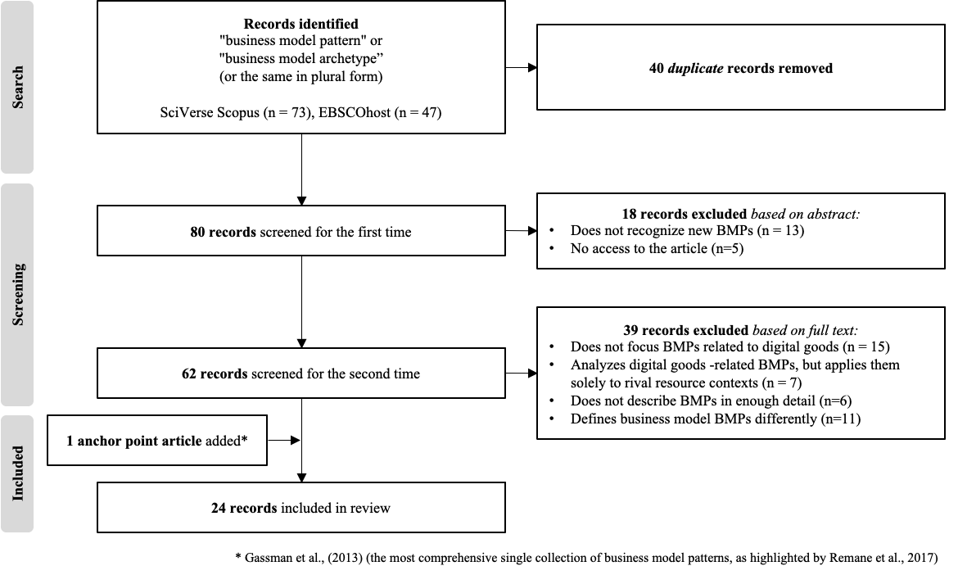
Figure 1. Flow diagram for study selection

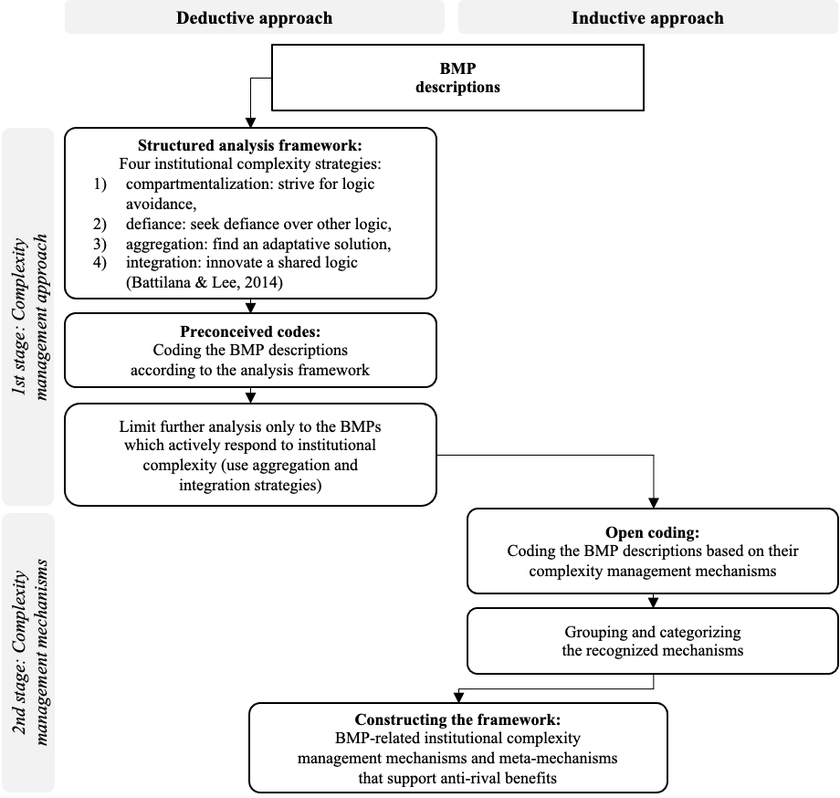
Figure 2. Flow of qualitative analysis

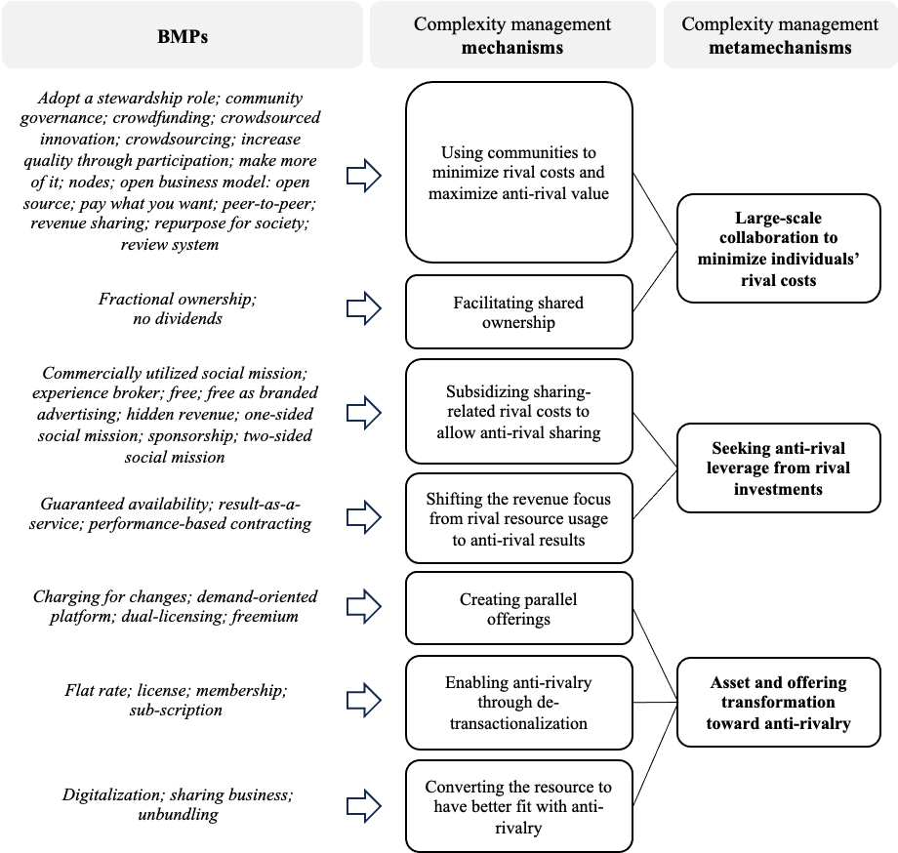
Figure 3. Data structure

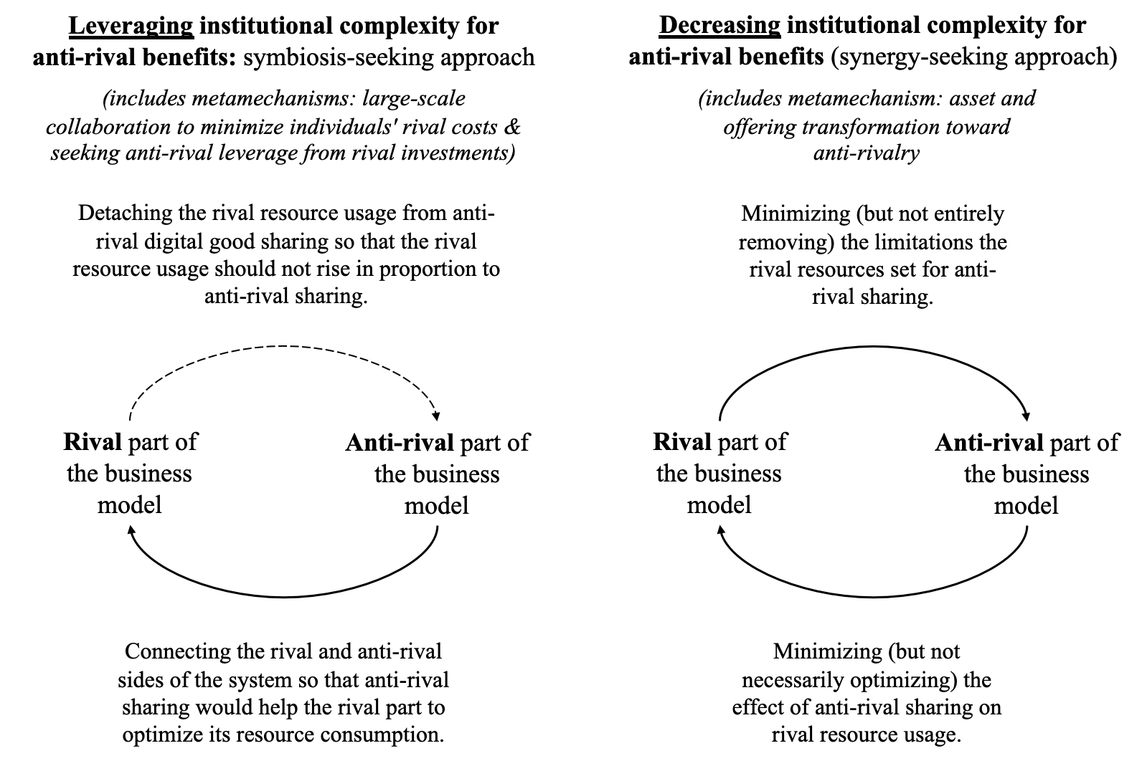
Figure 4. Symbiotic vs. synergetic approach to seeking anti-rival benefits

