1. Digitaalitulo

1. Analogiatulo

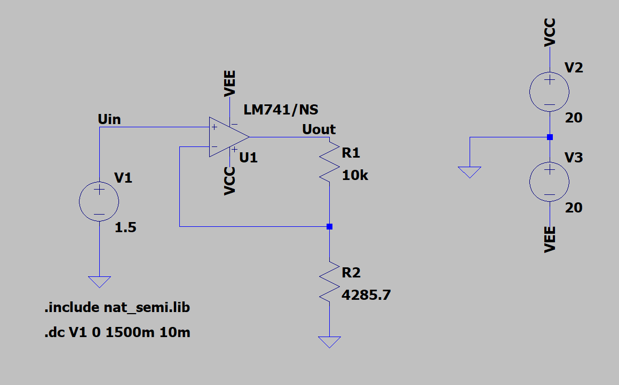

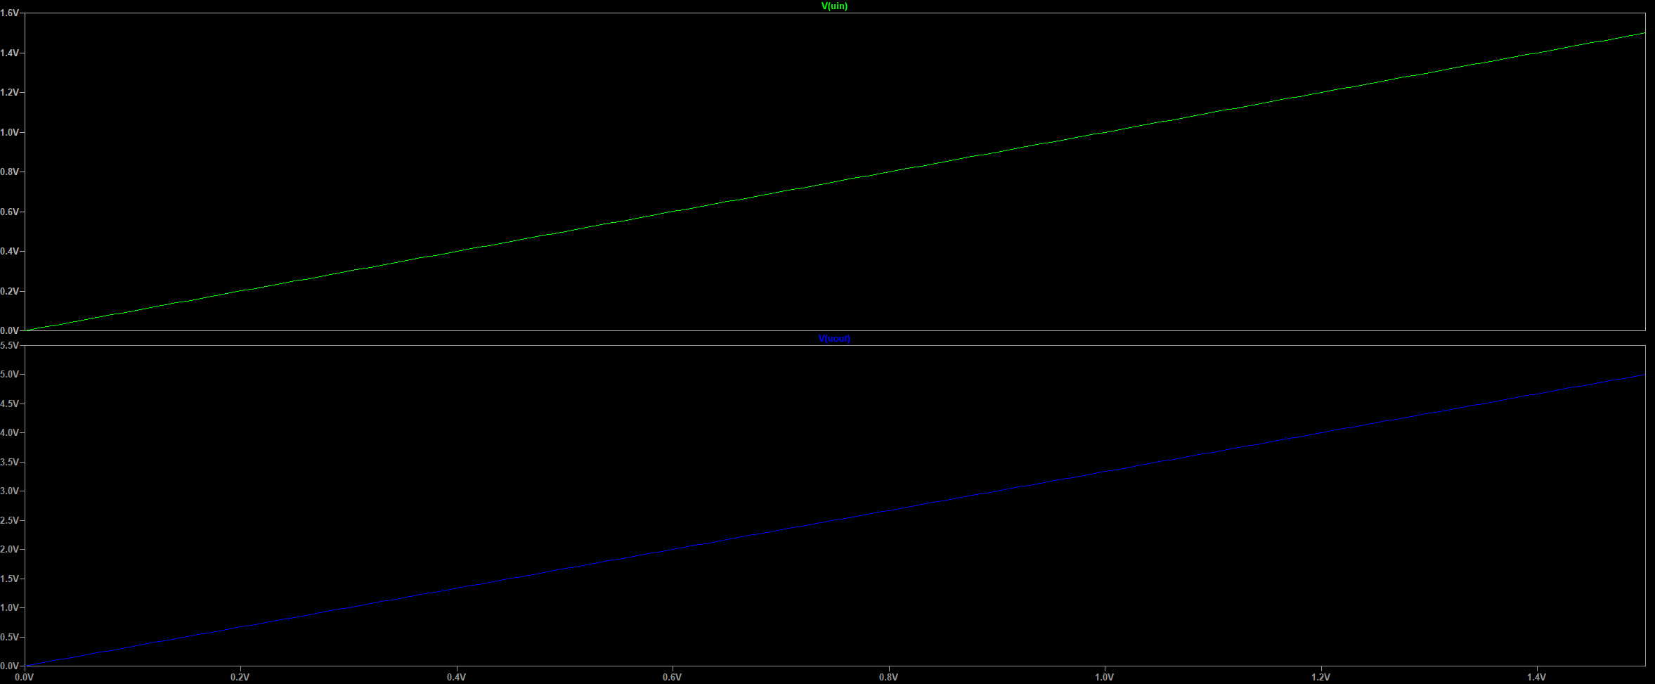

1. Digitaalilähtö

1. Analogialähtö

tässä simulaatiokuvissa kuvaaja lähtee nousemaan väärään aikaan?

1. DC operating point

aja tää läppärillä kans, nimi vaihtuu

1. DC sweep

1. Transient sweep

1. AC sweep

