Development Metrics

Andrew Villeneuve

08/10/2020

### The Study

Eggs laid by broodstock *Urosalpinx cinerea* from two Pacific sites and five Atlantic sites were collected and separated by population in individual tea strainers in two acclimation temperatures, 20° and 24°C. We reared these snails for use in the $CT_{max}$ experiment, but we were able to also gain valuable information on the embryo clutch/egg capsule, hatch time, and survival for each population.

## Number of Embryos

After being laid and we had labeled individual egg cases in tea strainers, each egg case was photographed at least three times during development using a Leica digital microscope. From these photographs, we were able to establish the starting number of embryos in each capsule. The multiple photos allowed us to account embryos that may have been hidden in other photos. We did not count nurse embryos.

## Hatching time

We checked adult broodstock every day for evidence of egg capsule laying. When capsules were identified, ideally with the mother still laying eggs, we removed each egg capsule, marked the mother, and noted the date of laying. Once the egg capsules were distributed into their separate tea strainers in respective acclimations, we checked daily for hatching. On the day of hatch, we marked the date. We counted an egg as hatched once the first juvenile crawled out of the top of the egg capsule, thus allowing for the free exchange of water inside the capsule and the ability for all juveniles to crawl out.

## Survivorship

Once juveniles hatched from their capsules, we counted the number of juveniles that successfully developed into juvenile snails. To calcualte survivorship, we divided the number of initial embryos by the number of successfully developed juveniles.

## Metadata

# site

Two-letter abbreviation of sites used. Correspond to the following sites:

site.meta<-data.table(siteID = c("GB","WH","OY","BF","FB","HM","TO"),site=c("Great Bay","Woods Hole","Oyster","Beaufort","Folly Beach","Humboldt","TO"),state=c("NH","MA","VA","NC","SC","CA","CA"))  
site.meta

## siteID site state  
## 1: GB Great Bay NH  
## 2: WH Woods Hole MA  
## 3: OY Oyster VA  
## 4: BF Beaufort NC  
## 5: FB Folly Beach SC  
## 6: HM Humboldt CA  
## 7: TO TO CA

# lat

Latitude of the site

# ocean

Used to sort out Atlantic and Pacific sites. A = Atlantic, P = Pacific

# acc

Acc is the acclimation temperature. Each population was reared in either 20°C or 24°C seawater (30PSU). We are interested in knowing if acclimation temperature will expose signs of plasticity in developmental rate and esurvivorhip for each population.

# no.embryos

The maxmum number of embryos counted in each egg capsule. This number sometimes was determined by advancing forward to later photos when embryos were obscured. “Nurse eggs” were not counted.

# lay.date

Date egg capsules were first observed within broodstock tanks (m/dd/yyyy)

# date.hatched

Date at which the first snail was observed having emerged from the egg capsule OR date at which the egg capsule operculum was observed to be open, allowing seawater to enter the egg capsule freely. (m/dd/yyyy)

# no.hatch

Number of hatchling snails observed on date.hatched that were alive. Dead embryos were not counted.

# Time.to.hatch

Developmental time, calculated as the difference between lay.date and date.hatched. Measured in days

# survivor

Survivorship proportion for each egg capsule, calculated as no.hatch/no.embryos

# no.dead

Number of unsuccessful embryos per egg capsule, calculated as no.embryos - no.hatch

# mean

Mean SST for each site (degrees celsius)

# s.mean

Summer mean SST for each site, calculated as the range in values between 06/01 and 09/30. (degrees celsius)

# q.mean

Upper Quartile summer mean for each site, calculated as the upper 75th percentile of temperature observations over the summer (between 06/01 and 09/30). (degrees celsius)

# t.mean

Upper 90th percentile summer mean for each site, calculated over the summer (between 06/01 and 09/30). (degrees celsius)

# max

Maximum temperature for each site (degrees)

## Testing for collinearity

It appears that survival and Time to hatching are correlated, and so should not be included together in models. 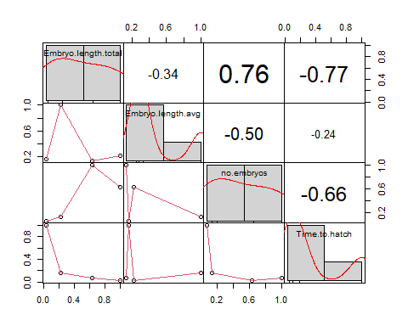

Does mom weight or mom length correlate with number of embryos? They do not appear to, but We will include moms in mixed effect models

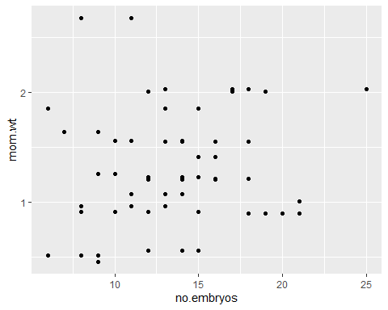

##   
## Call:  
## lm(formula = no.embryos ~ mom.wt, data = data.moms)  
##   
## Residuals:  
## Min 1Q Median 3Q Max   
## -7.5936 -3.1035 -0.1158 2.5908 11.2947   
##   
## Coefficients:  
## Estimate Std. Error t value Pr(>|t|)   
## (Intercept) 12.4520 1.3378 9.308 1.91e-13 ***  
## mom.wt 0.6171 0.9303 0.663 0.51   
## ---  
## Signif. codes: 0 '***' 0.001 '**' 0.01 '*' 0.05 '.' 0.1 ' ' 1  
##   
## Residual standard error: 3.976 on 63 degrees of freedom  
## Multiple R-squared: 0.006937, Adjusted R-squared: -0.008826   
## F-statistic: 0.4401 on 1 and 63 DF, p-value: 0.5095

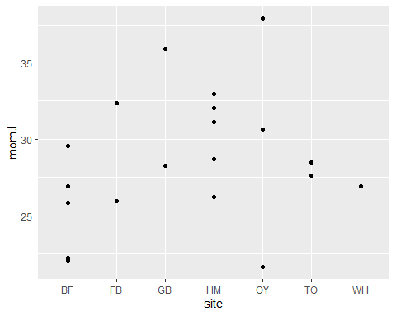

## Number of Embryos analysis

##   
## Model selection based on AICc:  
##   
## K AICc Delta_AICc AICcWt Cum.Wt LL  
## Mod7 4 456.17 0.00 0.29 0.29 -223.85  
## Mod6 4 456.67 0.50 0.23 0.52 -224.09  
## Mod5 4 457.21 1.04 0.17 0.70 -224.37  
## Mod4 4 457.59 1.42 0.14 0.84 -224.56  
## Mod1 3 460.19 4.02 0.04 0.88 -226.95  
## Mod9 4 460.32 4.16 0.04 0.92 -225.92  
## Mod3 4 460.62 4.46 0.03 0.95 -226.07  
## Mod2 4 460.81 4.64 0.03 0.98 -226.17  
## Mod8 4 461.12 4.96 0.02 1.00 -226.32

## q.mean t.mean s.mean mean lat   
## 0.0006352571 0.0017826690 0.0004141762 0.0237558563 0.0231219485

##   
## Call:  
## model.avg(object = modeavelist)  
##   
## Component model call:   
## glmmTMB(formula = no.embryos ~ <4 unique rhs>, data = data, family =   
## compois, ziformula = ~0, dispformula = ~1)  
##   
## Component models:   
## df logLik AICc delta weight  
## 1 4 -223.85 456.17 0.00 0.35  
## 4 4 -224.09 456.67 0.50 0.27  
## 2 4 -224.37 457.21 1.04 0.21  
## 3 4 -224.56 457.59 1.42 0.17  
##   
## Term codes:   
## cond(max) cond(q.mean) cond(s.mean) cond(t.mean)   
## 1 2 3 4   
##   
## Model-averaged coefficients:   
## (full average)   
## Estimate Std. Error Adjusted SE z value Pr(>|z|)   
## cond((Int)) 3.298669 0.337097 0.341605 9.656 <2e-16 ***  
## cond(max) -0.011391 0.017147 0.017191 0.663 0.508   
## cond(t.mean) -0.008678 0.015626 0.015666 0.554 0.580   
## cond(q.mean) -0.006218 0.013426 0.013461 0.462 0.644   
## cond(s.mean) -0.004670 0.011368 0.011398 0.410 0.682   
##   
## (conditional average)   
## Estimate Std. Error Adjusted SE z value Pr(>|z|)   
## cond((Int)) 3.29867 0.33710 0.34160 9.656 < 2e-16 ***  
## cond(max) -0.03262 0.01223 0.01241 2.629 0.00857 **   
## cond(t.mean) -0.03189 0.01253 0.01271 2.508 0.01214 *   
## cond(q.mean) -0.03002 0.01248 0.01266 2.372 0.01768 *   
## cond(s.mean) -0.02723 0.01180 0.01197 2.274 0.02294 *   
## ---  
## Signif. codes: 0 '***' 0.001 '**' 0.01 '*' 0.05 '.' 0.1 ' ' 1

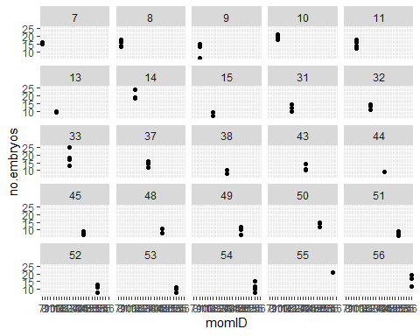

## Family: compois ( log )  
## Formula: no.embryos ~ max + (1 | momID)  
## Data: data  
##   
## AIC BIC logLik deviance df.resid   
## 454.7 464.7 -223.4 446.7 85   
##   
## Random effects:  
##   
## Conditional model:  
## Groups Name Variance Std.Dev.  
## momID (Intercept) 0.05573 0.2361   
## Number of obs: 89, groups: momID, 25  
##   
## Overdispersion parameter for compois family (): 0.425   
##   
## Conditional model:  
## Estimate Std. Error z value Pr(>|z|)   
## (Intercept) 3.37139 0.34209 9.855 <2e-16 ***  
## max -0.03124 0.01225 -2.550 0.0108 *   
## ---  
## Signif. codes: 0 '***' 0.001 '**' 0.01 '*' 0.05 '.' 0.1 ' ' 1

## [1] 0.7767647

## chisq ratio rdf p   
## 67.0169090 0.7884342 85.0000000 0.9248531

## # R2 for Mixed Models  
##   
## Conditional R2: 0.295  
## Marginal R2: 0.059

So, the null model predicts this the best. We can say that the number of embryos does not appear to really change by home population. But, a few models were within the 2 delta AIC limit. So let’s plot with one.

## `geom_smooth()` using formula 'y ~ x'

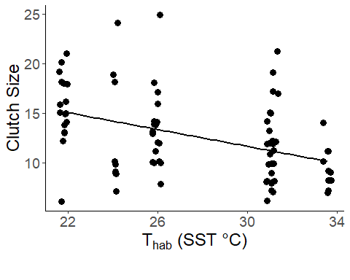

## Time to hatch analysis

##   
## Model selection based on AICc:  
##   
## K AICc Delta_AICc AICcWt Cum.Wt LL  
## clutch_lat*acc 6 356.63 0.00 0.27 0.27 -171.80  
## lat*acc 6 356.71 0.09 0.26 0.53 -171.85  
## mean*acc 6 357.33 0.70 0.19 0.72 -172.15  
## clutch_mean*acc 6 357.35 0.72 0.19 0.91 -172.16  
## mean+acc 5 361.19 4.56 0.03 0.94 -175.23  
## clutch_mean+acc 5 361.40 4.77 0.02 0.96 -175.34  
## lat+acc 5 362.58 5.95 0.01 0.98 -175.93  
## clutch_lat+acc 5 362.83 6.20 0.01 0.99 -176.05  
## s.mean*acc 6 367.24 10.61 0.00 0.99 -177.11  
## clutch_s.mean*acc 6 367.43 10.80 0.00 0.99 -177.20  
## s.mean+acc 5 367.88 11.25 0.00 0.99 -178.58  
## clutch_s.mean+acc 5 368.22 11.59 0.00 0.99 -178.75  
## t.mean+acc 5 368.59 11.96 0.00 0.99 -178.93  
## q.mean+acc 5 368.63 12.00 0.00 1.00 -178.95  
## q.mean*acc 6 368.68 12.05 0.00 1.00 -177.83  
## t.mean*acc 6 368.86 12.23 0.00 1.00 -177.92  
## clutch_q.mean*acc 6 368.96 12.33 0.00 1.00 -177.97  
## clutch_t.mean+acc 5 368.97 12.34 0.00 1.00 -179.12  
## clutch_q.mean+acc 5 369.01 12.38 0.00 1.00 -179.14  
## clutch_t.mean*acc 6 369.14 12.51 0.00 1.00 -178.06  
## max+acc 5 369.33 12.70 0.00 1.00 -179.30  
## clutch_max+acc 5 369.80 13.17 0.00 1.00 -179.54  
## max*acc 6 370.44 13.81 0.00 1.00 -178.71  
## clutch_max*acc 6 370.86 14.23 0.00 1.00 -178.92  
## lat 4 567.34 210.71 0.00 1.00 -279.43  
## clutch_lat 4 567.34 210.71 0.00 1.00 -279.43  
## clutch_mean 4 567.48 210.85 0.00 1.00 -279.50  
## mean 4 567.48 210.85 0.00 1.00 -279.50  
## clutch_s.mean 4 568.64 212.01 0.00 1.00 -280.08  
## s.mean 4 568.64 212.01 0.00 1.00 -280.08  
## t.mean 4 569.05 212.42 0.00 1.00 -280.28  
## clutch_t.mean 4 569.05 212.42 0.00 1.00 -280.28  
## clutch_q.mean 4 569.14 212.51 0.00 1.00 -280.33  
## q.mean 4 569.14 212.51 0.00 1.00 -280.33  
## max 4 569.54 212.91 0.00 1.00 -280.53  
## clutch_max 4 569.54 212.91 0.00 1.00 -280.53  
## clutch_null 3 570.50 213.87 0.00 1.00 -282.11  
## null 3 570.50 213.87 0.00 1.00 -282.11

## q.mean t.mean s.mean mean lat no.embryos   
## 0.0006131231 0.0016308927 0.0003972143 0.0214173486 0.0226580855 0.5773288033   
## survivor   
## 0.6983107702

##   
## Call:  
## model.avg(object = a, b)  
##   
## Component model call:   
## glmmTMB(formula = Time.to.hatch ~ <2 unique rhs>, data = data, family =   
## gaussian, ziformula = ~0, dispformula = ~1)  
##   
## Component models:   
## df logLik AICc delta weight  
## 124 6 -171.85 356.71 0.00 0.58  
## 135 6 -172.15 357.33 0.61 0.42  
##   
## Term codes:   
## cond(acc) cond(lat) cond(mean) cond(acc:lat) cond(acc:mean)   
## 1 2 3 4 5   
##   
## Model-averaged coefficients:   
## (full average)   
## Estimate Std. Error Adjusted SE z value Pr(>|z|)   
## cond((Int)) 32.4505 12.1039 12.1155 2.678 0.0074 **  
## cond(lat) 0.2424 0.2208 0.2212 1.096 0.2730   
## cond(acc24) -6.3649 8.2058 8.2229 0.774 0.4389   
## cond(acc24:lat) -0.1638 0.1587 0.1592 1.028 0.3037   
## cond(mean) -0.1944 0.2367 0.2370 0.820 0.4123   
## cond(acc24:mean) 0.1158 0.1520 0.1525 0.759 0.4478   
##   
## (conditional average)   
## Estimate Std. Error Adjusted SE z value Pr(>|z|)   
## cond((Int)) 32.45052 12.10387 12.11549 2.678 0.00740 **   
## cond(lat) 0.42102 0.09736 0.09881 4.261 2.03e-05 ***  
## cond(acc24) -6.36490 8.20583 8.22293 0.774 0.43891   
## cond(acc24:lat) -0.28441 0.09716 0.09860 2.884 0.00392 **   
## cond(mean) -0.45819 0.10605 0.10762 4.258 2.07e-05 ***  
## cond(acc24:mean) 0.27295 0.10772 0.10931 2.497 0.01253 *   
## ---  
## Signif. codes: 0 '***' 0.001 '**' 0.01 '*' 0.05 '.' 0.1 ' ' 1

## Family: gaussian ( identity )  
## Formula: Time.to.hatch ~ mean * acc + (1 | hatchID)  
## Data: data  
##   
## AIC BIC logLik deviance df.resid   
## 356.3 371.3 -172.2 344.3 83   
##   
## Random effects:  
##   
## Conditional model:  
## Groups Name Variance Std.Dev.  
## hatchID (Intercept) 0.955 0.9772   
## Residual 2.161 1.4699   
## Number of obs: 89, groups: hatchID, 26  
##   
## Dispersion estimate for gaussian family (sigma^2): 2.16   
##   
## Conditional model:  
## Estimate Std. Error z value Pr(>|z|)   
## (Intercept) 46.1430 1.7556 26.283 < 2e-16 ***  
## mean -0.4632 0.1054 -4.397 1.1e-05 ***  
## acc24 -15.4300 1.8439 -8.368 < 2e-16 ***  
## mean:acc24 0.2863 0.1111 2.577 0.00996 **   
## ---  
## Signif. codes: 0 '***' 0.001 '**' 0.01 '*' 0.05 '.' 0.1 ' ' 1

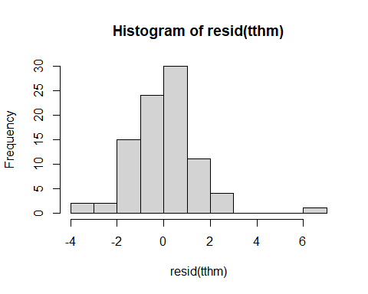

## R2m R2c  
## [1,] 0.906739 0.9353247

## # A tibble: 14 x 3  
## # Groups: site [7]  
## site acc Time.to.hatch  
## <chr> <fct> <dbl>  
## 1 BF 20 36.6  
## 2 BF 24 26.9  
## 3 FB 20 36.5  
## 4 FB 24 29.3  
## 5 GB 20 41.8  
## 6 GB 24 29.2  
## 7 HM 20 38.3  
## 8 HM 24 27.7  
## 9 OY 20 39   
## 10 OY 24 27.6  
## 11 TO 20 39   
## 12 TO 24 27   
## 13 WH 20 40   
## 14 WH 24 28.8

## # A tibble: 14 x 3  
## # Groups: site [7]  
## site acc Time.to.hatch  
## <chr> <fct> <dbl>  
## 1 BF 20 1.51   
## 2 BF 24 1.11   
## 3 FB 20 3.54   
## 4 FB 24 0.577  
## 5 GB 20 2.59   
## 6 GB 24 1.47   
## 7 HM 20 1.80   
## 8 HM 24 1   
## 9 OY 20 0   
## 10 OY 24 1.13   
## 11 TO 20 4.36   
## 12 TO 24 1.15   
## 13 WH 20 0   
## 14 WH 24 1.26

Now that we have a model averaged summary of our data, we will plot one of the best fit models (mean temperature) for visualization.

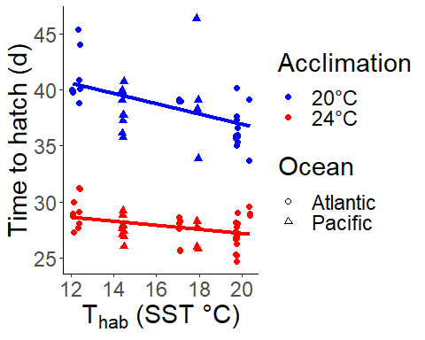

## Survivorship analysis

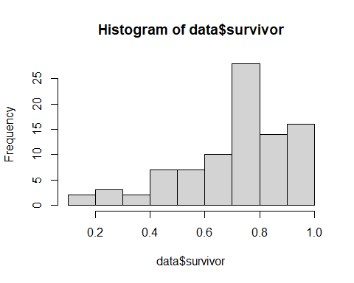

##   
## Model selection based on AICc:  
##   
## K AICc Delta_AICc AICcWt Cum.Wt LL  
## clutch_q.mean 3 402.29 0.00 0.15 0.15 -198.00  
## clutch_s.mean 3 402.40 0.11 0.14 0.28 -198.06  
## clutch_t.mean 3 402.67 0.38 0.12 0.41 -198.19  
## clutch_q.mean+acc 4 403.82 1.53 0.07 0.47 -197.67  
## clutch_lat 3 403.84 1.55 0.07 0.54 -198.78  
## clutch_s.mean+acc 4 403.94 1.65 0.06 0.60 -197.73  
## clutch_max 3 404.05 1.76 0.06 0.67 -198.88  
## clutch_t.mean+acc 4 404.22 1.92 0.06 0.72 -197.87  
## clutch_mean 3 404.72 2.43 0.04 0.76 -199.22  
## clutch_q.mean*acc 5 405.10 2.81 0.04 0.80 -197.19  
## clutch_s.mean*acc 5 405.22 2.93 0.03 0.83 -197.25  
## clutch_null 2 405.35 3.06 0.03 0.87 -200.61  
## clutch_lat+acc 4 405.44 3.15 0.03 0.90 -198.48  
## clutch_t.mean*acc 5 405.59 3.30 0.03 0.92 -197.43  
## clutch_max+acc 4 405.64 3.35 0.03 0.95 -198.58  
## clutch_mean+acc 4 406.39 4.10 0.02 0.97 -198.96  
## clutch_max*acc 5 407.24 4.95 0.01 0.98 -198.26  
## clutch_lat*acc 5 407.51 5.21 0.01 0.99 -198.39  
## clutch_mean*acc 5 408.48 6.19 0.01 1.00 -198.88

##   
## Model selection based on AICc:  
##   
## K AICc Delta_AICc AICcWt Cum.Wt LL  
## clutch_q.mean 3 402.29 0.00 0.15 0.15 -198.00  
## clutch_s.mean 3 402.40 0.11 0.14 0.28 -198.06  
## clutch_t.mean 3 402.67 0.38 0.12 0.41 -198.19  
## clutch_q.mean+acc 4 403.82 1.53 0.07 0.47 -197.67  
## clutch_lat 3 403.84 1.55 0.07 0.54 -198.78  
## clutch_s.mean+acc 4 403.94 1.65 0.06 0.60 -197.73  
## clutch_max 3 404.05 1.76 0.06 0.67 -198.88  
## clutch_t.mean+acc 4 404.22 1.92 0.06 0.72 -197.87

##   
## Call:  
## model.avg(object = a, b, c, d, e, g, h, i)  
##   
## Component model call:   
## glmmTMB(formula = y ~ <8 unique rhs>, data = data, family = binomial,   
## ziformula = ~0, dispformula = ~1)  
##   
## Component models:   
## df logLik AICc delta weight  
## 4 3 -198.00 402.29 0.00 0.20  
## 5 3 -198.06 402.40 0.11 0.19  
## 6 3 -198.19 402.67 0.38 0.17  
## 14 4 -197.67 403.82 1.53 0.09  
## 2 3 -198.78 403.84 1.55 0.09  
## 15 4 -197.73 403.94 1.65 0.09  
## 3 3 -198.88 404.05 1.76 0.08  
## 16 4 -197.87 404.22 1.92 0.08  
##   
## Term codes:   
## cond(acc) cond(lat) cond(max) cond(q.mean) cond(s.mean) cond(t.mean)   
## 1 2 3 4 5 6   
##   
## Model-averaged coefficients:   
## (full average)   
## Estimate Std. Error Adjusted SE z value Pr(>|z|)  
## cond((Int)) -0.407109 1.769627 1.776683 0.229 0.819  
## cond(q.mean) 0.023330 0.040035 0.040148 0.581 0.561  
## cond(s.mean) 0.020525 0.036661 0.036765 0.558 0.577  
## cond(t.mean) 0.018943 0.037130 0.037236 0.509 0.611  
## cond(acc24) -0.030885 0.090922 0.091807 0.336 0.737  
## cond(lat) -0.008063 0.028439 0.028529 0.283 0.777  
## cond(max) 0.005466 0.020544 0.020612 0.265 0.791  
##   
## (conditional average)   
## Estimate Std. Error Adjusted SE z value Pr(>|z|)   
## cond((Int)) -0.40711 1.76963 1.77668 0.229 0.8188   
## cond(q.mean) 0.07857 0.03252 0.03299 2.382 0.0172 *  
## cond(s.mean) 0.07316 0.03066 0.03109 2.353 0.0186 *  
## cond(t.mean) 0.07731 0.03338 0.03386 2.283 0.0224 *  
## cond(acc24) -0.11846 0.14606 0.14817 0.799 0.4240   
## cond(lat) -0.08638 0.04358 0.04420 1.954 0.0507 .  
## cond(max) 0.06497 0.03393 0.03441 1.888 0.0590 .  
## ---  
## Signif. codes: 0 '***' 0.001 '**' 0.01 '*' 0.05 '.' 0.1 ' ' 1

## Family: binomial ( logit )  
## Formula: y ~ q.mean + (1 | momID)  
## Data: data  
##   
## AIC BIC logLik deviance df.resid   
## 397.7 405.2 -195.9 391.7 86   
##   
## Random effects:  
##   
## Conditional model:  
## Groups Name Variance Std.Dev.  
## momID (Intercept) 0.3725 0.6104   
## Number of obs: 89, groups: momID, 25  
##   
## Conditional model:  
## Estimate Std. Error z value Pr(>|z|)   
## (Intercept) -0.94691 0.84757 -1.117 0.2639   
## q.mean 0.07654 0.03379 2.265 0.0235 *  
## ---  
## Signif. codes: 0 '***' 0.001 '**' 0.01 '*' 0.05 '.' 0.1 ' ' 1

## [1] 0.195359

## chisq ratio rdf p   
## 16.9962298 0.1976306 86.0000000 1.0000000

## q.mean t.mean s.mean mean lat   
## 0.0005503195 0.0014313634 0.0003786011 0.0253332990 0.0226013638   
## no.embryos survivor Time.to.hatch   
## 0.5876502975 0.7332158481 0.8418082178

## R2m R2c  
## theoretical 0.1519378 0.6352461  
## delta 0.1296547 0.5420813

The summer mean only is the best predictor of survivorship. I decided to ignore number of embryos and time to hatch for now.

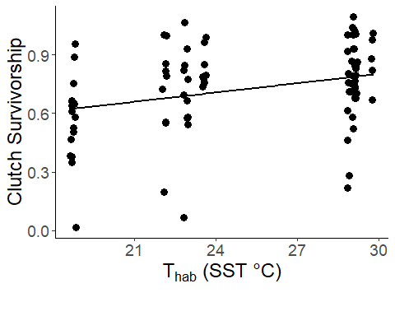

## `geom_smooth()` using formula 'y ~ x'

