**Introduction to Social and Professional Issues**

**Industrial Revolution**

* The process of change from an agrarian and handicraft economy to one dominated by industry and machine manufacturing. These technological changes introduced novel ways of working and living and fundamentally transformed society.

**The Historical Context**

**1st Industrial Revolution**

* Invention of the stream engine in the 1880s which ushered in new processes that relied on the new technology.

**2nd Industrial Revolution**

* The shift to petroleum and electric power introduced leaner and less cumbersome machinery which caused more efficient manufacturing processes to be used.

**3rd Industrial Revolution**

* In the middle of the 20th century, the early development of automation and robotics became the trend in manufacturing.
* The same era also saw the first use of computerized systems tasked to manage and analyze data.

**Industry 4.0**

* Industry 4.0 can be defined as the integration of intelligent digital technologies into manufacturing and industrial processes. It encompasses a set of technologies that include industrial IoT networks, AI, Big Data, robotics, and automation.
* Notes: Internet can now communicate with other people like messenger any connected. Internet optics also AI like ChatGPT.

**Industry 5.0**

* The term Industry 5.0 refers to people working alongside robots and smart machines. It’s about robots helping humans work better and faster by leveraging advanced technologies like the Internet of Things (IoT) and big data. It adds a personal human touch to the industry 4.0 pillars of automation and efficiency.
* Note: people working alongside robot is the difference to 4.0

**The 5 Industrial Revolutions**

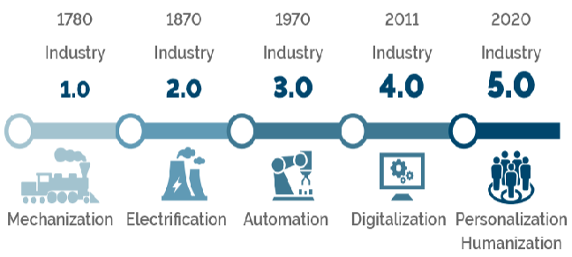

**Issues in the International and Local Context**

**Global Impact**

* Technology has developed into the driving force that molds the world into continuous advancements
* Economic Implications:
  + Digital Transformation and business models
  + Gig economy and the future of work
  + Notes: Like part time
* Socio-Cultural Implications
  + Digitalization of communication and social interactions
  + Notes: like telegram
  + Impact of traditional cultures and communities
  + Notes: cultures become different because of influence in YouTube
* Environmental Impact
  + E-waste and sustainable technologies practices
  + Ex: Cellphone waste
  + Renewable energy solutions in tech
  + Ex: Like the solar panels

**Local Variations in applications**

* Technology disparities within and across regions
  + Notes: some areas are not 5g like in Baguio we are 5g in Dagupan there is 3g only like that
* Different socio-economic circumstances change the citizens' and the government's response to new technologies.
  + Notes: We use cellphone they use keypad
* There can be inconclusion programs and infrastructure development initiatives to capitalize in new technologies and ideas.
* The establishments of tech innovation hubs and clusters can be part of these types of initiatives too
* There is also the case for the lack of access to technology and infrastructure powered by industry 4.0

**Social Issues in Information Technology**

**Privacy Concerns in the Digital Age**

* There have been concerns about the amount of data that is collected by companies through normalized ways such as cookies and digital footprints.
  + Notes: Service provider can see your data's even though your incognito, they can trace you.
* Various countries have put out their own legislations to combat this such as India and Indonesia with their blanket ban on Chinese-made websites and services.
  + Notes: Using your information by other people
* Organizations such as European union have also been pushing against various ways of data collection in their member countries.
  + Notes: some accounts are banned to prevent misuse of data links

**Job Displacements**

* The current outlook of people with technology is the implications that widespread automation would impact job security
  + Notes: Shows how they use your data, not reading agree to use your data read contract to know salary like that.
* The need of reskilling and Upskilling now becomes the only option for work that requires some level of skill
  + Notes: jobs lesser because of machineries
* Recent events in 2023 such as the Hollywood's writers' guilds of America and screen actor's guild strikes are publicly known and real-world effects companies leaning towards automating every work including creative ones.

**Digital Divide**

* There has also been an increase in the socioeconomic disparities between those that have access to the new technologies to those that don’t
* Even a simple disparity in internet access may affect ones standing in terms of their ability to learn or even be aware of the present state of society

**Ethical Considerations**

* Responsible AI and Decision-Making
  + Bias in Algorithms and Ethical AI development
* Digital Ethics in Social Media
  + Privacy and Misinformation Issues
* Data Privacy Regulations
* Ethical Dilemmas faced by IT professionals
* Notes: Make vote buying

**Professional Issues in the IT Industry**

**Professional Issues**

* There are various things to be aware of as It Professionals in the industry such as
* Ethical Responsibilities in Tech Careers:
  + Codes of ethics for tech professionals
  + Ethical Decision-Making in tech Companies
* Career Development inTech:
  + Skills development and countinous learning.
  + Mentorship and Leadership opportunities.

**Professional Issues**

* Environmental Responsibility:
  + Reducing the carbon footprint of technology
  + Sustainable practices in tech companies.