AIM
To design and implement a Bank Account Management System in Java using object-oriented programming concepts such as attributes, methods, constructors, object creation, inheritance, method overriding, deposits, withdrawals, interest calculation, and fund transfers.

DESCRIPTION
The program creates a base class named Account containing account number, account holder name, balance, and account type. It provides methods for depositing money, withdrawing money, transferring funds, and displaying account details.
SavingsAccount inherits from Account and adds an interestRate attribute with a calculateInterest() method. CurrentAccount inherits from Account and adds an overdraftLimit attribute. It overrides the withdraw() method so that withdrawal is permitted up to the available balance plus the overdraft limit.
Objects of SavingsAccount and CurrentAccount are created and used to perform deposits, withdrawals, interest calculation, and fund transfers. Account details are displayed before and after transactions.

ALGORITHM
  - Start the program.
  - Create the base class Account.
  - Define accountNumber, accountHolderName, balance, and accountType attributes.
  - Define a constructor to initialize the account details.
  - Define deposit(), withdraw(), transfer(), and displayAccountDetails() methods.
  - Create SavingsAccount by inheriting Account.
  - Add interestRate and define calculateInterest() to calculate and add interest to the balance.
  - Create CurrentAccount by inheriting Account.
  - Add overdraftLimit and override withdraw() to allow withdrawal within the overdraft limit.
  - Create SavingsAccount and CurrentAccount objects.
  - Display the initial account details.
  - Perform deposits, withdrawals, and interest calculation.
  - Transfer money from the SavingsAccount to the CurrentAccount.
  - Display the updated account details and final balances.
  - Stop the program.

UML DIAGRAM
+ +
| Account |
+ +
| - accountNumber |

| - accountHolderName |
| - balance |
| - accountType |
+ +
| + deposit() |
| + withdraw() |
| + transfer() |
| + displayAccount. ()|
+----------+ +
^
+-------------+ +
| |
+---------+----------+ +---------+ +
| SavingsAccount | | CurrentAccount |
+--------------------+ + +
| - interestRate | | - overdraftLimit |
+--------------------+ + +
| + calculateInterest| | + withdraw() |
+--------------------+ + +

SOURCE CODE

class Account {

int accountNumber;

String accountHolderName;

double balance;

String accountType;

// Constructor

Account(int accountNumber, String accountHolderName,

double balance, String accountType) {

this.accountNumber = accountNumber;

this.accountHolderName = accountHolderName;

this.balance = balance;

this.accountType = accountType;

}

// Deposit

void deposit(double amount) {

balance = balance + amount;

System.out.println("Deposited: Rs." + amount);

}

// Withdraw

void withdraw(double amount) {

if (amount <= balance) {

balance = balance - amount;

System.out.println("Withdrawn: Rs." + amount);

} else {

System.out.println("Insufficient balance!");

}

}

// Transfer

void transfer(Account receiver, double amount) {

if (amount <= balance) {

balance = balance - amount;

receiver.balance = receiver.balance + amount;

System.out.println("Transferred: Rs." + amount);

System.out.println("To Account: " + receiver.accountNumber);

} else {

System.out.println("Insufficient balance for transfer!");

}

}

// Display account

void displayAccountDetails() {

System.out.println("Account Number : " + accountNumber);

System.out.println("Account Holder : " + accountHolderName);

System.out.println("Account Type : " + accountType);

System.out.println("Balance : Rs." + balance);

}

}

// Savings Account inherits Account

class SavingsAccount extends Account {

double interestRate;

// Constructor

SavingsAccount(int accountNumber, String accountHolderName,

double balance, double interestRate) {

super(accountNumber, accountHolderName, balance, "Savings");

this.interestRate = interestRate;

}

// Calculate interest

void calculateInterest() {

double interest = balance * interestRate / 100;

balance = balance + interest;

System.out.println("Interest Rate : " + interestRate + "%");

System.out.println("Interest Earned : Rs." + interest);

}

}

// Current Account inherits Account

class CurrentAccount extends Account {

double overdraftLimit;

// Constructor

CurrentAccount(int accountNumber, String accountHolderName,

double balance, double overdraftLimit) {

super(accountNumber, accountHolderName, balance, "Current");

this.overdraftLimit = overdraftLimit;

}

// Method overriding

void withdraw(double amount) {

if (amount <= balance + overdraftLimit) {

balance = balance - amount;

System.out.println("Withdrawn: Rs." + amount);

} else {

System.out.println("Withdrawal exceeds overdraft limit!");

}

}

// Display overdraft

void displayOverdraft() {

System.out.println("Overdraft Limit : Rs." + overdraftLimit);

}

}

// Main class

public class BankAccountManagement {

public static void main(String[] args) {

SavingsAccount savings =

new SavingsAccount(101, "Deekshitha", 10000, 5);

CurrentAccount current =

new CurrentAccount(102, "Rahul", 5000, 3000);

System.out.println("===== BEFORE TRANSACTIONS =====");

System.out.println("\nSavings Account");

savings.displayAccountDetails();

System.out.println("\nCurrent Account");

current.displayAccountDetails();

current.displayOverdraft();

// Deposit

System.out.println("\n===== DEPOSIT =====");

savings.deposit(2000);

current.deposit(3000);

// Withdrawal

System.out.println("\n===== WITHDRAWAL =====");

savings.withdraw(1500);

current.withdraw(9000);

// Calculate interest

System.out.println("\n===== INTEREST CALCULATION =====");

savings.calculateInterest();

// Transfer money

System.out.println("\n===== FUND TRANSFER =====");

savings.transfer(current, 2000);

// Display details after transactions

System.out.println("\n===== AFTER TRANSACTIONS =====");

System.out.println("\nSavings Account");

savings.displayAccountDetails();

System.out.println("\nCurrent Account");

current.displayAccountDetails();

current.displayOverdraft();

// Final balances

System.out.println("\n===== FINAL BALANCES =====");

System.out.println("Savings Account Balance : Rs." + savings.balance);

System.out.println("Current Account Balance : Rs." + current.balance);

}

}

OUTPUT SCREENSHOT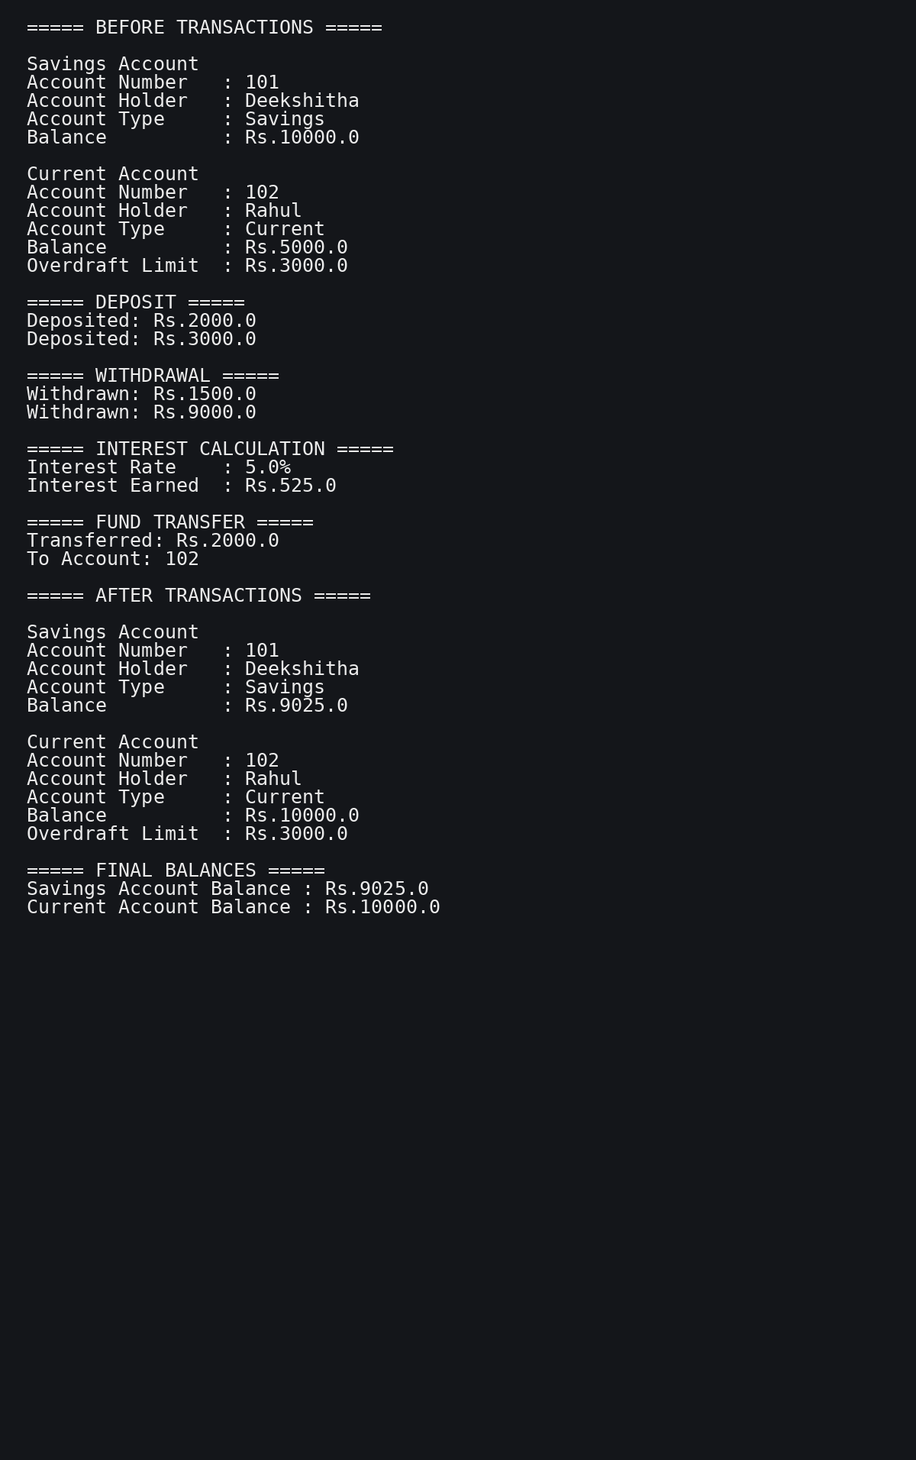

The above output represents the terminal output obtained after compiling and executing the Java program.

RESULT
Thus, the Bank Account Management System was successfully designed and implemented in Java. The program demonstrates constructors, attributes, methods, object creation, inheritance, method overriding, deposits, withdrawals, interest calculation, overdraft handling, and fund transfer operations. The final balances of the Savings Account and Current Account are displayed successfully.

