Solution Architecture Document

Solution Architecture Document
INNC-BNP

REVISION HISTORY
Ver. | Description of Change | Author | Date | Approved
 |  |  |  | Name | Effective Date
1.0 | Document creation | Pavlo Vilenchyk | July 8, 2025
1.1 | Costs | Pavlo Vilenchyk | Aug 17, 2025

Related Artifacts
Ref. | Name

Contents
1 Executive Summary 5
2 Introduction 6
2.1 Definitions, Acronyms, Abbreviations 6
2.2 Solution Architecture Document Scope 6
2.3 Solution Architecture Stakeholders 6
3 Solution Approach 8
3.1 Business goals associated with solution 8
3.1.1 Improve Member Experience and Usability 8
3.1.2 Standardize and Streamline GIN/LN Management 8
Enable members to easily create, manage, validate, and share Global Item Numbers (GINs) and Location Numbers (LNs), in compliance with X-Customer standards. 8
3.1.3 Enhance Data Visibility and Sharing 8
3.1.4 Improve Scalability and Cost Efficiency 8
3.1.5 Ensure Compliance, Security, and Auditability 8
3.2 constrains 8
3.2.1 Identity Platform Constraint 8
3.2.2 Deployment Model Constraint 8
3.2.3 Platform & Hosting Constraint 8
3.2.4 Legacy Data Migration 8
3.2.5 Data Format Compatibility 9
3.2.6 Browser Compatibility 9
3.2.7 Compliance and Auditability 9
3.2.8 Technical Standards Compliance 9
3.3 Quality attributes 9
3.4 Solution overview 10
3.4.1 Architecture-Driven Goals & Approach 10
4 Architecture components 12
4.1 High-Level Architecture Overview 12
4.2 Deployable Containers of the solutions 13
4.3 Web Application (SPA Frontend) 14
4.4 Core Backend Services 15
4.4.1 User Management Service 15
4.4.2 Prefix Management Service 16
4.4.3 Product (GIN) Management Service 17
4.4.4 Location (LN) Management Service 18
4.4.5 Access Data Service 19
4.4.6 Integration Gateway 20
4.4.7 Notification Service 21
4.4.8 Help & Feedback Service 22
4.5 Data and Storage 23
4.6 Integration and Messaging 24
4.7 Reporting and Analytics 25
5 Deployment approach 26
5.1 API protection pattern 26
5.2 High availability solution deployment 26
5.3 highly available ZONE-REDUNDANT APPLICATION/services deployment 27
6 Dependencies, risks, and assumptions 28
6.1 Dependencies 28
6.1.1 Cloud/Azure 28
6.1.2 Security/Identity 28
6.1.3 Data/Search 28
6.1.4 External Systems 28
6.1.5 Client/UX 28
6.1.6 Reporting 28
6.1.7 Ops/Compliance 28
6.2 Risks (with quick mitigations) 29
6.3 Assumptions 30
7 Delivery 30
7.1 Methodology 30
7.1.1 Work Breakdown by Modules/Containers 30
7.1.2 Risk-Based Estimation 30
7.1.3 Phase-Based Delivery (per RFP §Project Structure): 30
7.1.4 Effort Aggregation → Timeline 30
7.2 estimations 31
7.2.1 Work breakdown 31
7.2.2 Work breakdown summary 36
7.3 Timeline, team structure 37
7.3.1 Detailed resource plan 38
7.4 Pricing including the total cost 39
7.4.1 Resources cost 39
7.4.2 Azure monthly cost estimate 40

Executive Summary
EPAM Systems is pleased to propose a scalable, secure, and cloud-native Member Application Solution for X-Customer, leveraging Microsoft Azure and built on the Reliable Web App (RWA) architectural pattern. The proposed platform consists of independently deployable services aligned to distinct business capabilities—ensuring modularity, agility, and ease of maintenance as X-Customer grows and evolves.
The solution comprises core services for managing Products (GIN), Locations (LN), Prefixes, Users, Data Access, Reporting, Notifications, Integration APIs, and Feedback. Each service will be independently developed, deployed, and scaled, enabling X-Customer to adapt quickly to changing needs, introduce new functionality incrementally, and optimize performance and availability across the system.
This architecture addresses X-Customer’s critical objectives: supporting 256,000+ users, delivering 99.9% availability, and offering intuitive, role-based user experiences. By decoupling services, we ensure seamless management of GINs and LNs, powerful data search and sharing via a publish-subscribe model, and real-time performance for high-volume transactions. RESTful APIs managed through Azure API Management will support partner and third-party integrations, while Azure SQL and Service Bus enable reliable data processing and event-driven messaging.
Security is at the core of our design. We integrate with X-Customer’s enterprise identity system via Azure AD B2C to enable claims-based Single Sign-On (SSO) and extend support for federated authentication with external identity providers (e.g., Google, Microsoft, Okta). This allows corporate users to authenticate using their existing credentials while ensuring secure, controlled access.
With EPAM’s engineering excellence and proven delivery model, X-Customer will receive a future-ready platform that reduces long-term costs, increases compliance with supply chain standards, and elevates member satisfaction. Our service-oriented, Azure-native solution empowers X-Customer to lead confidently in supply chain visibility, data governance, and global collaboration.

Introduction

Definitions, Acronyms, Abbreviations
Abbreviation or Acronym | Definition
AKS | Azure Kubernetes Service
API | Application Programming Interface
ASR | Architecturally Significant Requirement
CI/CD | Continuous Integration/Continuous Deployment
CQRS | Command Query Responsibility Segregation
GIN | Global Item Number
HA/DR | High Availability / Disaster Recovery
IaC | Infrastructure as Code
LN | Location Number
NFR | Non-Functional Requirement
RFP | Request for Proposal
RWA | Reliable Web App
SLA | Service Level Agreement
SOA | Service-Oriented Architecture
SPA | Single Page Application
WAF | Web Application Firewall

Solution Architecture Document Scope
The Solution Architecture Document details the complete design of the Member Application Solution, outlining its construction on the Microsoft Azure platform using the Reliable Web App (RWA) pattern for .NET. It will specify how key Azure services—such as App Service, Service Bus, Cosmos DB, and API Management—are integrated through patterns like Queue-Based Load-Leveling and CQRS to deliver a scalable, secure, and maintainable platform that meets all X-Customer's requirements.

Solution Architecture Stakeholders
Stakeholder Side | Stakeholder Role | Stakeholder Name | Contacts | Architectural Work Request Reasons
X-Customer | VP, Information Technology | Eleanor Vance | evance@x-customer.com | Strategic business goals, budget approval, overall project sponsorship.
X-Customer | Director, App Development | Marcus Thorne | mthorne@x-customer.com | Business context, legacy system details, resource allocation, team integration.
X-Customer | Product Manager, Member Services | Sofia Reyes | sreyes@x-customer.com | Functional requirements, user stories, feature prioritization, user experience goals.
X-Customer | Lead Enterprise Architect | David Chen | dchen@x-customer.com | Ensuring compliance with existing enterprise architecture and long-term strategy.
X-Customer | Senior Business Analyst | Olivia Grant | ogrant@x-customer.com | Detailed process flows, data mapping, and clarification of business rules.
X-Customer | IT Security & Compliance Officer | Ben Carter | bcarter@x-customer.com | Defining security NFRs, data privacy rules, and compliance requirements.
X-Customer | Principal Database Administrator | Hannah Wei | hwei@x-customer.com | Legacy database schema, data migration strategy, and data performance needs.
X-Customer | IT Operations Manager | Ian Petroff | ipetroff@x-customer.com | Defining SLAs, monitoring requirements, and operational readiness criteria.
EPAM | Account Director | Charles Miller | charles_miller@epam.com | Main commercial point of contact, client relationship management.
EPAM | Delivery Manager | Anya Sharma | anya_sharma@epam.com | Project execution, timeline, budget, risk management, stakeholder identification.
EPAM | Lead Solution Architect | Jeremy North | jeremy_north@epam.com | Overall technical vision, key technology decisions, authoring the SAD.
EPAM | Senior Software Engineer (.NET) | Kenji Tanaka | kenji_tanaka@epam.com | Backend technical feasibility, RWA pattern implementation details.
EPAM | Senior Software Engineer (React) | Fatima Rossi | fatima_rossi@epam.com | Frontend technical feasibility, SPA implementation, UI/UX component design.
EPAM | Principal QA Engineer | Leo Gonzalez | leo_gonzalez@epam.com | Test strategy, NFR testing approach (performance, security), quality metrics.
EPAM | Lead DevOps Engineer | Isabella Jones | isabella_jones@epam.com | CI/CD pipeline design, Infrastructure as Code (IaC) strategy, deployment plan.

Solution Approach

Business goals associated with solution

Improve Member Experience and Usability
Deliver an intuitive, web-based application that provides a modern user interface with role-driven workflows, dashboards, and contextual help.

Standardize and Streamline GIN/LN Management

Enable members to easily create, manage, validate, and share Global Item Numbers (GINs) and Location Numbers (LNs), in compliance with X-Customer standards.

Enhance Data Visibility and Sharing
Implement a robust publish/subscribe data model that allows members to share and access validated information with trading partners and third parties.

Improve Scalability and Cost Efficiency
Replace existing fragmented tools with a scalable, cloud-ready architecture that reduces future enhancement costs and supports long-term growth.

Ensure Compliance, Security, and Auditability
Provide a secure, auditable solution with strong identity management (including SSO and federated login), record validation, workflow approvals, and detailed audit logs.

constrains

Identity Platform Constraint
Description: The solution must integrate with X-Customer’s enterprise identity management system.
Details: Claims-based authentication using OAuth2/SAML via Azure AD B2C, with support for federated identity providers (e.g., Google, Okta, Microsoft).
RFP Reference: NFR-3

Deployment Model Constraint
Description: The application must be web-based with no requirement for client-side installation.
Details: Must operate via browser (SPA model); client runtime dependencies like Flash or local installs are disallowed.
RFP Reference: NFR-7

Platform & Hosting Constraint
Description: The solution must be cloud-ready and support multi-environment deployment.
Details: Environments include Development, Test, Staging, and Production. Requires automated deployment using DevOps pipelines and Infrastructure-as-Code (IaC).
RFP Reference: NFR-6, NFR-11

Legacy Data Migration
Description: Existing application data, including user information, must be migrated to the new system.
Details: The architecture must support transformation logic for legacy formats and ensure data integrity.
RFP Reference: NFR-12

Data Format Compatibility
Description: Must support a wide range of file formats for import and export.
Details: Formats include CSV, Excel, XML, tab-delimited, iDocs, and more. Both PC and Mac compatibility is required.
RFP Reference: G-12, D-5

Browser Compatibility
Description: The application must support current and prior versions of all major browsers.
Details: Browsers include Chrome, Firefox, Safari, Edge, and Internet Explorer 9 or later.
RFP Reference: NFR-13

Compliance and Auditability
Description: The system must be auditable and accessible.
Details: Must comply with WCAG 2.0 Level A accessibility standards and provide a complete audit trail of system activity.
RFP Reference: NFR-20, NFR-21

Technical Standards Compliance
Description: The solution must follow X-Customer’s established technical standards.
Details: Any deviation from coding, integration, or technology standards must be documented and assessed with no added cost to X-Customer.
RFP Reference: NFR-5

Quality attributes
Priority | Quality Attribute | Measurable Metric
H, H | Availability | 99.9% uptime; recovery within 5 minutes of failure (NFR-8, NFR-9)
H, H | Scalability | Supports 256,000 users with 10% concurrency without performance degradation (NFR-2)
H, H | Security | SSO via OAuth2/SAML; federated login; RBAC; all access logged (NFR-3, NFR-10, G-1)
H, H | Modifiability | New module deployed independently with zero downtime; configuration by admins (NFR-5, NFR-6)
H, M | Performance | Login < 2s; navigation < 1s; transactions < 2s; searches < 3s under 250 user load (NFR-14)
H, M | Auditability | Every change/action logged and traceable by user ID and timestamp (NFR-20, G-7.4)
H, M | Interoperability | Integration with external systems like SAP via REST APIs (NFR-4, P-19, L-15)
H, L | Accessibility | WCAG 2.0 Level A compliance for all UI screens (NFR-21)
M, M | Usability | Role-driven UI with contextual help; user tasks completed in ≤ 2 minutes (G-2, G-10)
M, M | Deployability | CI/CD deployment to 4 environments with <30m rollback (NFR-11)
L, L | Testability | Unit test coverage ≥ 80%; automated pipeline test pass rate ≥ 95%

Solution overview
EPAM Systems proposes a modular, cloud-native architecture for the Member Application Solution, leveraging independently deployable services hosted on Microsoft Azure. The solution is structured around business-aligned capabilities and is designed to address X-Customer’s most critical functional and non-functional requirements as captured in the RFP, ensuring long-term agility, resilience, and operational excellence.

Architecture-Driven Goals & Approach
The solution's architecture is shaped by a set of key Architecture Significant Requirements (ASRs), each of which directly influences design choices at both system and service levels:
Availability & Reliability (ASR: Availability – NFR-8, NFR-9)
The application is designed for 99.9% uptime, with auto-healing, active-active failover, and disaster recovery implemented via Azure Front Door, Azure App Service, and SQL failover groups across regions.
Scalability & Performance (ASR: Scalability, Performance – NFR-2, NFR-14)
The system supports over 256,000 users with 10% concurrency and sub-second API/UI responsiveness. Stateless services and Azure SQL with elastic pools allow horizontal scaling as traffic grows.
Security & Federated Identity (ASR: Security – NFR-3, NFR-10, G-1, G-13.7)
Azure AD B2C provides claims-based SSO with support for OAuth2/SAML and federated login (e.g., Google Workspace, Microsoft Entra ID), enabling secure access for enterprise members. RBAC is enforced at API and data levels.
Service Modularity (ASR: Modifiability – NFR-5, NFR-6)
The application is built as a set of independently deployable .NET services:
- User Management
- Prefix Registry
- Product (GIN) Management
- Location (LN) Management
- Data Access & Sharing
- Notification
- Reporting
- Feedback & Help
- Integration Gateway
Each is logically isolated, versioned, and owned by a dedicated agile team for maximum modifiability and maintainability.
Data Interoperability & Integration (ASR: Interoperability – NFR-4, D-7, P-19, L-15)
All business functions are exposed through versioned REST APIs secured and managed via Azure API Management. External systems (e.g., SAP, QuickBooks) are supported through standard integrations.
Business Workflow & Validation (ASR: Functionality – G-3, NFR-16)
Each domain service implements workflow automation (approval, validation, verification) using durable functions and event-driven triggers. Rules align to X-Customer’s business logic and standard compliance.
Audit & Reporting (ASR: Auditability – NFR-19, NFR-20, G-7.4)
Event logs and data changes are tracked in an immutable audit store. Reporting services generate usage, transaction, and change logs on demand.
User-Centered Experience (ASR: Usability & Accessibility – G-2, G-6, G-10, NFR-21)
A single-page application (SPA) UI delivers a role-driven, accessible interface using modern UI libraries compliant with WCAG 2.0 Level A. The dashboard summarizes tasks, capacity, notifications, and record status.
Deployability & Automation (ASR: Deployability – NFR-11)
All services are containerized and deployed across four environments (Dev, Test, Staging, Prod) using Azure DevOps pipelines with infrastructure as code (IaC) and automated test coverage.
Data Portability (ASR: Portability – G-12, D-5, P-5, L-5)
Import/export is supported in CSV, XML, iDocs, Excel, and other formats with validation, mapping, and transformation logic built in to support business workflows and third-party integration.

Architecture components

High-Level Architecture Overview
The Member Application Solution is a modular, service-oriented web application designed to enable X-Customer members to create, manage, and share numeric identifiers for Products (GIN) and Locations (LN), while also providing a secure, scalable, and intuitive experience.

Diagram Key
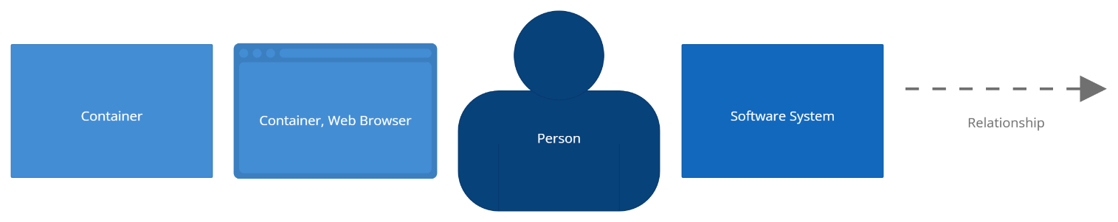
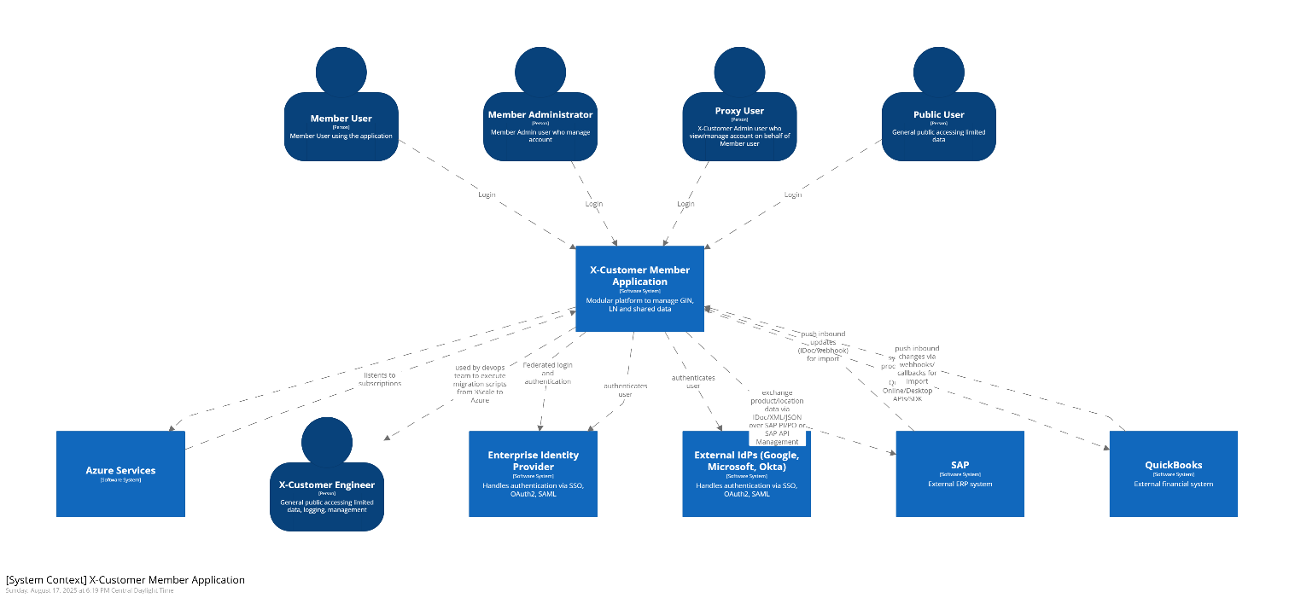

Deployable Containers of the solutions
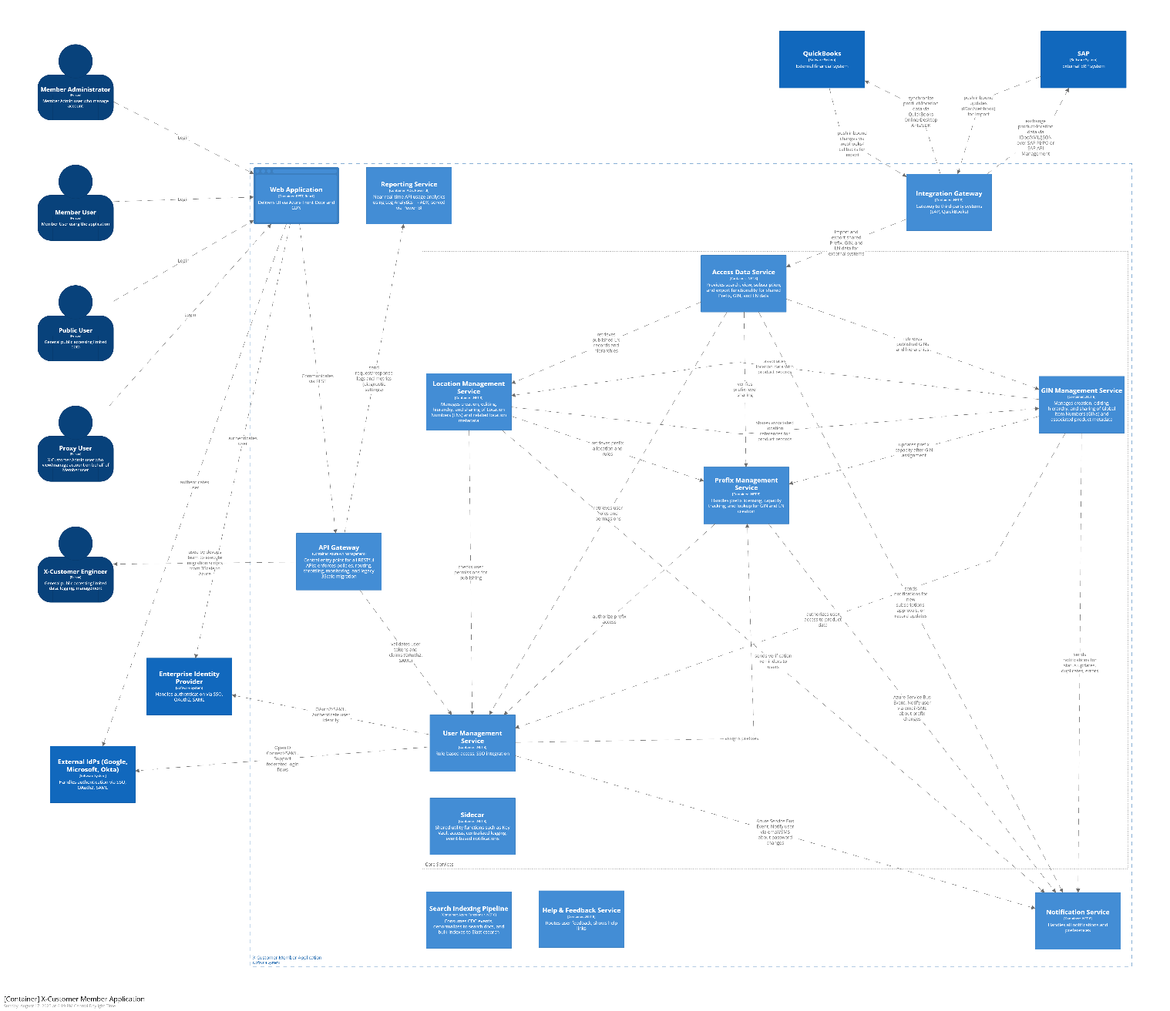

Web Application (SPA Frontend)
- Authentication & Authorization (WebAuth) – Entry point SPA module providing login, SSO, and role-based UI access.
- Prefixes Branch (WebPref) – UI for prefix licensees to manage prefix attributes and capacities.
- Product Branch (WebProd) – UI for product owners to create, edit, and manage Global Item Numbers (GINs) with barcode generation.
- Location Branch (WebLoc) – UI for managing Location Numbers (LNs), hierarchies, and verification.
- Access Data/Search Branch (WebAccess) – UI for search, view, subscribe, and export of Prefix/GIN/LN records.
- Reporting Module (WebReports) – Provides usage, subscription, and audit dashboards to members.
- Help & Feedback Module (WebHelp) – Offers contextual help, tutorials, videos, and feedback submission.
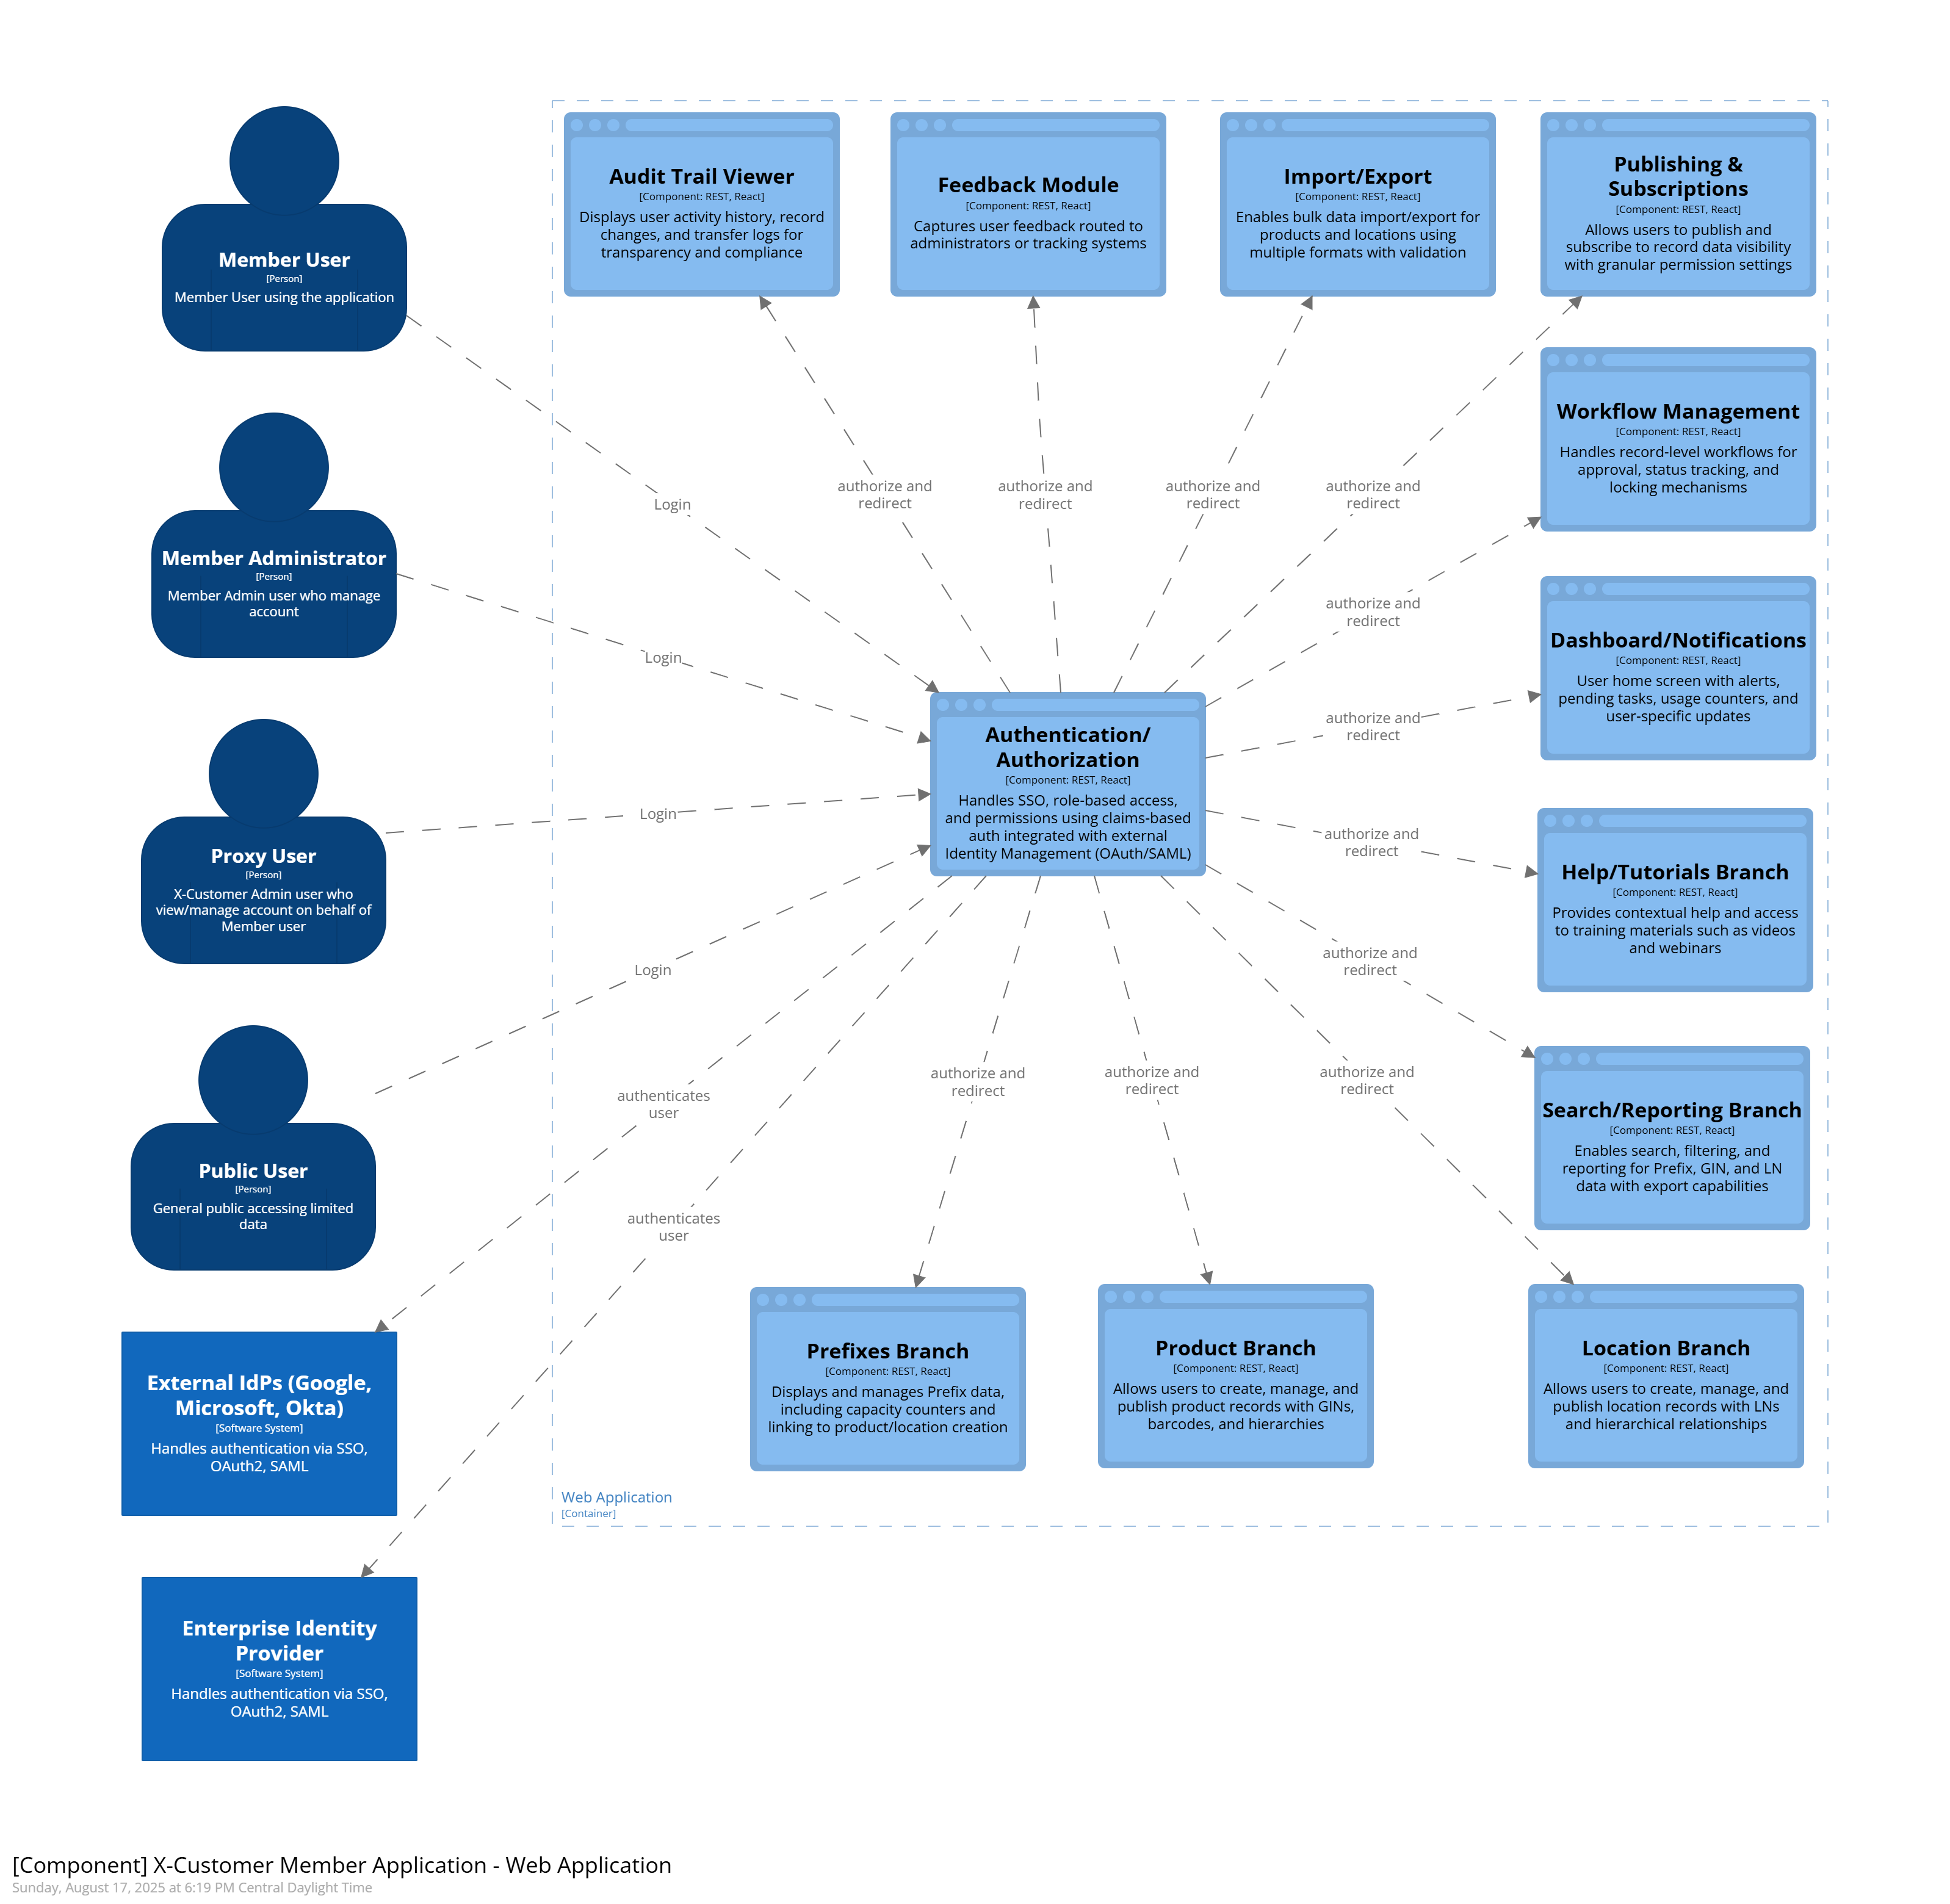

Core Backend Services

User Management Service
Provides RBAC, SSO integration, profile management, password reset, and federated login.
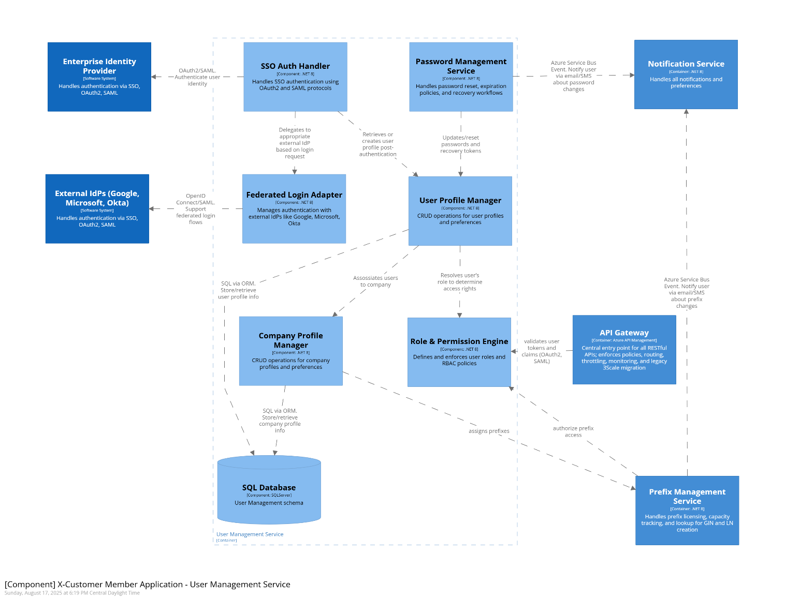
[G-1, G-2, G-4; NFR-3, NFR-7]

Prefix Management Service
Manages prefix licensing, assignments, and usage counters.
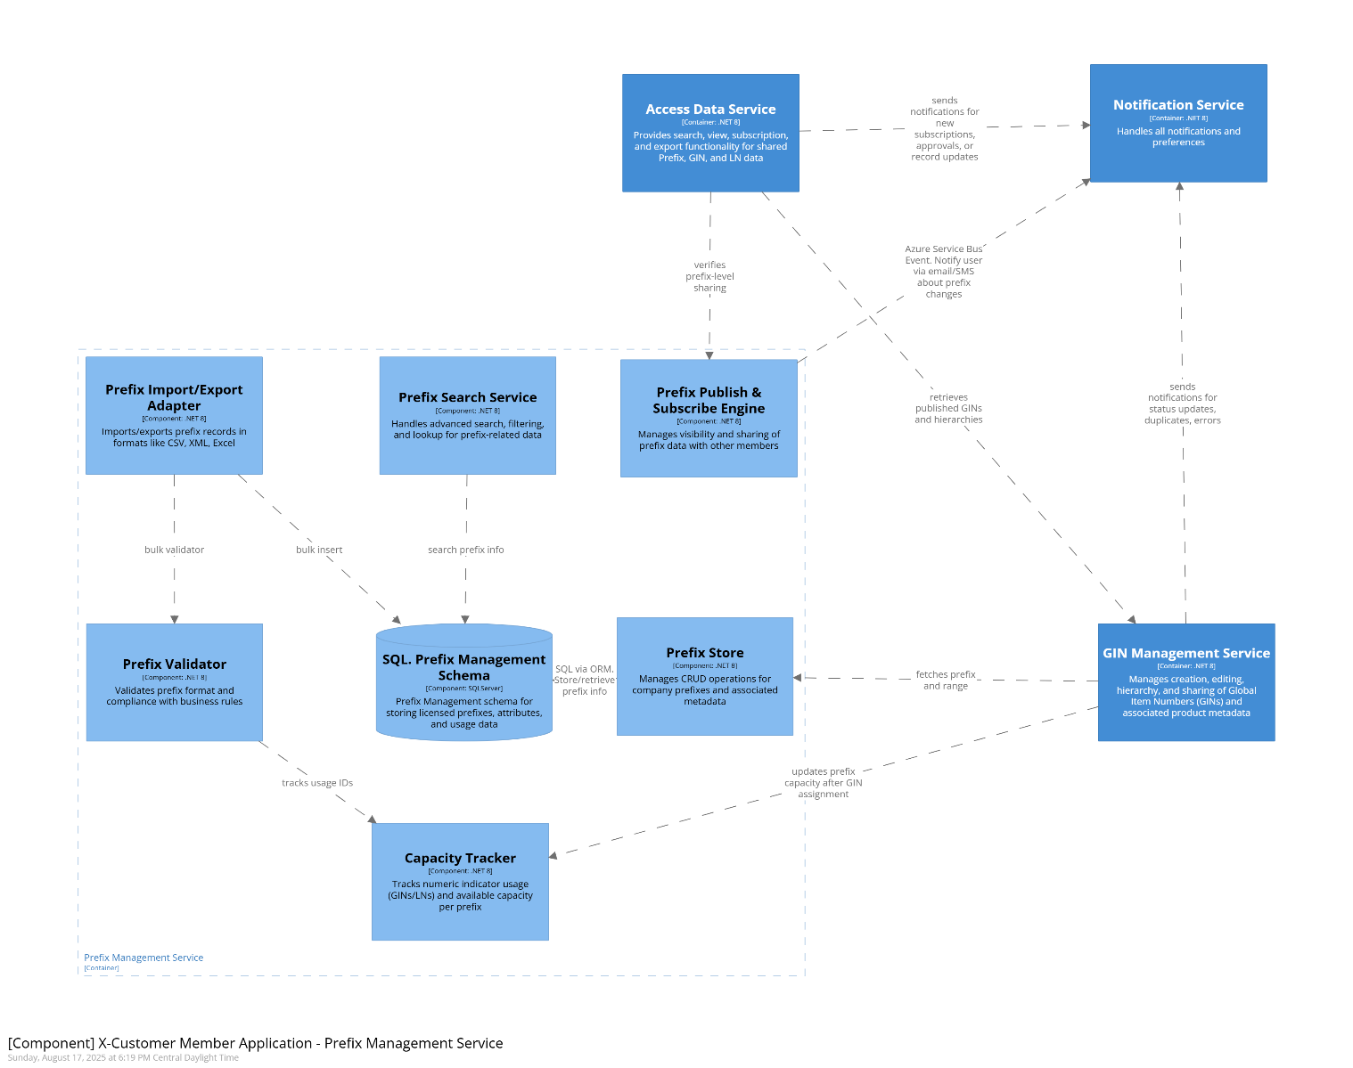
[G-5; P-1 (dependency); L-1 (dependency); G-13]

Product (GIN) Management Service
CRUD operations on product identifiers (GINs), barcode generation, hierarchy validation.
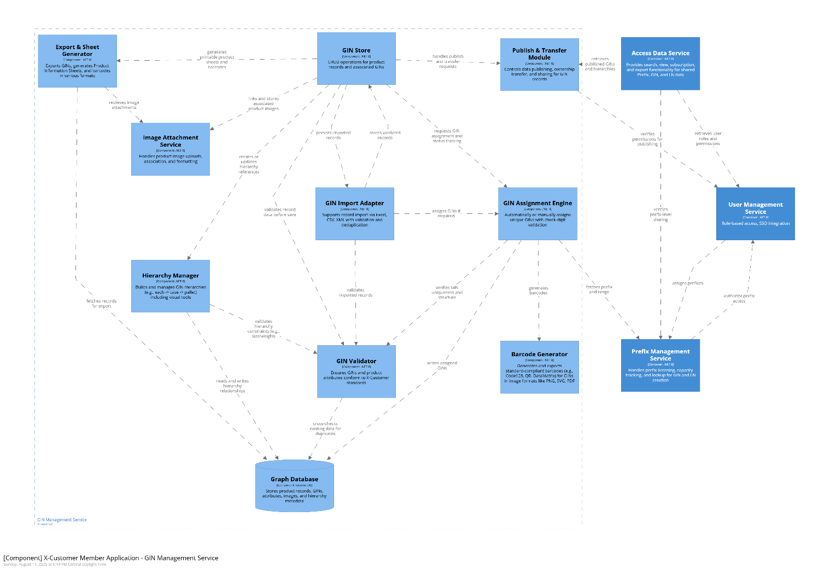
[P-1…P-19 esp. P-10/P-11, P-13/P-14, P-15, P-19]

Location (LN) Management Service
CRUD operations on location identifiers (LNs), hierarchies, duplicate detection, verification.
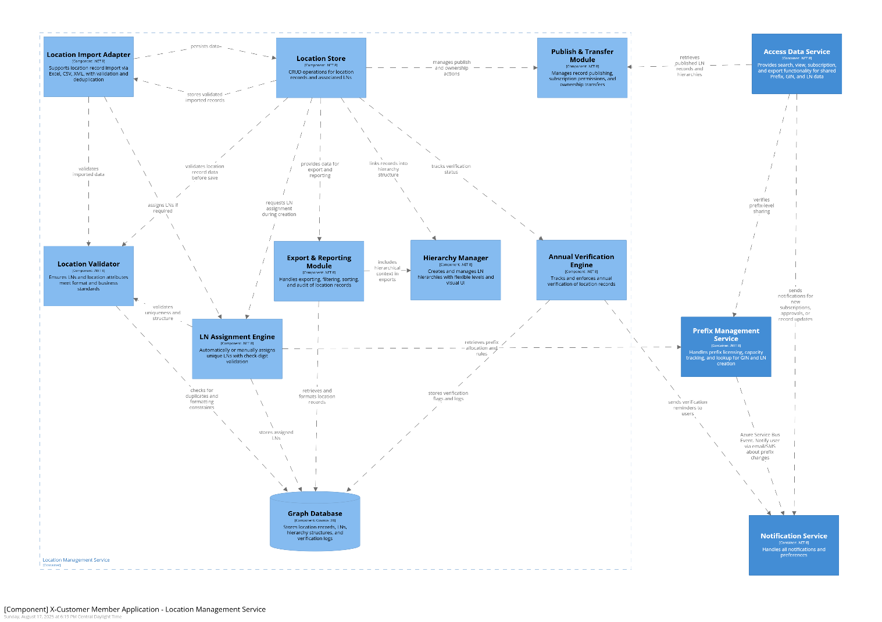
[L-1…L-15 esp. L-7/L-8, L-12, L-13, L-15]

Access Data Service
Exposes search and subscription API for Prefix, GIN, and LN datasets; integrates with Elasticsearch for optimized queries.
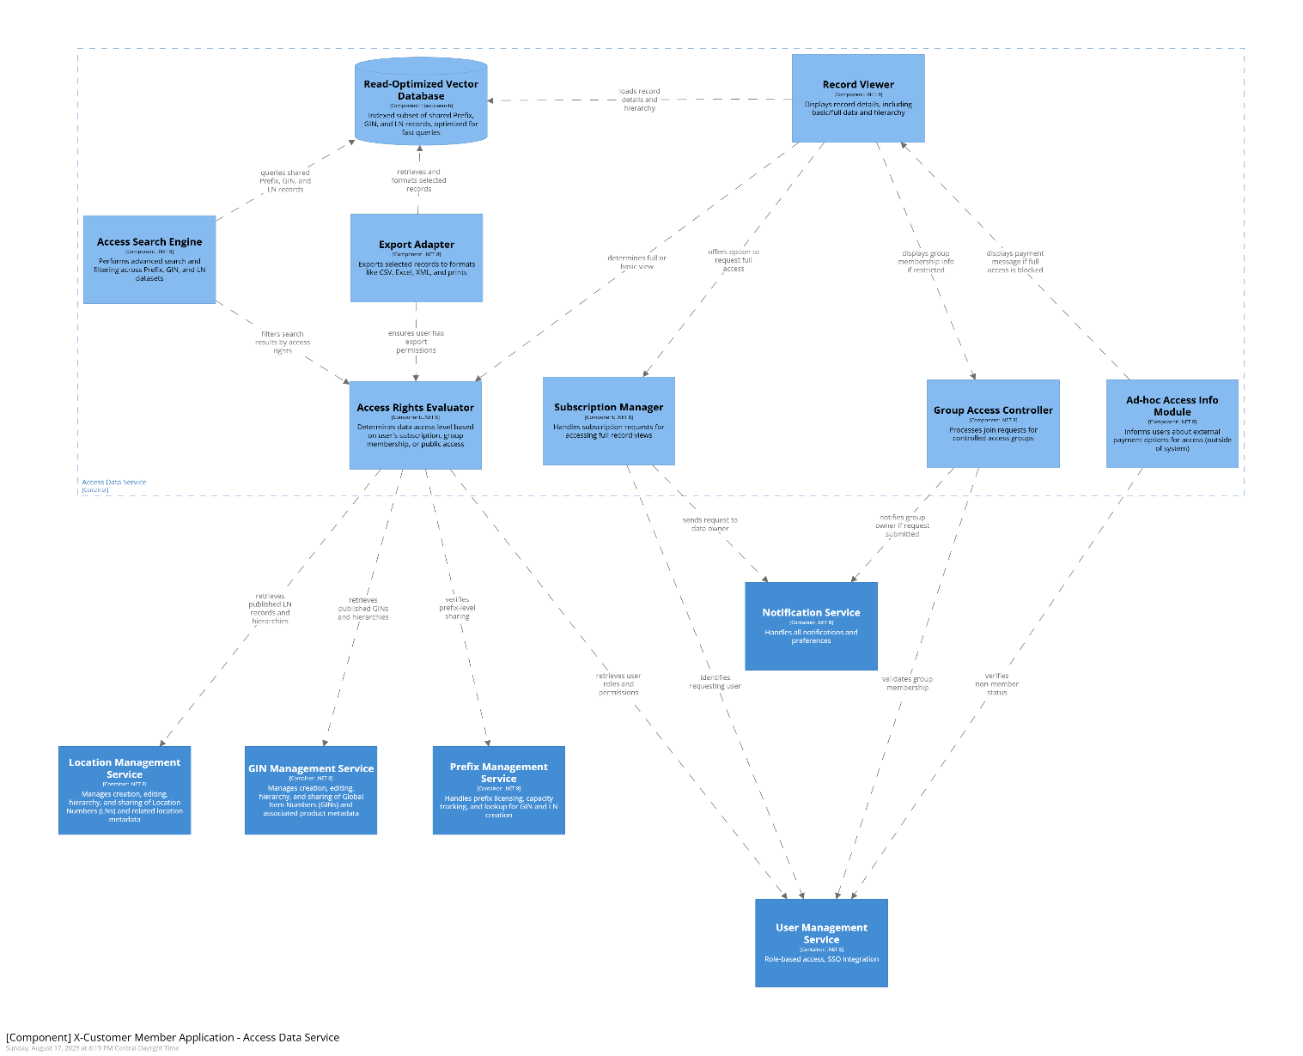
[D-1…D-8; G-6; G-13; NFR-2]

Integration Gateway
Provides connectors for external systems (SAP, QuickBooks), transformations, and import/export workflows.
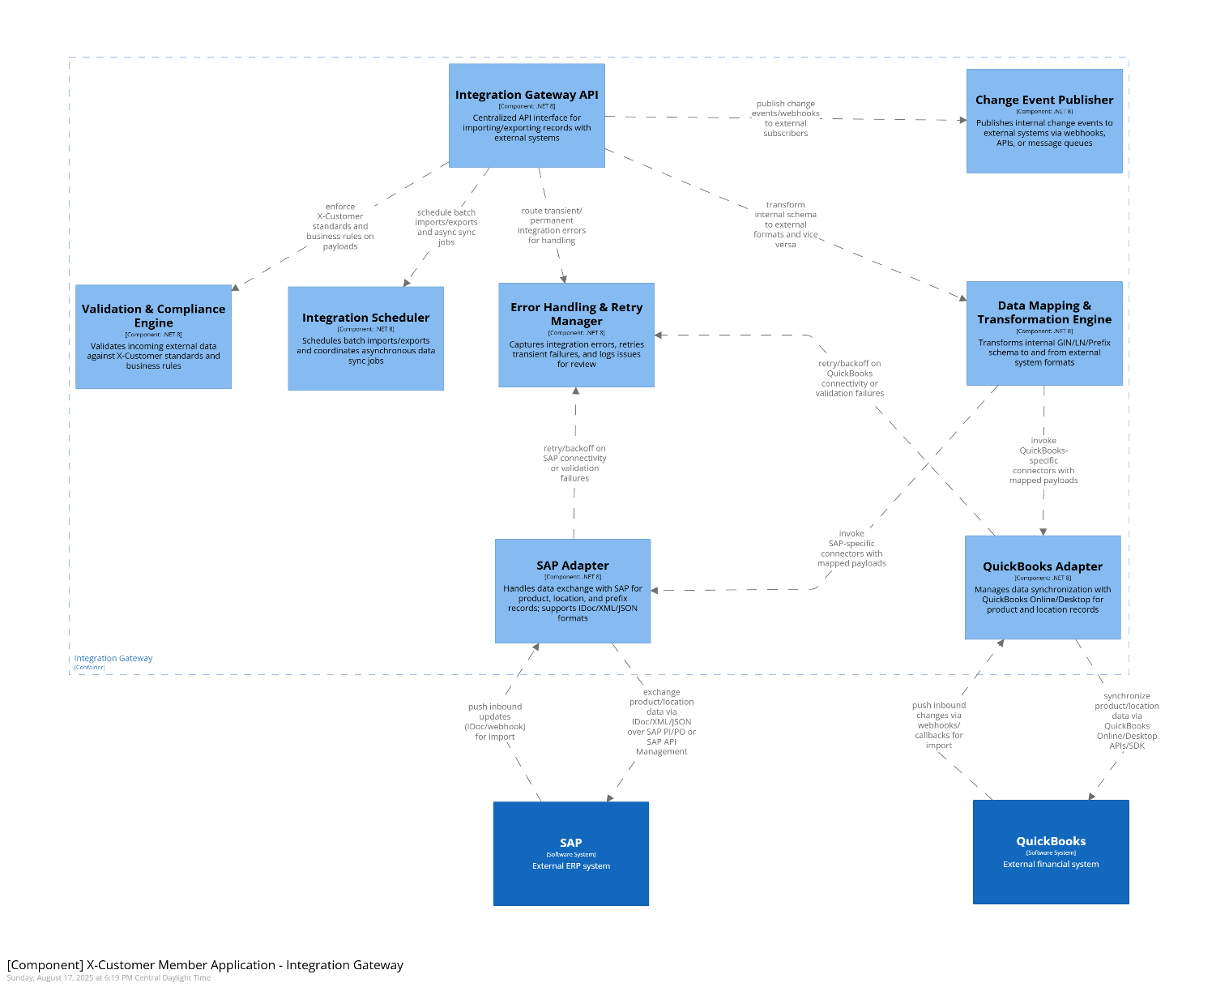
[P-19; L-15; G-12; NFR-4]

Notification Service
Delivers system/user notifications (email, SMS, in-app) via Azure Communication Services and Event Grid.
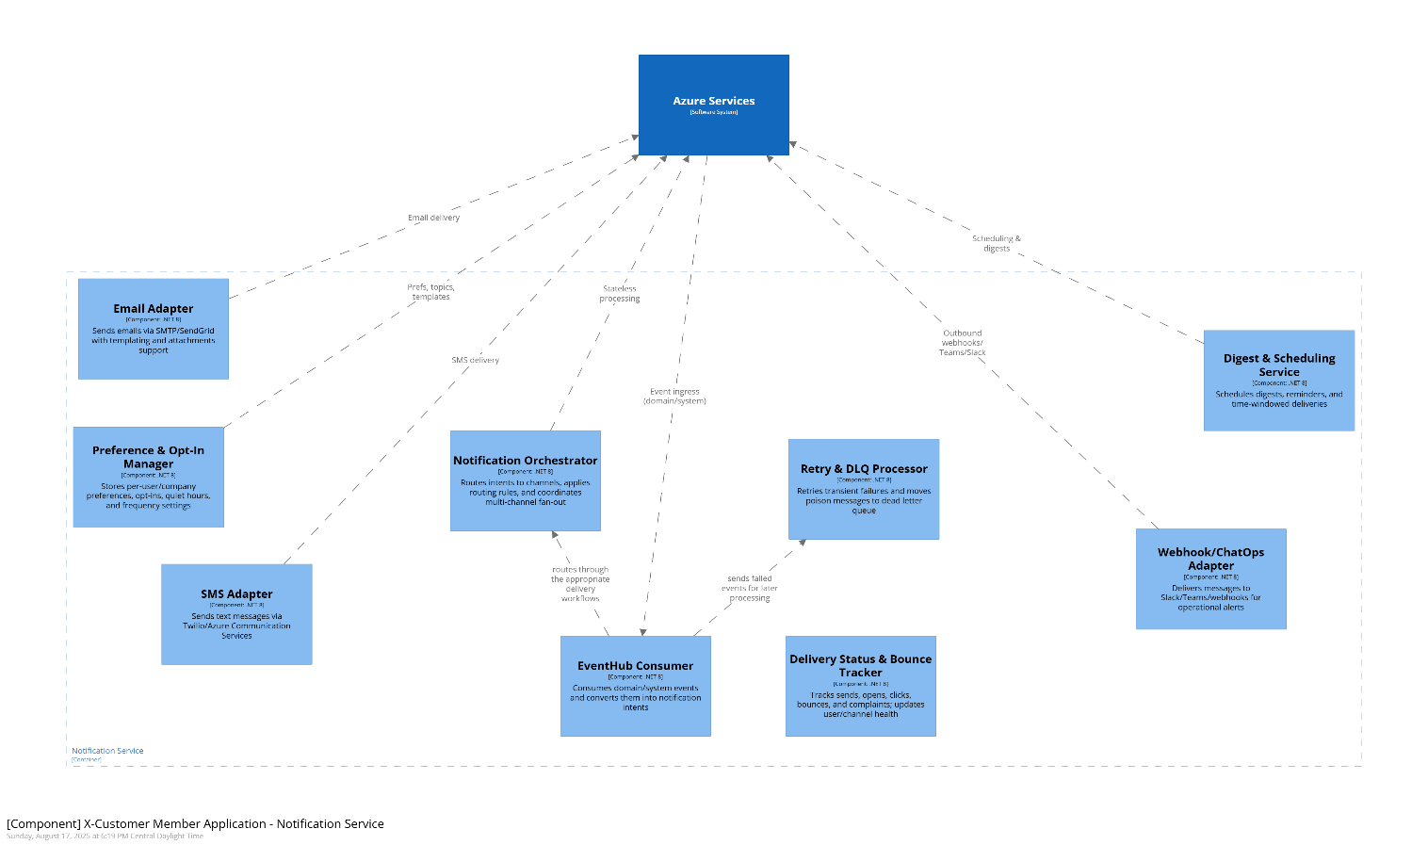
[G-8, G-8.1…G-8.5; NFR-17]

Help & Feedback Service
Manages contextual help, tutorials, and routes feedback to internal tracking.
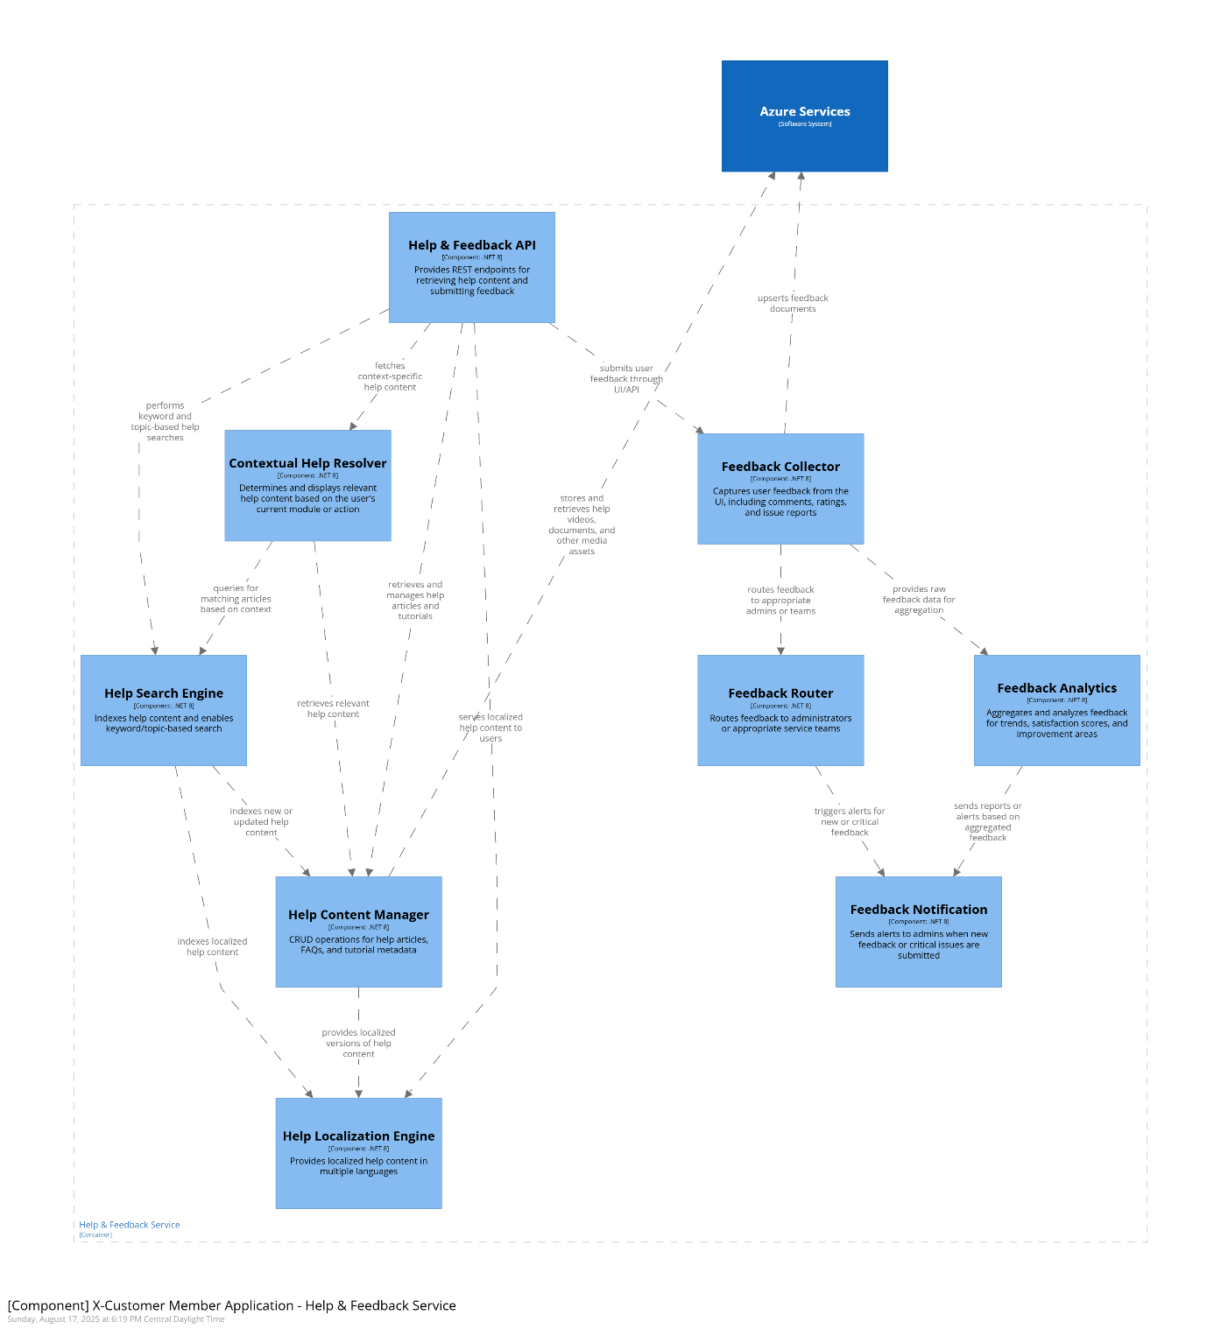

[G-9, G-10, G-11; NFR-17]

Data and Storage
- Azure SQL Databases – Primary transactional storage for Prefix, GIN, LN, and user management schemas.
- Graph Database (Cosmos DB / Gremlin) – Stores hierarchical structures for product and location relationships.
- Elasticsearch (Read-only Store) – Optimized search index for Access Data queries.
- Azure Blob Storage – Stores help documents, videos, product images, audit logs.
- Azure Key Vault – Secures credentials, API keys, and integration secrets.

Search Indexing Pipeline
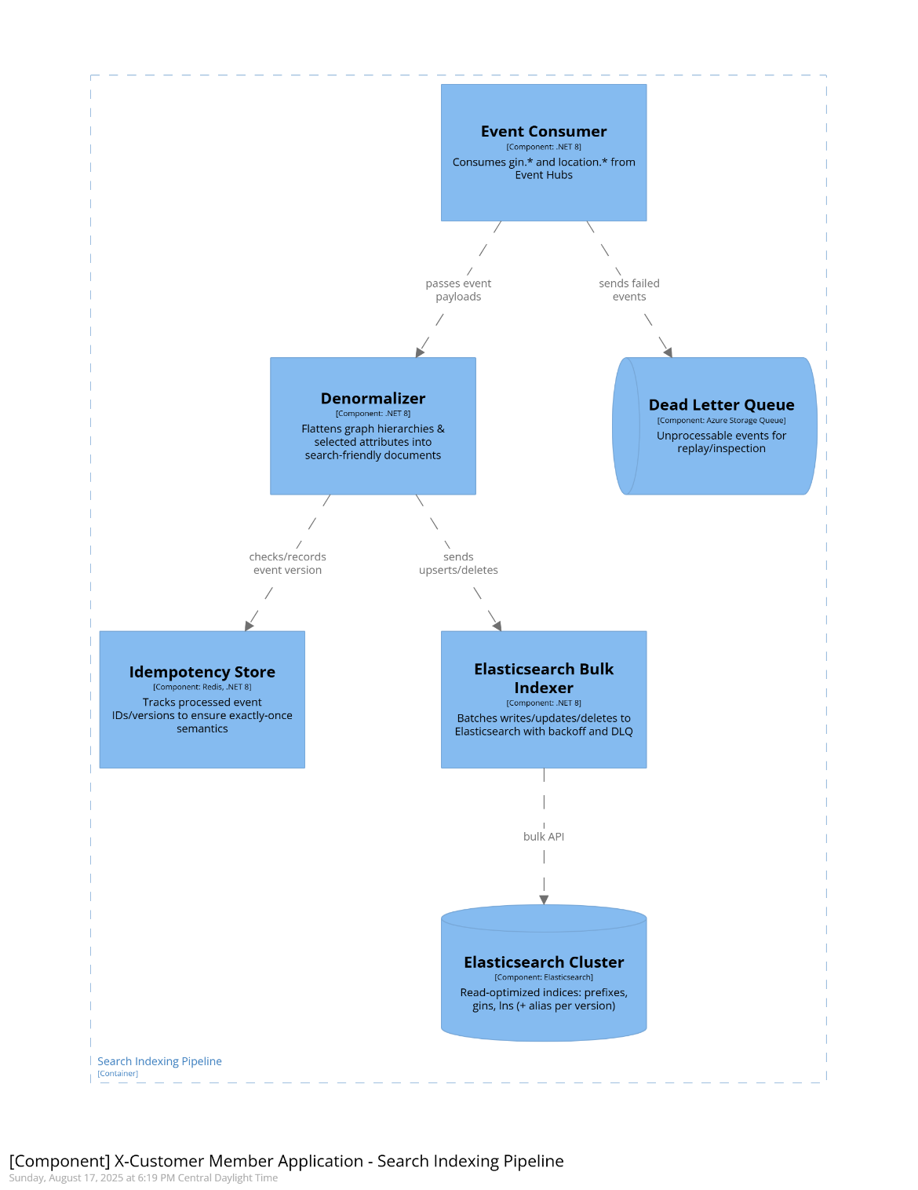

Integration and Messaging
- Azure API Management (APIM) – Single API gateway for frontend and external API consumers, migrated from 3Scale.
- Azure Service Bus – Queues for asynchronous integration and event-driven communication between services.
- Azure Event Hubs – High-volume telemetry, reporting, and CDC (change data capture) streaming to reporting pipelines.

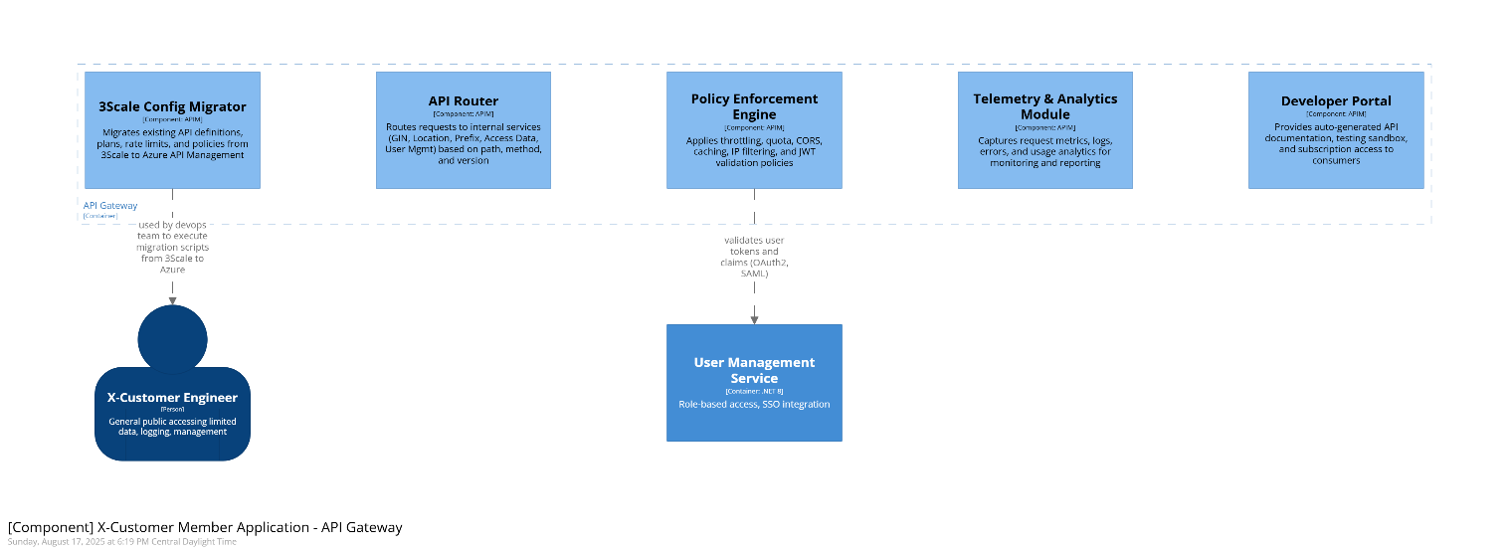

Reporting and Analytics
- Power BI – Provides user-facing dashboards and scheduled reports.
- Azure Data Explorer (ADX) + Log Analytics for faster near-real-time reporting.
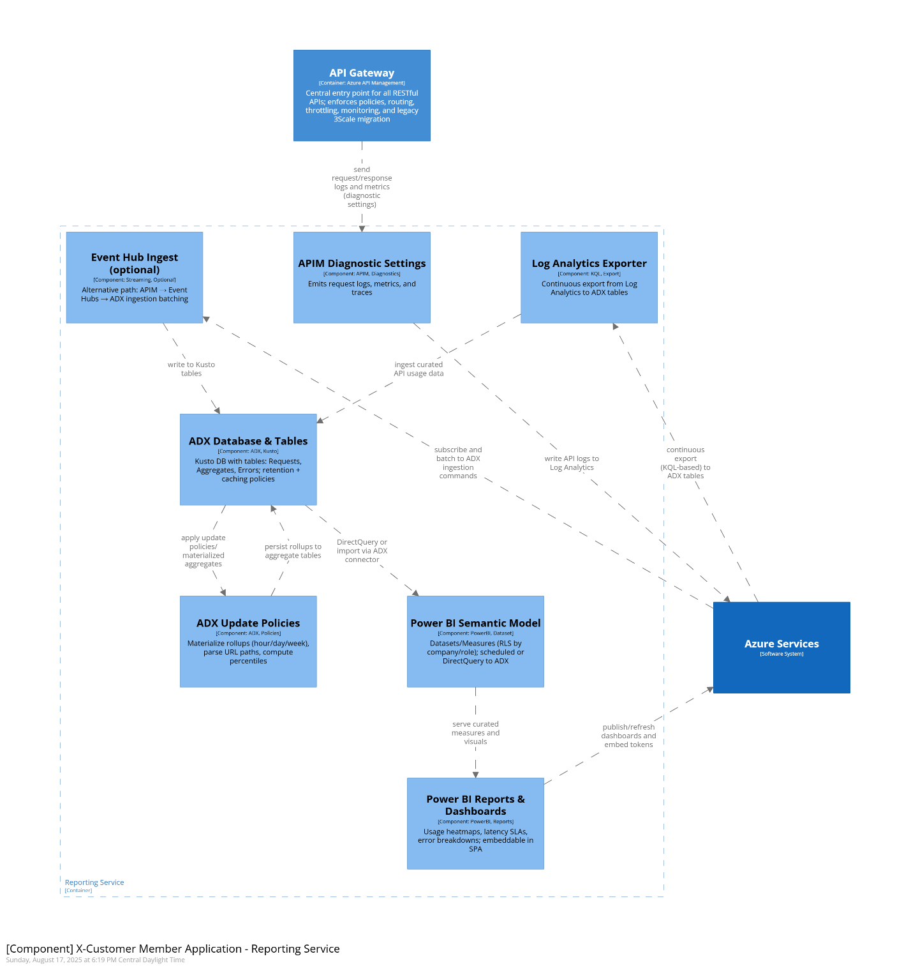

Deployment approach

API protection pattern
Azure API Management (APIM) acts as a central security and control layer in front of your backend services:
- APIM as the only public entry point – All APIs are exposed through APIM, never directly from backend apps.
- Azure Front Door / Application Gateway – Provides global load balancing, TLS termination, WAF, DDoS protection before APIM.
- Network isolation – Backend services (App Service, Functions, etc.) sit in a private VNet/subnet, accessible only via APIM.
- Authentication & Authorization – APIM enforces OAuth2/JWT, subscription keys, throttling, quotas, and IP filtering before requests reach backends.
- Centralized policies – Cross-cutting concerns (logging, caching, transformations, CORS) are applied uniformly in APIM.
- Observability – Telemetry flows to Application Insights/Log Analytics, giving a single monitoring plane for APIs.
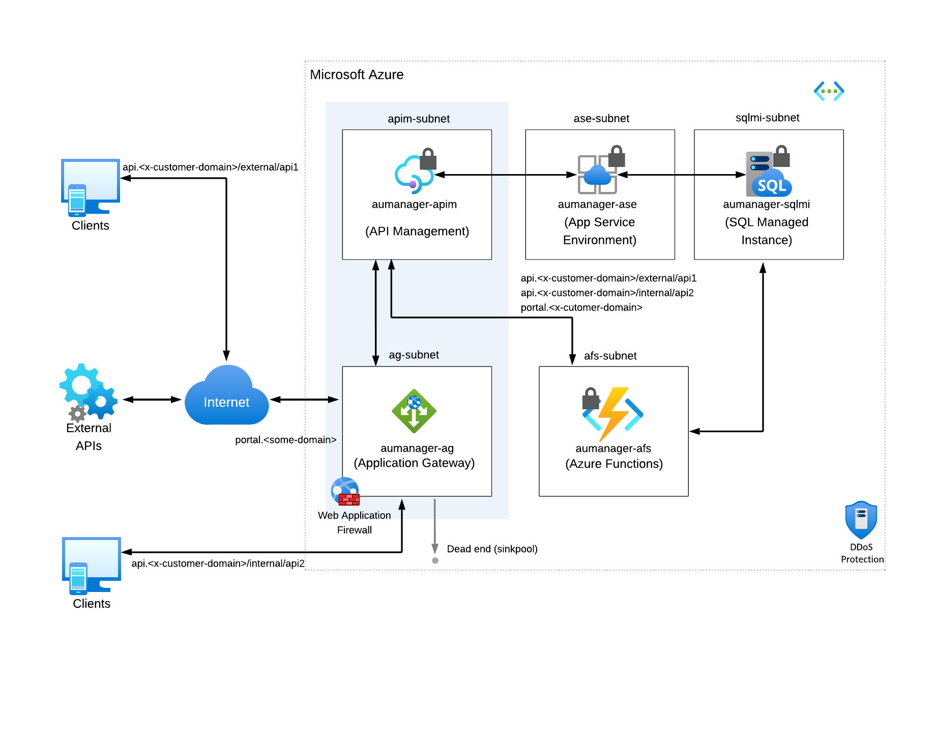

High availability solution deployment
Run identical ASEs in multiple regions, fronted by a global load balancer (Front Door/Traffic Manager), with geo-replicated data stores, so user workloads automatically fail over and stay online during regional outages.
Multi-region deployment – The same ASE (with App Services / APIs) is deployed in two or more Azure regions.
Traffic distribution – Azure Front Door or Traffic Manager routes user traffic across regions, providing load balancing and failover.
VNet integration – Each ASE is isolated in its own subnet within a virtual network, securing inbound/outbound connectivity.
Aactive/passive – Regions can both serve traffic (active/active) or one remain standby (active/passive) depending on business needs.
Data replication – Backend databases (Azure SQL, Cosmos DB, Storage) use geo-replication or failover groups to maintain data availability across regions.
Resilience and SLA – This design ensures apps remain available even if an entire Azure region goes down, meeting strict availability SLAs.
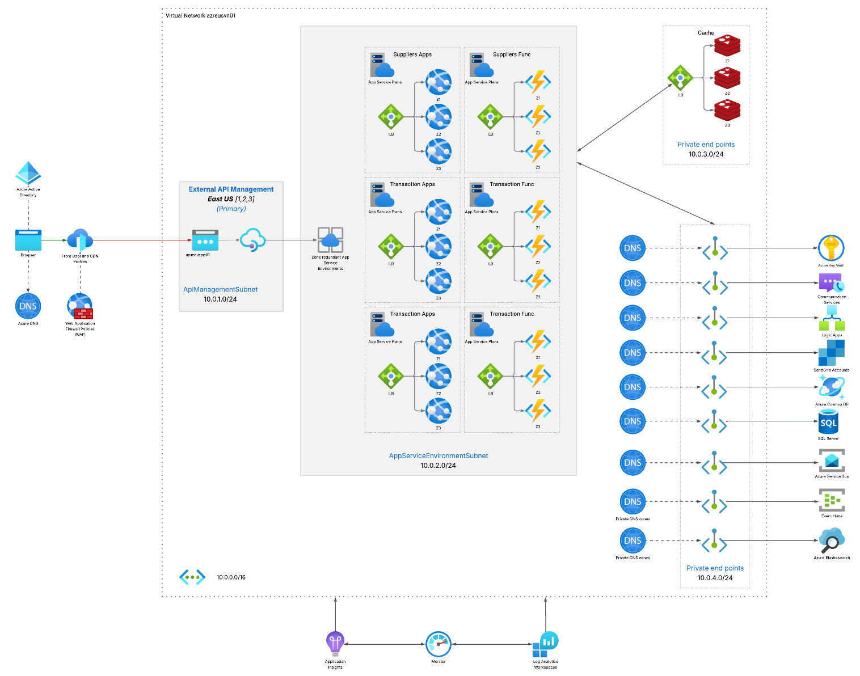

highly available ZONE-REDUNDANT APPLICATION/services deployment
This baseline architecture is based on the Basic web application architecture and extends it to provide detailed guidance for designing a secure, zone-redundant, and highly available web application on Azure. The architecture exposes a public endpoint via Azure Application Gateway with Web Application Firewall. It routes requests to Azure App Service through Private Link. The App Service application uses virtual network integration and Private Link to securely communicate to Azure PaaS services such as Azure Key Vault and Azure SQL Database.
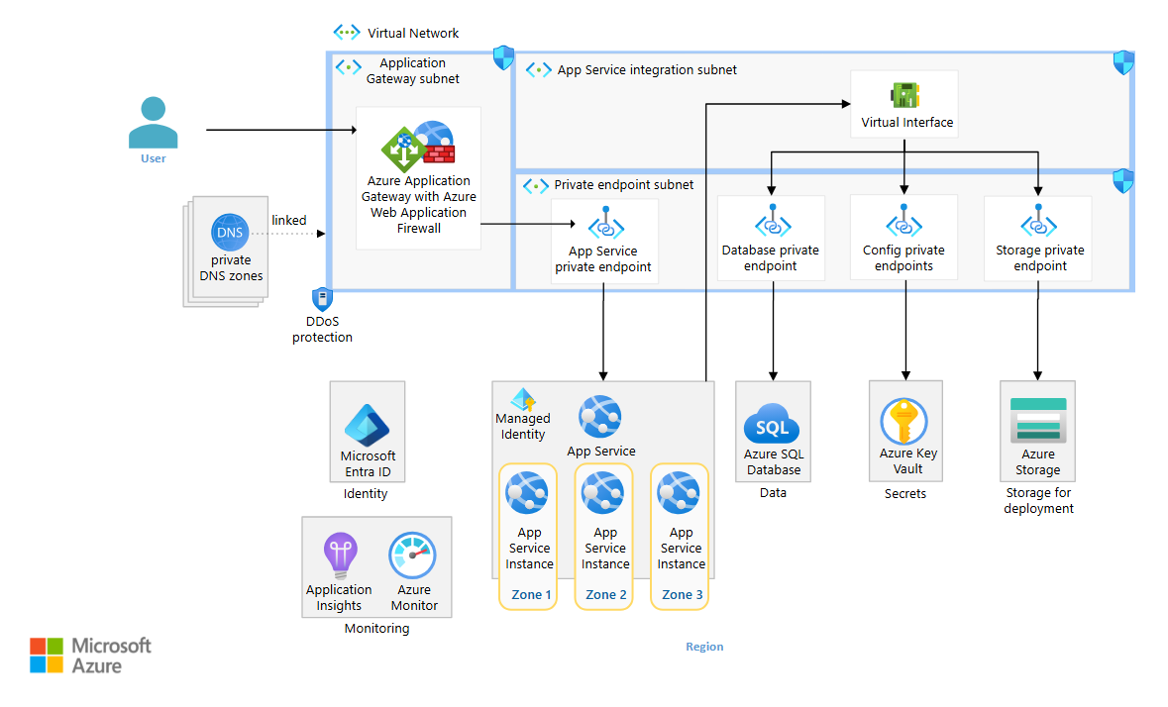

Dependencies, risks, and assumptions

Dependencies

Cloud/Azure
Azure APIM (Premium), Front Door/WAF, App Service/AKS/Functions, Service Bus, Event Hubs (Geo-DR alias), Cosmos DB (multi-region), Azure SQL (Failover Groups), Blob Storage (RA-GZRS), Key Vault (Purge Protection), App Insights/Log Analytics, optional ADX/Databricks/Power BI.

Security/Identity
Enterprise IdP (OAuth2/OIDC/SAML), managed identities for services, RBAC enforcement in User Mgmt and APIM policies.

Data/Search
Elasticsearch cluster (CCR for DR), Cosmos DB Change Feed or outbox for CDC, Azure AI Search (optional for Help/Feedback).

External Systems
SAP endpoints (IDoc/API), QuickBooks (QBO/QBD) APIs + credentials; network connectivity (VPN/Private Link/allowlists).

Client/UX
React SPA build/deploy pipeline, CDN caching, feature flags, accessibility (WCAG) guidelines.

Reporting
APIM diagnostics to Log Analytics/Event Hubs; ingestion into ADX/Databricks; Power BI workspaces/tenants and RLS.

Ops/Compliance
Backup/restore policies (SQL, Cosmos, ES snapshots), DR runbooks, monitoring/alerting standards, data retention & PII policies.

Risks (with quick mitigations)
APIM migration from 3Scale complexity (High): policy parity gaps, rewriting custom filters. → Pilot per API, automated tests, blue/green cutover, fall-back route.
Cross-service schema drift (GIN/LN/Prefix) (Medium): breaks CDC/indexing/reporting. → Versioned contracts, schema registry, consumer-driven contracts, canary index.
Elasticsearch ops/DR (Medium): CCR lag, index alias mishandling on failover. → Runbooks, alias discipline, periodic failover drills, monitoring lag.
Event loss/duplication in CDC (Medium): at-least-once delivery causes duplicates. → Idempotent consumers, event versioning, DLQ replay tooling.
Identity/RBAC misconfiguration (Medium): over-privileged access via APIM/IdP. → Least privilege, automated policy tests, security reviews, secrets in KV only.
SAP/QuickBooks integration variability (Medium): throttling, schema/field mismatches. → Back-pressure queues, retry with jitter, mapping rules & sandbox tests.
Performance under load (search/reporting) (Medium): hot partitions, ES shard imbalance. → Partition/key design reviews, autoscale, shard rebalancing, perf tests.
DR readiness (Medium): geo services configured but untested. → Quarterly chaos/game-days, documented RTO/RPO, synthetic probes and alerts.
Licensing/cost overruns (Medium): Power BI/ES usage spikes. → Budgets, autoscale limits, FinOps dashboards, usage alerts.
Data quality for reporting (Low/Med): incomplete/late APIM diagnostics. → Diagnostics as code, coverage checks, fallback exports.

Assumptions
Enterprise IdP is available and supports OAuth2/OIDC (preferred) and/or SAML; Just-In-Time provisioning handled by User Mgmt.
Network connectivity to SAP/QuickBooks is approved (VPN/allowlists), and non-prod sandboxes exist for both.
RPO/RTO targets accepted as proposed (e.g., SQL FO Group RPO <30s, EH alias manual failover RTO ~15 min).
Data residency/compliance permits multi-region replication and diagnostic log export to monitoring services.
Search read model is authoritative for Access Data; primary writes remain in domain stores (SQL/Cosmos).
Change Feed/outbox available for all domains that contribute to ES/Reporting; deletes captured via full-fidelity or soft-delete.
Power BI tenant and workspace governance (RLS, datasets refresh schedules) are provided by the client org.
A11y & i18n requirements align to WCAG 2.1 AA and a defined locale list; content owners will supply translations.
Ops: DevOps owns IaC (Bicep/Terraform), CI/CD, environment parity, secrets via Key Vault, and scheduled DR drills.
Cutover: 3Scale→APIM migration can proceed API-by-API with temporary dual-running period.

Delivery

Methodology
The methodology is a risk-based, component-driven estimation approach, aligned with phased delivery and cross-functional team roles as required by the RFP.

Work Breakdown by Modules/Containers
The solution is divided into distinct modules (Authentication, Prefix, Product, Location, Access Data, Reporting, Help, Integration Gateway, etc.), each aligned with functional requirements (P-, L-, D-, G-series in the RFP).

Risk-Based Estimation
- Each component is assigned a risk level (Low, Medium, High).
- Effort in working days for each team is scaled according to the risk level.
- Example: High-risk components require additional buffer and more cross-team involvement.

Phase-Based Delivery (per RFP §Project Structure):
- Requirements & Design
- Development & Testing
- Implementation
- Post-production Support & Transition

Effort Aggregation → Timeline
- Working days per component/team are aggregated into sprints/phases.
- Dependencies between services (e.g., Prefix → GIN → Access Data) inform sequencing.

estimations

Work breakdown
No. | Activity | Description | Risk level | Back end | DB | DBA | UI/UX Design | Front end | Dev Ops
1 | SPA Web Application | Single Page Application providing end-user UI for all modules
 | Authentication/Authorization | Handles SSO, role-based access, and permissions using claims-based auth integrated with external Identity Management (OAuth/SAML) | High | 24 | 0 | 0 | 6 | 20 | 6
 | Prefixes Branch | Displays and manages Prefix data, including capacity counters and linking to product/location creation | Medium | 13 | 0 | 0 | 6 | 16 | 4
 | Product Branch | Create/manage product records (GINs), images, hierarchies, barcodes, and exports | High | 30 | 0 | 0 | 8 | 28 | 6
 | Location Branch | Create/manage location records (LNs), hierarchies, verification, and exports | High | 30 | 0 | 0 | 8 | 28 | 6
 | Search/Reporting Branch | End-user search, filters, saved views, and report launchers | Medium | 13 | 0 | 0 | 6 | 16 | 4
 | Help/Tutorials Branch | Contextual help, tutorials, and training links embedded in SPA | Low | 6 | 0 | 0 | 6 | 11 | 2
 | Dashboard/Notifications | User start screen with alerts, tasks, counters, and shortcuts | Medium | 13 | 0 | 0 | 7 | 19 | 4
 | Workflow Management | Record approval, status tracking, and locking UX | High | 24 | 0 | 0 | 8 | 24 | 4
 | Publishing & Subscriptions | UI to publish/share data and manage subscriptions | Medium | 16 | 0 | 0 | 6 | 16 | 4
 | Import/Export | Bulk import/export UX with progress, validation, and error review | Medium | 16 | 0 | 0 | 6 | 16 | 4
 | Feedback Module | Capture user feedback, ratings, and route to admins | Low | 9 | 0 | 0 | 3 | 11 | 2
 | Audit Trail Viewer | Display record history and change logs | Medium | 13 | 0 | 0 | 4 | 13 | 2
 | Sidecar Utility Service (Frontend) | Shared client-side utilities (logging hooks, health pings, feature flags) | Low | 6 | 0 | 0 | 2 | 9 | 2
 |  |  |  | 213 | 0 | 0 | 76 | 227 | 50
2 | Prefix Management Service | Handles prefix licensing, capacity tracking, and lookup for GIN/LN creation
 | Prefix Store | CRUD operations for company prefixes and metadata | Medium | 19 | 10 | 6 | 0 | 0 | 4
 | Capacity Tracker | Tracks usage and available capacity per prefix | Medium | 16 | 7 | 4 | 0 | 0 | 4
 | Prefix Validator | Validates prefix format and compliance rules | Medium | 13 | 4 | 0 | 0 | 0 | 2
 | Prefix Publish & Subscribe Engine | Manages visibility and sharing of prefix data | Medium | 16 | 4 | 0 | 0 | 0 | 4
 | Prefix Search Service | Advanced search and filtering for prefix data | Medium | 13 | 4 | 0 | 0 | 0 | 2
 | Prefix Import/Export Adapter | Bulk import/export of prefix records | Medium | 13 | 4 | 0 | 0 | 0 | 4
 | SQL Database (Prefix) | Prefix management schema and persistence | Medium | 7 | 13 | 10 | 0 | 0 | 6
 | Key Vault Reader | Secure retrieval of secrets/credentials | Low | 5 | 0 | 0 | 0 | 0 | 2
 |  |  |  | 102 | 46 | 20 | 0 | 0 | 28
3 | GIN Management Service | Manages creation, editing, hierarchy, sharing of GINs and product metadata
 | GIN Store | CRUD for product records and GINs | High | 28 | 12 | 6 | 0 | 0 | 4
 | GIN Assignment Engine | Auto/manual assignment with check-digit | High | 24 | 8 | 4 | 0 | 0 | 4
 | GIN Validator | Validates GINs and product attributes | Medium | 13 | 6 | 0 | 0 | 0 | 2
 | Hierarchy Manager (GIN) | Build/manage product hierarchies | High | 24 | 8 | 0 | 0 | 0 | 4
 | Image Attachment Service | Upload and manage product images | Medium | 13 | 4 | 0 | 0 | 0 | 2
 | Export & Sheet Generator | Generate product sheets and barcodes | Medium | 16 | 4 | 0 | 0 | 0 | 4
 | Barcode Generator | Create standard-compliant barcodes (PNG/SVG/PDF) | Medium | 13 | 0 | 0 | 0 | 0 | 2
 | Publish & Transfer Module | Publishing and ownership transfer | Medium | 13 | 4 | 0 | 0 | 0 | 4
 | GIN Import Adapter | Import via Excel/CSV/XML with dedupe | Medium | 13 | 4 | 0 | 0 | 0 | 4
 | SQL Database (GIN) | Product/Gin schema and persistence | Medium | 7 | 13 | 10 | 0 | 0 | 6
 | Key Vault Reader | Secrets for image/barcode/export services | Low | 5 | 0 | 0 | 0 | 0 | 2
 |  |  |  | 169 | 63 | 20 | 0 | 0 | 38
4 | Location Management Service | Manages creation, editing, hierarchy, sharing of LNs and location metadata
 | Location Store | CRUD for location records and LNs | High | 28 | 12 | 6 | 0 | 0 | 4
 | LN Assignment Engine | Auto/manual LN assignment with check-digit | High | 24 | 8 | 4 | 0 | 0 | 4
 | Location Validator | Validates LNs and attributes | Medium | 13 | 6 | 0 | 0 | 0 | 2
 | Hierarchy Manager (Location) | Build/manage location hierarchies | High | 24 | 8 | 0 | 0 | 0 | 4
 | Location Import Adapter | Import via Excel/CSV/XML with dedupe | Medium | 13 | 4 | 0 | 0 | 0 | 4
 | Export & Reporting Module | Exports and simple reports for LNs | Medium | 13 | 4 | 0 | 0 | 0 | 4
 | Publish & Transfer Module | Publishing and ownership transfer | Medium | 13 | 4 | 0 | 0 | 0 | 4
 | Annual Verification Engine | Tracks/enforces annual verification | Medium | 13 | 4 | 0 | 0 | 0 | 4
 | SQL Database (Location) | Location/LN schema and persistence | Medium | 7 | 13 | 10 | 0 | 0 | 6
 | Key Vault Reader | Secrets for adapters/exports | Low | 5 | 0 | 0 | 0 | 0 | 2
 |  |  |  | 153 | 63 | 20 | 0 | 0 | 38
5 | Access Data Service | Provides search, view, subscription, and export functionality for shared Prefix, GIN, and LN data
 | Access Search Engine | Performs advanced search and filtering across Prefix, GIN, and LN datasets | Medium | 16 | 0 | 0 | 0 | 0 | 4
 | Record Viewer | Displays record details, including basic/full data and hierarchy | Medium | 13 | 0 | 0 | 0 | 0 | 4
 | Subscription Manager | Handles subscription requests for accessing full record views | High | 30 | 0 | 0 | 0 | 0 | 6
 | Group Access Controller | Processes join requests for controlled groups | Medium | 13 | 0 | 0 | 0 | 0 | 4
 | Export Adapter | Exports records to CSV/Excel/XML and prints | Medium | 13 | 0 | 0 | 0 | 0 | 4
 | Access Rights Evaluator | Determines view level based on roles/subscriptions | High | 24 | 0 | 0 | 0 | 0 | 6
 | Ad-hoc Access Info Module | Surfaces payment info for ad-hoc access (out of scope payments) | Low | 6 | 0 | 0 | 0 | 0 | 2
 | Read-Optimized Store (Elasticsearch) | Indexed shared data optimized for queries | Medium | 10 | 10 | 7 | 0 | 0 | 7
 | Key Vault Reader | Secrets for export/index access | Low | 5 | 0 | 0 | 0 | 0 | 2
 |  |  |  | 130 | 10 | 7 | 0 | 0 | 39
6 | API Gateway (Azure APIM) | Central API entry; policies, routing, throttling, analytics; migration from 3Scale
 | 3Scale Config Migrator | Migrate definitions, plans, policies to APIM | High | 24 | 0 | 0 | 0 | 0 | 16
 | API Router | Route to internal services by path/version | Medium | 13 | 0 | 0 | 0 | 0 | 9
 | Policy Enforcement Engine | JWT, quota, CORS, caching, IP filtering | High | 24 | 0 | 0 | 0 | 0 | 16
 | Telemetry & Analytics Module | Collect usage metrics and errors | Medium | 10 | 0 | 0 | 0 | 0 | 9
 | Developer Portal | Docs, try-it, subscription keys | Medium | 13 | 0 | 0 | 7 | 0 | 7
 |  |  |  | 84 | 0 | 0 | 7 | 0 | 57
7 | Notification Service | Multi-channel notifications (email, SMS, push, in-app) with templates and preferences
 | EventHub Consumer | Consumes events and creates notification intents | Medium | 13 | 0 | 0 | 0 | 0 | 6
 | Notification Orchestrator | Routing, rules, multi-channel fan-out | High | 24 | 0 | 0 | 0 | 0 | 8
 | Template & Localization Engine | Render content with variables and i18n | Medium | 13 | 0 | 0 | 4 | 0 | 4
 | Preference & Opt-In Manager | User/company preferences and quiet hours | Medium | 13 | 4 | 0 | 0 | 0 | 4
 | Topic & Subscription Router | Targeted delivery by topic/group | Medium | 13 | 0 | 0 | 0 | 0 | 4
 | Policy & Rate Limit Engine | Throttling, dedupe, suppression | Medium | 13 | 0 | 0 | 0 | 0 | 4
 | Retry & DLQ Processor | Retries and dead-letter handling | Medium | 10 | 0 | 0 | 0 | 0 | 4
 | Delivery Status & Bounce Tracker | Track sends, opens, bounces | Medium | 10 | 0 | 0 | 0 | 0 | 4
 | In-App Notification Hub | WebSocket/WebPush delivery + unread state | Medium | 13 | 0 | 0 | 4 | 10 | 6
 | Email Adapter | Send via ACS/SMTP | Low | 7 | 0 | 0 | 0 | 0 | 3
 | SMS Adapter | Send via ACS/Twilio | Low | 7 | 0 | 0 | 0 | 0 | 3
 | Mobile/Web Push Adapter | Push via FCM/APNS/WebPush | Low | 9 | 0 | 0 | 0 | 0 | 3
 | Webhook/ChatOps Adapter | Slack/Teams/webhooks for ops | Low | 7 | 0 | 0 | 0 | 0 | 3
 | Digest & Scheduling Service | Schedules digests/reminders | Medium | 10 | 0 | 0 | 0 | 0 | 4
 | Notification API | APIs for intents/templates/preferences | Medium | 13 | 0 | 0 | 0 | 0 | 6
 | Key Vault Reader | Secrets and credentials | Low | 5 | 0 | 0 | 0 | 0 | 2
 | Audit & Compliance Logger | Immutable audit for notifications | Medium | 10 | 4 | 0 | 0 | 0 | 4
 |  |  |  | 190 | 8 | 0 | 8 | 10 | 72
8 | Help & Feedback Service | Help content, tutorials, search, localization, and feedback capture
 | Help Content Manager | CRUD for articles, FAQs, tutorials | Medium | 13 | 4 | 0 | 4 | 0 | 4
 | Help Media Storage | Store videos, images, docs | Low | 6 | 0 | 0 | 0 | 0 | 3
 | Help Search Engine | Index and query help content | Medium | 10 | 4 | 0 | 0 | 0 | 4
 | Contextual Help Resolver | Serve context-aware help items | Medium | 10 | 0 | 0 | 4 | 7 | 4
 | Help Localization Engine | Localized content support | Medium | 10 | 0 | 0 | 4 | 0 | 2
 | Feedback Collector | Capture comments/ratings/issues | Medium | 10 | 0 | 0 | 4 | 10 | 4
 | Feedback Router | Route feedback to admins/teams | Low | 6 | 0 | 0 | 0 | 0 | 2
 | Feedback Analytics | Aggregate and analyze feedback | Medium | 10 | 4 | 0 | 0 | 0 | 4
 | Feedback Notification | Notify admins on new/critical items | Low | 6 | 0 | 0 | 0 | 0 | 2
 | Help & Feedback API | REST endpoints for help/feedback | Medium | 13 | 0 | 0 | 0 | 0 | 4
 | Key Vault Reader | Secrets for integrations | Low | 5 | 0 | 0 | 0 | 0 | 2
 | Audit Logger | Record content and admin changes | Medium | 9 | 4 | 0 | 0 | 0 | 4
 |  |  |  | 108 | 16 | 0 | 16 | 17 | 39
9 | Integration Gateway | Adapters and pipelines for SAP and QuickBooks integrations
 | Integration Gateway API | Central API for imports/exports | Medium | 13 | 0 | 0 | 0 | 0 | 6
 | SAP Adapter | IDoc/XML/JSON via SAP PI/PO or APIs | High | 28 | 4 | 0 | 0 | 0 | 16
 | QuickBooks Adapter | QBO/QBD API/SDK sync | High | 24 | 4 | 0 | 0 | 0 | 12
 | Data Mapping & Transformation Engine | Map internal‚Üîexternal schemas | High | 24 | 4 | 0 | 0 | 0 | 8
 | Validation & Compliance Engine | Validate against standards/rules | Medium | 13 | 4 | 0 | 0 | 0 | 4
 | Integration Scheduler | Batch job coordination | Medium | 10 | 0 | 0 | 0 | 0 | 4
 | Change Event Publisher | Publish webhooks/queues to externals | Medium | 13 | 0 | 0 | 0 | 0 | 6
 | Error Handling & Retry Manager | Retries/backoff and logging | Medium | 10 | 0 | 0 | 0 | 0 | 4
 | Integration Audit Logger | Full transaction logging | Medium | 10 | 4 | 0 | 0 | 0 | 4
 | Key Vault Reader | External creds/certs | Low | 5 | 0 | 0 | 0 | 0 | 2
 |  |  |  | 150 | 20 | 0 | 0 | 0 | 66
10 | Search Indexing Pipeline | Consumes CDC events and indexes denormalized docs into Elasticsearch
 | Event Consumer | Subscribe to gin.*, location.*, prefix.\* | Medium | 13 | 0 | 0 | 0 | 0 | 6
 | Denormalizer | Flatten graph/hierarchy to search docs | High | 24 | 4 | 0 | 0 | 0 | 8
 | Idempotency Store | Track processed event versions | Medium | 10 | 4 | 0 | 0 | 0 | 4
 | Elasticsearch Bulk Indexer | Batch upserts/deletes with backoff | High | 24 | 4 | 0 | 0 | 0 | 8
 | Dead Letter Queue | Hold poison messages for replay | Low | 6 | 0 | 0 | 0 | 0 | 3
 | Elasticsearch Cluster | Search indices & aliases | Medium | 7 | 10 | 10 | 0 | 0 | 10
 |  |  |  | 84 | 22 | 10 | 0 | 0 | 39
11 | Lightweight Reporting (ADX + Power BI) | Near real-time API usage analytics via Log Analytics ‚Üí ADX, served in Power BI
 | APIM Diagnostic Settings | Emit request logs and metrics | Low | 5 | 0 | 0 | 0 | 0 | 5
 | Log Analytics Exporter | Continuous export to ADX | Medium | 10 | 4 | 0 | 0 | 0 | 7
 | Event Hub Ingest (optional) | Stream diagnostics to ADX | Medium | 10 | 0 | 0 | 0 | 0 | 7
 | ADX Database & Tables | Kusto tables with policies | Medium | 7 | 7 | 4 | 0 | 0 | 7
 | ADX Update Policies | Materialize rollups and parsing | Medium | 9 | 4 | 0 | 0 | 0 | 6
 | Power BI Semantic Model | Datasets/measures with RLS | Medium | 7 | 0 | 0 | 4 | 0 | 4
 | Power BI Reports & Dashboards | Usage heatmaps, SLAs, errors | Medium | 6 | 0 | 0 | 7 | 0 | 4
 |  |  |  | 54 | 15 | 4 | 11 | 0 | 40
12 | Resilience & DR | Cross-region HA/DR, backups, automation, and chaos validation
 | Azure Front Door (Global) | Anycast entry, WAF, health probes | Medium | 10 | 0 | 0 | 0 | 0 | 13
 | Traffic Manager (Optional) | DNS failover for non-HTTP endpoints | Low | 6 | 0 | 0 | 0 | 0 | 6
 | APIM - Region A | Primary gateway (Premium) | Medium | 10 | 0 | 0 | 0 | 0 | 10
 | APIM - Region B | Secondary gateway (Premium) | Medium | 10 | 0 | 0 | 0 | 0 | 10
 | App Tier - Region A | Stateless apps/functions (active) | Medium | 10 | 0 | 0 | 0 | 0 | 9
 | App Tier - Region B | Stateless apps/functions (warm/active) | Medium | 10 | 0 | 0 | 0 | 0 | 9
 | Cosmos DB (Multi-Write) | Multi-region writes, auto failover | High | 12 | 16 | 12 | 0 | 0 | 16
 | Azure SQL (Failover Group) | Geo-replicated with listener | High | 12 | 16 | 16 | 0 | 0 | 16
 | Event Hubs (Geo-DR Alias) | Paired namespaces with alias | High | 12 | 4 | 8 | 0 | 0 | 16
 | Service Bus (Geo-DR) | Paired namespaces/alias | High | 12 | 4 | 8 | 0 | 0 | 16
 | Blob Storage (RA-GZRS) | Geo-redundant, read-access | Medium | 7 | 4 | 4 | 0 | 0 | 7
 | Elasticsearch (CCR) | Cross-cluster replication | High | 12 | 8 | 12 | 0 | 0 | 16
 | ADX (Follower DB) | Follower DB for DR | Medium | 7 | 4 | 4 | 0 | 0 | 9
 | Key Vault (Geo) | Geo-replicated, purge protection | Medium | 7 | 0 | 0 | 0 | 0 | 7
 | ASR/Backup | Backups and runbook ties | Medium | 7 | 4 | 4 | 0 | 0 | 10
 | Log Analytics + App Insights | Telemetry and alerts | Medium | 7 | 0 | 0 | 0 | 0 | 7
 | Failover Runbooks (Automation) | One-click failover orchestration | High | 16 | 0 | 0 | 0 | 0 | 20
 | Chaos Studio | Fault injection and game days | Medium | 7 | 0 | 0 | 0 | 0 | 7
 |  |  |  | 174 | 60 | 68 | 0 | 0 | 204

Work breakdown summary
No. | Service | Back end | DB | DBA | UI/UX Design | Front end | Dev Ops | Total
 |  | man/day
1 | SPA Web Application | 213 | 0 | 0 | 76 | 227 | 50 | 566
2 | Prefix Management Service | 102 | 46 | 20 | 0 | 0 | 28 | 196
3 | GIN Management Service | 169 | 63 | 20 | 0 | 0 | 38 | 290
4 | Location Management Service | 153 | 63 | 20 | 0 | 0 | 38 | 274
5 | Access Data Service | 130 | 10 | 7 | 0 | 0 | 39 | 186
6 | API Gateway (Azure APIM) | 84 | 0 | 0 | 7 | 0 | 57 | 148
7 | Notification Service | 190 | 8 | 0 | 8 | 10 | 72 | 288
8 | Help & Feedback Service | 108 | 16 | 0 | 16 | 17 | 39 | 196
9 | Integration Gateway | 150 | 20 | 0 | 0 | 0 | 66 | 236
10 | Search Indexing Pipeline | 84 | 22 | 10 | 0 | 0 | 39 | 155
11 | Lightweight Reporting (ADX + Power BI) | 54 | 15 | 4 | 11 | 0 | 40 | 124
12 | Resilience & DR | 174 | 60 | 68 | 0 | 0 | 204 | 506
 | Subtotal by dev | 1611 | 323 | 149 | 118 | 254 | 710
15% | VAC&SICK | 242 | 49 | 23 | 18 | 39 | 107
10% | Team Communication | 162 | 33 | 15 | 12 | 26 | 71
5% | Code review/KT | 81 | 17 | 8 | 6 | 13 | 36
5% | Management | 81 | 17 | 8 | 6 | 13 | 36
 | TOTAL by Dev | 2177 | 439 | 203 | 160 | 345 | 960 | 4284
20% | TOTAL QA | 436 | 88 | 41 | 32 | 69 | 192 | 858

Resource Plan | Total days | Project time line
Resource Plan | Total days | Months
Resource Plan | Total days | 1 | 2 | 3 | 4 | 5 | 6 | 7 | 8
Backend Team
Tech Lead | 336 | 2 | 2 | 2 | 2 | 2 | 2 | 2 | 2
Senior Developer | 504 | 3 | 3 | 3 | 3 | 3 | 3 | 3 | 3
Developer | 1344 | 8 | 8 | 8 | 8 | 8 | 8 | 8 | 8
TOTAL Backend Team | 2184
Frontend Team
Senior Developer | 147 |  | 1 | 2 | 2 | 2
Developer | 210 |  | 2 | 2 | 3 | 3
UX Designer | 168 |  | 2 | 2 | 2 | 2
TOTAL Frontend Team | 525
TOTAL DevOps | 966 | 6 | 6 | 6 | 6 | 6 | 6 | 5 | 5
TOTAL DBA | 651 | 4 | 4 | 4 | 4 | 4 | 4 | 4 | 3
TOTAL QA | 861 | 1 | 3 | 4 | 7 | 7 | 7 | 6 | 6

Timeline, team structure

Detailed resource plan

Resource Plan | Total days | Project time line
Resource Plan | Total days | Feb-26 |  |  |  | Mar-26 |  |  |  |  | Apr-26 |  |  |  | May-26 |  |  |  |  | Jun-26 |  |  |  | Jul-26 |  |  |  | Aug-26 |  |  |  |  | Sep-26
Resource Plan | Total days | Week
Resource Plan | Total days | 1 | 2 | 3 | 4 | 5 | 6 | 7 | 8 | 9 | 10 | 11 | 12 | 13 | 14 | 15 | 16 | 17 | 18 | 19 | 20 | 21 | 22 | 23 | 24 | 25 | 26 | 27 | 28 | 29 | 30 | 31 | 32 | 33 | 34 | 35
Backend Team
Tech Lead | 345 | 1 | 2 | 2 | 2 | 2 | 2 | 2 | 2 | 2 | 2 | 2 | 2 | 2 | 2 | 2 | 2 | 2 | 2 | 2 | 2 | 2 | 2 | 2 | 2 | 2 | 2 | 2 | 2 | 2 | 2 | 2 | 2 | 2 | 2 | 2
Senior Developer | 495 | 1 | 2 | 2 | 2 | 2 | 3 | 3 | 3 | 3 | 3 | 3 | 3 | 3 | 3 | 3 | 3 | 3 | 3 | 3 | 3 | 3 | 3 | 3 | 3 | 3 | 3 | 3 | 3 | 3 | 3 | 3 | 3 | 3 | 3 | 3
Developer | 1340 | 4 | 4 | 4 | 8 | 8 | 8 | 8 | 8 | 8 | 8 | 8 | 8 | 8 | 8 | 8 | 8 | 8 | 8 | 8 | 8 | 8 | 8 | 8 | 8 | 8 | 8 | 8 | 8 | 8 | 8 | 8 | 8 | 8 | 8 | 8
TOTAL Backend Team | 2180
Frontend Team
Senior Developer | 150 |  |  |  |  |  |  | 1 | 1 | 2 | 2 | 2 | 2 | 2 | 2 | 2 | 2 | 2 | 2 | 2 | 2 | 2 | 2
Developer | 220 |  |  |  |  |  |  | 1 | 1 | 3 | 3 | 3 | 3 | 3 | 3 | 3 | 3 | 3 | 3 | 3 | 3 | 3 | 3
UX Designer | 160 |  |  |  | 1 | 2 | 2 | 2 | 2 | 2 | 2 | 2 | 2 | 2 | 2 | 2 | 2 | 2 | 2 | 1 | 1 | 1
TOTAL Frontend Team | 530
TOTAL DevOps | 960 | 2 | 2 | 2 | 2 | 4 | 6 | 6 | 6 | 6 | 6 | 6 | 6 | 6 | 6 | 6 | 6 | 6 | 6 | 6 | 6 | 6 | 6 | 6 | 6 | 6 | 6 | 6 | 6 | 6 | 6 | 6 | 6 | 6 | 6 | 6
TOTAL DBA | 650 | 2 | 2 | 2 | 2 | 2 | 4 | 4 | 4 | 4 | 4 | 4 | 4 | 4 | 4 | 4 | 4 | 4 | 4 | 4 | 4 | 4 | 4 | 4 | 4 | 4 | 4 | 4 | 4 | 4 | 4 | 4 | 4 | 4 | 4 | 4
TOTAL QA | 865 | 1 | 1 | 1 | 1 | 3 | 3 | 3 | 3 | 3 | 3 | 3 | 3 | 3 | 4 | 7 | 7 | 7 | 7 | 7 | 7 | 7 | 7 | 7 | 7 | 7 | 7 | 6 | 6 | 6 | 6 | 6 | 6 | 6 | 6 | 6

Pricing including the total cost

Resources cost
Resource Plan | Total days | Hourly Rate $ | Hours / Day | Total by Role $
Backend Team
Tech Lead | 345 | 50 | 8 | 138000
Senior Developer | 495 | 40 | 8 | 158400
Developer | 1340 | 30 | 8 | 321600
TOTAL Backend Team | 2180
Frontend Team
Senior Developer | 150 | 40 | 8 | 48000
Developer | 220 | 35 | 8 | 61600
UX Designer | 160 | 35 | 8 | 44800
TOTAL Frontend Team | 530
TOTAL DevOps | 960 | 45 | 8 | 345600
TOTAL DBA | 650 | 45 | 8 | 234000
TOTAL QA | 865 | 30 | 8 | 207600
Total $ |  |  |  | 1559600

Azure monthly cost estimate
App Service Plan Premium: picked P2v3 (2 vCores, 7GB) x2 instances for HA. Scale up/down adjusts cost.
ADX medium: 2-node D13_v2. Replace/remove if you only use Databricks or Synapse.
Elasticsearch average: 3-node cluster, each 8 vCores, 32 GB RAM, ~2 TB storage.
APIM/Front Door/Service Bus/Event Hubs sized per expected concurrent user & event load (≈25k concurrent at peak).
Cosmos DB sized for 20k RU/s autoscale, 2 regions, 400 GB.
SQL Failover sized at 8 vCores.
Azure API Management Premium | 1 unit | 1 | $2,795/unit-month | 2795
Azure App Service Plan Premium v3 (P2v3, 2 instances) | 2x 2 vCores, 7GB RAM, 720h | 2 | $0.40/vCore-hour | 1728
Azure Front Door Standard | 5 TB egress + 100M requests | 5120 GB + 100M req | $0.083/GB; $0.009/10k req | 549.96
Azure Event Hubs Standard | 2 Throughput Units, 720h | 2 | $0.03/TU-hour | 43.2
Azure Service Bus Premium | 1 Messaging Unit, 720h | 1 | $0.99/MU-hour | 712.8
Azure Cosmos DB (multi-region) | 20k RU/s + 400 GB | 20k RU/s * 2 | $0.008/100 RU/s-hour; $0.25/GB | 2404
Azure SQL Database (Failover Group) | 8 vCores (primary+secondary) + storage | 8 vCores | $0.378/vCore-hour | 2277.28
Azure Blob Storage (RA-GZRS, hot) | 2 TB | 2048 GB | $0.03/GB-month | 61.44
Azure Key Vault | 10 keys + 1M ops | 10 + 1M | $1/key; $0.03/10k ops | 13
Azure Monitor (App Insights + Log Analytics) | 1,500 GB ingested | 1500 GB | $2.30/GB | 3450
Azure Databricks (medium) | Standard DS3_v2 3-node cluster, 24x7 | 3 nodes | ~$0.27/DBU-hour + VM cost | 2200
Azure Data Explorer (ADX, medium) | D13_v2 (8 vCores, 56GB) 2 nodes, 720h | 2 | $0.45/vCore-hour | 518.4
Elasticsearch (avg Azure VM config) | 3-node cluster D8s_v4 (8 vCores, 32GB) + 2 TB | 3 nodes + storage | $0.38/vCore-hour + $0.12/GB | 820
TOTAL |  |  |  | 19773.68

