SafeRent SSO Modernization and Auth0 Integration – Solution Architecture Document (SAD)
SRS-SSO

REVISION HISTORY
Ver. | Description of Change | Author | Date | Approved
 |  |  |  | Name | Effective Date
1.0 | Document creation | Pavlo Vilenchyk | 22-Oct-2025

Related Artifacts
Ref. | Name

Contents
1 Executive Summary 5
2 Introduction 6
2.1 Definitions, Acronyms, Abbreviations 6
2.2 Solution Architecture Document Scope 6
2.3 Solution Architecture Stakeholders 7
3 Context 8
3.1 Technology Strategy 8
4 Requirements 8
4.1 Business Goals Associated with the Solution 8
4.2 Functional Requirements 9
4.2.1 Unified Authentication 9
4.2.2 Federated Identity Support 9
4.2.3 Centralized Authorization 9
4.2.4 User Provisioning 9
4.2.5 Integration with Existing Applications 9
4.2.6 Session Management 9
4.2.7 Audit and Logging 9
4.2.8 API Security 9
4.2.9 PMS Integration via MITS 3.0 9
4.3 Non-Functional Requirements 9
4.3.1 Security 9
4.3.2 Scalability 9
4.3.3 Availability & Reliability 9
4.3.4 Performance 10
4.3.5 Interoperability 10
4.3.6 Auditability & Compliance 10
4.3.7 Maintainability 10
4.4 Constraints 10
4.5 Assumptions 10
5 Quality Attributes 11
5.1 Key Quality Attributes 11
6 Baseline architecture 12
6.1 SYSTEM context 12
6.1.1 Legend 12
6.1.2 SafeRent Solutions Software Platform 12
6.1.3 Authentication Sources 12
6.2 CONTAINER DIAGRAM 13
6.2.1 Legend 13
6.2.2 SafeRent Solutions Software Platform. Components 14
6.2.3 Current Authentication Types by Component 14
7 Target Solution Architecture 16
7.1 Regular Web Applications with Single Sign-On 16
7.1.1 SAML Federation 16
7.2 Single-Page Applications (SPA) with API 17
7.2.1 (Microsoft Entra ID / Azure Authentication 17
7.3 External PMS IdPs (MRI, Yardi, AppFolio) 18
7.4 Logout process 19
7.4.1 Forms (Local ASP.NET Authentication) 19
7.4.2 Local Token (Legacy Application-Issued Tokens → SPA + API) 19
7.4.3 Microsoft Entra ID / Azure Authentication (via Auth0 Enterprise OIDC) 19
7.4.4 SAML Federation (Auth0 as SP) 19
7.4.5 External PMS IdPs (MRI, Yardi, AppFolio, etc.) — B2B/M2M & Interactive 20
7.5 Deployment View 21
7.5.1 Infrastructure Overview 21
7.5.2 Compute and Application Hosting 22
7.5.3 Data Layer 22
7.5.4 Identity and API Management 22
7.5.5 DevOps and Automation 22
7.5.6 Monitoring and Observability 22
7.5.7 Security and Compliance 22
7.5.8 High Availability and Scalability 22
7.6 Addressing key quality attributes 22
7.6.1 Interoperability 22
7.6.2 Performance 23
7.6.3 Scalability 23
7.6.4 Security 23
7.6.5 Availability and Reliability 23
7.6.6 Observability 23
7.6.7 Testability 23
7.6.8 Conceptual Integrity 24
8 SafeRent Solutions LLC – Auth0 Integration and SSO Modernization 24
8.1 1. Detailed Work Plan 24
8.2 Implementation Timeline (8 Weeks) 25
8.3 Governance and Quality Assurance 25
8.4 4. Summary 25
9 SSO Implementation checklist 26

Executive Summary
SafeRent Solutions LLC currently operates several applications that use a legacy ASP.NET Forms-based authentication model, where each system manages its own credentials, sessions, and authorization logic. This decentralized approach increases operational overhead, limits scalability, and creates inconsistent security controls across platforms.
The goal of this project is to modernize SafeRent’s identity and access management architecture by implementing a Single Sign-On (SSO) solution based on Auth0, a cloud-native Identity-as-a-Service (IDaaS) platform. The new solution will centralize authentication, authorization, and user management across all SafeRent products, enabling a seamless and secure login experience for customers, partners, and internal users.
The target architecture will leverage industry standards such as OpenID Connect (OIDC) and OAuth 2.0 to replace forms-based authentication with token-based security. Auth0 will serve as the centralized Identity Provider (IdP), managing user identities, enforcing access policies, and integrating with external providers such as Azure Active Directory and Google Workspace. This architecture enhances security through multi-factor authentication (MFA) and unified policy enforcement while simplifying compliance with standards such as SOC 2 and GDPR.
The solution will be implemented in phased stages, starting with key applications during the MVP phase and expanding to all systems over time. Once complete, SafeRent will achieve a modern, scalable, and secure SSO ecosystem, improving user experience, reducing maintenance effort, and aligning identity management with future growth and cloud transformation initiatives.

Introduction

Definitions, Acronyms, Abbreviations
Abbreviation or Acronym | Definition
SSO | An authentication method that lets users access multiple applications with one set of login credentials, simplifying user management and improving security.
IdP | A service that authenticates users and issues identity information or tokens consumed by other systems (service providers) to grant secure access.
OAUTH | An open standard for access delegation that lets users grant limited access to their resources on one service to another, without sharing passwords.
OIDC | An identity layer built on OAuth 2.0 that adds authentication, allowing applications to verify user identity and obtain profile information via standardized tokens.
SAML | An XML-based framework for exchanging authentication and authorization data between identity providers and service providers, commonly used for enterprise SSO.
OpenID | An open standard for decentralized authentication that allows users to log into multiple sites using a single identity from an OpenID provider.
JWT | A compact, digitally signed token format used to securely transmit identity and claims information between parties in authentication systems.
OWIN | A standard interface that decouples .NET web applications from servers, enabling flexible middleware pipelines and simplified integration with authentication frameworks.
SCIM | A standardized protocol that automates user identity creation, updates, and removal across different systems, simplifying lifecycle management in cloud environments.

Solution Architecture Document Scope
This Solution Architecture Document defines the modernization and reimplementation of SafeRent Solutions LLC’s authentication and authorization framework for both external B2B and internal users. The primary goal of the project is to migrate from the existing ASP.NET Forms-based authentication model to a centralized, secure, and standards-compliant Single Sign-On (SSO) solution powered by Auth0.

The document outlines the design, architecture, and integration strategy required to implement a unified identity management platform supporting modern authentication protocols such as OpenID Connect (OIDC), OAuth 2.0, and SAML 2.0. It covers the transformation of legacy authentication modules, the introduction of centralized Identity Provider (IdP) services, and the enablement of federated access for partner and corporate users.

The scope includes defining target architecture, key design components, interoperability with existing enterprise systems, and compliance with security and scalability requirements. It also details the migration approach, configuration of trust relationships between identity sources, and integration with external directories and applications.

The resulting solution will enhance security posture, streamline user access management, and improve user experience through a single, consistent, and cloud-ready authentication platform that aligns with modern enterprise identity and access management practices.

Solution Architecture Stakeholders
Stakeholder Side | Stakeholder Role | Stakeholder Name | Contacts | Architectural Work Request Reasons
SafeRent | Sr.Manager Client Success | Blanca Doe | bdoe@email.com | Business context
SafeRent | CTO, Engineering | Jonathan Doe | jdoe@email.com | Business context
SafeRent | Enterprise Architect | David Dough | ddougn@email.com | Business context, Legacy and modernized systems implementation details
SafeRent | Program  Manager | Nata Dove | ndove@email.com | Implementation details
SafeRent | Software Engineer | Thomas Pope | tp@email.com | Technical and domain expertise. BackOffice Apps
EPAM | Delivery Manager | Lesia Foe | lfoe@email.com | Customer’s tech-stack and used approaches familiarity, stakeholder identification
EPAM | Software Engineer | Emanuel Oh | eoh@email.com | Technical and domain expertise. MyRental Apps.
EPAM | Software Engineer | Michael Oh | moh@email.com | Technical and domain expertise. SRSWeb Apps.
EPAM | Test Automation Engineer | Esmeralda Go | ego@email.com | QA expertise, testing strategy identification
EPAM | Software Architect | Pavlo Voe | pvo@email.com | RPS umbrella architecture

Context
SafeRent Solutions operates a set of business applications and services with distinct user groups and separate authentication mechanisms. Over time, this has resulted in multiple credential stores and fragmented identity management practices across the organization.
The modernization initiative aims to reimplement authentication and authorization using a unified Single Sign-On (SSO) architecture, consolidating internal and external user access under a centralized identity platform. Internal SafeRent users will authenticate through the corporate Azure Entrata IdP (Azure AD), while client and partner organizations will connect via their own identity providers through standard federation protocols.
All SafeRent applications are hosted in Google Cloud Platform (GCP), while Azure serves exclusively as the corporate identity provider. The unified SSO solution will provide consistent, secure, and standards-based authentication across all systems.

Technology Strategy
The client currently operates multiple user identity stores across heterogeneous environments. User credentials and roles for SRSWeb and MyRental are stored in SQL Server databases, while BackOffice applications utilize a PostgreSQL schema named OS, and CRM users are managed within PostgreSQL schema aam. Additionally, Dynamics users are authenticated through the corporate Azure Entrata directory. Some MyRental users are already integrated with external SAML-based identity providers (IdPs).
The target state aims to consolidate authentication and authorization flows under a unified, standards-based Single Sign-On (SSO) architecture. All internal SafeRent users will authenticate through the corporate Azure Entrata IdP (Azure AD), while client and partner users will authenticate using their own identity providers, with trust federation established through OpenID Connect (OIDC) and SAML 2.0 protocols. The modernized solution will enable secure, consistent, and standards-compliant access across all internal and external systems, ensuring simplified identity management and improved governance.
Technologies already being used or planned for the modernization stream:
- Cloud: Google Cloud Platform (GCP)
- Identity Platform: Auth0 (as centralized SSO orchestration and user federation layer)
- Protocols: OIDC, OAuth 2.0, SAML 2.0, SCIM (for automated user provisioning)
- Backend Integration: .NET and OWIN middleware for token validation and claims transformation
- Frontend Applications: ASP.NET, Angular, React (depending on subsystem)
- VCS Provider: GitLab
- CI/CD: GitLab Pipelines with deployment to GCP Cloud Run and GKE
- Monitoring & Logging: DataDog, Azure Application Insights (for identity audit integration), and Splunk (for legacy systems)
- API Management: Apigee (for centralized API gateway, access control, and analytics)
This strategy ensures unified authentication, cross-platform interoperability, and secure identity federation across all user domains, while maintaining flexibility for future cloud-native enhancements and enterprise compliance initiatives.

Requirements

Business Goals Associated with the Solution
The primary business goal is to modernize and centralize authentication and authorization for all SafeRent applications, providing a unified and secure access experience for both internal and external users. The new solution must ensure compliance with industry standards, improve operational efficiency, and reduce maintenance costs associated with managing multiple user stores and authentication mechanisms.

Key objectives include:
- Establishing a single identity management and authentication platform for internal and external users.
- Enhancing user experience by enabling seamless Single Sign-On (SSO) across all SafeRent applications.
- Strengthening security posture through centralized policy enforcement and federated identity integration.
- Reducing operational overhead by decommissioning redundant credential stores.
- Enabling secure interoperability with Property Management Systems (PMS) and third-party B2B integrators through standardized authentication mechanisms.
- Ensuring compliance with data privacy and security standards (e.g., SOC 2, GDPR).

Functional Requirements

Unified Authentication
All internal SafeRent users must authenticate via the corporate Azure Entrata IdP (Azure AD).

Federated Identity Support
External (client and partner) users must authenticate via their own IdPs or Auth0 DB using OIDC or SAML 2.0 federation.

Centralized Authorization
Roles and claims must be managed and issued by Auth0, propagated through standardized tokens (JWT).

User Provisioning
Automated user lifecycle management must be supported via SCIM or equivalent APIs for synchronization with external IdPs.

Integration with Existing Applications
All legacy and modern applications (ASP.NET, Angular, React) must be integrated with the new SSO architecture without major redesign.

Session Management
Single logout (SLO) and session timeout policies must be consistent across all applications.

Audit and Logging
Authentication and authorization events must be centrally logged and traceable through DataDog and Azure Application Insights.

API Security
All exposed APIs must be protected through Apigee, enforcing OAuth 2.0 access tokens and rate-limiting policies.

PMS Integration via MITS 3.0
The solution must support secure interoperability with external Property Management Systems (PMS) such as Yardi Software and MRI Software using the MITS 3.0 standard.
Each MITS 3.0 request and response must include an authentication token (Auth0-issued JWT or equivalent) to ensure identity verification and access traceability across B2B integrations.
The authentication layer must provide a standardized token issuance and validation mechanism that can be consumed by PMS systems through existing APIs or middleware.

Non-Functional Requirements

Security
- Authentication and token management must follow best practices for encryption, signing, and token expiry (JWT, OAuth 2.0).
- MFA (Multi-Factor Authentication) must be enforced for all administrative and internal user access.

Scalability
- The solution must support horizontal scaling within GCP (GKE and Cloud Run) to handle increased authentication and PMS integration loads without performance degradation.

Availability & Reliability
System uptime must meet or exceed 99.9%.
Redundant deployment across multiple GCP zones to ensure failover and continuity.

Performance
- Average authentication response time should not exceed 500 ms under normal load conditions.
- PMS MITS 3.0 integrations must process authentication tokens with minimal latency impact (<200 ms overhead).

Interoperability
- The solution must integrate seamlessly with Azure AD, Auth0, external IdPs, Apigee, and PMS providers (Yardi, MRI).

Auditability & Compliance
- All identity and B2B integration events must be auditable for compliance purposes, with logs retained per corporate policy.

Maintainability
- Configuration and policies must be managed through centralized repositories (GitLab) with automated deployment pipelines.

Constraints
- All business applications are hosted in GCP; integration with Azure AD is limited to identity federation.
- Legacy systems must remain operational during transition; coexistence with existing authentication flows may be required temporarily.
- MITS 3.0 integration with external PMS vendors must conform to vendor-specific API schemas and operational constraints.
- Minimal disruption to existing user access during cut-over and migration phases is mandatory.

Assumptions
- Azure Entrata IdP (Azure AD) is available and managed centrally by the corporate IT organization.
- External clients and PMS vendors can support OIDC, SAML 2.0, or token-based authentication under MITS 3.0 specifications.
- Existing user databases will be phased out or synchronized progressively into the centralized Auth0 solution.
- DataDog and Azure Application Insights licenses and integrations are available across all environments.

Quality Attributes

Key Quality Attributes
Priority | Quality Attribute | Description / Measurable Metric
H | Security | All authentication and authorization mechanisms must comply with industry standards (OAuth 2.0, OIDC, SAML 2.0). Tokens (JWT) must be signed and validated using asymmetric keys (RS256 or ES256). MFA is mandatory for internal administrative roles. All data in transit must be encrypted (TLS 1.2+).
H | Interoperability | The solution must enable seamless integration between SafeRent applications, Auth0, Azure AD, external IdPs, and third-party PMS systems such as Yardi and MRI. MITS 3.0 integrations must accept and validate Auth0-issued tokens for secure B2B transactions.
H | Scalability | The system must support horizontal scaling within GCP infrastructure (GKE and Cloud Run) to handle peak authentication loads and B2B integration volumes. Scaling operations must occur without downtime or user session loss.
H | Availability | The SSO and authentication services must maintain a minimum of 99.9% uptime. Redundant components must be deployed across multiple GCP availability zones to ensure high availability and automatic failover.
H | Performance | End-to-end authentication response time must not exceed 500 ms for standard login operations and 200 ms for token validation within PMS MITS 3.0 integrations. System throughput must support concurrent authentication requests with linear scalability under load.
M | Auditability | All authentication, token issuance, and API access events must be logged centrally via DataDog and Azure Application Insights. Logs must include trace IDs for correlation across distributed systems and comply with corporate retention policies.
M | Maintainability | System configuration, policies, and deployment automation must be managed via GitLab repositories and pipelines. Any configuration change must be version-controlled and deployed automatically through CI/CD pipelines.
M | Testability | All services must include automated unit and integration tests covering at least 80% of critical code paths. End-to-end authentication scenarios must be validated through test pipelines prior to production deployment.
M | Reliability | The authentication service must automatically recover from transient errors and support retry mechanisms for PMS and API integrations. Persistent token store and session management components must ensure data consistency after failover.
M | Usability | The authentication flow must provide a consistent, user-friendly experience across all SafeRent applications. SSO transitions between internal and external systems should be transparent and require no repeated credential entry.
L | Extensibility | The system must allow onboarding of new IdPs, PMS systems, and B2B partners without major architectural redesign. New integrations must be achievable through configuration and token policy extension rather than code modification.

Baseline architecture

SYSTEM context

Legend
Pic.1

SafeRent Solutions Software Platform
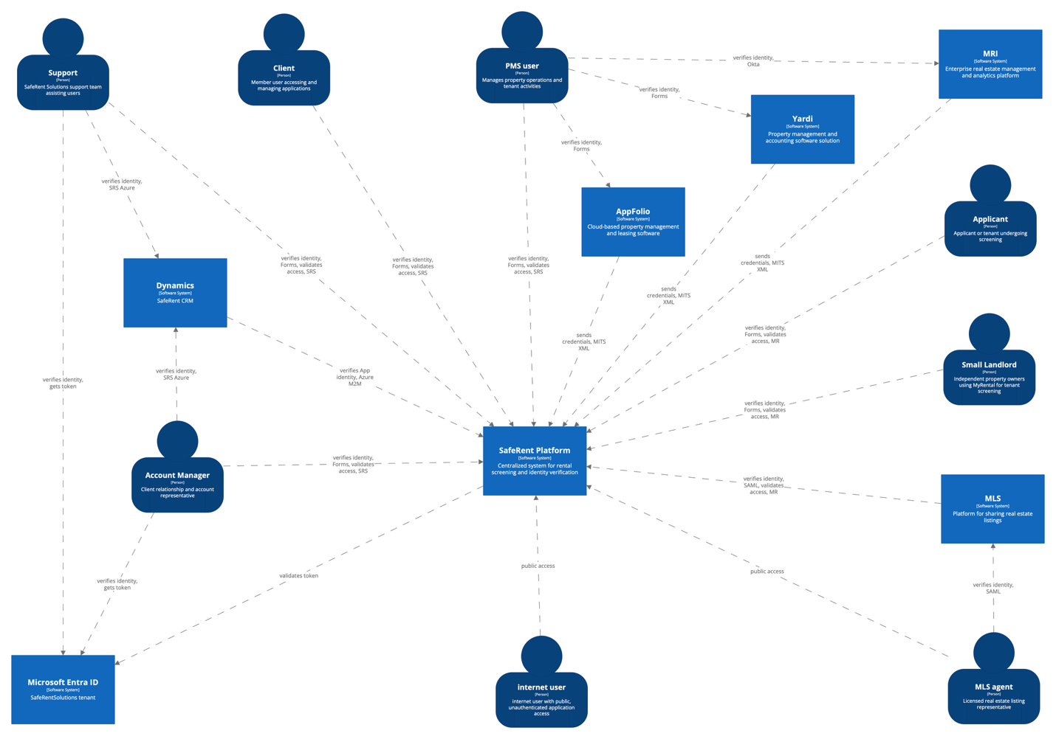

Authentication Sources
Group | User Role | Authentication Source | Description
Public Access Internet Users | Internet User | Public (no authentication) | Anonymous visitors accessing public pages of SRS or MyRental without authentication; can browse listings, general information, or initiate tenant applications.
SRS and MyRental Authenticated Users | Client | SRS Users DB | Authenticated user representing a property management company using SafeRent or MyRental to manage tenant screenings and property data.
 | Applicant | SRS Users DB | Prospective tenant submitting rental applications and background screenings through the SafeRent or MyRental portal.
 | SmallLandlord | SRS Users DB | Independent or small-scale property owner using MyRental to list properties and manage tenant applications without enterprise PMS integration.
Corporate Users (Microsoft EntraID Authentication) | Support | Microsoft Entra ID (Corporate SSO) | SafeRent internal support team managing customer cases, user issues, and access troubleshooting via BackOffice tools.
 | Account Manager | Microsoft Entra ID (Corporate SSO) | SafeRent client relationship representative responsible for onboarding, client configuration, and permissions management through administrative portals.
PMS and MLS Users (External System Authentication) | PMS User | PMS SSO (e.g., Yardi, MRI, AppFolio via MITS 3.0) | Property management system operator accessing SafeRent services through SSO-enabled MITS 3.0 B2B interface.
 | MLS Agent | MLS SSO (e.g., regional MLS federation) | Licensed real estate agent accessing SafeRent tenant screening or listing integrations via MLS partner platforms.

CONTAINER DIAGRAM

Legend
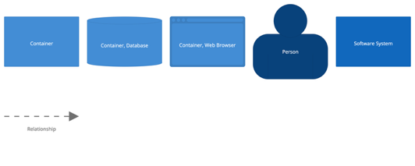

SafeRent Solutions Software Platform. Components
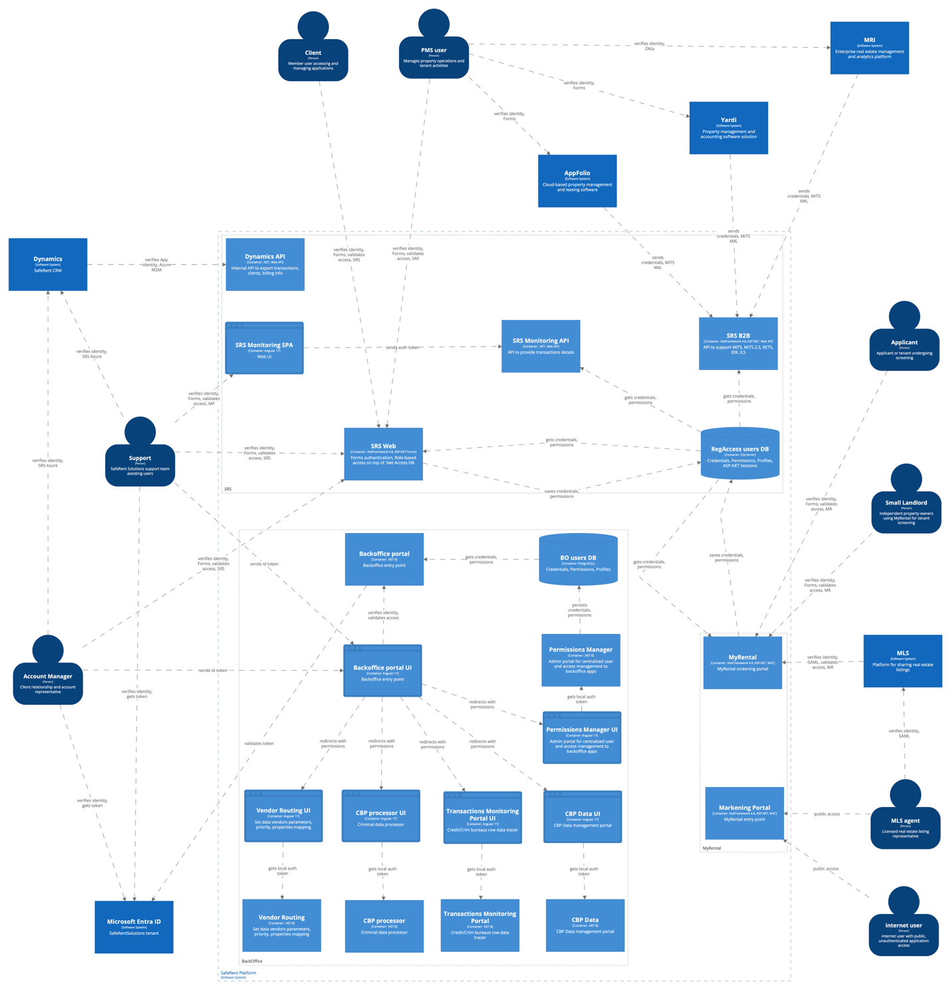

Current Authentication Types by Component
Authentication Type | Component / Application | Notes
Forms (Local ASP.NET Authentication) | SRS Web | Uses ASP.NET Forms authentication with local SQL credential store.
 | MyRental | Uses local credentials; some users access via SAML (MLS federation).
Local Token (Legacy Application-Issued Tokens) | SRS Monitoring SPA | Authenticates users with local credentials; consumes tokens from Monitoring API.
 | SRS Monitoring API | Issues tokens to SPA; validates user session locally.
 | Permissions Manager UI | Issues and validates tokens internally; no centralized identity.
 | CBP Data UI / CBP Data | Internal app authentication with local token validation.
 | CBP Processor UI / CBP Processor | Internal application pairing using legacy token exchange.
 | Vendor Routing UI / Vendor Routing | Validates local token for routing and vendor management.
 | Transactions Monitoring Portal UI / Transactions Monitoring Portal | Uses token-based session from app backend; no SSO integration.
Microsoft Entra ID / Azure Authentication | BackOffice Portal UI / BackOffice Portal | Authenticated via Azure Entra ID (OIDC) for corporate users.
 | Dynamics API | Uses Azure Entra M2M token for system-to-system integration.
SAML Federation | MyRental (via MLS) | Supports SAML IdP login from MLS for agents.
Public (No Authentication) | Marketing Portal | Public-facing access for general information and lead generation.
External PMS IdPs | PMS integrations (MRI, Yardi, AppFolio) | External PMS systems use their own IdPs for user authentication.

Target Solution Architecture
Target SSO Authentication Flow Across Internal and External Domains
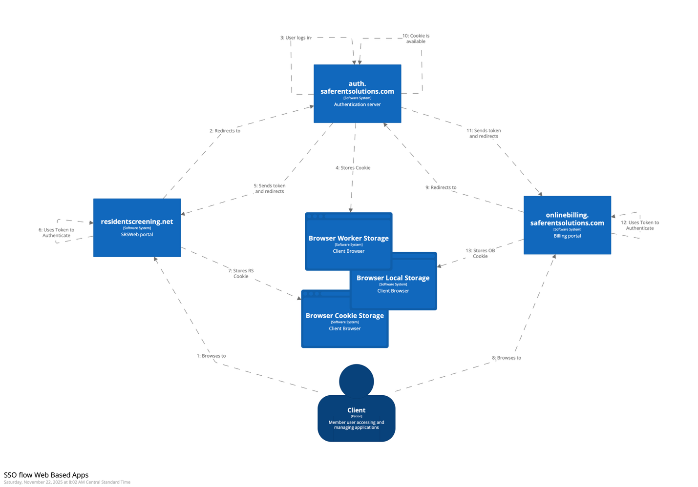

Target authentication architecture for each application type, including the relevant Auth0 architecture scenario.
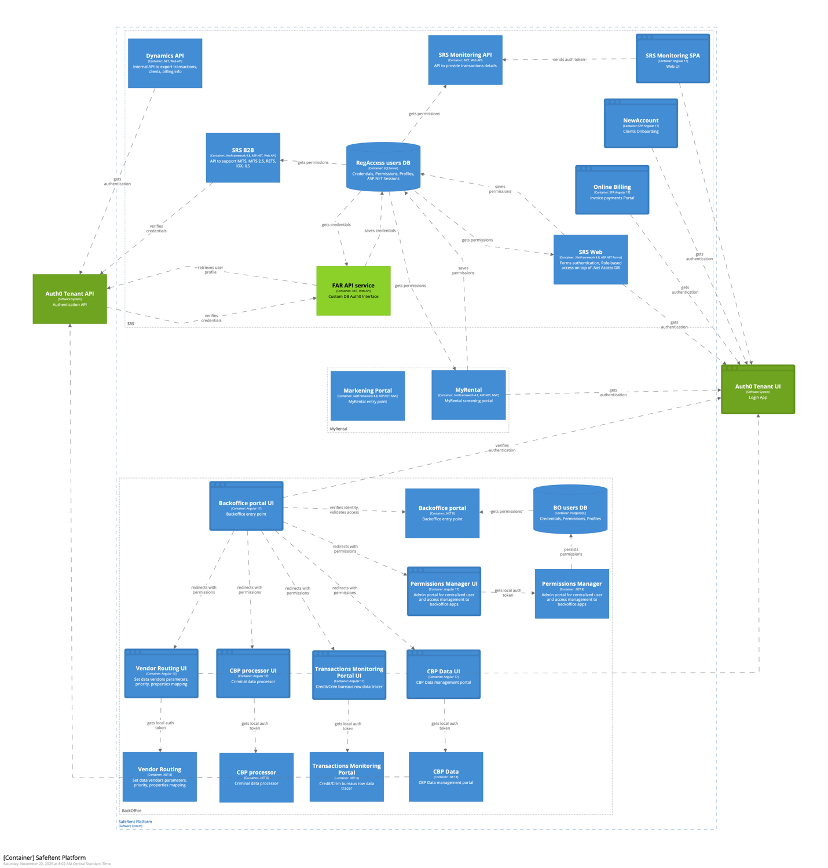
Integration Scenarios diagrams.

Regular Web Applications with Single Sign-On
Applications: SRS Web, MyRental
Migrate to Auth0-based authentication using the .NET Framework OWIN library.

Regular Web App (Login via Auth0) Authentication Flow.
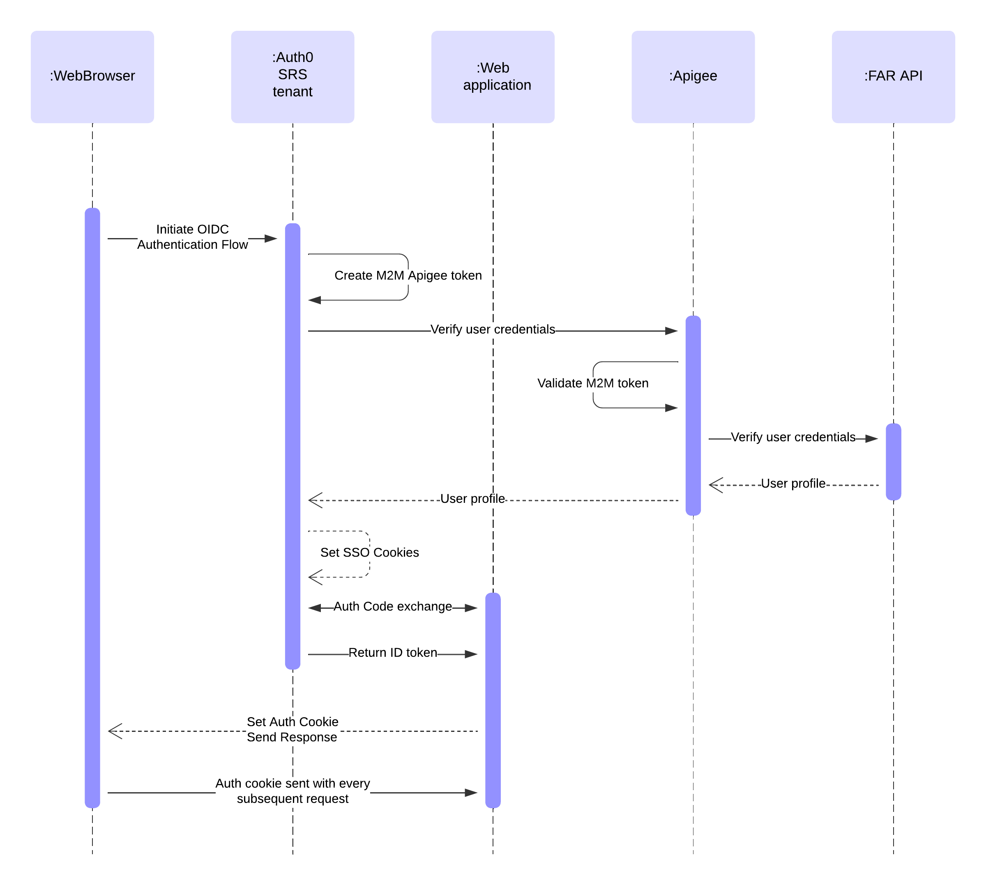
- Replace ASP.NET Forms login with Auth0 Universal Login using OIDC Authorization Code.
- Apps validate Auth0-issued ID and access tokens via ID and access tokens.
- Support per-tenant callback/logout URLs; secrets and certificates stored in GCP Secret Manager.
- Users managed in Auth0 or through FarUser API for SRS credentials Database integration.
- Roles and permissions resolved from the centralized SRS Permissions service via JWT claims.

SAML Federation
Target: Auth0 serves as the Service Provider (SP) for MLS and partner identity providers.
Follow scenario: SAML Federation (Auth0 as SP)
- Accept SAML assertions from external IdPs and exchange them for OIDC tokens for internal apps.
- Support both SP-initiated and IdP-initiated flows.
- Attribute mapping from SAML assertions to standard OIDC claims and roles.
- Enforce central logout through Auth0; step-up MFA enabled where external IdPs lack MFA.

Single-Page Applications (SPA) with API
Applications: Back Office applications, Monitoring portal
Replace all local tokens with Auth0-issued JWTs managed through centralized OIDC/OAuth2 flows.

SPA + API. Authorization Code Flow with Proof Key for Code Exchange (PKCE)
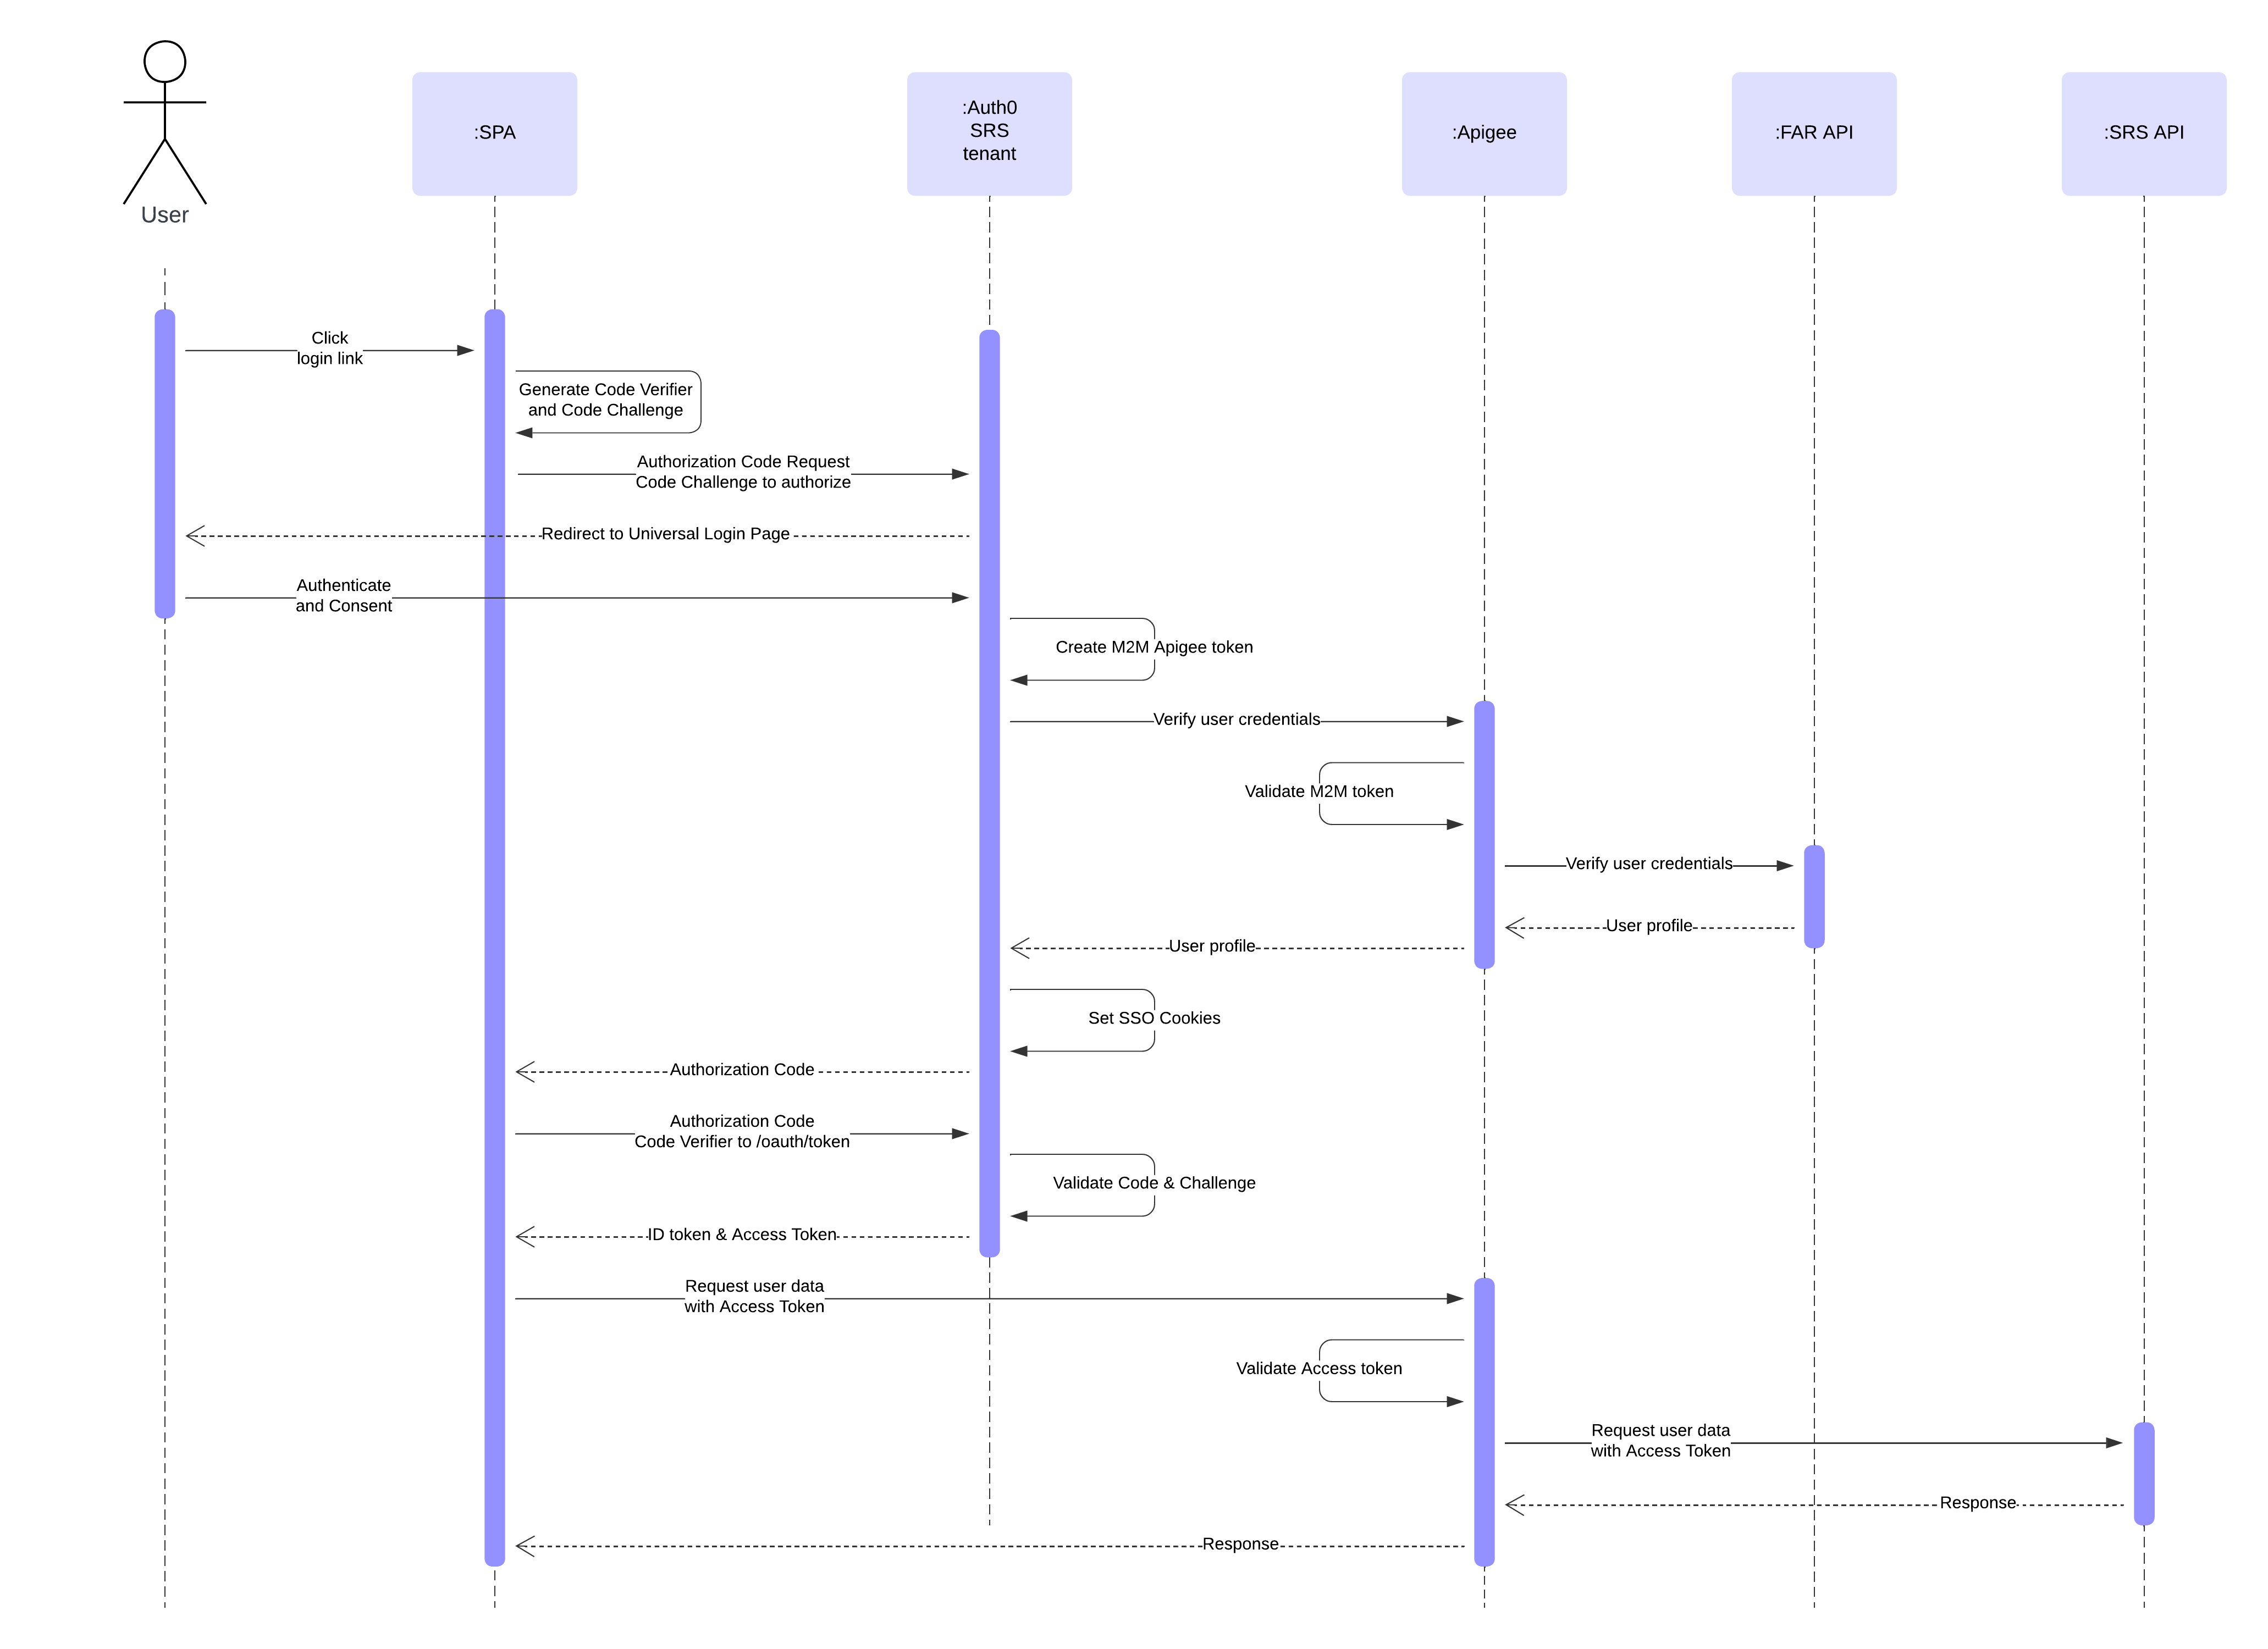

- Frontend SPAs authenticate using Auth Code + PKCE; APIs validate Auth0 access tokens.
- Internal services (APIs-to-APIs) use Client Credentials flow.
- Apigee acts as API Gateway validating tokens and enforcing scopes.
- Token lifetimes, rotation, and signing keys managed centrally by Auth0; secrets stored in GCP SM.
- Roles standardized using RBAC and included as scopes in JWTs.

(Microsoft Entra ID / Azure Authentication
Target: Keep Entra ID as corporate IdP via an Auth0 Enterprise OIDC connection.
Follow scenario: Enterprise Identity Providers (OIDC/SAML Federation)
- Corporate users authenticate via Microsoft Entra ID, federated through Auth0.
- Auth0 issues tokens to downstream apps for consistent trust and claims structure.
- Entra user attributes and groups mapped to Auth0 roles using rules/actions.
- Entra Conditional Access and MFA policies remain enforced upstream.

External PMS IdPs (MRI, Yardi, AppFolio)
Enable B2B and PMS integrations through secure SSO and API token flows.
Follow scenario: Machine-to-Machine (M2M) / B2B API Integration
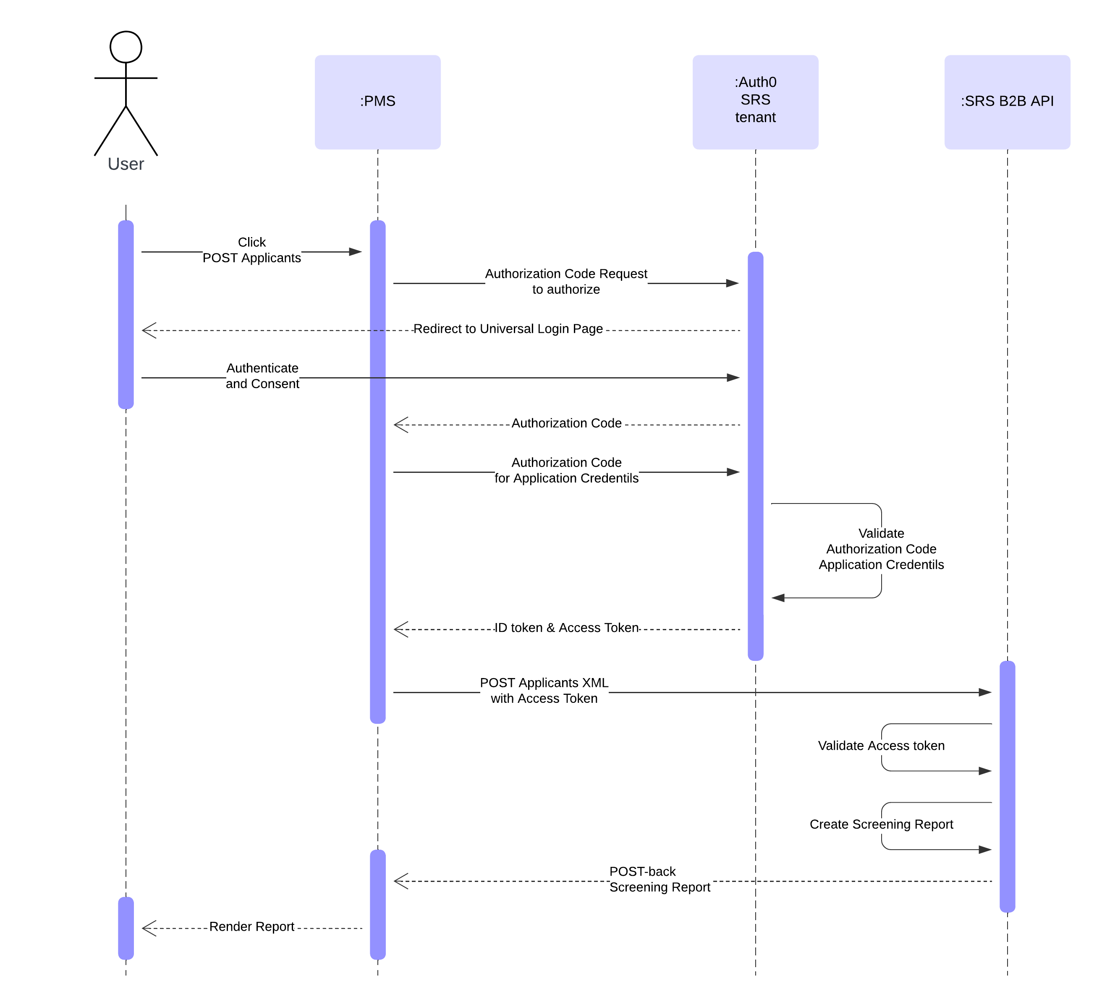
- PMS systems use OAuth 2.0 Client Credentials to obtain tenant-scoped access tokens via Auth0.
- Interactive SSO enabled via SAML or OIDC Enterprise connections for PMS IdPs.
- Tokens validated through Apigee or directly via Auth0 JWKS; secrets managed in GCP SM.
- Auth0-issued bearer tokens embedded into MITS 3.0 protocol as auth.token for partner system authentication.
- Maintain strict tenant isolation, rate limits, and per-partner scope definitions.

Logout process
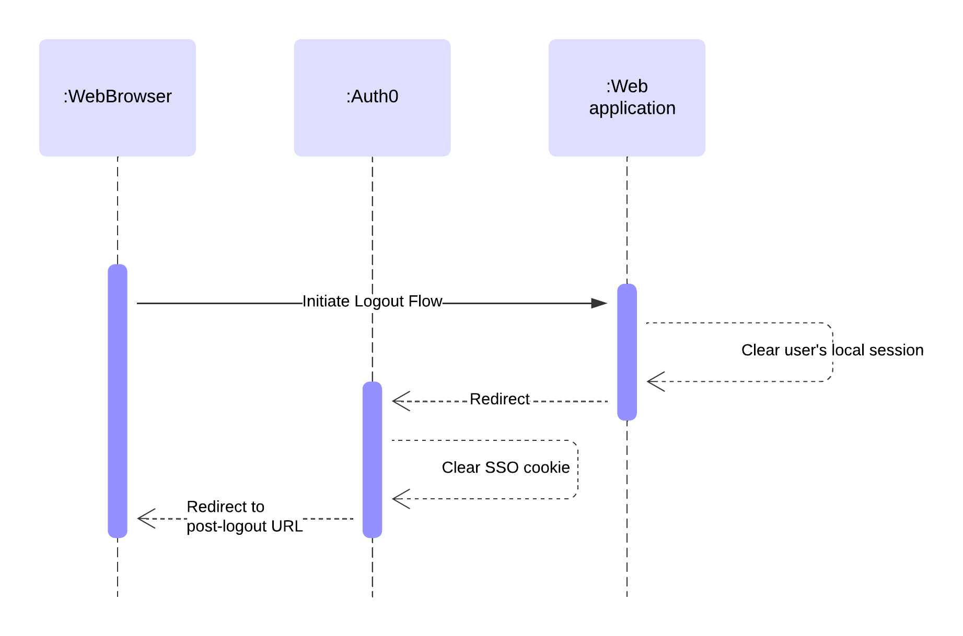

Forms (Local ASP.NET Authentication)
Scenario: Regular Web App (Auth0 SSO, .NET Framework OWIN)
- App invokes Auth0 /v2/logout with client_id and returnTo, then clears its local session cookie.
- If Refresh Tokens are used, call /oauth/revoke to invalidate them; rely on short-lived Access Tokens.
- For federated users (e.g., Entra ID), enable federated logout when supported; otherwise perform local + Auth0 session logout.

Local Token (Legacy Application-Issued Tokens → SPA + API)
Scenario: SPA + API
- SPA calls Auth0 /v2/logout and clears in-app storage (no tokens left in memory/storage).
- APIs are stateless: no “logout” on the API—tokens simply expire; revoke RTs if issued.
- Gateway (Apigee) immediately blocks future calls once tokens expire/are revoked.

Microsoft Entra ID / Azure Authentication (via Auth0 Enterprise OIDC)
Scenario: Enterprise Identity Providers (OIDC/SAML Federation)
- App triggers Auth0 /v2/logout → clears Auth0 session and app session.
- If configured, Auth0 initiates upstream (Entra) logout; if upstream SLO isn’t available, rely on Auth0 + app session termination.
- Claims/roles are re-issued only on next login; sessions respect Entra Conditional Access on re-auth.

SAML Federation (Auth0 as SP)
Scenario: SAML Federation (Auth0 as SP)
- App redirects to Auth0 /v2/logout. If SAML SLO is supported by the partner IdP, Auth0 performs SP-initiated SLO to the IdP.
- If partner IdP lacks SLO, perform local logout (app + Auth0 session) and allow the IdP session to expire independently.
- All downstream apps rely on Auth0 session state; user is signed out globally once Auth0 session ends.

External PMS IdPs (MRI, Yardi, AppFolio, etc.) — B2B/M2M & Interactive
Scenario: Machine-to-Machine (M2M) (for APIs) + Enterprise Identity Providers (for interactive SSO)
- M2M/API: no user session to “log out.” Use short-lived Access Tokens, revoke Client Credentials tokens when needed, and rotate PMS client secrets/keys.
- Interactive SSO: same as SAML/OIDC federation—trigger Auth0 /v2/logout; if PMS IdP supports SLO, Auth0 propagates it upstream.
- Gateway (Apigee) enforces token expiry/revocation immediately; partner scopes/tenants restrict any residual access.

Deployment View
Deployment architecture integrates Auth0 for identity, Apigee for secure API management, GCP for scalable infrastructure, GitLab for CI/CD, and Datadog for observability, forming a robust, secure, and maintainable foundation for SafeRent’s unified SSO environment.
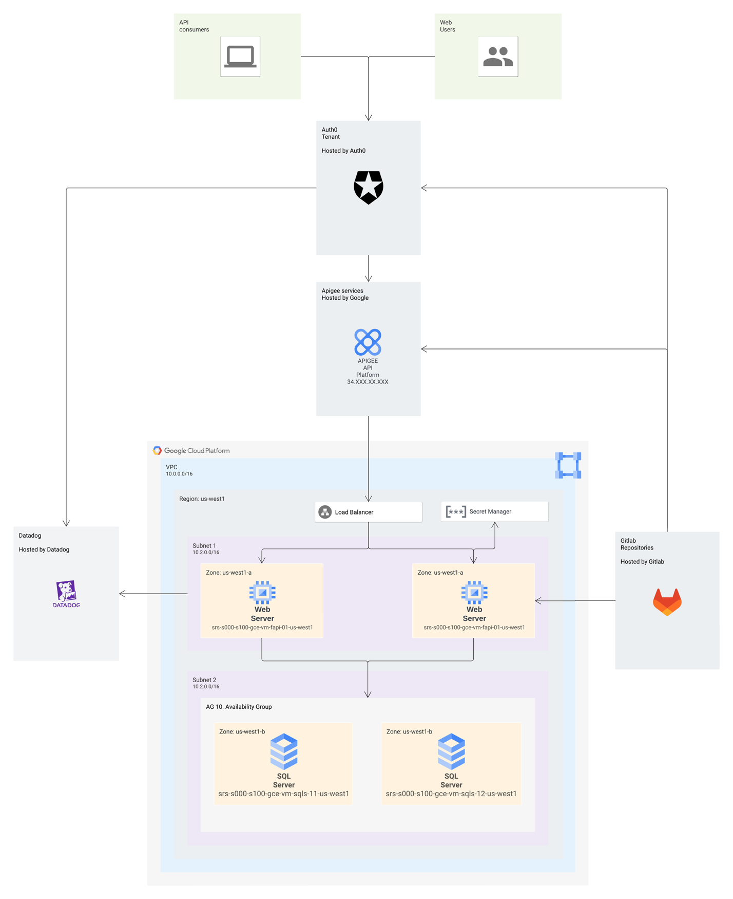

Infrastructure Overview
- The system operates in a dedicated GCP Virtual Private Cloud (VPC 10.0.0.0/16) within the us-west1 region.
- All applications are distributed across multiple subnets and availability zones to achieve redundancy and zero downtime.
- A GCP Load Balancer routes incoming traffic to backend web servers, balancing user and API requests.

Compute and Application Hosting
- Web Servers (srs-s000-s100-gce-vm-fap-01-us-west1) host SafeRent web applications such as SRSWeb, MyRental, BackOffice, and Permissions Manager.
- Each web server instance authenticates users through Auth0 Universal Login and connects to internal APIs through Apigee.
- Applications retrieve configuration secrets, certificates, and encryption keys from Google Cloud Secret Manager.

Data Layer
- Two SQL Server instances (srs-s000-s100-gce-vm-sqls-11/12-us-west1) are configured in an Availability Group (AG10) for synchronous replication and high availability.
- Database connectivity uses private networking within the VPC; no public access is allowed.

Identity and API Management
- Auth0 Tenant (Hosted by Auth0) serves as the single identity provider for all SafeRent applications. It issues OAuth2 and OpenID Connect tokens for both web and API access.
- Apigee API Platform (Hosted by Google) acts as the secured entry point for API consumers, handling authentication via Auth0 tokens, applying rate limiting, and managing API policies.

DevOps and Automation
- GitLab Repositories store source code, infrastructure-as-code scripts, and CI/CD pipelines.
- GitLab pipelines automate build, test, and deployment stages for all application components, with promotion through DEV → QA → UAT → PROD environments.

Monitoring and Observability
- Datadog (Hosted by Datadog) provides infrastructure and application monitoring, collecting performance metrics, logs, and traces from GCP workloads.
- Datadog dashboards integrate with GCP monitoring and Apigee analytics for unified visibility.

Security and Compliance
- Secrets and certificates are managed exclusively in GCP Secret Manager with IAM-based access controls.
- Traffic between all components is encrypted (HTTPS/TLS 1.2+).
- Audit trails from Auth0, Apigee, and Datadog support compliance and operational visibility.

High Availability and Scalability
- Load balancing and horizontal scaling policies automatically adjust to workload demands.
- Web, API, and identity components operate independently, ensuring fault isolation and resilience.

Addressing key quality attributes

Interoperability
The SSO solution integrates seamlessly with multiple internal and external systems through standard, open protocols and interfaces.
- Authentication and Authorization: All SafeRent and MyRental applications use Auth0 with OAuth 2.0, OpenID Connect, and SAML 2.0 to ensure interoperability across web, API, and third-party PMS (Property Management Systems) integrations.
- API Communication: Apigee API Platform enables RESTful communication between GCP-hosted services and external partners, with secure token validation through Auth0.
- B2B Integrations: Support for MITS 3.0 protocol with token-based authentication ensures secure interoperability with partner PMS systems such as Yardi and MRI Software.
Result: A standards-based, vendor-neutral architecture ensuring broad compatibility and minimal coupling.
Confidence: High.

Performance
System performance is optimized through distributed deployment and managed cloud services.
- Web applications and APIs are deployed on GCE instances in multiple zones, behind a GCP Load Balancer for even traffic distribution.
- Apigee provides caching, rate limiting, and request routing to maintain low latency.
- Datadog monitors response times and resource usage to proactively detect performance bottlenecks.
Expected throughput: Supports thousands of concurrent sessions with authentication and authorization response times below 300 ms (p95).
Confidence: High.

Scalability
The architecture supports horizontal scaling at both application and database layers.
- Apigee automatically scales API gateways to handle bursts in API calls.
- SQL Server AG10 configuration provides vertical scalability and data replication across zones.
Confidence: High.

Security
Security is ensured through a defense-in-depth approach combining modern identity management, encrypted communication, and centralized secret handling.
- Auth0 manages user identities, MFA, and secure token issuance.
- All API and user interactions are protected with TLS 1.2+ encryption.
- Secrets and certificates are stored in GCP Secret Manager, never embedded in application code.
- Apigee enforces OAuth 2.0 token verification, request quotas, and threat protection policies.
- Continuous security monitoring and vulnerability scanning are automated through GitLab CI/CD pipelines.
Confidence: High.

Availability and Reliability
Redundant GCE web and SQL instances deployed across multiple zones ensure no single point of failure.
- Apigee and Auth0 provide SLA-backed availability of 99.9%+.
- Datadog alerts and dashboards provide operational awareness, allowing proactive incident management.
Confidence: High.

Observability
Datadog collects metrics, logs, and distributed traces from all components.
- Apigee analytics provides detailed API performance and error insights.
- Integration with GitLab pipelines supports deployment tracking and versioned audit trails.
Confidence: Medium–High (dependent on complete Datadog instrumentation coverage).

Testability
Continuous Integration and Deployment pipelines in GitLab ensure automated build, test, and deployment processes.
- Unit and integration tests are triggered on each commit.
- API tests are integrated into Apigee staging environments.
- Auth0 tenant configurations are validated through sandbox environments before promotion.
Target coverage: 80% unit and 60% integration test coverage.
Confidence: Medium–High.

Conceptual Integrity
The architecture follows microservices principles and domain-driven design.
- Common authentication and authorization mechanisms are standardized across all SafeRent applications.
- CI/CD, logging, and monitoring are unified under GitLab and Datadog to ensure consistency and repeatability.
Confidence: High.

SafeRent Solutions LLC – Auth0 Integration and SSO Modernization
This part of the document implementation work plan for the SafeRent Solutions Auth0 Integration and Single Sign-On (SSO) Modernization Project. It defines the scope of activities, estimated engineering effort, risk levels, and an eight-week execution timeline. The goal of the initiative is to modernize user authentication and authorization across the SafeRent ecosystem by implementing Auth0 as a unified Identity Provider, modernizing the SRS B2B interface with token-based authentication (MITS 3.0), and integrating key components within the Google Cloud Platform (GCP) environment.

1. Detailed Work Plan
The table below outlines the key activities required to implement the integration. Effort estimates are expressed in engineering days per discipline and may run in parallel across workstreams.

Activity / Module | Description | Risk Level | Days (BackEnd Devs) | Days (FrontEnd Devs) | Days (DB Admin) | Days (DevOps)
Auth0 Tenant Setup & Configuration | Establish DEV/UAT/PROD tenants. Configure Universal Login, MFA, and RBAC. | Medium | 5 | 0 | 1 | 3
Custom Database Connection Design | Define a unified Custom Database schema for integration via FarUser API. | High | 6 | 0 | 3 | 0
FarUser API – Development | Develop REST API implementing Auth0 Custom DB interface in .NET 8. | High | 10 | 0 | 2 | 2
FarUser API – GCP Deployment & Secrets | Deploy FarUser API to GCP, integrate with GCP Secret Manager, secure via Apigee. | High | 3 | 0 | 0 | 5
Apigee Gateway Configuration | Expose FarUser API and SRS B2B endpoints through Apigee Gateway with OAuth 2.0 policies. | Medium | 3 | 0 | 0 | 5
SRS B2B Modernization (MITS 3.0) | Replace static credentials with OAuth 2.0 Bearer tokens for partner integrations. | High | 8 | 0 | 2 | 2
Auth0 Actions & Token Enrichment | Implement Auth0 Actions for claims enrichment using Permissions Manager API. | Medium | 4 | 0 | 0 | 1
SPA Integration | Implement Auth0 SPA SDK and configure callback/logout URLs for Angular applications. | Medium | 0 | 10 | 0 | 0
Legacy .NET Applications Update | Migrate SRS Web and MyRental applications to OIDC-based authentication. | High | 8 | 0 | 0 | 0
API Security Retrofit | Implement JWT validation and enforce Auth0 scopes and claims across all APIs. | Medium | 6 | 0 | 0 | 1
GCP Secret Manager Implementation | Centralize key and credential management with automated rotation and IAM roles. | Low | 1 | 0 | 0 | 4
GitLab CI/CD for Auth0 Configuration | Implement automated Auth0 configuration promotion via GitLab pipelines. | Medium | 1 | 0 | 0 | 6
GitLab CI/CD for FarUser API Deployment | Develop build and deployment pipeline with secret injection from GCP SM. | Medium | 2 | 0 | 0 | 4
MLS Federation Setup | Integrate MLS through SAML/OIDC federation with attribute normalization. | Medium | 3 | 0 | 0 | 1
DataDog & Observability Integration | Enable monitoring of Auth0 log streams, Apigee metrics, and GCP components. | Low | 1 | 0 | 0 | 3
Comprehensive QA and End-to-End Testing | Conduct full authentication flow validation including JIT migration and MFA. | Medium | 4 | 3 | 1 | 1
B2B Partner Validation | Test OAuth token issuance and validation with Yardi, MRI, and other partners. | High | 4 | 0 | 1 | 2
Documentation and Knowledge Transfer | Deliver technical documentation, runbooks, and operational handover. | Low | 2 | 1 | 0 | 1

TOTAL ESTIMATED EFFORT
Role | People | Days
Backend Developers | 5 | 71
Frontend Developers | 1 | 14
Database Administrator | 1 | 10
DevOps Engineers | 2 | 40

Implementation Timeline (8 Weeks)
The following timeline represents a phased implementation approach with parallel workstreams across backend, frontend, DevOps, and database teams.
Week | Key Activities
Week 1 | Project initiation; Auth0 tenant provisioning; GCP Secret Manager setup; GitLab CI/CD skeleton creation.
Week 2 | Development of FarUser API; GCP integration; deployment to DEV environment.
Week 3 | Configuration of Custom DB Connection in Auth0; JIT migration testing with SQL Server and PostgreSQL.
Week 4 | Integration of SPAs and legacy .NET apps using Auth0 Universal Login and OIDC middleware.
Week 5 | Deployment of Apigee Gateway for FarUser API and modernization of SRS B2B interface to OAuth tokens (MITS 3.0).
Week 6 | Implementation of CI/CD pipelines for Auth0 and FarUser API; MLS Federation; DataDog integration.
Week 7 | Execution of end-to-end testing, B2B partner validation (Yardi, MRI), and pre-production readiness checks.
Week 8 | Production deployment, migration cutover, documentation finalization, and operational handover.
All credentials, secrets, and certificates throughout the implementation are securely stored in Google Cloud Secret Manager and governed through IAM-based access control with automated rotation and full audit logging.

Governance and Quality Assurance
All development and deployment activities will be governed under SafeRent’s Agile delivery model with continuous integration and gated promotion. Quality assurance follows test-driven development practices, automated validation in CI/CD pipelines, and adherence to code review and security policies.

4. Summary
This implementation plan provides the formal structure, sequencing, and workload estimation required for successful delivery of the Auth0 SSO modernization. The project will establish a unified authentication framework, enhance security posture through token-based B2B integration, and streamline operations through cloud-native automation and observability.

SSO Implementation checklist

Analyze
# | Item | Guidance | Completed | Notes
Architecture
AC10 | Determine tenant naming  Create a unique name convention for each Auth0 tenant | Accounts and Tenants |  | ***-saferentsolution
AC20 | Determine production tenant provision  Provision an Auth0 production tenant for each user domain you need to support | Tenant Settings Best Practices |  | saferentsolutions
AC30 | Provision a development tenant for each production tenant  Provision an Auth0 development tenant for each production tenant you have defined | Set Up Multiple Environments |  | dev-saferentsolutions
AC40 | Provision a staging tenant for each production tenant  Provision an Auth0 test tenant for each production tenant you have defined | Set Up Multiple Environments |  | ppd-saferentsolutions
AC50 | Custom domain naming  Apply custom domain naming to each Auth0 tenant to provide branding and security benefits | Custom Domains |  | auth.saferentsolutions.com, ppd-auth.saferentsolutions.com, 301-auth.saferentsolutions.com
AC60 | Associate tenants with your account  Contact your Auth0 representative or the Auth0 Support Center (at http://bit.ly/2V5mViG to ensure all tenants are associated with your Auth0 contractual agreement for feature permission parity | Child Tenant Request Process
AC70 | Extensions  Review use of Auth0 Extensions to customize and extend Auth0 beyond base product capabilities | Extensions |  | Real-time Webtask Logs  Version 1.3
User Provisioning
AC100 | Identity provisioning via database connections  Review use of Auth0 as an identity provider to provide sign-up and user identification | Database Identity Providers |  | Custom DB (FarAPI service)
AC110 | Identity migration  Review use of Auth0 as an identity provider to provide user identification by migrating from your existing legacy identity store | Migrating to Auth0 from a Custom User Store |  | In progress
AC120 | Existing identity storage  Review use of Auth0 to provide user identification directly from your existing (legacy) identity store | Authenticate Users Using Your Database | N/A
AC130 | Third Party identity providers  Review use of third-party social identity providers in support of user provisioning | Social Identity Providers | N/A
AC140 | Hooks  Review use of Auth0 Hook extensibility to further customize and extend Auth0's base product capabilities | Hooks |  | Set of actions has been implemented
User Authentication
AC200 | Universal Login  Review Auth0 Universal Login in support of Single Sign On (SSO) and industry best practice | Universal Login |  | ulogin.aspx
Design
# | Item | Guidance | Completed | Notes
Architecture
DC10 | Custom domain naming  Apply custom domain naming to each Auth0 tenant to provide branding and security benefits | Custom Domains
User Provisioning
DC100 | User self sign up  Leverage Auth0 database connection for storing the user id, password, and (optional) username information collected during the sign-up process | Database Identity Providers
DC110 | User migration  Use Auth0 database connection to provide a secure Auth0 hosted replacement for your legacy identity store (not applicable if you will not be migrating users) | User Migration |  | In progress
DC120 | Existing identity storage  Review use of Auth0 to provide user identification directly from your existing (legacy) identity store | Authenticate Users Using Your Database
User Authentication
DC200 | Application integration  Follow the Quickstart that best aligns with your technology stack in order to obtain design guidance for your specific application. | Quickstarts
DC220 | Universal Login  The most secure way to authenticate users via use of browser redirect workflow | Universal Login
DC230 | Universal Login customization  Simple customization as well as advanced customization provides guidance on a range of capabilities that support custom branding and other UI design requirements | Simple Login Customization |  | Logo, wording, messages
 |  | Advanced Login Customization |  | See Auth0 actions, forms, hooks
DC240 | Password reset customization  Provide Change Password customization to suit your organisation’s branding as well as other UI design requirements | Edit Password Reset Page |  | SSO Planning Board
DC250 | Guardian Multi-factor page customization  Customize the Guardian Mult-factor page (not applicable if you are not using multi-factor authentication) | Guardian Multi-factor Login Page | N/A
DC260 | Social connection registration  Register for each social identity provider to mitigate limitations of out-of-box Auth0 Developer Keys (not applicable if you are not using social connections) | Test Social Connections with Auth0 Developer Keys | N/A
DC270 | Custom social connection  Customize a connection for a ocial provider not supported out-of-box (not applicable if you are not using social connections) | Custom Social Connections | N/A
DC280 | Auth0 as a SAML service provider  Review design considerations for using Auth0 as a SAML service provider (not applicable if you do not need to support a SAML service provider context) | SAML Considerations for Using Auth0 as Service Provider
Build
# | Item | Guidance | Completed | Notes
Architecture
BC10 | Rules best practice aligned  Review Rule implementation for alignment with best practice guidance for configuration (not applicable if you are not using Rule Extensibility) | Rules Security Recommendations
BC14 | Hooks best practice aligned  Review use of Auth0 Hook extensibility to further customize and extend Auth0's base product capabilities | Hooks
BC16 | Custom database scripts best practice aligned  Review Custom Database Script implementation for alignment with best practice (not applicable if you are not using custom database or automatic user migration functionality) | Add Custom Database Configuration Parameters |  | Secrets
BC30 | Real-time webtask logging  Enable real-time webtask logging for extensibility debugging (not applicable if you are not using Auth0 extensibility features such as Rules, Hooks or custom database) | Real-time Webtask Logs
BC40 | CI (Continuous Integration)  Regular integration and test Auth0 of custom extensibility (et-al) prior to automatic deployment (also applicable if you are not using a CI/CD pipeline) | Continuous Deployment Pipelines and Open Source Node.js Web Apps | In progress | Terraform scripts. In progress
User Provisioning
BC100 | Custom database scripts best practice aligned  Review Custom Database Script implementation for alignment with best practice guidance (not applicable if you are not using custom database or automatic user migration functionality) | Create Database Action Scripts
BC110 | Hooks best practice aligned  Implementation for Hooks aligned with best practice guidance provided here. Not applicable if you are not using either of the the Pre-User-Registration or the Post-User-Registration Hook extensibility points. | Hooks
User Authentication
BC200 | Application integration  Follow the Quickstart that best aligns with your technology stack in order to obtain design guidance for your specific application. | Quickstarts
BC210 | Application isolation  Review guidance for more information regarding application definitions in Auth0 and to mitigate reuse client identifiers or credentials across different applications | Applications
BC220 | Auth0 Authentication SDK  Follow guidance to make use of the Auth0 SDK that best aligns with your technology stack rather than calling the Auth0 Authentication API directly | Libraries
BC230 | Auth0 Authentication API rate limit handling  Handling of HTTP Status Code 429s implemented and followed the guidance provided here concerning Auth0 Rate Limit metrics for the Authentication API | Rate Limit Policy for Auth0 APIs
Test
# | Item | Guidance | Completed | Notes
Architecture
TC10 | Session lifetime limits for Single Sign On (SSO) configured  Configure session lifetime limits for SSO | Configure Session Lifetime Limits for SSO
TC20 | Tenant wide allowed logout URLs defined  Specify logout redirect URLs and not defined as localhost (not mandatory, but it is a best practice recommendation to provide user logout functionality) | Redirect Users After Logout
TC30 | Tenant environment tag assigned  Assign an environment tag for each tenant | Set the Environment
TC35 | Tenant production checks run  Run automated tests on your production tenant configuration and address any issues raised (also applicable for non-production tenants) | How to Run Production Checks
TC40 | Real-time webtask logging  Enable real-time webtask logging for extensibility debugging (not applicable if you are not using Auth0 extensibility features such as Rules, Hooks or custom database) | Real-time Webtask Logs
User Authentication
TC200 | Allowed callback URLs defined  Specify redirect URLs and not defined as localhost. | Redirect Users After Login
Quality Assurance
TC700 | Performance test  Test performance to uncover issues with implementation | Performance Testing
TC705 | Performance test tooling  Review third-party tools for performance related testing | Third-Party Testing Tools
TC710 | Load test scheduling  Schedule performance load testing in accordance with Auth0 load testing policy (not applicable if you do not need to load test) | How to Request Load Testing | FALSE
TC715 | Load test  Perform performance load testing in accordance with Auth0 load testing policy and requirements (not applicable if you do not need to load test) | Load Testing Policy | FALSE
 |  | Load Testing Requirements
TC720 | Mock test Authentication API  Mock test as a supplement to mitigate restrictions associated with Auth0 load testing (recommended but not mandatory if you do not need to load test) | Testing Your Auth0 Implementation
TC725 | Mock test Management API  Mock test for Management API calls as a supplement to mitigate restrictions associated with Auth0 load testing (not applicable if no independent calls are made to the Auth0 Management API) | Testing Your Auth0 Implementation
Deploy
# | Item | Guidance | Completed | Notes
Architecture
DEC10 | Tenant administrators defined  Provision tenant administrators | Manage Tenant Administrators in the Dashboard
DEC15 | Tenant administration delegation defined  Provision delegated tenant administrator (not applicable if you’re not using tenant Delegated Administration) | Manage Tenant Administrators in the Dashboard
DEC17 | MFA for tenant administrators enabled  Enroll tenant administrators for MFA (Multi-factor Authentication) | Enrolling in Multi-factor Authentication
DEC20 | Support URL configured  Configure the URL for your company/organization support page and as a best practice for your production tenant deployment | Tenant Settings in the Dashboard
DEC25 | Support email configured  Configure the email address used to contact your company/organization support team and as a best practice for your production tenant deployment | Tenant Settings in the Dashboard
DEC30 | Session lifetime limits for SSO configured  Configure session lifetime limits for SSO | Configure Session Lifetime Limits for Single Sign On
DEC40 | Tenant wide allowed logout URLs defined  Specify logout redirect URLs and not defined as localhost (not mandatory but recommended) | Redirect Users After Logout
DEC50 | Tenant environment tag assigned  Assign environment tag for each tenant | Set the Environment
DEC55 | Tenant production checks run  Run automated tests on production tenant configuration and address any issues raised (also applicable for non-production tenants) | How to Run the Production Checks
DEC57 | Tenant production checks best practice aligned  Align production tenant checks with best practices (also applicable for non-production tenants) | Production Checks: Best Practices
DEC60 | Anomaly detection enabled  Protect against brute force attacks and use of breached passwords | Set Anomaly Detection Preferences
DEC70 | Install Auth0 Extensions  Install desired extensions into each tenant | Extensions |  | Real-time Webtask Logs  Version 1.3
User Provisioning
DEC100 | Review user signup policy for database connections  Disable user signup where not required (not applicable if your are not using Auth0 database connections) | Disable user signup if it's not appropriate for each database connection |  | In progress
DEC110 | Set password policy for database connections  Setup recommended password policy for database connections (not applicable if you are not using Auth0 database connections) | Set password policy for database connections |  | In progress
User Authentication
DEC200 | Allow callback URLs defined  Specify redirect URLs not defined as localhost. | Redirect Users After Login
DEC210 | Application grant types aligned  Disable grant types not required or recommended in your application (not applicable if you are not using OIDC or OAuth2 workflows) | Available Grant Types
DEC220 | Social connection developer keys replaced  Complete registration for each social identity provider to mitigate limitations of out-of-box Auth0 Developer Keys (not applicable if you are not using social connections) | Test Social Connections with Auth0 Developer Keys
DEC225 | Social connection identity data reviewed  Review data being requested from each social connection (not applicable if you are not using social connections) | Review requested data
DEC230 | RSA-SHA256 used as signature algorithm  Configure SAML connections to sign requests and use RSA-SHA256 (not applicable if you are not using SAML) | Use RSA-SHA256 for SAML connections
User Profile Management
DEC400 | Set password policy for database connections  Setup recommened password policy for database connections (not applicable if you are not using Auth0 database connections) | Set password policy for database connections
User Logout
DEC500 | Allowed logout URLs defined  Specify logout redirect URLs and not defined as localhost (not mandatory but recommended) | Redirect users after logout
Deployment Automation
DEC800 | Integration test for Rules  For custom Rule extensibility, execute integration test(s) prior to automated deployment (also applicable if you are not using CI/CD pipeline, though not required if you are not using Rule extensibility) | How to unit test rules as part of CI/CD pipeline | N/A
DEC810 | Integration test for Hooks  For custom Hook extensibility, execute integration test(s) prior to automated deployment (also applicable if you are not using a CI/CD pipeline, though not required if you are not using Hook extensibility) | Hooks
DEC820 | Integration test for custom database scripts  Execute integration test(s) when authenticating users using your own database or automatically migrating users prior to automated deployment (also applicable if you are not using a CI/CD pipeline, through not required if you have not implemented custom database scripts) | Custom Database Error Handling and Troubleshooting |  | In progress
Monitor
# | Item | Guidance | Completed | Notes
Operations
MC900 | Review Dashboard notifications  Review Auth0 important announcements sent to you tenant Dashboard and, depending on severity, to email registered for Auth0 Dashboard Administrators | Tenant Settings in the Auth0 Dashboard
MC910 | Review security bulletins  Review notifications regarding security-related tests conducted by Auth0 and any security-related changes or actions required | Auth0 Security Bulletins
MC920 | Subscribe to Auth0 Service Status  Subscribe via the Auth0 status dashboard to get Auth0 service status information | Auth0 Status |  | Log streams, Datadog US5 instance
MC930 | Monitor Auth0 Service Uptime  Monitor Auth0 via the uptime dashboard to get Auth0 service status information | Auth0 Uptime |  | Log streams, Datadog US5 instance
MC940 | View log data  View log data by checkpoint and search criteria to gain insight into operational events | What can I use logs for? |  | Log streams, Datadog US5 instance
MC950 | Export log data for aggregation  Export to third-party logging services for log preservation and aggregation | Export Auth0 logs to an external service |  | Log streams, Datadog US5 instance
MC960 | Monitor third-party service status  Monitor external service status to see identity provider status (not applicable if you are not using social connections) | Check External Services Status

