**TASK 1**

Create a simple FreeStyle Job To Install Nginx on your

server (tools:jenkins, ubuntu vm)

1.Create a Jenkins job to install Nginx:

Open Jenkins Dashboard

Click new item -> Name of the Task -> Choose Freestyle project -> ok

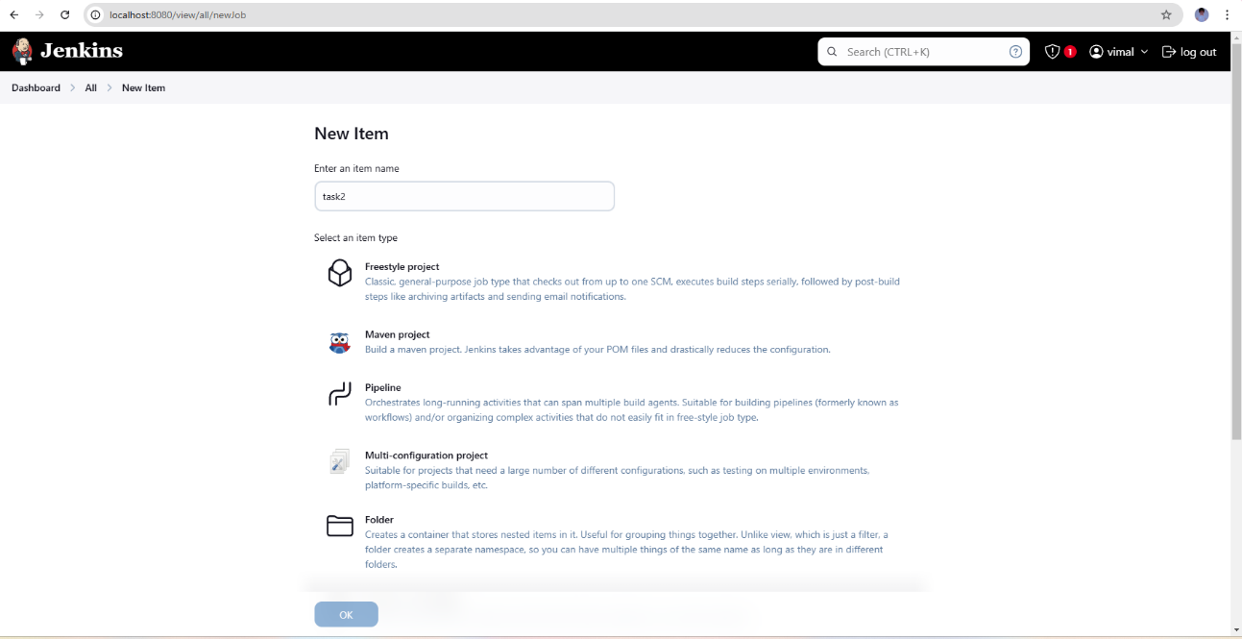

2.installing nginx in ubuntu through Jenkins

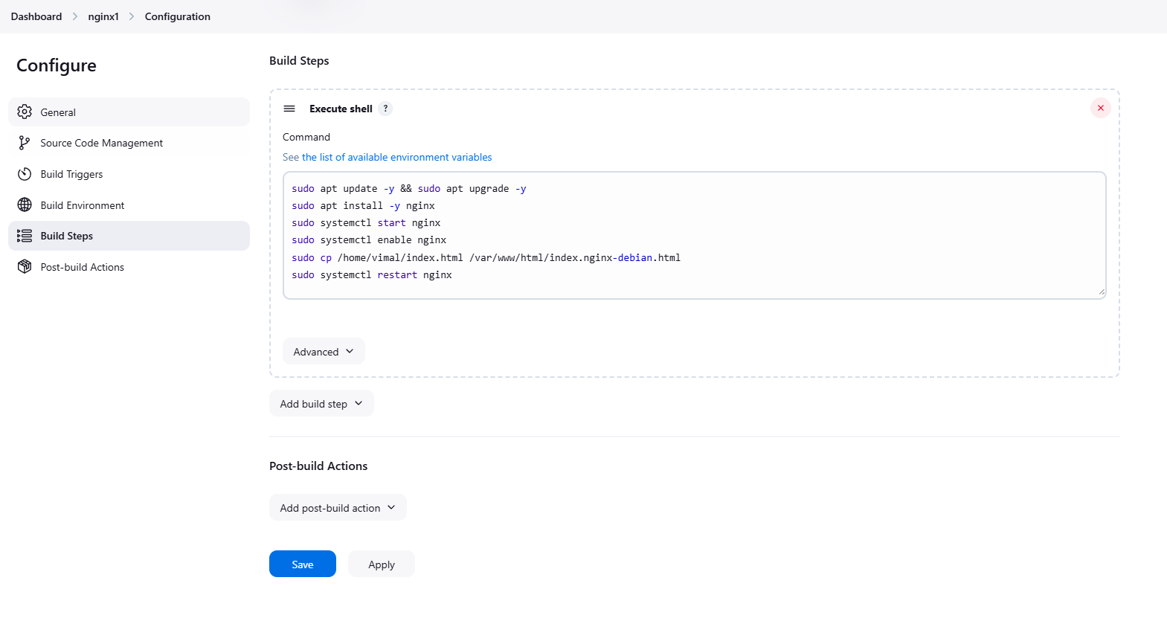

3.output in console:

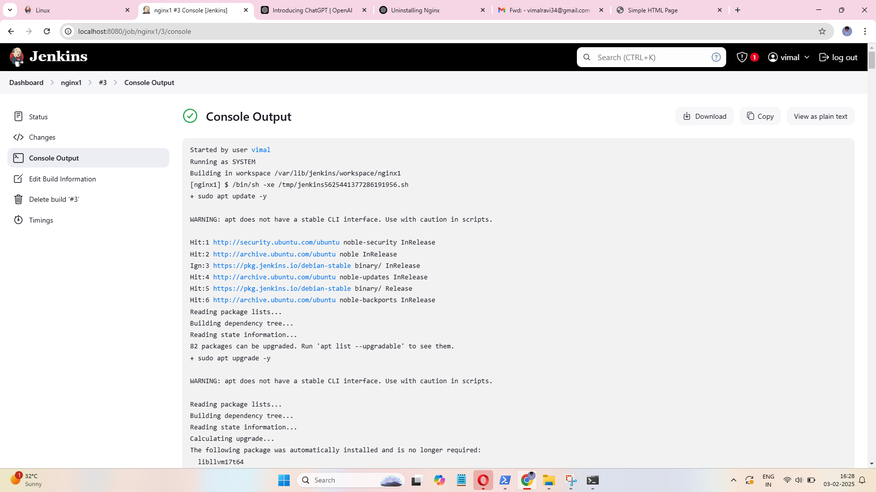

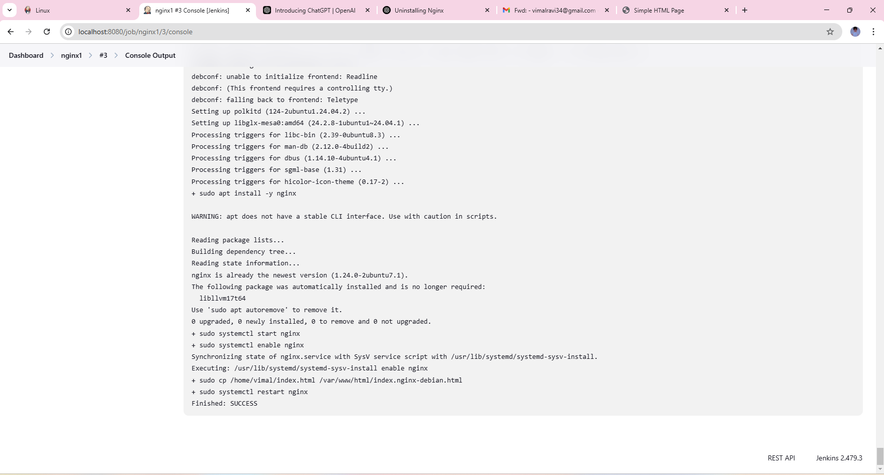

4.output in chrome

