**TASK 2**

STEP1:ADD HTML CODE INSIDE THE BUILD FOLDER

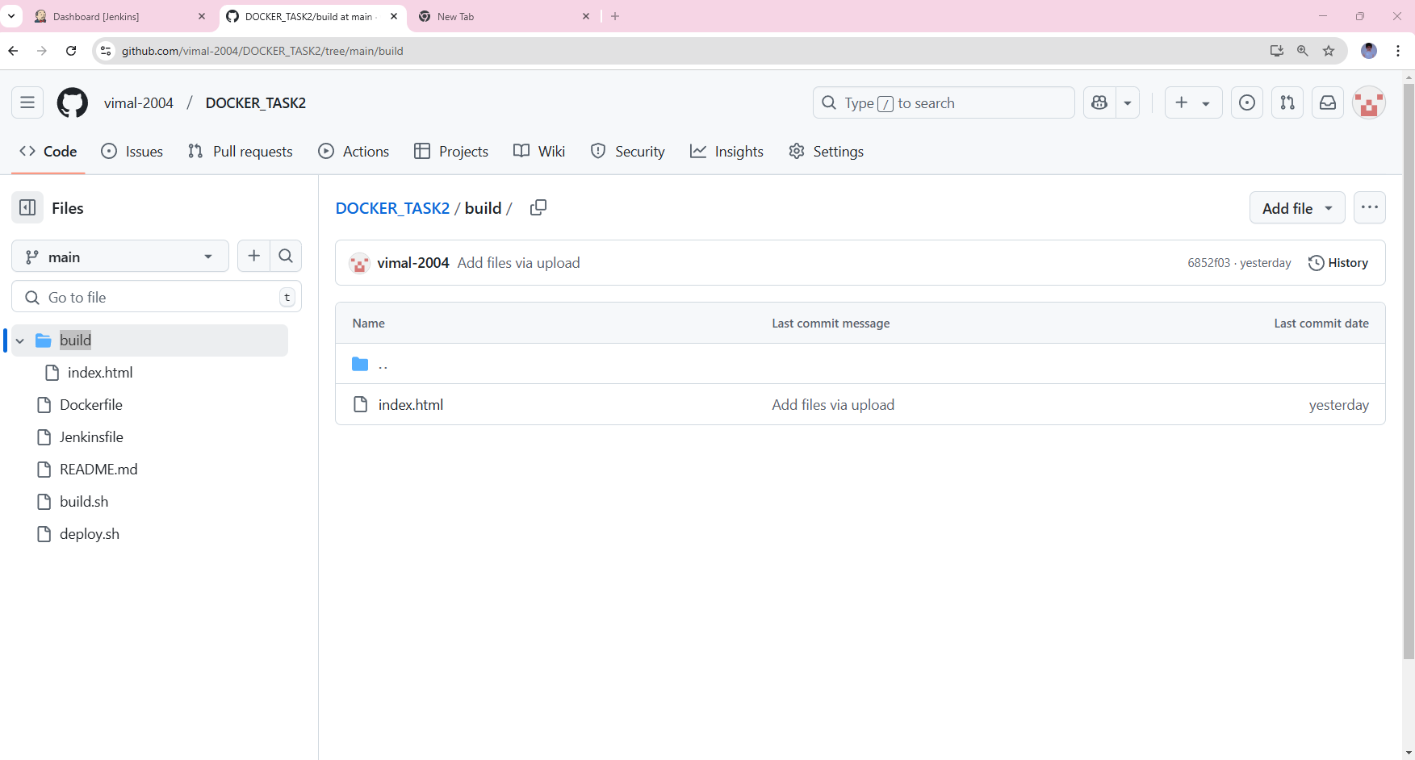

STEP2: ADD DOCKER HUB USERNAME & PASSWORD &FILE NAME LIKE TASK2 IN DEPLOY.SH

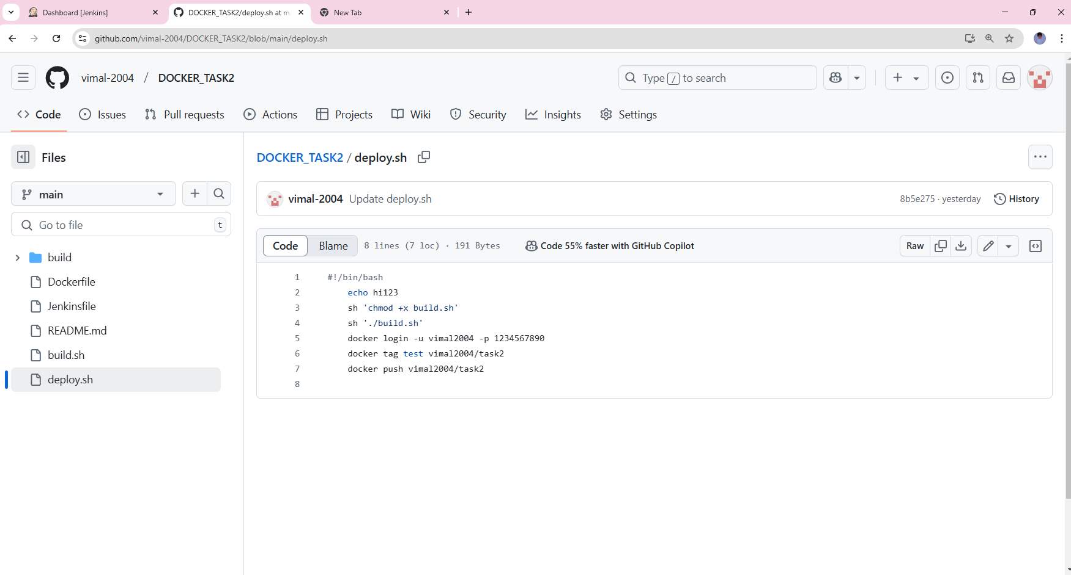

STEP3: ADD LOCAL HOST PORT IN BUILD.SH

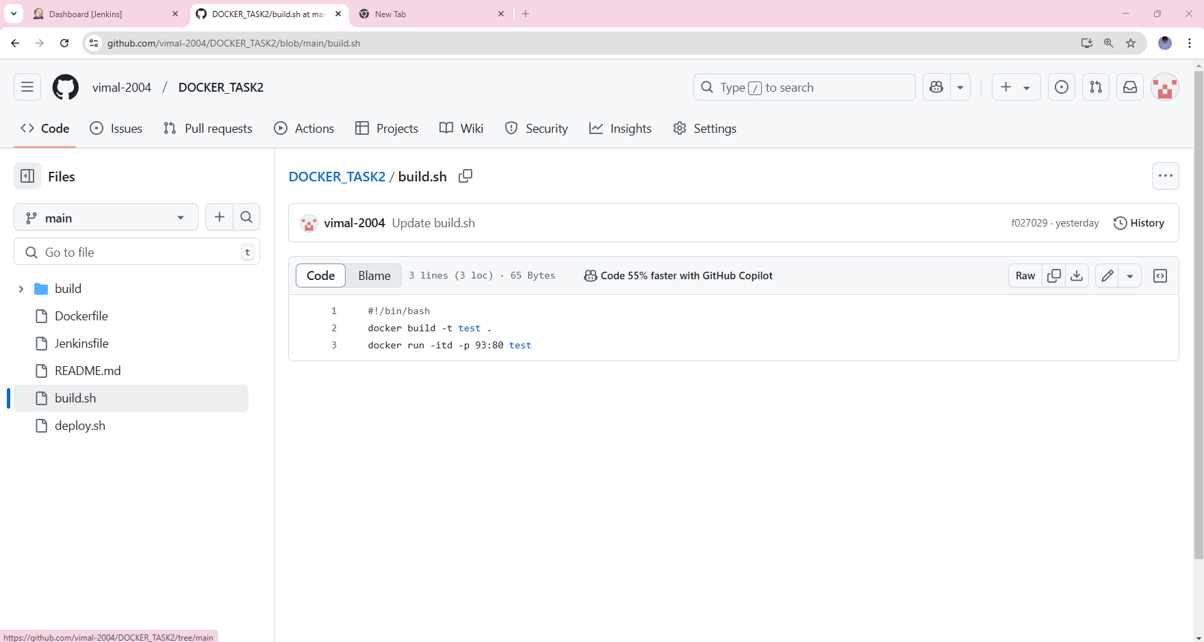

STEP4: CREATE A NEW ITEM AND CHOOSE PIPLE LINE

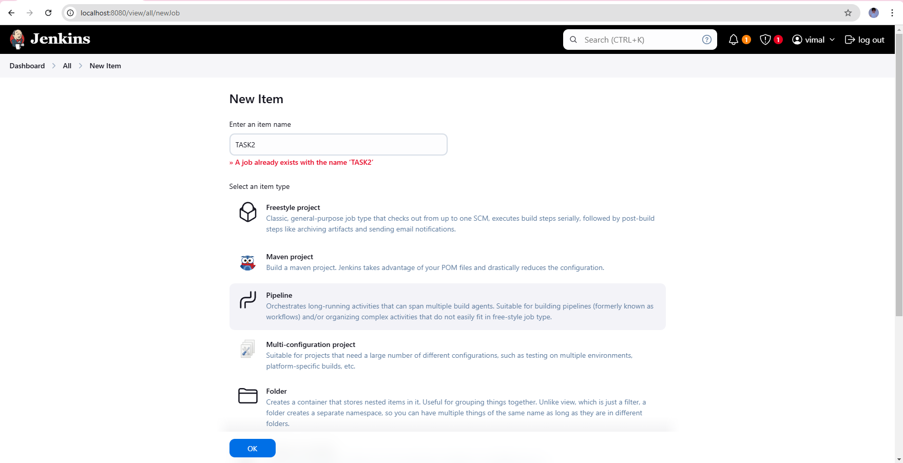

STEP5: CHOOSE GITHUB HOOK->CHOOSE DEFINITION SCM->CHOOSE GIT& GIVE GITHUB REPO LINK:

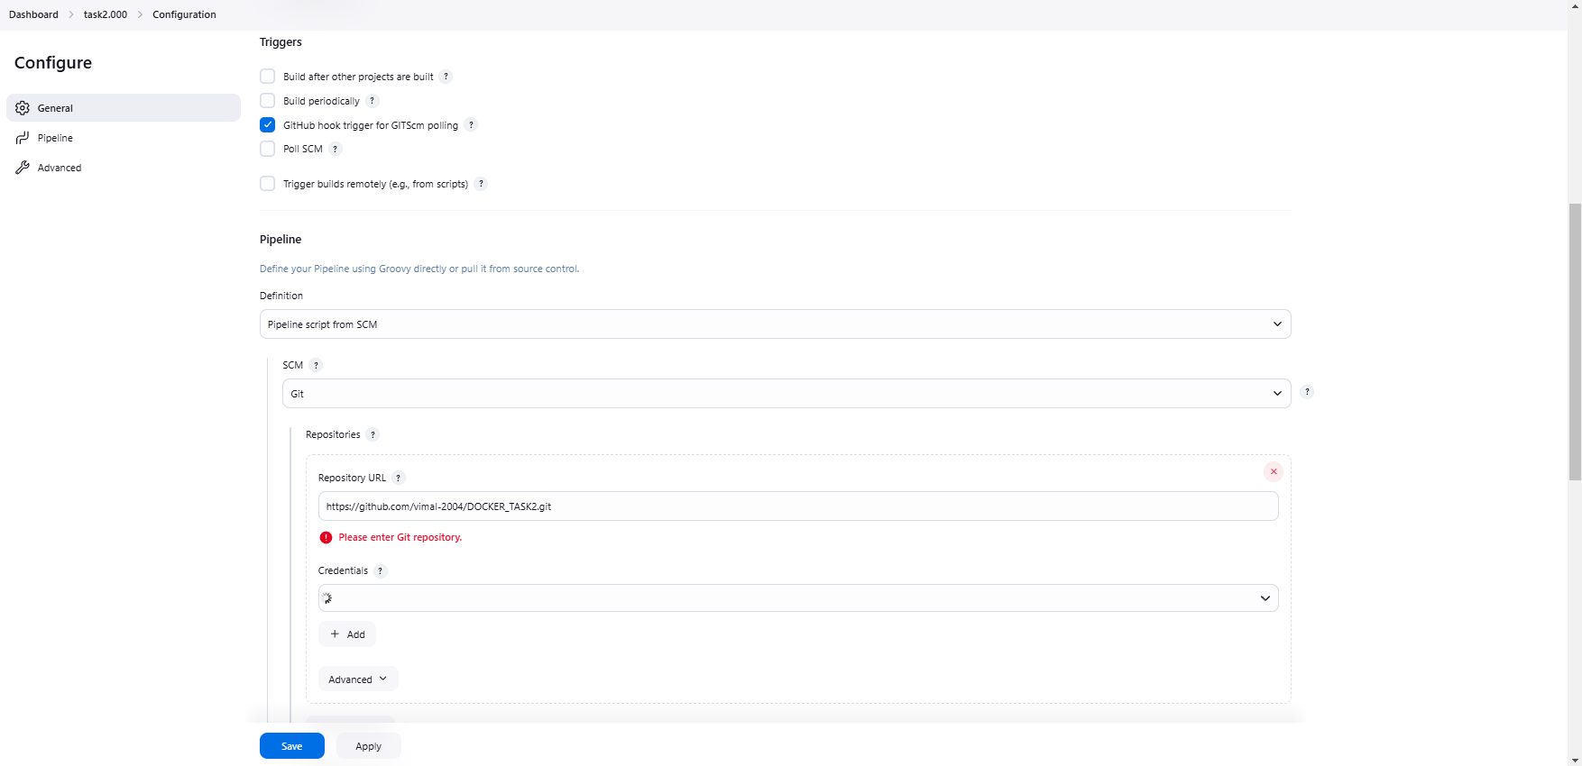

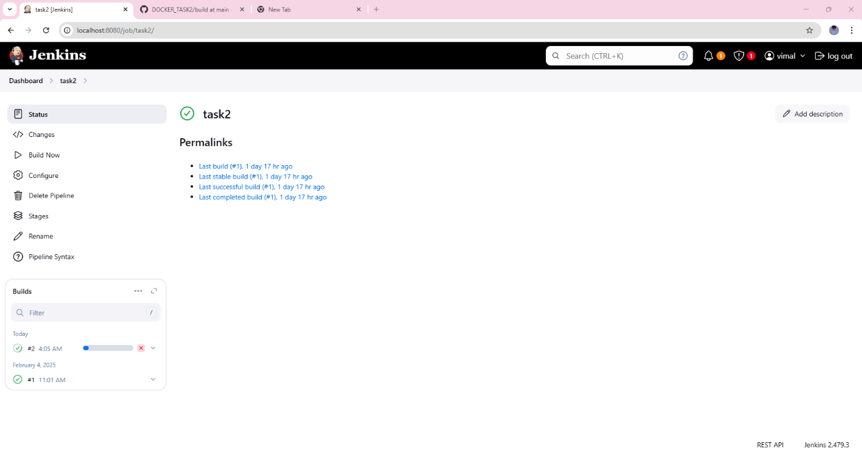STEP6: RUN THE TASK 2 BY USING BUILD NOW :

STEP6: OUTPUT IN LOCALHOST:93