**TASK 3**

STEP1**:** Installation 🡪 choose linux ->debian packages

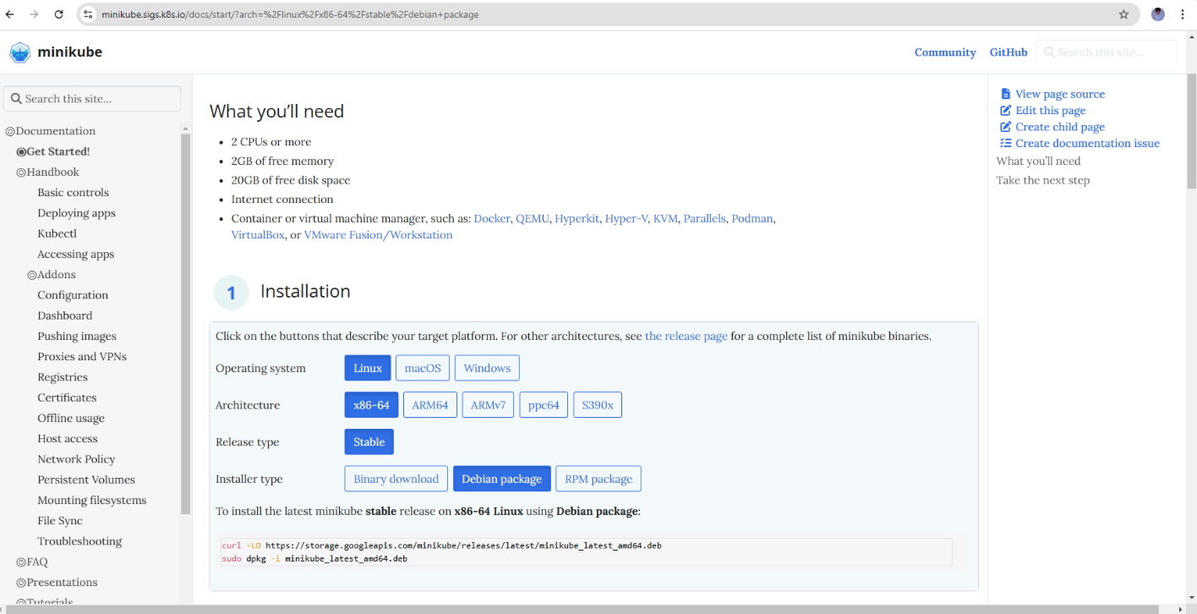

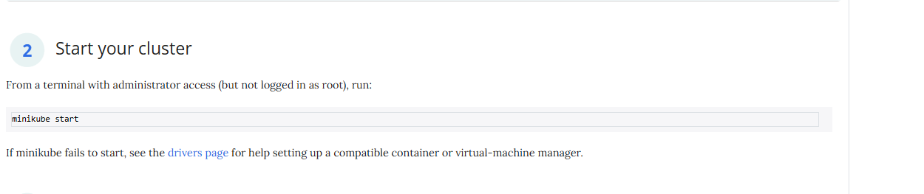

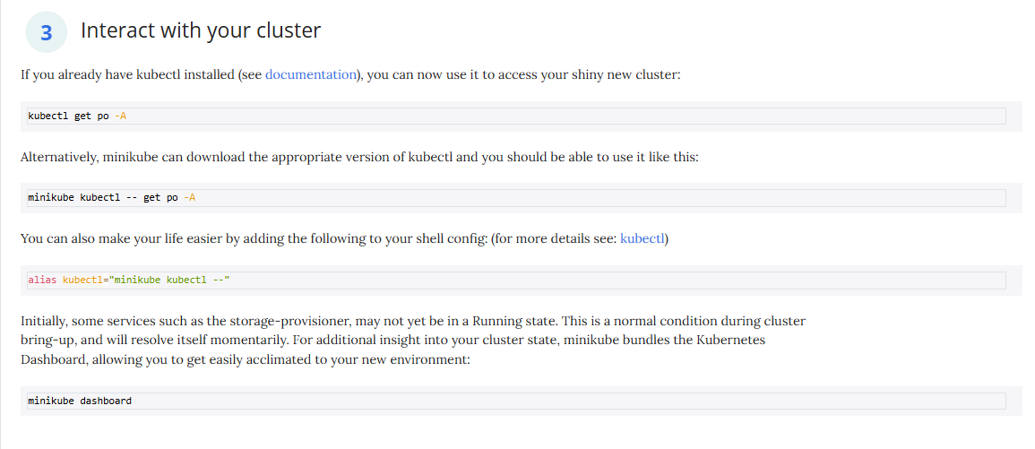

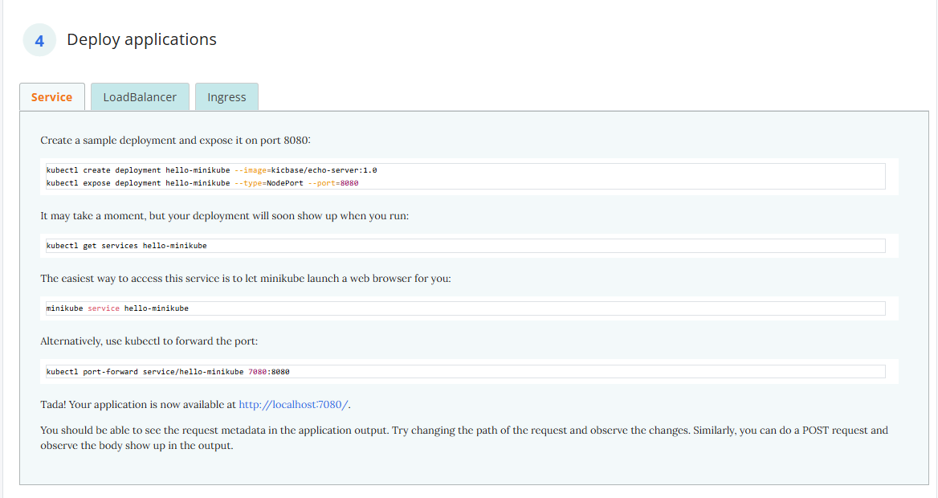

STEP2: by using ubuntu apply all the above commands for installation

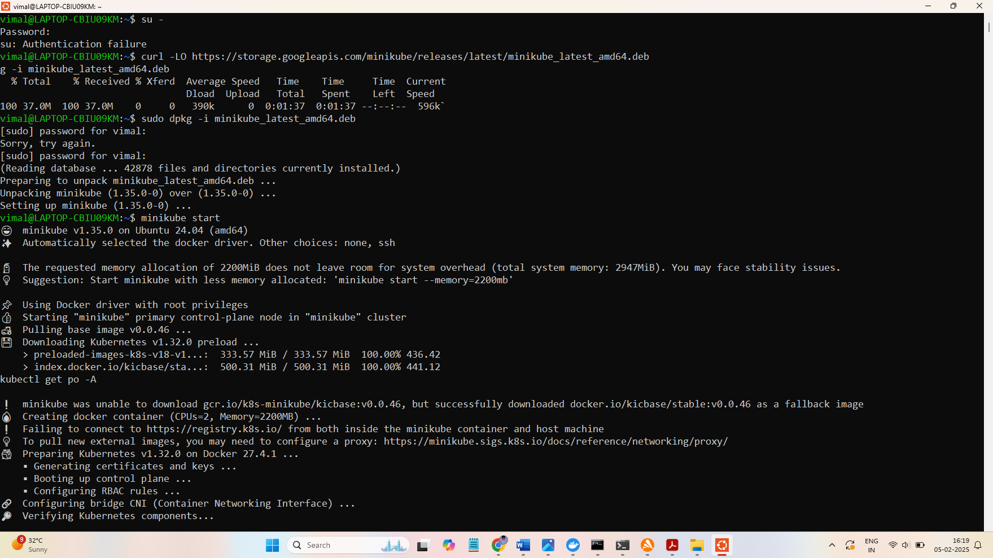

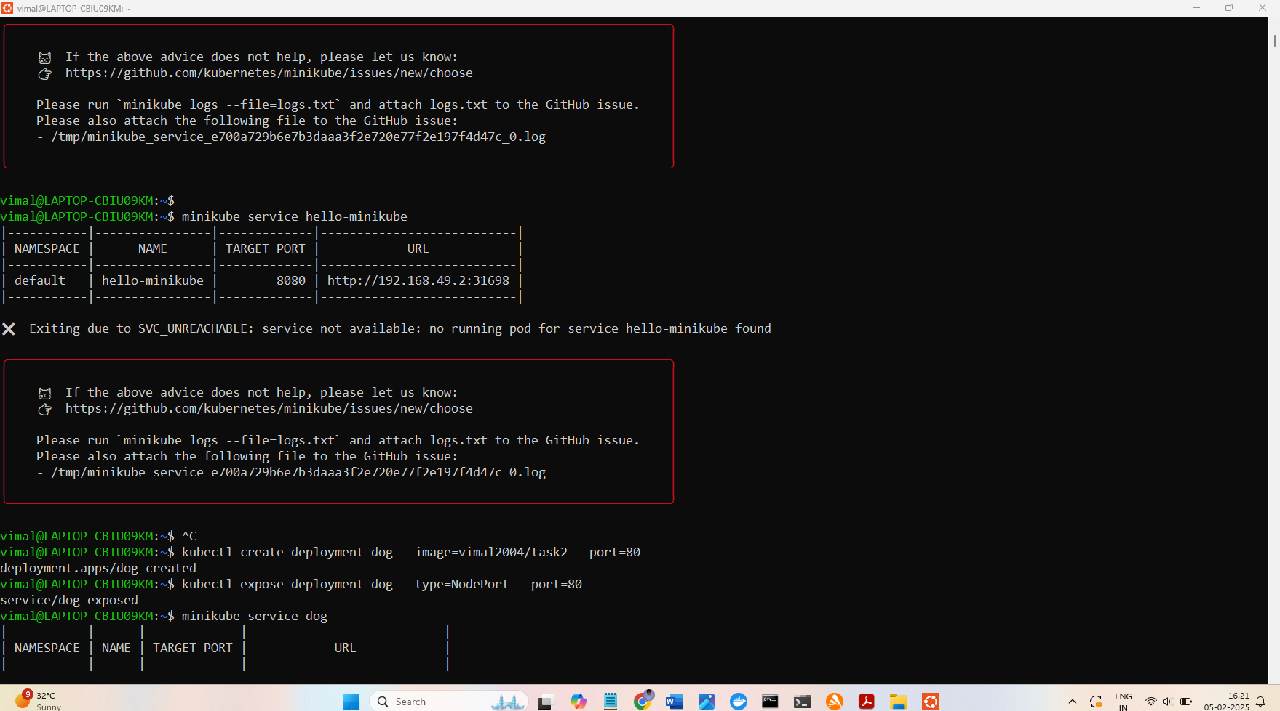

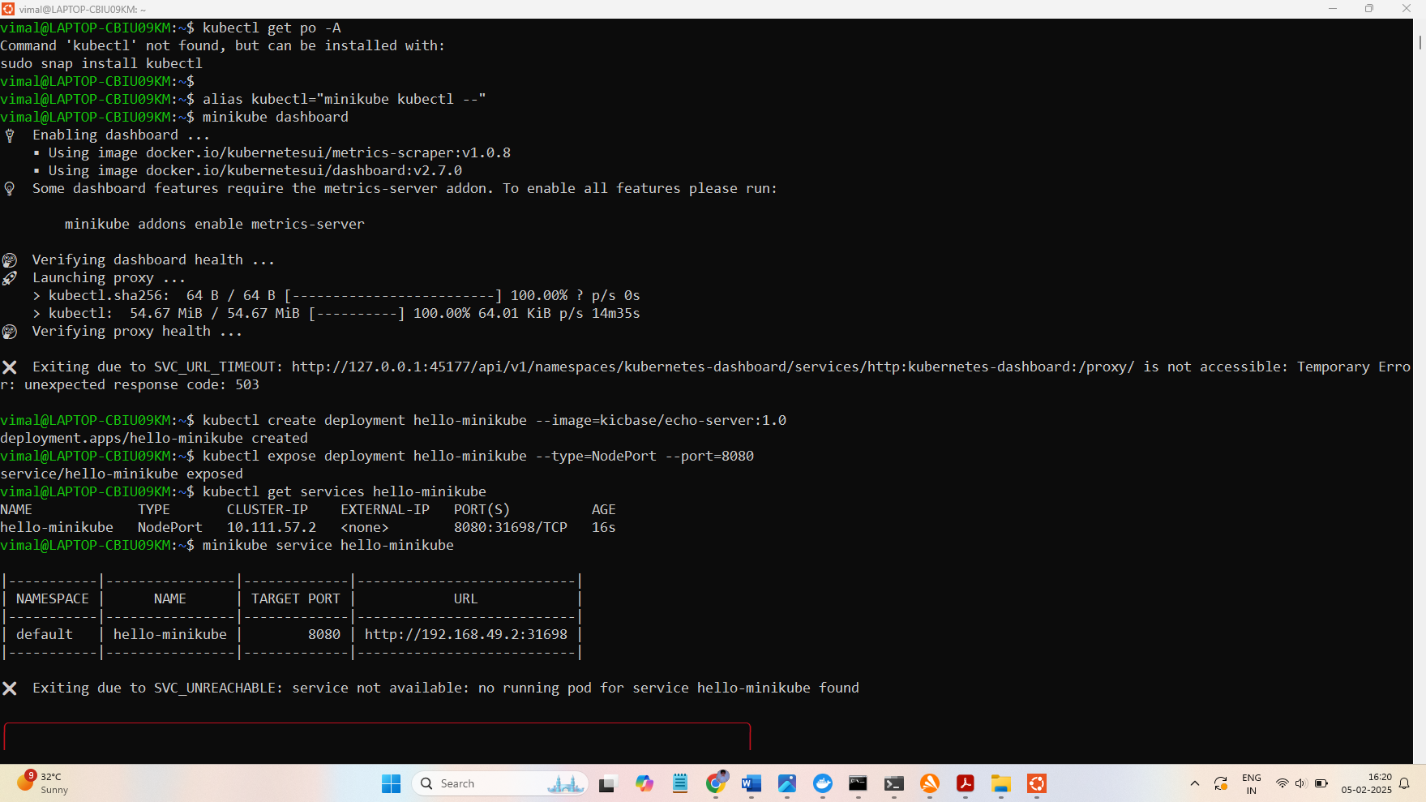

STEP3: Add the docker hub user name and the task name

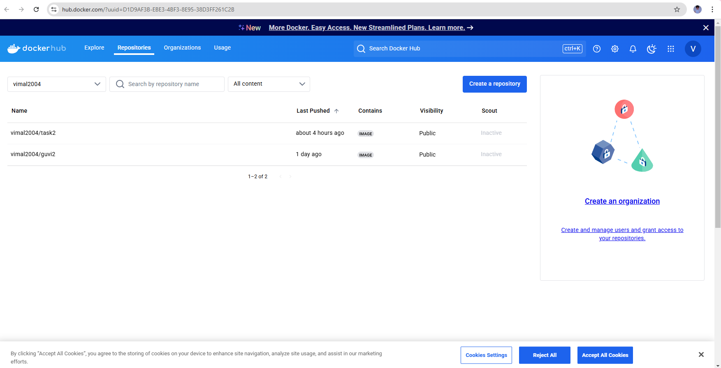

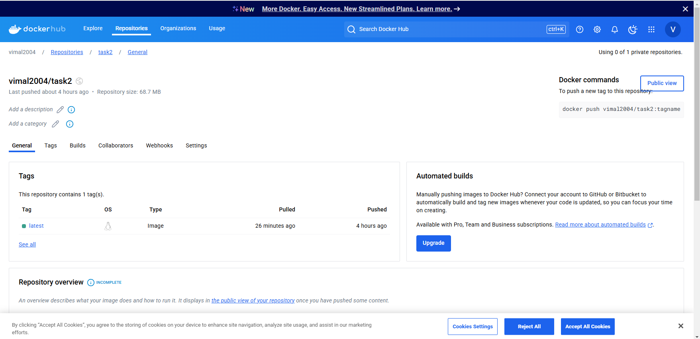

HERE I GIVE : kubectl create deployment dog --image=vimal2004/task2 --port=80

Dog 🡪 image name

Vimal2004 🡪 docker hub user name

Task2 🡪 my taskpipeline name

Port 🡪 80

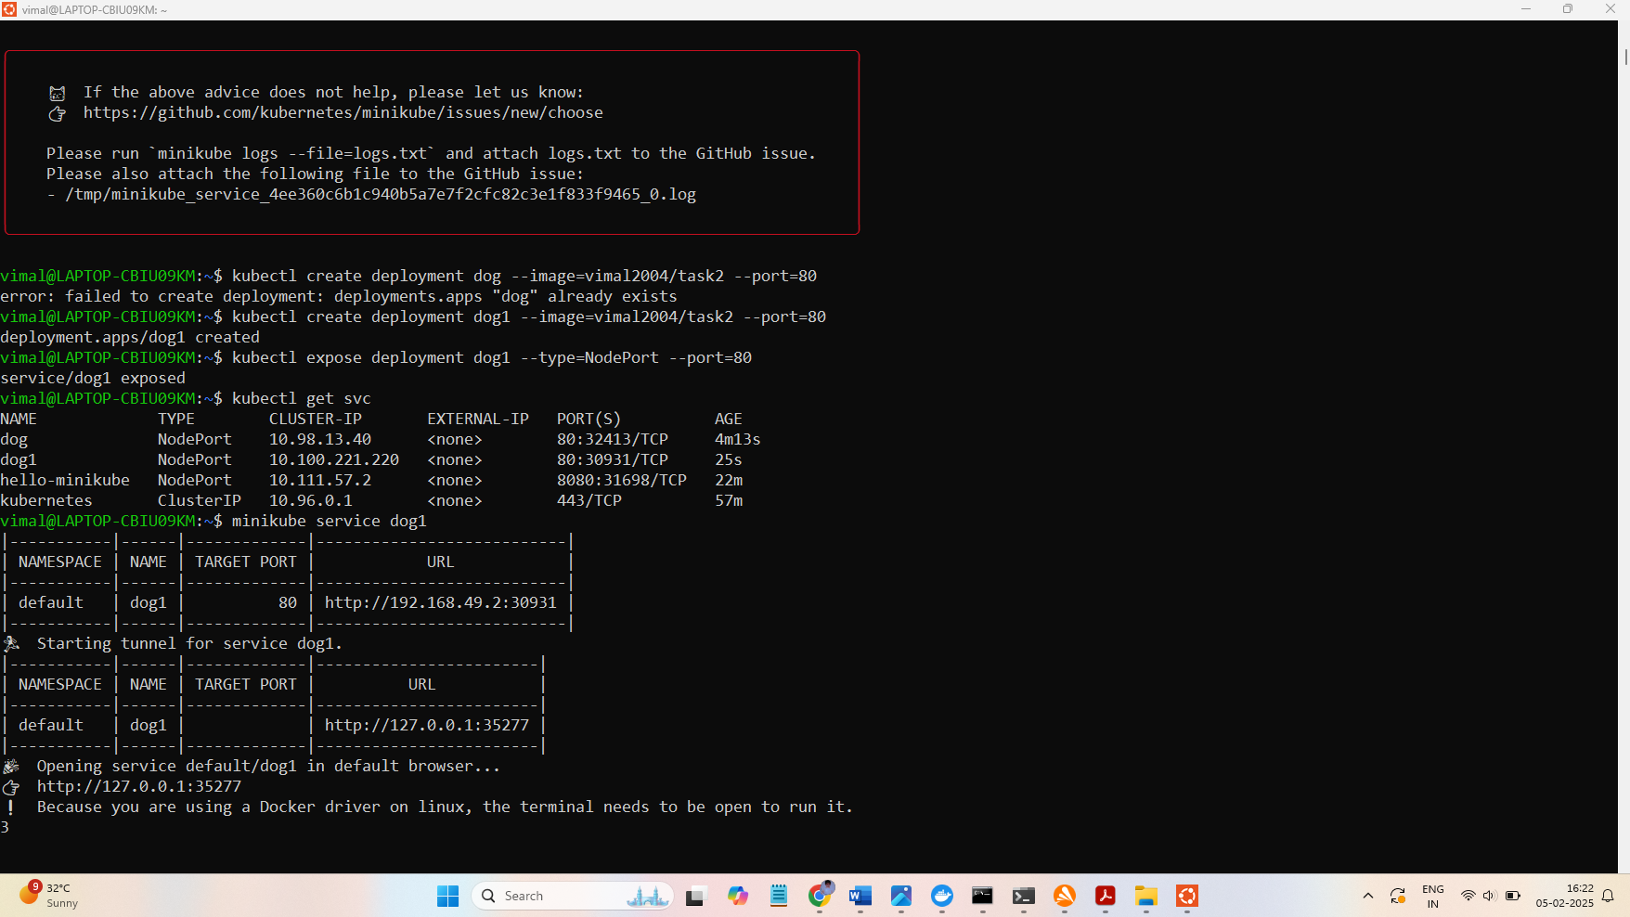

**STEP4:**

After that copy the second http url link and run on your local host   
  
here I run the second url which is  
  
<http://127.0.0.1:35277>  
  
  
  
then it show our task output 