DEVOPS

TASK-4

vimal-22ISR059

step1: vim file .txt paste the code and give escape+shift :wq



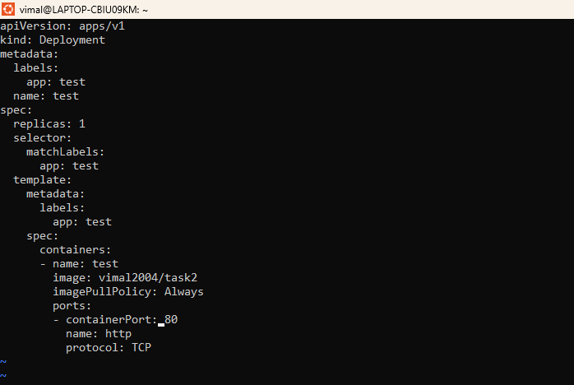

Step2: vim expose.txt , paste the code and give escape+shift :wq



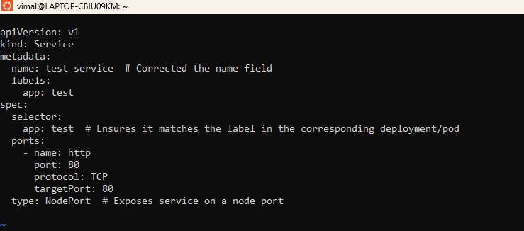

Step3: run🡪 kubectl apply -f file.txt

run 🡪kubectl apply -f expose.txt

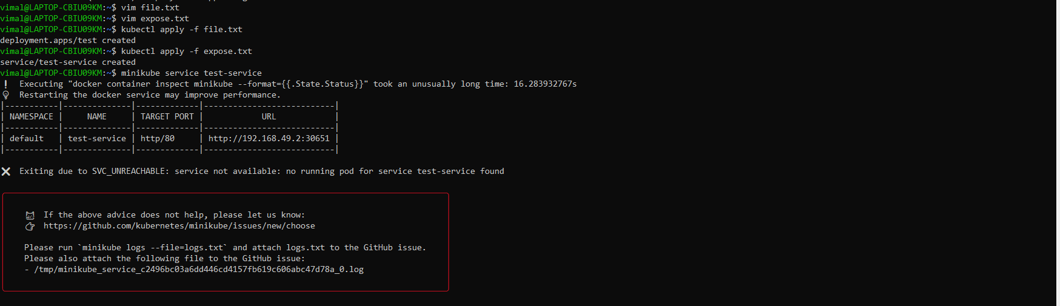

The above error is occurred for Docker is not login

To solve the issue give “ docker login “ -> give username &password

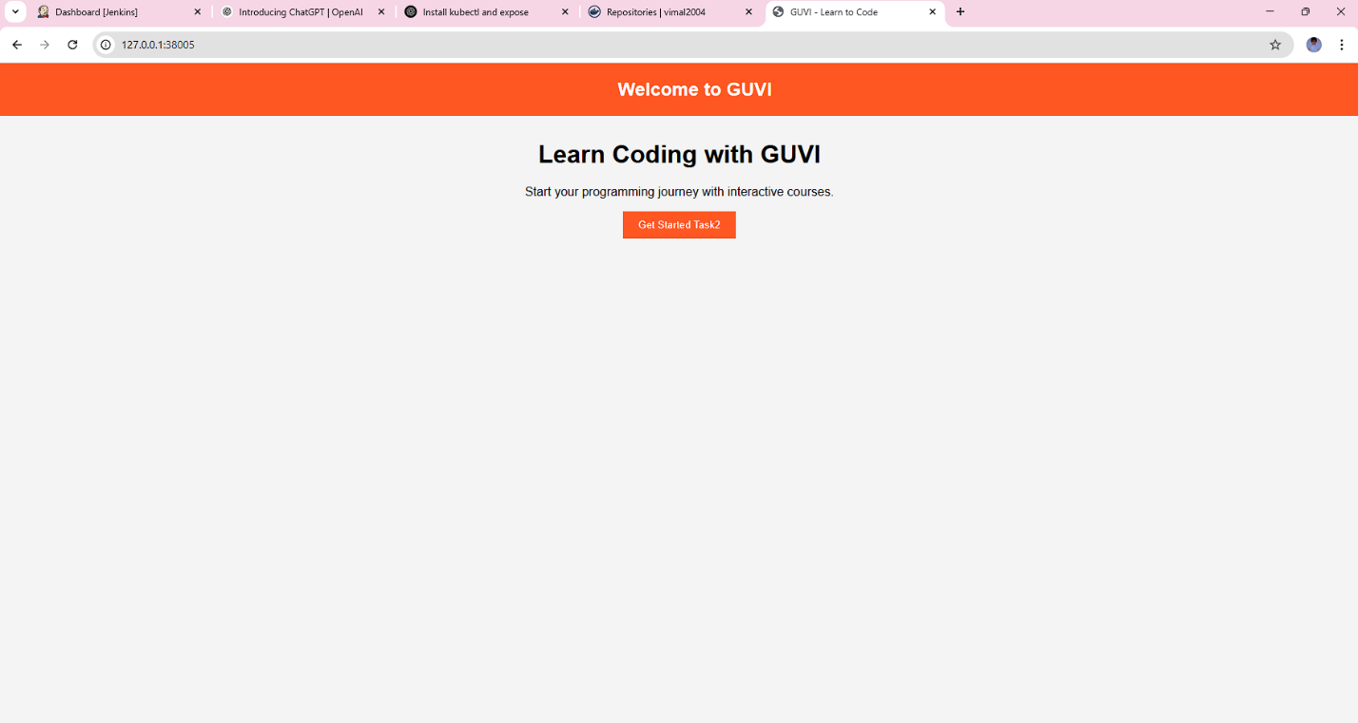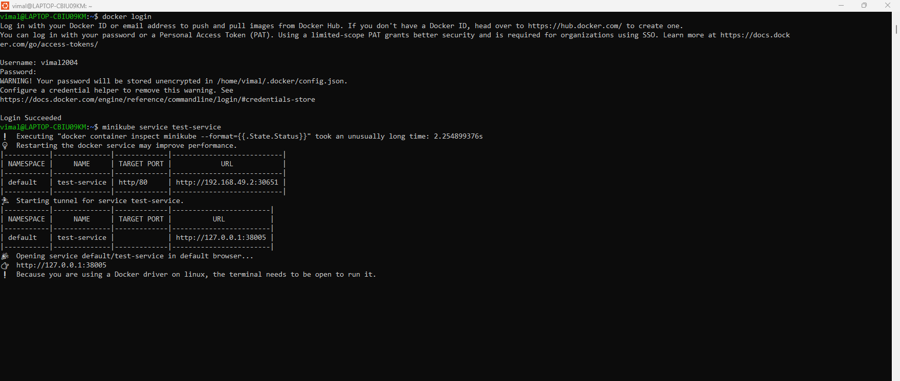

Step4: copy the second url ,then run your localhost