# **AI-Powered Adaptive Quiz**

# “A learning platform designed with Generative Artificial Intelligence and Machine Learning”

# **1. Introduction**

### **1.1 Problem Statement**

The standard methodology employed in a classroom environment or teaching online is a one-size-fits-all approach to education that accounted for pacing and the level of difficulty not being determined before being introduced to learners. In educational settings, these methodologies presume a "fixed difficulty level" exists as a variable in pace, knowledge gaps, or when the learner is ready to transition to higher levels of accomplishment:

* Repetition of ideas they already know.
* Being exposed to material that is either too simple, which leads to boredom, or too complex, which leads to frustration.
* Insufficient customization and feedback, which leads to lower engagement and poor retention. These flaws make it difficult to transfer knowledge effectively and do not take into account different learning styles.

Adaptive learning systems that can:

* Dynamically modify tests and content based on a learner's performance in real-time;
* Offer prompt feedback, astute hints, and direction to reinforce learning are desperately needed to overcome these constraints.
* Predict the optimal difficulty of content and track progress through a spectrum of topics.

To address this challenge, we have created an adaptive quiz system based on artificial intelligence that uses machine learning algorithms, generative AI, and user interfaces to deliver a tailored, performance-oriented learning environment.

### **1.2 Objectives**

The primary aim of the AI-Powered Adaptive Quiz Game is to develop a scalable, smart, and modular platform that applies adaptively generated quizzes and insights to enhance student engagement and learning efficiency. The objective of this project is to bridge the gap between customized learning paths and mass-testing.   
. Among the specific objectives are:

* **Auto Quiz Making:** Depending on a adjusted T5 transformer model, this way creates questions that fit a certain field on topics chosen by the learner and related text.
* **Dynamic difficulty level** prediction, based on a learned XGBoost classifier, varies quiz levels (easy, medium hard) in real time according to user performance accuracy, average response time to questions, and retry behavior.
* **Gameified Feedback System:** User motivation raised right away through streak tracking, AI difficulty analysis insights, and motivational messaging.
* **Performance monitoring** generates for users detailed dashboards showing improvement statistics, topic-based performance and score progress to steer future learning.
* **Personalized Learning Suggestions**: AI-powered learning recommendations based on the quiz performance and subject-matter proficiency of each learner for personalized YouTube tutorials and course links.
* **End-to-end integration** includes the process of building a dynamic and adaptive learning environment with the integration of a robust backend system, Technology used was e.g., Node.js, Flask, and MongoDB, with advanced frontend frameworks including Next.js and Tailwind CSS.

This project forms the foundation for an intelligent tutoring system that promotes ongoing knowledge construction and, in turn, adapts to the learner, in accordance with the objectives of adaptive learning and individualized learning.

## **2. Literature Review**

Generative AI has transformed the education scene in the past few years. AI has made it possible to create custom lessons, quizzes, learning routes, and even completely interactive experiences. Learning is becoming more engaging, fascinating, and customized to every student's individual needs because of this shift.

Dickey and Bejarano's GAIDE framework (Generative AI for Dynamic Educational Content) is a popular approach in this area. Their model emphasizes applying AI to generate educational content, like puzzles and quizzes, automatically. Without losing the flexibility and personalization of the content for students, the aim is to reduce the manual effort for teachers.

Teachers can then use AI to adapt the material to students' needs instead of making static tests or assignments, leaving them time to focus on teaching rather than content creation [1].

Added to this, Łodzikowski, Foltz, and Behrens highlighted the ways in which AI can enhance adaptive learning. Their research elucidates how AI systems can analyze a student's performance and alter the difficulty level of the content in response. For example, the system will steadily increase the level of difficulty in the questions if a student is consistently answering them correctly. It will, however, slacken and give simpler questions to enhance confidence if they're struggling. It's a good tactic to maintain students interested but not overwhelmed. However, they also raise ethical issues, especially ensuring that AI does not inject bias or inexact information in the learning material [2].

Platforms like AI Dungeon have already proved how a student can interact with content through choices which affect the storyline lesson adjustments[3][4].

The use of AI chatbots in classrooms such as ChatGPT has leverage. Students are enabled to ask questions using these resources and get elaborate answers instantaneously. Though it is of great help, the use needs to be smart, as a supplement to rational thinking and not a replacement. It should be ensured by the educators that rather than answering questions, these resources stimulate questioning and reasoning.[5].

In conclusion, it is evident from the body of research that generative AI is revolutionizing education. AI is enhancing the impact and customization of education through immersive storytelling, personalized learning pathways, and real-time adaptive quizzes.To ensure that these technologies actually aid in the development of each learner, it is equally critical to address issues with accuracy, bias, and ethical use.

### **3. Technologies Employed**

#### **Backend:**

1. **Express.js and Node.js**
   * The AI-Powered Adaptive Quiz Game's backend is built with Node.js. The platform can manage large numbers of concurrent connections in real time thanks to this server-side JavaScript runtime. It is renowned for having an event-driven, non-blocking architecture, which makes it perfect for real-time processing applications like live feedback and quizzes.
   * The API server is constructed using the Express.js framework. It is a simple web framework for Node.js that makes managing HTTP requests, middleware integration, and routing easier. By processing incoming requests and providing the relevant information, Express assists in managing user authentication, quiz submissions, and interactions with AI models.
2. **Python Flask**
   * The AI-Powered Adaptive Quiz Game uses Flask as its backend framework for its machine learning models. For supporting machine learning models, it is incredibly versatile and lightweight. Setting up endpoints that provide model predictions, like figuring out the quiz's difficulty or creating customized quiz questions, is done with Flask.
   * Serving XGBoost and other quiz difficulty prediction models, where the model's output is sent back to the frontend in real-time, is where it excels.
3. **XGBoost**
   * A strong and effective machine learning algorithm called XGBoost is used to forecast a user's quiz difficulty. It examines information such as the user's prior performance, quiz attempts, time spent on each question, and retries. This ensures a balanced learning experience by assisting in determining whether the subsequent set of questions should be easier, harder, or of comparable difficulty.
   * By dynamically modifying quiz difficulty based on student performance, XGBoost, which excels at predictive tasks, contributes to the intelligence of the adaptive learning system.
4. **Pickle in Python**
   * The trained machine learning models (such as the XGBoost model) are serialized using Pickle. It allows the models to be saved and serialized to the disk, so they can be loaded without retraining each time the application starts. This leads to efficient model reuse and faster application startup.

#### **Frontend:**

1. **Next.js**
   * The AI-Powered Adaptive Quiz Game's frontend is constructed with the React-based Next.js framework. Building a quick, scalable, and SEO-optimized web application is made simple with Next.js's full-stack solution. Server-side rendering (SSR) and static site generation (SSG), two essential Next.js features, guarantee quick performance and more seamless user interactions. Routing, page management, quiz display, and the user interface as a whole all use it.
2. **React.js**
   * React.js is used to create interactive, reusable, and dynamic user interface elements. Reactpowers the quiz interface in the game, managing dynamic updates like question display, multiple-choice answer provision, user input processing, score updating, and real-time feedback.
3. **Tailwind CSS**
   * The frontend is styled using Tailwind CSS, a utility-first CSS framework. With predefined utility classes for styling components, it enables quick and adaptable UI design. Tailwind offers a clear, responsive, and consistent user interface for the quiz game and speeds up development by eliminating the need to write custom CSS.

#### **Machine Learning:**

1. **T5 (Generative AI for Quiz Generation)**
   * Using provided content, quiz questions are dynamically generated using T5 (Text-to-Text Transfer Transformer). T5 converts user-provided topics or text passages into multiple-choice questions. This method guarantees that the quiz material stays current and adjusts to the student's current area of interest, resulting in a personalized and captivating learning experience.
   * Additionally, T5 uses past answers to modify the questions' level of difficulty, establishing an intelligent feedback loop that tailors the information to each user.
2. **XGBoost**
   * XGBoost is essential for forecasting future question difficulty based on learner performance. It assesses metrics related to user performance, such as retries, accuracy, and response time. By utilizing these features, XGBoost optimizes the user's learning curve by modifying the quiz's subsequent questions' difficulty so that it is neither too easy nor too hard.
3. **SVD (Singular Value Decomposition) for Personalized Recommendations**
   * To suggest customized quiz questions, collaborative filtering employs SVD (Singular Value Decomposition). SVD assists in identifying performance similarities by examining the patterns of prior users' responses and makes question recommendations based on users' strengths and weaknesses. By tailoring the material to the learner's level of understanding, it helps to make the quiz experience more unique.

#### **Data Handling and Visualization:**

1. **NumPy & Pandas**
   * Data processing and manipulation are done with NumPy and Pandas. Large array handling and mathematical operations, including averaging and processing numerical data for machine learning, fall under the purview of NumPy. Pandas assists in cleaning and organizing the data so that it can be fed into the models. Additionally, it is employed for tasks like data splitting, filtering, and user performance trend analysis.
2. **Matplotlib & Seaborn**
   * The user's progress is visualized using Matplotlib and Seaborn. For instance, Seaborn creates more intricate statistical plots that assist in analyzing correlations and distributions within the quiz data, offering insights into topics like quiz difficulty and student performance, while Matplotlib creates line graphs that show score progression.
3. **Scikit-learn**
   * A machine learning library called Scikit-learn offers resources for data preprocessing, dataset splitting, and model performance evaluation. It is used to divide the quiz data into training and testing sets, scale and normalize the data for machine learning, and assess the accuracy of the model.

**4. System Architecture**

The AI-Powered Adaptive Quiz Game system is designed using a modular, multi-layered architecture. It offers a smooth, customized learning experience by integrating the database, frontend, backend, and machine learning models.

#### **Frontend (React.js + Next.js)**

React.js and Next.js, when combined, provide a quick, responsive, and scalable frontend. It is made to manage real-time interactions, customized user feedback, and dynamic quiz creation.

* **Handling User Input:** Gather information like Time Spent, Question ID, User ID, and Past Answers.
* The quiz interface shows questions, multiple-choice answers, and instant performance feedback.
* **Results Display:** Users can view their performance, the AI-predicted level of difficulty, and customized suggestions after finishing the test.

#### **Backend (Node.js + FastAPI)**

The backend is in charge of managing user sessions, responding to API queries, and interacting with machine learning models to deliver real-time predictions and suggestions.

* **Handling User Interaction:** The backend processes the data (time, answers, etc.) sent by the frontend and uses machine learning models to predict the degree of difficulty and produce suggestions.
* **Integration of Models:** T5 and XGBoost are called by the backend to generate quizzes and make predictions.
* **Feedback in real time:** The frontend receives real-time answers, quiz difficulty, and suggestions from the backend.

#### **Machine Learning Models:**

1. Using context or specific topics, T5 (Generative AI for Quiz Generation) creates dynamic quiz questions.
2. Based on user performance data, XGBoost (Performance Prediction) forecasts the ideal level of difficulty for forthcoming tests.
3. Personalized Question Recommendations, or SVD, make question recommendations based on user similarity and past performance.

#### **Database (MongoDB)**

User data, such as quiz results, historical performance, and user interactions, are stored and managed using MongoDB. This enables the system to monitor development over time and modify tests to suit the needs of the student.

### **System Architecture Diagram**

The AI-Powered Adaptive Quiz Game's information flow is explained by the following system architecture diagram:

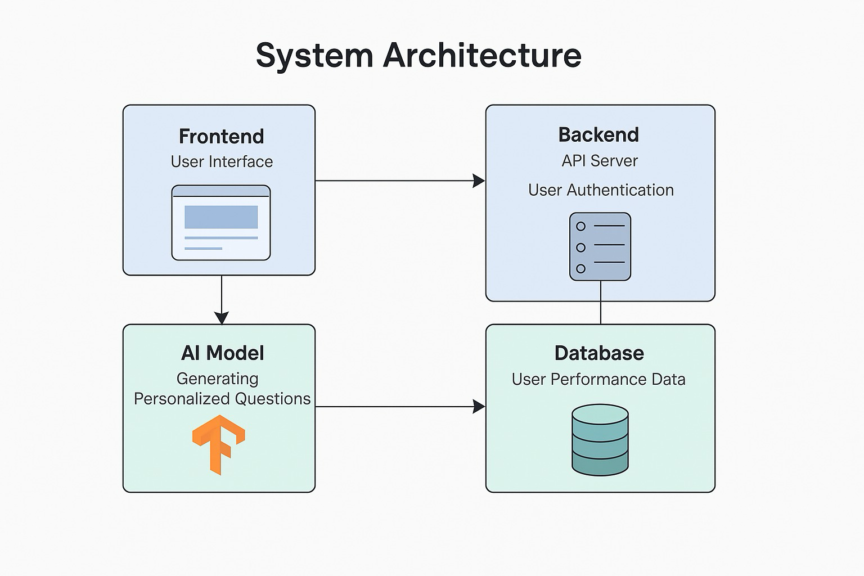

Figure 1: Architecture of an AI-Powered Learning System

This diagram shows the architecture of an intelligent learning platform with four main parts: (1) a database that stores user performance data; (2) a backend that manages authentication and API services; (3) an AI model that creates customized questions; and (4) a frontend user interface for learner interaction. The system creates a customized learning experience by dynamically adjusting instructional materials to each learner's needs. Through the use of AI-driven personalization and user progress analysis, the platform seeks to maximize engagement and retention of knowledge while preserving scalability for future improvements.

**Important characteristics:**

* AI personalization for adaptive learning
* Safe user verification
* Data-driven monitoring of performance
* Expandable modular design

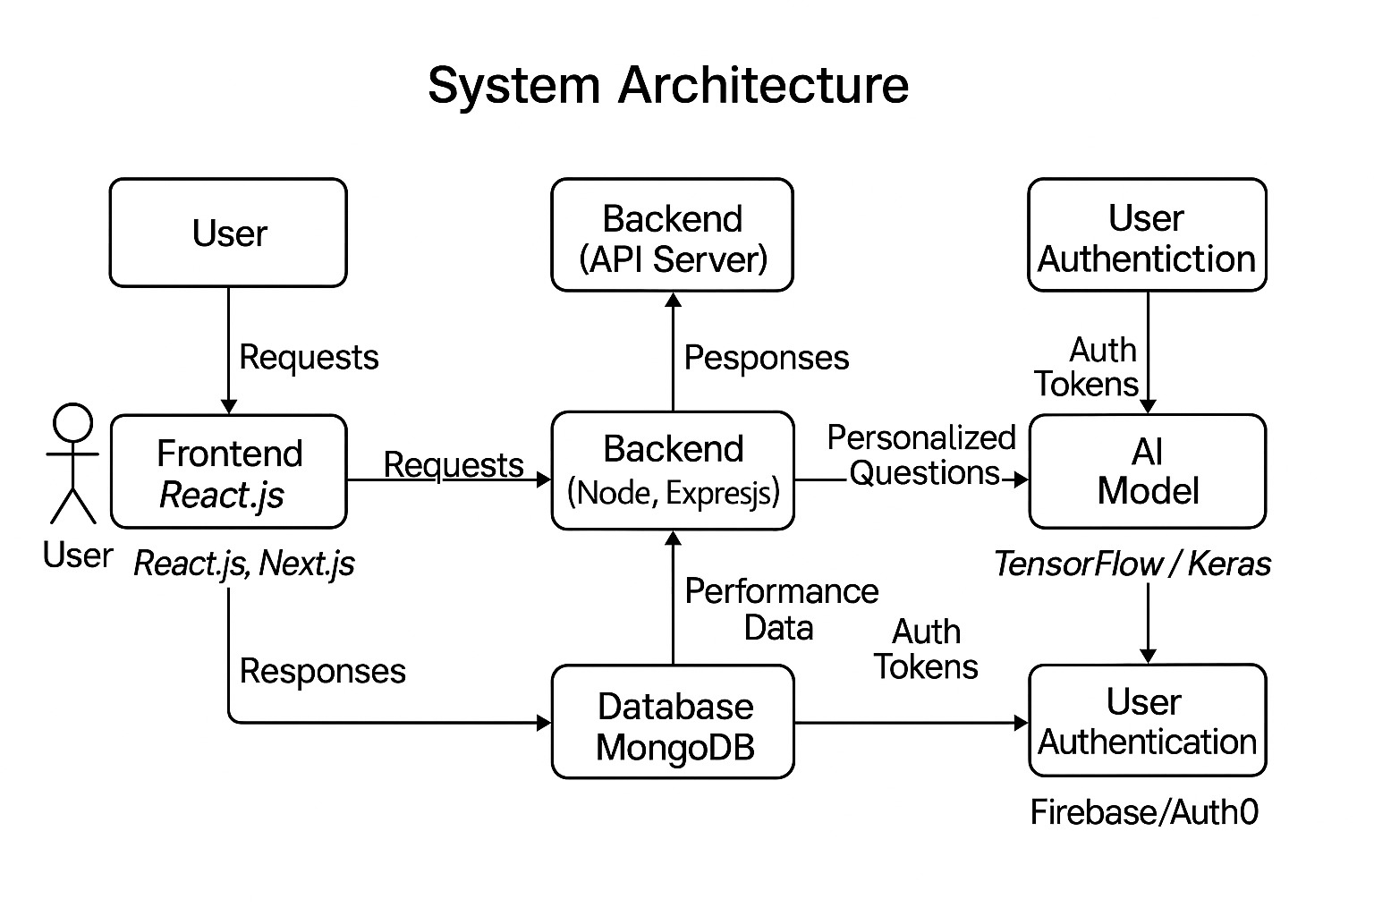

Figure 2: Workflow of an End-to-End Learning Platform

This architecture diagram shows how an AI-enhanced learning platform would operate:

* **User Interaction:** Students use a React.js/Next.js frontend to submit requests.
* **Backend Processing:** API routing and authentication are managed by the Node.js/Express.js server.
* **Integration of AI:** Customized question sets are produced by the TensorFlow/Keras model.
* **Data Layer:** User performance metrics are stored and retrieved by MongoDB.

**Technical Flow:**

User → Frontend → Auth Request → Backend → AI Model → Database ② Database → AI Model → Backend → Frontend → Customized Response → User

**Important attributes:**

* The JavaScript ecosystem (React, Node) for full-stack efficiency is the modern stack.
* **Safe Access:** Dedicated user management auth layer
* **Dynamic Content:** Question generation driven by ML adjusts to each person's development
* **NoSQL Flexibility:** Schema-less performance tracking is made possible by MongoDB.
* **Execution Note:** Bidirectional data flow between components is indicated by arrows.

Figure 2 outlines implementation technologies and request/response patterns for development guidance, whereas Figure 1 depicts conceptual blocks.

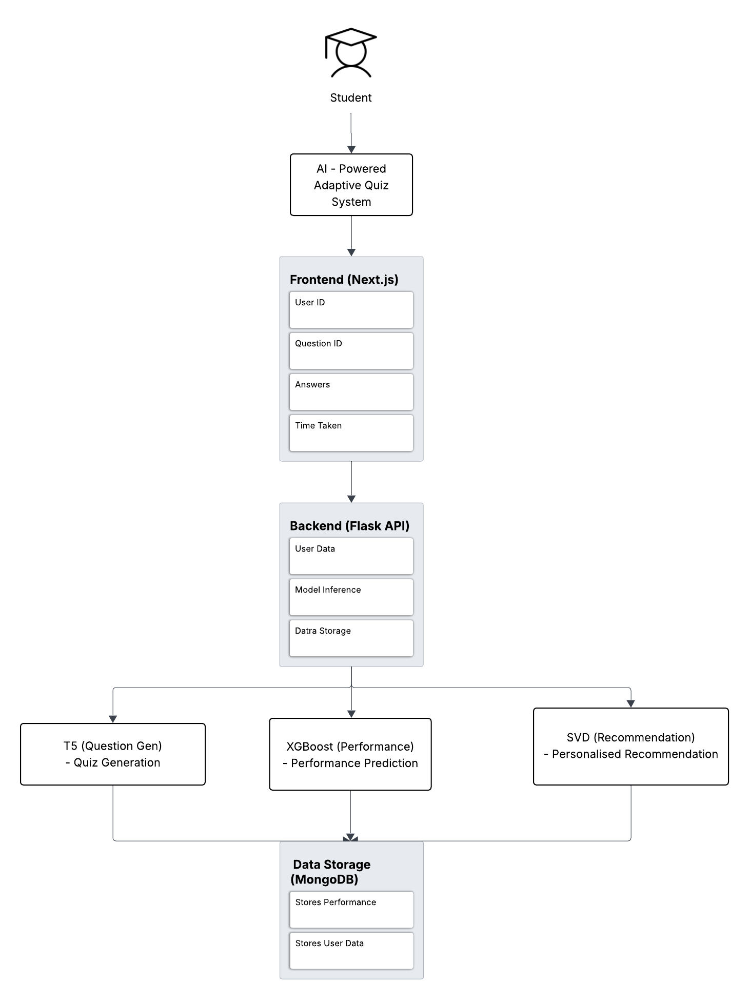

Figure 3: Adaptive Quiz System Driven by AI

Students engage with the system at the outset via a Next.js frontend that gathers quiz results (answers, time spent). This information is sent to a Flask backend, which manages three essential AI tasks: (1) XGBoost forecasts student performance, (2) SVD offers tailored suggestions, and (3) TS Model creates new quiz questions. In order to create a continuous improvement loop where each interaction improves quiz personalization in the future, all user data and results are stored in MongoDB. Real-time adaptation to unique learning styles is made possible by the architecture, which also ensures safe user data management.

**Important elements:**

* **Frontend:** The Next.js user interface
* **AI Models:** TS/XGBoost/SVD trio Backend: Flask API processor
* **Database:** MongoDB storage

**Data Flow Diagram**

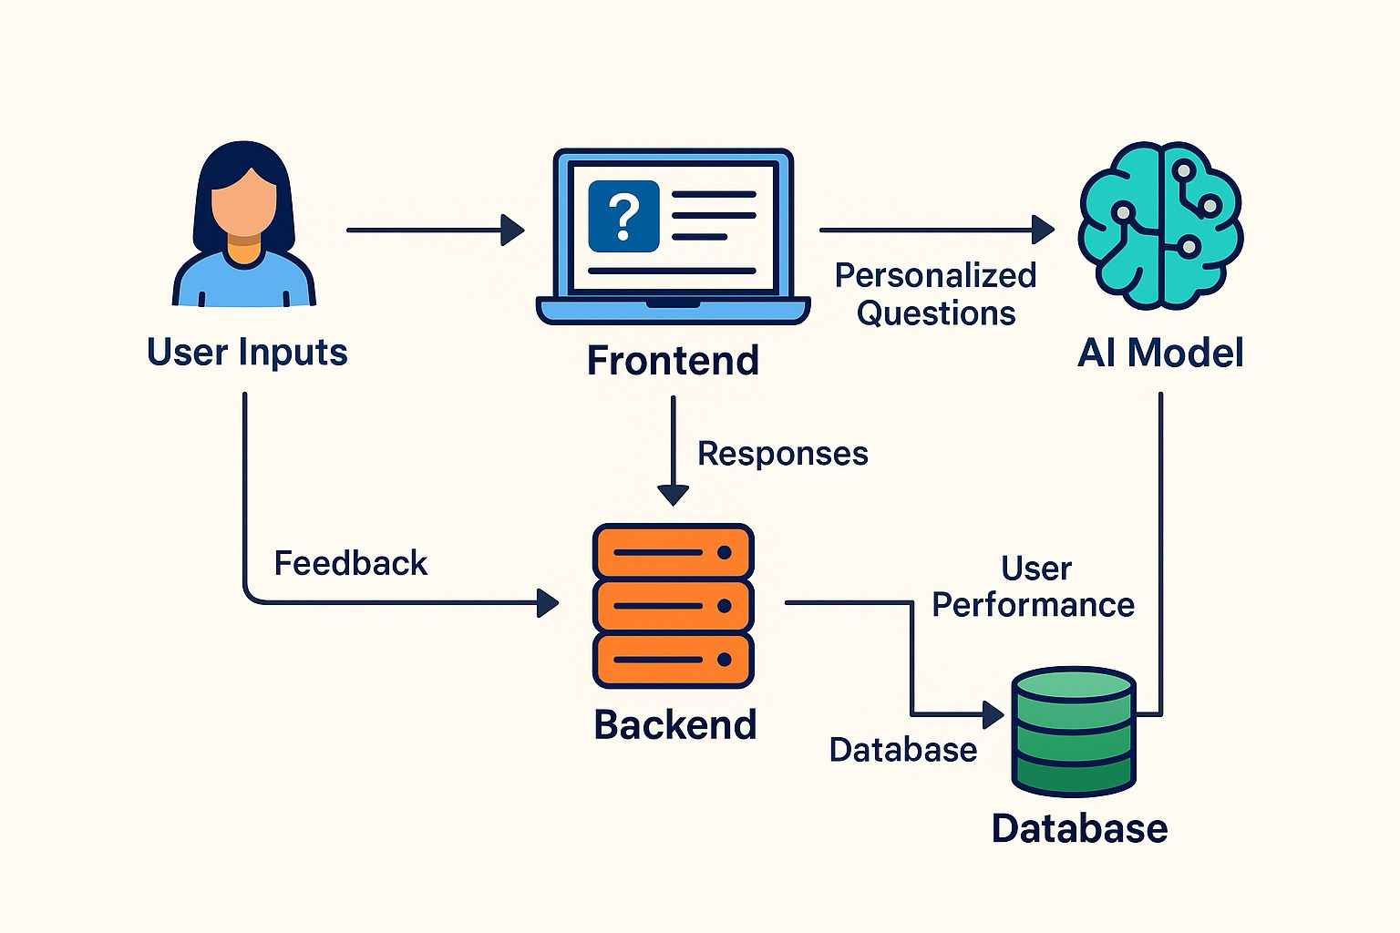

Figure 4: A Learning System Driven by User Feedback

An AI-powered learning system is depicted in this diagram, where users provide input and feedback via a frontend interface. The data is then sent to backend servers for processing. In order to create a continuous improvement loop that provides the user with more individualized educational content, the system uses this data in conjunction with user performance data that has been stored in the database to generate personalized questions and recommendations using its AI model.

**Component Interaction Diagram**

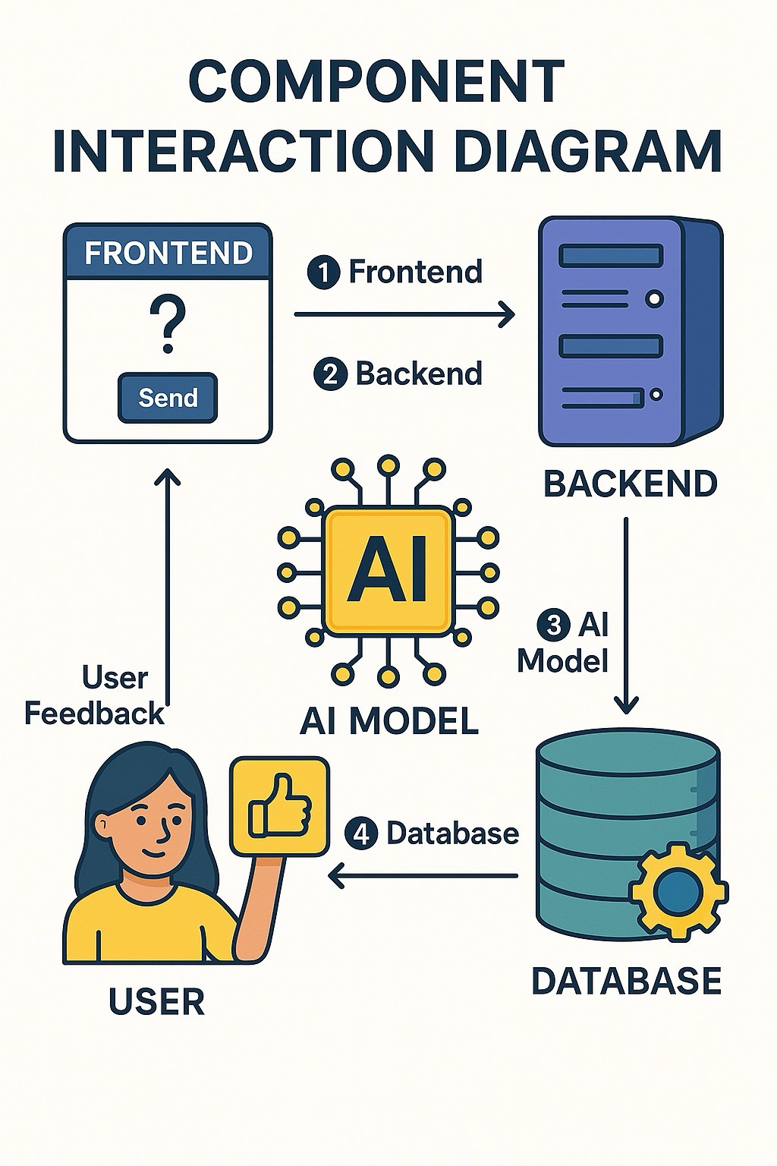

Figure 5: Diagram of Component Interaction

The workflow between the main system components is depicted in this diagram:

* The frontend is used by the user.
* Data is sent from the frontend to the backend.
* Information is processed by the backend using an AI model, and the results are saved in a database. The AI model then provides the user with feedback.

**Quiz Interface Preview**

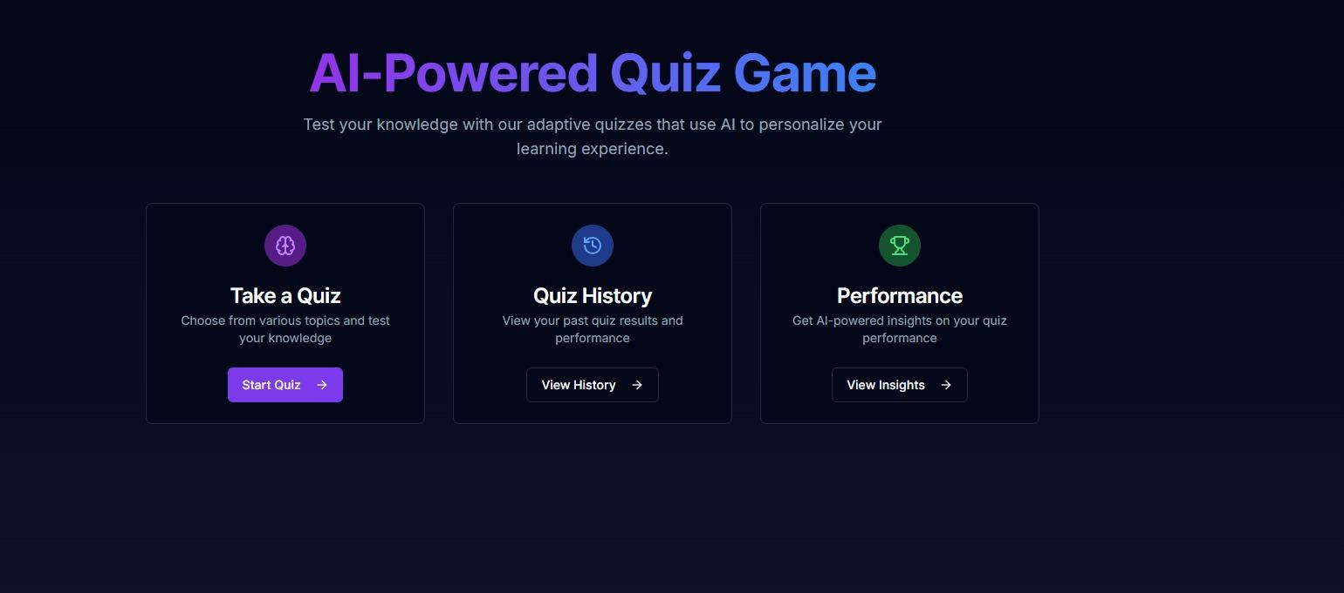

Figure 6: Quiz Dashboard: Main menu with history, AI-powered performance insights, and quiz selection.

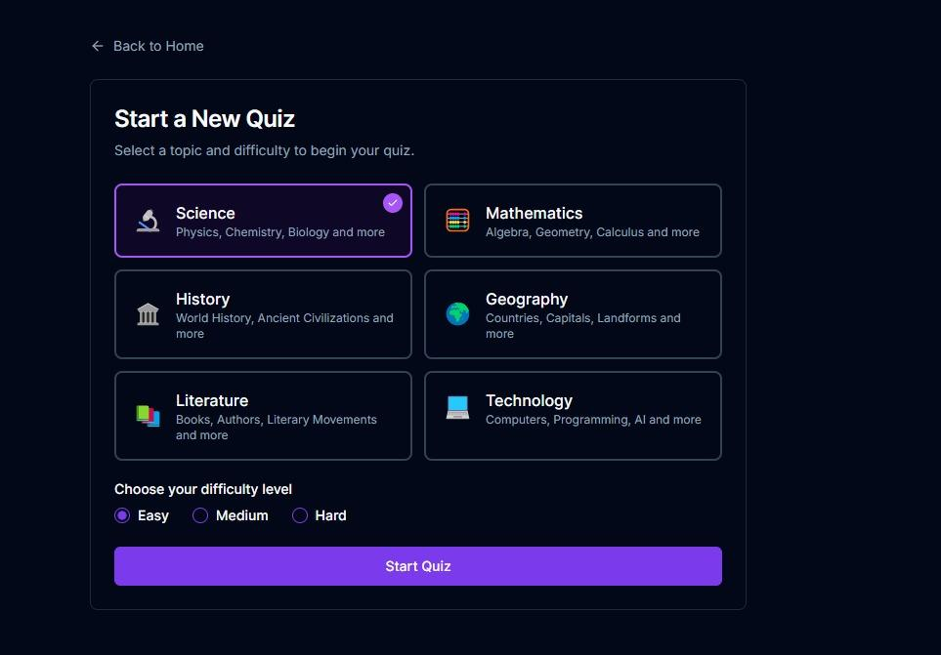Figure 7: Quiz Selection Screen.

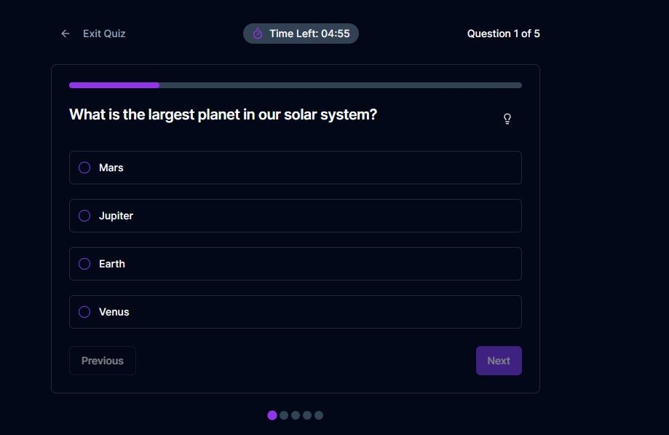Figure 8: A multiple-choice question about the largest planet in the solar system is shown in Quiz Interface, along with a timer.

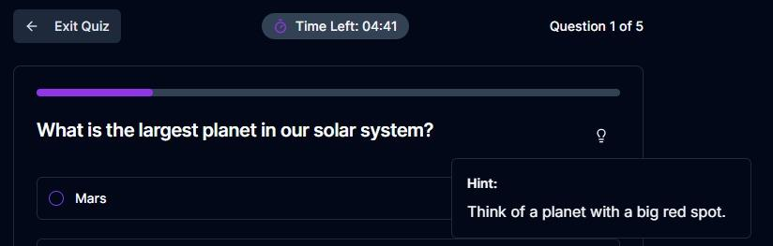Figure 9: Hint Feature: This feature displays the identical query along with an AI-generated hint that refers to the "big red spot.”

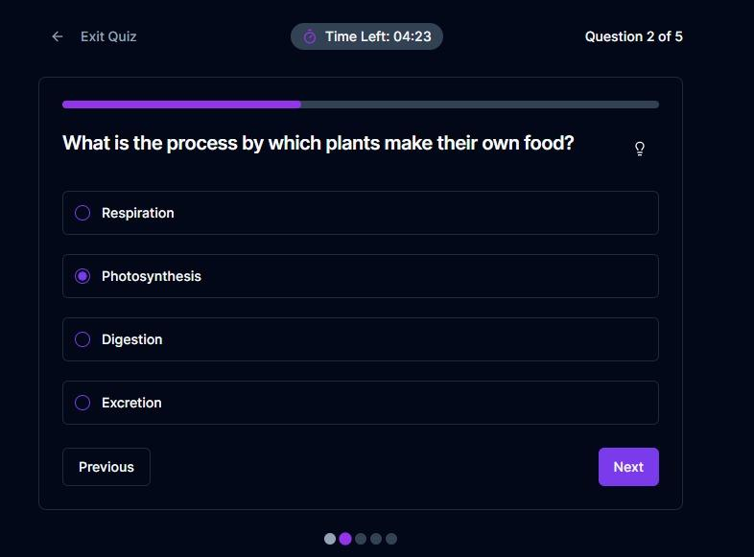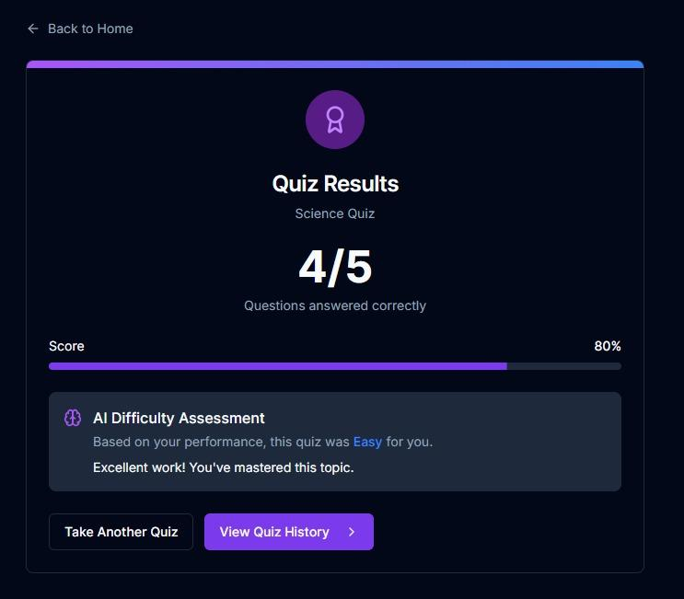

Figure 10: Quiz Results: AI-powered difficulty assessment and feedback summarizes performance (80% score).

In combination Figures 6–10 show the user interface of an AI-powered adaptive quiz system, where students respond to timed questions (such as those about photosynthesis and planetary science) with optional explanations. Post-quiz results, including a score of 80% and AI-generated difficulty feedback ("Easy"), are displayed in Figure 9, and the main dashboard for quiz selection, history tracking, and performance analytics is shown in Figure 10. When combined, they show an AI-enhanced personalized learning cycle that includes adaptive feedback and question delivery.

**Past Quiz Results Overview**

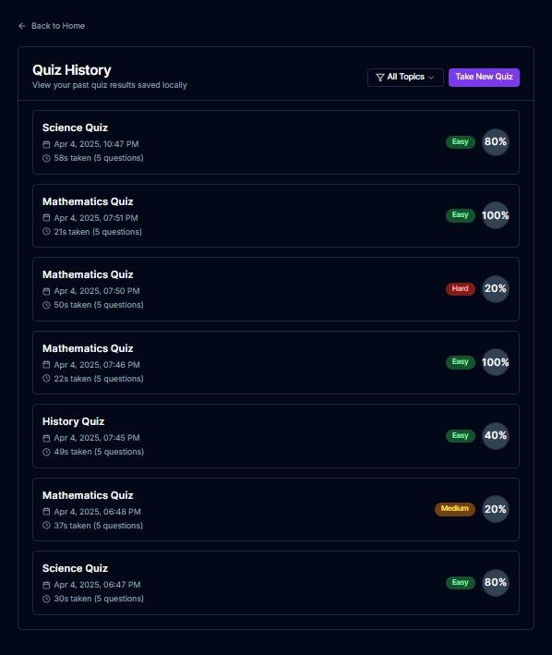Figure 11: Dashboard for Performance Summary

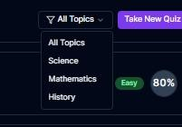

Figure 12: Log of Quiz

These images bring out the quiz analytics features of the setup. While Figure 13 gives a shorter look at performance with an 80% score shown and easy ways to retake quizzes or check topics, Figure 12 gives a full record of past quiz tries marked with time, length, and subjects (Science, Mathematics, History). Together, they display how the setup can watch user progress and trend in performance.

**Performance Metrics from Completed Quizzes**

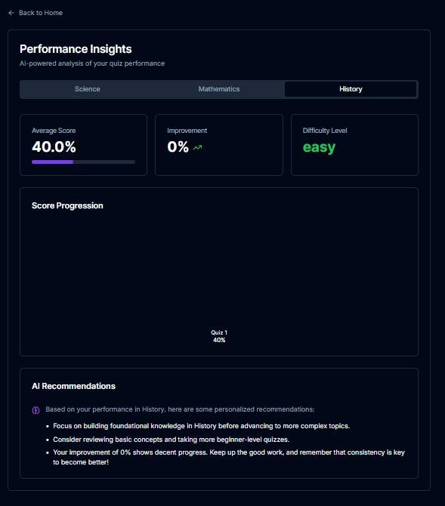Figure 13: Progress Tracker for History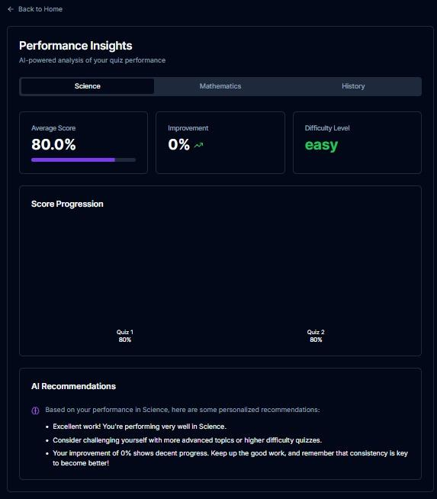

Figure 14: Progress Tracker for Science

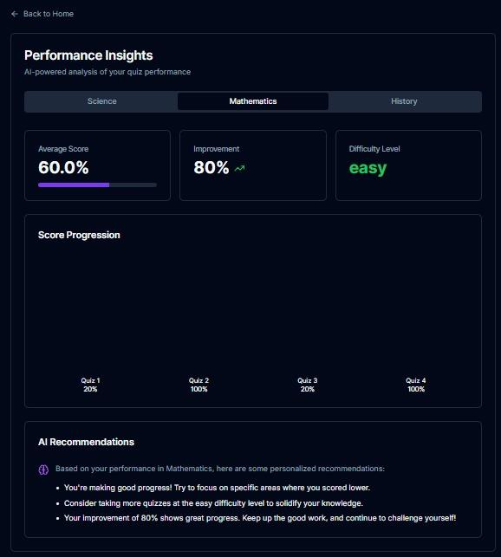

Figure 15: Progress Tracker for Mathematics

In combination These three dashboards show performance analytics produced by AI based on quiz results. Figure 16 tracks progress in mathematics (20%–100% fluctuations) with improvement strategies; Figure 15 highlights consistent 80% scores in science with suggestions to advance difficulty; and Figure 14 presents a science-focused report with a 40% average score and beginner recommendations. The system's adaptive feedback capabilities are demonstrated by the following: 1) Subject-wise score tables; 2) Graphical progress timelines; and 3) Personalized AI study recommendations.

### **5. Dataset & Data Preprocessing**

#### **Datasets Used:**

#### **SQUAD:** The Stanford Question Answering Dataset SQUAD for questions related to science and general knowledge also includes question-answer pairs extracted from Wikipedia articles.

#### **MathQA:** It is a dataset that focuses on mathematical problems thus challenges are abundant in this dataset ranging from simple math to very complex problem solving.

#### **AI2 Science Questions (AI2 ARC):** It has questions from varied topics in science that belong to the subjects of biology, chemistry, and physics.

#### **Data Preprocessing:**

Several preprocessing steps were taken before using the data for model training:

* **Tokenization:** We tokenized question-answer pairs of the dataset so that they become manageable by the models. This ensures output (questions) and input (context) are in a format that can be understood by the models.
* The numerical values in the data set (like time taken to answer questions) were normalized so as to make the model process data more efficiently.
* Data Splitting: The dataset is partitioned into training, validation, and test datasets so that model can learn from one part of data and evaluate on other hidden parts.
* Handling Missing Data: Either remove the missing data from the data set or impute it by some statistical tools so that all possible data can be modeled.

The machine learning models were able to learn from preprocessed datasets, which also enhanced their capacity to create adaptive tests and forecast performance.

### **6. Models Used and Executed**

For the Adaptive learning experience, this project employed several machine learning models:

1. The T5 (Text-to-Text Transfer Transformer)

**Implementation:** Using the quiz question dataset, we adjusted the T5 model. The model could produce pertinent multiple-choice questions in real time if it were given contextual information (such as a text passage or a particular subject). The question's level of difficulty was modified according to the student's prior performance.

1. Extreme Gradient Boosting, or XGBoost, is used to forecast quiz difficulty based on user performance.

**Implementation:** This model was built to predict the probability of a user correctly answering the next questions. We used user data, which comprised the count of correct answers, time taken per question, and number of attempts made to predict the ideal difficulty level for the upcoming set of questions. This model is very important to keep ensuring that the exam rigor does not cross the comfortable limit for the student.

1. The purpose of SVD (Singular Value Decomposition) is to offer tailored question suggestions.

**Implementation:** Based on historical behavior, we use SVD to evaluate user performance data and propose new questions. SVD is used to identify the similarity between a user’s answers and those of other users with comparable performance. This model allows the system to propose questions that are relevant and appropriate for each student. Once integrated into the system backend, these models instantly process user input, provide tailored suggestions and customized quiz content to improve learning objectives.

### **7. Results and Evaluation**

**Findings**

* The chosen topics of users were reflected in the generated questions, and the level of difficulty was dynamically modified according to their previous performance.
* Using user performance data, the XGBoost model was able to accurately predict quiz difficulty levels.
* Customized Suggestions: The SVD model made tailored quiz recommendations based on the user's past performance.

**Evaluation Criteria:**

* Accuracy: We evaluated this by comparing expected results, such as quiz difficulty and follow-up question accuracy, with actual user behavior.
* F1 Score: To ensure a balanced performance in creating appropriate questions and the right difficulty level, we used F1 Score to evaluate the model's precision and recall, especially in the prediction task.
* User feedback: Teachers and students provided feedback on the quality and suggestions of quiz questions and said that the system was able to customize the learning experience better than traditional static systems.

Based on the evaluation results, the system improved user engagement and learning outcomes by adjusting the learning path and quiz difficulty.

### **8. Conclusion**

Although the project has had excellent results, there is still much that can be done to improve it. For instance, further automation could be affected by the provision of custom learning paths along with personally generated feedback, and natural language processing could be implemented to make the system more conversational, allowing students to ask questions in their own words. Fun elements like leaderboards and prizes could be added to the application to increase the motivation of users. We can further extend this system to other subjects such as history, languages, and humanities with more flexible datasets. Along the way, we will surely deal with scaling up the system to support more users with ease. Finally, enhancing the AI model with more data and additional features for tracking learning behavior could make the tests even more accurate and relevant for each learner. All these modifications make the AI-empowered adaptive quiz games even better for all students.

### **9. Future Work**

● The system's interactivity can be enhanced even more with natural language processing (NLP) functionality to allow questions to be asked or answered in natural language.  
● Gamification: In-game elements such as leaderboard scores, achievements, and levels can be added to engage and encourage students even more.  
● Learning can be enhanced further with the addition of features like badges or rewards in a virtual environment for completing tests or achieving high scores.  
● Expand Subject Matter: Besides math and science, the system can be expanded to include the humanities, history, and language learning.   
● The flexibility of the platform would be enhanced by introducing additional domain-specific datasets and improved question-generation models for these subjects.   
● Scalability: The system can handle more students worldwide by supporting a large number of simultaneous users, incorporating cloud-based technology, and optimizing backend architecture for distributed learning environments.   
● Improvement in AI Model: To improve the accuracy and individuality of the quiz, the models today can be enhanced and fine-tuned.

These future improvements would turn the AI-Powered Adaptive Quiz Game into an even more powerful tool for personalized learning, capable of adapting to the diverse learning needs of students across the globe.

**10. References**

1. Dickey, M., & Bejarano, J. (2023). *GAIDE: A Framework for Using Generative AI to Assist in Course Content Development*. Retrieved from [arxiv.org](https://arxiv.org/abs/2308.12276).
2. Łodzikowski, A., Foltz,P.,& Behrens,L.(2024).*GenerativeAI and Its Educational Implications*. Retrieved from [arxiv.org](https://arxiv.org/abs/2401.08659).
3. Maity,S.,&Deroy,P. (2024). *Generative AI and Its Impact on Personalized Intelligent Tutoring Systems*. Retrieved from [arxiv.org](https://arxiv.org/abs/2410.10650).
4. Narrative-Based Learning (2023). *Narrative-Based Learningin Virtual Environments*. Retrieved from [en.wikipedia.org](https://en.wikipedia.org/wiki/Narrative-based_learning).
5. AI Dungeon(2023). *AI-Generated Interactive Storytelling*.Retrieved from [en.wikipedia.org](https://en.wikipedia.org/wiki/AI_Dungeon).
6. Generative AI (2023). *Generative AI: Implications and Applications for Education*.Retrieved from [arxiv.org](https://arxiv.org/abs/2305.07605).
7. ChatGPT in Education (2023).*ChatGPT in Education: EnhancingLearning Experiences*. Retrieved from [en.wikipedia.org](https://en.wikipedia.org/wiki/ChatGPT_in_education).