**RND of various Security testing tool for Mobile Application:**

**Keywords Searched:** Mobile Security Testing, test security of apps in android mobile, Mobile application Security testing tools.

**Tools found:**

1. **Netcraft:** http://www.netcraft.com/security-testing/mobile-app-security-testing/

Findings:

* + Netcraft provide internet security services including anti-fraud and anti-phishing services, application testing.
  + It is a paid version.

1. **Bug Crowed:** https://bugcrowd.com/

Findings:

* + Bugcrowd gives you all the tools necessary to run successful crowd sourced security programs.
  + Penetration Test, Vulnerabilities and Automated Scanner
* For Web application.

1. **Cigital:** <https://www.cigital.com>

Findings:

* + Application Security Testing, Software Security Strategy and Penetration Testing.
  + Penetration Test, Vulnerabilities and Automated Scanner
  + It is a paid version.

1. **WhiteHat: https://www.whitehatsec.com**

Findings:

* + Dynamic Application Security Testing, Static Application Security Testing and Mobile Application Security Testing.
  + For Web and Mobile application
  + It is a paid version.

1. **Appcelerator:** http://www.appcelerator.com

Findings:

* + Perform Security testing.
  + For Mobile application
  + It is a paid version. Unable to sign up for free trial.

1. **Metasploit:** https://www.metasploit.com

Findings:

* + Penetration Testing, Vulnerability Validation and Improve security by prioritizing exploitable vulnerabilities.
  + For Mobile application
  + It is a paid version.

1. **W3af:** <http://w3af.org>

Findings:

* + w3af is a Web Application Attack and Audit Framework.
  + For Web application
  + It is an open source tool.

1. **Checkmark:** <https://www.checkmarx.com>

Findings:

* + Application Security Testing.
  + For Mobile application
  + It is a paid tool.

1. **AndroTotal:** <https://andrototal.org>

AndroTotal is a free service to scan suspicious APKs against multiple mobile antivirus apps.

Findings:

* + Detections of issues.
  + Scan apk
  + It is a open source scanning tool.
  + View Analysis Result

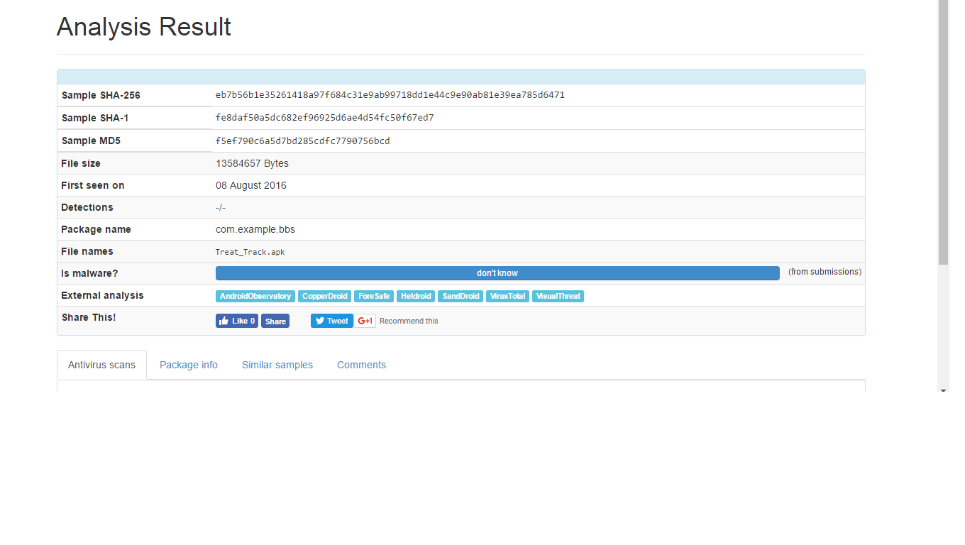

**Note:** Summary reports is not in brief, so we cannot implement this tool.

1. **SandDroid:** http://sanddroid.xjtu.edu.cn

An automatic Android application analysis system.

Findings:

* Code Feature Analysis
* Sensitive API Analysis
* Http Data Recovery
* Data Leakage Monitor
* Risky Behaviors Summary
* Risk Score: Calculate the risk score based on the static and dynamic analysis result
* It is a open source scanning tool.

**Good Tool to go with.**

1. **Eacus:** <http://www.mobiseclab.org/eacus.jsp>

A lite Android app analysis framework

Findings:

* Android app analysis framework
* Plugin Analysis: FakeID Check
* Advance Analysis: Risk Level
* It is an open source scanning tool.

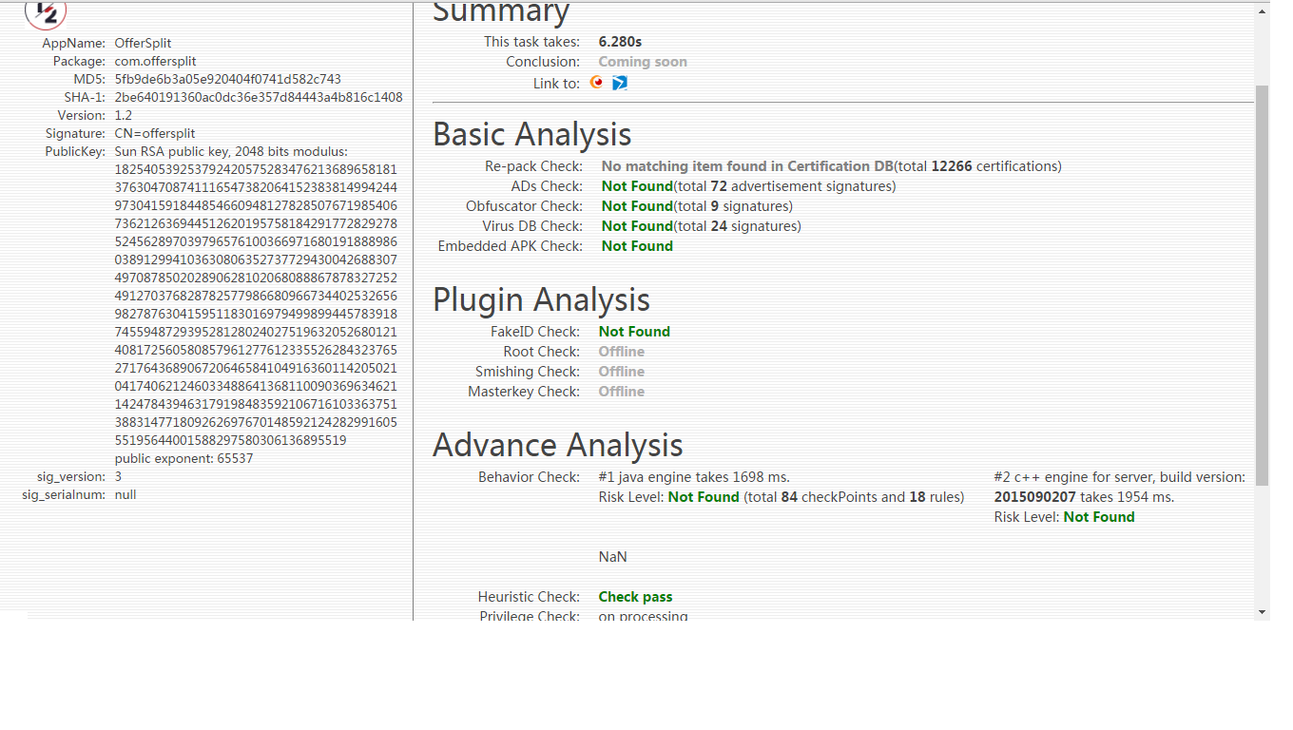

Currently following this one.