GAPANCHOR LEAD-CALL INTELLIGENCE PIPELINE
End-to-End Architectural Specification & Implementation Blueprint
Version 1.0 • October 2026 • Confidential Internal Specification

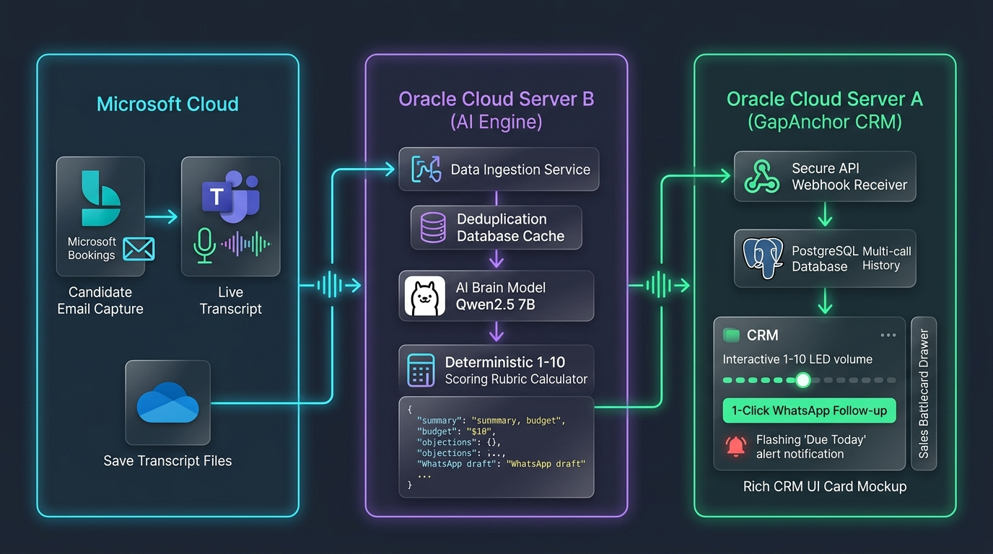
Figure 1: High-Level System Architecture (Microsoft Cloud → Oracle Server B AI Engine → Oracle Server A CRM)
1. Executive Summary & Purpose
GapAnchor operates an enterprise training and consultation CRM specialized in supply chain systems (Manhattan Active WMS, Blue Yonder, Kinaxis, and SAP S/4HANA). This blueprint outlines an automated, zero-subscription lead-call intelligence pipeline designed to:
- 100% Autonomous Ingestion: Automatically capture, parse, and summarize sales conversations conducted over Microsoft Teams without manual note-taking.
- Structured Deal Extraction: Extract core commercial parameters including requirement urgency, confirmed budget, decision-maker authority, timeline, and objections.
- Deterministic Scoring: Calculate an objective, rubric-based score (1–10) in code, visualized as an interactive volume slider on the CRM with manual override capability.
- Accelerated Closing: Equip sales closers with instant objection counter-pitches (sales battlecards) and 1-click personalized WhatsApp follow-up drafts.
- Zero Recurring Cost: Maintain 100% free-tier architecture utilizing Oracle Cloud Always-Free Compute (Ampere ARM) and local open-source LLMs (Qwen2.5 7B via Ollama).
2. Infrastructure & Architectural Topology
The pipeline is strictly divided into three decoupled tiers to safeguard the core CRM database, isolate AI compute workloads, and prevent vendor lock-in:
Component | Host Environment | Primary Responsibility | Key Tech Stack
Microsoft Cloud | Microsoft 365 Tenant | Candidate booking, calendar invite dispatch, live call audio transcription, and transcript persistence. | MS Bookings, Teams, OneDrive / MS Graph API
Server B (AI Worker) | Oracle Cloud Free Tier (Ampere A1 ARM) | OneDrive poller daemon, SQLite deduplication cache, timestamp engagement math, Ollama Qwen2.5 7B extraction, deterministic rubric calculation. | Ubuntu 24.04, Ollama, Qwen2.5 7B (Q4_K_M), SQLite, Python 3.12
Server A (CRM & DB) | Oracle Cloud Server A (Existing) | Secure API webhook receiver, safe duplicate email lead resolution, multi-call timeline persistence, interactive 1-10 volume UI, and WhatsApp dispatch. | Next.js 14, PostgreSQL (Supabase/Prisma), Tailwind CSS, Lucide

3. Safe Lead Matching & Duplicate Email Resolution
A database audit of GapAnchor's existing enquiries revealed that 82 candidate email addresses appear multiple times due to repeated website submissions over time. A naive query (e.g., findFirst({ where: { email } })) introduces a critical risk of attaching new call notes to an outdated, closed record.
The pipeline implements a 4-tier waterfall resolution engine on Server A:
- Tier 1 (Active Email Match): Server A lowercases and trims the candidate email received from Microsoft Bookings. It searches for records where email matches AND status != 'Resolved', sorting by messageTimestamp DESC. This ensures notes attach to the active, open sales cycle.
- Tier 2 (Phone Number Fallback): If no active email match is found (e.g., candidate used a secondary personal email), Server A cleans the phone number to the last 10 digits and queries the phone index.
- Tier 3 (Automated Provisioning): If the candidate has never submitted a website enquiry prior to booking the call, Server A automatically provisions a new Enquiry record tagged with source: 'teams_booking_call' and status: 'Open'.
- Tier 4 (Multi-Call History): Every call creates a unique LeadCall record in the multi-call timeline, preserving previous call summaries and displaying lead progression over time.
4. Deterministic Scoring Rubric (Pure Code Math)
To eliminate LLM arithmetic hallucinations and ensure consistent lead qualification, Ollama (Qwen2.5 7B) is only responsible for extracting qualitative signals. Server B's Python service computes the final 1–10 score using a deterministic point rubric:
Criteria | Points Awarded | Extraction Heuristic
Need Level | High = 3 pts | Medium = 2 pts | Low = 1 pt | Candidate specifically requests certification/live sandbox for an active project or job switch.
Budget Feasibility | Confirmed High = 3 pts | Moderate = 2 pts | Unwilling = 0 pts | Candidate or employer approved budget (e.g. ₹40k - ₹50k) vs seeking free materials.
Timeline Urgency | Immediate (<14d) = 2 pts | Within 1 Mo = 1 pt | Vague = 0 pts | Target joining date or upcoming workplace cutover deadline.
Decision Authority | Direct Decision Maker = 2 pts | Influencer/Student = 1 pt | Candidate pays personally or possesses manager authority vs dependent on third party.
Engagement Bonus | +1 Bonus Point (Capped at 10) | Candidate spoke >= 55% of the total call duration based on timestamp analysis.

5. Feature & User Experience Specifications
5.1. Interactive 1–10 Volume Meter (Score Gauge + Override)
The CRM displays a sleek 10-stepped LED volume gauge next to each lead. While Server B automatically populates the score based on the rubric, sales agents retain full authority to click or drag the gauge (e.g., bumping a 7 to a 9). An instant, background PATCH request synchronizes the override directly to PostgreSQL.
5.2. 1-Click WhatsApp Follow-up Dispatch
Server B generates a personalized, professional 2-sentence WhatsApp recap tailored to what was agreed on the call. A prominent green button on the lead card generates a direct wa.me link with URL-encoded text. Clicking opens WhatsApp Web or the desktop client with the draft pre-populated, enabling review and dispatch in 2 seconds.
5.3. Objection Counter-Pitch (Sales Battlecards)
When candidates voice hesitation regarding fees, placement guarantees, or curriculum depth, Qwen2.5 pairs the objection with a pre-configured GapAnchor counter-pitch inside the call drawer. Closer reps immediately see the winning response when executing callbacks.
5.4. Engagement Analytics (Call Length & Candidate Talk Ratio)
Python on Server B computes total call duration and the candidate-to-organizer talk ratio from transcript timestamps at zero AI compute cost. A badge (e.g., ⏱️ 24m • 🗣️ Candidate: 61%) alerts reps to high-engagement prospects.
5.5. Dismissible Dealbreaker Red Flags
Severe disqualifiers (e.g., employer refused sponsorship, requests for cracked software, or unsolvable timezone conflicts) trigger a warning pill. Crucially, a click on [✕ Dismiss] marks the warning as dismissed in the database if the closer determines the candidate is workable.
5.6. 'Due Today' Callback Smart Filter
When a callback date is extracted, it populates callFollowUpDate. A top-level 'Due Today' filter tab isolates prospects scheduled for contact on the current calendar date, sorted from score 10 down to 1.
5.7. 1-Click Batch Enrollment
Once a candidate converts, a 1-click action connects the lead directly into the SessionParticipant roster of the upcoming training batch (e.g., Manhattan Active WMS Batch 36), recording amount due, amount paid, and seat reservation.
5.8. 'Ask AI' Command Bar (Natural Language Deal Finder)
A floating search bar at the top of the CRM allows reps to ask questions (e.g., 'Which Manhattan WMS leads have budget above ₹40k and requested callback this week?'). Server A sends sanitized in-memory text summaries to Server B (Qwen), returning ranked recommendations in 2–3 seconds without exposing the database directly.
6. Phased Implementation Roadmap
- Phase 1 (CRM Backend & Schema): Extend prisma/schema.prisma with LeadCall model and Enquiry fields. Run prisma db push. Create secure webhook route at app/api/leads/call-summary/route.ts with Bearer API key protection.
- Phase 2 (CRM Frontend UI): Implement the 1–10 interactive volume slider, 1-click WhatsApp button, 'Due Today' smart filter, dismissible red flag pill, and call intelligence drawer in app/enquiries/page.tsx.
- Phase 3 (Server B AI Worker): Provision Oracle Ampere A1 ARM compute instance. Install Ollama and pull qwen2.5:7b-instruct-q4_K_M. Configure SQLite deduplication registry and MS Graph poller daemon.
- Phase 4 (Integration & Verification): Perform end-to-end dry run with test transcript. Implement 'Ask AI' query pipeline. Deploy systemd continuous polling service.

