DKD-XAI: Explainable AI for Early Diabetic Kidney Disease Risk Stratification
Project Summary & Outcomes Report | End-to-End Overview
Author: Vimal Vijayan (Roll No. 17030925059) • Mentor: Dr. Mayura Nagar • Date: October 2026
――――――――――――――――――――――――――――――――――――――――――――――――――――――――――
1. Executive Summary
Diabetic Kidney Disease (DKD) is one of the most severe microvascular complications of diabetes, affecting nearly 40% of diabetic patients and standing as the leading cause of end-stage renal disease globally. Traditionally, DKD is diagnosed only after kidney damage has already occurred, using laboratory markers like elevated Urine Albumin-to-Creatinine Ratio (UACR ≥ 30 mg/g) or reduced estimated Glomerular Filtration Rate (eGFR < 60 mL/min/1.73m²).
The DKD-XAI project provides an end-to-end clinical machine learning and generative explainable AI (XAI) solution. Its central breakthrough is predicting kidney damage risk early using exclusively non-kidney routine parameters (e.g., blood pressure, age, HbA1c, lipids, diabetes duration) while strictly eliminating data leakage. The project was executed in two systematic phases:
- Phase 1 (Predictive Pipeline & Explainability): Harmonized 4,024 adult diabetic patients across 4 NHANES cycles, benchmarked four ML/DL algorithms (Logistic Regression, Random Forest, XGBoost, and PyTorch Deep Learning MLP), established chronological temporal validation, and calculated transparent SHAP feature attributions.
- Phase 2 (Evidence-Grounded AI Agent & Clinical Web Interface): Engineered a Groq-powered clinical reasoning agent (Llama 3.3 70B) grounded in official ADA 2026 / KDIGO 2022 guidelines with strict automated faithfulness checks, paired with a full-stack interactive web application featuring natural-language vitals extraction.
📌 CORE HIGHLIGHTS: • Best Overall Model: XGBoost achieved 0.732 AUROC on holdout testing and 0.723 on unseen future temporal cycles.
• Strict Zero Leakage: Serum creatinine, eGFR, and UACR are strictly forbidden as model inputs.
• Trustworthy AI: Generative explanations cite verifiable medical guidelines with zero statistical hallucinations.

2. Cohort Data & Zero-Leakage Architecture
Data was pooled from the U.S. Centers for Disease Control (CDC) National Health and Nutrition Examination Survey (NHANES), spanning four cycles from 2013 to 2023. Only adult participants (18+) with verified diabetes (doctor-diagnosed or HbA1c ≥ 6.5%) who had complete laboratory measurements were included.
NHANES Survey Cycle | Participant Count | Status / Pipeline Usage
2013–2014 (_H cycle) | 790 adults | Reconstructed from raw XPT files
2015–2016 (_I cycle) | 892 adults | Reconstructed from raw XPT files
2017–March 2020 (P_ cycle) | 1,455 adults | Standardized baseline cohort
Aug 2021–Aug 2023 (_L cycle) | 887 adults | Temporal holdout evaluation set
Total Unified Cohort | 4,024 adults | Preserved 100% real records (no synthesis)

The 13 Non-Kidney Input Features: Age, Biological Sex (Female), HbA1c (%), Body Mass Index (BMI), Waist Circumference (cm), Systolic Blood Pressure (SBP), Diastolic Blood Pressure (DBP), HDL Cholesterol, Total Cholesterol, Diagnosed Diabetes Indicator, Insulin Usage, Oral Diabetes Pill Usage, and Diabetes Duration in Years.
The Two Clinical Target Tasks:
1. Any Kidney Damage (dkd_any): Binary prediction (1,578 positive vs 2,446 negative; 39.2% prevalence) where positive means single-visit UACR ≥ 30 mg/g OR eGFR < 60 mL/min/1.73m².
2. Early DKD vs None (early_dkd): Distinguishes early microalbuminuria with preserved filtration (UACR 30–300 mg/g and eGFR ≥ 60) from healthy kidneys (699 early cases vs 2,446 controls; 22.2% positive among 3,145 eligible rows; 879 advanced cases excluded).
3. Phase 1: Machine Learning & Deep Learning Pipeline
Phase 1 established an empirical comparison across four diverse model architectures: Linear (Logistic Regression with L2 regularization), Tree Ensemble (Random Forest and XGBoost), and Deep Learning (PyTorch Multi-Layer Perceptron). The pipeline incorporated 80/20 stratified holdout splits, 5-fold cross-validation, Youden's J threshold optimization on out-of-fold training data, and SHAP (SHapley Additive exPlanations) explainability.
Outcome A: Any Kidney Damage (dkd_any) — Holdout Test Performance (N = 805)
Model Architecture | CV AUROC | Test AUROC | 95% CI | Sensitivity | Specificity | Accuracy | Threshold
XGBoost (Selected Best) | 0.732 | 0.732 | 0.699–0.768 | 62.7% | 72.2% | 68.4% | 0.513
Random Forest | 0.729 | 0.727 | 0.693–0.762 | 59.8% | 72.8% | 67.7% | 0.501
PyTorch MLP (DL) | 0.723 | 0.729 | 0.694–0.762 | 70.9% | 63.6% | 66.5% | 0.474
Logistic Regression | 0.719 | 0.722 | 0.687–0.757 | 60.4% | 72.8% | 68.0% | 0.527

Outcome B: Early DKD vs None (early_dkd) — Holdout Test Performance (N = 629)
Model Architecture | CV AUROC | Test AUROC | 95% CI | Sensitivity | Specificity | Accuracy | Threshold
PyTorch MLP (Selected Best) | 0.678 | 0.643 | 0.590–0.693 | 52.9% | 69.1% | 65.5% | 0.507
Random Forest | 0.678 | 0.657 | 0.601–0.707 | 48.6% | 70.1% | 65.3% | 0.510
Logistic Regression | 0.676 | 0.644 | 0.589–0.696 | 50.7% | 68.3% | 64.4% | 0.506
XGBoost | 0.674 | 0.666 | 0.612–0.713 | 62.9% | 62.2% | 62.3% | 0.486

Chronological Temporal Validation (Trained on 2013–2020, Tested on 2021–2023)
To rigorously test model generalization against cohort drift over time, all models were tuned and trained exclusively on the historical cycles (2013–2020, N = 3,137) and evaluated on the subsequent cycle (2021–2023, N = 887). XGBoost maintained a strong temporal AUROC of 0.7230 (AUPRC: 0.6653, Sensitivity: 62.7%, Specificity: 70.8%), confirming that the learned risk patterns are durable and transportable across real-world survey cohorts.
Top Clinical Risk Drivers Revealed by SHAP: Across all tree and linear attributions, the dominant contributors to elevated kidney damage risk were: (1) Older Age, (2) Elevated Glycated Hemoglobin (HbA1c > 8.0%), (3) High Systolic Blood Pressure (SBP > 140 mmHg), (4) Longer Diabetes Duration (> 10 years), and (5) High Body Mass Index (BMI > 30 kg/m²). Protective features lowering predicted risk included well-managed SBP (< 120 mmHg) and normal HbA1c (< 6.5%).

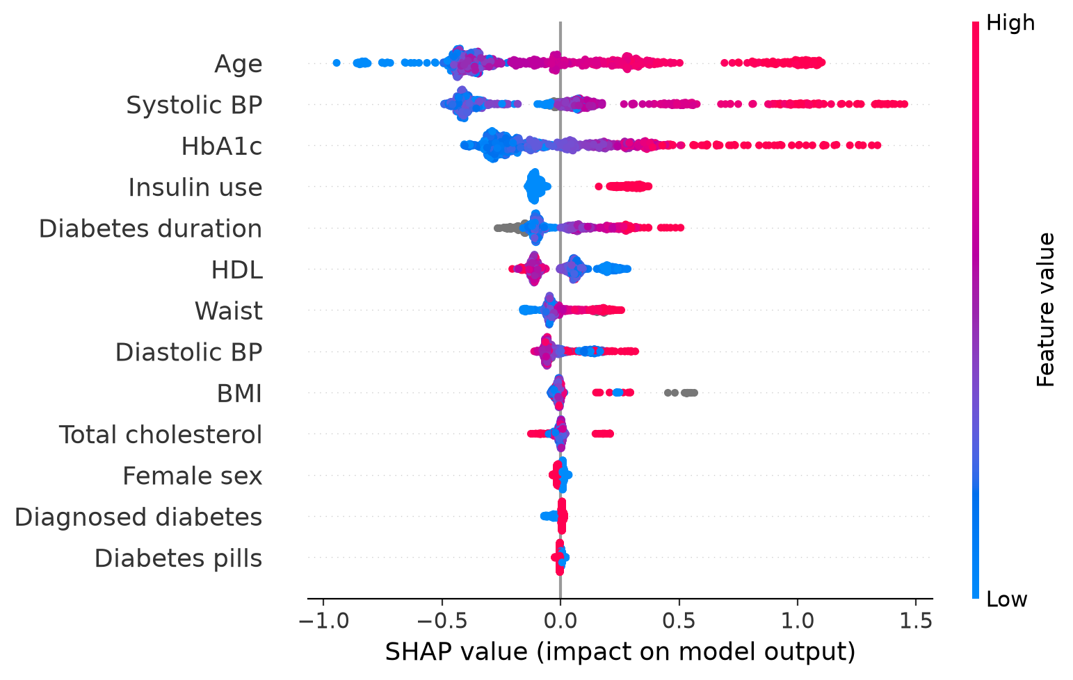
Figure 1: SHAP Beeswarm Plot — Feature attributions and directionality for XGBoost on the test cohort.
4. Phase 2: Evidence-Grounded AI Agent & Interactive Web Platform
A critical failure mode of clinical AI is the 'black-box' dilemma: clinicians cannot act on unexplained risk numbers, and generic generative LLMs tend to hallucinate inaccurate medical advice or make ungrounded statistical claims. Phase 2 tackled this directly by building a specialized, multi-tiered Explainable AI Clinical System.
- Dynamic Model Binding: The agent dynamically loads whichever model was selected by Phase 1 (XGBoost or PyTorch MLP), calculates the exact individual risk probability, and extracts patient-specific positive and negative SHAP factors.
- Evidence Grounding (dkd_evidence_base.json): For each top risk driver, the agent retrieves verified clinical guidelines from the American Diabetes Association (ADA Standards of Care 2026) and KDIGO 2022 Guidelines. The LLM is restricted to citing only these verified sources.
- Groq-Powered LLM Reasoning (Llama 3.3 70B): Generates concise (~120 words), plain-English clinical risk summaries explaining why the patient is at risk, attaching mandatory source citations, and ending with a clear reminder that this is a risk estimate, not a diagnosis.
- Automated Faithfulness Verification: Every LLM output undergoes a deterministic post-generation check to confirm: (1) exact risk % is preserved, (2) no ungrounded numbers were introduced, and (3) all citations correspond exactly to retrieved sources.
- Deterministic Offline Fallback: If the Groq API is offline or without internet access, a rule-based template generates identical, 100% faithful explanations with zero downtime.
Phase 2 Product: Interactive Clinical Web Application
To make the predictive engine accessible to clinicians, a production-grade web dashboard was developed:
• FastAPI Backend (backend_server.py): Provides REST endpoints for live model inference, natural language vitals extraction, and AI agent explanation generation.
• React/Vite Frontend (frontend/): Built with healthcare-grade UI (soft slate, medical teal #0D9488, clinical typography).
• Dual Input Modes: Traditional structured clinical vitals form alongside a Conversational Natural Language Assistant where clinicians can paste unstructured clinical shorthand (e.g., '65M, T2D for 15y, A1c 9.2, BP 155/90, BMI 31') which is automatically parsed into features.
• Visual SHAP Attribution Meters: Dynamic color-coded bar meters displaying exact risk-increasing factors in coral-red and protective factors in emerald-green.
• Pre-loaded Benchmark Patients: 4 real clinical test cases (e.g., High-Risk Longstanding Diabetic, Well-Controlled Early Patient) selectable via a 1-click header dropdown.
📌 PHASE 2 OUTCOMES & SAFETY: • Faithfulness Checker: Catches altered percentages, invented clinical facts, and ungrounded citations.
• Clinician Workflow: Translates complex tabular data and model math into an actionable 1-minute risk narrative.
• Verified Sources: Every claim links to official ADA and KDIGO clinical guidelines.

5. Scientific Limitations & Ethical Cautions
For complete scientific transparency and clinical safety, the following boundaries are formally defined in the project:
- Cross-Sectional Marker Proxies: NHANES measures UACR and eGFR at a single survey visit. Clinical diagnostic criteria for CKD require persistent abnormalities for > 3 months. Therefore, labels are single-visit risk markers, not confirmed diagnoses.
- No National Prevalence Claims: The pipeline evaluates predictive ML algorithms without applying NHANES complex survey weights, strata, or clusters. Metrics reflect cohort performance, not US population prevalence.
- SHAP is Attribution, Not Causation: SHAP values describe how the model weighted a given feature for its statistical score. They do not demonstrate that altering that feature (e.g. lowering waist circumference) will directly cure or halt kidney disease.
- Research Prototype Status: This system is an academic research prototype designed to support clinical triage and risk awareness; it is not a standalone diagnostic medical device.
6. Comprehensive Phase 1 vs Phase 2 Summary
Project Dimension | Phase 1: Machine Learning & XAI | Phase 2: AI Agent & Web App
Core Objective | Predict kidney damage using routine vitals; compare ML vs DL algorithms. | Translate predictions into faithful, guideline-backed explanations and UI.
Models / Tools | Logistic Regression, Random Forest, XGBoost, PyTorch MLP, TreeSHAP. | Groq API (Llama 3.3 70B), FastAPI, React/Vite, Faithfulness Checker.
Key Evaluation | Holdout CV, 95% Bootstrap CI, Chronological Temporal Holdout (2021–2023). | Citation verification, exact risk % consistency, latency, usability.
Best Model Selected | XGBoost (dkd_any: 0.732 AUROC); PyTorch MLP (early_dkd: 0.678 CV AUROC). | Loads whichever model Phase 1 selected dynamically via joblib metadata.
Key Output / Artifact | Trained models (.joblib), ROC/PR curves, SHAP beeswarm & dependence plots. | dkd_ai_agent.py, backend_server.py, interactive clinical web dashboard.
Verification Guardrail | Stratified CV, leakage test (validate_project.py), Youden's threshold. | Faithfulness checker (flags hallucinations, uncited claims, altered numbers).
Final Clinical Deliverable | Validated mathematical risk score and top contributing numerical factors. | Interactive patient narrative report with guideline citations and interactive UI.

― End of DKD-XAI Comprehensive Project Summary ―
Prepared for Academic & Clinical Review • October 2026

