**IBM NAAN MUDHALVAN**

**SKILL UP**

**PROJECT TITLE: SMART WATER SYSTEM**

**COLLEGE: PERI INSTITUTE OF TECHNOLOGY**

**DEPT: ELECTRONICS AND COMMUNICATION ENGINEERING**

**DOMAIN: INTERNET OF THINGS (IOT)**

**Submitted By**

**VIJAYA SRI Y (au411521106060)**

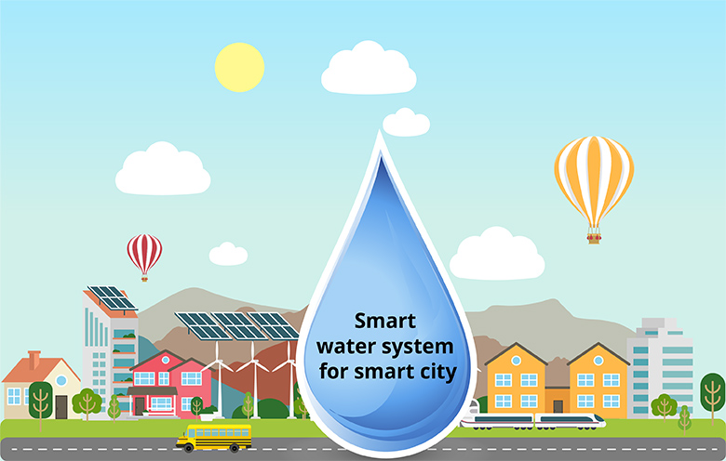

**PHASE-4:**

* 1. **Objective of this Phase:**
* According to phase-4 guidelines, In this section I’ll be building the project by performing different activities like feature engineering, real time working, etc. Now, I am going to develop this project by using feature engineering and I am going to providing real time system of this project.
  1. **Feature Engineering:**
* Feature engineering is essential for data analysis and optimal decision making in IoT-enabled intelligent water systems. This includes strategies such as selection of relevant parameters (water volume, quality, and temperature), collection of data over a specific period of time, and handling of missing or error data Time series features are released time-course analysis, while statistical processing provides important insights into the distribution of information . Methods such as principal component analysis (PCA) can be used for dimensionality reduction. In addition, domain-specific features are designed to provide unique insights. Aspect interactions are analyzed to reveal complex relationships. By refining and enhancing data characteristics, feature engineering ensures that the system can make accurate, informed decisions based on information gathered from IoT devices.
  1. **Features of Smart Water Management:**
* A smart water management system using IoT incorporates several key features to enhance efficiency and sustainability. It employs sensors to monitor water parameters like level, quality, and temperature, providing real-time data. Automated controls enable timely response to fluctuations, optimizing water distribution. Leak detection mechanisms swiftly identify and mitigate losses. User interfaces, accessible via mobile apps or web platforms, empower consumers to track usage and set conservation goals. Additionally, data analytics offer insights for proactive decision-making. These features collectively ensure a more intelligent, responsive, and eco-conscious approach to water resource management..
  1. **Real time working:**

The step by step working is given below:

**Step 1 :** Connect all the components according to the step by step procedure mentioned in Phase-3.

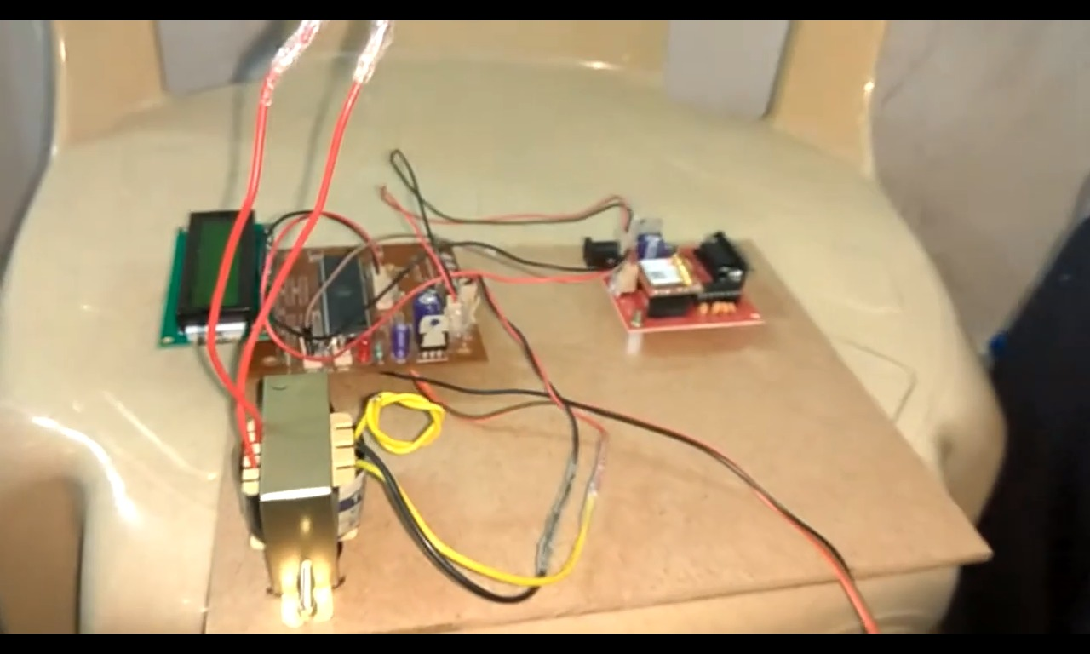

**Step 2 :** Power ON the circuit and it will show like this in the LCD Display.

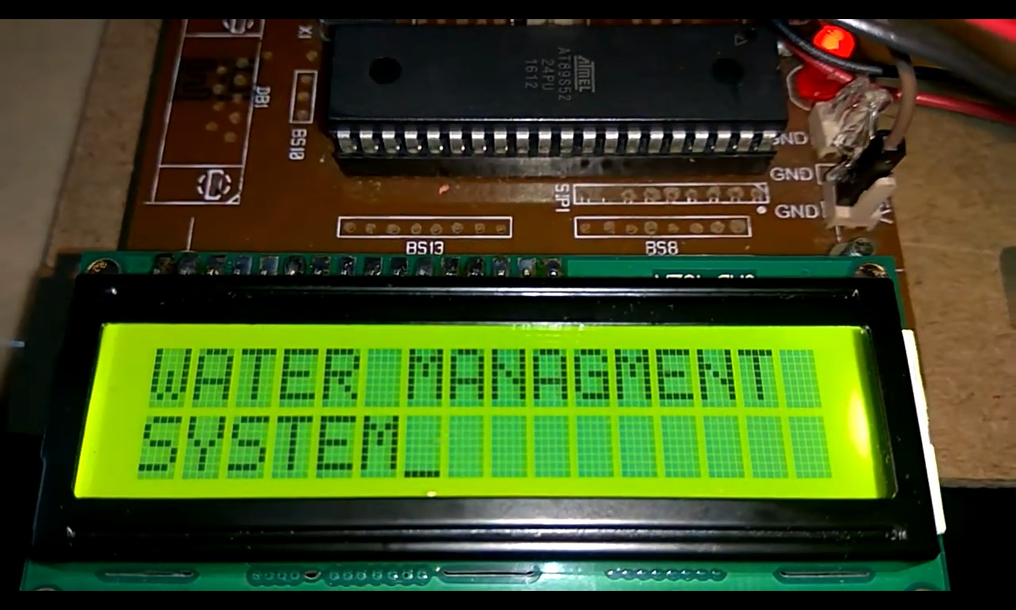

**Step 3 :** First, the water tank (cup) is empty.

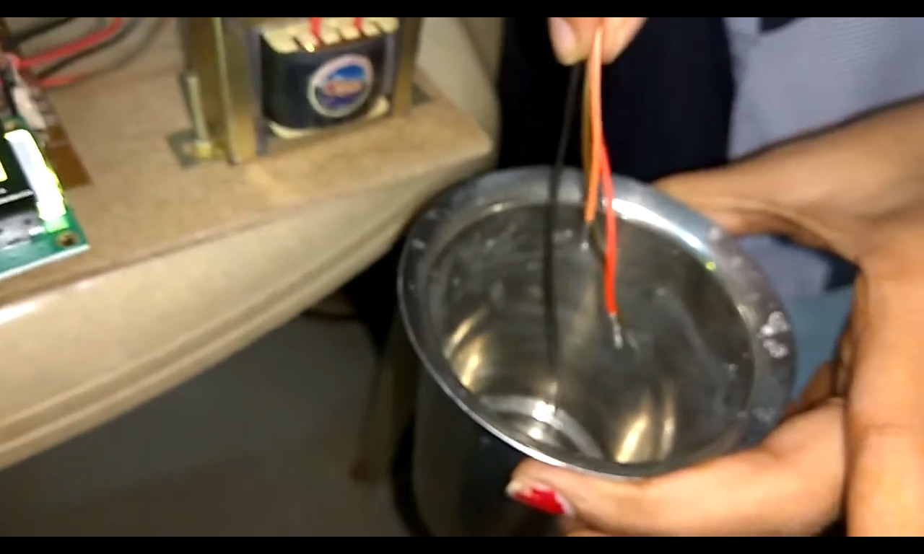

**Step 4 :** When the water tank (cup) is empty, it will display as empty.



**Step 5 :** Then thewater tank (cup) is filled for about 33% of water



**Step 6 :** When the water tank (cup) is 33% filled, it will display like this.

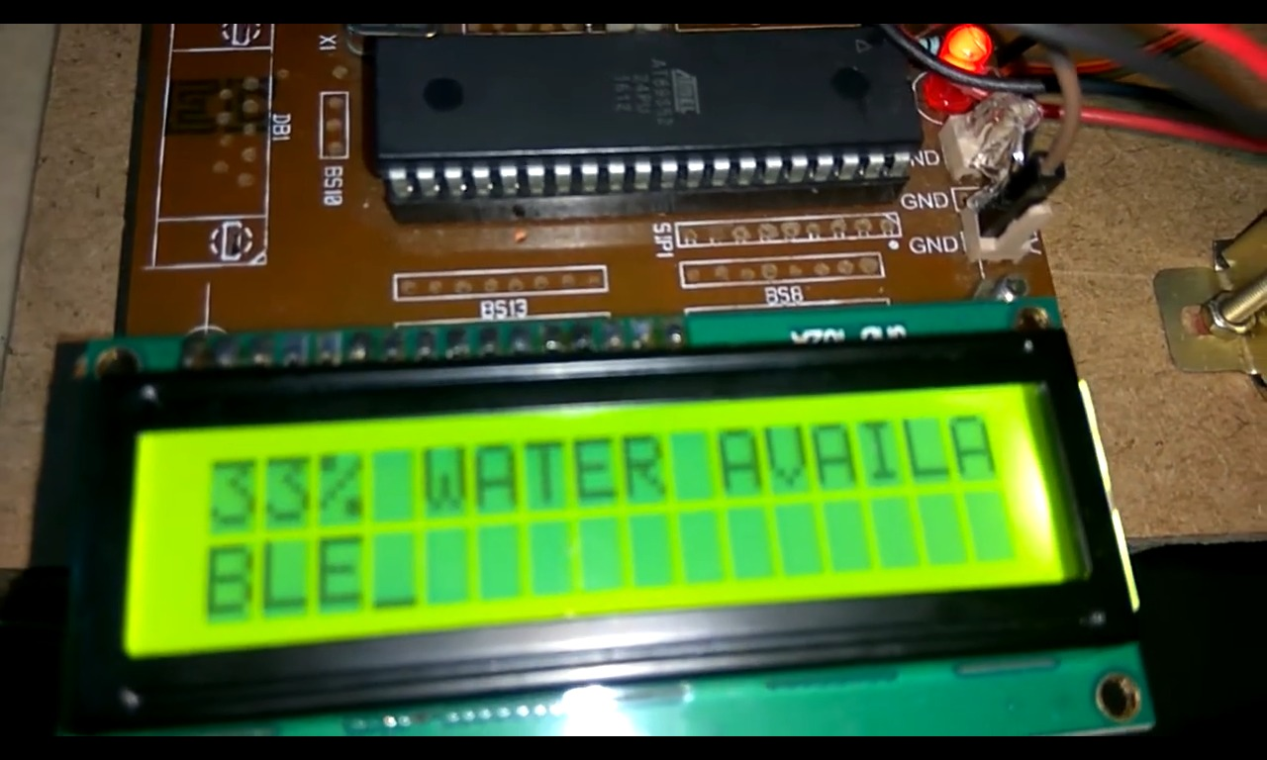

**Step 7 :** The chart is updated for every 50 seconds. For 33% water, the chart is given as,

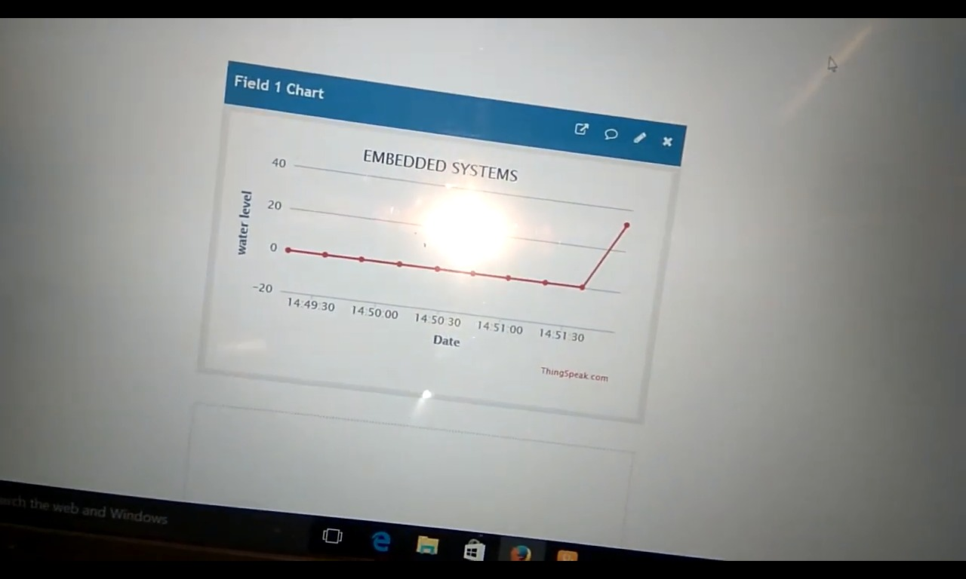

**Step 8 :** Then thewater tank (cup) is filled for about 66% of water

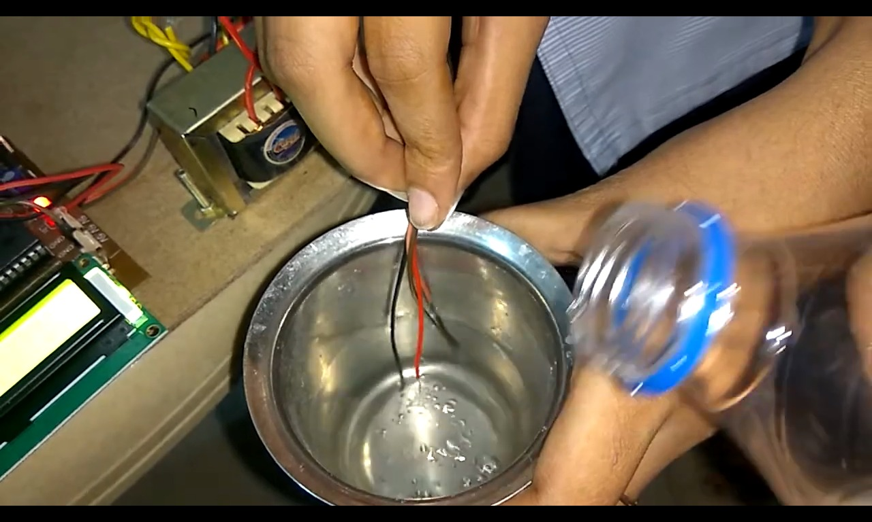

**Step 9 :** When the water tank (cup) is 66% filled, it will display like this,

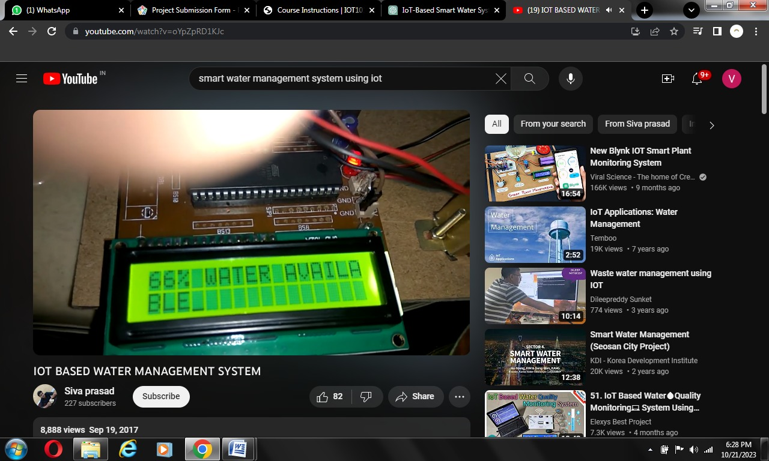

**Step 10 :** For 66% water, the chart is given as,

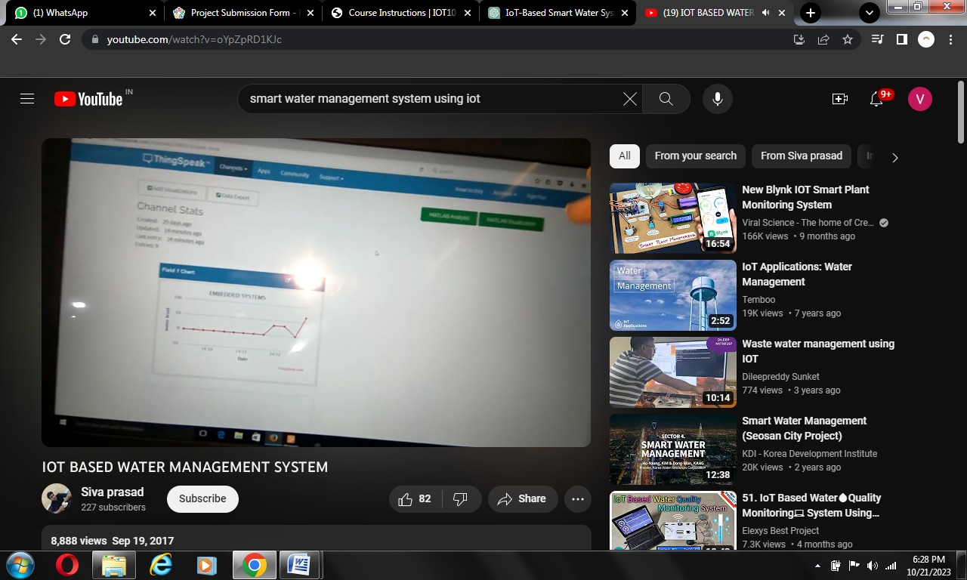

**Step 11 :** Then thewater tank (cup) is filled for about 99% of water

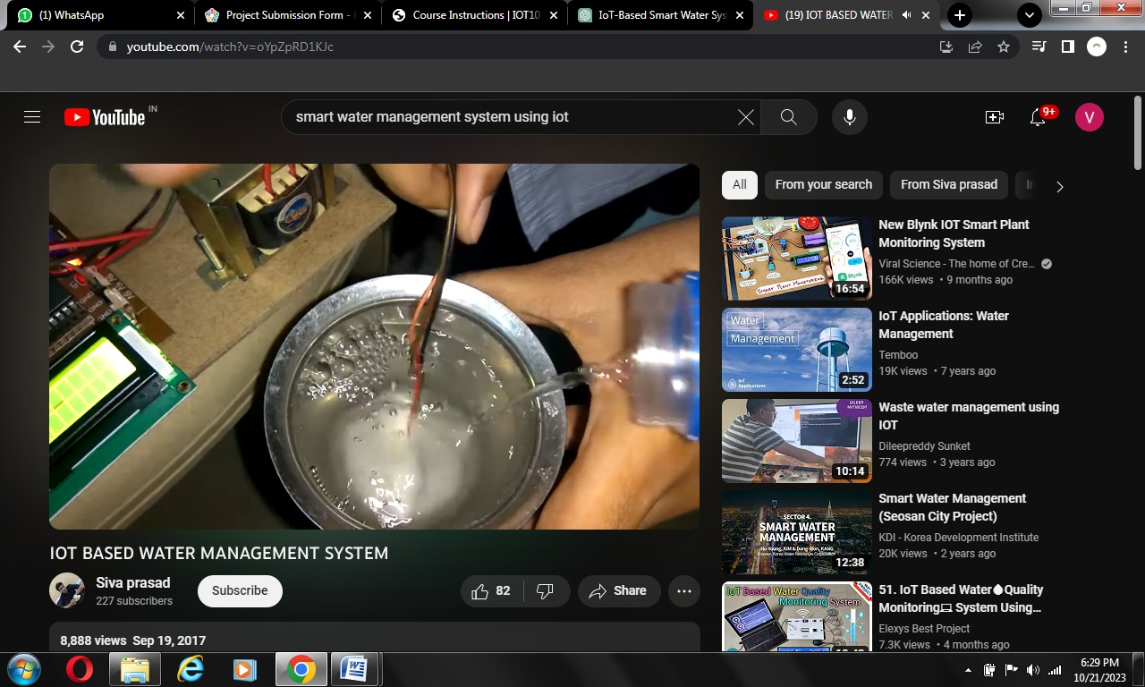

**Step 12 :** When the water tank (cup) is 99% filled, it will display like this.

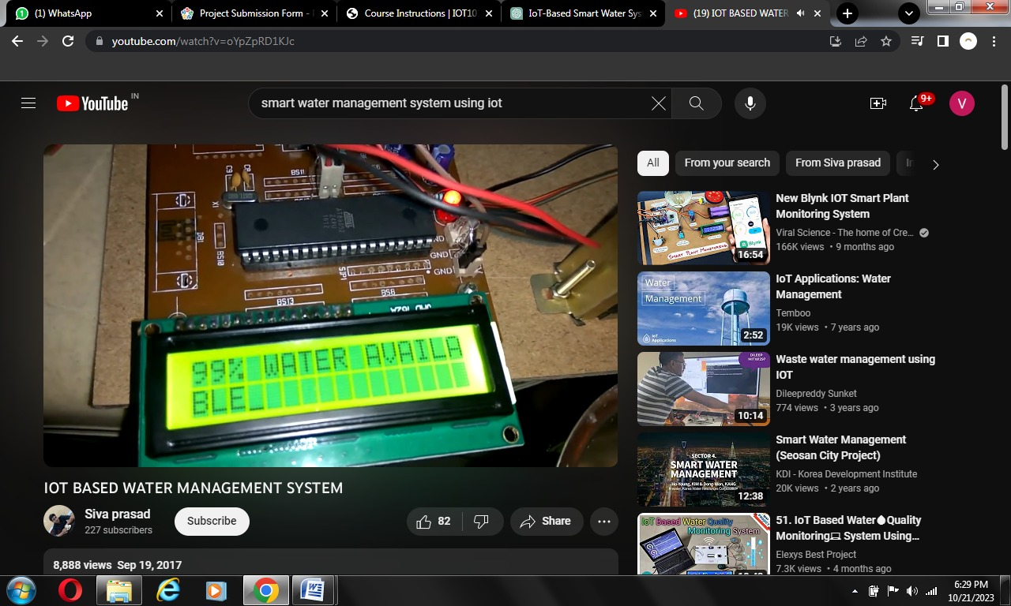

**Step 13 :** For 99% water, the chart is given as

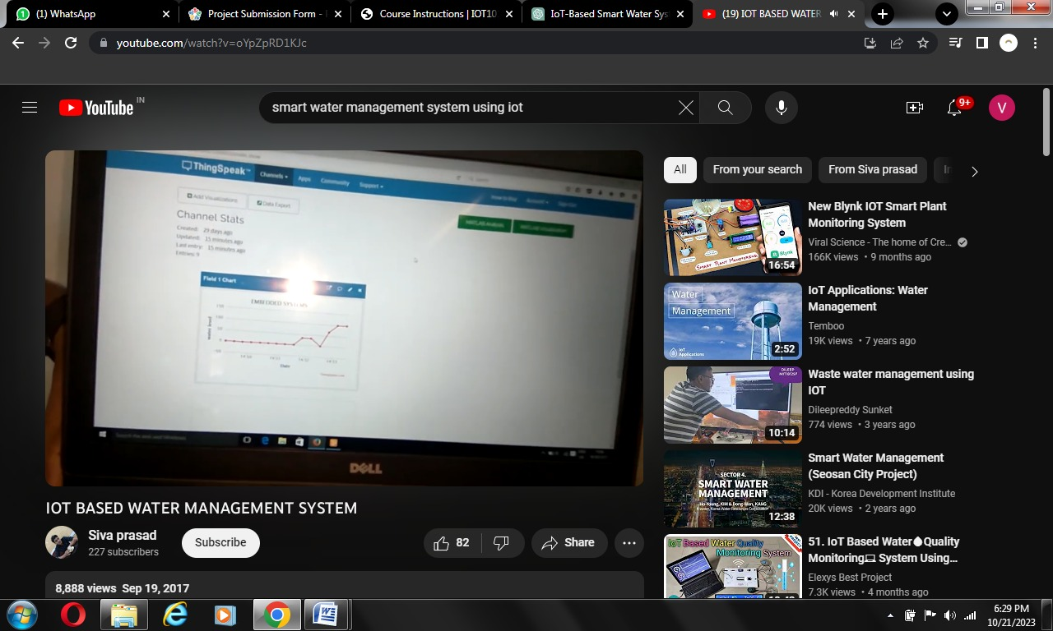

* 1. **Advantages:**
* Real-time Monitoring
* Efficient Resource Allocation
* Leak Detection and Prevention
* Remote control and Automation
* Predictive Maintenance
* Data-Driven Insights
* Enhanced User Awareness
* Environmental Impact
* Early Warning systems
* Cost efficient
  1. **Conclusion :**
* Smart water management, enabled by IoT technology, revolutionizes how we monitor and conserve water. It provides real-time data, improves environmental sustainability, enhances public health, and strengthens communities. Ongoing collaboration, innovation, and investment are essential for a sustainable water future.