# Performance Test Report Example

* Scope
* Monitoring Points
* Test Plan
* Load Tests to Find the Baseline
* Soak Tests
* Results

# Scope

|  |  |
| --- | --- |
| **Key** | **Value** |
| Goal | Verify if the system remains stable during 4hs of work-load |
| Environment | Test |
| Application | sys-customers |
| API resource | /customers |
| Data | internalId=123456  client_id (specific for performance testing)  client_secret (specific for performance testing) |
| Nodes to be monitored | * Cloudhub workers * API Manager - Analytics |
| Nodes excluded | Backend system nodes: PeopleSoft server |
| Baseline redline | Do not allow CPU% to exceed 70%.  Do not allow Memory% to exceed 70%. |
| Testing tool | JMeter: <http://jmeter.apache.org/> |

# Monitoring Points

|  |  |
| --- | --- |
| **Node** | **Metrics** |
| Workers | CPU  Memory  Mule Messages |
| API Manager | TPS  HTTP Error Codes |
| PeopleSoft | Excluded |
| Local machine | CPU  Memory |

# Test Plan

Configuring the Thread Group.

|  |  |
| --- | --- |
| **Key** | **Value** |
| Threads | 100 |
| RampUp | 10 |
| ramp-up/threads relation | 0.1 (every 0.1 secs a new thread is created) |

Define the Thread Group.

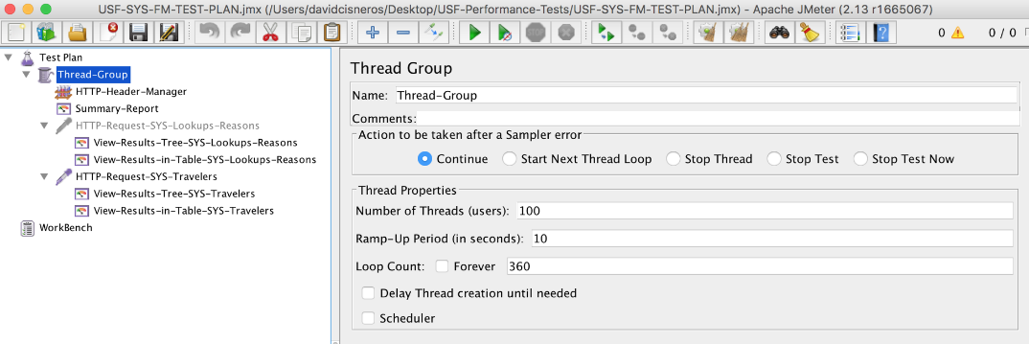

Define the headers (client_id/client_secret) in a header manager.

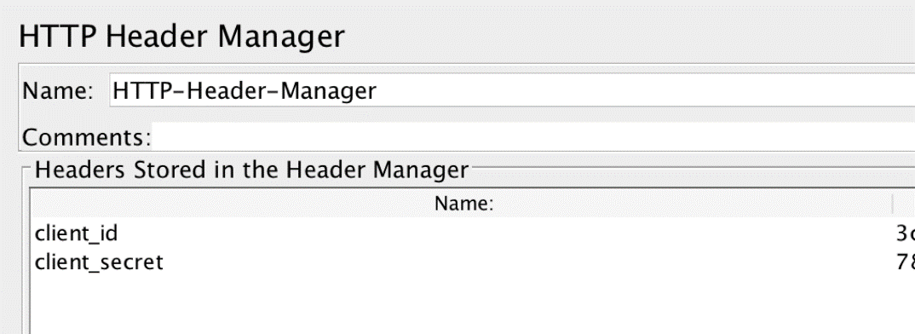

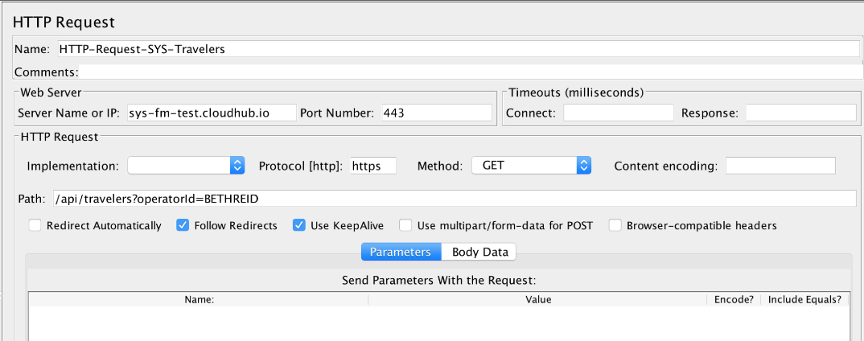

# Load Tests to Find the Baseline

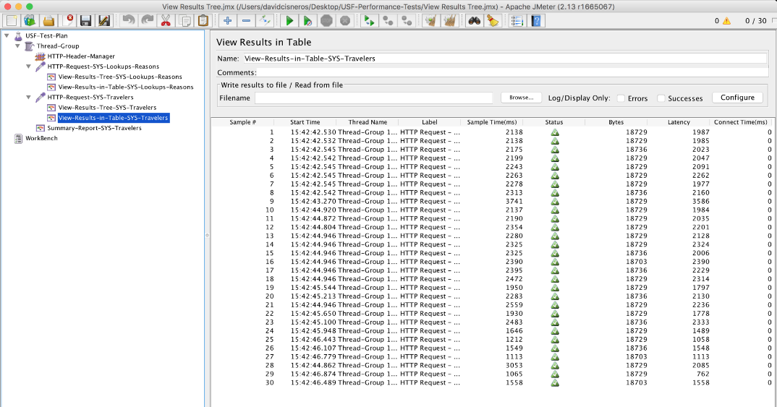

# Soak Tests

Base Line + loop count increased to reach the desired time.

|  |  |
| --- | --- |
| **Key** | **Value** |
| Threads | 100 |
| RampUp | 10 |
| ramp-up/threads relation | 0.1 (every 0.1 secs a new thread is created) |
| loop count | 360 (x 4) |

Execute from Command Line: from {JMETER_HOME}/bin

./jmeter.sh -n -t {JMETER_PLAN_PATH}/JMETER_PLAN_NAME.jmx -l {LOGS_OUTPUTH_PATH}/LOG_ANY_NAME.csv

Execution and monitoring (Cloudhub, API Manager, Local/Test-exec Machine monitoring)

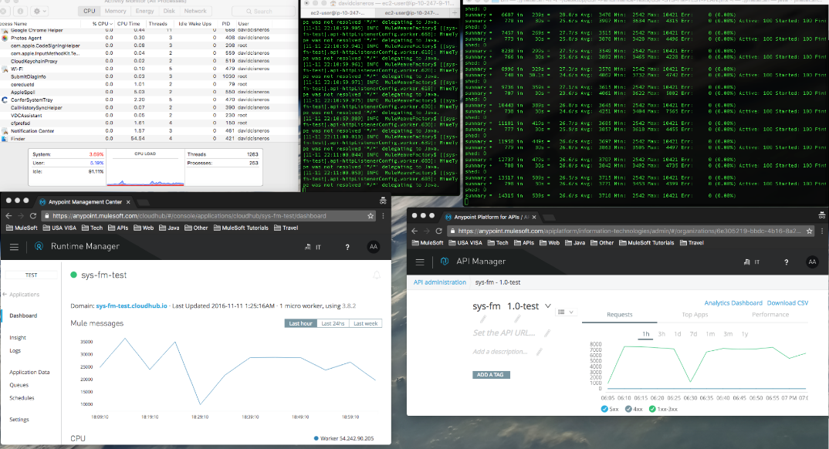

# Results

* Baseline: 100 threads, ramp-up 10
* Stability time-unit: 4 hs
* Stability: Ok