3 major task we need to do
- Each and everyone should choose a template of their choice
- That template is going to be used for front end project
- You have to convert the template into react project.
- Routing in react js

When we have js, css, image folder with us, we copy all of them into public folder of our react js
Any file outside the src folder we can not import them.

Style ={{‘width’:’200px’, width:’200px’ }}
Background-color
backgroundColor
react-router-dom

BrowserRouter, Routes, Route and Link
Axios + express js rest-api
Each Link is going to provide a url
Each url is associcated with the component

Props:-
Properties :-
<input type=”text” name=”username” size=”50” />
For admin we have a different menu and for user we have different menu
We will display two different menu’s on the bassis of usertype passed as a props to the component
We will pass type user to menu component
In menu component we will check the type of user and after that we will return the component name which is having menu’s for different type of users.
1-Menu
2-AdminMenu
3-CustomerMenu

We are going to declare a variable and with event handling in React we will update the value and expect that it will update our component.
onclick => onClick ={}

state of component
<body onload=”” >
Statefull and stateless components
UseState

Import {useState} from ‘react’;

First name
Middle name
Last name
Gender
Dob
Address line 1
Address line 2
City
State
Country
Phone no .

Const [userForm, setUserForm]= useState({
Fname:’’,
Mname:’’,
Lname:’’,
Dob:’’});
{(e)=>setUserForm({…userForm,fname:e.target.value}) }
<select onChange={(e)=>setUserForm({…userForm,gender:e.target.value}) }>
<option >choose gender</option>
<option value=”male”>Male</option>
<option value=”female”>Female </option>
</select>
Date: 6-5-26
useForm,
useEffect
useEffect :- express js

Life cycle of the component
<body onload=””>
Unload
Component is mounted.
Component is unmounted
Component is updated.
We are having props and states
Class Home
{
Constructor()
{

}
}
useEffect(()=>{},[dependency array (props,state)]);

in useEffect we write code to fetch the data from the REST-API to display on the component.
How use effect called whenever a dependency is changed

Npm init –y
And we got this output
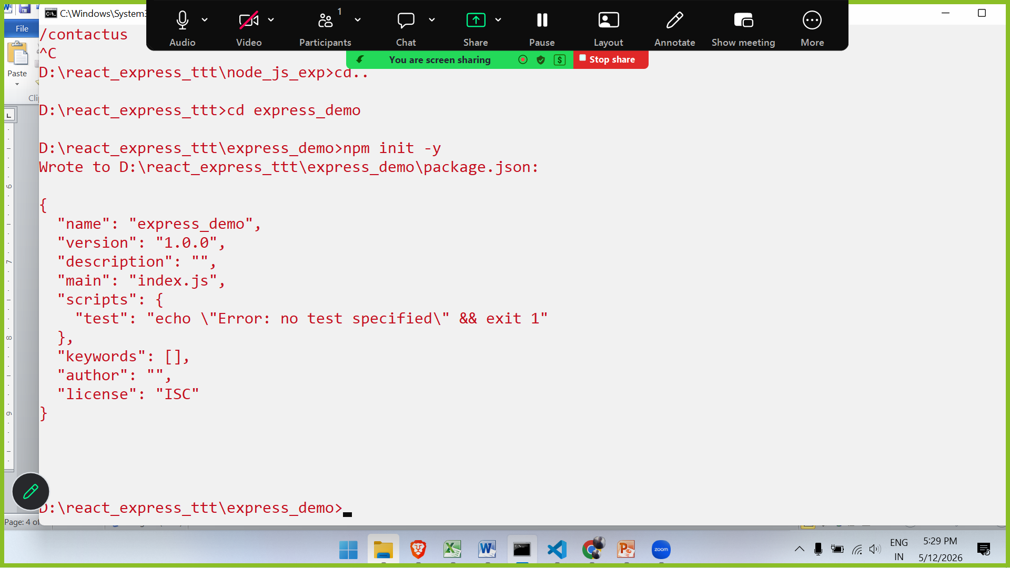

Express js
Npm install express
mysql2
multer
nodemon

express :-
response.
Combo of write & end method which is known as send method.
Res.send(html/text/json);

Npx nodemon server.js
Node server.js

Npm start

Date :- 12-5-26
NodeJS + ExpressJS
Built in module :- http, https,
Fs, path, url,
http :-

we just upload our files to server and
WEB-server

Scripting engine. Php,
Browser

Node js itself
http module
createServer(function(req,res){

}).listen(8080,()=>console.log(“server running at port no 8080”));
Localhost:8080/
Response.write
End
Res.writeHead(statuscode, {})
Routing with nodejs
Req.url

