06/10/2026 - Task
Completed By:Vimala Rani A(212223040240)

- Alert: Write a Python Selenium program to handle JavaScript alerts using accept(), dismiss(), and send_keys().
- Dropdown: Write a Python Selenium program to select dropdown options using visible text, value, and index.
- Wait: Write a Python Selenium program to demonstrate explicit waits using WebDriverWait and Expected Conditions.
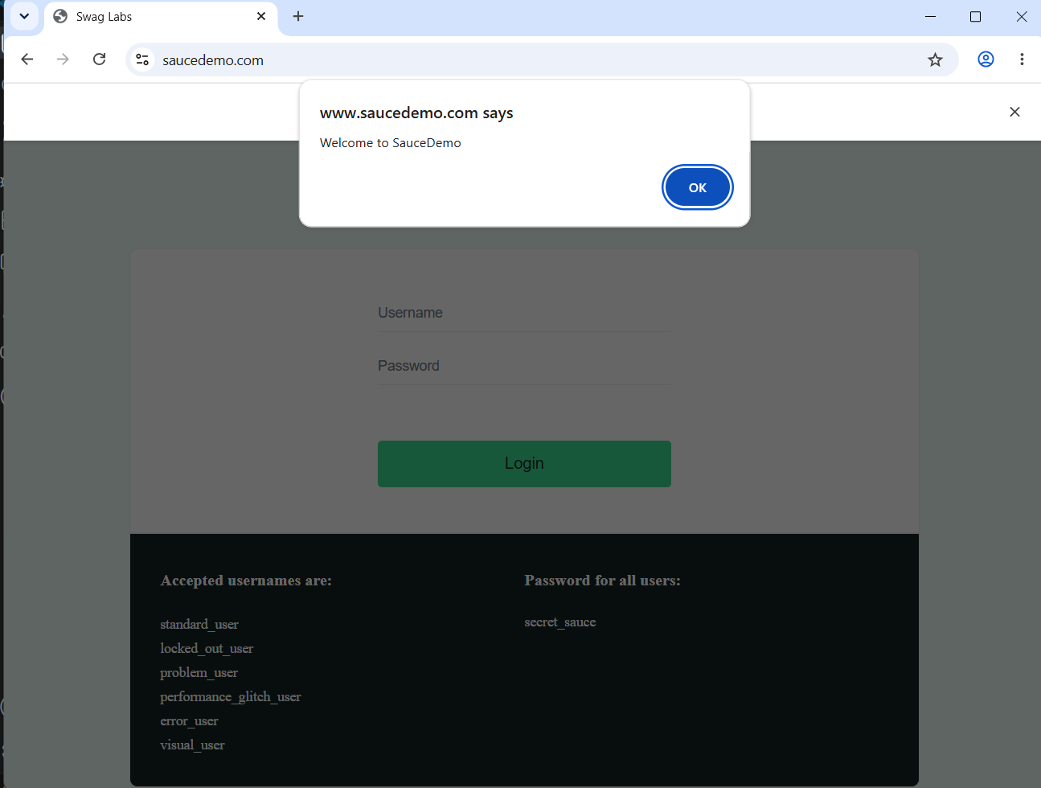
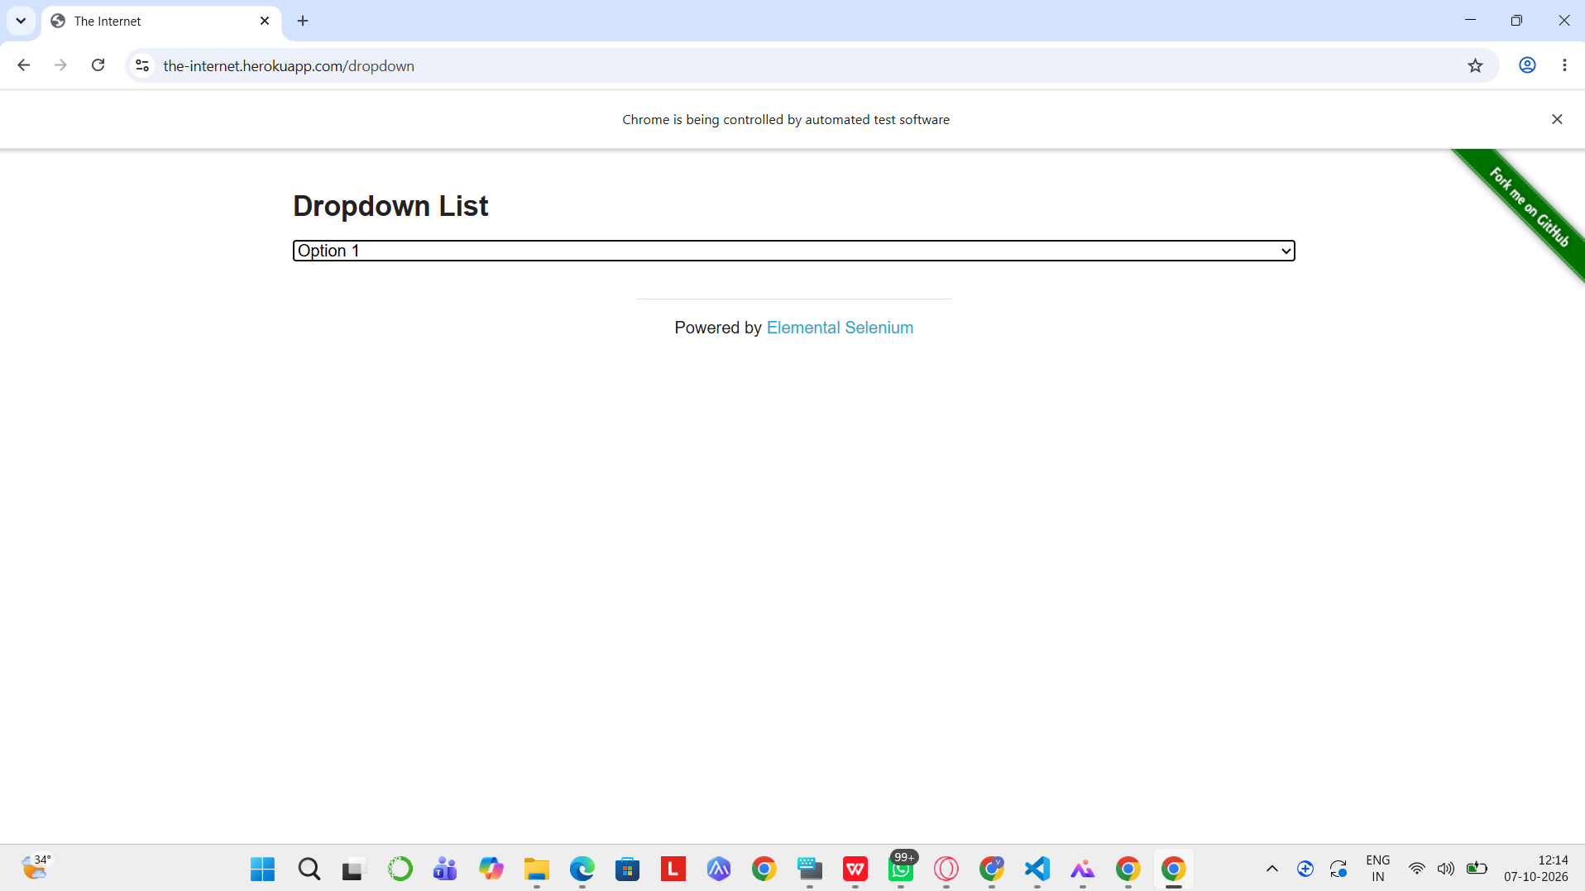
from selenium import webdriver
from selenium.webdriver.common.by import By
from selenium.webdriver.common.keys import Keys
from selenium.webdriver.support.ui import WebDriverWait
from selenium.webdriver.support import expected_conditions as EC

driver = webdriver.Chrome()
wait = WebDriverWait(driver, 15)

def find_click(selectors):
for by, value in selectors:
try:
e = WebDriverWait(driver, 5).until(
EC.presence_of_element_located((by, value))
)
if e.is_displayed():
driver.execute_script("arguments[0].click();", e)
return True
except:
pass
return False

driver.get("https://www.amazon.in/")
driver.maximize_window()

search = wait.until(
EC.element_to_be_clickable((By.ID, "twotabsearchtextbox"))
)
search.send_keys("wireless mouse")
search.send_keys(Keys.ENTER)

products = wait.until(
EC.presence_of_all_elements_located(
(By.XPATH, "//div[@data-component-type='s-search-result']")
)
)

added = False

for p in products:
try:
link = p.find_element(
By.XPATH,
".//a[contains(@href,'/dp/') or contains(@href,'/gp/product/')]"
)
driver.get(link.get_attribute("href"))

if find_click([
(By.ID, "add-to-cart-button"),
(By.NAME, "submit.add-to-cart"),
(By.ID, "add-to-cart-button-ubb"),
(By.CSS_SELECTOR, "input[value='Add to Cart']"),
(By.CSS_SELECTOR, "input[title='Add to Shopping Cart']")
]):
added = True
break
except:
pass

if not added:
print("Add to Cart failed")
driver.quit()
exit()

find_click([(By.ID, "nav-cart")])

if not find_click([
(By.NAME, "proceedToRetailCheckout"),
(By.XPATH, "//input[contains(@name,'proceedToRetailCheckout')]"),
(By.XPATH, "//span[contains(.,'Proceed to Buy')]/ancestor::a[1]"),
(By.XPATH, "//span[contains(.,'Proceed to Buy')]/ancestor::button[1]"),
(By.ID, "sc-buy-box-ptc-button")
]):
print("Proceed to Buy failed")
driver.quit()
exit()

wait.until(lambda d: "signin" in d.current_url.lower())

print("Amazon login page opened")
print("Automation stopped")

input("Press ENTER to close...")
driver.quit()

Github link: https://github.com/vimalaraniA/testcase.git

