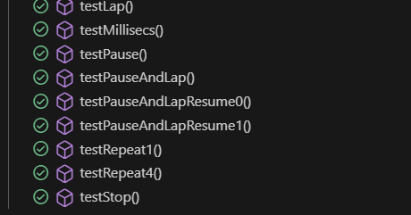

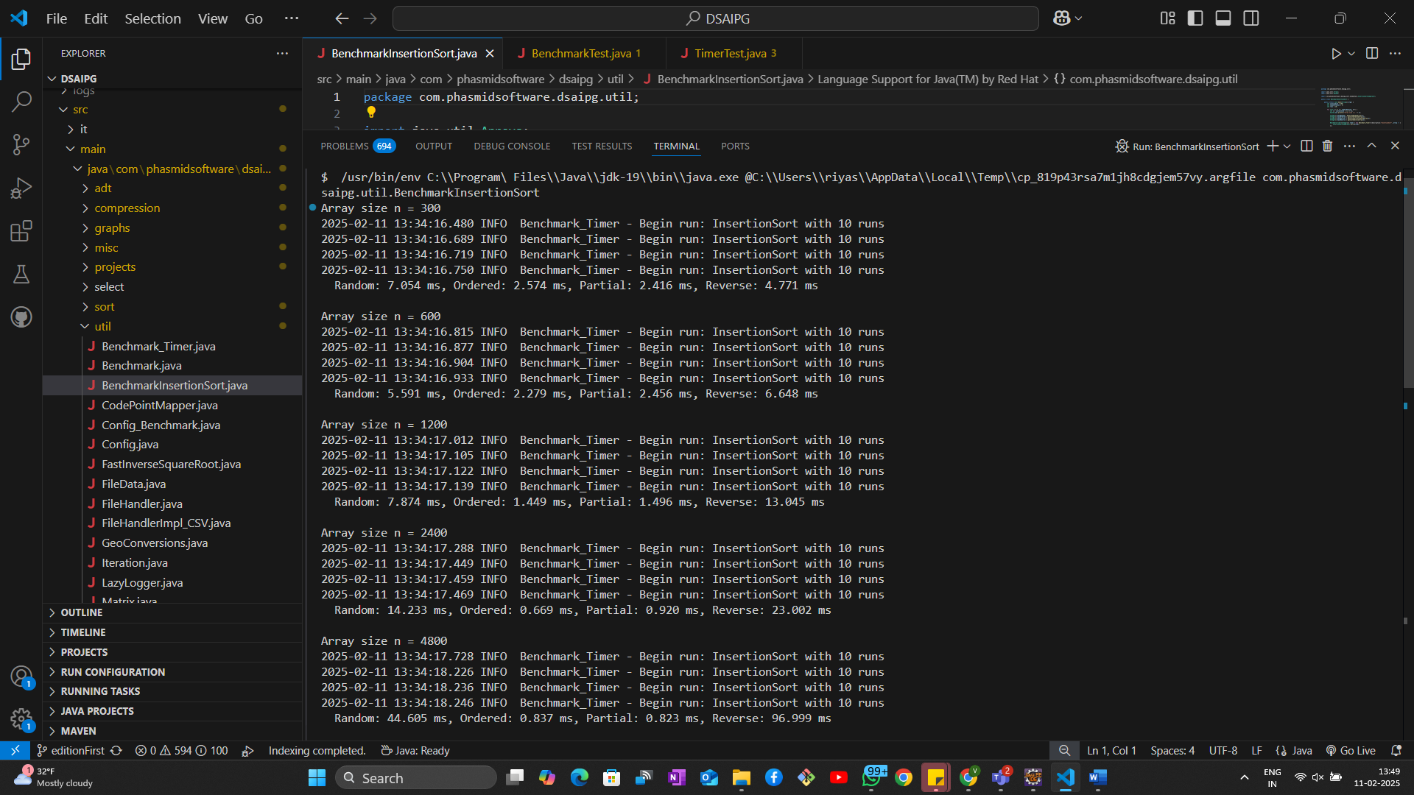

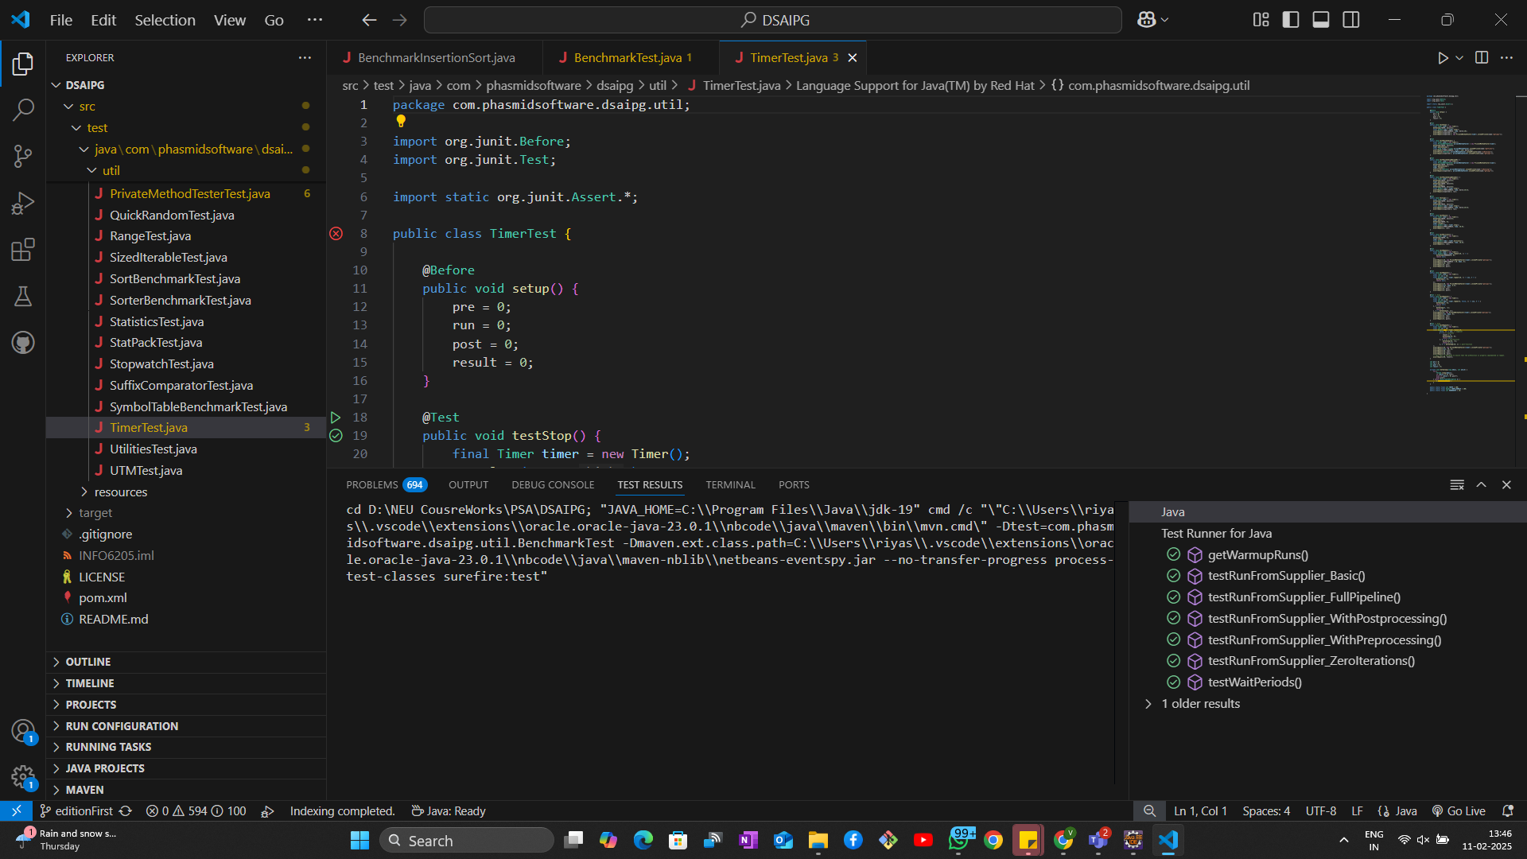

Array Size (n) | Random (ms) | Ordered (ms) | Partial (ms) | Reverse (ms)
300 | 4.027 | 1.671 | 1.646 | 3.094
600 | 2.534 | 1.513 | 1.423 | 3.632
1200 | 4.566 | 1.107 | 1.172 | 7.888
2400 | 10.494 | 0.571 | 0.901 | 19.911
4800 | 37.641 | 0.696 | 1.132 | 73.938

CONCLUSIONS:
- Best Case (O(n)): Ordered input runs in near-linear time.
- Average Case (~O(n²)): Random and partially ordered input take significantly longer as n grows.
- Worst Case (O(n²)): Reverse order is consistently the slowest, confirming quadratic growth.
- Insertion Sort is only suitable for small datasets or nearly sorted data. For larger datasets, Merge Sort or Quick Sort would be more efficient.

