**PSG COLLEGE OF TECHNOLOGY, COIMBATORE – 641004**

**DEPARTMENT OF INFORMATION TECHNOLOGY**

**5/4/2023**

**EXERCISE – 2**

1. To access CRED programs, one needs to have a credit score of 750 or more.  
   Given that the present credit score is X, determine if one can access CRED programs or not. If it is possible to access CRED programs, output YES, otherwise output NO.
2. A study has shown that playing a musical instrument helps in increasing one's IQ by 7 points. Chef knows he can't beat Einstein in physics, but he wants to try to beat him in an IQ competition. Given that Einstein’s IQ is170, and Chef currently has an IQ of X. Determine if, after learning to play a musical instrument, Chef's IQ will become strictly greater than Einstein's. Print "Yes" if it is possible for Chef to beat Einstein, else print "No" (without quotes).
3. Chef is currently working for a secret research group called NEXTGEN. While the rest of the world is still in search of a way to utilize Helium-3 as a fuel, NEXTGEN scientists have been able to achieve 2 major milestones

* Finding a way to make a nuclear reactor that will be able to utilize Helium-3 as a fuel
* Obtaining every bit of Helium-3 from the moon's surface

Moving forward, the project requires some government funding for completion, which comes under one condition: to prove its worth, the project should power Chefland by generating at least A units of power each year for the next B years. Help Chef determine whether the group will get funded assuming that the moon has X grams of Helium-3 and 1 gram of Helium-3 can provide Y amount of power.

Given A, B, X and Y , determine whether the group will get funded.

1. Print the following pattern

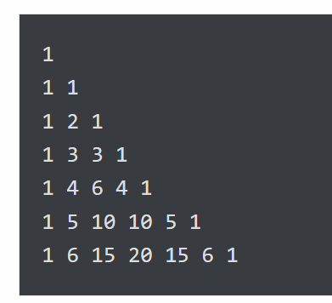

5. An integer is called *squarefree* if it is not divisible by any perfect squares other than 1. For instance, 42 is squarefree because its divisors are 1, 2, 3, 6, 7, 21, and 42, and none of those numbers (except 1) is a perfect square. On the other hand, 45 is not squarefree because it is divisible by 9, which is a perfect square. Write a program that asks the user for an integer and tells them if it is squarefree or not.

6. Write a program to play the following simple game. The player starts with $100. On each turn a coin is flipped and the player has to guess heads or tails. The player wins $9 for each correct guess and loses $10 for each incorrect guess. The game ends either when the player runs out of money or gets to $200.

7. The GCD (greatest common divisor) of two numbers is the largest number that both are divisible by. For instance, gcd(18,42) is 6 because the largest number that both 18 and 42 are divisible by is 6. Write a program that asks the user for two numbers and computes their gcd. Shown below is a way to compute the GCD, called Euclid's Algorithm.

* + First compute the remainder of dividing the larger number by the smaller number
  + Next, replace the larger number with the smaller number and the smaller number with the remainder.
  + Repeat this process until the smaller number is 0. The GCD is the last value of the larger number.

8. Write a program that draws “modular rectangles” like the ones below. The user specifies the width and height of the rectangle, and the entries start at 0 and increase typewriter fashion from left to right and top to bottom, but are all done mod 10. Below are examples of a 3 × 5 rectangle and a 4 × 8.

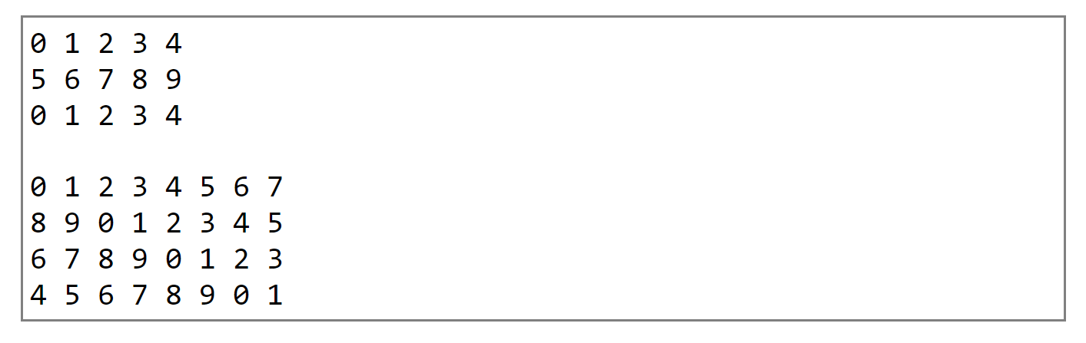

9. Write a program that prints out the sine and cosine of the angles ranging from 0 to 345° in 15° increments. Each result should be rounded to 4 decimal places. Sample output is shown below:

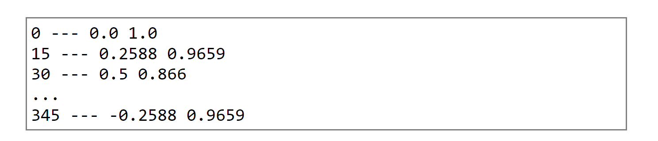

[Hint: use math module]

10. Write a Python program that will:

* + Ask the user for seven numbers
  + Print the total sum of the numbers
  + Print the count of the positive entries, the number entries equal to zero, and the number of negative entries. Use an if, elif, else chain, not just three if statements.

11. random guesser

Allow the user to guess for a number. If the user finds the number within max number of tries, he wins the game.

After each try, the system can provide hint to aid the user in the next guess. It can print either lower (or) higher depending on the whether the guess was lower than the number (or) higher than the number.

Refine the code so that number of hints are increased to 4 namely ‘higher’, ‘much higher’, ‘lower’, ‘much lower’. If the absolute difference between the guess and the number is greater than 10

12. Write a program that plays rock, paper, scissors:

* + Create a program that randomly prints 0, 1, or 2.
  + Expand the program so it randomly prints rock, paper, or scissors using if statements. Don't select from a list, as shown in the chapter.
  + Add to the program so it first asks the user their choice.
  + (It will be easier if you have them enter 1, 2, or 3.)
  + Add conditional statement to figure out who wins.