**Seminar Report**

**On**

**Android VS iOS : The Battle for Mobile Operating System Dominance**

**In partial fulfillment for the award of the degree**

**Of**

**BACHELOR OF COMPUTER APPLICATION**

**[B.C.A]**

**Year 2023-2024**

**SUBMITTED BY: GUIDED BY:**

**Vimal bhesaniya Asst. Prof. Pratiksha Patel**

**BCA-6th SEMESTER**

**Submitted to:**



**SHRI SHAMBHUBHAI V. PATEL COLLEGE OF**

**COMPUTER SCIENCE & BUSINESS**

**MANAGEMENT**

Affiliated to

**Veer Narmad South Gujarat University**

❖ Abstract 3

❖ History 4

ANDROID 4

IOS 5

❖ Introduction 7

❖ Topic Detail 7

✰ User interface 7

✰ Exclusive features 8

✰ Software upgrades 9

✰ Speed 10

✰ Apps Available on iOS vs. Android 10

✰ Stability of Apps and the Operating System 11

✰ Device Selection 11

✰ security 11

✰ Privacy 12

✰ Building and Publishing Apps for iOS vs. Android 13

✰ Voice Commands on Android vs. iOS 13

✰ The Bottomline: Choosing between iOS and Android 13

✓ iOS pros and cons 13

✓ Android pros and cons 14

❖ Topic Example 15

✓ User Interface (UI) and Design: 15

✓ Customization: 16

✓ Hardware Options: 16

❖ Applications : 18

✓ Android vs iOS: Applications 18

✓ iOS is important for businesses for several reasons: 19

❖ Topic Diagrams or figures 21

❖ Topic related comparative technology/Comparative charts/tables 22

❖ Advantages & Disadvantages 24

❖ Enhancement of Topic/ Future enhancement 26

❖ Conclusion : 27

❖ References : 28

# Abstract

This case is about the competition between the two mobile operating systems Android andiOS to gain the top slot among the mobile operating systems. Android was launched byGoogle Inc. (Google) to gain control over the way mobile internet was emerging. Android gained quick acceptance from consumers as well as handset makers and was locked in anintense competitive battle with Apple Inc.’s (Apple) mobile operating system iOS in the key US market. Though Apple dismissed the competition from Android, many analysts opinedthat the threat to iOS from Android was real and happening. Android was an open sourcemobile operating system which was given to various mobile operators free of cost in contrast to iOS which was a proprietary operating system used only in Apple’s mobile devices. Even though iOS had the largest number of applications available for any mobile operating system,the number of applications available for Android was increasing due to greater freedom beinggiven to the application developers. Rather than being limited to just smartphones, thecompetition between Android and iOS was extending to other devices like tablet computersas these two mobile operating systems were increasingly being used in such other portablecomputing devices. To take the competition forward, Google said that it was planning tointroduce low cost Android powered smartphones in emerging markets like India and China.Industry observers noted that the stakes for both the companies were high as traditionally ithad been observed that in such a fight, one platform dominated the market (for instance,Microsoft vs. Apple and IBM, eBay vs. Yahoo Auctions and Auction Universe, Google vs.Yahoo and Microsoft). They were watching closely to see which platform would eventuallydominate the market and which company would have the last laugh.

# History

# ANDROID

* 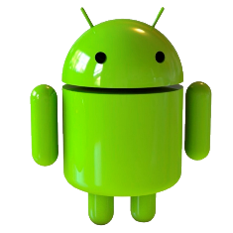Android history began in October 2003. This was well before the term smartphone became ubiquitous. It was also several years before Apple announced the first iPhone and iOS. Android Inc was founded in Palo Alto, California. Rich Miner, Nick Sears, Chris White, and Andy Rubin were its four founders. At the time, Rubin mentioned Android Inc would develop “smarter mobile devices that are more aware of its owner’s location and preferences.”
* Rubin revealed in a 2013 speech in Tokyo that Android OS was originally meant to improve the operating systems of digital cameras. Even back then, the market for standalone digital cameras was declining. A few months later, Android Inc shifted gears towards using the OS inside mobile phones.
* Google bought Android in 2005 and everything changed.
* In 2005, the next significant chapter in Android history began when Google acquired the original company. Rubin and other founding members continued developing the OS under their new owners. They then decided to use Linux as the basis for the Android OS. That made it possible to offer the operating system to third-party mobile manufacturers for free. Google and the Android team felt the company could profit from providing other services, including apps.
* Rubin stayed at Google as head of the Android team until 2013. This was when the Mountain View company announced Andy would be leaving the division. In late 2014, Rubin left Google altogether and launched a startup business incubator before eventually returning to the smartphone business with the ill-fated Essential in 2017.
* Irina Blok created the now-familiar logo for the Android OS while working for Google. It looks like a combination of a robot and a green bug. Blok has said the only directive the Google design team gave her was to make the logo look like a robot. Blok also stated that one of her inspirations for the final design for the Android mascot was the familiar restroom logos representing “Men” and “Women.”
* One thing that Blok and Google decided was to make the Android robot itself an opensource project. Nearly every other huge company would protect such a logo or mascot from redesigns. However, tons of people have modified Android’s logo, because Google allows such changes under the Creative Commons 3.0 Attribution License.
* The Android mascot — also known as just “Andy” — was overhauled alongside much of Android’s branding in 2019. Andy may have lost his body, but the new look is now more ubiquitous across Android’s branding.

# IOS

* 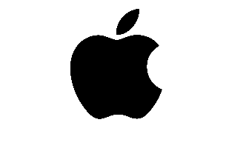In what is widely regarded as his greatest presentation ever, Apple's Steve Jobs introduced the iPhone to the world on January 9th, 2007. In the five-plus years since then, the iPhone, iPad, and iPod Touch have literally redefined the entire world of mobile computing. That world is moving so quickly that iOS is already amongst the older mobile operating systems in active development today. That certainly doesn't mean it's underpowered or underfeatured — quite the contrary. Through what can only be described as relentless and consistent improvement over the years, Apple has made iOS one of the most feature-rich and well-supported platforms on the market.
* Apple Inc. Is an American[multinational corporation](http://en.wikipedia.org/wiki/Multinational_corporation)that designs and markets[consumer electronics,](http://en.wikipedia.org/wiki/Consumer_electronics)[computer software,](http://en.wikipedia.org/wiki/Computer_software)and[personal computers.](http://en.wikipedia.org/wiki/Personal_computer) The company's best-known hardware products includethe[Macintosh](http://en.wikipedia.org/wiki/Macintosh)line of computers, the[iPod,](http://en.wikipedia.org/wiki/IPod)the[iPhone](http://en.wikipedia.org/wiki/IPhone)andthe[iPad.](http://en.wikipedia.org/wiki/IPad)Apple software includes the[Mac OS X](http://en.wikipedia.org/wiki/Mac_OS_X)[operatingsystem;](http://en.wikipedia.org/wiki/Operating_system)the[iTunes](http://en.wikipedia.org/wiki/ITunes)media browser; the[iLife](http://en.wikipedia.org/wiki/ILife)suite of multimediaand creativity software; the[iWork](http://en.wikipedia.org/wiki/IWork)suite of productivitysoftware;[Aperture,](http://en.wikipedia.org/wiki/Aperture_(software))a professional photography package;[Final Cut Studio,](http://en.wikipedia.org/wiki/Final_Cut_Studio)a suite of  professional audio and film-industry software products;[Logic Studio,](http://en.wikipedia.org/wiki/Logic_Studio)a suite of music production tools; the[Safari](http://en.wikipedia.org/wiki/Safari_(web_browser))web browser; and[iOS,](http://en.wikipedia.org/wiki/IOS_(Apple))a mobile operating system. As of October 2010, the company operates 317[retail stores](http://en.wikipedia.org/wiki/Apple_Store)in ten countries, and an[online store](http://en.wikipedia.org/wiki/Apple_Store_(online))wherehardware and software products are sold. As of May 2011, Apple is one of the[largestcompanies in the world](http://en.wikipedia.org/wiki/List_of_corporations_by_market_capitalization)and the most valuable technology company in the world, havingsurpassed Microsoft.Established on April 1, 1976 in[Cupertino,](http://en.wikipedia.org/wiki/Cupertino,_California)[California,](http://en.wikipedia.org/wiki/California)and incorporated January 3, 1977, thecompany was previously named Apple Computer, Inc., for its first 30 years, but removed theword "Computer" on January 9, 2007, to reflect the company's on-going expansion intothe[consumer electronics](http://en.wikipedia.org/wiki/Consumer_electronics)market in addition to its traditional focus on personal computers. Asof September 2010, Apple had 46,600 full time employees and 2,800 temporary full timeemployees worldwide and had worldwide annual sales of $65.23 billion.For reasons as various as its philosophy of comprehensive aesthetic design to its[distinctiveadvertising campaigns,](http://en.wikipedia.org/wiki/Apple_Inc._advertising)Apple has established a unique reputation in the consumer electronicsindustry. This includes a customer base that is devoted to the company and its brand, particularly in the United States.magazine named Apple the most admired companyin the United States in 2008 and in the world in 2008, 2009, and 2010. The company has alsoreceived[widespread criticism](http://en.wikipedia.org/wiki/Criticism_of_Apple_Inc.)for its contractors' labour, environmental, and business practices.
* understand smartphone operating system to new users, a powerful platform for app developers, and a relatively un-fragmented experience across multiple devices. Perhaps the most remarkable thing about iOS is how similar the OS as it exists today is to the OS as it existed 2007, yet the number and breadth of features that Apple has baked in since then is mind boggling. Far from suffering from the "feature creep" that typically bogs down operating systems over time, iOS has managed to stay relatively snappy and is more internally consistent than anything else available today. And iOS 8 — launching on devices this fall — looks to evolve the story even further.
  + How did we get from a platform that began without third-party apps, multitasking, or even copy / paste support to where we are today? Read on to see exactly how Apple evolved its mobile platform over the years, in our history of iOS.
  + During the original iPhone announcement, Apple touted that it ran on the same Unix core as Mac OS X and that it used many of the same tools. However, it was clear even then that while there may be some shared elements between OS X and this new phone OS, it was a different-enough beast to warrant its own branding. When the original iPhone launched, the OS was called "iPhone OS" and it kept that name for four years, only changing to iOS with the release of iOS 4 in June of 2010. For the sake of simplicity (and because it's a much-less awkward phrase), I'm going to indulge in a little revisionist history here and refer to all versions of the operating system as "iOS" in this piece.

## Introduction

handset manufacturers free of cost to control the smartphone business Google’s entry into the mobile operating system market became imminent with many people all over the worldstarting to browse the internet on their mobile phone Many analysts were initially sceptical about the Android’s chances of success. They said Android would be a wasteful investmentfor Google, which did not have much experience in developing operating systems to competewith giants like Apple and RIM. James Faucette, an analyst at Pacific Crest Securities, Inc.(Pacific Crest), said, "For Google, Android is a cash drain. They are going to lose money onAndroid as an operating system. They hope to make it up from the services that they aredelivering through their infrastructure and servers." But Android silenced critics by growingrapidly and proving to be a viable alternative to Apple's iOS.However, in October 2009, Gartner Inc. (Gartner) predicted that the Android software wouldovertake iOS by 2012[.](http://www.icmrindia.org/casestudies/catalogue/Marketing/Android%20Vs%20iOS2.htm#6])This new projection by Gartner raised expectations about Android. Apple’s iOS had, till then, been the choice of millions of smartphone users all over the world as well as third party application developers. As the operating systems used in mobile phones became the main domain in the battle for dominance in the mobile sector, the growth of Android put more pressure on Apple, which had been basking in success after emerging as the world’s biggest technology company in terms of market capitalization, overtaking Microsoft Corporation (Microsoft).Android’s rapid growth was attributed to many factors. The most important of these was theadvantage Android had over iOS by virtue of being an open source operating system. iOS, on the other hand, was a closely guarded proprietary operating system used in the products of asingle firm. Many third party application developers started to prefer Android to iOS due tothe flexibility it gave to them in developing applications. Another factor attributed for thegrowth was the adoption of Android by some major handset manufacturers like HTCCorporation (HTC) and Motorola Inc. (Motorola) which, in turn, had tie-ups with some major telecom operators like Verizon Wireless (Verizon). Android also gave operators someflexibility -- some of the services like email could be customized to be offered by theoperators themselves. This adoption of Android by major handset manufacturers helped it become the operating system in many top smartphones

## Topic Detail

### User interface

* iOS and Android both use touch interfaces that have a lot in common - swiping, tapping and pinch-and-zoom. Both operating systems boot to a homescreen, which is similar to a computer desktop. While an iOS home screen only contains rows of app icons, Android allows the use of widgets, which display auto-updating information such as weather and email. The iOS user interface features a dock where users can pin their most frequently used applications.
* A status bar runs across the top on both iOS and Android, offering information such the time, WiFi or cell signal, and battery life; on Android the status bar also shows the number of newly received emails, messages and reminders.
* A comparison of some of the features of the Android 11 and iOS 14 is here. Android 11 highlights include:
  + Priority conversations
  + Unified Device controls and payments
  + One-time permissions
  + Native screen recording
  + Improved media controls
  + Enhanced support for foldable devices
* iOS 14 highlights include:
  + Custom Widget Stacks
  + Picture in Picture
  + Compact Phone Calls
  + Third-Party default apps
  + Search in apps
  + Emoji Search
  + Exposure Lock
  + QuickTake Video
  + Pinned chats in Messages
* Many different manufacturers make Android phones and they often include some customization over the vanilla Android experience. e.g. HTC Sense or Samsung TouchWiz. Depending upon your device and carrier, there may be pre-installed apps that are bundled with your Android device.

### Exclusive features

* Features exclusive to iOS include:
* iMessage :- Perhaps the most popular iOS app, iMessage handles both SMS messages (when the other party is on a non-Apple platform) as well as Apple-supported chat (when all participants use iMessage). Its integration with Apple Pay makes sending and receiving money via iMessage extremely easy.
* AirDrop :- AirDrop uses Bluetooth to share files, pictures, videos and links from the iPhone to any Apple device. It is very easy to use.
* Share WiFi passwords :- Sharing WiFi passwords between two iOS devices is a breeze. Simply hold them close together and a pop-up will appear asking if you'd like to share your password.
* App offloading :- iOS automatically identifies apps that you do not use and removes them from the device. Data from the apps is retained and they get reinstalled when you want to use them.
* Breezy setup of new devices :- Apple makes it very easy to switch from an old iPhone to a new iPhone. When setting up a new iPhone, importing apps, data, passwords and settings is a breeze.
* Features exclusive to Android include :
* Customizing the Home screen :- Android offers a lot of flexibility for adding widgets and customizing the layout of the home screen. It also supports other apps taking over the management of the home screen.
* File management :- Android allows users to choose a file manager, and also provides access to the file system. Plugging an Android device into a PC exposes the phone's file system as just another drive, allowing drag and drop access for moving files between the phone and the PC.
* Expandable Storage :- Most Android phones come with expandable storage. While the phone may only have 32 or 64GB of storage, you can add a microSD card to expand it by up to 1TB more.
* Multiple Users and Guest accounts :- While iOS is a single-user operating system, Android has added support for multiple users, and even a guest account. This is especially useful for sharing your phone with kids or with a friend who may need it temporarily.
* Split screen :- iOS only supports split screen for iPads. Android supports this feature for phones as well.

### Software upgrades

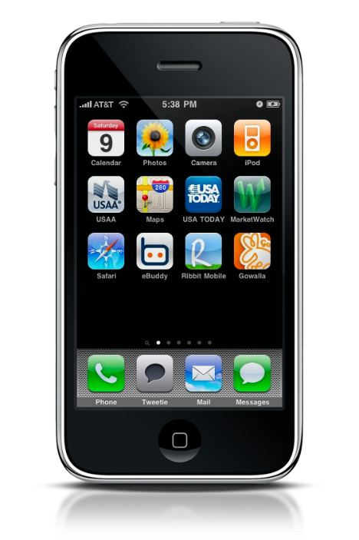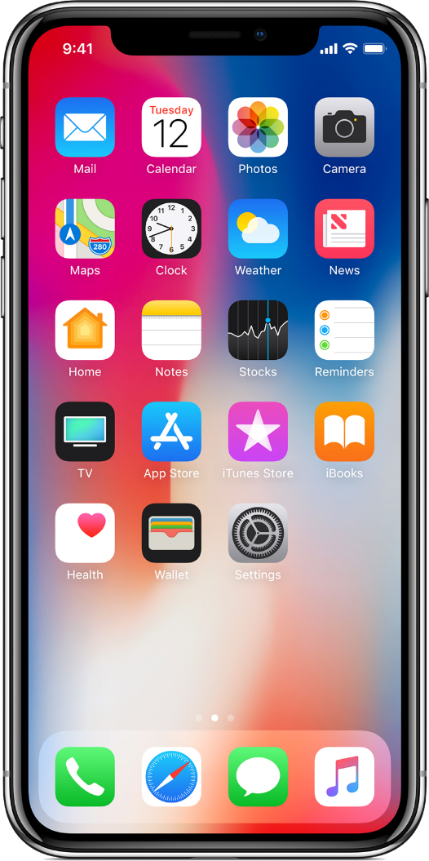

OLD NEW

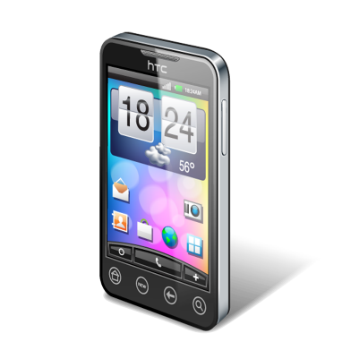 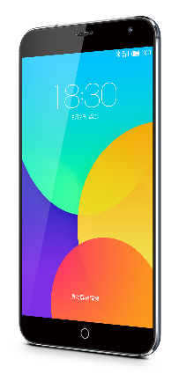

* This is one area where iOS users have a massive advantage. iOS upgrades are generally available to all iOS devices. When Apple release iOS 14 in the fall of 2020, it was made available for iPhone models as old as the iPhone 6S, which was released in Sep 2015. Apple cites hardware capability as the reason some older devices may not receive all new features in an upgrade.
* Although Google does update Android frequently, some users may find that they do not receive the updates on their phone, or even purchase phones with out-of-date software. Phone manufacturers decide whether and when to offer software upgrades. They may not offer an upgrade to the latest version of Android for all the phones and tablets in their product line. Even when an upgrade is offered, it is usually several months after the new version of Android has been released.

### Speed

* With the A-series chips that Apple designs in-house, the company has a roughly two-year lead over the best Android phones, which typically run Qualcomm's Snapdragon series chips. The iPhone 12 easily beats both Samsung Galaxy 20 and Google's Pixel 5 in Geekbench 5 and 3DMark's Wild Life stress tests.

### Apps Available on iOS vs. Android

* Android gets apps from Google Play, which currently has over 1 million apps available, most of which will run on tablets. However, some Android devices, such as the Kindle Fire, use separate app stores that have a smaller selection of apps available. Many originally iOS-only apps are now available for Android, including Instagram and Pinterest, and Google’s more open app-store means other exclusive apps are also available, including Adobe Flash Player and BitTorrent. Android also offers access to Google-based apps, such as Youtube and Google Docs.
* The Apple app store currently offers over 1 million apps, about 30% of which are available for the iPad. Most developers prefer to develop games for iOS before they develop for Android. A list of iOS-only games is maintained here on Wikipedia.
* The bottomline when comparing Google and Apple's app stores is that most popular apps are available for both platforms. But for tablets, there are more apps designed specifically for the iPad while Android tablet apps are often scaled up versions of Android smartphone apps. Developers at startups often focus on one platform (usually iOS) when they first launch their smartphone app because they do not have resources to serve multiple platforms from the get go. For example, Instagram started with iOS and their Android app came much later.
* Another consideration is being able to run Android apps on Windows PCs. Android apps distributed via Amazon's app store are compatible with Windows. In some use cases, for paid apps that you want to run both on your tablet and PC, this would give Android an advantage.

### Stability of Apps and the Operating System

* The Crittercism Mobile Experience Report published in March 2014 ranked Android KitKat as more stable than iOS 7.1. Other findings from the report include:
* Android 2.3 Gingerbread has the highest total crash rate, at 1.7%. Other versions of Android — Ice Cream Sandwich, Jelly Bean, and KitKat — have a crash rate of 0.7%.
* iOs 7.1 has a crash rate of 1.6%., and the rates for iOS 7.0 and iOS 5 are 2.1% and 2.5% respectively.
* Phone versions of both Android and iOS are more stable than their tablet versions.
* Crash rates for apps vary by category — games are most likely to crash (4.4% crash rate) and e-commerce apps have the lowest crash rate of 0.4%.

### Device Selection

* A wide variety of Android devices are available at many different price points, sizes and hardware capabilities.
* iOS is only available on Apple devices: the iPhone as a phone, the iPad as a tablet, and the iPod Touch as an MP3 player. These tend to be more expensive than equivalent hardware using Android

### security

* Android’s applications are isolated from the rest of the system’s resources, unless a user specifically grants an application access to other features. This makes the system less vulnerable to bugs, but developer confusion means that many apps ask for unnecessary permissions. The most widespread malware on Android is one where text messages are sent to premium rate numbers without the knowledge of the user, and the sending of personal information to unauthorized third parties. As it is the more popular smartphone operating system, it is more likely to be the focus of attacks.
* Malware writers are less likely to write apps for iOS, due to Apple's review of all the apps and verification of the identity of app publishers. However, if an iOS device is jailbroken and apps installed from outside Apple's store, it can be vulnerable to attacks and malware. Both iOS and Android are also vulnerable to bugs e.g. phones crashing when playing a specific video, which is a type of software bug that has affected both iOS and Android devices.
* In the real world, the security of an Android or iOS device is only as good as the software updates that have been applied to it. This is where iOS shines because of the fragmented nature of the Android ecosystem. Apple releases software updates and makes them available to all iOS devices at the same time. On Android, Google releases software updates and security patches to Nexus devices. Devices from other manufacturers lag behind because the manufacturer must take these security updates from Google and apply them to their own devices "in the wild". Virtually all manufacturers do a poor job at this. Most don't release patches to devices older than 12-18 months. Even when they do, these security updates are rolled out months after Nexus devices receive them.
* That Android devices are less secure is also evidenced by this bounty program; a company that obtains security exploits from hackers and sells them to governments has a bounty on 0-day (i.e., previously unknown) exploits for iOS ($1.5 million), Android ($200,000) and Flash ($80,000). The amounts of the bounties are a rough proxy for how easy it is to exploit these platforms in practice.
* So a security-conscious individual or company should use either iOS or Nexus devices.

### Privacy

* Both iOS and Android are "vulnerable" to a certain kind of privacy leak: an app installed on either platform can get a list of all other apps installed on the same device. This means your calculator app can find out that you use Tinder and relay that information back to its publisher, who is then free to use this info in whatever way they choose. In November 2014, Twitter announced that it is now tracking the list of apps its users have installed on their phones. Twitter is far from being the only company doing this.
* Permissions requested by Pandora's Android app. An Android user cannot use Pandora's app without accepting all of these permission requests.
* Permissions requested by Pandora's Android app. An Android user cannot use Pandora's app without accepting all of these permission requests.
* Beyond the list of apps, when it comes to protecting users' private information, iOS wins. Until Android Marshmallow was released in 2015, when installing apps on Android, the user was presented with all the permissions that the app is requesting. This was an all-or-nothing proposition. The user could choose to accept the app's request for permissions or not install the app at all. App developers take advantage of this "feature" and request a lot of user information. For example, Pandora's mobile app on Android requests permissions for your Google identity, contacts, calendar, photos, media, files and even call information.
* Pandora's app on iOS gets no such permissions. After it is installed and opened by the user, an iOS app may request additional permissions like location and access to Contacts. But the user can reject these permission requests. Even after approving the permission requests, iOS users can quickly glance at which apps have access to their Contacts and location data, and turn off access for apps with which they no longer want to share this data.
* Android M (or Marshmallow) allowed a new permissions regime where apps could request permissions as needed. However, a majority of Android apps still take the approach of requesting permissions upfront. While it is possible to manage app permissions on Android at a more granular level, this option is buried deep in the settings.

### Building and Publishing Apps for iOS vs. Android

* Android apps are programmed using C, C++ and Java. It is an "open" platform; anyone can download the Android source code and Android SDK for free. Anyone can create and distribute Android apps for free; users are free to download apps from outside the official Google Play store. There is, however, a one-time $25 registration fee for developers who want to publish their apps (whether free or paid apps) on the official Google Play store. Apps published on Google Play undergo a review by Google. The Android SDK is available for all platforms - Mac, PC and Linux.
* iOS apps are programmed using Objective-C. Developers must pay $99 every year for access to the iOS SDK and the right to publish in Apple's app store. The iOS SDK is only available for the Mac platform.
* Some app development xplatforms - such as Titanium Appcelerator and PhoneGap - offer a way to code once (say in Javascript and/or HTML) and have the platform convert it into "native" code for both Android and iOS platforms.

### Voice Commands on Android vs. iOS

* iOS uses Siri, a voice-based virtual assistant, to understand and respond to both dictation as well as spoken commands. Siri includes many features, such as reading sports scores and standings, making reservations at restaurants and finding movie times at the local theater. You can also dictate texts and emails, schedule calendar events, and interface with car audio and navigation.
* Android offers a similar assistant, Google Now, which features the above abilities, plus can keep track of your calendar and give verbal reminders when it is time to leave. It allows for voice search and dictation.

### The Bottomline: Choosing between iOS and Android

* To summarize the key pros and cons of Android and iOS:

### iOS pros and cons

* **Massive app ecosystem**: distinct advantage for tablet apps while on smartphones popular apps are usually available for both platforms
* **Deeper integration with Facebook and Twitter**: it is easier to post updates and share on social networks using iOS than Android because of how deeply integrated these platforms are with iOS.
* **iOS-only apps** like Passbook, FaceTime, and mobile payments app Square (available on iOS 3GS,4,4S,5 and up, nut only for a limited Android phones)
* **Interface is locked down**: Limited customization options for the home screens; only rows of app icons are allowed. No third-party apps are pre-installed by the wireless carrier. Users can only install apps from the App Store
* **Software upgrades**: Apple offers software upgrades to all devices that have the hardware capable of handling the new software. This means devices stay current with software features for at least two to three years.
* **Better privacy controls**: iOS offers better control over the access apps have to users' private information such as contacts and location.

### Android pros and cons

* **Massive hardware selection**: A large number of Android devices are available at various price points, with varying hardware capabilities, screen sizes and features.
* **Highly customizable user experience**: The home screen can be customized with not just app icons but widgets that allow the user to stay connected or informed. Other examples include SwiftKey, which modifies your Android smartphone’s keyboard, and apps that emulate older gaming consoles. Google has fewer restrictions than Apple on what kinds of apps it allows in its Play store. Moreover, you can choose to install Android apps from places other than the Google Play store.
* Several prominent people have shifted from iPhone to Android. Android's connection to the Google ecosystem of services is strong and arguably more useful compared with Apple's cloud services suite.

# Topic Example

### User Interface (UI) and Design:

##### iOS User Interface:

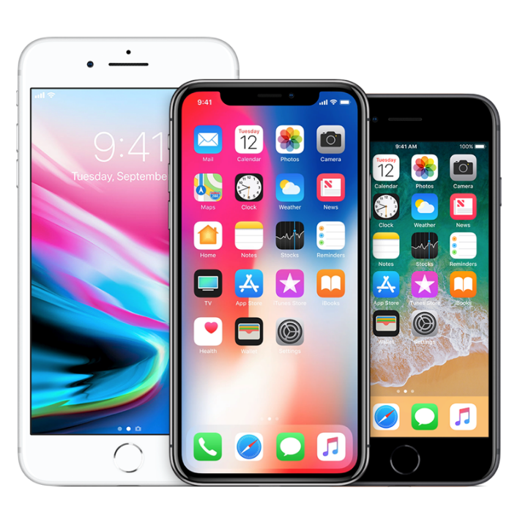

* iOS is known for its sleek, minimalist design with a focus on simplicity and elegance.
* The home screen typically consists of rows of app icons arranged in a grid pattern, with a dock at the bottom for frequently used apps.
* iOS uses gestures extensively for navigation, such as swiping, tapping, and pinching.
* The Control Center, accessible by swiping down from the top right corner, provides quick access to settings like Wi-Fi, Bluetooth, and screen brightness.
* Multitasking is achieved by swiping up from the bottom of the screen to reveal the app switcher, allowing users to easily switch between recently used apps.

##### Android User Interface:

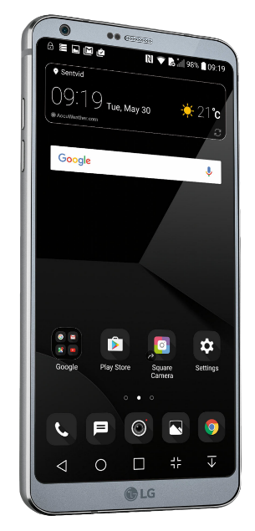

* Android offers more customization options compared to iOS, allowing users to personalize their home screens with widgets, app shortcuts, and custom wallpapers.
* The home screen can be customized with various launchers, which offer different layouts, themes, and gestures.
* Android uses a navigation bar or gestures for navigation, with options for virtual buttons or gesture-based controls.
* Notifications are displayed in the notification shade, accessible by swiping down from the top of the screen, and can be expanded or dismissed individually.
* Android offers a split-screen mode for multitasking, allowing users to run two apps side by side.

### Customization:

##### Android Customization:

* Home Screen Customization: Android allows users to customize their home screens with widgets, app shortcuts, custom app icons, and live wallpapers. Users can rearrange icons and widgets freely, creating unique layouts.
* Launchers: Android users can install third-party launchers from the Google Play Store to change the look and feel of their home screens. Launchers offer various themes, icon packs, and customization options, allowing users to personalize their devices extensively.
* System Themes: Some Android devices support system-wide theming, allowing users to change the overall color scheme, icons, and fonts system-wide.
* Custom ROMs: Advanced users can install custom ROMs, which are modified versions of the Android operating system, offering additional features, optimizations, and customization options beyond what is available on stock Android.
* Accessibility Options: Android offers accessibility features such as font size adjustments, color inversion, and magnification gestures to cater to users with specific needs.

##### **iOS Customization:**

* App Icons: While iOS does not natively support changing app icons, users can create shortcuts to apps using the Shortcuts app and customize the icon, name, and appearance of the shortcut. This allows for some degree of customization, although it's more limited compared to Android.
* Widgets: With iOS 14 and later versions, Apple introduced support for widgets on the home screen, allowing users to add widgets of varying sizes and functionalities to their home screens for quick access to information.
* System-wide Appearance: iOS offers limited system-wide appearance customization options, such as light and dark mode, dynamic wallpapers, and accent colors. However, customization options are more restricted compared to Android.
* Accessibility Features: iOS includes a range of accessibility features such as text size adjustments, color filters, and magnification, catering to users with different accessibility needs.

### Hardware Options:

##### Android Hardware Options

* Android is an open-source operating system used by various manufacturers to power their smartphones, tablets, and other devices.
* There is a wide range of Android devices available from numerous manufacturers, including Samsung, Google, LG, Motorola, OnePlus, Xiaomi, Huawei, and many others.
* Android devices come in various form factors, including smartphones, tablets, foldable phones, and wearables like smartwatches and fitness trackers.
* Android devices are available at different price points, ranging from budget-friendly options to high-end flagship devices with premium features.
* Users have a wide selection of hardware options to choose from, including devices with different screen sizes, resolutions, camera configurations, processors, storage capacities, and battery life.

##### iOS Hardware Options:

* iOS is exclusive to Apple's hardware products, including the iPhone, iPad, iPod Touch, Apple Watch, and Apple TV.
* Apple offers a limited range of hardware options compared to Android, with a focus on a few flagship iPhone models released annually, as well as a selection of iPad models catering to different use cases.
* Apple's hardware products are known for their premium build quality, design, and performance, with a reputation for reliability and longevity.
* While there is less diversity in terms of hardware options compared to Android, Apple's devices are known for their integration with each other and the seamless user experience they provide across the Apple ecosystem.
* Apple's devices are typically positioned in the higher price range, with flagship iPhone models commanding premium prices, although older models may become more affordable over time.

# Applications :

### Android vs iOS: Applications

* **Android:**

##### Budget-conscious users:

* Wider range of devices at various price points.
* Power users: More customization options, open-source nature allows deeper tinkering.
* Multitasking & productivity: Split-screen multitasking, widgets, diverse file management options.
* Gaming: Wider hardware variety, access to emulators and cloud gaming services.
* Customization: Deeper personalization of launcher, themes, icons, etc.

##### Business professionals:

Android holds a significant share of the global smartphone market. By targeting Android users, businesses can reach a large and diverse audience, including consumers and professionals across various demographics and regions.

##### Customization and Flexibility:

Android offers a high level of customization and flexibility, allowing businesses to tailor mobile applications to specific needs and branding requirements. This flexibility can be particularly beneficial for businesses operating in niche markets or with unique requirements.

##### Affordability and Accessibility:

Android devices are available at various price points, including budget-friendly options, making them accessible to a broad range of users. This affordability can be advantageous for businesses targeting price-conscious consumers or employees who require company-issued devices.

##### Integration with Google Services:

Android seamlessly integrates with various Google services such as Gmail, Google Drive, Google Calendar, and Google Maps. This integration can streamline business processes, improve productivity, and enhance collaboration among employees.

##### Enterprise Features:

Android offers robust enterprise features and management capabilities through platforms like Android Enterprise. These features include secure app distribution, device management, remote device wiping, and data encryption, making Android a suitable choice for businesses with strict security and compliance requirements.

##### Development Flexibility:

Android development is supported by a wide range of development tools and frameworks, including Android Studio, Kotlin, and Java. Businesses can leverage these tools to develop custom applications tailored to their specific needs, whether it's for internal use, customer-facing applications, or enterprise solutions.

* Integration with Existing Systems:

Android applications can easily integrate with existing IT infrastructure and backend systems, allowing businesses to leverage their investments in technology and streamline business processes.

##### Globalization and Localization:

Android supports localization features that enable businesses to localize applications for different languages, cultures, and regions. This capability is essential for businesses targeting international markets and diverse audiences.

* **iOS:**
* Ease of use: Simple and intuitive interface, known for smooth performance.
* Tight integration with Apple ecosystem: Seamless connection with Macbooks, iPads, Airpods, etc.
* Security & privacy: Strict app store policies and frequent updates offer strong security.
* Gaming: High-quality, optimized games due to hardware and software control.
* Content creation: Excellent camera quality, video editing tools, and integration with creative apps.
* Here are some specific application examples:

##### Business professionals:

### iOS is important for businesses for several reasons:

##### Security and Privacy:

iOS is renowned for its robust security features and strict privacy policies. This makes it a preferred choice for businesses dealing with sensitive data, such as financial institutions, healthcare organizations, and government agencies. The App Store's stringent review process ensures that apps meet high security standards, reducing the risk of malware and data breaches.

##### Enterprise Features:

iOS offers a range of enterprise-focused features and tools to enhance productivity and collaboration in business settings. This includes built-in support for secure email and messaging, VPN connectivity, device management capabilities through Mobile Device Management (MDM) solutions, and integration with enterprise systems like Microsoft Exchange and Active Directory.

##### Developer Support:

Apple provides comprehensive resources and support for developers building business apps for iOS. This includes robust development frameworks like SwiftUI and UIKit, as well as development tools such as Xcode and TestFlight for testing and deployment. The Developer Program offers access to beta releases, technical support, and App Store distribution, enabling businesses to create and distribute custom apps efficiently.

##### User Experience:

iOS is known for its intuitive user interface, smooth performance, and consistent user experience across devices. This enhances user satisfaction and productivity, leading to higher adoption rates for business apps. The design guidelines provided by Apple ensure that apps are user-friendly and visually appealing, enhancing the overall brand image and customer satisfaction.

##### **Integration with Apple Ecosystem:**

iOS devices seamlessly integrate with other Apple products and services, such as Macs, iPads, Apple Watch, and Apple TV. This allows businesses to leverage the full potential of the Apple ecosystem, enabling features like Handoff, Continuity, AirDrop, and iCloud synchronization for seamless workflow across devices. Integration with iCloud ensures that data is synchronized securely across devices, enhancing productivity and collaboration.

##### **Market Share and Demographics:**

While Android has a larger market share globally, iOS users tend to have higher purchasing power and engagement levels. This makes iOS users an attractive demographic for businesses targeting affluent or tech-savvy consumers. Additionally, iOS users are more likely to spend money on apps and in-app purchases, making the platform lucrative for businesses generating revenue through mobile apps.

# Topic Diagrams or figures

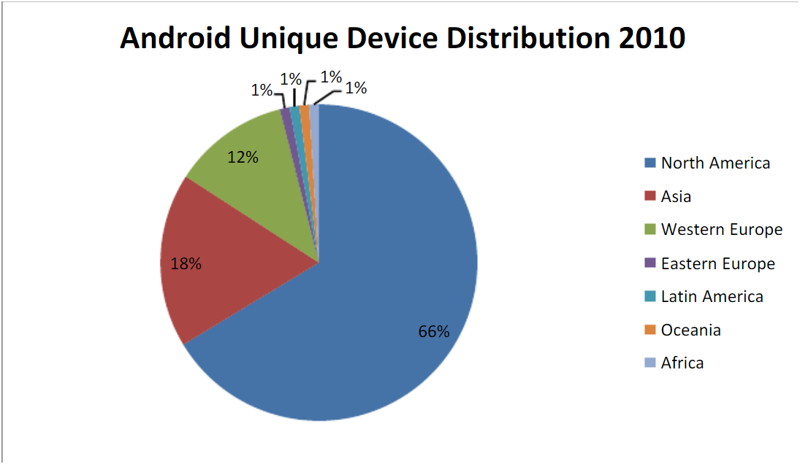

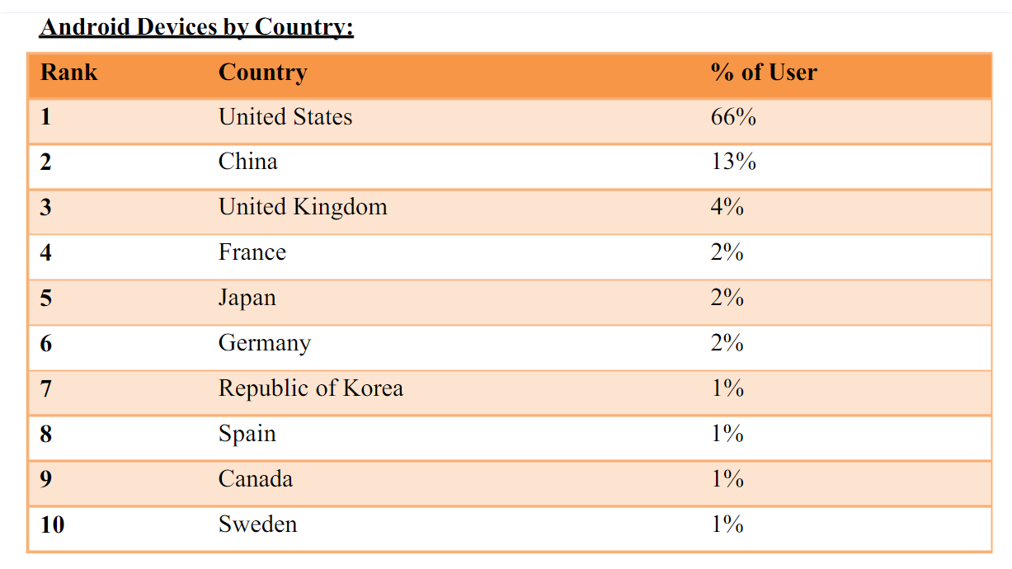

# Topic related comparative technology/Comparative charts/tables

* Windows Phone 7 has clearly been designed to be the centerpiece of a Microsoft-centric world, both for applications and for cloud-based Microsoft services.
* That becomes clear when you start the phone for the first time and you're asked for your Windows Live ID.
* There's a version of Outlook built into the operating system, and it works and syncs as you would expect -- seamlessly.
* The browser, naturally, is based on Internet Explorer. But the real news is Mobile Office, which includes mobile versions of Word, Excel, PowerPoint, OneNote and SharePoint.
* They're not the full-blown Windows versions, but they do the job very nicely. Neither the iPhone nor Android phones have anything comparable built into the operating system.
* There's also excellent integration with Microsoft's cloud-based services, including Hotmail. The People app integrates with the cloud-based Windows Live very nicely. Windows Live, in turn, integrates nicely with Facebook, so you get Facebook feeds and information delivered to you that way.
* I've also used Windows Phone 7 with the beta of Microsoft Office 365, a suite of cloud-based services including Exchange, SharePoint and more. No surprise here -- Office 365 integrates more easily and cleanly with Windows Phone 7 devices than it does with iPhones or Android devices.
* But Windows Phone 7 doesn't always play nicely with services from other companies. For example, it recognizes only one Google Calendar, so if you've got multiple ones, you're out of luck. And you may also run into glitches with Google Calendar synchronization.
* Windows Phone 7 is also missing some important features, notably copy and paste. (Microsoft says this will be fixed in the first update to Windows Phone 7.) This feature isn't absolutely vital for a phone; if you're mostly using it for entertainment or keeping in touch with friends, you won't need to use copy and paste that much. But it's a surprising and serious drawback, given that the platform includes Office Mobile, which is clearly designed for business.
* Also missing is a universal in-box. Unlike Android and the iPhone, Windows Phone 7 can't show you all your e-mail messages from multiple services in a single location. Instead, you have to check each account individually, a decided drawback for people who want to use their smartphones as universal communications hubs.
* Missing as well is any ability to tether via Wi-Fi, USB or Bluetooth.
* You have to sync music to Windows Phone 7 devices using Microsoft's Zune software. Zune has its fans, but I don't count myself among them. I find setup and syncing initially confusing, although once you do find your way around it, it's serviceable.

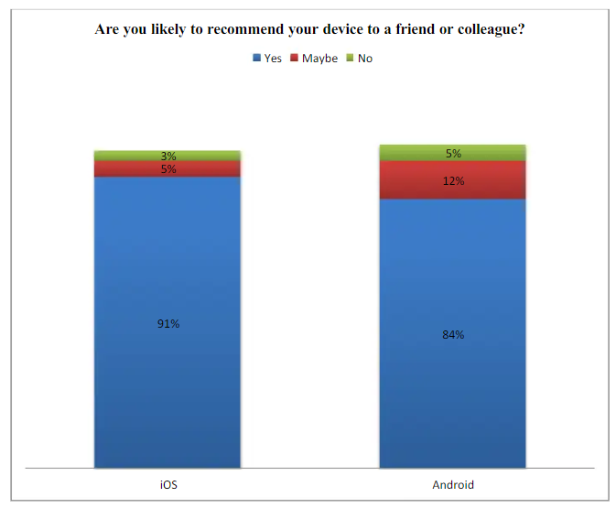

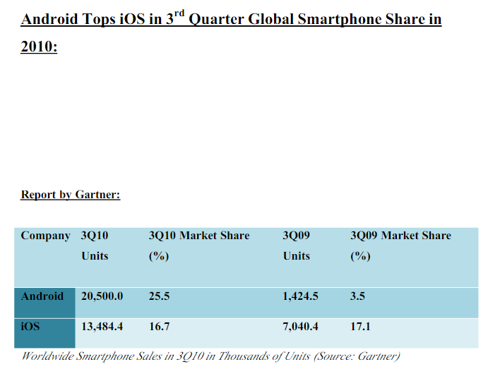

# Advantages & Disadvantages

##### Android:

##### Advantages:

* Open Source: Android is an open-source platform, allowing for greater customization and flexibility for developers.
* Hardware Diversity: Android runs on a wide range of devices manufactured by various companies, offering users more choices in terms of features, design, and price.
* Customization: Android allows users to customize their device's interface, install third-party apps from sources other than the official app store, and tweak system settings to their preferences.
* Google Services Integration: Tight integration with Google services such as Gmail, Google Maps, and Google Drive provides seamless access to these services.
* Affordability: Android devices are available at various price points, making them more accessible to a wider range of users.

##### Disadvantages:

* Fragmentation: The Android ecosystem is fragmented, with multiple versions of the operating system and varying levels of hardware capabilities across devices. This can lead to compatibility issues and slower software updates.
* Security Concerns: Due to its open nature, Android is more susceptible to malware and security threats compared to iOS. Users need to be vigilant about security measures and app permissions.
* Inconsistent User Experience: Different manufacturers may apply their own customizations and skins on top of Android, leading to inconsistencies in user experience across devices.
* Slower Updates: Android updates may take longer to roll out to devices due to the involvement of manufacturers and carriers in the update process. This can result in delayed access to new features and security patches.
* Resource Intensive: Some Android devices may suffer from performance issues and battery drain due to resource-intensive customizations and background processes.

##### iOS:

##### Advantages:

* Uniform User Experience: iOS offers a consistent and intuitive user experience across all Apple devices, ensuring familiarity and ease of use for users.
* Optimized Hardware-Software Integration: Apple designs both the hardware and software for its devices, leading to optimized performance, efficiency, and seamless integration between the two.
* App Quality: The App Store has strict guidelines for app submission, resulting in a curated selection of high-quality apps that are generally well-optimized for iOS devices.
* Security: iOS is known for its strong security features, including built-in encryption, sandboxing of apps, and strict app permissions. This makes iOS devices less vulnerable to malware and security breaches.
* Timely Updates: Apple releases iOS updates directly to its devices, ensuring timely access to new features, performance improvements, and security patches for all supported devices.

##### Disadvantages:

* Limited Customization: iOS offers limited customization options compared to Android, with users having less control over the device's interface and system settings.
* Closed Ecosystem: iOS devices are tightly integrated into Apple's ecosystem, limiting interoperability with non-Apple devices and services.
* Hardware Options: Apple offers a limited range of device models and configurations compared to the variety available in the Android market, potentially limiting options for users with specific preferences or budget constraints.
* Higher Cost: iOS devices tend to be more expensive than their Android counterparts, making them less accessible to budget-conscious consumers.
* App Store Restrictions: Apple's strict App Store policies and guidelines can sometimes limit the availability of certain apps or features, as well as stifle innovation for developers.

# Enhancement of Topic/ Future enhancement

##### Android :

1. Foldable and Dual-Screen Support: With the growing popularity of foldable and dual-screen devices, Android will likely focus on optimizing the platform to better support these form factors, providing more seamless multitasking and enhanced user experiences.

2. *Privacy and Security Features:* Android will continue to invest in improving privacy and security features to address concerns about data protection and malware. This may include enhancements in app permission management, sandboxing of apps, and stronger encryption standards.

3. *Artificial Intelligence (AI) Integration:* Android will likely integrate AI more deeply into the platform to enhance various aspects of user experience, such as predictive typing, smart suggestions, and personalized recommendations.

4. *Augmented Reality (AR) and Virtual Reality (VR):* Android will further develop support for AR and VR technologies, enabling more immersive experiences across a wide range of applications, from gaming to productivity tools.

5. *Continued Optimization for Performance and Battery Life:* Android will focus on optimizing resource utilization to improve overall performance and battery life, ensuring smoother operation and longer device uptime.

##### iOS:

1. *Enhanced Augmented Reality (AR) Capabilities:* Apple will likely continue to invest in AR technologies, leveraging the ARKit framework to enable more advanced AR experiences in apps and games.

2. *Improvements in Siri and AI Integration:* Apple will enhance Siri's capabilities by integrating more advanced AI algorithms, enabling more natural language processing, contextual understanding, and personalized recommendations.

3. *Health and Wellness Features:* iOS will expand its health and wellness capabilities, leveraging the Health app and Apple Watch integration to provide more comprehensive health monitoring, analysis, and insights.

4. *Continued Focus on Privacy and Security:* Apple will maintain its commitment to user privacy and security by introducing more robust privacy features, such as enhanced tracking prevention, secure data sharing, and stricter app review processes.

5. *Integration with Other Apple Ecosystem Services:* iOS will further integrate with other Apple ecosystem services, such as Apple Fitness+, Apple TV+, and Apple Arcade, providing a seamless experience across different devices and services.

## Conclusion :

### Android:

* **Customization**: Android offers extensive customization options, allowing users to personalize their devices to a high degree.
* **Hardware Diversity**: Android runs on a wide range of devices with different features, designs, and price points, providing users with more choices.
* **Open Ecosystem**: Android's open ecosystem fosters innovation and flexibility in app development and distribution.
* **Integration with Google Services**: Android seamlessly integrates with various Google services, making it ideal for users invested in Google's ecosystem.

### iOS:

* **Ease of Use**: iOS is known for its simplicity and intuitive user interface, making it attractive to users who prefer straightforward experiences.
* **App Quality and Optimization**: iOS tends to have higher-quality apps and better optimization across devices due to standardized hardware and software.
* **Privacy and Security**: iOS prioritizes privacy and security with features like App Tracking Transparency and strong encryption, appealing to users concerned about their digital privacy.
* **Ecosystem Integration**: iOS offers seamless integration with other Apple products and services, providing a cohesive ecosystem for users who own multiple Apple devices.

### Potential Outcomes:

1. **For Users Seeking Customization and Flexibility**: Android may be the preferred choice due to its extensive customization options and diverse hardware selection.
2. **For Users Prioritizing Simplicity and Seamless Integration**: iOS could be the better option, offering a user-friendly experience and tight integration with other Apple devices and services.
3. **For Privacy-Conscious Users**: iOS may be favored for its strong emphasis on privacy and security features such as App Tracking Transparency.
4. **For Users Invested in Google's Ecosystem**: Android's seamless integration with Google services makes it a compelling choice for those heavily reliant on Gmail, Google Drive, and other Google products.

## References :

##### Tech News Websites:

* Websites like CNET, The Verge, TechCrunch, and Engadget often publish articles, reviews, and comparisons between Android and iOS.

##### Official Documentation and Websites:

* Refer to the official documentation and websites of Android (developer.android.com) and iOS (developer.apple.com) for detailed technical information, updates, and best practices.

##### Market Research Reports:

* Reports from market research firms like IDC, Gartner, and Statista provide insights into market trends, market share, and consumer preferences regarding Android and iOS devices.

##### Technology Forums and Communities:

* Platforms like Reddit (r/Android, r/iOS), Stack Overflow, and XDA Developers forums host discussions, debates, and user experiences related to Android and iOS.

##### Academic Journals and Papers:

* Scholarly articles and papers in journals related to computer science, mobile computing, and human-computer interaction may provide in-depth analysis and research findings on topics related to Android and iOS.

##### Books:

* Books authored by experts in the field of mobile development, technology, and user experience design may offer comprehensive insights into the architecture, features, and evolution of Android and iOS platforms.

##### User Surveys and Feedback:

* User surveys conducted by reputable organizations or companies like Pew Research Center, Nielsen Norman Group, or JD Power provide insights into user satisfaction, preferences, and usage patterns regarding Android and iOS devices.

##### Tech Blogs and Opinion Pieces:

* Blogs and opinion pieces by tech analysts, industry experts, and thought leaders provide valuable perspectives and insights into the strengths, weaknesses, and future trends of Android and iOS platforms.