**Wells Fargo Technology Hackathon 2022**

**Team Name: CHEETAH**

**Challenge: Name Pronunciation Tool**

**Business Need:**

Wells Fargo employees and contingent workers come from an amazing diversity of backgrounds, and the variety of names within the company is profound. Often, employees find themselves struggling with the pronunciation of names. What can we do to make it easier for employees to pronounce other’s names as they would like them to be pronounced, and for employees to let others know how they would like their names pronounced?

**Challenge Description:**

This challenge will deliver a solution for phonetic pronunciation of names. The successful solution will enable Wells Fargo employees to understand the pronunciation of people’s names in two ways:

1. Standard Pronunciation: The solution will provide standard aural pronunciations for names, based on rules. Standard solutions may come from industry-standard solutions.
2. Non-Standard Pronunciation: The solution will enable employees to override standard pronunciations and provide custom pronunciations for cases where the employee prefers pronunciation that differs from the pronunciation provided by the standard solution.

The solution will provide a user interface for administrators and employees to look up pronunciations. More importantly, the solution will provide an API, providing name pronunciation as a service. The user interface will allow employees to record and play back non-standard pronunciations.

**System Architecture Diagram**

**Data Flow Diagram 1**

**Data flow sequence (**Between Spring Boot and Database)

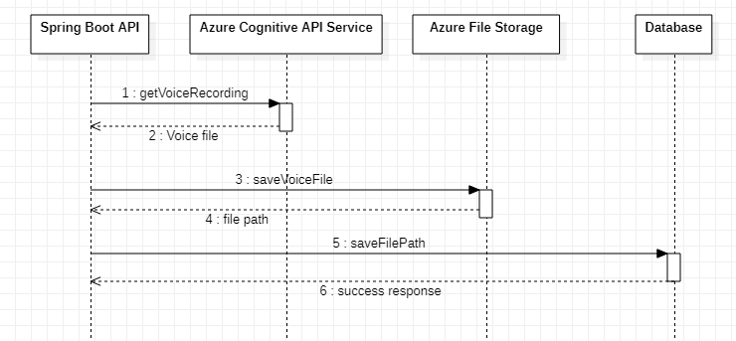

**User Stories**

* NPCH-001

**As** an Administrator

**I need** to be able to upload any Employee’s standard pronunciation of his/her name

**So that** any employee logging into the Name Pronunciation tool should be able to hear his/her standard name pronunciation.

**Status – DONE**

**Comment –** The administrator is given an option to upload any employee’s standard name pronunciation into the Name Pronunciation tool. The upload function accepts an excel file with the employee names as an input parameter, which will be converted to the recorded voice format with the help of the Azure Cognitive Services (Text to Speech) and Azure Blob, and which then will be saved as URL to the Azure SQL DB.

* NPCH-002

**As** an Employee

**I want** the system to provide a standard pronunciation of my name

**So that** other employees can address me in the way I prefer to be addressed.

**Status** – **DONE**

**Comment** – When an employee logs into the Name Pronunciation tool, he will have an option to play and listen to the standard pronunciation of his name.

* NPCH-003

**As** an Employee

**I want** to be able to provide a custom pronunciation to override the suggested pronunciation of my name

**So that** other employees can address me in the way I prefer to be addressed.

**Status** – **DONE**

**Comment** – Employee will be given an option to Record and override his standard name pronunciation with the custom name pronunciation in the Name Pronunciation tool. The employee will also be provided an option to listen to his custom recorded voice before overriding the standard format and saving to the DB.

* NPCH-004

**As** an Employee

**I need** to be able to opt out of the pronunciation service

**So that** the system defaults back to the standard pronunciation of my name.

**Status** – **DONE**

**Comment** – Currently this functionality is provided to an Admin to Reset to the standard name pronunciation format, if an employee reaches out to the admin requesting for opting out of the non-standard/ custom name pronunciation format.

Team plans to give this functionality at the Employee level in the future sprint, if required.

* NPCH-005

**As** an Employee

**I want** to have an option to select a country to pronounce as per selected country

**So that** given name will have different pronunciation in different countries.

**Status** – **DONE**

**Comment** – Currently this functionality is included as part of the input excel file, which is uploaded by the Admin, with Country code as a field which is then recognized by the Azure Cognitive Services to output the standard name pronunciation format.

Team plans to extend this functionality to user selection in future sprint, if required.

* NPCH-006

**As** an Employee

**I want** to be able to hear the non-standard (if provided) or standard pronunciation of any employee’s name

**So that** I can address the other employee as the way he/she prefers to be addressed.

**Status** – **DONE**

**Comment** – A search option is provided to an Employee to search any other Employee’s name pronunciation so that he can connect with the other Employee by knowing how he/she prefers to be addressed.

* NPCH-007

**As** an Administrator

**I need** to be able to maintain pronunciations of Employees

**So that** the system operates properly.

**Status** – **DONE**

**Comment** – Admin’s home page is designed to list out the Employees, which displays the standard name pronunciation recorded voice with other details. Admin has the option to listen to the recorded standard name pronunciation voice as well as a Reset option.

The Reset option is currently provided to the Admin to take up any request from an Employee who is seeking out to opt out of the name pronunciation service. Opting out is achieved by resetting back the custom recorded name pronunciation format back to the standard name pronunciation format.

Admin is also given a search option to search by employee name.

Team plans to extend the functionalities of the Admin in future sprints, if required.

**Technologies & Tools Used**

Spring Boot, React, Azure Cognitive Services, Azure File Storage, Azure SQL DB

**API Listing**

[**emp-pronounce-controller**](https://namepronounciation-tool.azurewebsites.net/swagger-ui/index.html?configUrl=/v3/api-docs/swagger-config#/emp-pronounce-controller)

**GET**

* [/cheetah/getAllEmployees](https://namepronounciation-tool.azurewebsites.net/swagger-ui/index.html?configUrl=/v3/api-docs/swagger-config#/emp-pronounce-controller/getAllEmployees)  
   - Gets all the employees details (including the recorded voice) to display as a list in Admin Home Page
* [/cheetah/genericSearch/employee/{searchString}](https://namepronounciation-tool.azurewebsites.net/swagger-ui/index.html?configUrl=/v3/api-docs/swagger-config#/emp-pronounce-controller/searchEmployees)  
  - Gets the employee details when searched with an employee name

**POST**

* [/cheetah/admin/upload](https://namepronounciation-tool.azurewebsites.net/swagger-ui/index.html?configUrl=/v3/api-docs/swagger-config#/emp-pronounce-controller/uploadFile)  
  - Uploads the employee details including the standard name pronunciation recording to the DB
* [/cheetah/standard/record](https://namepronounciation-tool.azurewebsites.net/swagger-ui/index.html?configUrl=/v3/api-docs/swagger-config#/emp-pronounce-controller/postVoiceRecord)
* [/cheetah/record](https://namepronounciation-tool.azurewebsites.net/swagger-ui/index.html?configUrl=/v3/api-docs/swagger-config#/emp-pronounce-controller/updateVoiceRecord)
* [/cheetah/v2/record](https://namepronounciation-tool.azurewebsites.net/swagger-ui/index.html?configUrl=/v3/api-docs/swagger-config#/emp-pronounce-controller/stream)

**NOTE**: Search Criteria will be more extensible with the next phase (like including employee ID or AD-ENT etc.)

[**login-controller**](https://namepronounciation-tool.azurewebsites.net/swagger-ui/index.html?configUrl=/v3/api-docs/swagger-config#/login-controller)

**GET**

* [/auth/ping](https://namepronounciation-tool.azurewebsites.net/swagger-ui/index.html?configUrl=/v3/api-docs/swagger-config#/login-controller/ping)

**POST**

* [/auth/login](https://namepronounciation-tool.azurewebsites.net/swagger-ui/index.html?configUrl=/v3/api-docs/swagger-config#/login-controller/login)
* To authenticate the user trying to login
* [/auth/resetPassword](https://namepronounciation-tool.azurewebsites.net/swagger-ui/index.html?configUrl=/v3/api-docs/swagger-config#/login-controller/resetPassword)
* To reset the login password

***Reference*** - [Swagger UI (namepronounciation-tool.azurewebsites.net)](https://namepronounciation-tool.azurewebsites.net/swagger-ui/index.html?configUrl=/v3/api-docs/swagger-config#/)

**UI Screens**

Login Screen



Admin Home Page

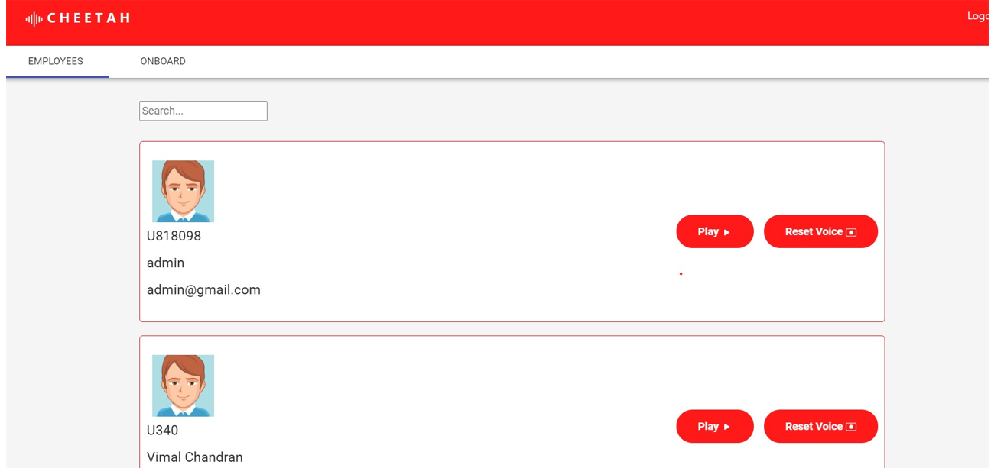

Admin -Employees Onboard Page

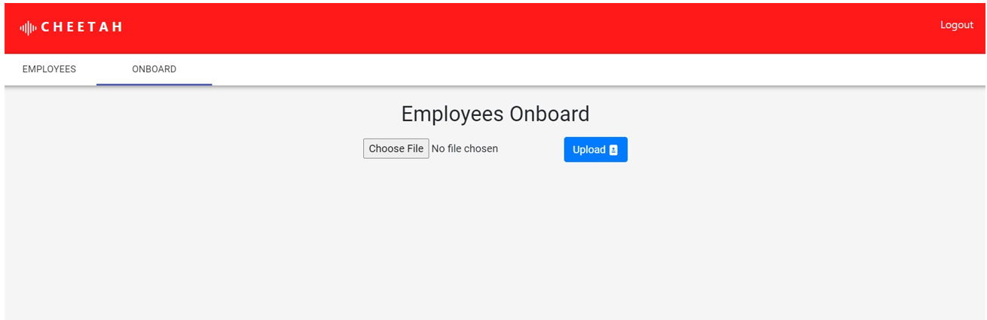

Excel template sample screenshot for Employees Onboard function

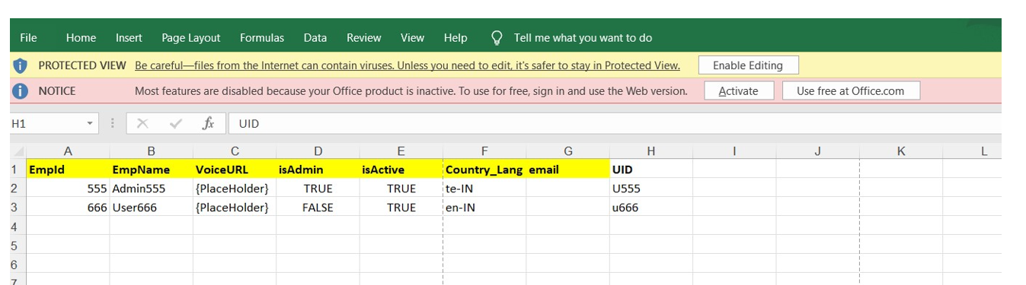

Admin - Employee Onboarding Successfully uploaded

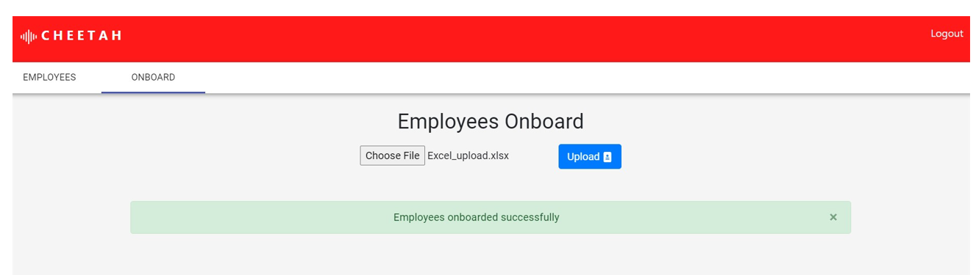

Admin – Employee Search

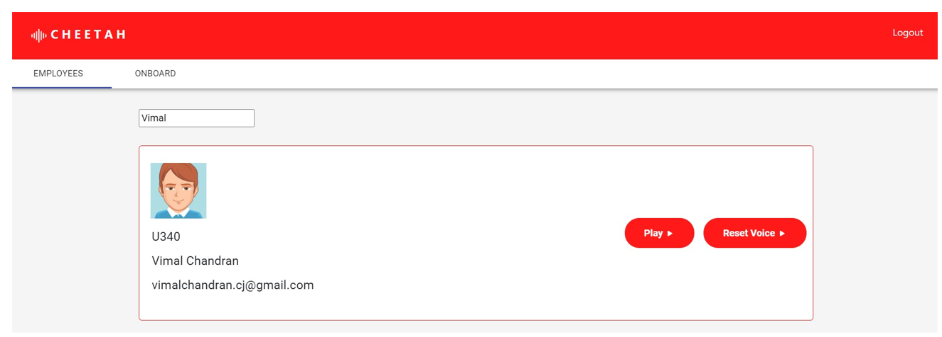

Employee – Home Page

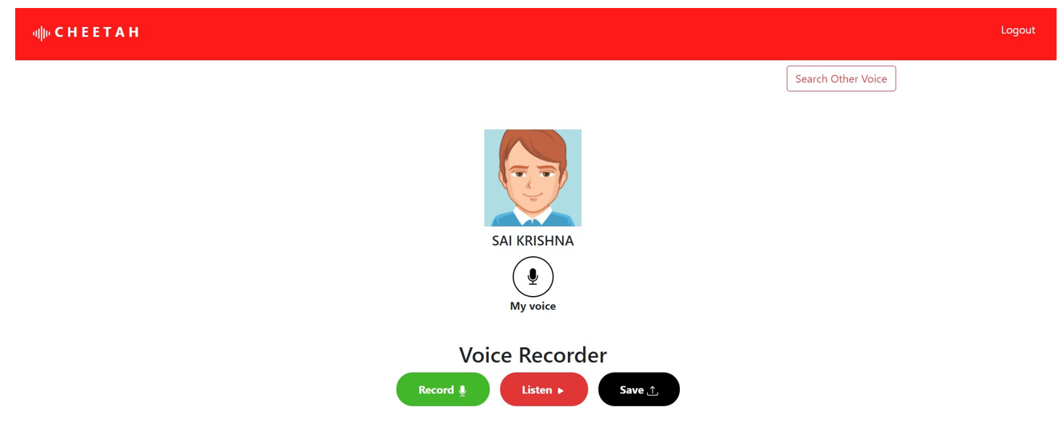

Employee – Opting for a Custom Voice Recording and Saved successfully to DB

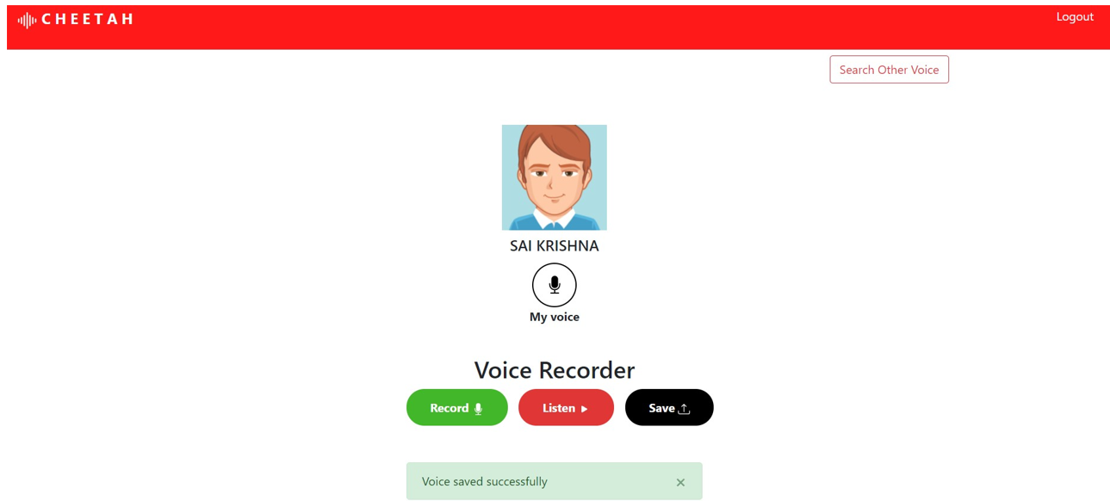

Employee - Search for other Employee Name Pronunciation

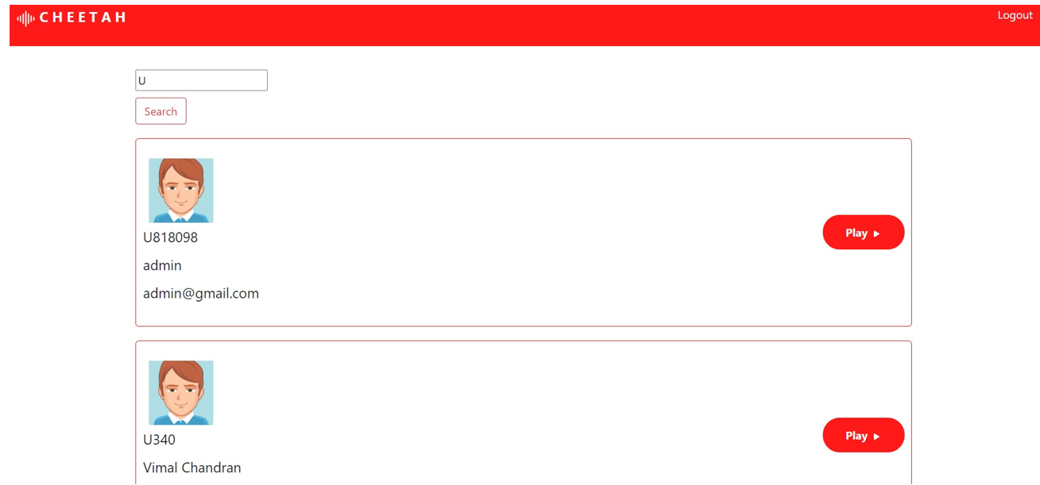

Link to GIT Repo -

**Backend microserive Services :**

[**https://github.com/vimalcj/cheetah-server**](https://github.com/vimalcj/cheetah-server)

**Frontend react UI :**

[**https://github.com/vimalcj/cheetah-ui**](https://github.com/vimalcj/cheetah-ui)

**Document repository:**

[**https://github.com/vimalcj/cheetah**](https://github.com/vimalcj/cheetah)

Link to Demo Video -

https://sqlvahil7754uizsa4.blob.core.windows.net/voice-blob/cheetah_name_tool_demo.mp4