**MOBUYS Documentation**

**Versi 01**

1. React-native init ProjectAwesome
2. cd ProjectAwesome.
3. Extract  sourcecode.

Copy folder application, assets,native-base-them OR ALL file and folder

1. Structure :

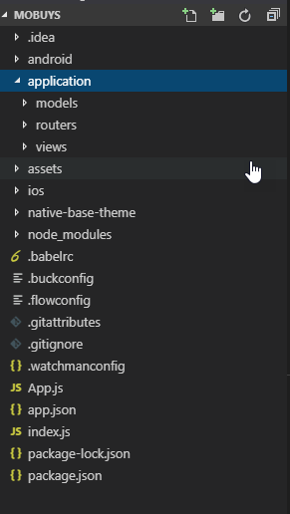

1. Install dependencies :

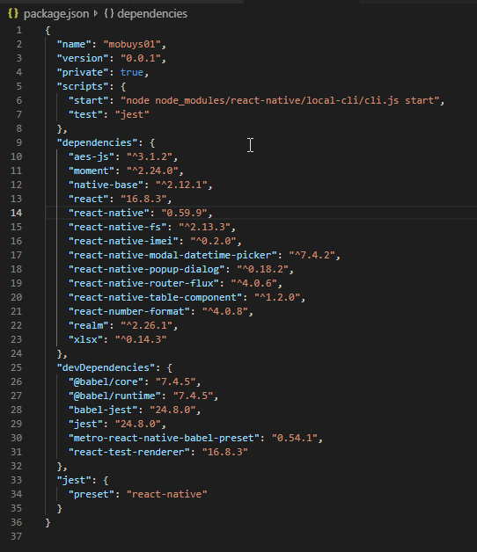

* Npm install [realm@2.26.1](mailto:realm@2.26.1) –save

1. After install native-base

comand line : node node_modules/native-base/ejectTheme.js

1. ../android/app/build.gradle

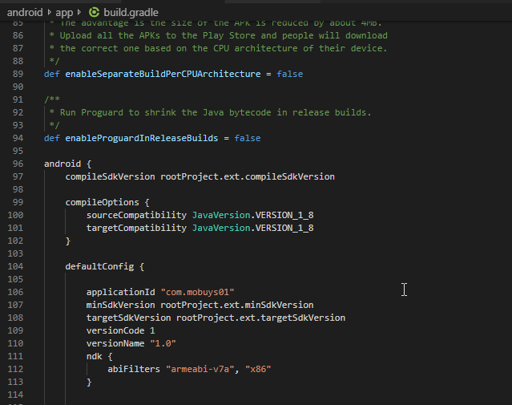

1. **Mixing 32- and 64-bit Dependencies in Android**

* In your gradle.properties in the project root, add the line android.useDeprecatedNdk=true.
* Add the following block to your build.gradle file, adding an exclude line for every 64-bit dependency you found in step 2.

android {

...

defaultConfig {

...

ndk {

abiFilters "armeabi-v7a", "x86"

}

}

}

1. Enjoy...