**Internship Documentation :**

**Company Name : Akash Technolab**

**Internship technology : PHP**

**Submitted By : vimal nareshkumar gandhi**

**Task 1 :**

1. Installation and learing about wordpress
2. Features and defects of wordpress
3. simple blog creation using wordpress

Installation of wordpress:

Software required : Xampp server.

Step : 1 : Download the setup of wordpress of latest version.

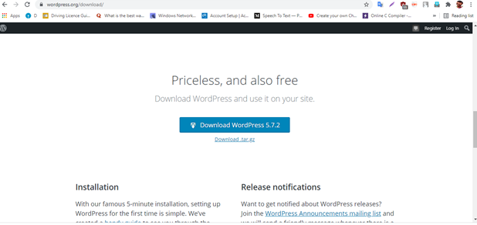

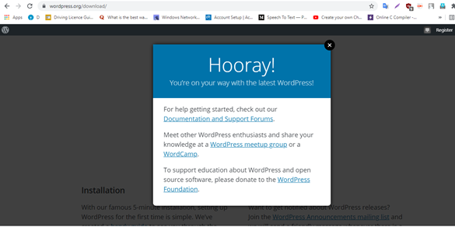

Step : 2 : Set a directory structure.

C: / Xampp / htdocs / make your installation directory.

Extract the setup and paste into your directory.

Step : 3 : Now installation process begin.

Write localhost/yourfoldername

After the Select language popup will display do the selection of language –

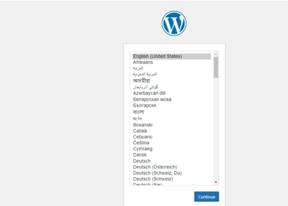

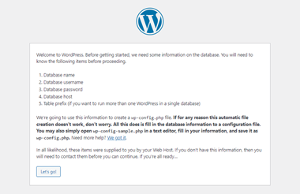

Next step : choose a database and credential of localhost

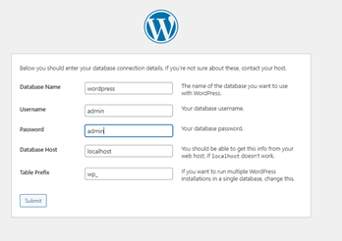

Run the installation.

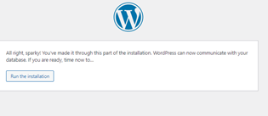

After installation done click on login

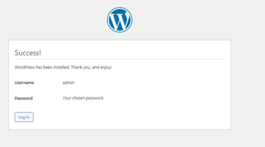

Login here.

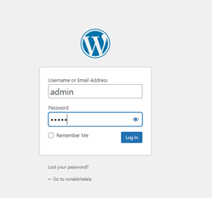

And all is set view your dashboard.

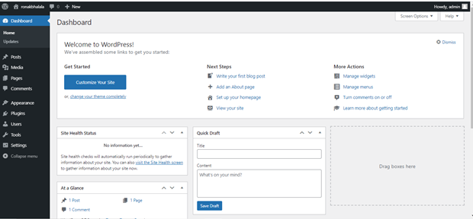

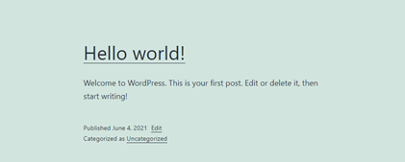

Task 2:

Theme implementation on blog.



