**Internship Documentation :**

**Company Name : Akash Technolab**

**Internship technology : PHP**

**Submitted By : Vimal Nareshkumar Gandhi**

**Task 1 : understanding Wordpress environment**

**Menu editing in Wordpress**

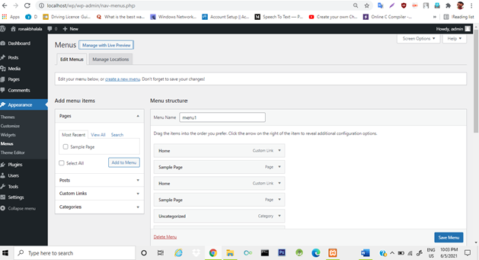

**Theme installation.**

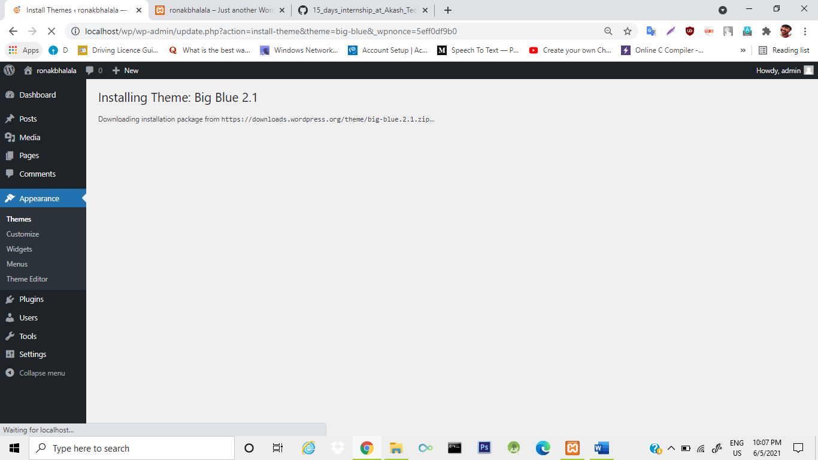

**Updated theme :**

