**JMETER TESTING IN AWS**

**Architectural Diagram**

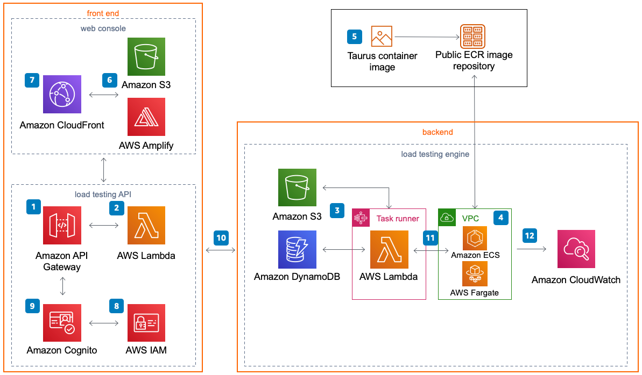

**STEPS:**

* **Create a CloudFormation Template**
* <https://aws.amazon.com/solutions/implementations/distributed-load-testing-on-aws/>
* Follow this link

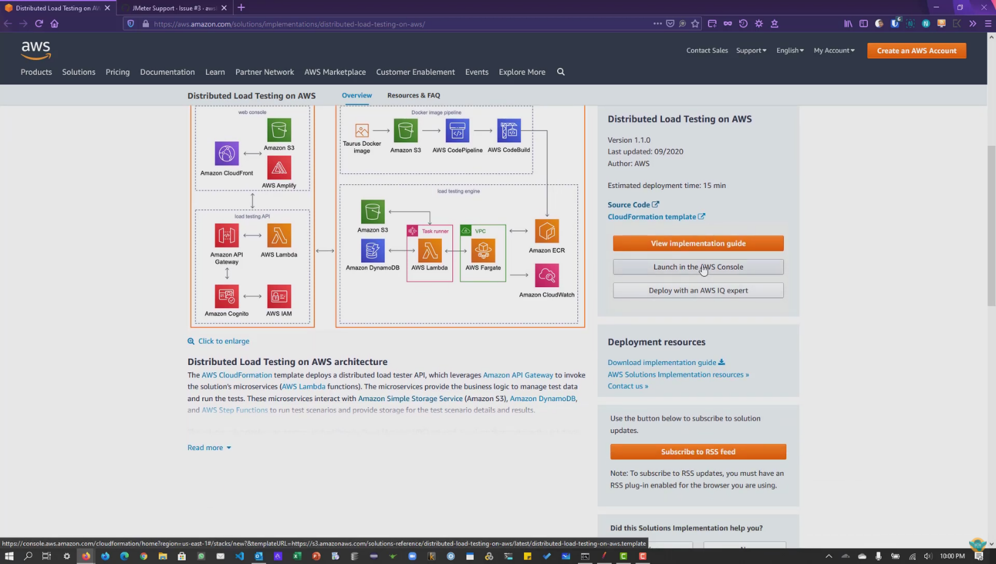



* **Specify template**

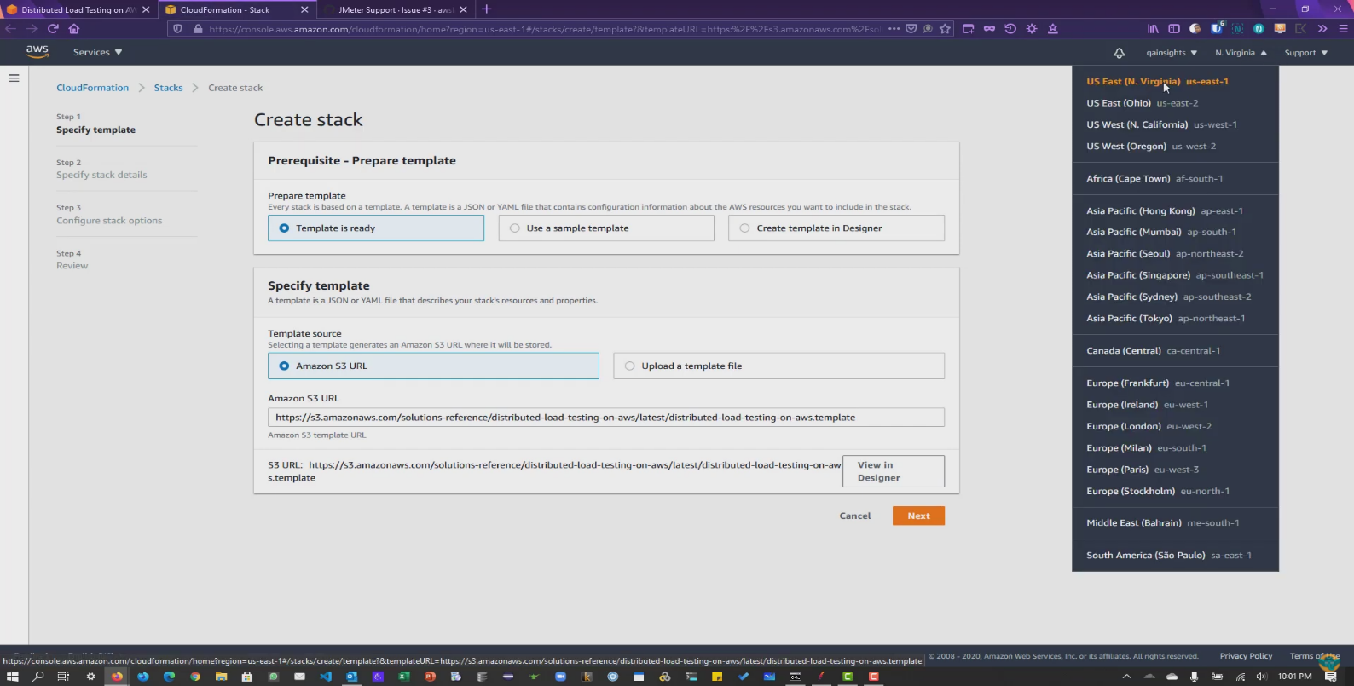



* **Specify stack details**



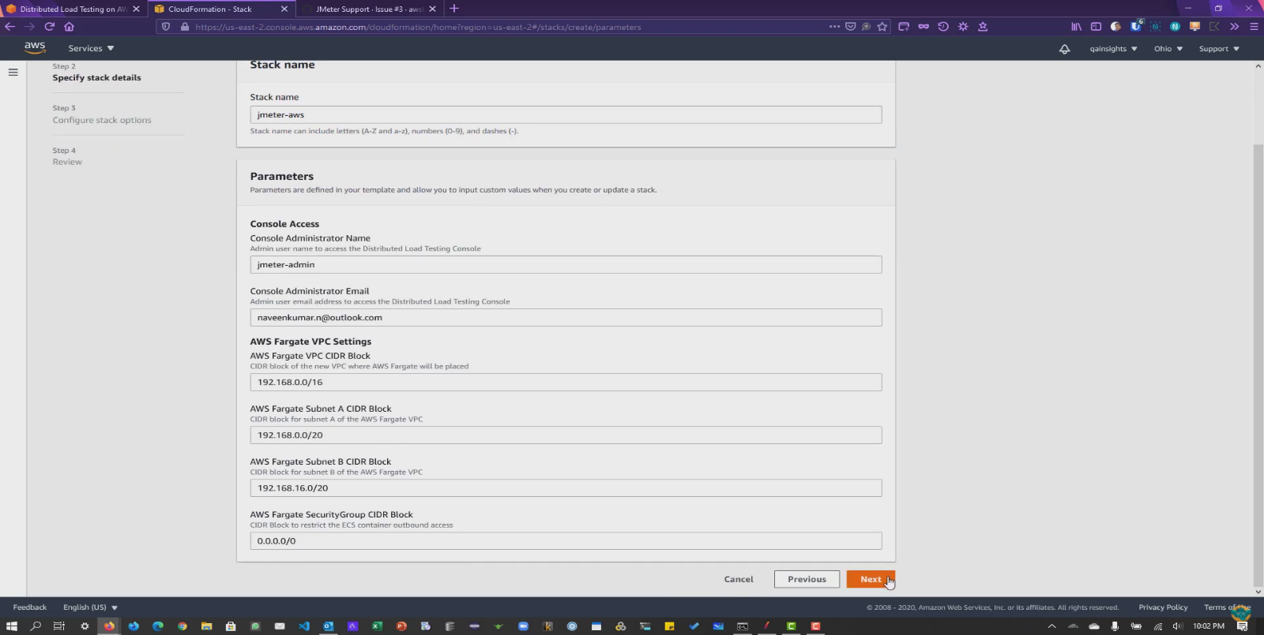



* **Configure Stack options(set as dedault)**

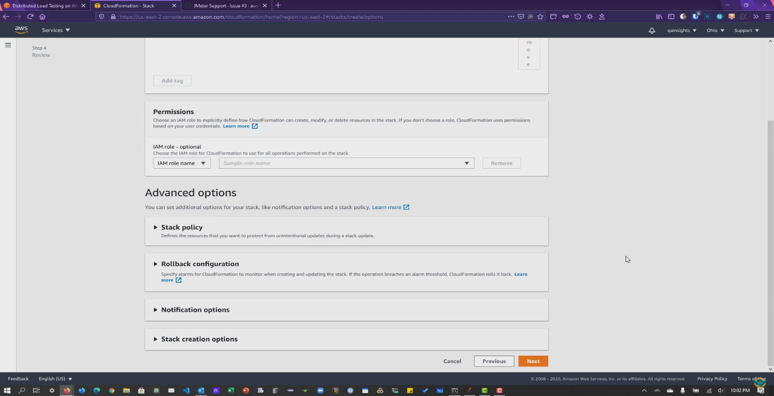



* **Review and create the stack**

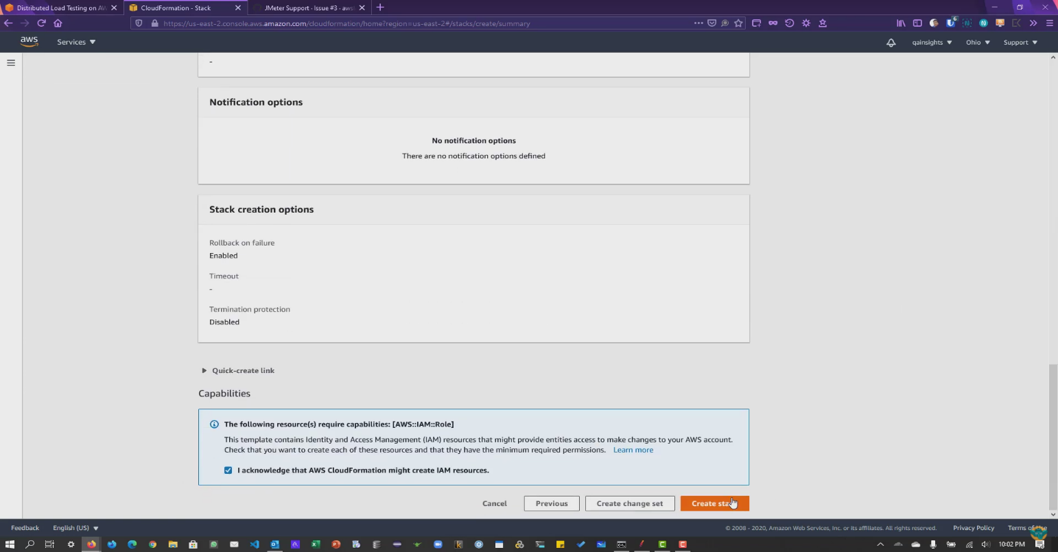

* Wait until the stack is created it may take some time
* After the stack got created Login to JMeter console you will get the credentials in mail

**This is the Load testing console**

* Upload a sample jmx file u done in JMeter in script file

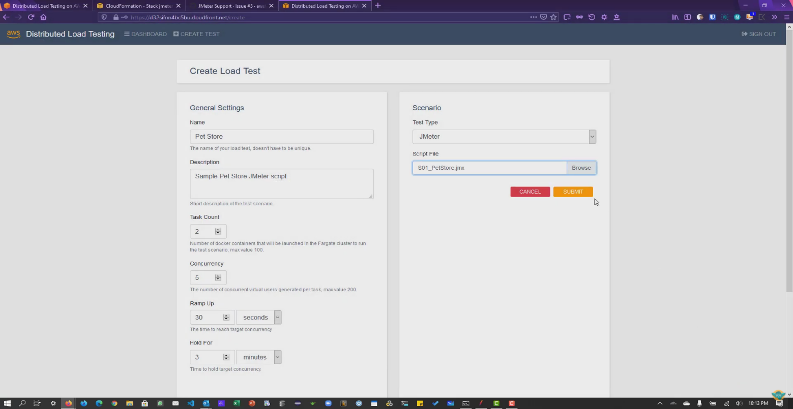



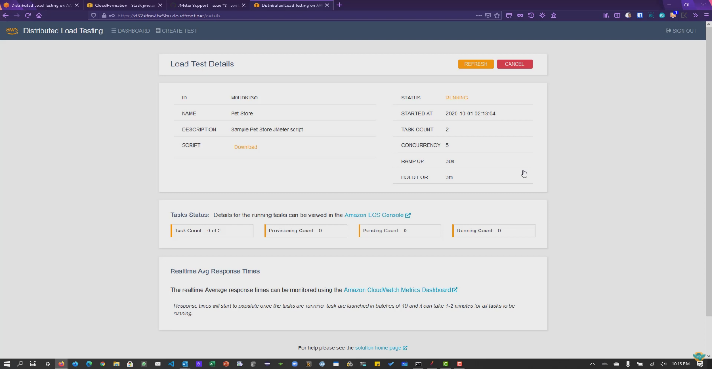



**Explore Ecs console and CloudWatch Metrics dashboard to explore more details about the test.**

**To see test results, refresh the console**

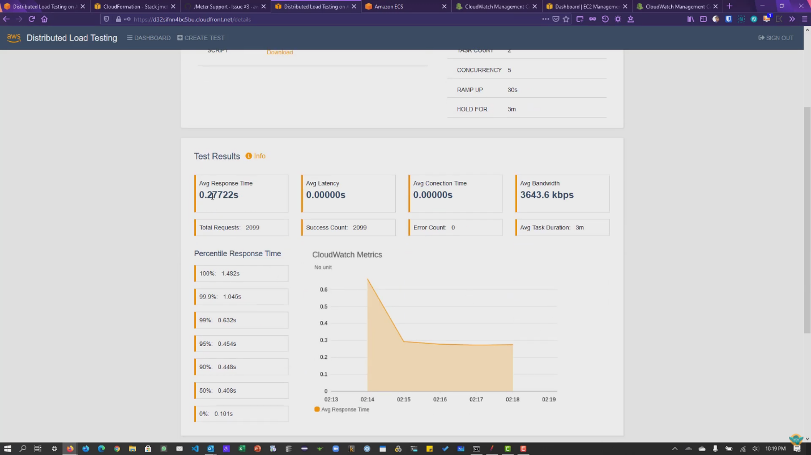

Test results will be populated in console (it takes some time)

For more queries visit

<https://www.youtube.com/watch?v=AMwSWhdLFQc>