**SBA 3:**

To complete the activity as explained across from each of the group.

Details are as below:





GROUP-4 : CYPRESS

* HTML CODE

|  |  |  |
| --- | --- | --- |
|  | <head>     <title>Angular JS Forms</title>     <script src = "<https://ajax.googleapis.com/ajax/libs/angularjs/1.3.14/angular.min.js>"></script>         <style>        table, th , td {           border: 1px solid grey;           border-collapse: collapse;           padding: 5px;        }        table tr:nth-child(odd) {           background-color: #f2f2f2;        }        table tr:nth-child(even) {           background-color: #ffffff;        }     </style>      </head>  <body>         <h2> Sample Application</h2>     <div ng-app = "mainApp" ng-controller = "studentController">                <form name = "studentForm" novalidate>           <table border = "0">              <tr>                 <td>Enter first name:</td>                 <td><input name = "firstname" type = "text" ng-model = "firstName" required>                                           <span ng-show = "studentForm.firstname.$error.required">First Name is required.</span>                    </span>                 </td>              </tr>                            <tr>                 <td>Enter last name: </td>                 <td><input name = "lastname"  type = "text" ng-model = "lastName" required>                                           <span ng-show = "studentForm.lastname.$error.required">Last Name is required.</span>                    </span>                 </td>              </tr>                            <tr>                 <td>Email: </td><td><input name = "email" type = "email" ng-model = "email" length = "100" required>                                           <span ng-show = "studentForm.email.$error.required">Email is required.</span>                       <span ng-show = "studentForm.email.$error.email">Invalid email address.</span>                    </span>                 </td>              </tr>                            <tr>                 <td>                    <button ng-click = "reset()">Reset</button>                 </td>                 <td>                    <button ng-disabled = "studentForm.firstname.$dirty &&                       studentForm.firstname.$invalid || studentForm.lastname.$dirty &&                       studentForm.lastname.$invalid || studentForm.email.$dirty &&                       studentForm.email.$invalid" ng-click="submit()">Submit</button>                 </td>              </tr>                             </table>        </form>     </div>         <script>        var mainApp = angular.module("mainApp", []);                mainApp.controller('studentController', function($scope) {           $scope.reset = function() {              $scope.firstName = "";              $scope.lastName = "";              $scope.email = "";           }                     $scope.reset();        });     </script>     <b>Graduated:</b>      <form>       <input type="radio" id="yes" name="graduation_status" value="YES">       <label for="yes">YES</label><br>       <input type="radio" id="no" name="graduation_status" value="NO">       <label for="no">NO</label><br>     </form>  <form action="/action_page.php"> <label for="status"><b>Marital Status:</b></label> <select name="Single" id="Single">   <option value="Married">Married</option>   <option value="Divorced">Divorced</option>   <option value="Single">Single</option>   </select> <br><br> <input type="submit" value="Submit"> </form> <b>Languages known:</b> <div>   <label>     <input type="checkbox" class="radio" value="1" name="fooby[1][]" />English</label>   <label>     <input type="checkbox" class="radio" value="1" name="fooby[1][]" />Hindi</label>   <label>     <input type="checkbox" class="radio" value="1" name="fooby[1][]" />Malayalam</label>     <label>       <input type="checkbox" class="radio" value="1" name="fooby[1][]" />Tamil</label> </div> <br><br> <input type="SUBMIT" value="SUBMIT">      </body> </html>  OUTPUT:     * TESTING SCENARIOS IN CYPRESS * CODE |  |

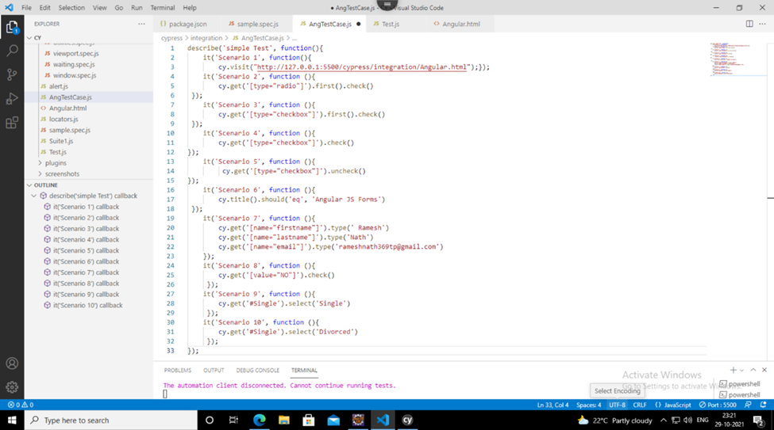

* TESTCASE 1

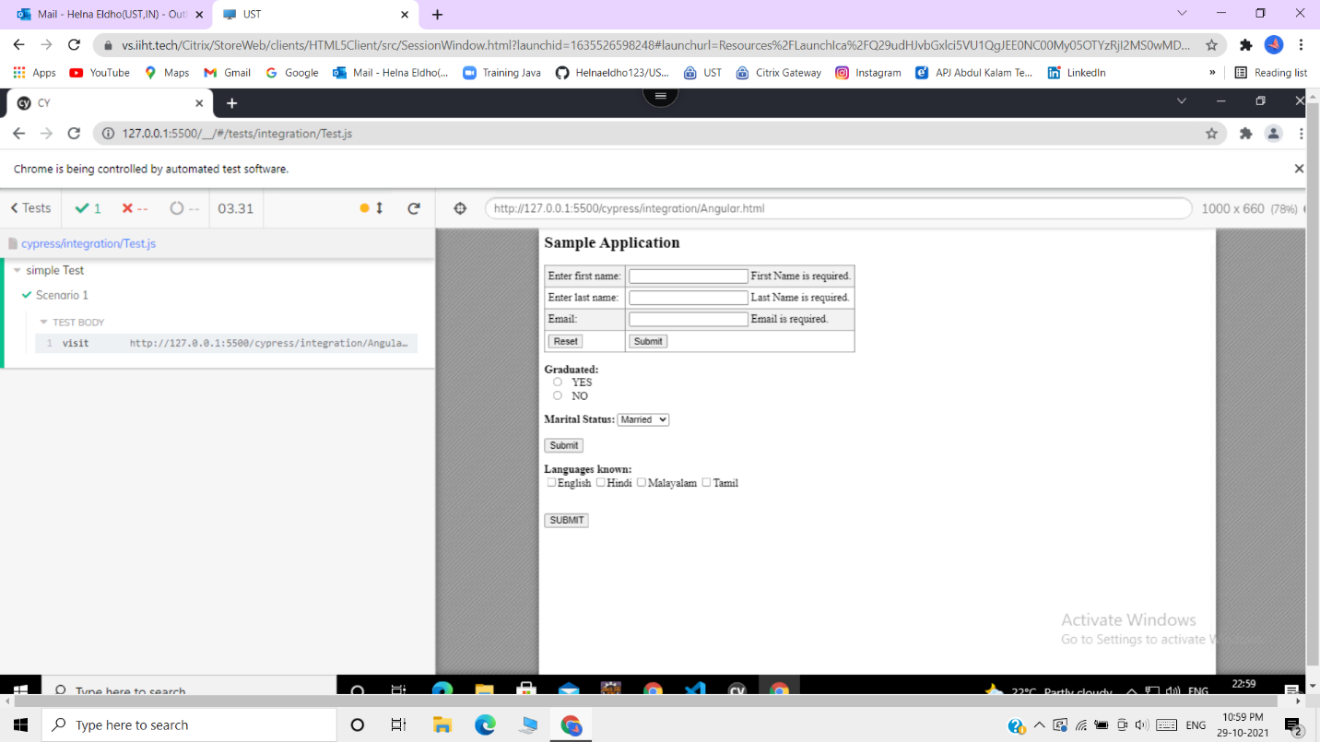

* TESTCASE 2

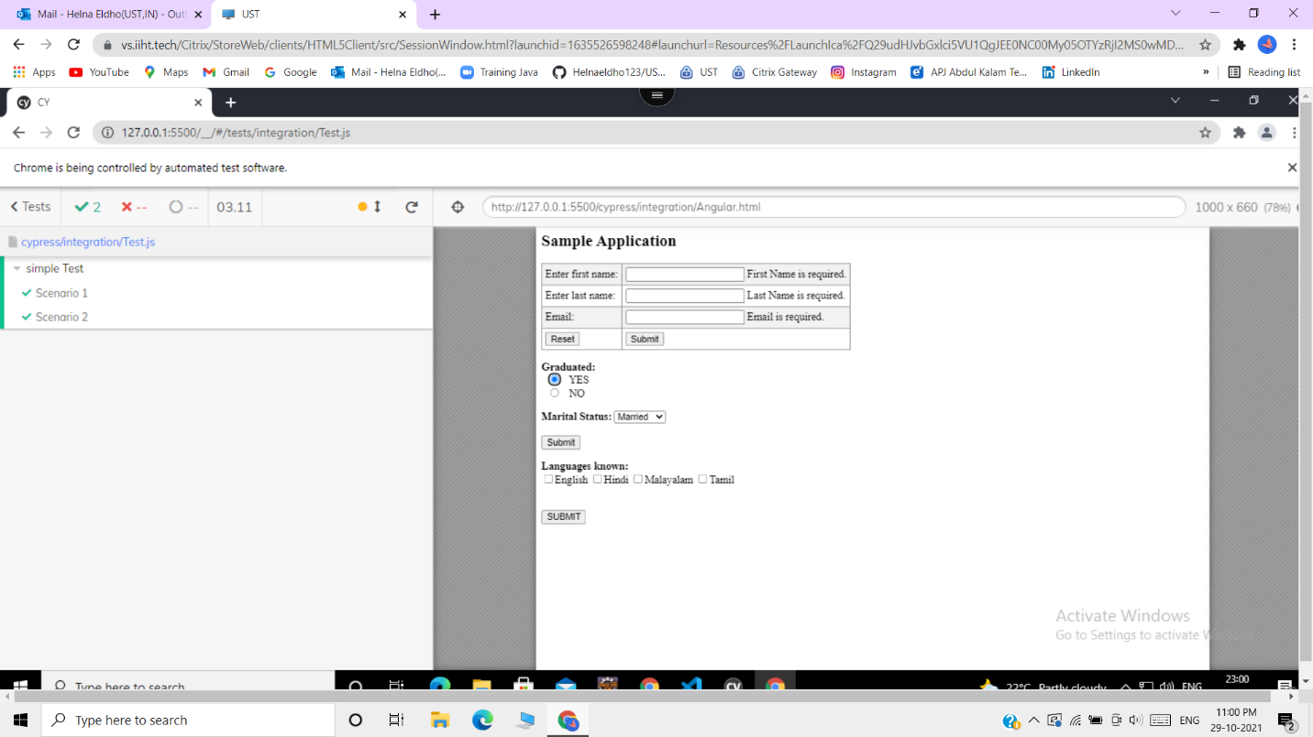

* TESTCASE 3

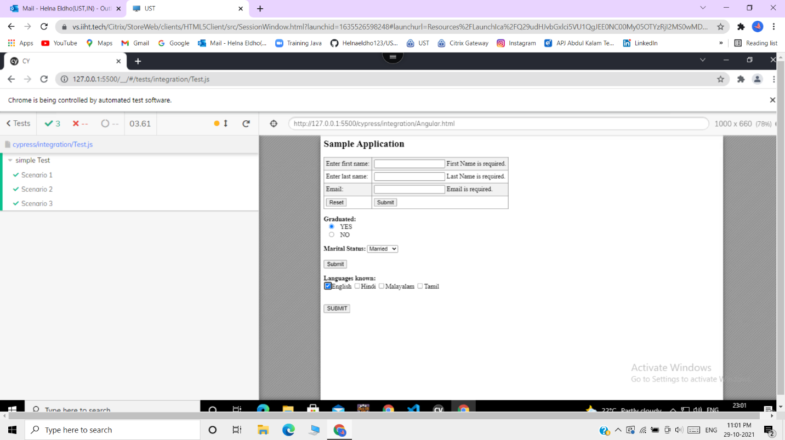

* TESTCASE 4

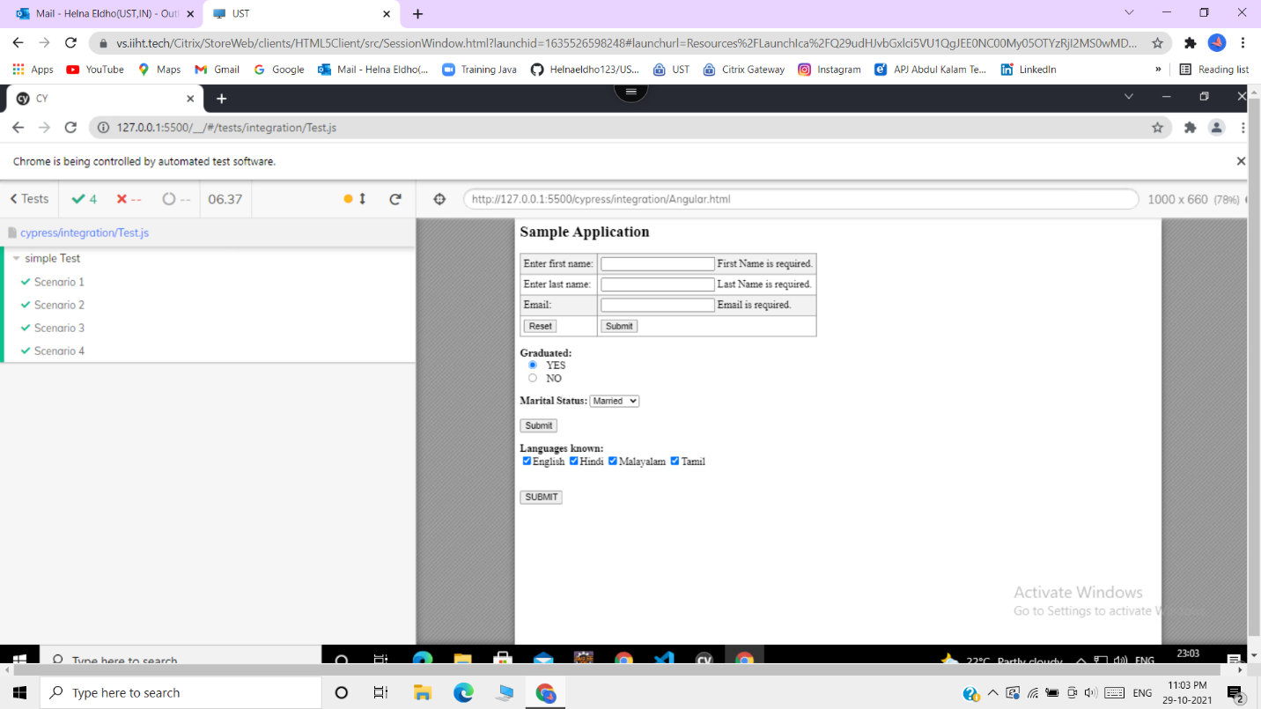

* TESTCASE 5

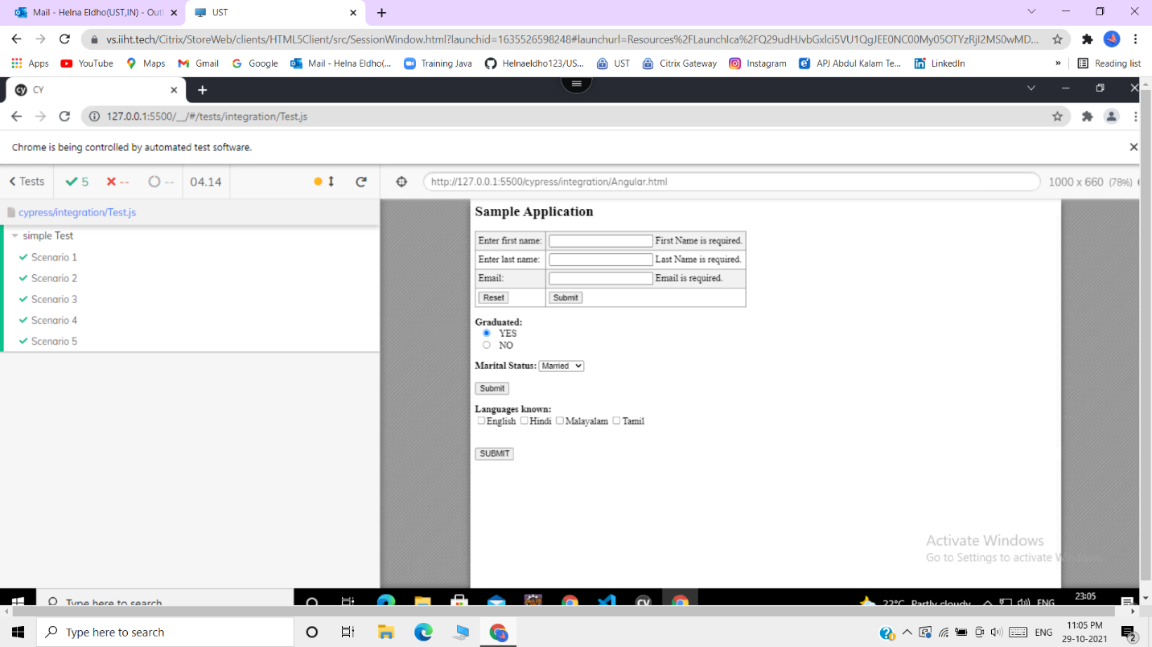

* TESTCASE 6

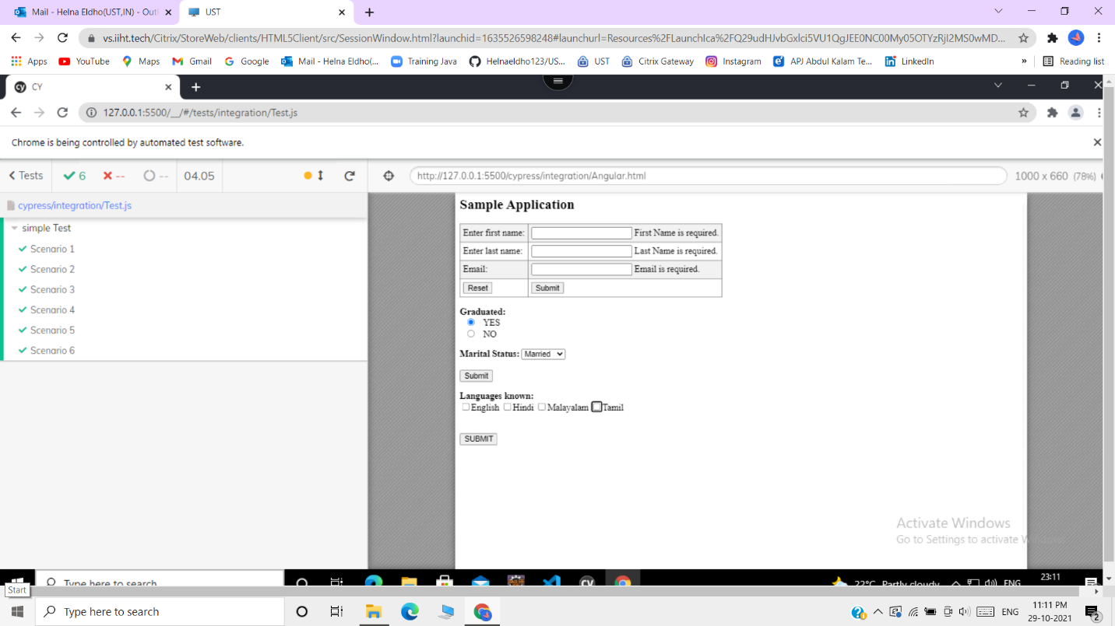

* TESTCASE 7

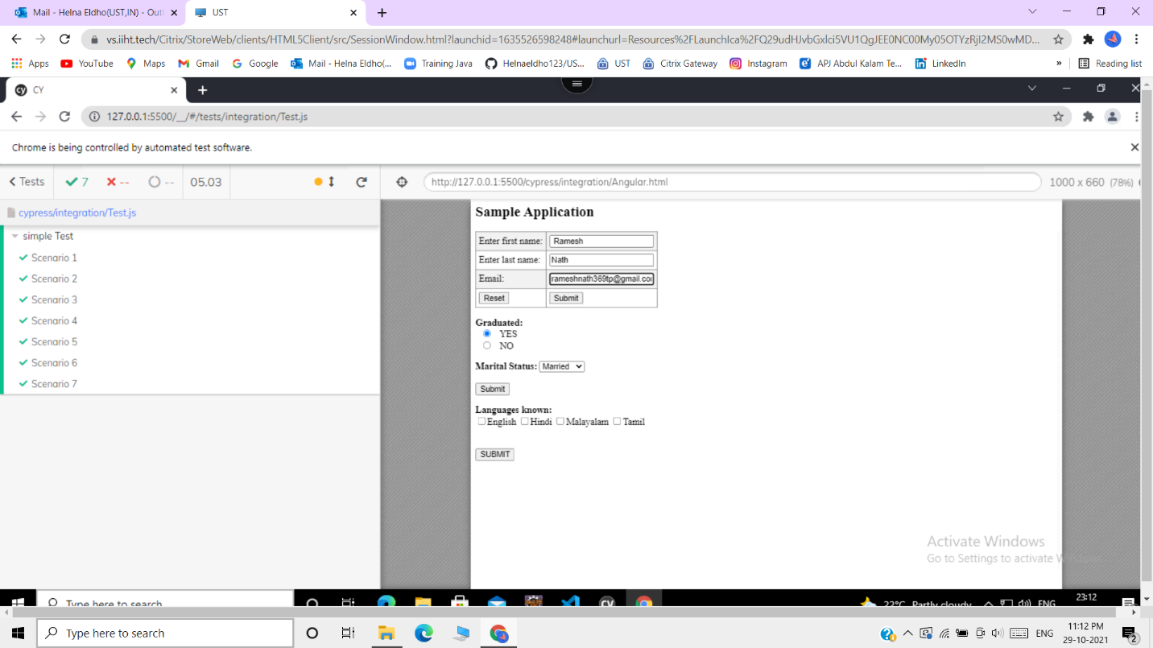

* TESTCASE 8

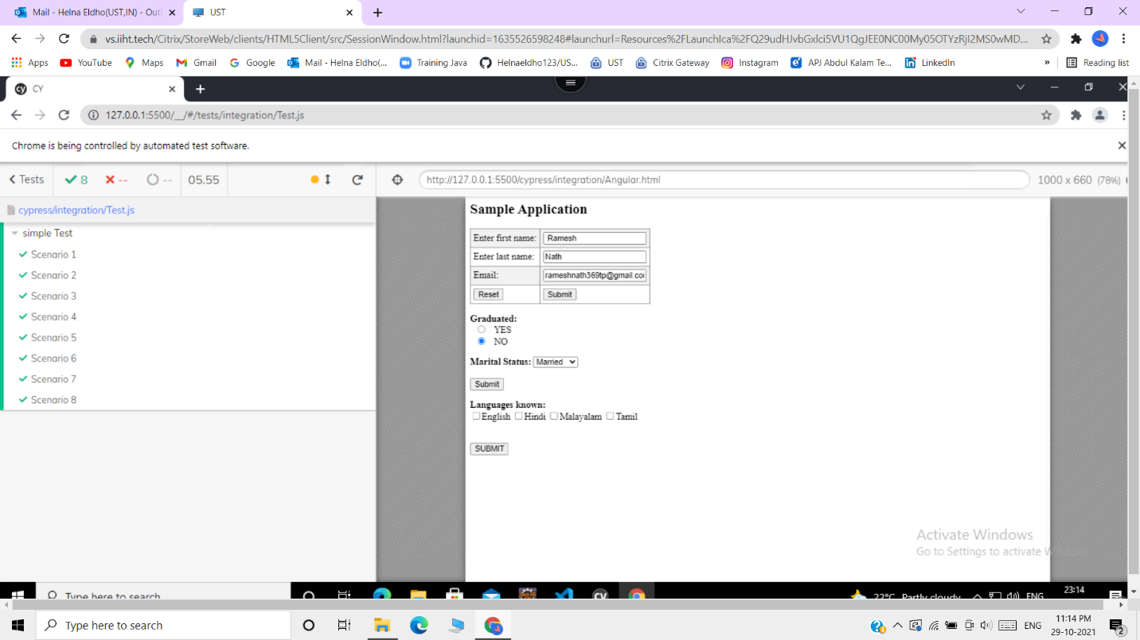

* TESTCASE 9

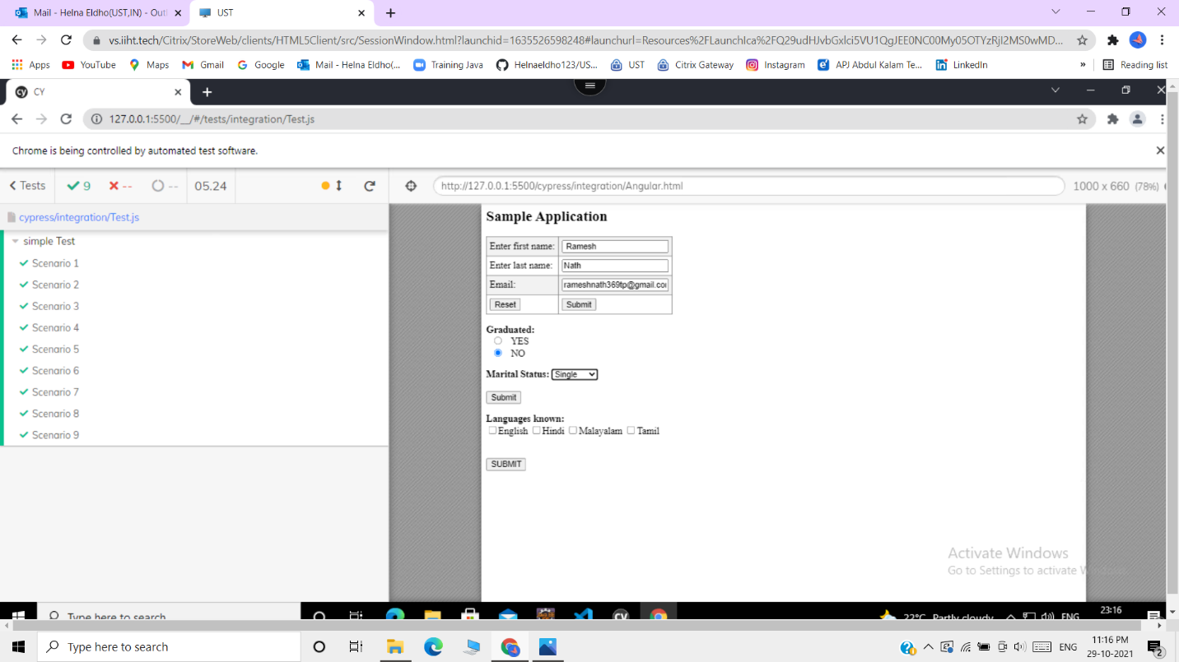

* TESTCASE 10

