**GROUP-4**

To build using Jenkins the dining module of urban ladder.

StepDefinitions

package StepDefinitions;

import org.openqa.selenium.By;

import org.openqa.selenium.WebDriver;

import org.openqa.selenium.chrome.ChromeDriver;

import io.cucumber.java.en.Given;

import io.cucumber.java.en.Then;

import io.cucumber.java.en.When;

public class StepDefinition {

WebDriver driver =null;

@Given("the user opens the browser")

public void the_user_opens_the_browser() {

System.setProperty("webdriver.chrome.driver","C:\\Users\\ustjavasdetb417\\Downloads\\chromedriver_win32 (1)\\chromedriver.exe");

driver = new ChromeDriver();

driver.manage().window().maximize();

}

@When("the user navigates to urban ladder")

public void the_user_navigates_to_urban_ladder() {

driver.get("https://www.urbanladder.com/");

}

@Then("click Dining")

public void search_Dining() throws InterruptedException {

// driver.findElement(By.xpath("//span[@class='topnav_itemname'")).click();

System.out.println("Clicking on Dinning Table");

driver.findElement(By.xpath("//*[@id=\"topnav_wrapper\"]/ul/li[4]/span")).click();

Thread.sleep(3000);

driver.navigate().to("https://www.urbanladder.com/dining-tables?src=g_topnav_dining_dining-tables-sets_dining-tables");

Thread.sleep(3000);

System.out.println("Close pop up");

driver.findElement(By.xpath("//*[@id=\"authentication_popup\"]/div[1]/div/div[2]/a[1]")).click();

Thread.sleep(3000);

driver.findElement(By.xpath("//*[@id=\"filters_availability_In_Stock_Only\"]")).click();

System.out.println("Checkboxing now");

Thread.sleep(2000);

driver.findElement(By.xpath("//*[@id=\"filters-form\"]/div[1]/div/div/ul/li/div[1]")).click();

Thread.sleep(2000);

driver.findElement(By.xpath("//*[@id=\"price_limit_4535-49323\"]")).click();

Thread.sleep(2000);

System.out.println("Clicing radio button");

driver.findElement(By.xpath("//*[@id=\"price_limit_4535-49323\"]")).click();

Thread.sleep(2000);

driver.findElement(By.xpath("//*[@id=\"filters-form\"]/div[1]/div/div/ul/li/div[1]")).click();

Thread.sleep(2000);

System.out.println("Clearing filter");

driver.findElement(By.xpath("//*[@id=\"filters-form\"]/div[1]/div/div/ul/li/div[2]/div/div/ul/li[1]/div/div[1]/span[2]")).click();

Thread.sleep(2000);

System.out.println("click on table");

driver.navigate().to("https://www.urbanladder.com/products/arabia-6-seater-dining-table?sku=FNTBDI11TK10001&src=room");

Thread.sleep(2000);

System.out.println("Click on Help");

driver.findElement(By.xpath("//*[@id=\"header\"]/section/div/ul[1]/li[1]/a")).click();

driver.findElement(By.xpath("//*[@id=\"4192\"]/div[2]/div")).click();

System.out.println("Clicking on track order");

driver.findElement(By.xpath("//*[@id=\"header\"]/section/div/ul[1]/li[2]/a")).click();

System.out.println("Passing values to access orders");

driver.findElement(By.id("ip_379403698")).sendKeys("Grp4");

Thread.sleep(2000);

driver.findElement(By.id("ip_394711104")).sendKeys("9727283221");

Thread.sleep(3000);

driver.findElement(By.xpath("//*[@id=\"app-container\"]/div/main/section/form[1]/button/span[1]")).click();

Thread.sleep(3000);

System.out.println("Window closed");

driver.close();

}

}

TestRunner

package StepDefinitions;

import org.junit.runner.RunWith;

import io.cucumber.junit.Cucumber;

import io.cucumber.junit.CucumberOptions;

@RunWith(Cucumber.class)

@CucumberOptions(features="src/main/resources/Features",glue= {"StepDefinitions"},

monochrome=true)

public class TestRunner {

}

Pom File

<project xmlns="http://maven.apache.org/POM/4.0.0" xmlns:xsi="http://www.w3.org/2001/XMLSchema-instance" xsi:schemaLocation="http://maven.apache.org/POM/4.0.0 https://maven.apache.org/xsd/maven-4.0.0.xsd">

<modelVersion>4.0.0</modelVersion>

<groupId>Capstoneproject</groupId>

<artifactId>Capstoneproject</artifactId>

<version>0.0.1-SNAPSHOT</version>

<dependencies>

<dependency>

<groupId>org.seleniumhq.selenium</groupId>

<artifactId>selenium-java</artifactId>

<version>2.47.1</version>

</dependency>

<dependency>

<groupId>io.cucumber</groupId>

<artifactId>cucumber-java</artifactId>

<version>5.7.0</version>

</dependency>

<dependency>

<groupId>io.cucumber</groupId>

<artifactId>cucumber-junit</artifactId>

<version>5.7.0</version>

</dependency>

<dependency>

<groupId>junit</groupId>

<artifactId>junit</artifactId>

<version>4.13</version>

</dependency>

</dependencies>

</project>

Steps:

* Take the project Right capstone in the Jenkins.
* Click on configure and paste the root of pom file in the build environment.

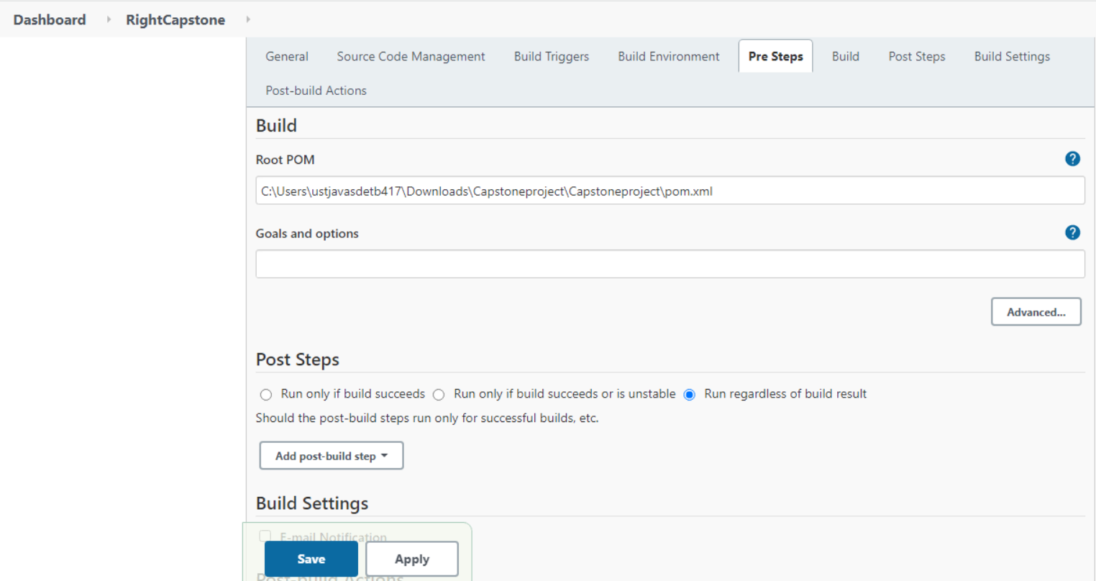

* Click on manage Jenkins🡪Global tool Configuration🡪Give the JDK Path🡪then, give the path of apache maven 3.3.1🡪Save and Apply.

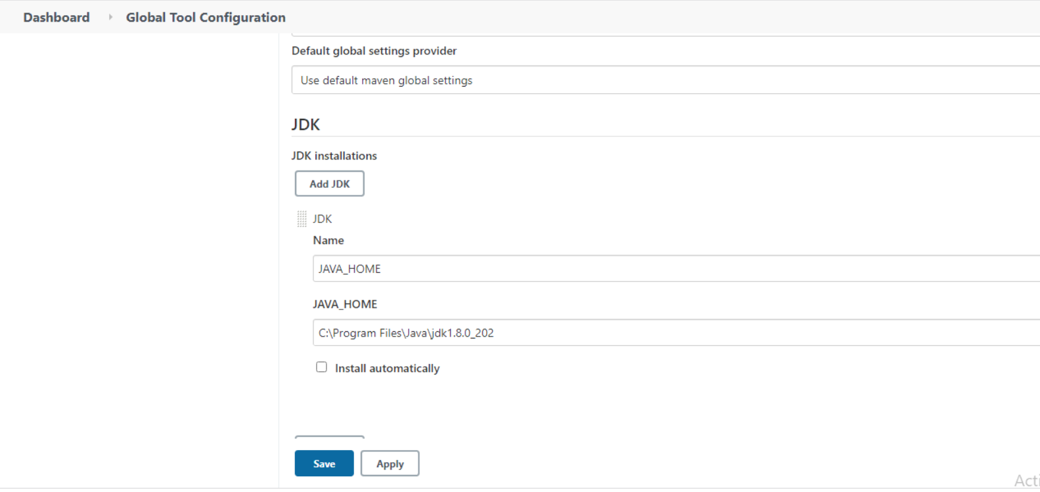

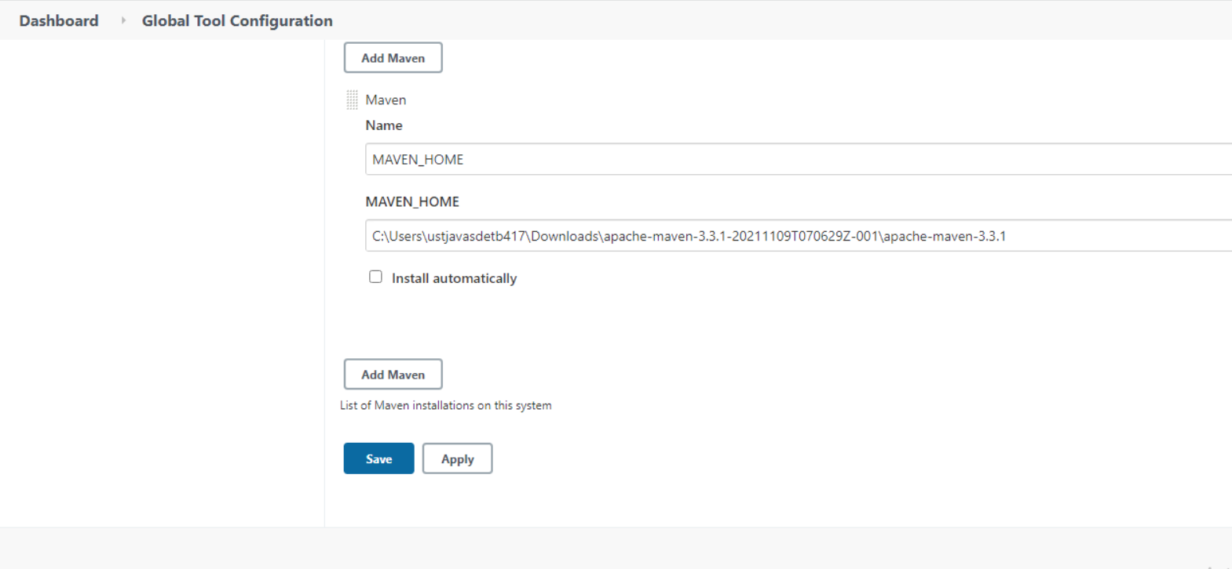

* Select the project🡪Buildnow🡪Click on the console output.

