**GROUP-4**

**PERFORMANCE CHECK FOR DINING MODULE OF URBANLADDER USING JMETER ON AWS**

* Create a Cloud Formation Template

[**https://aws.amazon.com/solutions/implementations/distributed-load-testing-on-aws/**](https://aws.amazon.com/solutions/implementations/distributed-load-testing-on-aws/)

* Specify template and stack details

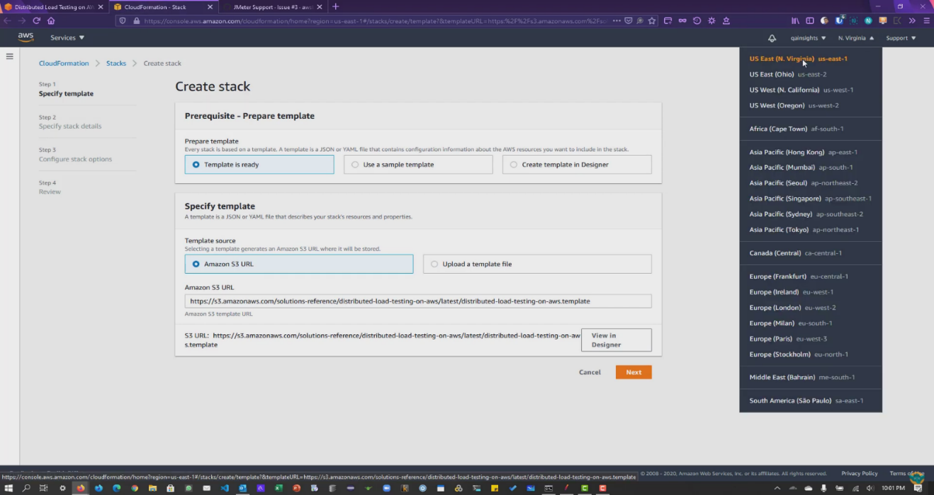

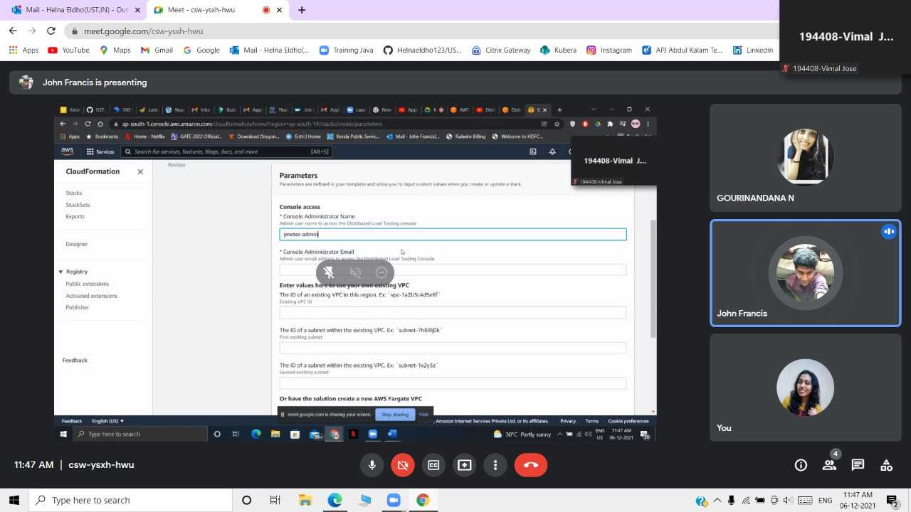

* Configure stack options

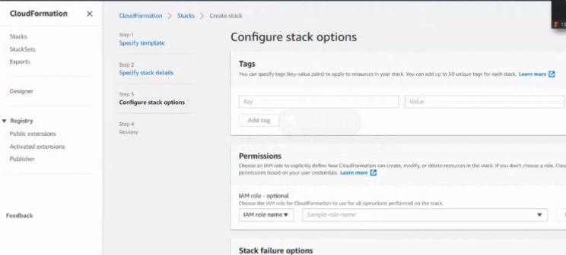

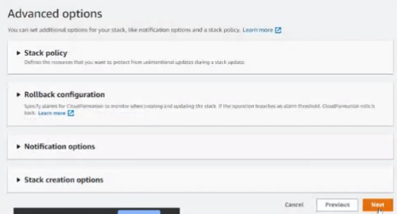

* Create the stack

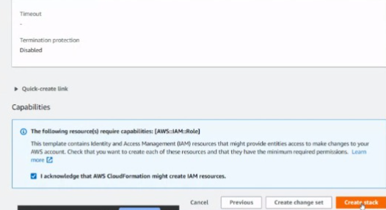

* After the stack got created login to jmeter console and you will get the credentials in the mail.

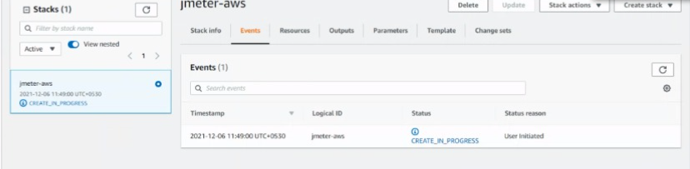

* Name the load test as Dining Urbanladder and give the values.

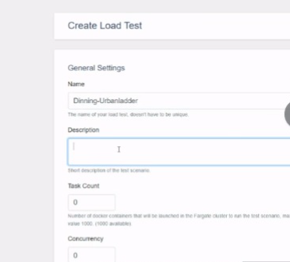

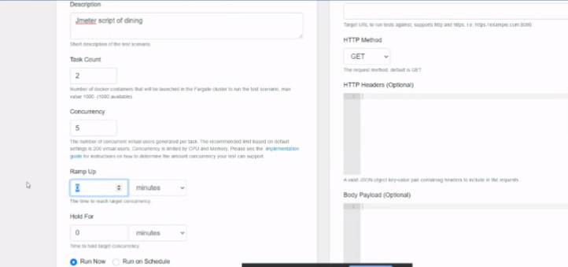

* In jmeter pass the server name and path at http request.

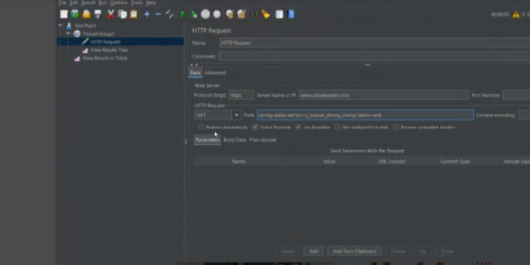

* Save and Run.

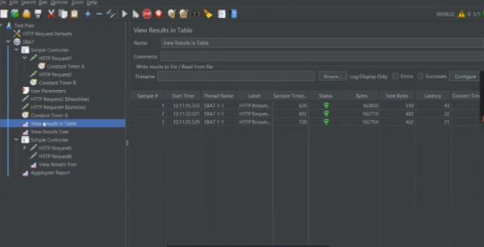

* Upload the JMX File in the loadtest console.

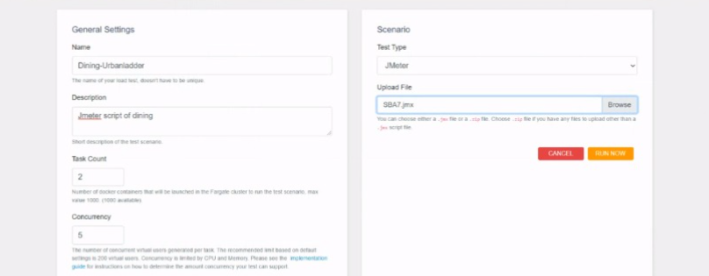

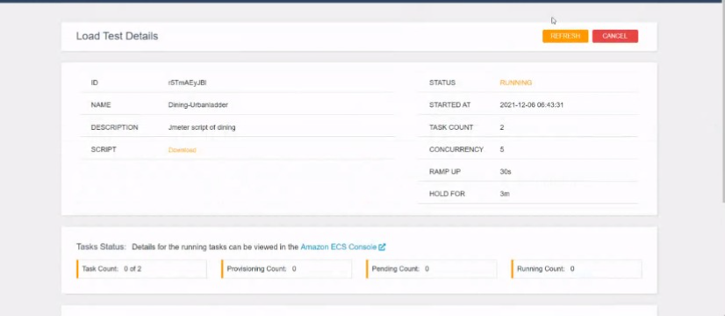

* Explore Ecs console and CloudWatch Metrics dashboard to explore more details about the test.

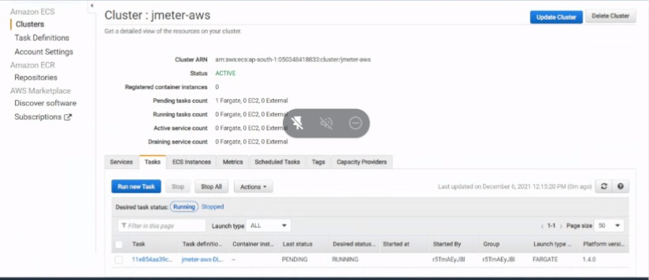

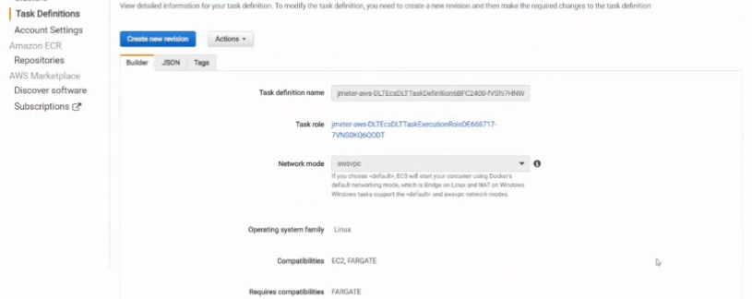

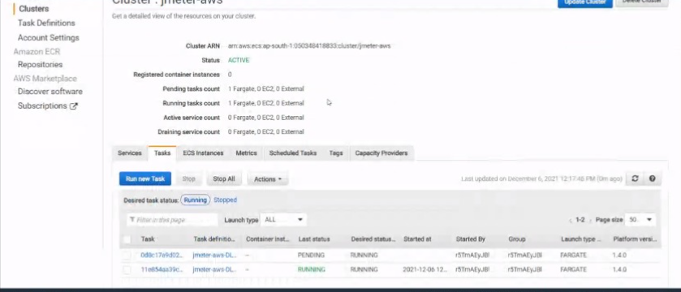

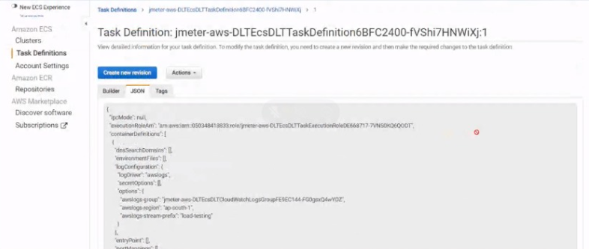

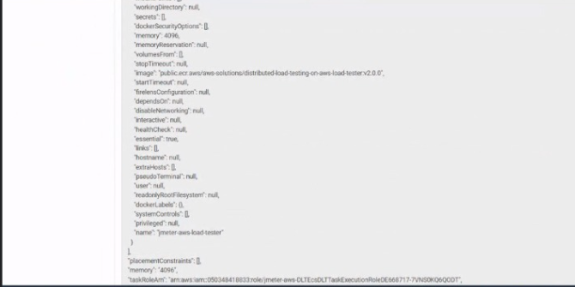

* To see the test result refresh the console.

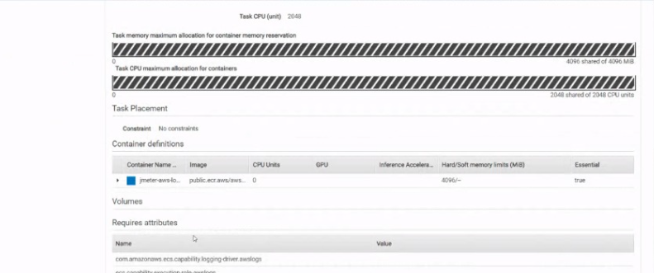

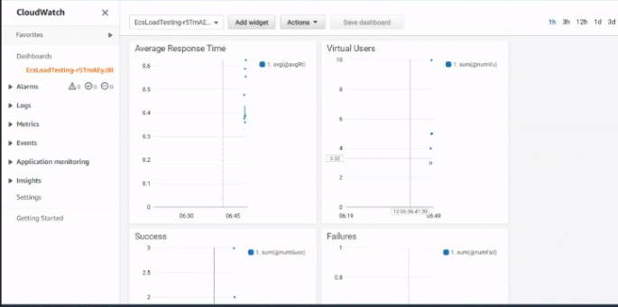

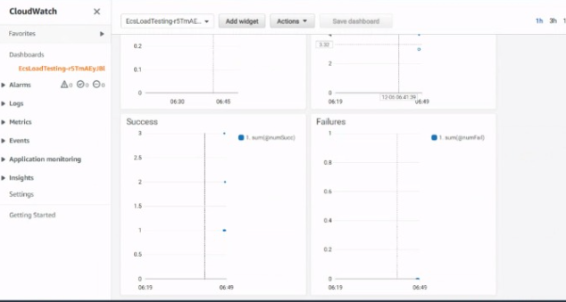

* Test results will be populated in the console of cloud watch metrics

