**PYTHON**

**Testing**

Install python 3.9.9

Update the version of pytest.

* Pip install -U pytest.



* To check the version of pytest.



* Create a folder in desktop
* Create a file in it



* Write this code there

import pytest

def test_file1_method1():

x=5

y=6

assert x+1 == y,"test failed"

assert x == y,"test failed"

def test_file1_method2():

x=5

y=6

assert x+1 == y,"test failed"

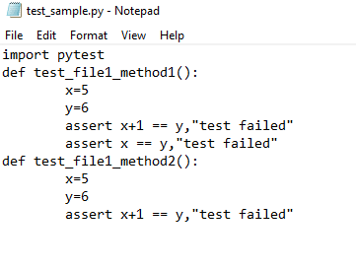

* Save it as test_sample.py
* Open command prompt from this



* Type py.test in cmd

