**Linux:**

**It is a Operating system which is similar to windows and mac os.**

It is open source. Ubuntu uses linux terminal

This solves main purpose like Admin management, File management better than any other OS.

**Cd: stands for change directory**

**cd : We use this choose path directory**

**pwd : To know the path where you are present**

**ls : This gives list of all files in the directory**

**Variations of ls:**

**ls ~: Gives/Jumps all files present in system or all home directory**

**ls .. : To return back to the previous directory from where you came**

**ls . : List files and folders in current directory**

**ls –a : List files and folders including the hidden ones**

**ls –al : List all files and folder including hidden one in long format or briefly**

**ls –l : List files and folder in long format**

**ls –p : Give al files in current directory**

**ls –p | grep pdf : Gives if any pdf file is present in the directory**

**ls –s _name_ : Gives all file present inside in tabular**

**ls –l _name_ : Gives al file present inside in long vertical format**

**ls – R - This displays all files present from top to bottom directories**

**pwd: present working directory**

**mkdir :**

Creating and operating on directories

**mkdir _name_ : This is for creating a directory**

**we can also create multiple directories at a time**

**mkdir _name1__name2__name3_**

**rmdir _name_ : Removes that particular directory**

**mkdir –p _name1_/_name2_ : Created nested directory(Second directory is present in the first directory)**

**cd _name_ : To traverse across directories we need cd**

**cd .. : Directs you to one directory before format**

**cd - : Just takes you previous directly**

**Touch: To create a file in the directory**

**touch _filename.txt_ : Create a file of txt type in the directory**

**cd /etc/ : Takes you to home directly**

**rm _filename_ : To delete a file**

**rm : To remove file from directory**

**rm –r _name_: Deletes that particular file in the directly**

**rm –i _name_: ask user permission before delete**

**rm –I _name_ : Does not user before deletion**

**rm –r directly _name_ : remove the directly recursively**

**rm –ir directory _name_ : removes the file or dir with asking permission**

**Copy & Move:**

**Cp doc1.txt doc2.txt**

**Mv _filename_ _NewfileLocation_**

**Mv doc2.txt doc3.txt**

**Sudo command helps users to run security commands, It gives superuser privilages**

**Sudo(Password authentication)**

**To rename a file:**

**Mv _filename_ _newfilename_**

**Mv test test1**

**cat command: Add content or info to any file**

**cat command used to display text files  
To print the commands of the file output stream**

**It can also be used to print, copy, combine and create text files**

**cat > file1**

**This is a test file.(cntl+D)-To return cmi(Command line interface)**

**cat file1**

**cat > file2**

**This is another file**

**cat doc2.txt : This prints content of that txt file in the output stream**

**combine 2 files:**

**cat file1 file2>newfile**

**cat newfile**

**Only text files can be displayed and combined.**

**MAN command:**

**It stands for manual, It is similar help file**

**man ls – List of all commands**

**History command:**

**Shows commands that we used in the past**

**History**

**Clear command:**

**To clean the terminal**

**Clear**

**Pr command:**

**To print from linux**

**Linux is a clone of UNIX, the multi-user operating system which can be accessed by many users simultaneously.**

**File permissions:**

**It is a multiuser operating system**

**Group:**

**User – Group can multiple users**

**All users in the group have the same file permissions**

**Security for linux**

**There are 3 types of users**

**1)user**

**2)Group**

**3)Others**

**R – read**

**W- write**

**X – execute**

**Chmod : To change permissions on a file. So, who can access(RWX)**

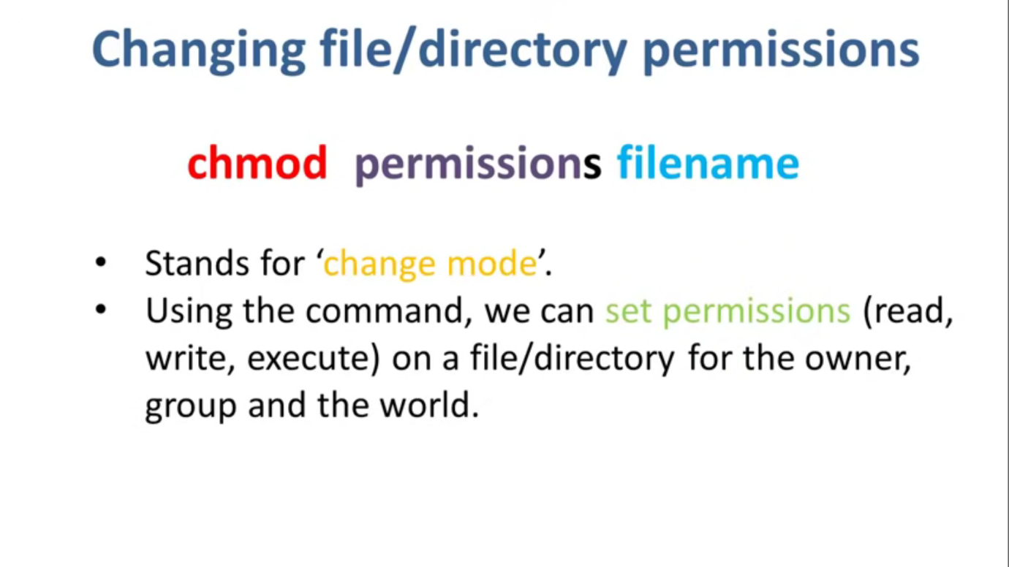

**Chmod can be used in 2 ways**

**1)Absolute mode**

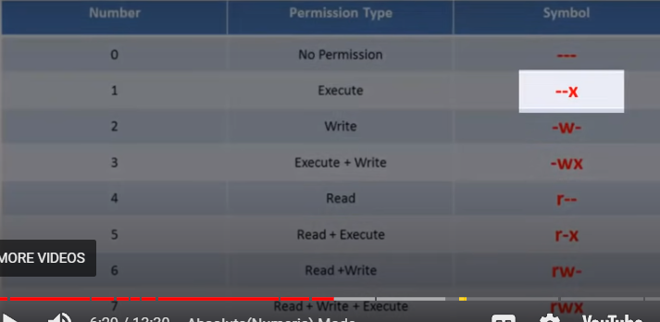

**In absolute you can change permissions for all 3 owners**

**But in symbolic mode you can change permissions for a specific owner**

**2)Symbolic mode**

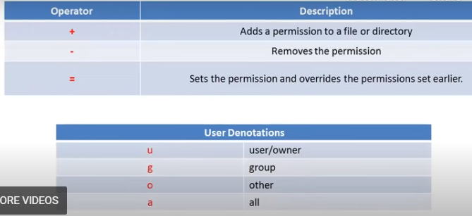

**Chowm:**

**This is can help change the ownership or group.**

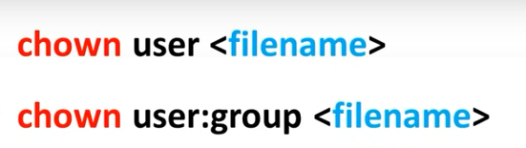

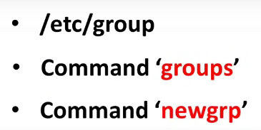

**2 groups cant have same filename**

**We can change ownership and grp both at a time**

**Chgrp command can change the group ownership with chrgp group filename.**

**Pipes:**

**We use pipes to run 2 or more commands consecutively**

**Grep: If you want to search a file or piece of information in file. We use grep command**

**1)Scan a document**

**2)Present the result in format you want**

**Grep _searchname_**

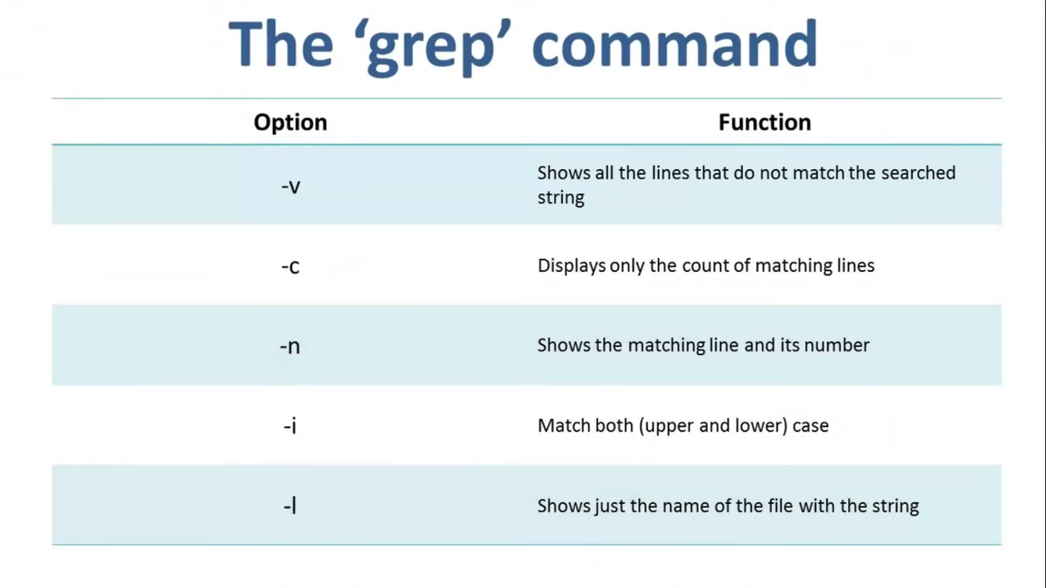

**Sort:**

**Sort _filename_**

**Filters:**

**The outputs of the first command will become the input for next command**

**Regular expressions**

**Special characters which help match data or identify same pattern**

**Regex is the syntax**

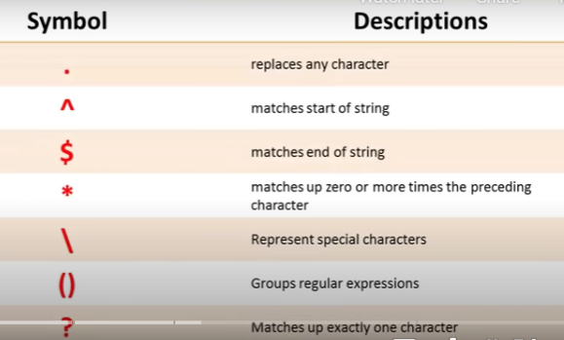

**Commonly used :**

**Tr**

**Sed**

**Vi**

**Grep**

**Interval expressions**

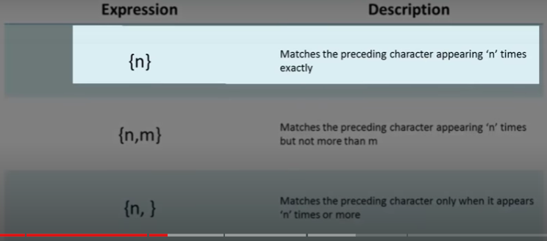

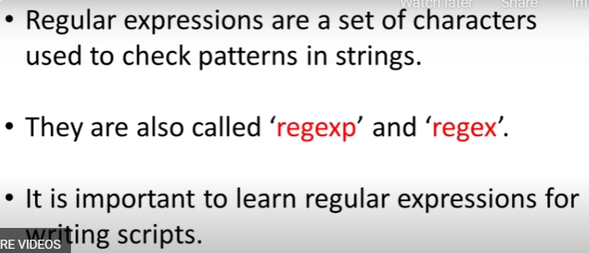

**Environment = OS + CPU**

**Variables:**

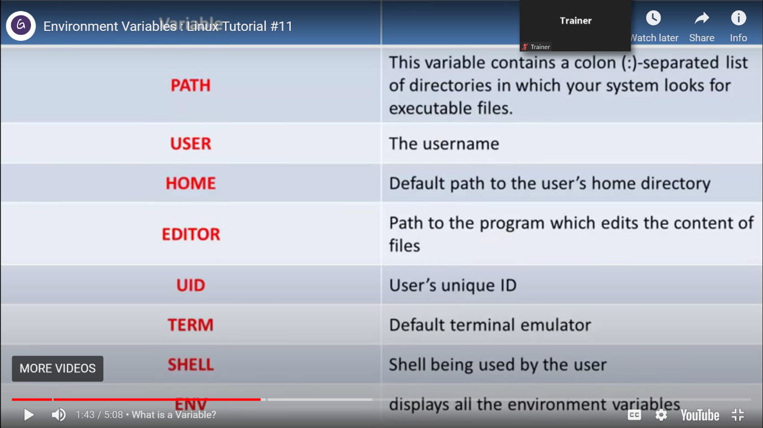

**Vi editor: Through editor or terminal**

**It is a way where we can edit our files in a linux os**

**Command mode, Insert mode(I keyword)**

**To start vi editor on terminal we need use**

**Vi _filenamenew_**

**It enters command mode by default**

**If u want switch then use I to switch to insertmode**

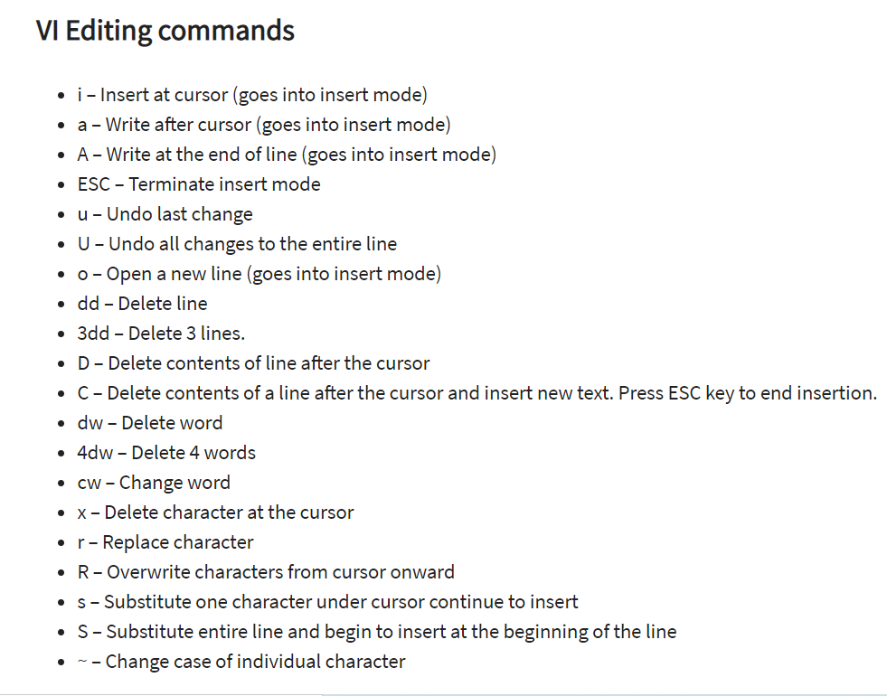

**To edit we need to be in insertmode after editing to save we need to again switch back to command mode**

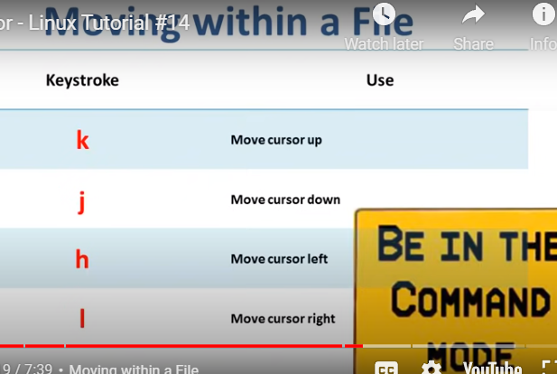

**The head and tail commands are for accessing a portion of information**

**Usually head helps us while we are accessing from beginning to end**

**And Tail helps us while accessing from end to start.**

**To access data that is present in middle of the file we can both use both head and tail together.**

**Using these we can get a part of input files for further processing.**

**Shell scripting:::**

It is a program to run series of commands.

The repeated commands can be put into a script and stored. And it can be executed anytime if needed. This basically reduces programming efforts

Shell is a interface between user and os

The OS is made of 2 main components:

Kernel

Shell

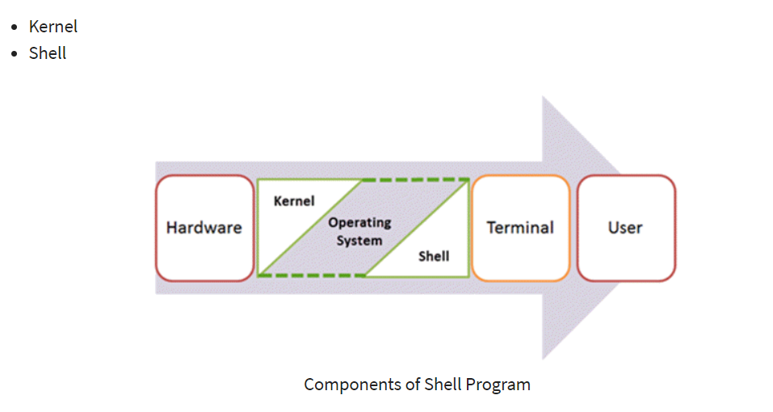

A kernel makes communication happen between hardware and software

Kernel is a inner most part of an operating system whereas shell is outermost part.

Shell wraps OS protecting it from accidental damage.

Shell scripts help us to execute multiple commands.

Vi is the editor, where can we can write our script.

For shell scripts the .sh extensions are mandatory

To start the script we need to use #!/bin/sh

Use I to enter insert mode for editing

To save the file use ESC + shift ZZ to save and exit after scripting in insert mode. So that we can return to command mode for executing file.

**Creating a shell script:**

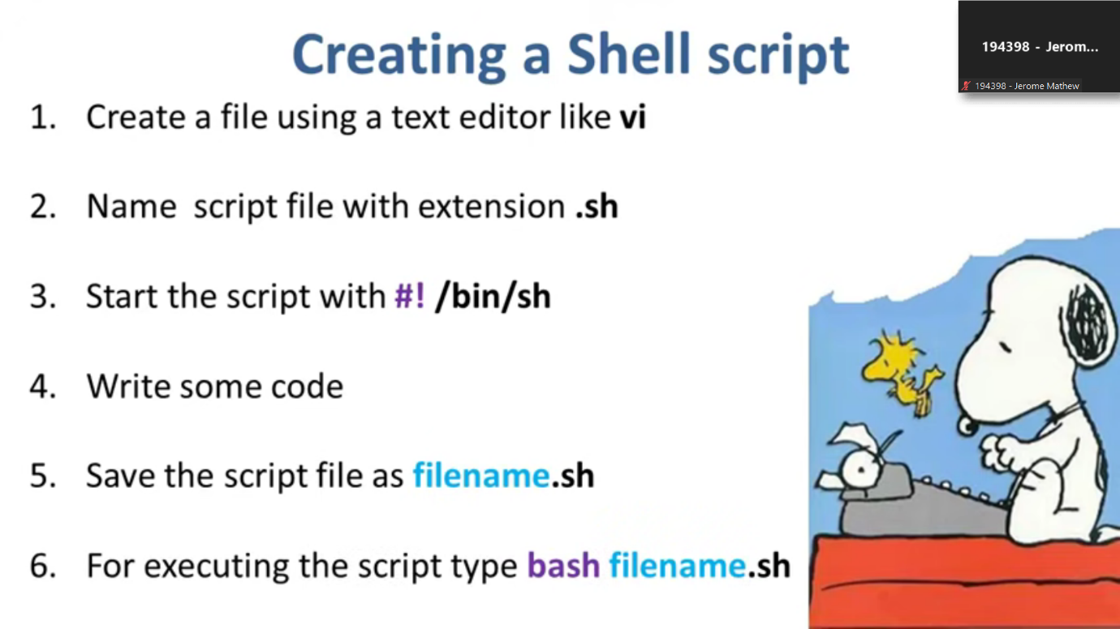

Shell variables: It contains info which can read by shell only.

We can use loops and conditionals to write good scripts for more functionality

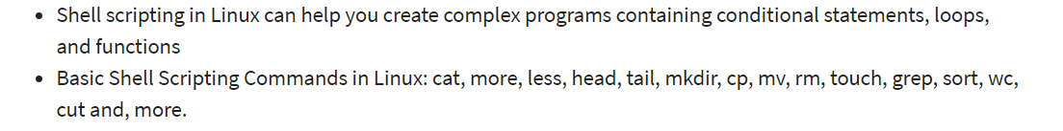

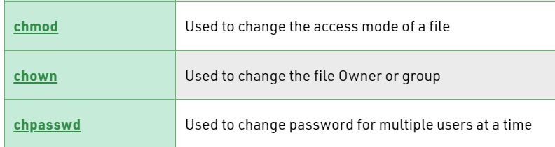

**Chmod : Use this to make a file as executable by bringing it to command mode from insert mode after editing.**

**Inference of scripts:**

**While loop in shell**

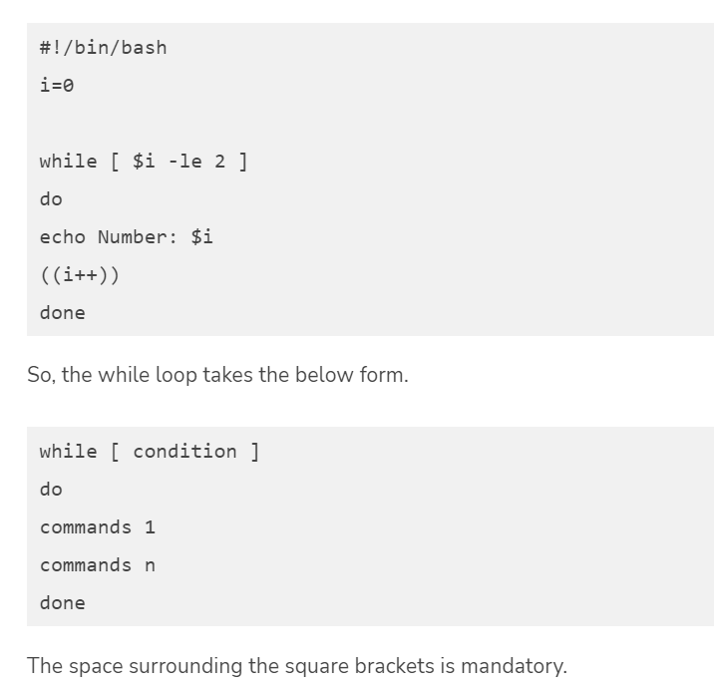

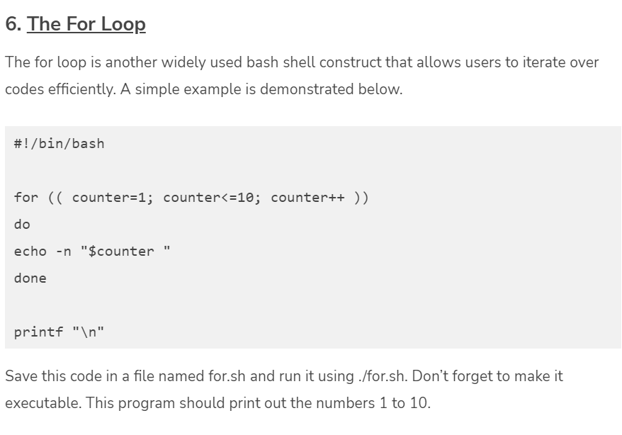

**Use read _name_**

**To take input from user**

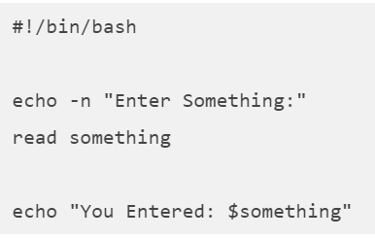

**$ to access any file**

**Conditionals: If statements**

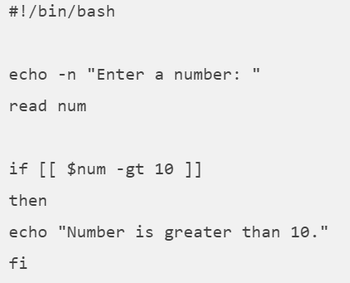

**If – Else statements:**

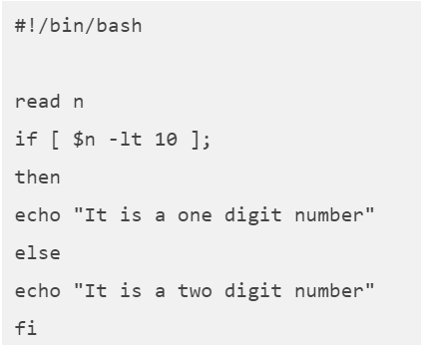

**Scroll down to see more scripts**

**Practice scripts:**

**1. Hello World**

Programmers often learn new languages via learning the hello world program. It’s a simple program that prints the string ***“Hello World”*** to the standard output. Then, use an editor like vim or nano to create the file hello-world.sh and copy the below lines into it.

#!/bin/bash

echo "Hello World"

Save and quit the file. Next, you need to make this file executable using the below command.

$ chmod a+x hello-world.sh

You can run this using any of the below two commands.

$ bash hello-world.sh

$ ./hello-world.sh

It will print out the string passed to echo inside the script.

**2. Using echo to Print**

The echo command is used for printing out information in bash. It is similar to the C function ‘printf’ and provides many common options, including escape sequences and re-direction.

Copy the below lines into a file called echo.sh and make it executable as done above.

#!/bin/bash

echo "Printing text"

echo -n "Printing text without newline"

echo -e "\nRemoving \t special \t characters\n"

Run the script to see what it does. The **-e** option is used for telling echo that the string passed to it contains special characters and requires extended functionality.

**3. Using Comments**

Comments are useful for documentation and are a requirement for high-quality codebases. It’s a common practice to put comments inside codes that deal with critical logic. To comment out a line, just use the **#**(hash) character before it. For example, check the below bash script example.

#!/bin/bash

# Adding two values

((sum=25+35))

#Print the result

echo $sum

This script will output the number 60. First, check how comments are used using **#** before some lines. The first line is an exception, though. It’s called the shebang and lets the system know which interpreter to use when running this script.

**4. Multi-line comments**

Many people use multi-line comments for documenting their shell scripts. Check how this is done in the next script called comment.sh.

#!/bin/bash

: '

This script calculates

the square of 5.

'

((area=5*5))

echo $area

Notice how multi-line comments are placed inside **:’** and **‘** characters.

**5. The While Loop**

The while loop construct is used for running some instruction multiple times. Check out the following script called while.sh for a better understanding of this concept.

#!/bin/bash

i=0

while [ $i -le 2 ]

do

echo Number: $i

((i++))

done

So, the while loop takes the below form.

while [ condition ]

do

commands 1

commands n

done

The space surrounding the square brackets is mandatory.

**6. The For Loop**

The for loop is another widely used bash shell construct that allows users to iterate over codes efficiently. A simple example is demonstrated below.

#!/bin/bash

for (( counter=1; counter<=10; counter++ ))

do

echo -n "$counter "

done

printf "\n"

Save this code in a file named for.sh and run it using ./for.sh. Don’t forget to make it executable. This program should print out the numbers 1 to 10.

**7. Receive Input from User**

Getting user input is crucial to implement user interaction in your scripts. The below shell script example will demonstrate how to receive user input within a shell program.

#!/bin/bash

echo -n "Enter Something:"

read something

echo "You Entered: $something"

So, the reading construct, followed by a variable name, is used for getting user input. The input is stored inside this variable and can be accessed using the $ sign.

**8. The If Statement**

If statements are the most common conditional construct available in Unix shell scripting, they take the form shown below.

if CONDITION

then

STATEMENTS

fi

The statements are only executed given the CONDITION is true. The fi keyword is used for marking the end of the if statement. A quick example is shown below.

#!/bin/bash

echo -n "Enter a number: "

read num

if [[ $num -gt 10 ]]

then

echo "Number is greater than 10."

fi

The above program will only show the output if the number provided via input is greater than ten. The **-gt** stands for greater than; similarly **-lt** for less than; **-le** for less than equal; and **-ge** for greater than equal. In addition, the [[ ]] are required.

**9. More Control Using If Else**

Combining the else construct with if allows much better control over your script’s logic. A simple example is shown below.

#!/bin/bash

read n

if [ $n -lt 10 ];

then

echo "It is a one digit number"

else

echo "It is a two digit number"

fi

The else part needs to be placed after the action part of if and before fi.

**10. Using the AND Operator**

The AND operator allows our program to check if multiple conditions are satisfied at once or not. All parts separated by an AND operator must be true. Otherwise, the statement containing the AND will return false. Check the following bash script example for a better understanding of how AND works.

#!/bin/bash

echo -n "Enter Number:"

read num

if [[ ( $num -lt 10 ) && ( $num%2 -eq 0 ) ]]; then

echo "Even Number"

else

echo "Odd Number"

fi

The AND operator is denoted by the **&&** sign.

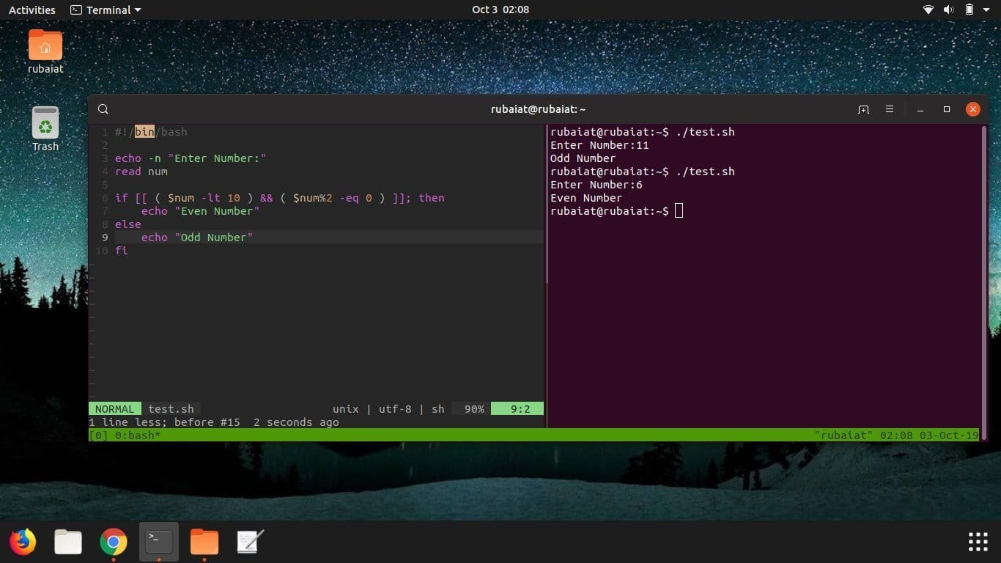

**11. Using the OR Operator**

The OR operator is another crucial construct that allows us to implement complex, robust programming logic in our scripts. Contrary to AND, a statement consisting of the OR operator returns true when either one of its operands is true. It returns false only when each operand separated by the OR is false.

#!/bin/bash

echo -n "Enter any number:"

read n

if [[ ( $n -eq 15 || $n -eq 45 ) ]]

then

echo "You won"

else

echo "You lost!"

fi

This simple example demonstrates how the OR operator works in Linux shell scripts. It declares the user as the winner only when he enters the number 15 or 45. The || sign represents the OR operator.

**12. Using Elif**

The elif statement stands for else if and offers a convenient means for implementing chain logic. Find out how elif works by assessing the following example.

#!/bin/bash

echo -n "Enter a number: "

read num

if [[ $num -gt 10 ]]

then

echo "Number is greater than 10."

elif [[ $num -eq 10 ]]

then

echo "Number is equal to 10."

else

echo "Number is less than 10."

fi

The above program is self-explanatory, so we won’t dissect it line by line. Instead, change portions of the script like variable names and values to check how they function together.

**13. The Switch Construct**

The switch construct is another powerful feature offered by Linux bash scripts. It can be used where nested conditions are required, but you don’t want to use complex **if-else-elif** chains. Take a look at the next example.

#!/bin/bash

echo -n "Enter a number: "

read num

case $num in

100)

echo "Hundred!!" ;;

200)

echo "Double Hundred!!" ;;

*)

echo "Neither 100 nor 200" ;;

esac

The conditions are written between the case and esac keywords. The *) is used for matching all inputs other than 100 and 200.

**14. Command Line Arguments**

Getting arguments directly from the command shell can be beneficial in a number of cases. The below example demonstrates how to do this in bash.

#!/bin/bash

echo "Total arguments : $#"

echo "First Argument = $1"

echo "Second Argument = $2"

Run this script with two additional parameters after its name. I’ve named it test.sh and the calling procedure is outlined below.

$ ./test.sh Hey Howdy

So, $1 is used for accessing the first argument, $2 for the second, and so on. Then, finally, the $# is used for getting the total number of arguments.

**15. Getting Arguments with Names**

The below example shows how to get command-line arguments with their names.

#!/bin/bash

for arg in "$@"

do

index=$(echo $arg | cut -f1 -d=)

val=$(echo $arg | cut -f2 -d=)

case $index in

X) x=$val;;

Y) y=$val;;

*)

esac

done

((result=x+y))

echo "X+Y=$result"

Name this script test.sh and call it as shown below.

$ ./test.sh X=44 Y=100

It should return X+Y=144. The arguments here are stored inside ‘**$@**‘ and the script fetches them using the Linux cut command.

**16. Concatenating Strings**

String processing is of extreme importance to a wide range of modern bash scripts. Thankfully, it is much more comfortable in bash and allows for a far more precise, concise way to implement this. See the below example for a glance into bash string concatenation.

#!/bin/bash

string1="Ubuntu"

string2="Pit"

string=$string1$string2

echo "$string is a great resource for Linux beginners."

The following program outputs the string “UbuntuPit is a great resource for Linux beginners.” to the screen.

**17. Slicing Strings**

Unlike many programming languages, bash doesn’t provide any in-built function for cutting portions of a string. However, the below example demonstrates how this can be done using parameter expansion.

#!/bin/bash

Str="Learn Bash Commands from UbuntuPit"

subStr=${Str:0:20}

echo $subStr

This script should print out “*Learn Bash Commands*” as its output. The parameter expansion takes the form **${VAR_NAME:S:L**}. Here, S denotes starting position, and L indicates the length.

**18. Extracting Substrings Using Cut**

The [Linux cut command](https://www.ubuntupit.com/simple-and-useful-linux-cut-command-in-unix/) can be used inside your scripts to ‘cut’ a portion of a string, aka the substring. The next example shows how this can be done.

#!/bin/bash

Str="Learn Bash Commands from UbuntuPit"

#subStr=${Str:0:20}

subStr=$(echo $Str| cut -d ' ' -f 1-3)

echo $subStr

Check out [this guide to understand how Linux Cut command works](https://www.ubuntupit.com/simple-and-useful-linux-cut-command-in-unix/).

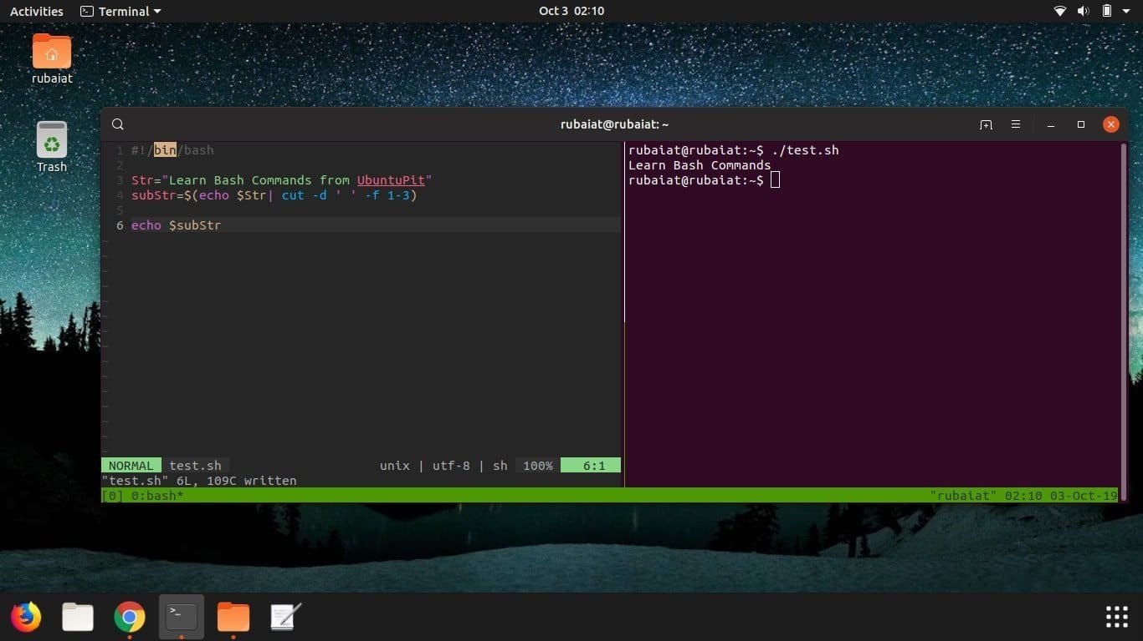

**19. Adding Two Values**

It’s quite easy to perform arithmetic operations inside Linux shell scripts. The below example demonstrates how to receive two numbers as input from the user and add them.

#!/bin/bash

echo -n "Enter first number:"

read x

echo -n "Enter second number:"

read y

(( sum=x+y ))

echo "The result of addition=$sum"

As you can see, adding numbers in bash is reasonably straightforward.

**20. Adding Multiple Values**

You can use loops to get multiple user input and add them to your script. The following examples show this in action.

#!/bin/bash

sum=0

for (( counter=1; counter<5; counter++ ))

do

echo -n "Enter Your Number:"

read n

(( sum+=n ))

#echo -n "$counter "

done

printf "\n"

echo "Result is: $sum"

However, omitting the **(( ))** will result in string concatenation rather than addition. So, check for things like this in your program.

**21. Functions in Bash**

As with any programming dialect, functions play an essential role in Linux shell scripts. They allow admins to create custom code blocks for frequent usage. The below demonstration will outline how functions work in Linux bash scripts.

#!/bin/bash

function Add()

{

echo -n "Enter a Number: "

read x

echo -n "Enter another Number: "

read y

echo "Adiition is: $(( x+y ))"

}

Add

Here we’ve added two numbers just like before. But here, we’ve done the work using a function called Add. So whenever you need to add again, you can just call this function instead of writing that section again.

**22. Functions with Return Values**

One of the most fantastic functions is allowing the passing of data from one function to another. It is useful in a wide variety of scenarios. Check out the next example.

#!/bin/bash

function Greet() {

str="Hello $name, what brings you to UbuntuPit.com?"

echo $str

}

echo "-> what's your name?"

read name

val=$(Greet)

echo -e "-> $val"

Here, the output contains data received from the Greet() function.

**23. Creating Directories from Bash Scripts**

The ability to run system commands using shell scripts allows developers to be much more productive. The following simple example will show you how to create a directory from within a shell script.

#!/bin/bash

echo -n "Enter directory name ->"

read newdir

cmd="mkdir $newdir"

eval $cmd

This script simply calls your standard shell command mkdir and passes it the directory name if you look closely. This program should create a directory in your filesystem. You can also pass the command to execute inside backticks(**“**) as shown below.

`mkdir $newdir`

**24. Create a Directory after Confirming Existence**

The above program will not work if your current working directory already contains a folder with the same name. For example, the below program will check for the existence of any folder named **$dir** and only create one if it finds none.

#!/bin/bash

echo -n "Enter directory name ->"

read dir

if [ -d "$dir" ]

then

echo "Directory exists"

else

`mkdir $dir`

echo "Directory created"

fi

Write this program using eval to increase your bash scripting skills.

**25. Reading Files**

Bash scripts allow users to read files very effectively. The below example will showcase how to read a file using shell scripts. First, create a file called editors.txt with the following contents.

1. Vim

2. Emacs

3. ed

4. nano

5. Code

This script will output each of the above 5 lines.

#!/bin/bash

file='editors.txt'

while read line; do

echo $line

done < $file

**26. Deleting Files**

The following program will demonstrate how to delete a file within Linux shell scripts. The program will first ask the user to provide the filename as input and will delete it if it exists. The Linux rm command does the deletion here.

#!/bin/bash

echo -n "Enter filename ->"

read name

rm -i $name

Let’s type in editors.txt as the filename and press y when asked for confirmation. It should delete the file.

**27. Appending to Files**

The below shell script example will show you how to append data to a file on your filesystem using bash scripts. It adds an additional line to the earlier editors.txt file.

#!/bin/bash

echo "Before appending the file"

cat editors.txt

echo "6. NotePad++" >> editors.txt

echo "After appending the file"

cat editors.txt

You should notice by now that we’re using everyday terminal commands directly from Linux bash scripts.

**28. Test File Existence**

The next shell script example shows how to check the existence of a file from bash programs.

#!/bin/bash

filename=$1

if [ -f "$filename" ]; then

echo "File exists"

else

echo "File does not exist"

fi

We are passing the filename as the argument from the command-line directly.

**29. Send Mails from Shell Scripts**

It is quite straightforward to send emails from bash scripts. The following simple example will demonstrate one way of doing this from bash applications.

#!/bin/bash

recipient=”admin@example.com”

subject=”Greetings”

message=”Welcome to UbuntuPit”

`mail -s $subject $recipient <<< $message`

It will send an email to the recipient containing the given subject and message.

**30. Parsing Date and Time**

The next bash script example will show you how to handle dates and times using scripts. Again, the Linux date command is used for getting the necessary information, and our program does the parsing.

#!/bin/bash

year=`date +%Y`

month=`date +%m`

day=`date +%d`

hour=`date +%H`

minute=`date +%M`

second=`date +%S`

echo `date`

echo "Current Date is: $day-$month-$year"

echo "Current Time is: $hour:$minute:$second"

Run this program to see how it works. Also, try running the date command from your terminal.

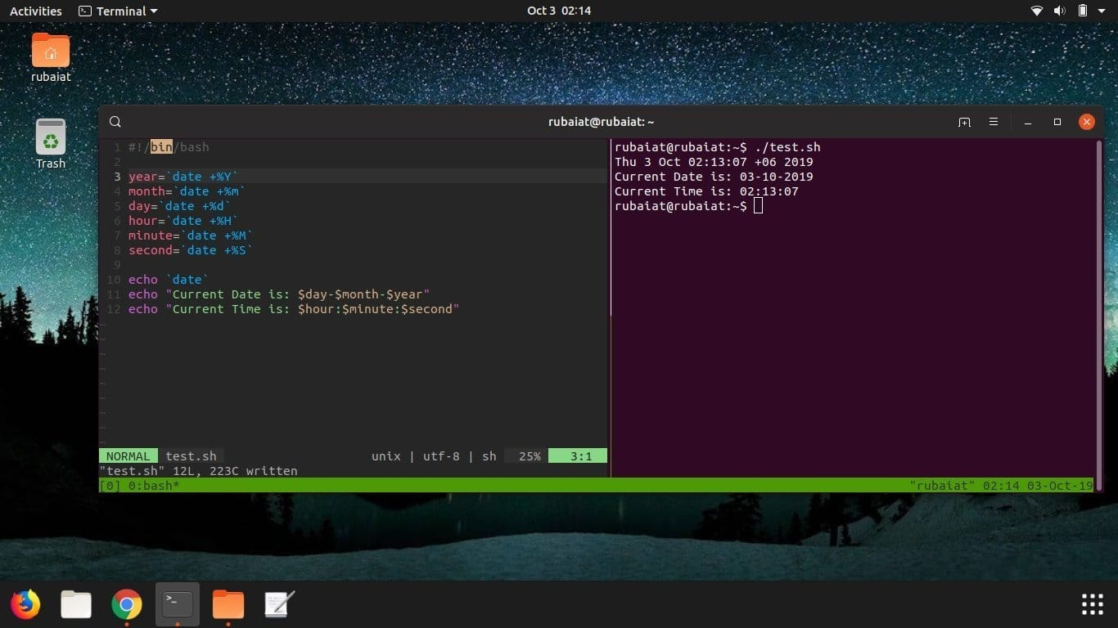

**31. The Sleep Command**

The sleep command allows your shell script to pause between instructions. It is useful in a number of scenarios, such as performing system-level jobs. The next example shows the sleep command in action from within a shell script.

#!/bin/bash

echo "How long to wait?"

read time

sleep $time

echo "Waited for $time seconds!"

This program pauses the last instruction’s execution until **$time** seconds, which the user in this case provides.

**32. The Wait Command**

The wait command is used for pausing system processes from Linux bash scripts. Check out the following example for a detailed understanding of how this works in bash.

#!/bin/bash

echo "Testing wait command"

sleep 5 &

pid=$!

kill $pid

wait $pid

echo $pid was terminated.

Run this program yourself to check out how it works.

**33. Displaying the Last Updated File**

Sometimes you might need to find the last updated file for certain operations. The following simple program shows us how to do this in bash using the awk command. It will list either the last updated or created file in your current working directory.

#!/bin/bash

ls -lrt | grep ^- | awk 'END{print $NF}'

For the sake of simplicity, we’ll avoid describing how awk functions in this example. Instead, you can simply copy this code to get the task done.

**34. Adding Batch Extensions**

The below example will apply a custom extension to all of the files inside a directory. Create a new directory and put some files in there for demonstration purposes. My folder has a total of five files, each named test followed by (0-4). I’ve programmed this script to add (**.UP)** at the end of the files. You can add any extension you want.

#!/bin/bash

dir=$1

for file in `ls $1/*`

do

mv $file $file.UP

done

Firstly, do not try this script from any regular directory; instead, run this from a test directory. Plus, you need to provide the directory name of your files as a command-line argument. Use period(.) for the current working directory.

**35. Print Number of Files or Directories**

The below Linux bash script finds the number of files or folders present inside a given directory. It utilizes the Linux find command to do this. First, you need to pass the directory name to search for files from the command line.

#!/bin/bash

if [ -d "$@" ]; then

echo "Files found: $(find "$@" -type f | wc -l)"

echo "Folders found: $(find "$@" -type d | wc -l)"

else

echo "[ERROR] Please retry with another folder."

exit 1

fi

The program will ask the user to try again if the specified directory isn’t available or have permission issues.

**36. Cleaning Log Files**

The next simple example demonstrates a handy way we can use shell scripts in real life. This program will simply delete all log files present inside your /var/log directory. You can change the variable that holds this directory for cleaning up other logs.

#!/bin/bash

LOG_DIR=/var/log

cd $LOG_DIR

cat /dev/null > messages

cat /dev/null > wtmp

echo "Logs cleaned up."

Remember to run this Linux shell script as root.

**37. Backup Script Using Bash**

Shell scripts provide a robust way to back up your files and directories. The following example will backup each file or directory that have been modified within the last 24 hour. This program utilizes the find command to do this.

#!/bin/bash

BACKUPFILE=backup-$(date +%m-%d-%Y)

archive=${1:-$BACKUPFILE}

find . -mtime -1 -type f -print0 | xargs -0 tar rvf "$archive.tar"

echo "Directory $PWD backed up in archive file \"$archive.tar.gz\"."

exit 0

It will print the names of the files and directories after the backup process is successful.

**38. Check Whether You’re Root**

The below example demonstrates a quick way to determine whether a user is a root or not from Linux bash scripts.

#!/bin/bash

ROOT_UID=0

if [ "$UID" -eq "$ROOT_UID" ]

then

echo "You are root."

else

echo "You are not root"

fi

exit 0

The output of this script depends on the user running it. It will match the root user based on the **$UID**.

**39. Removing Duplicate Lines from Files**

File processing takes considerable time and hampers the productivity of admins in many ways. For example, searching for duplicates in your files can become a daunting task. Luckily, you can do this with a short shell script.

#! /bin/sh

echo -n "Enter Filename-> "

read filename

if [ -f "$filename" ]; then

sort $filename | uniq | tee sorted.txt

else

echo "No $filename in $pwd...try again"

fi

exit 0

The above script goes line by line through your file and removes any duplicative line. It then places the new content into a new file and keeps the original file intact.

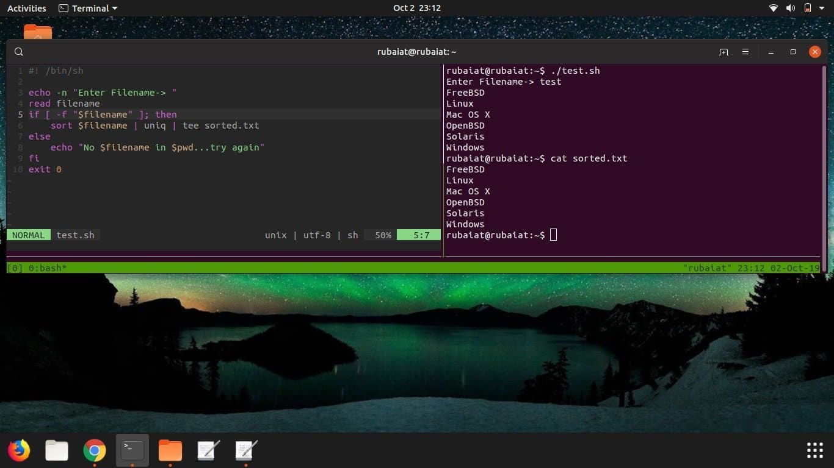

**40. System Maintenance**

I often use a little Linux shell script to upgrade my system instead of doing it manually. The below simple shell script will show you how to do this.

#!/bin/bash

echo -e "\n$(date "+%d-%m-%Y --- %T") --- Starting work\n"

apt-get update

apt-get -y upgrade

apt-get -y autoremove

apt-get autoclean

echo -e "\n$(date "+%T") \t Script Terminated"

The script also takes care of old packages that are no longer needed. You need to run this script using sudo else it will not work properly.

**Ending Thoughts**

Linux shell scripts can be as diverse as you can imagine. There’s literally no limit when it comes to determining what it can do or can’t. If you’re a new Linux enthusiast, we highly recommend you master these fundamental bash script examples. You should tweak them to understand how they work more clearly. We’ve tried our best to provide you with all the essential insights needed for modern Linux bash scripts. We’ve not touched on some technical matters due to the sake of simplicity. However, this guide should prove to be a great starting point for many of you.