**MONGO DB**

MongoDB is a source-available cross-platform document-oriented database program. Classified as a NoSQL database program, MongoDB uses JSON-like documents with optional schemas.

**Installation**

Before you start using MongoDB in Java programs, you need to make sure that you have MongoDB CLIENT and Java set up on the machine. Now, let us check how to set up MongoDB CLIENT.

* You need to download the jar mongodb-driver-3.11.2.jar and its dependency mongodb-driver-core-3.11.2.jar.. Make sure to download the latest release of these jar files.
* You need to include the downloaded jar files into your classpath.

## How to Download and Install MongoDB Compass

## Step 1 — Download the MongoDB MSI Installer Package

## 

## Step 2 — Install MongoDB with the Installation Wizard

## Make sure you are logged in as a user with Admin privileges. Then navigate to your downloads folder and double click on the .msi package you just downloaded. This will launch the installation wizard.

## Click Next to start installation.

## Accept the licence agreement then click Next.

## Select the Complete setup.

## Select “Run service as Network Service user” and make a note of the data directory, we’ll need this later.

## We won’t need Mongo Compass, so deselect it and click Next.

## Click Install to begin installation.

## Hit Finish to complete installation

## Step 3— Create the Data Folders to Store our Databases

## Navigate to the **C Drive** on your computer using Explorer and create a new folder called **data** here.

* Inside the data folder you just created, create another folder called db.

1. **Step 4** — Setup Alias Shortcuts for Mongo and Mongodb.

* Once installation is complete, we’ll need to set up MongoDB on the local system.
* Open up your Hyper terminal running Git Bash.
* Change directory to your home directory with the following command:

**The insert() Method**

To insert data into MongoDB collection, you need to use MongoDB's **insert()** or **save()** method.

Syntax

The basic syntax of **insert()** command is as follows −

>db. COLLECTION_NAME.insert(document).

**Eg:**

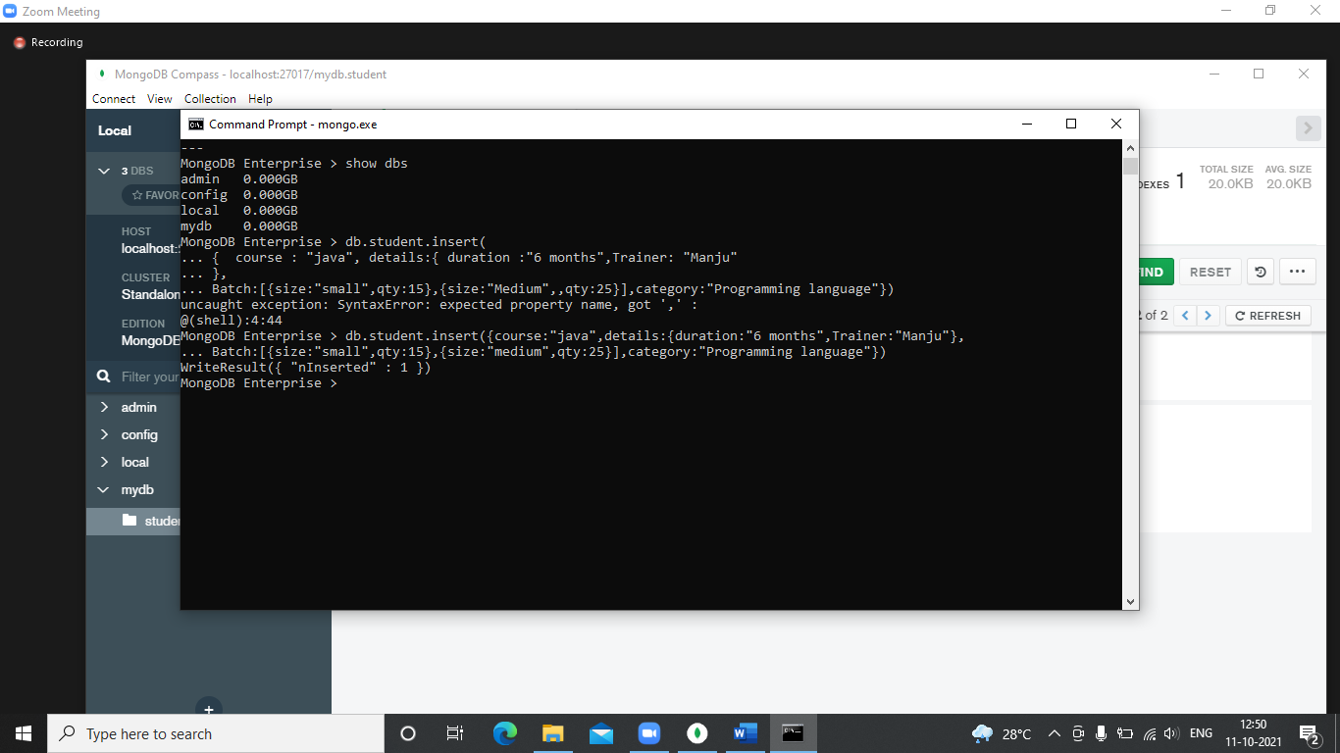

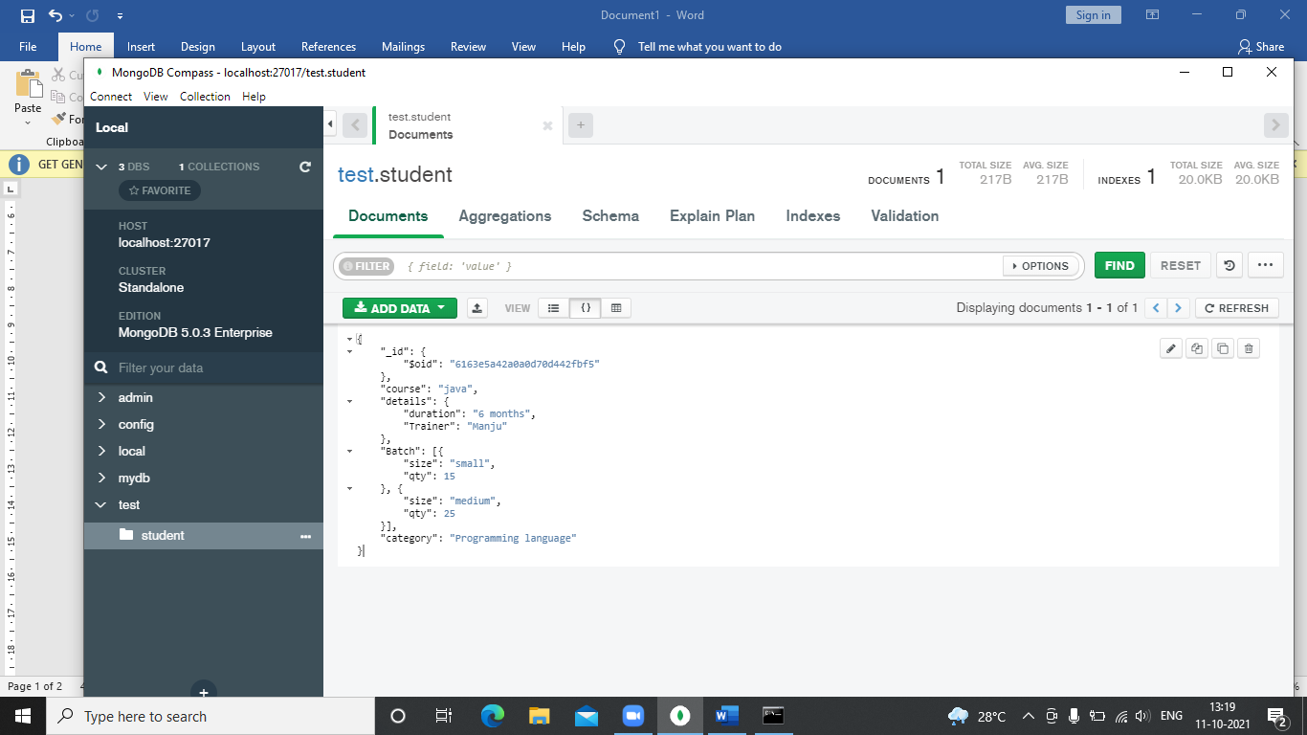

**Output**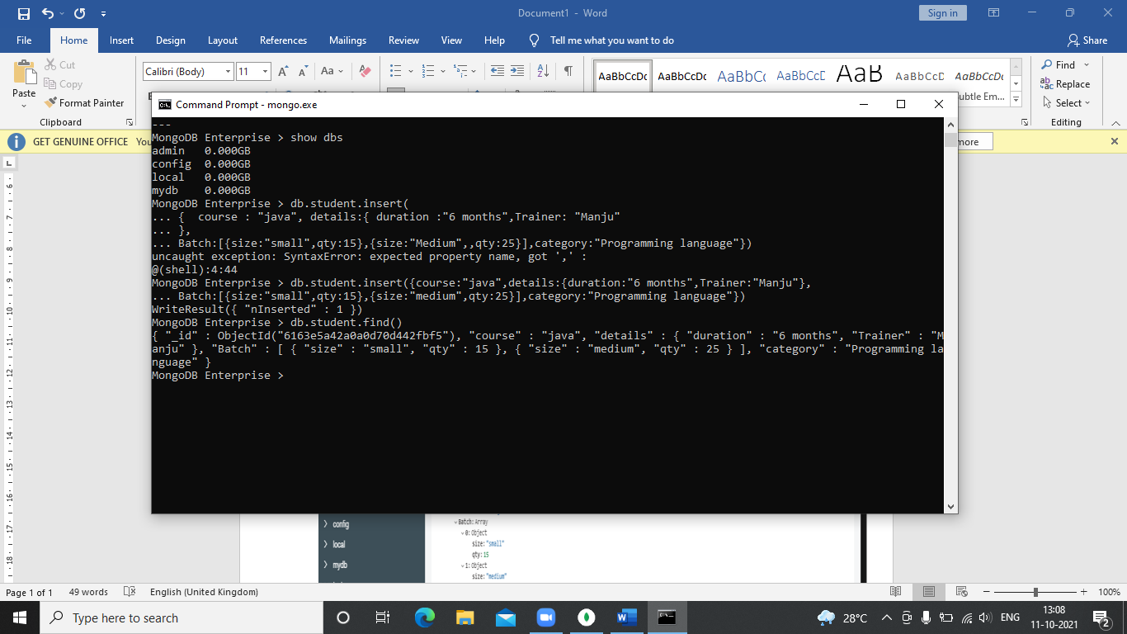

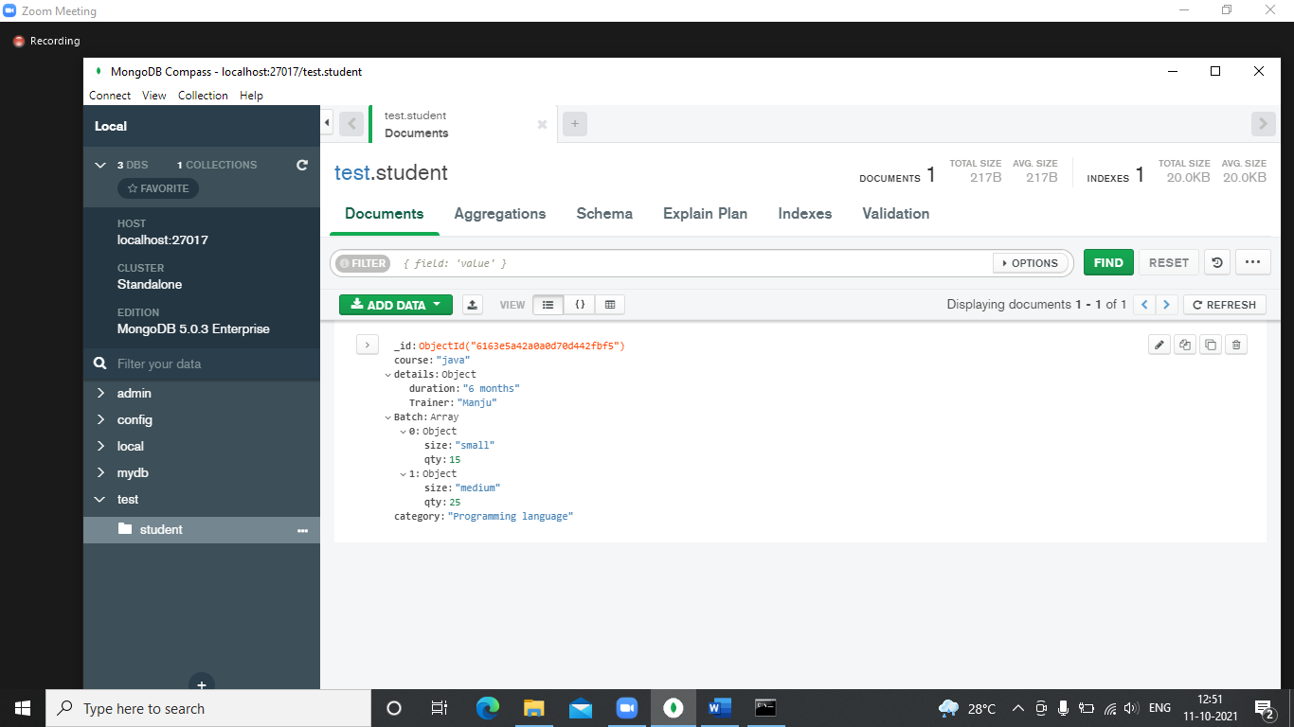

## The Update () Method

The **update()** method updates the values in the existing document.

Syntax

The basic syntax of **update ()** method is as follows −

>db. COLLECTION_NAME.update(SELECTION_CRITERIA, UPDATED_DATA)

**INPUT**

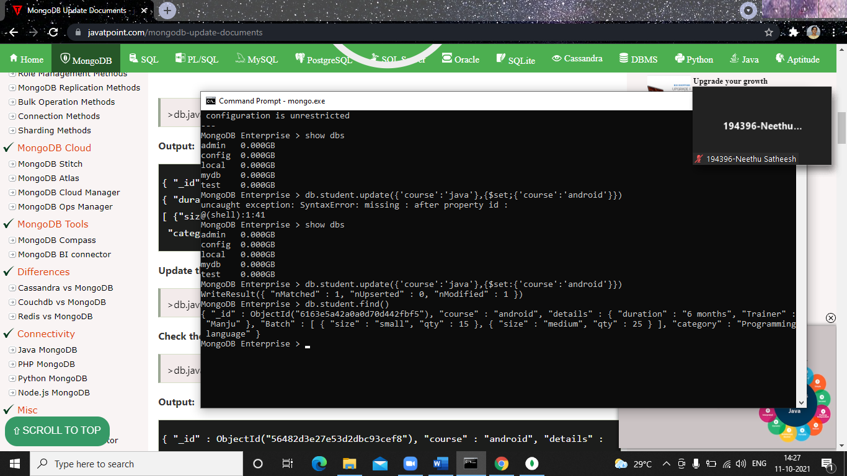

**OUTPUT**



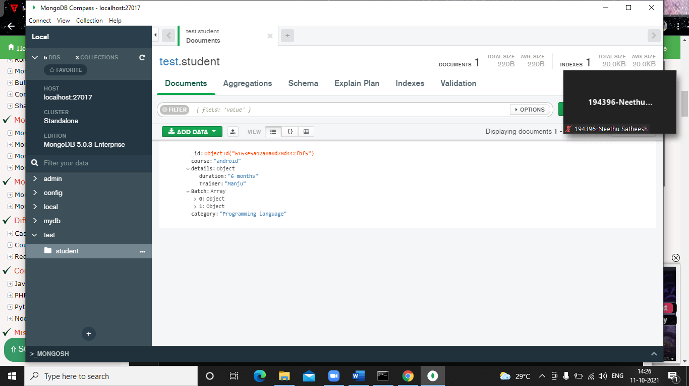

**The remove () Method**

MongoDB's **remove ()** method is used to remove a document from the collection. remove() method accepts two parameters. One is deletion criteria and second is justOne flag.

* **deletion criteria** − (Optional) deletion criteria according to documents will be removed.
* **justOne** − (Optional) if set to true or 1, then remove only one document.

Syntax

Basic syntax of **remove ()** method is as follows –

>db. COLLECTION_NAME.remove(DELLETION_CRITTERIA)



**Query documents**

The db.collection.find() method reads operations in mongoDB shell and retrieves documents containing all their fields.

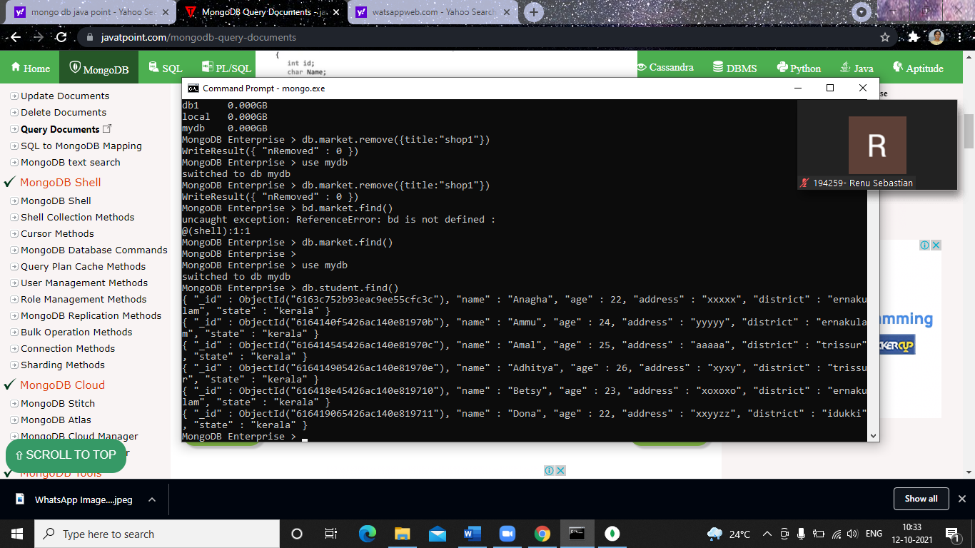

**The aggregate () Method**

For the aggregation in MongoDB, you should use **aggregate ()** method.

Syntax

Basic syntax of **aggregate ()** method is as follows −

>db. COLLECTION_NAME.aggregate(AGGREGATE_OPERATION)

### **$match**

### **The $match stage can use an index to filter documents if it occurs at the beginning of a pipeline.**

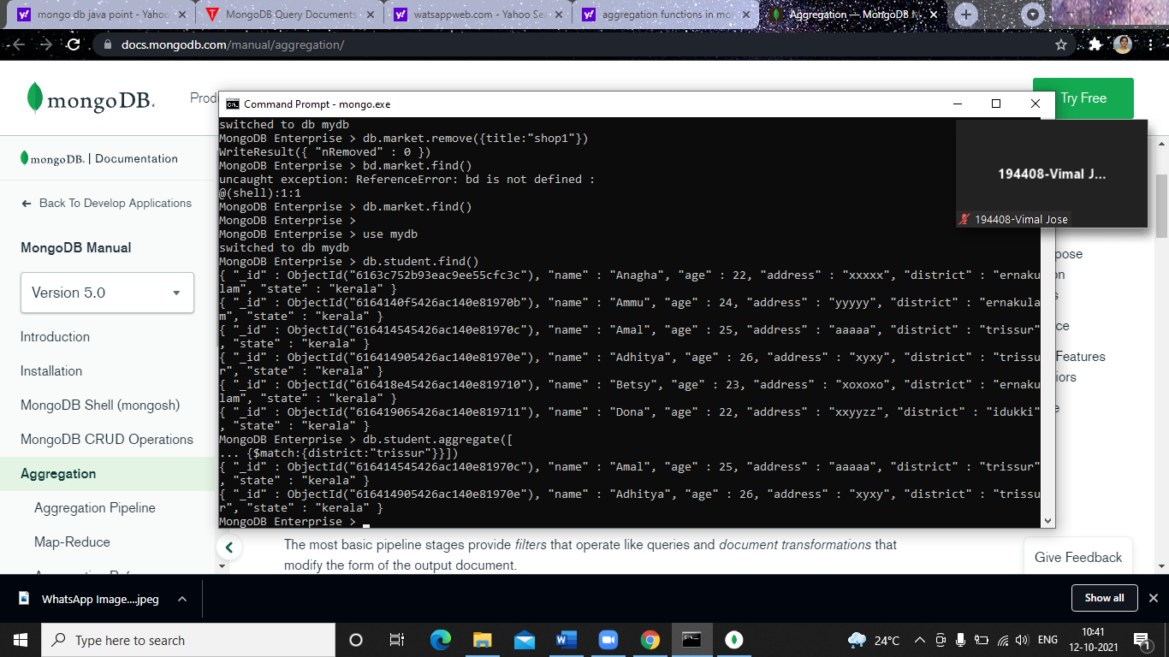

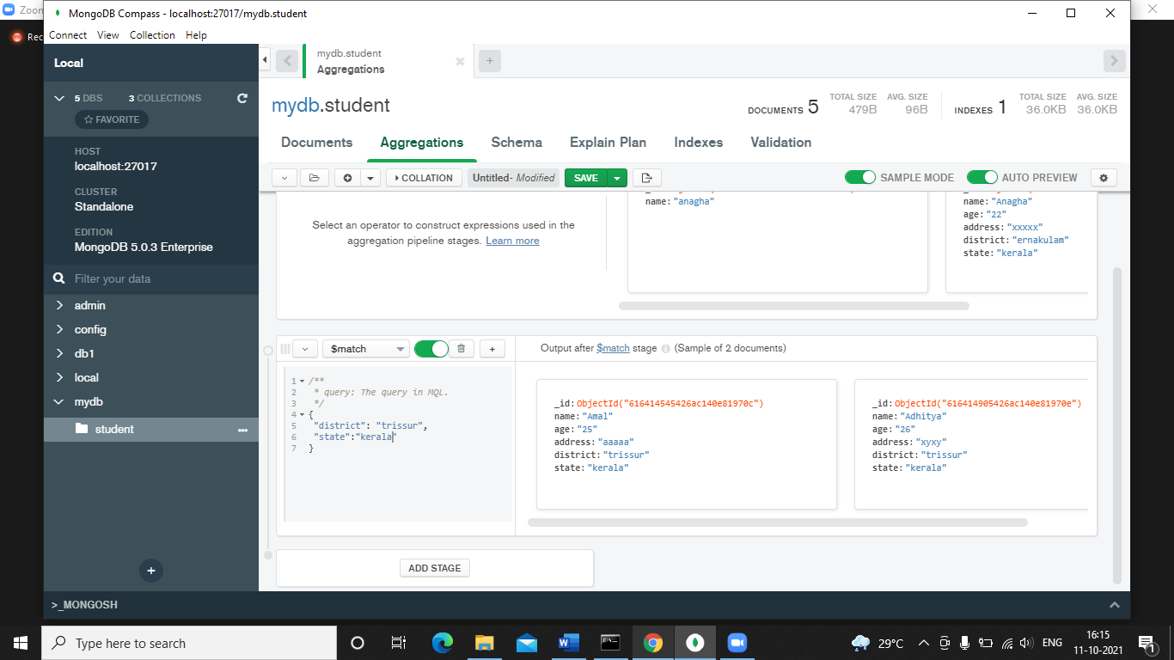

### **$sort**

### **The $sort stage can use an index as long as it is not preceded by a $project, $unwind, or $group stage.**

### **$group**

### **The $group stage can sometimes use an index to find the first document in each group if all of the following criteria are met:**

### **The $group stage is preceded by a $sort stage that sorts the field to group by,**

### **There is an index on the grouped field which matches the sort order and**

### **The only accumulator used in the $group stage is $first.**

