Design Document
For
Epidemic Early Warning System
Prepared by
Group C
Akshay Patil | apatil4@uic.edu
Aman Mahajan | amahaj3@uic.edu
Saket Bhat | sbhat6@uic.edu
Vimalkumar Patel | vpatel84@uic.edu

Table of Contents

1.System Wide View………………………………………………………………………………………………………………………………1
2.Use Case Diagram………………………………………………………………………………………………………………………………2
3.Activity Diagram…………………………………………………………………………………………………………………………………3
4 Sequence Diagram.………………………………………………………………………………………………………………………….…4
5.Class Diagram……..………………………………………………………………………………………………………………………………5
1.E-R Diagram………..………………………………………………………………………………………………………………………………6
1.Databases……………………………………………………………………………………………………………………………………………7

System Wide View

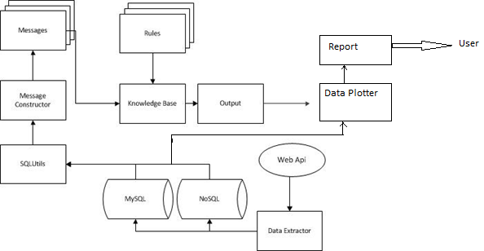
Figure 1 System Wide Diagram
Figure 1 shows how the server component of the system operates.
The data extractor gets data from weather stations reporting and archives of previous data, and updates the local databases.
The prediction system uses this collected data to form messages and fire rules to generate epidemic prediction output for every region the data is associated with under examination for early warning.
The reporting module uses the output generated by above process(which is stored in the database) to prepare the reports that can be published to the end users like health organizations and NGO’s.

Use Case Diagram

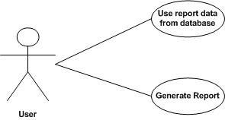
Figure 2 Use Case Diagrams

The role of user of the system i.e Health Organizations is as follows.
- Request for the list of available reports from the system.
- Download / View the report.
- Request th report in some format that suits their use.

Activity Diagram

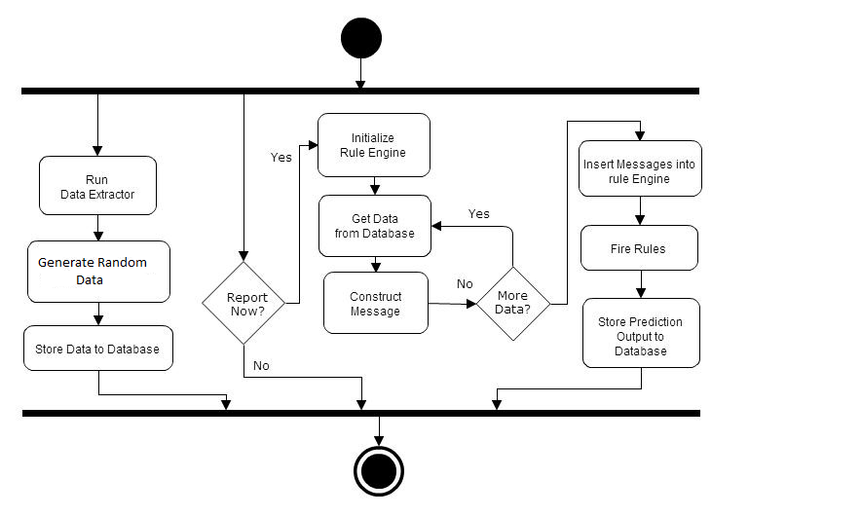
Figure 3 Activity Diagram
The system starts by spawning two processes. One of them is data extractor which loads data from various sources from the web, and stores in the database. The second is the report. It fetches data from relational and non-relational databases to construct messages. These messages are then passed on to the rule engine, which fires all the rules. Every time a message matches a rule, the probability of epidemic risk due to that matching rule is updated in the database. The collection of these updates constitutes the epidemic prediction report.

Sequence Diagram

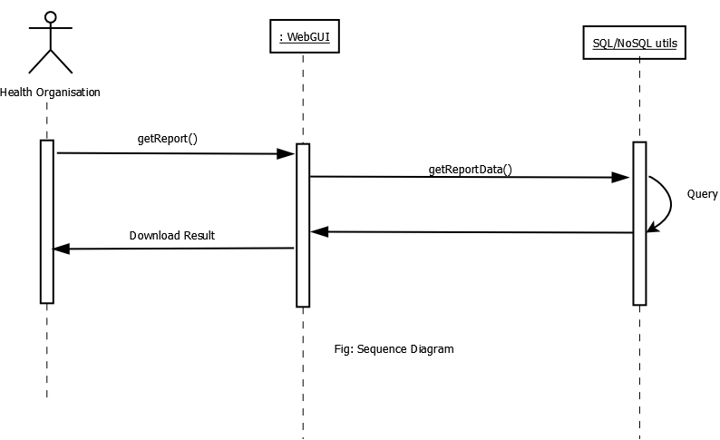
Figure 4 Sequence Diagram for Requesting Report List and downloading the reports
The external actor in this use case is a health organization or an NGO who are interested in the prediction for their particular regions. The actor logs onto the system using the web-GUI to view the available reports on the server.

Class Diagram

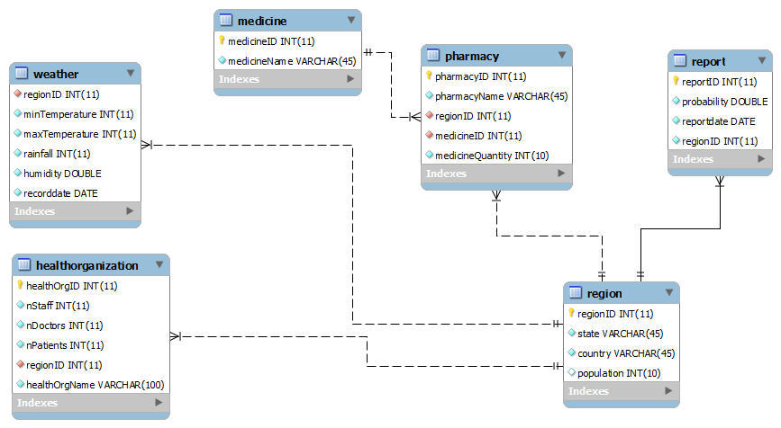
Figure 5 Class Diagram
The class diagram above shows the various classes used in Epidemic EWS. The various data members with their data types are shown in each method. The smallest region in the system is considered state of the country. Every state has health organizations and pharmacy stores and weather information for it is recorded. The diagram also describes the dependency and multiplicity relationships between each class.

Entity Relationship Diagram

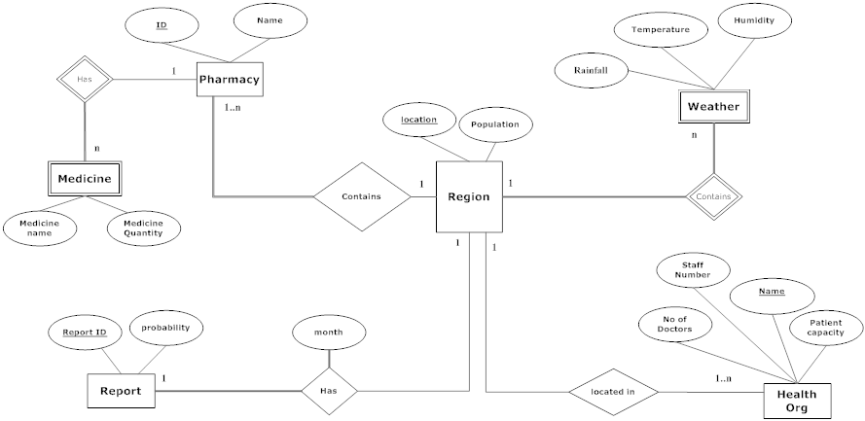
Figure 6 ER Diagram
Epidemic Early Warning System is used to predict the probability of an epidemic in a particular region by analyzing variables like rainfall, temperature statistics etc. Every region has a location name which uniquely identifies it and contains population statistics. Each region contains a number of pharmacies. For every pharmacy there is a name and a pharmacy id which uniquely identifies it. Each pharmacy contains different types of medicines. Medicine names and quantity are also recorded by the system. A large number of health organizations are located in a particular region. Each health organization contains doctors, staff, name and patient capacity. At the end of the month a report will be generated by the system which describes the probability of epidemic in a particular region. Every report is identified by its unique ID.

DATABASES
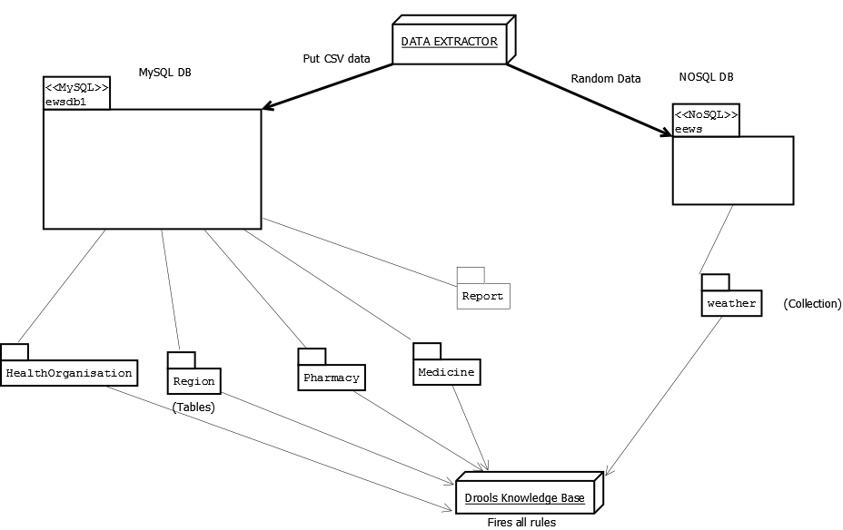

Above figure shows various databases and their tables and collection. The Data extractor as shown above generates and puts the data in the respective databases i.e MySQL and NoSQl.
The Drool Knowledge base fetches from tables and collection and fires the rules accordingly

