Software Requirements Specification

for

Epidemic Early Warning System

Version 1.0

Prepared by

|  |  |
| --- | --- |
| Akshay Patil | apatil4@uic.edu |
| Aman Mahajan | amahaj3@uic.edu |
| Saket Bhat | sbhat6@uic.edu |
| Vimalkumar Patel | vpatel84@uic.edu |

|  |  |
| --- | --- |
|  |  |
|  |  |
|  |  |
|  |  |
|  |  |

Contents

1 Introduction 1

1.1 Document Purpose 1

1.2 Product Scope 1

1.3 Intended Audience and Document Overview 1

1.4 References and Acknowledgments 1

2 Overall Description 2

2.1 Product Perspective 2

2.2 Product Functionality 2

2.3 Users and Characteristics 2

2.4 Operating Environment 2

2.5 Design and Implementation Constraints 3

2.6 User Documentation 3

2.7 Assumptions and Dependencies 3

3 Specific Requirements 4

3.1 External Interface Requirements 4

3.1.1 User Interfaces 4

3.1.2 Hardware Interfaces 4

3.1.3 Software Interfaces 4

3.1.4 Communications Interfaces 4

3.2 Functional Requirements 4

3.3 Behaviour Requirements 4

3.3.1 Use Case View 4

4 Other Non-functional Requirements 5

4.1 Performance Requirements 5

4.2 Safety and Security Requirements 5

4.3 Software Quality Attributes 5

Revisions

| Version | Primary Author(s) | Description of Version | Date Completed |
| --- | --- | --- | --- |
| 1.0 | Akshay Patil  Aman Mahajan  Saket Bhat  Vimalkumar Patel | Initial Draft | 09/21/2012 |

# Introduction

Every epidemic outbreak causes social and economic losses to a human society. Our project entitled “Epidemic Early Warning System” attempts to predict the probability of an epidemic in a particular country by analyzing variables like rainfall statistics, temperature, population etc. The following section describes the purpose and the scope of our project.

## Document Purpose

This document describes the requirements for Epidemic EWS. It identifies the functional requirements of the system along with various components and is intended for developers and users.

## Product Scope

In third world countries even small number of medical cases could take a face of an epidemic outbreak. As we all know “Prevention is better than cure!”, In such countries where medical facilities are not up to the mark and post epidemic outbreak are difficult to handle, an early warning system could come to the rescue.

The project is a rule based application which tries to predict the possibility of an epidemic based on various factors.

## Intended Audience and Document Overview

This document is intended for reference by developers, testers and users of the Epidemic EWS.

## References and Acknowledgments

[1] Andrew K. Githeko, and William Ndegwa, Predicting malaria epidemics in the Kenyan Highlands using climate data: a tool for decision makers, Global Change and Human Health, Volume 2, 2001.

# Overall Description

## Product Perspective

The Epidemic Early Warning System is a novel piece of software designed to output precursor to epidemic outbreaks. It does so by analyzing statistical data of past and current and calculates the possibility of outbreak of certain pandemic disease.

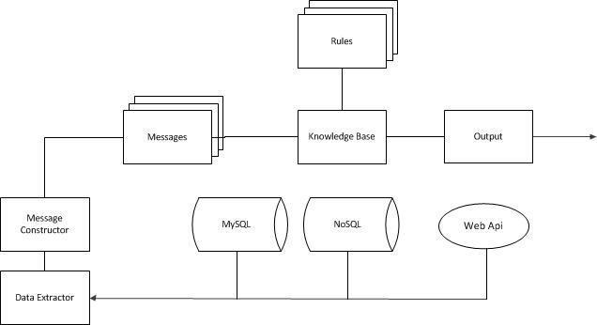

## Product Functionality

The system provides a report of an early warning for an epidemic in a country.

## Users and Characteristics

The system will be frequently used by end users to read generated reports of early warnings. Medical Agencies, officials of government agencies etc. constitute the end users.

## Operating Environment

The system requires at least an Intel i3 processor with minimum 2GB RAM and an internet connection with a bandwidth of 1Mbps or more. The system uses MySQL and MongoDB for relational and nosql database respectively. The system is built with the help of and uses Java Runtime Library and Drools library.

## Design and Implementation Constraints

There are some issues in the implementation of the Epidemic Early Warning System as mentioned below.

1. The implementation has to be done using open source software available, which causes the developer to use some workarounds for the desired features available only in commercial software.
2. The implementation of Data Extraction module needs to be on the lookout of any change in the API’s as well as the format of data provided by third parties.
3. All the documentation and support is to be provided in English only.

## User Documentation

The Epidemic Early Warning System will be delivered in form of a zip file containing the deliverable binaries and readme.txt file for user. The readme.txt will contain instruction on configuring and setup to get the system started.

## Assumptions and Dependencies

There are some assumptions which need to be considered.

1. As a beginning point, Epidemic Early Warning System is implemented to predict epidemic outbreak caused by mosquito as carrier/vector of the disease.
2. There are other factors that come into play like rainfall, temperature fluctuation, humidity, population of a region etc., will be incorporated into implementation as and when the kind of data is present and as required.

# Specific Requirements

## External Interface Requirements

### User Interfaces

The user interface of Epidemic EWS will enable to view reports generated by it.

### Hardware Interfaces

The system does not have any special hardware interface.

### Software Interfaces

The system runs on top of Java Virtual Machine and uses Drools library. It connects to MySQL and MongoDB databases to carry out tasks and generate reports. The Data Extraction module helps the system to feed data from the web into the database

### Communications Interfaces

The data from the web will be fetched using http requests and using custom API.

## Functional Requirements

The system needs to gather statistical data on various factors from the web. It generates early warning of epidemic on a monthly or yearly basis.

## Behaviour Requirements

### Use Case View

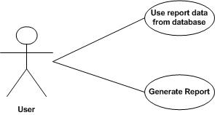

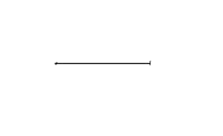

The user of the system can generate reports from the data in the database and publish the report in various formats.

# Other Non-functional Requirements

## Performance Requirements

Although Epidemic Early Warning System is not a real time system it cannot be assumed that performance cannot be an impediment for the project release. The data extractor has to be efficient in processing all the API’s, XML or CSV files and non-formatted data. Also, the databases have to be fine-tuned and configured to work at its best performance. This is important when the data size grows and requires big data / NoSQL databases for storing the data pulled from various sources. The rule engine to be selected for implementation must already implement Rete algorithm especially designed to work with data flows.

## Safety and Security Requirements

The software does not come with any guarantee or authenticity of data. It depends on the data collected from the various sources on past experience and predicts the epidemic. The software will undergo load testing with Apache JMeter and is very safe to use.

## Software Quality Attributes

Anyone using the software should be rest assured about its correctness. The usability of the software is taken care of and constant changes are made so that it becomes more user-friendly. It is platform independent and can work in any type of operating system supporting Java 7.