Testing Document

For

Epidemic Early Warning System

Prepared by

Group C

|  |  |
| --- | --- |
| Akshay Patil | [apatil4@uic.edu](mailto:apatil4@uic.edu) |
| Aman Mahajan | [amahaj3@uic.edu](mailto:amahaj3@uic.edu) |
| Saket Bhat | [sbhat6@uic.edu](mailto:sbhat6@uic.edu) |
| Vimalkumar Patel | [vpatel84@uic.edu](mailto:vpatel84@uic.edu) |

# Testing background Information:

The web app to be tested has a simple servlet in the background that accepts regionID and date to returns a JSON Document containing randomized Weather information.

The URL to access this Servlet is: <http://localhost:8080/EEWS_weatherWebApp/RandomWeather>

The input parameters are as follows:

1. Recorddate,
2. regionID

Such that a sample URL would look like following: <http://localhost:8080/EEWS_weatherWebApp/RandomWeather?regionID=46&recorddate=2007-7-13>

For the above sample request, a sample response would look like following:

**{'_id':'46_2007-7-13','regionID':'46','recorddate':'2007-7-13','minTemperature':'248','maxTemperature':'58','rainfall':'50','humidity':'54'}**

# Automated Testing Tools:

We are using Jmeter to load test the Random Data generation web app of our project.

The JMX plan constructed for the sam consists of ThreadGroups of 10 ramp ups.

Each ramping thread is a user that generates 100 requests to the web app each.

Hence our total requests in 10 seconds are 1000.

Please see on the next page some screen shots of our testing efforts using JMeter.

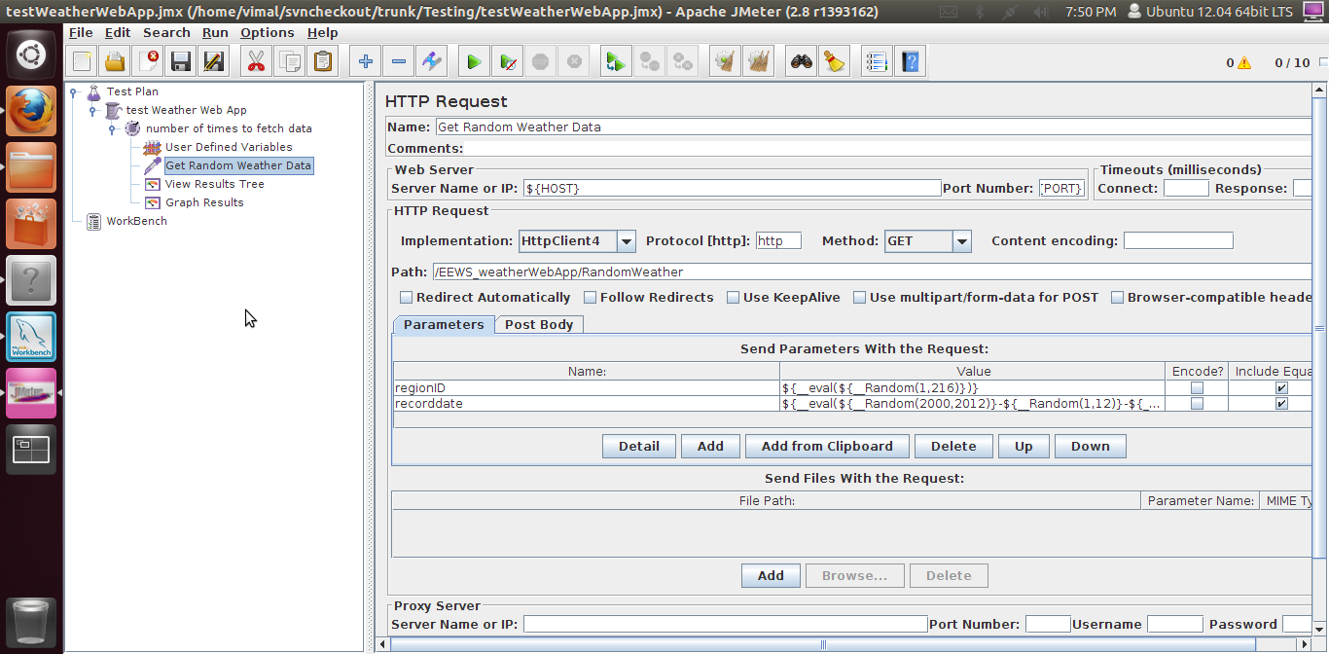

Fig1: ScreenShot showing all the settings required for HTTP Request sampler.

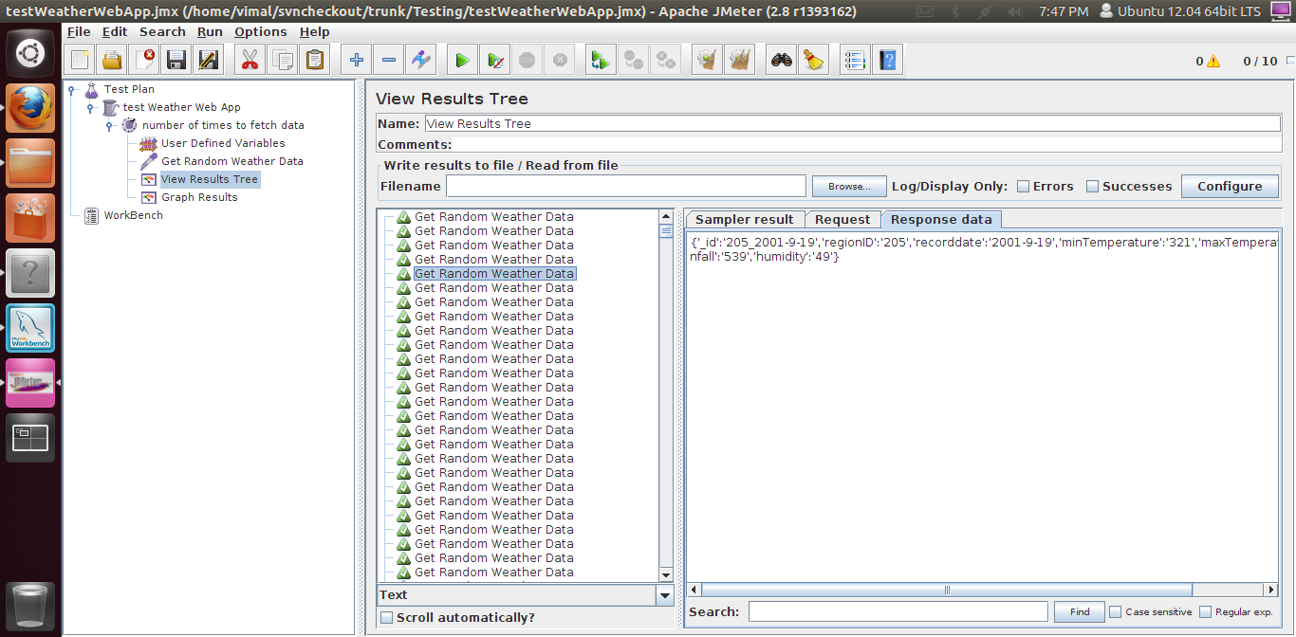

Fig 2: ScreenShot showing the results of the 1000 request responses during load testing.

# Load Testing:

To Load test the web app, 1000 users were simulated, ramping up at rate of 100 users per second.

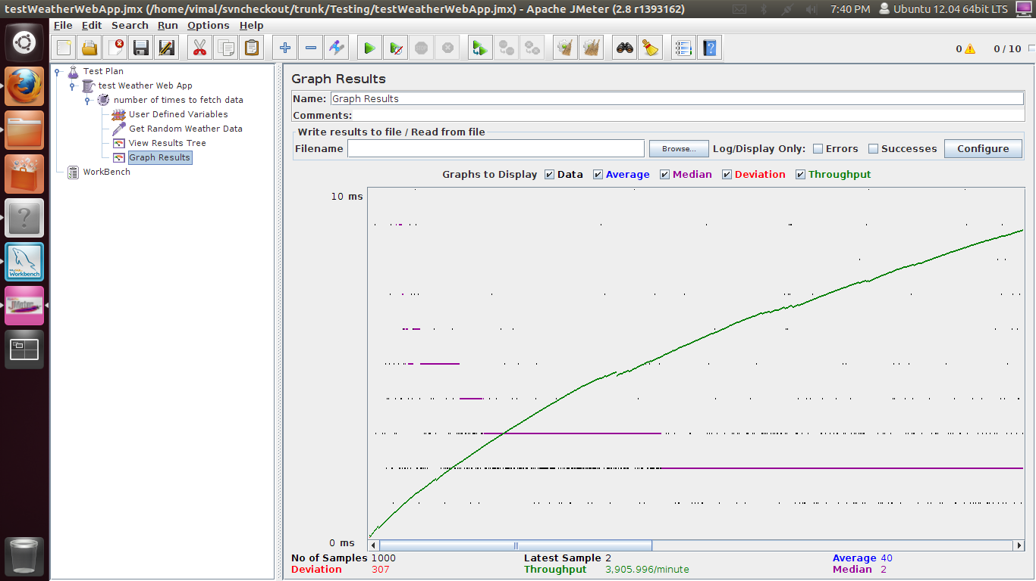

Fig 3: ScreenShot showing Throughput graph of the load testing.

# Initial Result of Load testing:

|  |  |
| --- | --- |
| **Parameters for evaluation** | **Value** |
| No of Samples | 1000 |
| Deviation | 307 |
| Error | 0.00% |
| Throughput | 97.9 per second |
| Avg Bytes per request/response | 312.4 |