SMART TASK AND TEAM MANAGEMENT SYSTEM USING PYTHON

PROJECT REPORT
Submitted by

MARI MURUGAN RAJESH M | -952322104031
PUMANI KARTHIK S | -952322104306
SANTHOSH LAXMANAN N | -952322104045
VIMAL RAJ V | -952322104054

In partial fulfillment for the award of the degree
of
BACHELOR OF ENGINEERING
IN
COMPUTER SCIENCE AND ENGINEERING


PSN ENGINEERING COLLEGE, TIRUNELVELI ANNA UNIVERSITY :: CHENNAI – 600 025 APRIL/MAY-2026

ANNA UNIVERSITY :: CHENNAI 600 025 BONAFIDE CERTIFICATE

Certified that this Project Report titled “SMART TASK AND TEAM MANAGEMENT SYSTEM USING PYTHON” is the bonafide work of VIMAL RAJ V (952322104054), SANTHOSH LAXMANAN N (952322104045), MARI MURUGAN RAJESH M (952322104031) and
PUMANI KARTHICK S (952322104306) who carried out the work under my supervision.

SIGNATURE SIGNATURE
Mr.K.PUNGARAJAN, B.E,M.E., Mr. K. PUNGARAJAN, B.E, M.E., HEAD OF DEPARTMENT SUPERVISOR

ASSISTANT PROFESSOR

Computer Science and Engineering Computer Science and Engineering PSN Engineering College PSN Engineering College
Tirunelveli -627 152 Tirunelveli -627 152

Submitted for the project Viva–voce examination held on

INTERNAL EXAMINER EXTERNAL EXAMINER

ACKNOWLEDGEMENT

I express my sincere and Heart full thanks to our Honorable Chairman
Dr.P.SUYAMBU, Ph.D. PSN Group of Institutions.
I am very much indebted to principal, Dr. M.S. RAVIKUMAR, Ph.D.
PSN Engineering college, Melathediyoor, Tirunelveli.
I express my extreme gratefulness to our Director, Dr. N. PRABHU, M.E, Ph.D, M.I.S.T.E,M.I.E PSN Engineering college, Melathidiyoor, Tirunelveli for providing me the kindly advise.
I record my sincere thanks to Mr.K.PUNGARAJAN, B.E,M.E.,Head of the Department, Department of Computer Science Engineering, PSN Engineering college, Melathediyoor, Tirunelveli, for allowing me to use the facilities in the college.
I express my sincere thanks to my guide Mr. K. PUNGARAJAN B.E, M.E., Assistant professor, Department of Computer Science Engineering, PSN Engineering college, Melathediyoor, Tirunelveli, for her encouragement and
valuable guidance
I extend my heartful thanks to all my staff members and friends those who are contributed moral support and encouragement to do this work. I also thanks all those who have directly or indirectly helped for the successful completion of this project work.

ABSTRACT

In the modern digital era, effective task and team management has become a critical requirement for organizations, institutions, and individuals to achieve productivity and efficiency. Traditional methods such as manual record keeping, spreadsheets, and basic applications often lack automation, proper coordination, and real-time tracking capabilities. These limitations lead to issues such as missed deadlines, poor communication, data inconsistency, and inefficient workload management. To address these challenges, this project proposes a Smart Task and Team Management System developed using Python.
The proposed system provides a centralized and user-friendly platform for managing tasks and coordinating team activities. It allows users to create, assign, update, and monitor tasks in a structured manner. The system supports multiple users with role-based access, enabling efficient distribution of responsibilities among team members. Features such as task prioritization, deadline management, and status tracking help ensure that tasks are completed within the given time frame.
One of the key aspects of the system is real-time collaboration, where users can access and update task information instantly. This improves communication within teams and reduces misunderstandings. The system also includes automated notifications and reminders, which help users stay informed about upcoming deadlines and pending tasks, thereby improving time management.
In addition, the system incorporates data visualization techniques to present task-related data in the form of charts, graphs, and dashboards. These visual representations enable users and managers to quickly analyze performance, identify trends, and detect delays or bottlenecks in the workflow. The use of structured data storage ensures data consistency, reliability, and easy retrieval of information.

CHAPTER 1 INTRODUCTION

  - INTRODUCTION
In the modern digital era, the efficient management of tasks has become a critical requirement for individuals, students, professionals, and organizations. With the increasing complexity of daily activities and workloads, traditional methods such as maintaining handwritten notes, diaries, or simple reminder applications are no longer sufficient. These methods often lead to disorganization, missed deadlines, and reduced productivity.
A Smart Task and Management System is designed to address these challenges by providing an intelligent and automated platform for organizing and tracking tasks. This system leverages the capabilities of the Python programming language to develop a flexible, scalable, and user-friendly solution. Python is widely used due to its simplicity, readability, and extensive support for libraries and frameworks.
The proposed system enables users to efficiently manage their tasks by allowing them to create, update, delete, and monitor tasks in real time. It also supports advanced features such as priority setting, deadline tracking, status updates, and reminders. These features help users stay organized and ensure that important tasks are completed on time.
The system is designed to minimize manual effort and maximize productivity. By automating routine processes, it reduces human errors and enhances efficiency. Additionally, the system can be integrated with graphical user interfaces (GUI) or web-based platforms, making it accessible across multiple devices.
Overall, the Smart Task and Management System aims to provide a reliable and effective solution for managing tasks in a structured and intelligent manner.

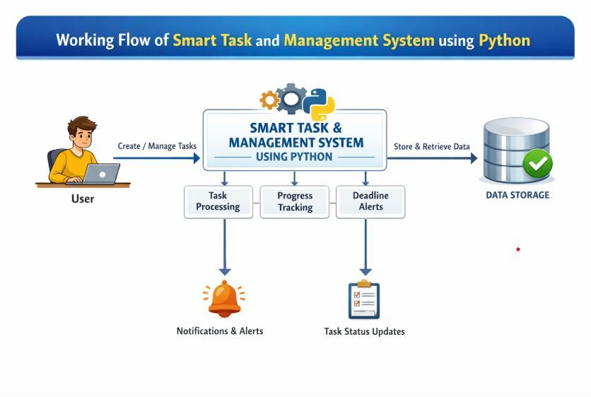

Figure 1.1 : Working Flow Smart Task and Management System Using Python

BACKGROUND OF THE STUDY
Task management has always been an essential part of human life, whether in personal activities, academic work, or professional environments. In earlier times, individuals relied heavily on traditional methods such as handwritten notes, paper-based planners, diaries, and wall calendars to organize their daily tasks. While these methods were simple and accessible, they lacked efficiency, flexibility, and scalability. Managing multiple tasks using manual systems often resulted in confusion, missed deadlines, and reduced productivity.
With the advancement of digital technology, task management has evolved significantly. The introduction of computers and mobile devices led to the development of digital task management tools. Applications such as to-do lists, reminder apps, and scheduling software improved the way people organize their work. These systems provided better accessibility, allowing users to manage tasks

anytime and anywhere. However, many of these tools are either too basic, lacking advanced features, or too complex for everyday users.
In recent years, there has been a growing demand for smart systems that not only store tasks but also assist users in managing them intelligently. A smart task management system integrates features such as automation, priority handling, deadline tracking, and notifications. These systems aim to reduce human effort and improve efficiency by providing timely alerts and structured organization of tasks.
Python has emerged as one of the most popular programming languages for developing such systems due to its simplicity, readability, and powerful ecosystem. It supports various libraries and frameworks that enable rapid development of applications, including graphical user interfaces (GUI), web applications, and database integration. This makes Python an ideal choice for building a smart and scalable task management system.
Despite the availability of many task management applications, there are still limitations such as lack of customization, dependency on internet connectivity, and complex user interfaces. Many users prefer a system that is simple, efficient, and tailored to their specific needs. This creates a need for a customized solution that balances usability and functionality.
The Smart Task and Management System developed in this project aims to address these issues by providing a user-friendly and efficient platform. It focuses on simplifying task management while incorporating essential features such as task tracking, prioritization, and reminders. The system is designed to be flexible and scalable, making it suitable for various users, including students, professionals, and small organizations.
Furthermore, the increasing importance of productivity and time management in today’s competitive environment highlights the need for such systems. Efficient task management not only improves individual performance but also enhances organizational efficiency. By leveraging modern technologies, this project contributes to the development of a practical solution for managing tasks effectively.

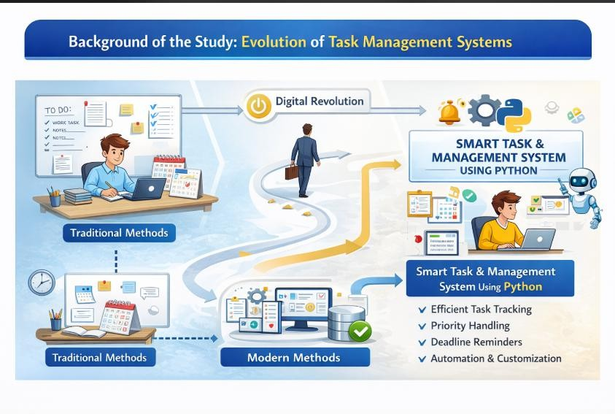
Figure 1.2 : Background of the Study: Evolution of Task Management System

PROBLEM STATEMENT
In today’s fast-paced environment, managing tasks efficiently has become increasingly challenging for individuals and organizations. Many people struggle to organize their daily activities due to the growing number of responsibilities and time constraints. Traditional methods such as handwritten notes, diaries, and basic reminder tools are still widely used, but they lack efficiency, flexibility, and reliability.
One of the major problems faced by users is the inability to properly prioritize tasks. Without a structured system, important tasks may be overlooked while less critical tasks consume more time. This leads to poor time management and decreased productivity. Additionally, tracking the progress of tasks manually is difficult and often results in confusion and duplication of work.
Another significant issue is missing deadlines. Many users rely on memory or simple reminders, which are not always effective. The absence of an intelligent notification system increases the risk of forgetting important tasks, leading to delays and reduced performance.

Existing digital task management tools, although helpful, come with their own limitations. Some applications are too complex for everyday users, requiring technical knowledge to operate. Others lack customization features, making them unsuitable for different user needs. Many systems also depend heavily on internet connectivity, limiting their usability in offline environments.
Furthermore, there is a lack of integration between task creation, tracking, and notification systems in many existing solutions. This results in fragmented workflows and inefficient task handling. Users often need to switch between multiple applications, which reduces efficiency and increases the chances of errors.
Security and data management also pose challenges. Many free tools do not provide secure data storage, leading to concerns about privacy and data loss. Additionally, users may find it difficult to retrieve or update stored tasks efficiently.
Considering these challenges, there is a need for a smart, efficient, and user-friendly task management system that can simplify task handling, improve productivity, and ensure better time management. The system should provide features such as task prioritization, deadline tracking, automated reminders, and an intuitive interface.
The proposed Smart Task and Management System using Python aims to address these issues by providing a centralized platform for managing tasks effectively. It focuses on reducing manual effort, minimizing errors, and enhancing overall efficiency through automation and structured task organization.

PROPOSED SOLUTION
To overcome the limitations of traditional and existing task management methods, this project proposes the development of a Smart Task and Management System using Python. The goal of this system is to provide an efficient, reliable, and user-friendly platform for managing tasks effectively.
The proposed system acts as a centralized platform where users can organize and manage their tasks in a structured manner. It allows users to create, update, delete, and monitor tasks easily. Each task can be assigned specific details

such as title, description, priority level, and deadline, which helps in better organization and execution.
A key feature of the system is priority-based task management, where tasks are categorized into high, medium, and low priority. This enables users to focus on the most important tasks first, improving time management and productivity.
The system also includes a deadline tracking and reminder feature. Users can set deadlines for tasks, and the system provides timely alerts or notifications to ensure that tasks are completed on time. This reduces the chances of missing important deadlines.
Another important feature is task status tracking. The system allows users to monitor the progress of tasks by categorizing them as pending, in progress, or completed. This provides clear visibility of work status and helps in better planning.
The proposed system is designed with a simple and user-friendly interface, making it easy to use for individuals with basic technical knowledge. The interface ensures smooth interaction and efficient task handling.
From a technical perspective, the system is developed using Python due to its simplicity, flexibility, and powerful libraries. It can be integrated with databases such as SQLite or MySQL to store and manage task data securely. This ensures efficient data retrieval and management.
Additionally, the system can be implemented as a desktop application or a web-based application, making it accessible across different platforms. It can also support offline functionality, depending on the implementation.
The system is designed to be scalable and customizable, allowing future enhancements such as team collaboration, cloud integration, and advanced analytics. This makes the system adaptable to different user needs.
In conclusion, the proposed Smart Task and Management System provides an effective solution for task organization and management. It reduces manual effort, improves productivity, and ensures efficient handling of tasks through automation and structured design.

TASK MANAGEMENT SYSTEM OVERVIEW
A Task Management System is a software application designed to help users plan, organize, monitor, and complete tasks efficiently. It provides a structured environment where all tasks can be managed in a systematic manner, reducing confusion and improving productivity.
In both personal and professional environments, individuals are required to handle multiple tasks simultaneously. Without a proper system, it becomes difficult to keep track of responsibilities, deadlines, and priorities. A task management system solves this problem by offering a centralized platform where users can manage all their activities in one place.
The system enables users to create tasks by entering essential details such as task title, description, priority level, and deadline. These tasks are then stored in a database, allowing users to access and manage them at any time. The ability to update and delete tasks provides flexibility in handling changing requirements.
One of the important aspects of a task management system is task organization. Tasks can be categorized based on priority (high, medium, low) or status (pending, in progress, completed). This classification helps users focus on important tasks and manage their time effectively.
Another key feature is task tracking and monitoring. The system continuously tracks the progress of tasks and displays their current status. This allows users to evaluate their performance and ensure that tasks are completed within the specified time.
The system also supports reminders and notifications, which alert users about upcoming deadlines or pending tasks. This feature plays a crucial role in avoiding delays and improving task completion rates.
Modern task management systems are often designed with user-friendly interfaces, making them easy to use for individuals with different levels of technical knowledge. They may be implemented as desktop applications, web applications, or mobile applications, providing flexibility and accessibility.
In addition, task management systems can be integrated with databases for efficient data storage and retrieval. This ensures that all task-related information is securely stored and can be accessed whenever needed.

Overall, a Task Management System is an essential tool that enhances productivity, improves time management, and ensures better organization of tasks. By automating routine processes and providing structured task handling, it helps users achieve their goals more efficiently.

FEATURES OF THE SYSTEM
The Smart Task and Management System includes several key features:

Task Creation
Users can create tasks by entering details such as task name, description, priority, and deadline.

Task Updating
Existing tasks can be modified based on changing requirements.

Task Deletion
Users can remove tasks that are no longer needed.

Task Tracking
The system tracks the progress of tasks and displays their current status.

Reminder System
Notifications are provided to alert users about upcoming deadlines.

User Interface
A simple and interactive interface ensures ease of use.

BENEFITS OF THE SYSTEM

Increased Productivity
The system helps users focus on important tasks and complete them efficiently.

Better Time Management
Deadlines and reminders ensure that tasks are completed on time.

Improved Organization
Tasks are stored in a structured manner, making them easy to manage.

Reduced Errors
Automation minimizes human errors in task handling.

Flexibility
The system can be customized based on user requirements.

APPLICATIONS OF THE SYSTEM
The Smart Task and Management System can be used in various domains:
- Education – Managing assignments, project submissions, exam schedules, and study plans efficiently.
- Business – Tracking projects, managing employee tasks, and ensuring timely completion of work.
- Personal Use – Organizing daily activities, setting reminders, and achieving personal goals.
- Healthcare – Scheduling appointments, managing patient-related tasks, and organizing medical workflows.
- IT Industry – Managing software development tasks, bug tracking, and project deadlines.
- Project Management – Dividing large projects into smaller tasks and monitoring progress effectively.
- Team Collaboration – Assigning tasks to team members and tracking their performance in group work.
- Event Management – Planning and organizing events by managing schedules, resources, and tasks.
- Freelancing – Managing multiple clients, deadlines, and work schedules efficiently.
- Time Management – Prioritizing tasks and improving productivity through structured planning.
- Startup Management – Helping small businesses organize operations and track progress.

- Remote Work Management – Supporting remote employees in managing tasks and deadlines effectively.
- Household Management – Organizing daily home activities such as shopping, bill payments, and chores.
- Research Work – Managing research tasks, deadlines, and documentation in academic or professional fields.

WORKING PRINCIPLE
The system operates through a series of steps:
- User Registration/Login – The user logs into the system using valid credentials to ensure secure access.
- Dashboard Access – After login, the user is directed to the dashboard where all tasks are displayed.
- Task Creation – The user creates tasks by entering details such as title, description, priority level, and deadline.
- Data Storage – All task details are stored securely in the database for future access and management.
- Task Categorization – Tasks are automatically organized based on priority (high, medium, low) and status (pending, in progress, completed).
- Task Assignment (Optional) – In multi-user systems, tasks can be assigned to different users or team members.
- Task Tracking – The system continuously tracks the progress of each task and updates its status.
- Reminder and Notification – Notifications or alerts are sent to users before deadlines to ensure timely completion of tasks.
- Task Updating – Users can modify task details such as deadlines, priorities, or descriptions as needed.
- Task Completion – Once a task is finished, the user marks it as completed in the system.

- Task Deletion – Unnecessary or completed tasks can be removed from the system if required.
- Data Retrieval – Users can view, search, and filter tasks based on different criteria such as date, priority, or status.
- Performance Monitoring – The system may provide insights into completed and pending tasks to help users improve productivity.

TECHNOLOGIES USED
The Smart Task and Management System is developed using modern technologies to ensure efficiency, scalability, and a user-friendly experience. The technologies used in this project are as follows:
- Python – Python is used as the core programming language for backend development. It is chosen for its simplicity, readability, and powerful libraries that support rapid application development.
- Flask – Flask is used as the backend web framework. It is a lightweight and flexible framework that helps in building RESTful APIs and handling server-side logic such as task creation, updating, deletion, and data processing.
- MySQL – MySQL is used as the database management system. It stores all task-related data such as task details, priorities, deadlines, and user information in a structured format, ensuring efficient data retrieval and security.
- HTML – HTML is used to design the basic structure of web pages in the frontend.
- CSS – CSS is used to style the user interface, making the application visually appealing and user-friendly.
- JavaScript – JavaScript is used to add interactivity to the frontend, enabling dynamic updates and smooth user interactions.
- ReactJS – ReactJS is used as the frontend library to build a responsive and interactive user interface. It allows efficient rendering of components and improves the overall performance of the application.

OBJECTIVES
The main objectives of this project are:
- To develop a smart task management system using Python
- To improve productivity and efficiency
- To provide a user-friendly interface
- To automate task tracking and reminders
- To ensure secure and structured data management

ADVANTAGES
The Smart Task and Management System offers several advantages that enhance productivity and efficiency in managing tasks. It is easy to use and provides a user-friendly interface, making it suitable for users with different levels of technical knowledge. The system saves time by automating task organization and reducing the need for manual tracking. It is highly efficient and helps users manage multiple tasks simultaneously without confusion.
The system improves task tracking by allowing users to monitor the status of tasks in real time. It also enhances productivity by organizing tasks based on priority and deadlines, ensuring that important tasks are completed on time. The reminder and notification features reduce the chances of missing deadlines, thereby improving time management.
Additionally, the system reduces workload by simplifying task handling and minimizing human errors. It provides structured data storage, making it easy to retrieve, update, and manage task information. The system is scalable and flexible, allowing future enhancements and customization based on user requirements.
Overall, the Smart Task and Management System improves workflow, supports better decision-making, and reduces dependency on traditional paper-based methods, making task management more effective and reliable.

LIMITATIONS
The Smart Task and Management System, while efficient and useful, has certain limitations that need to be considered. One of the primary limitations is that it requires basic technical knowledge to operate, especially during the initial setup and usage. Users who are not familiar with digital systems may take some time to understand and adapt to the application.
Another limitation is the dependency on system availability. Since the application is software-based, it requires a functioning device and, in some cases, internet connectivity to access all features. Any system failure, technical issues, or downtime may temporarily restrict access to the tasks.
Additionally, the current version of the system has limited features when compared to advanced enterprise-level task management tools. Features such as team collaboration, real-time synchronization, cloud storage, and advanced analytics may not be fully implemented in the initial version. This may restrict its usage in large-scale organizational environments.
The system may also face performance limitations when handling a large number of tasks or users, depending on the implementation and resources available. Security features may be basic in the initial version, which could require further enhancement for handling sensitive data.
Furthermore, the system may require regular maintenance and updates to fix bugs, improve performance, and add new features. Without proper updates, the system may become less efficient over time.
In conclusion, while the Smart Task and Management System provides an effective solution for task management, these limitations highlight the need for continuous improvement and future enhancements to make the system more robust, secure, and scalable.

FUTURE ENHANCEMENTS
The Smart Task and Management System can be further improved by incorporating several advanced features to enhance its functionality and usability. One of the key enhancements is the development of a mobile application, which will allow users to access and manage their tasks anytime and anywhere. This will increase the flexibility and accessibility of the system.

Another important improvement is the integration of artificial intelligence (AI) for smart task suggestions. AI can analyze user behavior, task history, and priorities to recommend tasks, set optimal deadlines, and improve overall productivity. This will make the system more intelligent and adaptive to user needs.
Cloud integration is also a significant enhancement that can be implemented. By storing data in the cloud, users can access their tasks from multiple devices without data loss. It also ensures better data security, backup, and synchronization across platforms.
In addition, the system can be enhanced by adding team collaboration features, allowing multiple users to work on shared tasks and projects. This will be beneficial for organizations and group-based work environments. Features such as task assignment, shared dashboards, and real-time updates can improve coordination among team members.
The inclusion of real-time notifications and alerts through email or mobile push notifications can further improve task tracking and deadline management. Advanced reporting and analytics features can also be added to provide insights into user performance, task completion rates, and productivity trends.
Furthermore, the system can be improved by implementing voice-based task management, enabling users to create and manage tasks using voice commands. Integration with third-party applications such as calendars and productivity tools can also enhance the overall functionality of the system.
In conclusion, these future enhancements will make the Smart Task and Management System more powerful, intelligent, and scalable. By incorporating modern technologies, the system can evolve into a comprehensive solution suitable for both individual and organizational use.

THESIS ORGANIZATION
The project report is organized as follows:
- Chapter 1: Introduction
- Chapter 2: Literature Review
- Chapter 3: Existing System
- Chapter 4: Proposed System
- Chapter 5: Results and Discussion
- Chapter 6: Conclusion
- Chapter 7: References

CHAPTER 2 LITERATURE REVIEW

2.1 INTRODUCTION
The rapid growth of digital collaboration has increased the need for efficient task and team management systems in both academic and professional environments. Traditional methods such as manual tracking or basic tools lack scalability, real-time collaboration, and intelligent decision-making capabilities. As a result, modern systems are being developed using advanced web technologies to enhance productivity and streamline workflow processes.
In recent years, task management platforms built using frameworks like Flask and front-end libraries such as React have gained popularity due to their flexibility, scalability, and ease of integration. These systems typically rely on databases like MySQL to manage structured data efficiently.
Existing research highlights the importance of features such as task prioritization, team collaboration, real-time updates, and performance tracking. Many studies also emphasize the integration of intelligent techniques like automation and Natural Language Processing to further enhance system usability and efficiency.
This literature review examines previous work and existing systems related to task and team management, identifies their limitations, and provides insights into how the proposed system can address these gaps using modern technologies like Python and web-based frameworks.
With the increasing reliance on digital platforms for project execution, organizations and academic institutions are adopting task and team management systems to improve coordination, transparency, and productivity. Earlier approaches to task management were mostly manual or used basic software tools, which lacked real-time collaboration, automation, and efficient tracking mechanisms. These limitations created the need for smarter, web-based solutions.
Modern task management systems are developed using technologies such as Python with lightweight frameworks like Flask for backend development. These frameworks allow developers to build scalable and efficient RESTful APIs that handle user requests, task assignments, and data processing. On the frontend,

libraries like React enable the creation of interactive and user-friendly interfaces, improving the overall user experience. For data storage, relational databases such as MySQL are widely used due to their reliability and structured data handling capabilities.
Several research studies and existing systems focus on key functionalities such as task scheduling, priority management, team collaboration, and progress monitoring. Some systems also integrate features like notifications, reporting dashboards, and role-based access control to enhance usability and security. Additionally, recent advancements highlight the use of intelligent techniques such as automation and concepts from Natural Language Processing to simplify task creation and improve communication between team members.
Despite these advancements, many existing systems face challenges such as limited scalability, lack of customization, poor user interface design, and insufficient real-time collaboration features. Some applications are also complex to use or require high system resources, making them less suitable for small teams or educational purposes.
Therefore, the proposed Smart Task and Team Management System aims to overcome these limitations by providing a lightweight, scalable, and user-friendly solution. By combining technologies like Flask for backend processing, React for frontend development, and MySQL for efficient data management, the system ensures better performance, flexibility, and ease of use.
This literature review provides a foundation for understanding current developments in task management systems and helps identify gaps that the proposed system intends to address.
In the modern digital era, effective task and team management has become a critical requirement for organizations, educational institutions, and software development teams. With the increasing complexity of projects and the need for real-time collaboration, traditional task management approaches such as manual scheduling, spreadsheets, and basic tools are no longer sufficient. These methods often lead to poor communication, lack of transparency, missed deadlines, and inefficient resource utilization.
To overcome these challenges, researchers and developers have introduced web-based task and team management systems that provide centralized platforms for organizing, assigning, and tracking tasks. These systems are designed to enhance collaboration among team members by offering features such as shared

workspaces, real-time updates, notifications, and performance monitoring. The evolution of such systems has been influenced by advancements in web technologies and software engineering practices.
Technologies like Python have played a significant role in developing scalable and efficient applications due to their simplicity and extensive library support. Frameworks such as Flask enable rapid backend development by providing lightweight structures for building RESTful services, handling HTTP requests, and integrating with databases. On the client side, modern JavaScript libraries like React are widely used to create dynamic, responsive, and interactive user interfaces that improve user engagement and usability.
For data management, relational database systems such as MySQL are commonly adopted to store structured information including user profiles, task details, team data, and activity logs. These databases ensure data integrity, consistency, and efficient retrieval, which are essential for the smooth functioning of management systems.
The literature indicates that many existing systems focus on key aspects such as task allocation, scheduling, collaboration, and tracking. Advanced systems also incorporate features like role-based access control, data visualization dashboards, automated reminders, and integration with third-party tools. Furthermore, emerging research explores the application of intelligent technologies, including Natural Language Processing and machine learning, to automate task creation, prioritize workloads, and enhance decision-making processes.
However, despite the availability of various tools and systems, several limitations still exist. Many applications are either too complex for small teams or lack customization options. Some systems fail to provide real-time updates, while others have poor user interface designs that reduce usability. Additionally, issues related to scalability, security, and performance remain significant concerns in existing solutions.
Considering these challenges, there is a strong need for a smart, efficient, and user-friendly task and team management system that can address these gaps. The proposed system aims to provide a simplified yet powerful platform by integrating modern technologies, ensuring better collaboration, improved productivity, and effective task management.

This extended literature review introduction sets the context for analyzing previous research works, identifying their strengths and limitations, and justifying the development of the proposed system.
In today’s fast-paced and technology-driven world, the successful completion of projects largely depends on efficient task management and seamless team collaboration. As organizations grow and projects become more complex, managing tasks manually or using conventional tools becomes increasingly difficult. Traditional approaches such as handwritten notes, spreadsheets, or standalone applications often result in poor coordination, lack of accountability, data redundancy, and increased chances of human error. These limitations highlight the necessity for advanced, automated systems that can effectively handle task allocation, monitoring, and team communication in a centralized environment.
Over the past decade, there has been a significant shift towards web-based and cloud-enabled task management systems. These systems provide users with the ability to access, update, and manage tasks from anywhere, thereby supporting remote work and distributed teams. The emergence of modern development technologies has played a crucial role in this transformation. Programming languages like Python have gained widespread adoption due to their simplicity, readability, and strong ecosystem. Backend frameworks such as Flask enable developers to build lightweight, scalable, and secure web applications that efficiently handle client requests, business logic, and database interactions.
On the frontend side, user experience has become a key factor in the success of any application. Libraries like React allow developers to create highly interactive and responsive user interfaces, making it easier for users to navigate the system, manage tasks, and collaborate with team members in real time. These interfaces support features such as dynamic dashboards, drag-and-drop task boards, and instant notifications, which enhance usability and engagement.
Data management is another critical component of task management systems. Relational database systems such as MySQL are widely used for storing and managing structured data, including user information, task details, deadlines, and activity logs. These databases ensure data consistency, integrity, and efficient retrieval, which are essential for maintaining system reliability and performance.

The existing body of literature reveals that many task and team management systems focus on functionalities such as task assignment, scheduling, progress tracking, and team communication. Some advanced systems incorporate additional features like role-based access control, analytics dashboards, automated notifications, and integration with third-party services. Furthermore, recent research trends emphasize the use of intelligent techniques such as Natural Language Processing and machine learning to enhance system capabilities. These technologies enable automation of repetitive tasks, intelligent task prioritization, and improved user interaction through features like chatbots and smart suggestions.
Despite these advancements, several challenges persist in existing systems. Many applications are either too complex for small teams or lack flexibility for customization according to user needs. Some systems suffer from performance issues when handling large datasets, while others do not provide effective real-time collaboration features. Additionally, concerns related to data security, privacy, and system scalability remain significant barriers to adoption. In some cases, poor user interface design and lack of intuitive navigation further reduce the effectiveness of these systems.
Therefore, there is a clear need for a smart, efficient, and user-friendly task and team management system that can overcome these limitations. The proposed system aims to address these gaps by leveraging modern web technologies to provide a scalable, secure, and easy-to-use platform. By integrating a Flask-based backend, a React-based frontend, and a MySQL database, the system ensures efficient task handling, real-time collaboration, and improved user experience.
This comprehensive introduction to the literature review establishes the background and context for analyzing existing research works. It also highlights the importance of developing an improved system that meets the evolving demands of modern teams and organizations, thereby justifying the need for the proposed solution.
In the contemporary digital landscape, effective task management and team coordination have become fundamental requirements for the successful execution of projects across various domains, including software development, education, business operations, and research. As organizations increasingly adopt agile methodologies and distributed work environments, the demand for efficient systems that can manage tasks, monitor progress, and facilitate collaboration has grown significantly. Traditional task management approaches, such as manual

record-keeping, email-based communication, and basic spreadsheet tools, are no longer adequate to handle the dynamic and complex nature of modern workflows. These conventional methods often lead to inefficiencies such as poor task visibility, lack of accountability, communication gaps, duplication of work, and missed deadlines.
To address these issues, researchers and developers have focused on building advanced task and team management systems that leverage modern web technologies. These systems provide centralized platforms where users can create, assign, prioritize, and track tasks in real time. The integration of such systems into organizational workflows has shown significant improvements in productivity, transparency, and overall project efficiency. The literature indicates that the evolution of these systems is closely linked with advancements in software development frameworks, database management systems, and user interface technologies.
Programming languages such as Python have emerged as a preferred choice for developing such systems due to their simplicity, flexibility, and extensive support for libraries and frameworks. In particular, backend frameworks like Flask provide a lightweight and modular approach to building web applications. Flask enables developers to design RESTful APIs, manage routing, handle user authentication, and integrate seamlessly with databases. Its minimalistic architecture allows for greater customization and scalability, making it suitable for both small-scale and enterprise-level applications.
On the frontend, the importance of creating intuitive and interactive user interfaces cannot be overstated. Modern JavaScript libraries such as React have revolutionized the way user interfaces are developed by enabling component-based architecture and efficient state management. React allows developers to build responsive and dynamic interfaces that enhance user experience through real-time updates, smooth navigation, and visually appealing dashboards. These capabilities are essential for task management systems, where users need quick access to information and seamless interaction with the platform.
For data storage and management, relational database systems like MySQL are widely adopted due to their robustness, reliability, and ability to handle structured data efficiently. These databases store critical information such as user credentials, task details, project timelines, team structures, and activity logs. Proper database design ensures data integrity, reduces redundancy, and supports efficient querying, which are crucial for maintaining system performance.

The review of existing literature reveals that most task and team management systems are designed with core functionalities such as task creation, assignment, scheduling, prioritization, and progress tracking. Many systems also include features like notification mechanisms, file sharing, collaborative workspaces, and reporting tools. Advanced systems go a step further by incorporating role-based access control, data visualization dashboards, and integration with third-party services such as calendars and communication platforms.
In recent years, there has been a growing interest in enhancing these systems with intelligent technologies. Concepts from Natural Language Processing and machine learning are being explored to automate repetitive tasks, provide smart recommendations, and improve user interaction. For example, NLP techniques can be used to interpret user inputs, generate task descriptions, and enable chatbot-based assistance, while machine learning algorithms can help in predicting task completion times and optimizing resource allocation.
Despite the significant progress made in this field, existing systems still face several limitations. Many applications are overly complex and require extensive training to use effectively, which can be a barrier for small teams or non-technical users. Some systems lack flexibility and customization options, making them unsuitable for diverse use cases. Additionally, performance issues may arise when handling large volumes of data or supporting a high number of concurrent users. Security and privacy concerns also remain critical, especially when sensitive organizational data is involved. Furthermore, not all systems provide efficient real-time collaboration features, which are essential in today’s remote and hybrid work environments.
Another important observation from the literature is the trade-off between functionality and usability. While some systems offer a wide range of features, they often compromise on user experience due to complex interfaces. Conversely, simpler systems may lack essential functionalities required for comprehensive task management. This gap highlights the need for a balanced solution that combines rich features with ease of use.
In light of these challenges, there is a clear need for the development of a smart, scalable, and user-friendly task and team management system. The proposed system aims to bridge the gaps identified in existing solutions by leveraging modern technologies and best practices in software development. By utilizing Flask for backend processing, React for frontend development, and

MySQL for data management, the system is designed to provide efficient performance, flexibility, and an enhanced user experience. Additionally, the system can be extended to incorporate intelligent features in the future, further improving its capabilities.
This detailed introduction to the literature review establishes a strong foundation for analyzing previous research works and existing systems. It highlights the evolution of task management technologies, identifies current trends and challenges, and justifies the need for the proposed system. The insights gained from this review will guide the design and implementation of a solution that effectively addresses the limitations of existing approaches while meeting the demands of modern users.

CHAPTER – 3 EXISTING SYSTEM

  - INTRODUCTION
The existing system for task and team management in many organizations is primarily based on manual methods or basic digital tools. Traditional approaches include maintaining task lists in notebooks, spreadsheets, or simple note-taking applications. While these methods are easy to use and widely accessible, they often lack efficiency, automation, and scalability when managing multiple tasks and teams simultaneously.
In manual systems, tasks are recorded on paper or basic files without any structured format. This leads to issues such as task duplication, difficulty in tracking progress, and lack of proper prioritization. Users may forget deadlines, miss important updates, or struggle to organize their workload effectively. Communication between team members is also limited, leading to misunderstandings and delays in project completion.
Digital tools like spreadsheets and basic applications provide some level of organization, but they still have significant limitations. These systems do not support real-time collaboration, automated reminders, or centralized task tracking. Additionally, there is no proper mechanism for assigning roles, monitoring team performance, or managing dependencies between tasks.
Furthermore, existing systems lack integration with modern technologies such as cloud storage, notifications, and intelligent tracking features. Security and data consistency are also concerns, especially when multiple users are involved. As a result, these systems are not suitable for dynamic environments where efficiency and collaboration are critical.
Moreover, scalability is a significant issue in existing systems. While manual or basic digital tools may work for small teams or individual use, they become inefficient when the number of users and tasks increases. Managing a large volume of tasks without automation becomes complex and time-consuming, leading to decreased efficiency and increased chances of errors.

The existing system also lacks proper reporting and analytics features. There is no effective way to generate reports on task completion rates, team performance, or project progress. Without these insights, it becomes difficult for managers to make informed decisions or identify areas that require improvement.
In addition, data security and backup are often overlooked in traditional systems. Important task-related data may be lost due to accidental deletion, system failure, or lack of proper storage mechanisms. This can result in significant setbacks, especially in critical projects where data integrity is essential.

Hence, the limitations of the existing system highlight the need for a more advanced, automated, and user-friendly task and team management solution.

BLOCK DIAGRAM OF EXISTING SYSTEM

Figure 3.1 Block Diagram of Existing System
In the existing system, task management follows a simple and unstructured workflow. The process begins with task creation, where users manually record tasks using notebooks, spreadsheets, or basic applications. These tasks are then stored locally without any centralized database or structured organization.
The next stage involves task assignment, which is often done manually through verbal communication, emails, or messages. This leads to a lack of clarity regarding responsibilities and deadlines. There is no proper system to track whether tasks are completed or pending.
Task tracking is limited, as users must manually update the status of each task. There are no automated reminders or notifications to ensure timely completion. Collaboration between team members is also inefficient, as there is no shared platform to monitor progress in real-time.
Finally, reporting and analysis are either absent or performed manually, making it difficult to evaluate performance or identify bottlenecks. Overall, the existing system lacks automation, structure, and real-time capabilities, reducing productivity and efficiency.

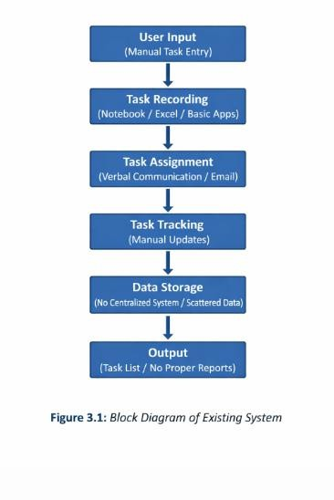

DATA VISUALIZATION
Data visualization is the graphical representation of data using visual elements such as charts, graphs, dashboards, and infographics. It plays a crucial role in transforming complex data into an easily understandable format, enabling users to quickly interpret information and make informed decisions. In task and team management systems, data visualization helps in tracking progress, analyzing performance, and identifying potential issues effectively.
In existing systems, data visualization is either very limited or completely absent. Most traditional methods rely on plain text, tables, or lists to represent task-related information. This makes it difficult for users to understand patterns, trends, or relationships within the data. For example, identifying overdue tasks or

analyzing team workload requires manual effort, which is both time-consuming and error-prone.
Although some digital tools like spreadsheets provide basic visualization features such as bar charts and pie charts, these are not dynamic in nature. Users must manually update the data to reflect changes, which reduces efficiency. Additionally, these visualizations are not integrated into a centralized system, making it difficult to access real-time insights.
Effective data visualization provides a clear overview of task distribution, project progress, and team performance. For instance, dashboards can display the number of completed, pending, and overdue tasks in graphical form. This allows managers and team members to quickly assess the status of the project without going through detailed reports.
Data visualization also supports better decision-making by highlighting key performance indicators (KPIs). It helps in identifying bottlenecks, workload imbalances, and areas that require attention. For example, a graph showing task completion rates over time can help in evaluating productivity and improving planning strategies.
Furthermore, visualization tools enhance communication within teams by presenting information in a clear and concise manner. Instead of relying on lengthy text-based reports, visual dashboards provide instant insights that can be easily understood by all team members, including non-technical users.
Another important aspect is real-time visualization, which is lacking in existing systems. Modern systems provide live updates through interactive dashboards, whereas traditional systems require manual refresh or updates. This limitation reduces the effectiveness of monitoring and delays response to critical issues.
In addition, advanced visualization techniques such as heat maps, Gantt charts, and progress bars are not available in existing systems. These tools are essential for tracking timelines, understanding task dependencies, and managing project schedules efficiently.
Overall, the lack of proper data visualization in the existing system reduces transparency, slows down decision-making, and affects overall productivity. This highlights the importance of integrating advanced and interactive visualization techniques in modern task and team management systems.

FEATURE EXTRACTION
Feature extraction is the process of identifying and selecting important attributes or characteristics from raw data that are useful for analysis and decision-making. In a task and team management system, feature extraction plays a significant role in organizing and interpreting task-related information such as task priority, deadlines, status, assigned users, and completion progress.
In existing systems, feature extraction is mostly performed manually by users. Tasks are created without any structured classification, and users must analyze each task individually to determine its importance and urgency. This manual approach increases the workload and often leads to inefficiencies, especially when dealing with a large number of tasks.
One of the key limitations of the existing system is the absence of automated feature identification. For example, the system does not automatically highlight overdue tasks, high-priority assignments, or tasks that require immediate attention. Users must manually review task lists to extract such information, which is time-consuming and prone to errors.
Additionally, there is no mechanism to categorize tasks based on different attributes such as priority level (high, medium, low), status (pending, in-progress, completed), or type (development, testing, documentation). This lack of categorization makes it difficult to filter and manage tasks effectively.
Feature extraction also involves identifying relationships between tasks, such as dependencies and sequences. In existing systems, these relationships are not clearly defined or visualized. As a result, users may not be aware of how one task affects another, leading to delays and poor planning.
Moreover, existing systems do not provide intelligent insights based on extracted features. For instance, there are no suggestions for task prioritization, workload balancing, or deadline management. Advanced systems use automated feature extraction to generate insights and recommendations, but such capabilities are missing in traditional approaches.
Another important aspect is the inability to analyze historical data. Feature extraction can be used to identify patterns and trends in past tasks, such as average completion time or frequently delayed tasks. However, existing systems do not support such analysis, limiting their usefulness in improving future performance.

Furthermore, the lack of automation in feature extraction affects overall productivity. Users spend more time organizing and analyzing tasks rather than focusing on actual work. This reduces efficiency and increases the chances of missing critical tasks.
In conclusion, feature extraction in the existing system is limited, manual, and inefficient. The absence of automated and intelligent feature identification reduces the system’s ability to provide meaningful insights and effective task management. This highlights the need for a more advanced system that can automatically extract and utilize features to improve productivity and decision-making.

SYSTEM PROCESSING / CLASSIFICATION
System processing and classification refer to the way tasks are handled, organized, and categorized within a system to improve efficiency and usability. In a task and team management system, this involves processing task data and classifying it based on various attributes such as priority, status, deadlines, and assigned users.
In the existing system, system processing is mostly manual and lacks automation. Tasks entered by users are not automatically processed or structured in a meaningful way. Users must manually review, organize, and update task details, which increases workload and reduces efficiency. This manual processing becomes more difficult as the number of tasks and users increases.
Classification of tasks is also limited in existing systems. Tasks are not automatically categorized into groups such as pending, in-progress, or completed. Similarly, there is no intelligent classification based on priority levels like high, medium, or low. Users are required to manually assign and track these categories, which can lead to inconsistencies and errors.
Another major limitation is the absence of workflow automation. In an efficient system, tasks should move automatically through different stages based on their status. However, in the existing system, there is no defined workflow or process automation. Each stage, from task creation to completion, is handled manually without any system support.

The system also lacks real-time processing capabilities. Updates made by one user may not be immediately visible to others, leading to delays and miscommunication. This affects collaboration and makes it difficult for teams to work efficiently on shared tasks.
Furthermore, there is no intelligent classification mechanism to analyze and group tasks based on patterns or similarities. For example, tasks related to a specific project, deadline, or team member are not automatically grouped together. This makes it difficult to filter and retrieve relevant information quickly.
Existing systems also do not support advanced processing features such as automatic reminders, deadline alerts, or task escalation. Without these features, users may miss important deadlines or fail to prioritize critical tasks effectively.
In addition, there is no integration of analytical processing in the existing system. The system does not analyze task data to generate insights such as workload distribution, team performance, or project progress. This limits the ability of managers to make data-driven decisions.
Overall, the system processing and classification in the existing system are basic, manual, and inefficient. The lack of automation, real-time updates, and intelligent classification reduces productivity and increases the chances of errors. These limitations highlight the need for an advanced system that can automate processing and provide accurate classification of tasks.

BASIC ARCHITECTURE
The basic architecture of the existing system is simple and unstructured. It typically consists of:
- A task input layer, where users manually enter task details
- A storage layer, such as notebooks or spreadsheets, where data is stored
- A processing layer, which is mostly manual and handled by users
- An output layer, where users view or update task information

This architecture lacks integration, automation, and scalability. There is no centralized database, no real-time updates, and no efficient communication mechanism between users.

INPUT LAYER
The input layer involves manual entry of task details such as task name, description, and deadline. Since there are no validation checks, incorrect or incomplete data may be entered.

PROCESSING LAYER
The processing layer is handled manually by users. Tasks are organized, updated, and tracked without any automated support, leading to inefficiency and errors.

OUTPUT LAYER
The output layer displays task information in the form of lists or tables. There are no advanced visualizations or real-time updates, making it difficult to monitor progress effectively.

DRAWBACKS OF EXISTING SYSTEM
The existing system for task and team management has several limitations that affect overall efficiency and productivity. One of the major drawbacks is the lack of automation, as most of the processes such as task creation, assignment, and tracking are performed manually. This increases the workload on users and consumes more time. Additionally, there is no real-time collaboration between team members, which leads to poor communication and delays in project completion.
Another significant issue is the difficulty in tracking task progress and deadlines. Since there are no automated reminders or notifications, users may forget important tasks or fail to complete them on time. The system also has a

high risk of data errors and duplication due to manual data entry, which affects the accuracy and reliability of information.
Furthermore, the existing system provides limited or no data visualization features. This makes it difficult for users to analyze task status, team performance, and project progress effectively. There is also no intelligent mechanism for task prioritization or classification, forcing users to manually organize and manage tasks based on their importance.
The absence of a centralized database is another drawback, as data is often scattered across different files or platforms. This leads to inconsistency and difficulty in accessing information. Moreover, the system lacks proper security measures and role-based access control, which may result in unauthorized access or data misuse.
Scalability is also a major concern in the existing system. While it may work for small teams, it becomes inefficient when handling large numbers of users and tasks. The system does not support multiple project management effectively and lacks features such as performance tracking, reporting, and analytics.
In addition, there is no proper backup or recovery mechanism, which increases the risk of data loss. The system also fails to identify task dependencies and workflows, making project management more complex. Overall, these drawbacks highlight that the existing system is inefficient, time-consuming, and not suitable for modern task and team management requirements.

CHAPTER – 4 PROPOSED SYSTEM

  - INTRODUCTION
In order to overcome the limitations of the existing system, a Smart Task and Team Management System is proposed. This system is designed to provide an efficient, automated, and user-friendly platform for managing tasks and team activities. With the rapid growth of technology and the increasing need for collaboration, modern systems must support real-time updates, centralized data management, and intelligent task handling.
The proposed system is developed using Python and focuses on improving productivity by automating task creation, assignment, tracking, and reporting. Unlike traditional systems, it provides a structured environment where tasks can be managed efficiently with proper categorization and prioritization. The system ensures better communication between team members by offering a centralized platform where all updates are visible in real time.
One of the major objectives of the proposed system is to reduce manual effort and minimize errors. By integrating features such as automated notifications, deadline reminders, and status updates, the system helps users stay organized and complete tasks on time. It also supports role-based access, allowing administrators to manage users and monitor overall performance effectively.
Furthermore, the system is designed to be scalable and flexible, making it suitable for both small teams and large organizations. It includes data visualization features such as dashboards and reports, which help users analyze task progress and team performance. The proposed system aims to enhance efficiency, transparency, and decision-making in task and team management.
In addition to these features, the proposed system improves coordination among team members by providing a shared workspace where tasks, updates, and progress can be accessed by authorized users. This eliminates communication gaps and ensures that everyone involved in a project is aligned with the goals and timelines. It also reduces dependency on external communication tools, as all relevant information is available within the system itself.

Another important aspect of the proposed system is its ability to handle multiple projects simultaneously. Users can manage different projects, assign tasks to various team members, and monitor progress without confusion. This multi-project capability makes the system highly efficient for organizations handling several tasks at once.
The system also emphasizes data security and reliability. All task and user data are stored in a centralized database with proper validation and access control mechanisms. This ensures that sensitive information is protected and only accessible to authorized users. Additionally, backup mechanisms can be implemented to prevent data loss and ensure continuity.
Moreover, the proposed system supports performance monitoring and reporting. Managers can generate reports to evaluate team performance, track task completion rates, and identify delays or bottlenecks. These insights help in improving planning and decision-making for future projects.
Overall, the proposed Smart Task and Team Management System provides a comprehensive solution to the challenges faced in traditional systems. By integrating automation, real-time updates, data visualization, and secure data handling, the system significantly improves productivity, accuracy, and collaboration in task management environments.

PROPOSED WORK

Figure 4.1 Block Diagram of Proposed System
In the proposed system, the workflow begins with user authentication, where users log in to access the system securely. Once authenticated, users can create and manage tasks through a structured interface. Task details such as title, description, priority, deadline, and assigned members are entered and stored in a centralized database.
The system then processes the task data and performs validation to ensure accuracy and completeness. After validation, tasks are categorized and assigned to respective team members. The system automatically updates task status based on user actions, such as marking tasks as in-progress or completed.
Real-time notifications and reminders are generated to alert users about upcoming deadlines and updates. The system also provides a dashboard for data

visualization, where users can view task statistics, progress reports, and team performance in graphical format.
Finally, the system generates reports and outputs that help in monitoring and decision-making. This automated workflow improves efficiency, reduces manual errors, and enhances collaboration among team members.

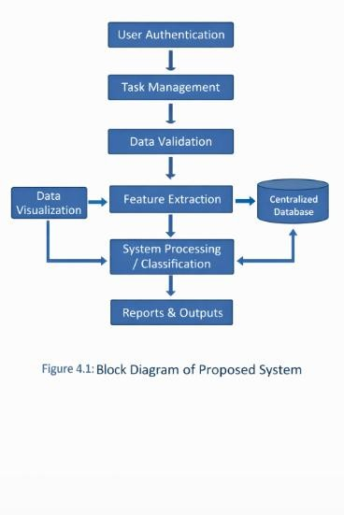

DATA VISUALIZATION
Data visualization in the proposed system plays a crucial role in presenting task-related information in an intuitive and interactive manner. Unlike the existing system, this system provides dynamic dashboards that display key metrics such as completed tasks, pending tasks, overdue tasks, and team performance.
Visualization tools such as bar charts, pie charts, and progress graphs are used to represent data effectively. These visual elements help users quickly understand the current status of projects without analyzing large amounts of textual data. For example, a progress chart can show the percentage of tasks completed within a project.
The system also supports real-time updates in visualizations, ensuring that users always have access to the latest information. This helps managers and team members make quick and informed decisions. Overall, data visualization enhances clarity, improves communication, and supports better project management.
Furthermore, data visualization improves communication within teams. Instead of relying on lengthy reports, users can share visual dashboards that clearly represent project status and performance. This makes it easier for both technical and non-technical users to understand the information.
The proposed system can also support advanced visualization techniques such as heat maps for workload distribution and Gantt charts for project scheduling. These tools provide a deeper understanding of task dependencies, timelines, and resource allocation.
Overall, data visualization in the proposed system enhances transparency, improves efficiency, and supports better decision-making. By providing clear and interactive graphical representations, the system ensures that users can manage tasks and teams more effectively compared to traditional methods.

FEATURE EXTRACTION
Feature extraction in the proposed Smart Task and Team Management System plays a crucial role in identifying and utilizing important attributes from task-related data. It involves extracting meaningful information such as task priority, deadlines, status, assigned users, completion percentage, and dependencies, which helps in efficient task processing and management.
Unlike the existing system, where feature extraction is performed manually, the proposed system automates this process. When a task is created, the system automatically extracts key features from the input data and organizes them into structured formats. This reduces human effort and ensures consistency in task management.
One of the major advantages of feature extraction in the proposed system is automatic prioritization. Based on deadlines, urgency, and task type, the system can identify high-priority tasks and highlight them for immediate attention. This helps users focus on critical activities and improves time management.
The system also extracts temporal features such as start date, end date, and task duration. These features are used to track progress and ensure that tasks are completed within the specified time frame. By analyzing these time-based attributes, the system can also detect delays and notify users accordingly.
Another important aspect is user-based feature extraction. The system identifies which user is assigned to which task and tracks their performance based on task completion rates. This helps in workload balancing by ensuring that no single team member is overloaded while others remain underutilized.
The proposed system also supports feature extraction for task status classification. It automatically categorizes tasks into different states such as pending, in-progress, completed, or overdue. This classification is continuously updated based on user actions, providing real-time insights into task progress.
In addition, the system can extract relational features such as task dependencies. For example, if one task depends on the completion of another, the system identifies this relationship and ensures proper sequencing. This helps in better project planning and avoids conflicts in task execution.
Feature extraction also enables the generation of insights and analytics. By analyzing extracted features, the system can identify patterns such as frequently

delayed tasks, common bottlenecks, or high workload periods. These insights are useful for improving future planning and decision-making.
Furthermore, the proposed system is designed to support scalability in feature extraction. As the number of tasks and users increases, the system can efficiently handle and process large volumes of data without performance degradation. This makes it suitable for both small teams and large organizations.
The integration of feature extraction with data visualization further enhances the usability of the system. Extracted features are represented graphically in dashboards, making it easier for users to interpret data and take appropriate actions.
Overall, feature extraction in the proposed system is automated, efficient, and intelligent. It not only simplifies task management but also provides valuable insights that improve productivity, planning, and team performance.

SYSTEM PROCESSING / CLASSIFICATION
The proposed system includes an advanced processing and classification mechanism that automates task management. Tasks are automatically classified based on their status, priority, and category. For example, tasks can be grouped as pending, in-progress, or completed.
The system also supports intelligent processing features such as automatic reminders, deadline alerts, and task updates. Real-time processing ensures that all users have access to the latest information, improving collaboration and coordination.
Additionally, the system can generate insights based on task data, such as identifying delays or workload imbalances. This intelligent classification and processing improve overall system performance and user experience.

BASIC ARCHITECTURE
The proposed system follows a structured architecture consisting of multiple layers:
- User Interface Layer – Allows users to interact with the system
- Application Layer – Handles task processing and business logic
- Database Layer – Stores all task and user data securely
This architecture ensures smooth communication between components and supports scalability and flexibility.

USER INTERFACE LAYER
This layer provides a user-friendly interface for task creation, assignment, and monitoring. It ensures easy navigation and interaction.

APPLICATION LAYER
This layer processes user inputs, performs validation, and manages task operations such as creation, update, and deletion.

DATABASE LAYER
This layer stores all information related to users, tasks, and team activities.
It ensures data consistency, security, and easy retrieval.

ADVANTAGES OF PROPOSED SYSTEM
The proposed system offers several advantages over the existing system. It provides automation in task management, reducing manual effort and saving time. Real-time collaboration allows team members to work efficiently and stay updated.
The system ensures accurate data handling through validation and centralized storage. It also provides advanced data visualization tools for better

analysis and decision-making. Additionally, features such as notifications, reminders, and task classification improve productivity and organization.
Overall, the proposed system is efficient, scalable, secure, and suitable for modern task and team management needs.

CHAPTER -5 RESULT AND DISCUSSION

  - PYTHON
Python was chosen as the programming language for developing the Smart Task and Team Management System due to its simplicity, flexibility, and wide range of libraries. Python has a large and active community, which makes it easier to resolve issues and find solutions quickly through platforms like Stack Overflow.
One of the major advantages of Python is the availability of powerful libraries and frameworks that simplify development. Frameworks such as Django or Flask help in building web applications efficiently, while libraries like Pandas and NumPy assist in handling and processing data. These tools reduce the complexity of coding and allow faster development and testing of the system.
Python also supports clean and readable syntax, making it easier to understand and maintain the code. This is particularly useful when implementing system logic such as task management, user authentication, and data processing. Although Python is dynamically typed and may sometimes lead to runtime errors, its advantages in rapid development and ease of use make it suitable for this project.

DEVELOPMENT ENVIRONMENT
The development environment plays a crucial role in the successful implementation of the Smart Task and Team Management System. A well-configured environment ensures smooth development, testing, and deployment of the application. For this project, a Python-based development environment is used due to its flexibility and wide support for web development frameworks and libraries.
An integrated development environment (IDE) such as Visual Studio Code or PyCharm is used for writing and managing the project code. These IDEs provide features such as syntax highlighting, code completion, debugging tools, and version control integration, which significantly improve developer

productivity. The debugging tools help in identifying and fixing errors efficiently during the development process.
The project environment is managed using virtual environments, which allow the installation of required libraries and dependencies without affecting the system-wide Python installation. This ensures that different projects can use different versions of libraries without conflicts. Tools like venv or virtualenv are used to create isolated environments for better dependency management.
For backend development, frameworks such as Django or Flask are utilized. These frameworks provide built-in functionalities for handling user authentication, database operations, and routing, which simplifies the development process. The use of such frameworks reduces development time and ensures better code organization.
The system uses a relational database such as SQLite or PostgreSQL to store task and user information. The database is integrated with the backend using Object-Relational Mapping (ORM), which allows developers to interact with the database using Python code instead of writing complex SQL queries. This improves efficiency and reduces the chances of errors.
Package management is handled using tools like pip, which allows easy installation, upgrading, and removal of Python libraries. Required libraries for the project include modules for data handling, authentication, and visualization. These packages are well-documented and widely supported by the Python community.
The development environment also supports testing and debugging. Unit testing is performed to ensure that individual components of the system work correctly. Debugging tools help track runtime errors and improve system reliability. Logging mechanisms are also used to monitor system behavior and identify issues during execution.
In addition, version control systems such as Git can be used to manage code changes and maintain project history. This allows multiple developers to collaborate effectively and ensures that previous versions of the project can be restored if needed.
The system is tested locally during development and can be deployed on web servers for real-time access. Deployment environments may include cloud

platforms or local servers, depending on project requirements. This ensures that the system is accessible to users anytime and from anywhere.
Overall, the development environment used in this project provides a stable, efficient, and flexible platform for building and maintaining the Smart Task and Team Management System. It supports rapid development, easy debugging, and smooth deployment, making it suitable for modern application development.

SYSTEM INTERFACE

Figure 5.1 Login Page
Figure 5.1 shows the login interface of the system, where users can securely access the application by entering their credentials. This ensures that only authorized users can use the system.

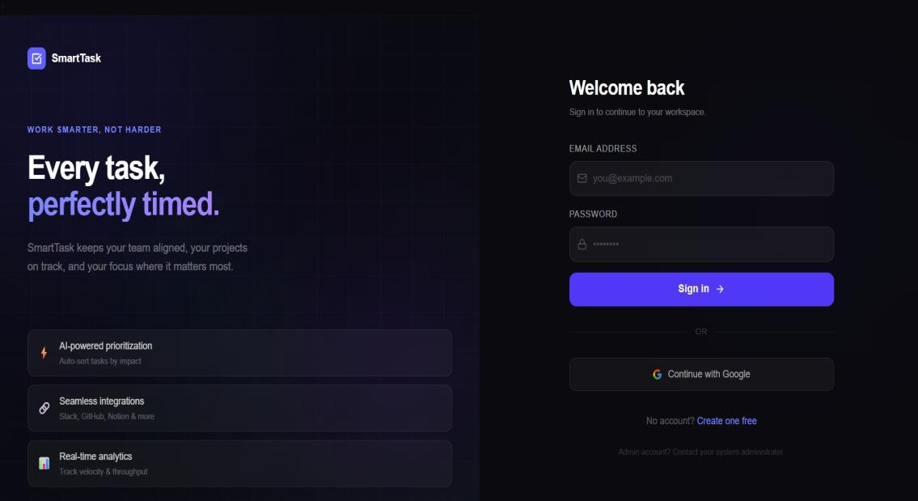

Figure 5.2 Dashboard
Figure 5.2 represents the main dashboard of the system. It provides an overview of tasks, including completed, pending, and overdue tasks. The dashboard helps users quickly understand the current status of their work.

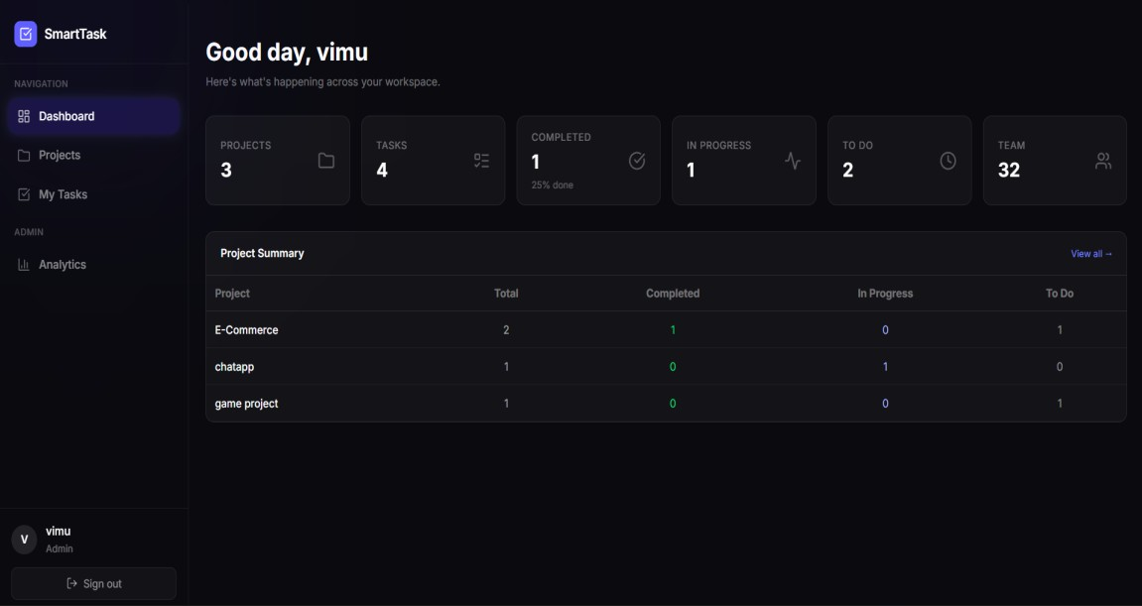

Figure 5.3 Task Creation
Figure 5.3 shows the task creation module.
Users can add new tasks by entering details such as task name, description, priority, and deadline. This simplifies task management and organization.

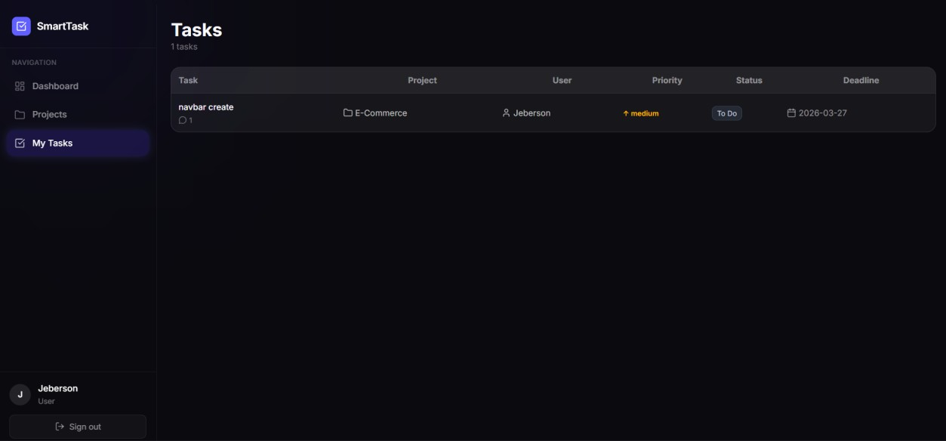

Figure 5.4 Task Assignment
Figure 5.4 represents task assignment, where tasks are assigned to different team members. This ensures proper distribution of work among users.

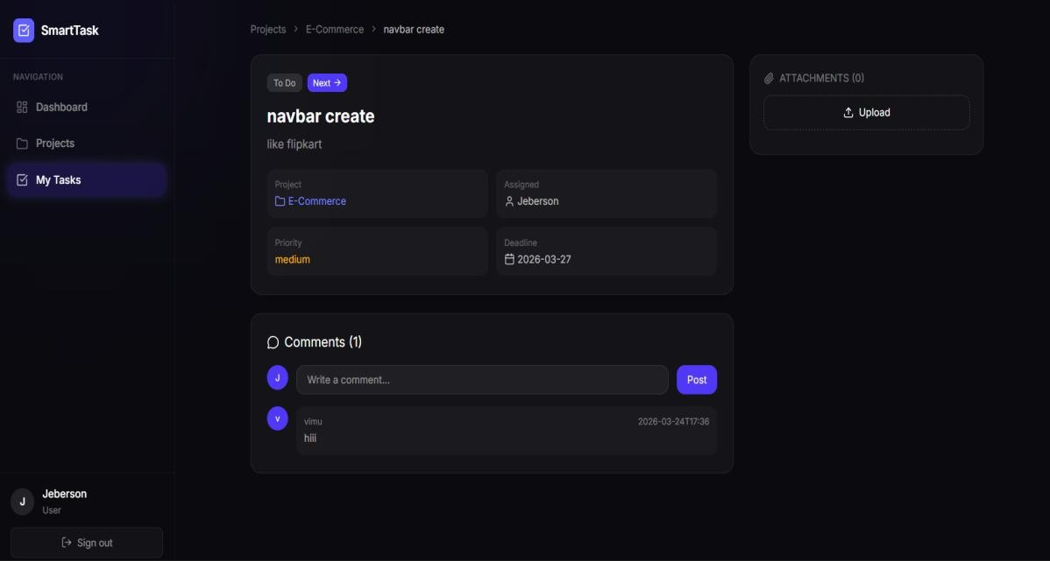

Figure 5.5 Task Tracking
Figure 5.5 shows task tracking functionality. Users can update task status as pending, in-progress, or completed. This helps in monitoring progress effectively.
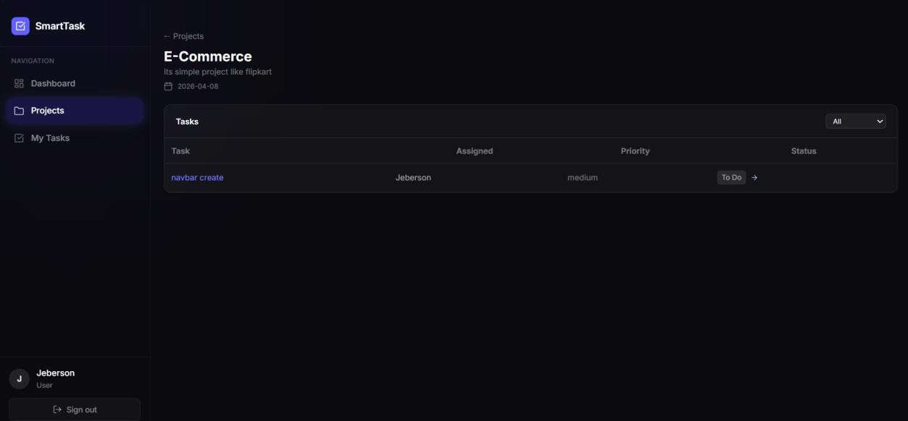

Figure 5.6 Data Visualization
Figure 5.6 illustrates data visualization features such as charts and graphs.
These visuals help users analyze task progress and team performance easily.

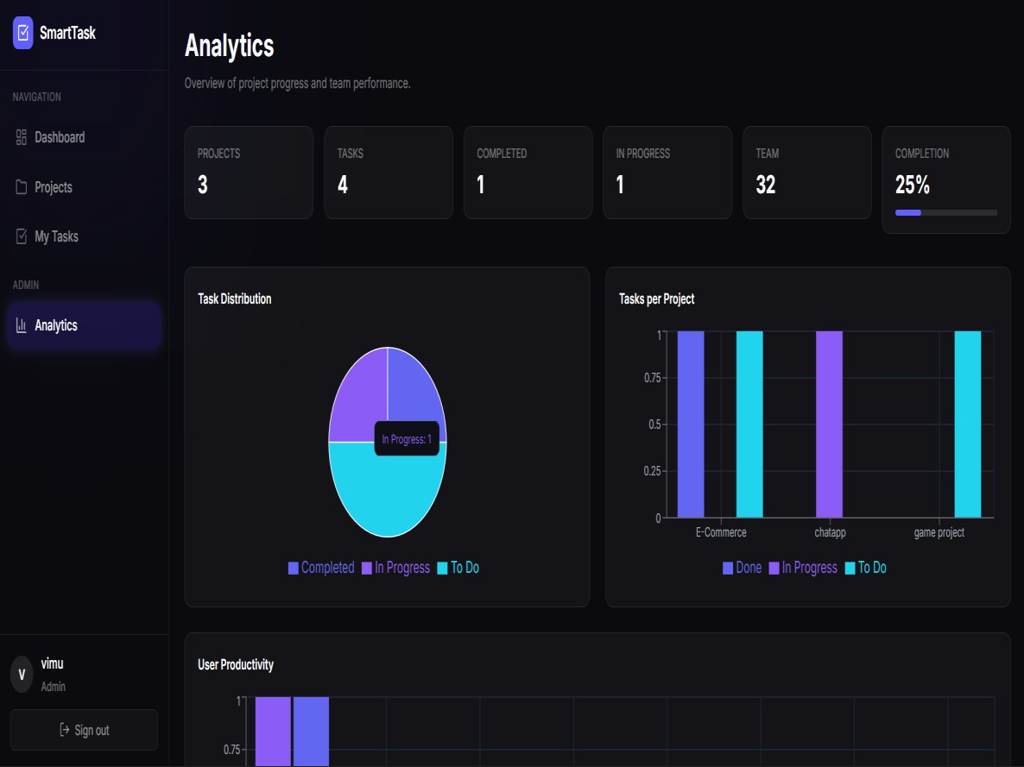

Figure 5.7 Reports and Outputs
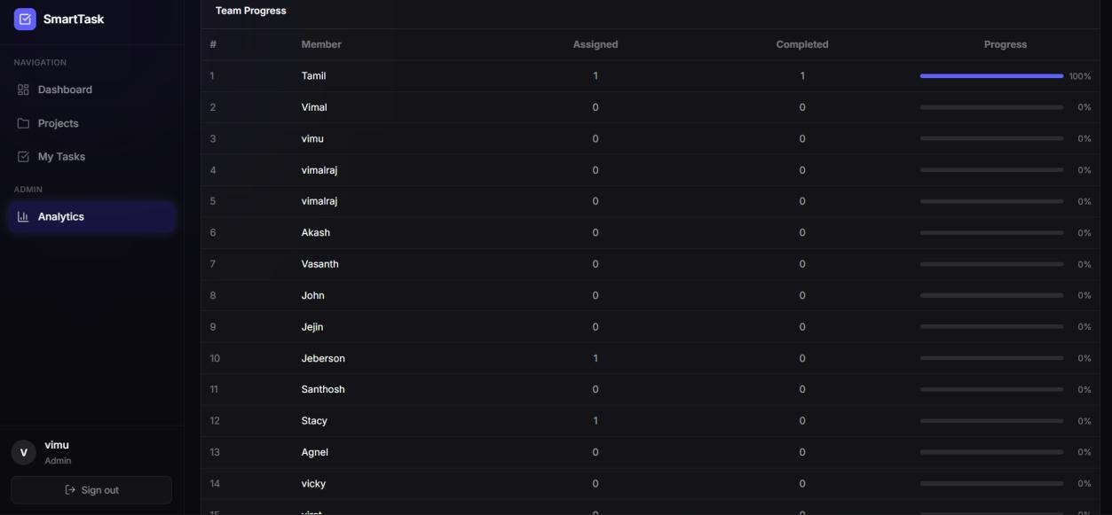
Figure 5.7 shows the reporting module. The system generates reports based on task completion, deadlines, and team performance, which assists in decision-making.

RESULTS
The proposed Smart Task and Team Management System was successfully implemented using Python. The system provides an efficient platform for managing tasks and team activities. It reduces manual effort by automating task creation, assignment, and tracking.
The results show that the system improves productivity by providing real-time updates and notifications. Users can easily monitor task progress and deadlines through dashboards and visualizations. The centralized database ensures data consistency and easy access to information.
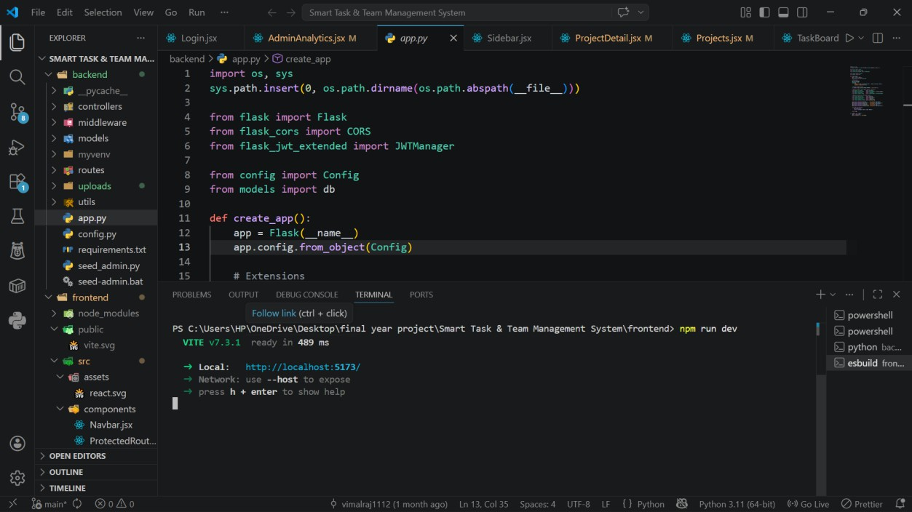
The system also enhances collaboration among team members by providing a shared platform for communication and task management. Overall, the implementation meets the objectives of improving efficiency, accuracy, and organization in task management.

DISCUSSION
The proposed system addresses the limitations of the existing system by introducing automation, real-time updates, and centralized data management. The use of Python enables rapid development and integration of various features.
The system performs efficiently in handling multiple tasks and users simultaneously. It provides accurate tracking of tasks and ensures timely completion through notifications and reminders. Data visualization features improve understanding and help in better decision-making.
However, there is scope for further improvement, such as integrating mobile applications, adding AI-based task recommendations, and enhancing security features. These improvements can make the system more powerful and user-friendly.

CONCLUSION
The Smart Task and Team Management System developed in this project provides an effective solution for managing tasks and team activities. It overcomes the drawbacks of traditional systems by introducing automation, real-time collaboration, and intelligent data handling.
The system improves productivity, reduces manual errors, and enhances communication among team members. With features such as task tracking, data visualization, and reporting, it ensures efficient project management.
In conclusion, the proposed system is reliable, scalable, and suitable for modern organizational needs. It can be further enhanced with additional features to meet future requirements and technological advancements.

CHAPTER – 6 CONCLUSION

CONCLUSION:
In the current era of rapid technological advancement, efficient task and team management has become essential for improving productivity and achieving organizational goals. With the increasing dependency on digital systems, traditional manual methods are no longer sufficient to handle complex tasks and collaborative work environments. This project proposed a Smart Task and Team Management System developed using Python to address these challenges.
The system provides an effective solution for managing tasks, assigning responsibilities, and tracking progress in a structured and organized manner. It simplifies the process of task management by automating key operations such as task creation, assignment, updating, and monitoring. By reducing manual effort, the system minimizes errors and enhances overall efficiency.
The proposed system also improves collaboration among team members by offering a centralized platform where users can access task information in real time. Features such as role-based access, notifications, and reminders ensure that users stay informed about updates and deadlines. This helps in completing tasks on time and maintaining better coordination within the team.
In addition, the system incorporates data visualization techniques to represent task-related information through charts and dashboards. These visual tools help users and managers to easily analyze project progress, identify delays, and make informed decisions. The system also supports proper data validation and structured storage, ensuring accuracy and reliability of information.
Furthermore, the project demonstrates the effectiveness of using Python and modern development tools in building scalable and flexible applications. The system can handle multiple users and projects simultaneously, making it suitable for both small teams and large organizations.
However, there is still scope for future improvements. Features such as mobile application support, cloud integration, and AI-based task

recommendations can be added to enhance the system further. Security features can also be strengthened to protect sensitive data more effectively.
In conclusion, the Smart Task and Team Management System successfully overcomes the limitations of the existing system by providing automation, real-time collaboration, and efficient data handling. The system improves productivity, enhances communication, and supports better decision-making. It serves as a reliable and scalable solution for modern task and team management requirements.

REFERENCES
CHAPTER - 7 REFERENCES

    - D. Merkel, “Docker: Lightweight Linux Containers for Consistent Development and Deployment,” Linux Journal, vol. 2014, no. 239, pp. 2–6, 2014.
    - A. B. Downey, Think Python: How to Think Like a Computer Scientist, 2nd ed., O’Reilly Media, 2015.
    - W. McKinney, “Data Structures for Statistical Computing in Python,” Proceedings of the 9th Python in Science Conference, pp. 51–56, 2010.
    - F. Chollet, Deep Learning with Python, Manning Publications, 2017.
    - A. Holovaty and J. Kaplan-Moss, The Definitive Guide to Django: Web Development Done Right, Apress, 2009.
    - M. Grinberg, Flask Web Development: Developing Web Applications with Python, 2nd ed., O’Reilly Media, 2018.
    - T. VanderPlas, Python Data Science Handbook, O’Reilly Media, 2016.
    - J. VanderPlas, “Visualization with Matplotlib,” Python Data Science Handbook, O’Reilly Media, 2016.
    - E. Tufte, The Visual Display of Quantitative Information, Graphics Press, 2001.
    - I. Sommerville, Software Engineering, 10th ed., Pearson, 2015.
    - R. Pressman and B. Maxim, Software Engineering: A Practitioner’s Approach, 8th ed., McGraw-Hill, 2014.
    - K. Schwaber and J. Sutherland, “The Scrum Guide,” Scrum.org, 2020.
    - J. Brownlee, Machine Learning Mastery with Python, Machine Learning Mastery, 2016.
    - P. Barry, Head First Python, 2nd ed., O’Reilly Media, 2016.

APPENDIX:

Importing Required Libraries
from flask import Flask, render_template, request, redirect, url_for, session import sqlite3
from datetime import datetime

Database Connection
def get_db_connection():
conn = sqlite3.connect('task_manager.db') conn.row_factory = sqlite3.Row
return conn

Creating Tables
def create_tables():
conn = get_db_connection()
conn.execute('''CREATE TABLE IF NOT EXISTS users (
id INTEGER PRIMARY KEY AUTOINCREMENT,
username TEXT, password TEXT
)''')

conn.execute('''CREATE TABLE IF NOT EXISTS tasks (
id INTEGER PRIMARY KEY AUTOINCREMENT,
title TEXT, description TEXT, priority TEXT,

deadline TEXT, status TEXT, user_id INTEGER
)''')
conn.commit() conn.close()

User Registration
@app.route('/register', methods=['GET', 'POST']) def register():
if request.method == 'POST':
username = request.form['username'] password = request.form['password']

?)",
conn = get_db_connection()
conn.execute("INSERT INTO users (username, password) VALUES (?,

(username, password)) conn.commit()
conn.close()

return redirect('/login')
return render_template('register.html')

User Login
@app.route('/login', methods=['GET', 'POST'])

def login():
if request.method == 'POST':
username = request.form['username'] password = request.form['password']

conn = get_db_connection()
user = conn.execute("SELECT * FROM users WHERE username=? AND password=?",
(username, password)).fetchone()
conn.close()

if user:
session['user_id'] = user['id'] return redirect('/dashboard')
return render_template('login.html')

  - Dashboard @app.route('/dashboard') def dashboard():
conn = get_db_connection()
tasks = conn.execute("SELECT * FROM tasks").fetchall() conn.close()
return render_template('dashboard.html', tasks=tasks)

Add Task
@app.route('/add', methods=['POST'])

def add_task():
title = request.form['title']
description = request.form['description'] priority = request.form['priority'] deadline = request.form['deadline']

conn = get_db_connection() conn.execute('''INSERT INTO tasks
(title, description, priority, deadline, status) VALUES (?, ?, ?, ?, ?)''',
(title, description, priority, deadline, 'Pending')) conn.commit()
conn.close()

return redirect('/dashboard')

  - Update Task Status @app.route('/update/<int:id>') def update_task(id):
conn = get_db_connection()
conn.execute("UPDATE tasks SET status='Completed' WHERE id=?", (id,)) conn.commit()
conn.close()
return redirect('/dashboard')

Delete Task

@app.route('/delete/<int:id>') def delete_task(id):
conn = get_db_connection()
conn.execute("DELETE FROM tasks WHERE id=?", (id,)) conn.commit()
conn.close()
return redirect('/dashboard')

