***RIGHT UP ON HOW NORMAL DISTRIBUTION IS A PROBABILITY DISTRIBUTION***

NORMAL DISTRIBUTION:

[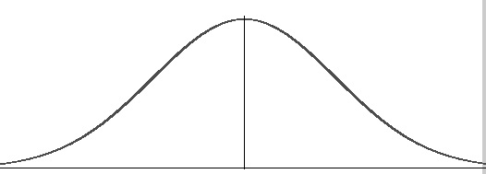](https://www.statisticshowto.datasciencecentral.com/wp-content/uploads/2013/09/normal-distribution-probability.jpg)

.

A [normal distribution](https://www.statisticshowto.datasciencecentral.com/probability-and-statistics/normal-distributions/), sometimes called the bell curve.

It’s a symmetric curve where its equally divided into two halves.

Nearly 99.7% of the values in the population lie in this curve.

Hence we can project most kind of insights from the data by using this bell curve.

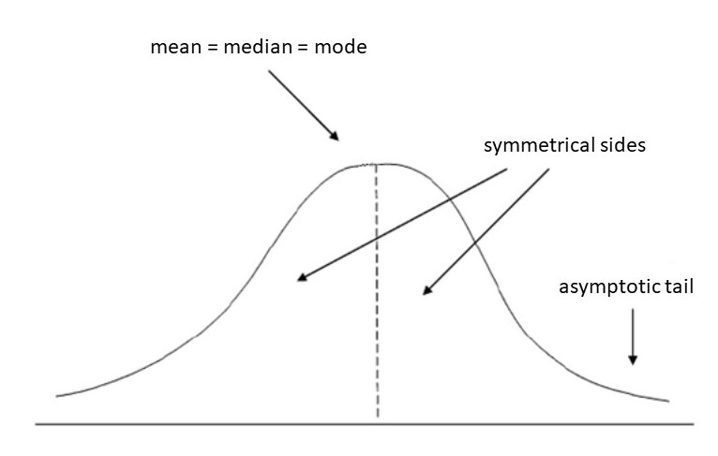

* The standard deviation tells you how tightly your data is clustered around the mean; It allows you to compare different distributions that have different types of data — including different means.

### Practical Applications of the Standard Normal Model

The standard normal distribution could help you figure out which subject you are getting good grades in and which subjects you have to exert more effort into due to low scoring percentages. Once you get a score in one subject that is higher than your score in another subject, you might think that you are better in the subject where you got the higher score. This is not always true.

You can only say that you are better in a particular subject if you get a score with a certain number of standard deviations above the mean. The standard deviation tells you how tightly your data is clustered around the mean; It allows you to compare different distributions that have different types of data — including different means.

For example, if you get a score of 90 in Math and 95 in English, you might think that you are better in English than in Math. However, in Math, your score is 2 standard deviations above the mean. In English, it’s only one standard deviation above the mean. It tells you that in Math, your score is far higher than most of the students (your score falls into the tail).  
Based on this data, you actually performed better in Math than in English!

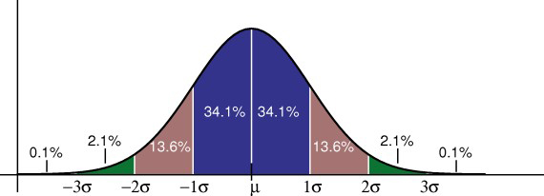

**Properties of a normal distribution**

* The [mean, mode and median](https://www.statisticshowto.datasciencecentral.com/probability-and-statistics/statistics-definitions/mean-median-mode/) are all equal.
* The curve is symmetric at the center (i.e. around the mean, μ).
* Exactly half of the values are to the left of center and exactly half the values are to the right.
* The total area under the curve is 1.

***EMPERICAL SPLIT :***

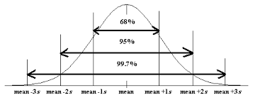

The **empirical rule**, also known as the three-sigma **rule** or the 68-95-99.7 **rule**, provides a quick estimate of the spread of data in a normal distribution given the **mean** and standard deviation. ... 95% of the data will fall within two standard deviations of the **mean**

**Probability Density Function:**

**Probability Density Functions** are a statistical measure **used** to get the discrete value, e.g., the price of a stock or ETF. ... A discrete variable can be measured exactly, while a continuous variable can have infinite values.

In this we can obtain the values in the range of -3 to +3 sigma. As the values fetched under this range can be opted for the further functional analysis.

**Probability and the Normal Curve**

The normal distribution is a continuous probability distribution. This has several implications for probability.

* The total area under the normal curve is equal to 1.