**Air Quality Analysis in Tamil Nadu**

|  |  |
| --- | --- |
| **Date** | **06-10-2023** |
| **Team ID** | **719** |
| **Project Name** | **Air Quality Analysis in Tamil Nadu** |

**Table of Contents**

|  |  |  |  |
| --- | --- | --- | --- |
| 1 | | Introduction | |
| 2 | Problem Statement | |
| 3 | | Design and Innovation Strategies | |
| 3.1 | | Data Collection and Feature Engineering | |
| 3.2 | | Data Pre-processing | |
| 3.3 | | Model Selection and Training | |
| 3.4 | | Geographic Analysis | |
| 3.5 | | Market Sentiment Analysis | |
| 3.6 | | Explainable AI (XAI) | |
| 3.7 | | Continuous Learning | |
| 4 | | Conclusion | |

**1. Introduction**

The introduction sets the stage for your project and provides context. You can start by explaining the importance of air quality analysis and its relevance in Tamilnadu. Highlight the health and environmental impacts of poor air quality. Mention the goal of your project, which is to analyze and improve air quality in the region.

**2. Problem Statement**

In this section, describe the specific problems related to air quality in Tamilnadu. Discuss factors contributing to poor air quality, such as industrial emissions, vehicular pollution, and natural sources. State the challenges faced in monitoring and controlling air pollution.

**3. Design and Innovation Strategies**

Explain the overall design and approach of your project. Discuss any innovative strategies or technologies you plan to use for air quality analysis and improvement. Mention any partnerships or collaborations with relevant organizations or government agencies.

**3.1. Data Collection and Feature Engineering**

Detail how you collected air quality data in Tamilnadu. Discuss the sources of data, including monitoring stations and sensors. Explain any feature engineering techniques used to preprocess the data, such as data cleaning, normalization, or feature extraction

**3.2. Data Pre-processing**

Elaborate on the steps taken to clean and prepare the data for analysis. Describe how missing values, outliers, and noise were handled. Discuss any data transformations or encoding methods used.

**3.3. Model Selection and Training**

Explain the selection of machine learning or statistical models for air quality prediction. Describe the training process, including the use of historical data and cross-validation techniques. Mention any model evaluation metrics used.

**3.4. Geographic Analysis**

Discuss the geographic aspects of air quality in Tamilnadu. Analyze spatial patterns and variations in air pollution levels across different regions. Use maps or visualizations to illustrate these patterns.

**3.5. Market Sentiment Analysis**

Explain how market sentiment analysis is integrated into the project. Describe the relevance of public perception and awareness of air quality issues. Discuss any sentiment analysis tools or techniques employed.

**3.6. Explainable AI (XAI)**

Highlight the importance of explainable AI in your project. Discuss methods and tools used to make the models interpretable and transparent. Explain how XAI helps in understanding the factors influencing air quality.

**3.7. Continuous Learning**

Emphasize the importance of continuous monitoring and learning in air quality management. Describe how your project aims to adapt and improve over time based on new data and insights. Mention any feedback loops or mechanisms for ongoing improvement.

 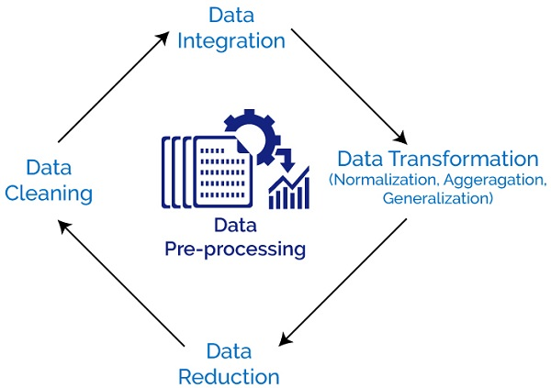

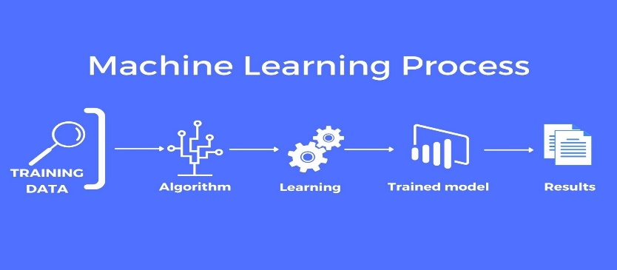

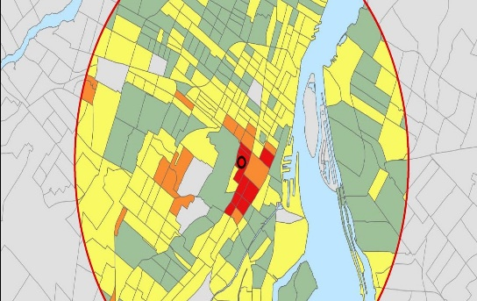 

**4. Conclusion**

Summarize the key findings and achievements of your project. Highlight the impact on air quality in Tamilnadu and its potential benefits for public health and the environment. Discuss future steps and recommendations for sustaining and enhancing air quality in the region.