DOMAIN : INTERNET OF THINGS

TEAM NO : 09

PROJECT TITLE : SMART WATER MANAGEMENT

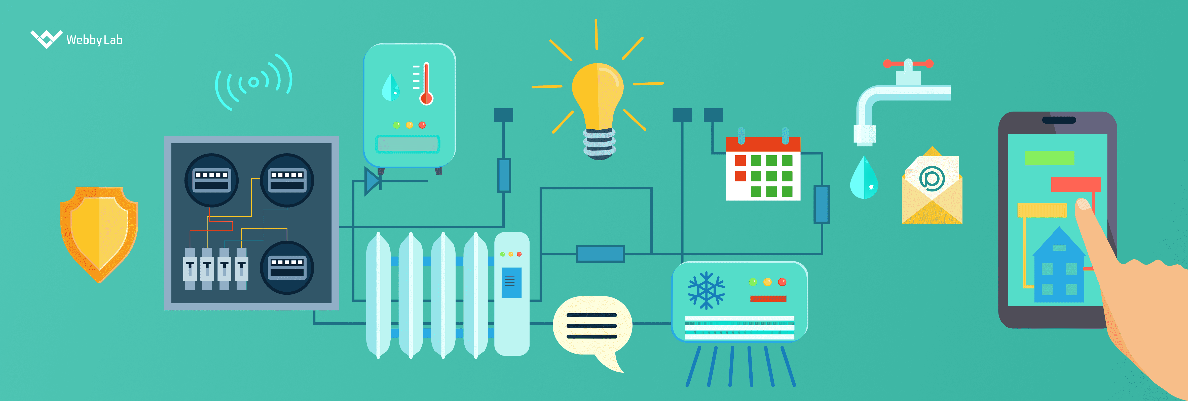

Transforming the design concept for IoT-based smart water management in public places into a real-world project involves several key steps. Here's a detailed process:

**1. Project Objectives Definition:**

🡪Objective Setting: The first step is to clearly define the project's objectives. In this case, the primary objective is to promote water conservation by monitoring and providing real-time water consumption data for public places like parks and gardens.

🡪Scope :Determination of the scope of the project, including the specific areas or locations where IoT sensors will be deployed, the level of data granularity required, and the expected outcomes.

🡪Key Performance Indicators (KPIs): Establishing several KPIs to measure the success of , such as reduced water consumption, cost savings, and improved sustainability.

**2. IoT Sensor System Design with hardware selection :**

🡪Sensor Selection: Choose appropriate IoT sensors for monitoring water consumption. For water management, , the sensors and meters which are needed are flow meters, pressure sensors, and water quality sensors.

**Ultrasonic Sensors**: Place ultrasonic sensors at water storage tanks or sources to measure water levels. These sensors can help track the quantity of water available.

**Water Sensors**: Install water sensors at various points in the irrigation system to detect water flow and detect any leaks or abnormal water usage.

**Temperature Sensors**: Usage temperature sensors to monitor environmental conditions that may affect water requirements for irrigation.

**Reset Logic**: Implement reset logic to ensure the system remains responsive and accurate. This may involve periodic calibration and maintenance routines.

**Relay Power**: Using of relay modules to control the water pumps or valves. These can be activated or deactivated based on sensor data.

**ESP8266 Wi-Fi Module**: Integratation of the ESP8266 module for wireless communication and data transfer to the central platform.

**Oscillator:** Utilize an oscillator for precise timekeeping and synchronization of data transmission.

🡪Sensor Placement: Determining the optimal locations for sensor deployment to ensure accurate data collection. The factors that are needed to be considered are water pipes, accessibility, and environmental conditions.

🡪Communication Protocol: The suitable communication protocol is MQTT, HTTP, LoRaWAN for data transmission from sensors to the central platform.

🡪Power Source :The power source for the sensors which is going to be used is battery-powered or wired depending on the deployment locations.

**3.Power supply :**

🡪 A stable and reliable power supply is essential for your IoT system. Here's how you can ensure a proper power supply:

1. Battery Backup: To ensure continuous operation, we are using a combination of mains power and battery backup. This is crucial in case of power outages. Utilize rechargeable batteries to keep the system running during disruptions.

2. Solar Power: If IoT sensors are deployed in outdoor locations like parks and gardens, solar panels are used for sustainable and efficient power source. They can charge the backup batteries and power the system during the day.

3. Energy-Efficient Components: Select energy-efficient sensors and microcontrollers to reduce power consumption. Inactive components should be put into low-power sleep modes when not in use.

4. Power Management Circuitry: Implement power management circuitry to regulate and distribute power to various components. This includes voltage regulators, battery charging circuits, and power control systems.

5. Redundancy: To ensure system reliability, consider redundant power supplies. If one power source fails, another can take over to keep the system operational.

**4. IoT Sensor Development:**

🡪Sensor Calibration: Calibrate the sensors to ensure accuracy in measuring water consumption.

🡪Data Acquisition: Develop software to collect data from the sensors and transmit it to the central platform in real-time. Use Python libraries and IoT development kits as needed.

🡪Data Security : Implementation of security measures to protect sensor data during transmission and storage.

**5. Data-Sharing Platform Development:**

🡪Database Design: Design a database to store the collected data securely . The database systems are MySQL or NoSQL databases, depending on the volume and structure of data.

🡪Web Application: User-friendly web-based interface is developed where users can access real-time water consumption data, historical trends, and conservation tips.

🡪API Development: APIs are created to enable data sharing with external applications or systems, allowing for integration with third-party services.

**6. IoT Integration:**

🡪Integration of Sensors: Deployment of the IoT sensors in the designated locations and ensure they are properly connected to the data transmission network.

🡪Data Processing: Setting up data processing pipelines to clean, validate, and analyze incoming data. Python libraries such as Pandas and NumPy are used for this task.

**7. Testing and Quality Assurance:**

🡪Conduct thorough testing of the entire system to ensure the accuracy of sensor data, data transmission, and the functionality of the web application.

🡪Implement error handling and monitoring to detect and address any issues in real-time.

**8. Deployment and Scaling:**

🡪Deploy the IoT system in the selected public places, starting with a pilot phase to validate its effectiveness.

🡪Plan for scalability by ensuring the system can accommodate additional sensors and locations as needed.

**9. Maintenance and Monitoring:**

🡪Establishing a maintenance schedule for sensors and the central system to ensure their continued operation.

🡪 Also implementing a monitoring system that alerts administrators to anomalies or system failures.

**10. User Engagement and Education:**

🡪 Promote the availability of real-time water consumption data to the public through outreach campaigns and educational materials.

🡪Encourage user engagement by providing tips and incentives for water conservation.

**11. Data Analysis and Reporting:**

🡪Continuously analyzing the collected data to identify trends, patterns, and potential areas for improvement.

🡪Generating regular reports and share insights with relevant stakeholders, such as government agencies and the public.

**12. Feedback Loop and Optimization:**

🡪Gathering feedback from users and stakeholders to make improvements to the system and address any issues or concerns.

🡪 Continuously optimizing the system for better water management and conservation.

**13. Compliance and Regulations:**

🡪We also ensure that the project complies with local regulations and standards related to water management and data privacy.

By following these steps, We have planned to transform the initial design concept into an innovative IoT-based smart water management system that promotes water conservation in public places effectively. Additionally, using Python and IoT technology as key components allows for flexibility, scalability, and data-driven decision-making throughout the project lifecycle.