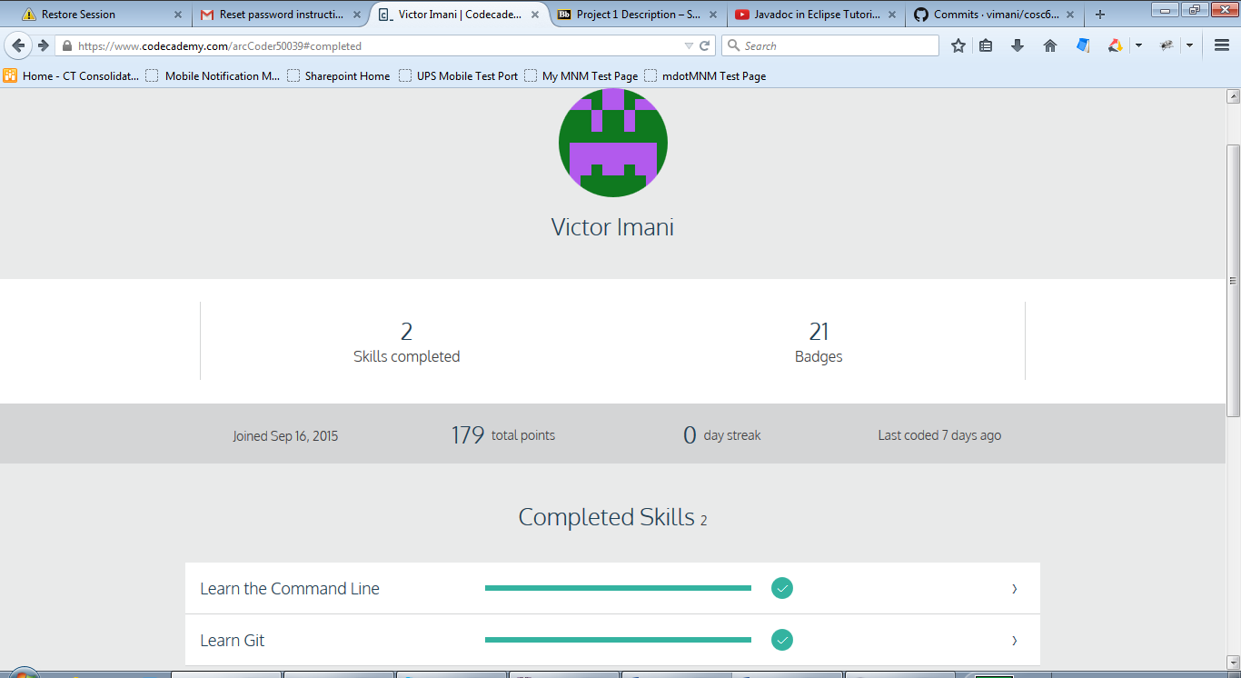

I learned that the GitHub is a distributed revision control system that records changes to a file or set of files over time so that you can recall specific versions later and also work on together with group members of a team. It helps developers have a full repository on their workstation, pushing changes to a remote origin location where others can then pull the changes from. I also learned that there is a command line tool and a desktop application version that helps developers connect and work together on their project where users are managed through their public SSH keys.