Binary Labelled Models Trained:

1. Only Source Trained model; Bilinear.
2. Only Source Trained model; Not Bilinear.
3. Parallel training of Source first trained model; Bilinear; RMS Prop; BCE Loss; No shuffle.
4. Parallel training of Source first trained model; Bilinear; ADAM; BCE Loss; No shuffle;

Date: 20-03-2022

Source Accuracy: 81.49 % (Epoch 158)

1. Parallel training with dataset 2 of model pretrained (18-03-2022) with dataset 1 model; Bilinear; ADAM; BCE Loss; No shuffle

Date: 21-03-2022

Source Accuracy: 86.15 % (Epoch 29)

1. Parallel training without Source first training model; Bilinear; ADAM; BCE Loss; No shuffle; LR scheduler

Date: 18-03-2022

Source Accuracy: (Epoch )

1. Parallel training without Source first training model; Bilinear; ADAM; Focal Loss; No shuffle;

Date: 25-03-2022

Source Accuracy: 95.46% (Epoch 177)

1. Parallel training with dataset 2; Bilinear; ADAM; **Focal Loss**; No shuffle; **No LR scheduler**

Date: 22-03-2022

Source Accuracy: 94.02% (Epoch 79)

1. Parallel training with dataset 2; Bilinear; ADAM; **BCE Loss**; No shuffle; No LR scheduler

Date: 25-03-2022

Source Accuracy: 91.82% (Epoch 79)

1. Parallel training with dataset 2; Bilinear; ADAM; **Focal Loss**; No shuffle; **LR scheduler**

Date: 25-03-2022

Source Accuracy: 92.34% (Epoch 79)

Multi Label Models Trained with Accuracy and Loss curve :

1. Parallel training with dataset 2; **GR_Lambda = 1** Bilinear; ADAM; **Focal Loss**; No shuffle; LR scheduler = No

Date : 18-04-2022

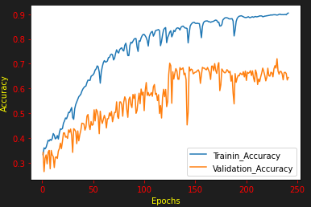

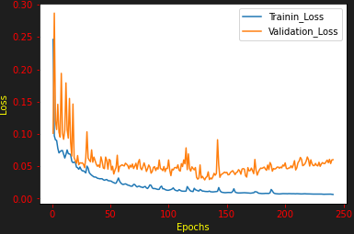

1. Parallel training with dataset 2;**GR_Lambda = 1**; Bilinear; ADAM; **CE Loss**; No shuffle; LR scheduler = No

Date : 21-04-2022

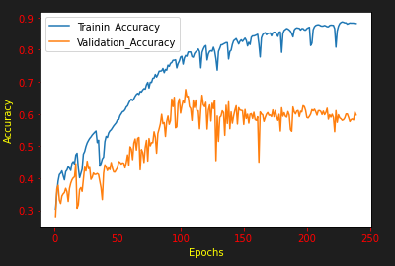

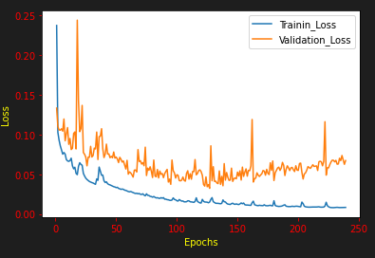

1. Parallel training with dataset 2;**GR_Lambda = 2**; Bilinear; ADAM; **Focal Loss**; No shuffle; LR scheduler = No

Date : 06-05-2022

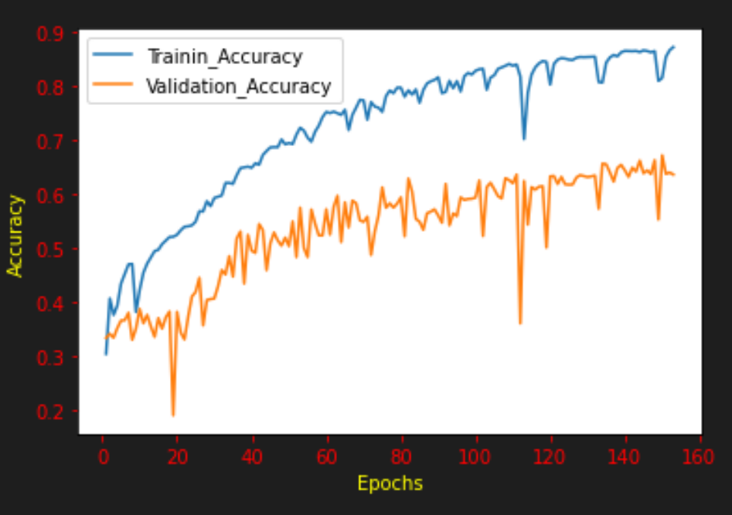

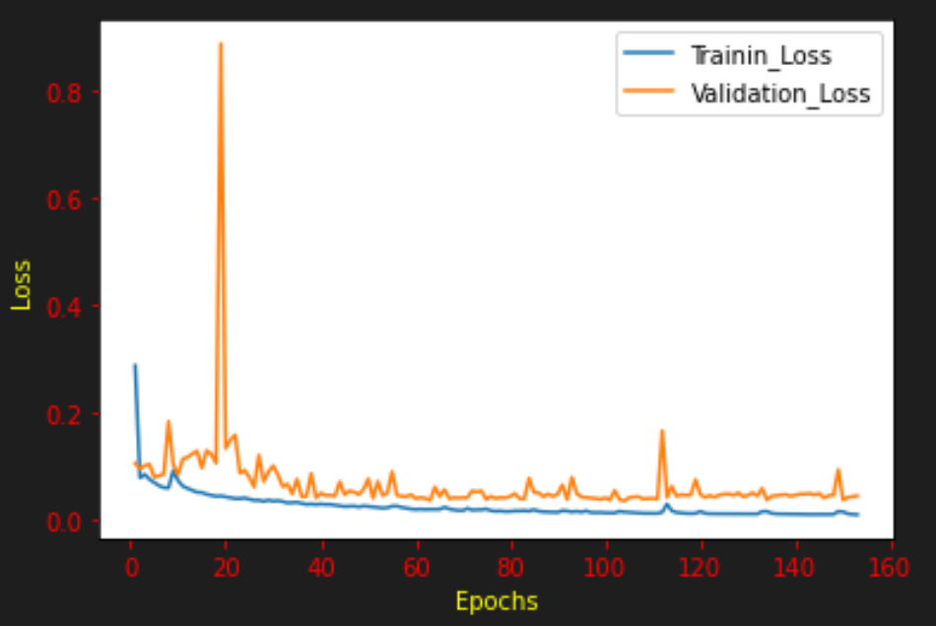

1. Parallel training with dataset 2;**GR_Lambda = 10**; Bilinear; ADAM; **Focal Loss**; No shuffle; LR scheduler = No

Date : 09-05-2022

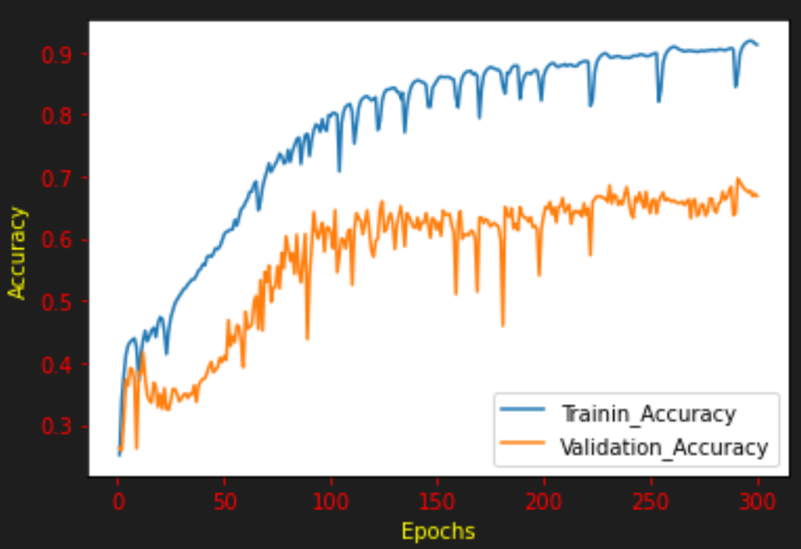

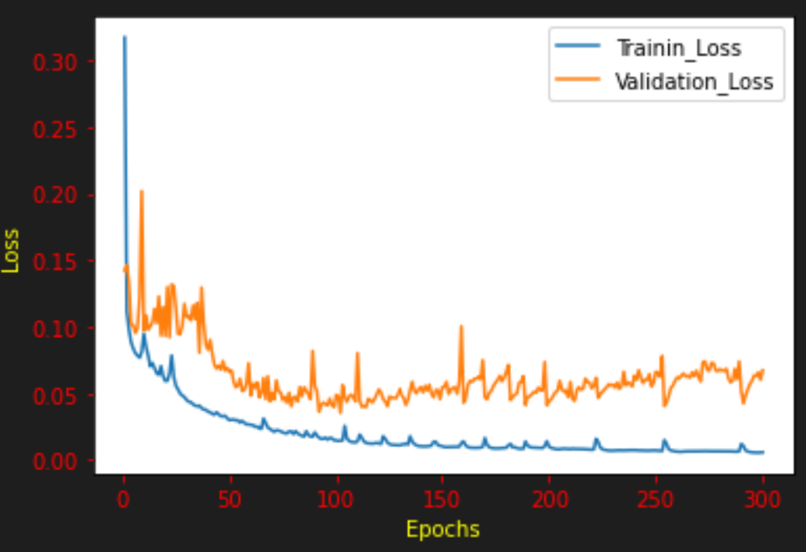

1. Parallel training with dataset 2 Modified UNET with maxpool of features; **GR_Lambda = 1**; Bilinear; ADAM; **Focal Loss**; No shuffle; LR scheduler = No

Date : 19-05-2022

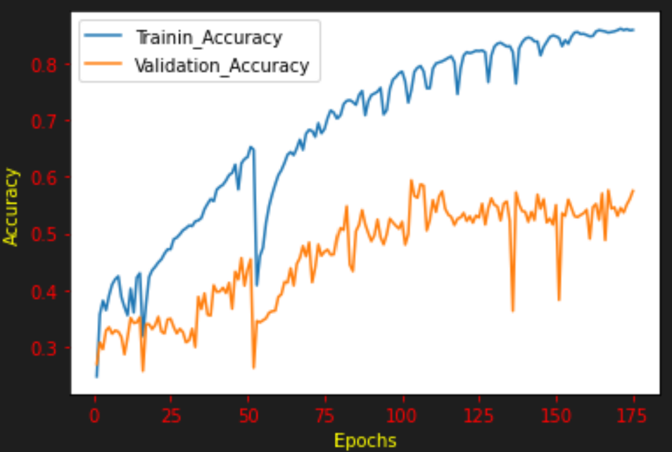

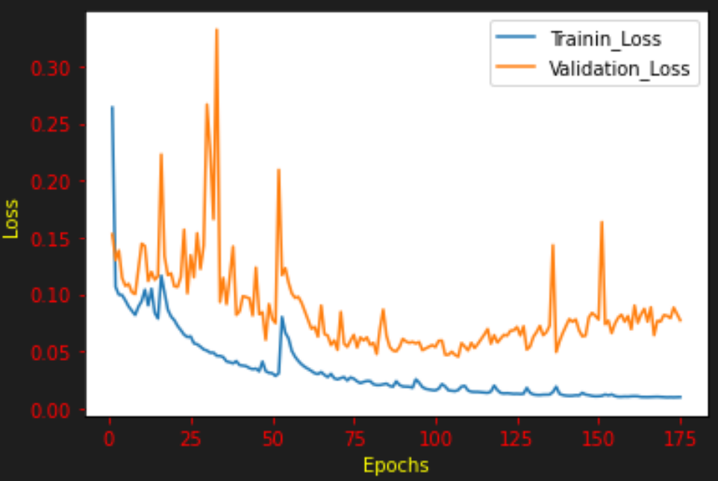

1. Parallel training with dataset 2 Modified UNET with maxpool of features; **GR_Lambda = 2**; Bilinear; ADAM; **Focal Loss**; No shuffle; LR scheduler = No

Date : 27-05-2022

