Create a Flask app **(API)** and perform CURD operation.

1. Tools used to create an application

To create flask application I used,

* Pycharm IDE – for code
* Xampp – for database
* GitHub – for store code online

1. Setup workspace
   1. Creare Virtual Environment

To create virtual environment,

*Python -m venv ./venv*

To activate the environment in windows,

*.\venv\Scripts\activate*

* 1. Install python libraries

Check the existing package in virtual environment,

*Pip list*

*Pip install flask*

*Pip install Flask-SQLAlchemy*

*Pip install SQLAlchemy*

1. Decode the requirements
   1. Home Page

Login As Member

Login As Admin

* 1. Login

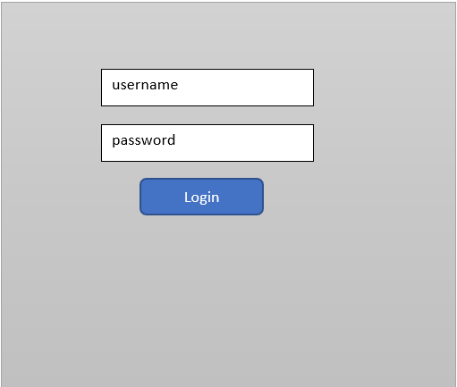

* 1. Admin Page with member information

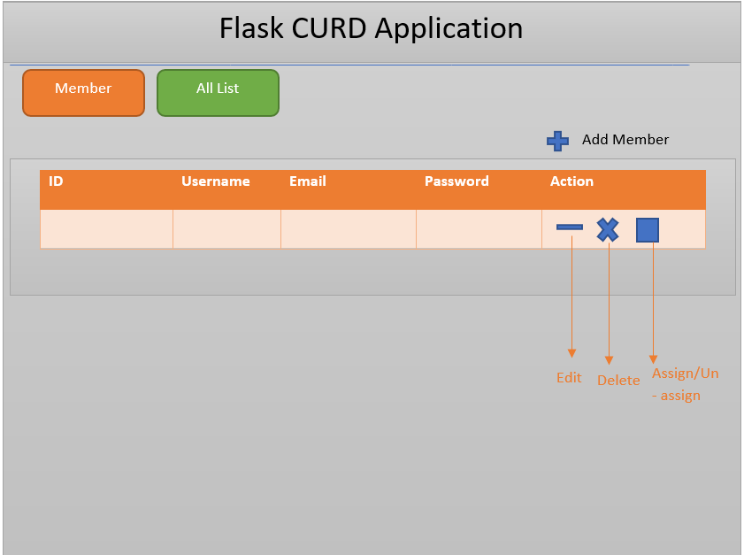

* 1. Admin Page with All List information

Flask CURD Application

|  |  |  |  |  |  |
| --- | --- | --- | --- | --- | --- |
| Index | Title | Description | Comments | Username | Action |
|  |  |  |  |  |  |

Add New List

Assign/Un-assign

Delete

Edit

All List

Member

* 1. User Page

Logout

Add Another List

Add Another Card

comments

Description

Title

1. Implementation
   * Home Page of application

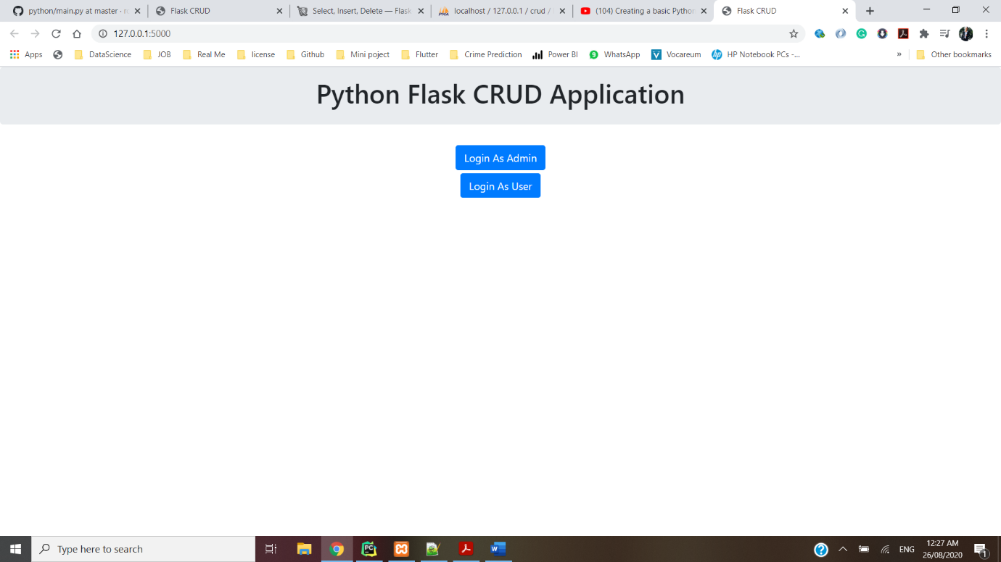

* Admin page with member details from database

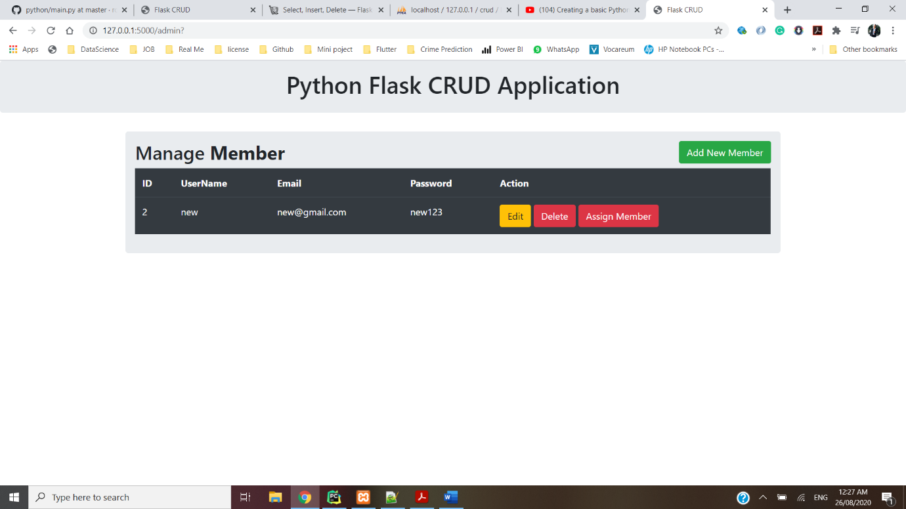

* Login Page

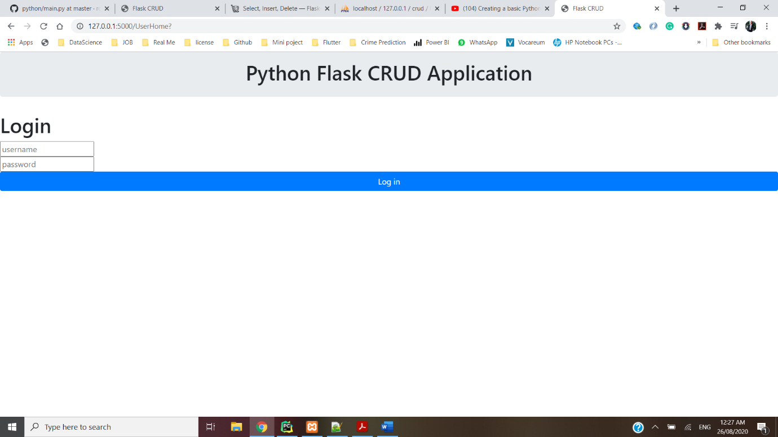

* Validation on Login page

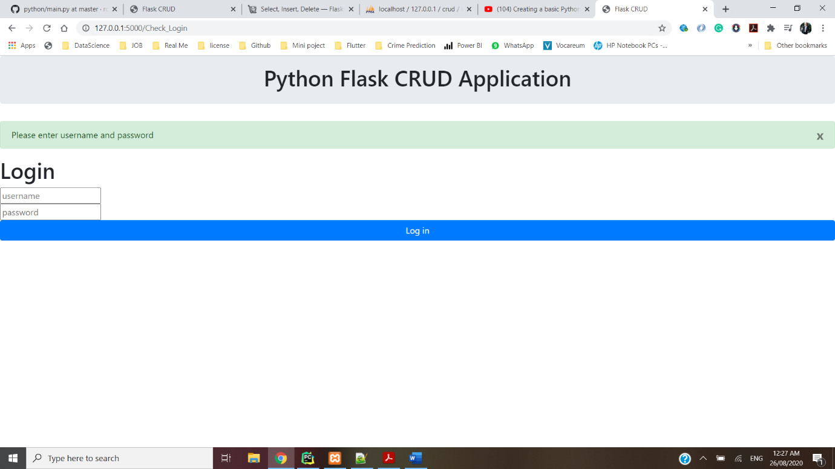

* After successfully login, user’s home page.

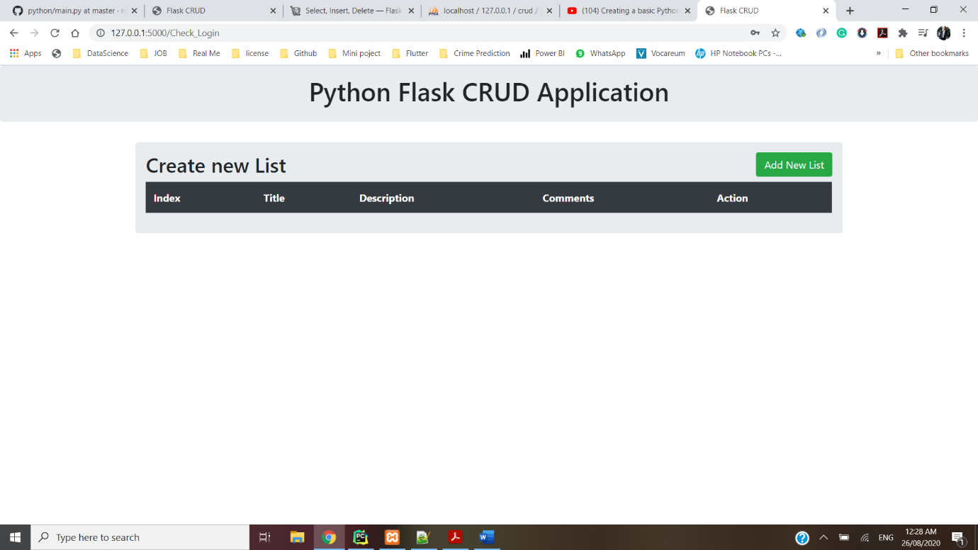

* By clicking on Add new List button, user can see the form to add details of list.

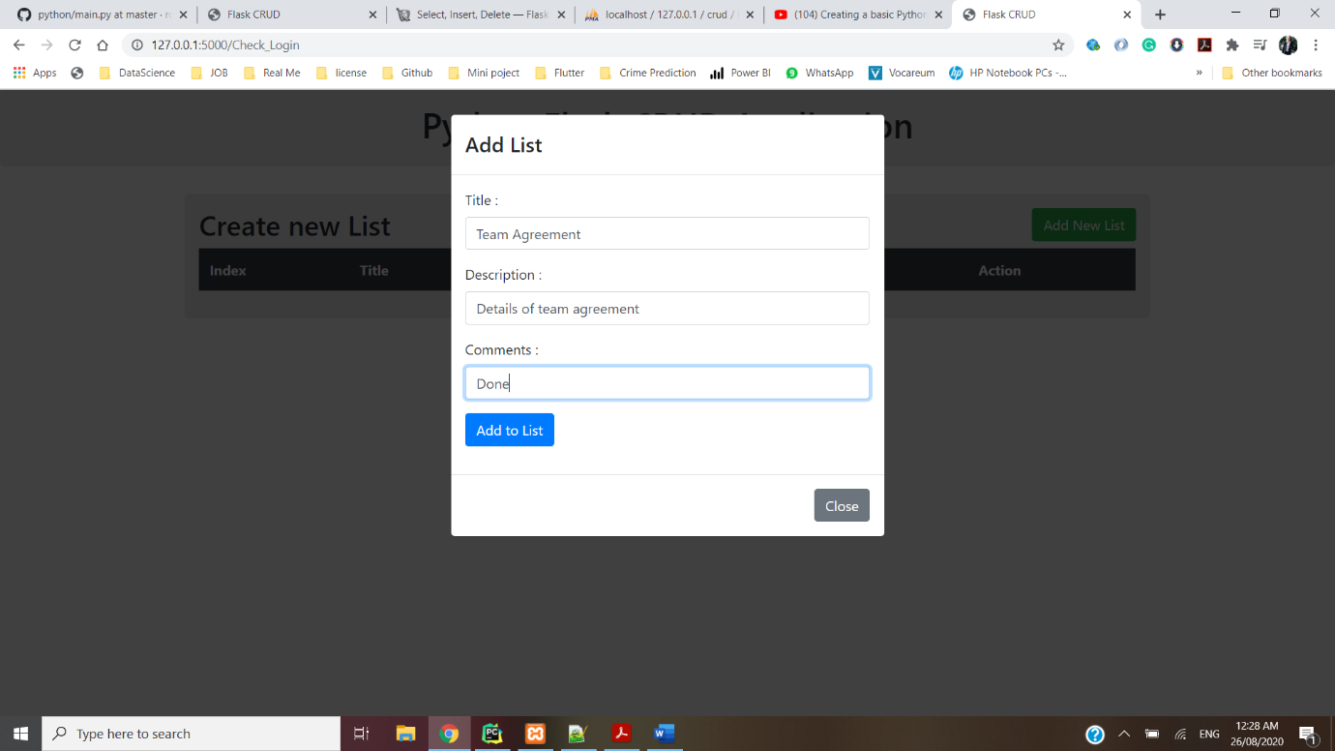

* After filled up the list form, added details are store into database.

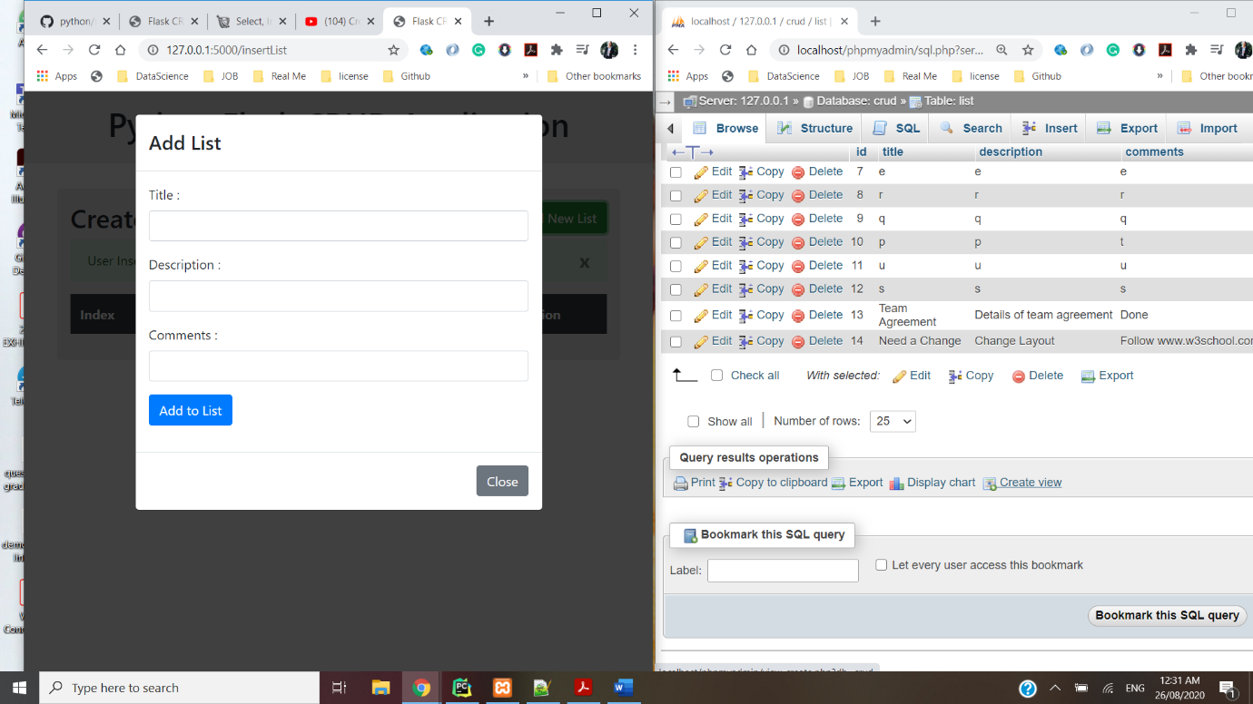

1. Personal Statement

To summarize, I tried my best in accomplish task after studying the flask framework. I work in the framework for the first time. Yet I did basic CURD process after doing research and applying to task. I used MySQL for the database, instead of Postgresql. The reason is I got stuck during Postgresql server installation. To attempt this test requirement, I keep work on MySQL.

1. Reference
   * <https://realpython.com/tutorials/flask/>
   * <https://flask-sqlalchemy.palletsprojects.com/en/2.x/queries/>